Supplemental Table:

Table S1. Spatial distribution of coral colonies as overall (unmarked) and by colony sex type (oocytes or spermaries, marked) for each site. Only corals with clear histological identifications and latitudinal/longitudinal coordinates were included in these analyses (n=99 colonies total). Corals were grouped by whether they produced oocytes (including hermaphrodites) or if they only produced spermatocytes for spatial analysis. “Mark” indicates comparisons made as follows: “unmarked” = unmarked overall analysis, “Oo-Oo” = marked analysis for oocyte producer to another oocyte producer distances, “Oo-Sp” = marked analysis or distance from an oocyte producer to a spermatocyte producer, “Sp-Oo” = marked analysis distance from a spermatocyte producer to an oocyte producer, and “Sp-Sp” = marked analysis distance from a spermatocyte producer to another spermatocyte producer. “Test” indicates the test run as follows: “Quadrat” = quadrat test, “G” = nearest neighbor (G-function) test, and “K” = pairwise comparison (Ripley’s K) test. Asterisks indicate significance.

 |  | Reef Site
Test | Mark | Hospital Point | Punta Donato | STRI Point
Quadrat | unmarked | 0.004* | 0.329 | <0.001*
G | unmarked | 0.07 | 0.17 | 0.46
K | unmarked | 0.02* | 0.05 | 0.01*
G | Oo-Oo | 0.32 | 0.28 | 0.84
K | Oo-Oo | 0.57 | 0.07 | 0.48
G | Oo-Sp | 0.21 | 0.12 | 0.45
K | Oo-Sp | 0.66 | 0.04* | 0.02*
G | Sp-Oo | 0.78 | 0.55 | 0.30
K | Sp-Oo | 0.58 | 0.06 | 0.04*
G | Sp-Sp | 0.19 | 0.14 | 0.24
K | Sp-Sp | 0.02* | 0.82 | 0.02*
Supplemental Figures:
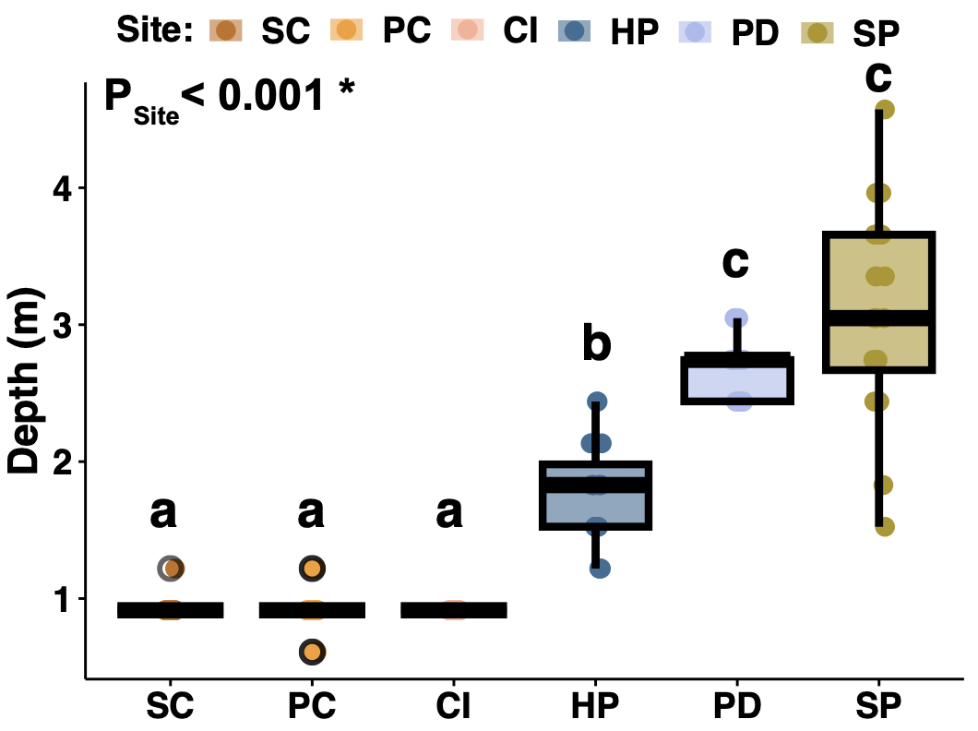
Fig. S1 Depth (m) comparisons across reef sites. Site depths (m) were pulled from coral metadata for each colony sampled. Site abbreviations are as follows: Sid Ciudad (SC), Punta Caracol (PC), Cristobal Island (CI), Hospital Point (HP), Punta Donato (PD), and STRI Point (SP). P-values were determined with Kruskal-Wallis and Dunn tests, significance is indicated with an asterisk for overall comparisons and lowercase letters for pairwise comparisons
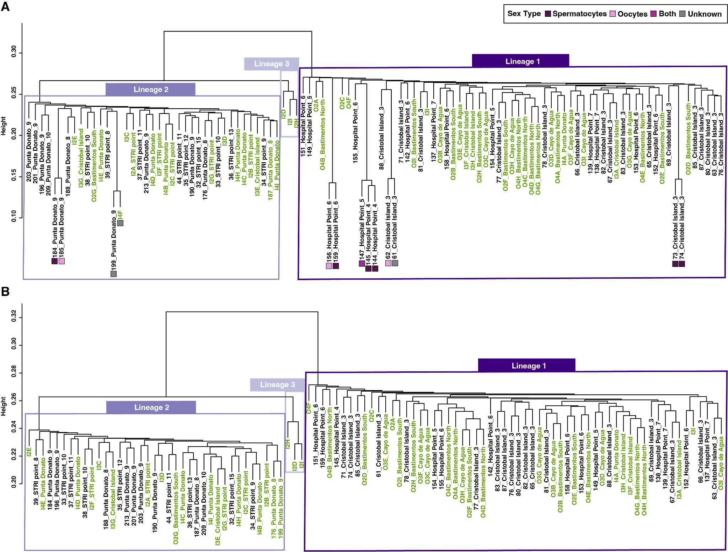Fig. S2 Lineage assignment of samples from 2bRADseq data. Lineage assignment of individuals across CI, HP, PD, and SP sites (black, numerical ColonyID) with colonies identified for each of the three S. siderea lineages from Aichelman et al. 2025 (green, ColonyID with letters) for each lineage. A) dendrogram of samples with the inclusion of identified clones and clone sex types, but technical replicates removed. B) Dendrogram of samples with clones and technical replicates removed. Names of samples are as follows: “ColonyID_Site_Depth(ft)”, with site and depth information only included when available

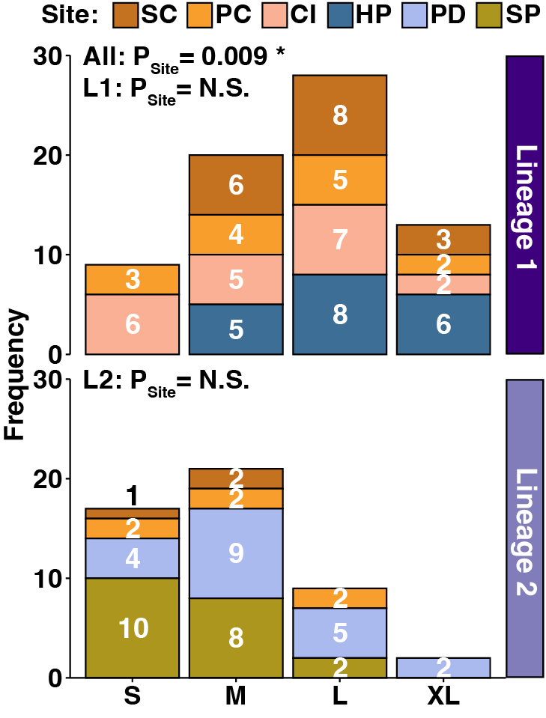
Fig. S3 Colony size observations across study sites and lineages. Histograms of colony size observations by study site and lineage. Site abbreviations are as follows: Sid Ciudad (SC), Punta Caracol (PC), Cristobal Island (CI), Hospital Point (HP), Punta Donato (PD), and STRI Point (SP). Significance was determined by Fisher’s Exact tests for all colonies (All) and within coral lineages (L1, L2) comparisons
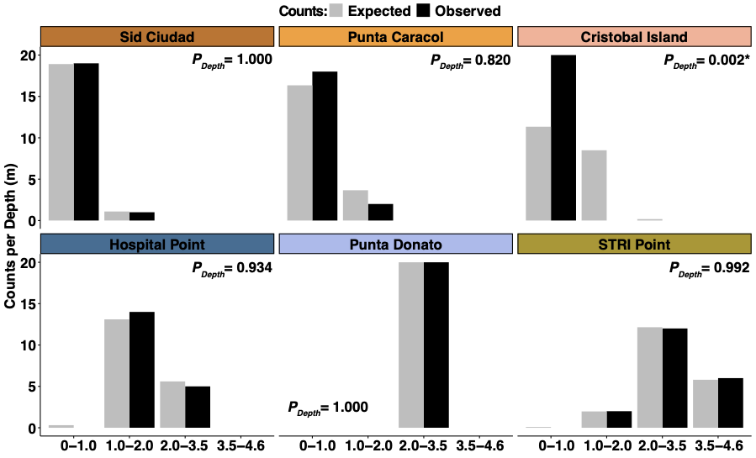
Fig. S4 Results of observed and expected coral colony densities per depth (m) bin for each reef site. Depth bins were determined by coral distributions across depths for all sites and are as follows: 0-1 m, 1-2 m, 2-3.5 m, and 3.5-4.6 meters. P-values were determined by Chi Square Tests for each site, asterisks indicate significance
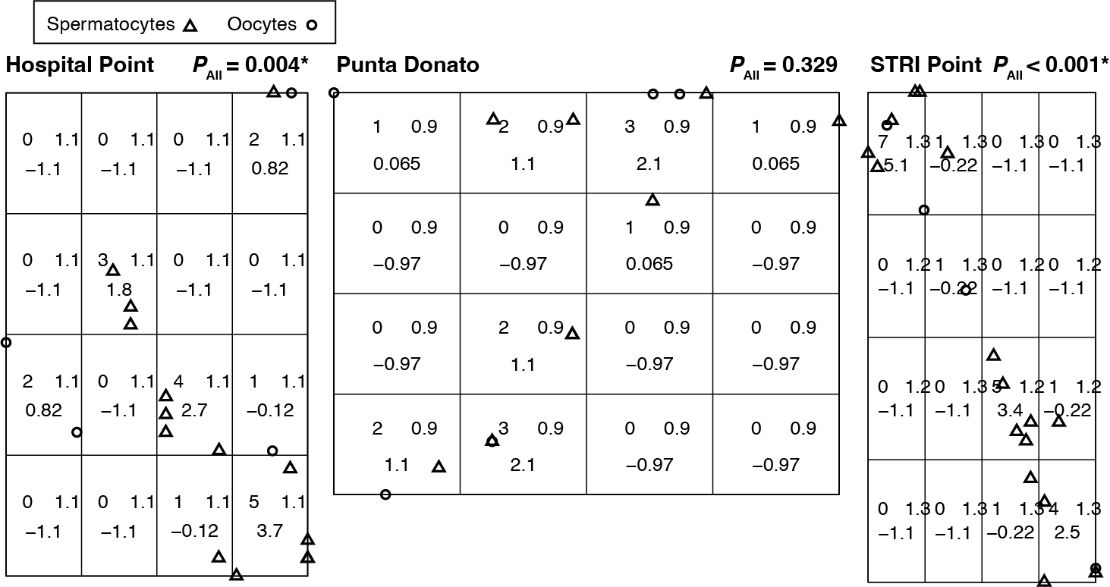
Fig. S5 Quadrat test for each reef site using overall, unmarked spatial comparisons of colonies. Spatial point pattern analysis using 4x4 quadrats for unmarked, overall comparisons (All) for Hospital Point, Punta Donato, and STRI Point. Note that other sites were not included due to a lack of oocyte-producing colonies. Plots are the point distributions overlaid on the 4x4 grids, with the quadrat measures included in the grids. P-values are the product of unmarked, overall comparisons by quadrat test for each reef site. Though not considered in the test, plotted points are marked by gametocytes produced as oocytes (circles, which includes all simultaneous hermaphrodites) or spermatocyte (triangles) for visual considerations
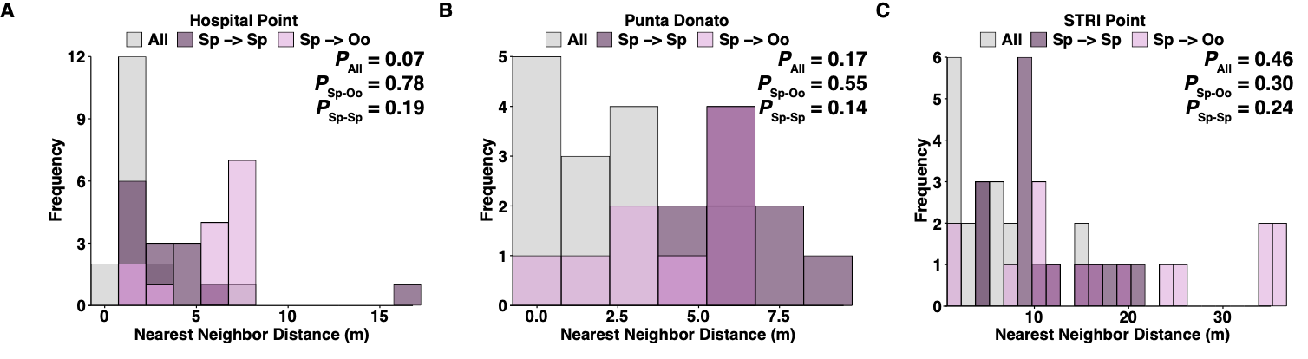
Fig. S6 Nearest neighbor spatial point pattern analyses for spermatocyte-producing colonies. Frequencies for spatial point pattern analysis using nearest neighbor (G) distances for overall comparisons (All), individuals with spermatocyte to other neighbors with spermatocyte (Sp → Sp), and individuals with spermatocyte to neighbors with oocytes (Sp → Oo) for (A) Hospital Point, (B) Punta Donato, (C) STRI Point. Note that other sites were not included due to a lack of oocyte-producing colonies. Plots represent three frequency distributions on the same axis, bars are not stacked. P-values are the product of unmarked overall G-test (Gest) and marked (oocytes or spermatocyte) G-test pairwise tests (Gcross). All individuals that produced oocytes, including simultaneous hermaphrodites, were grouped into “oocytes” for the spatial analyses
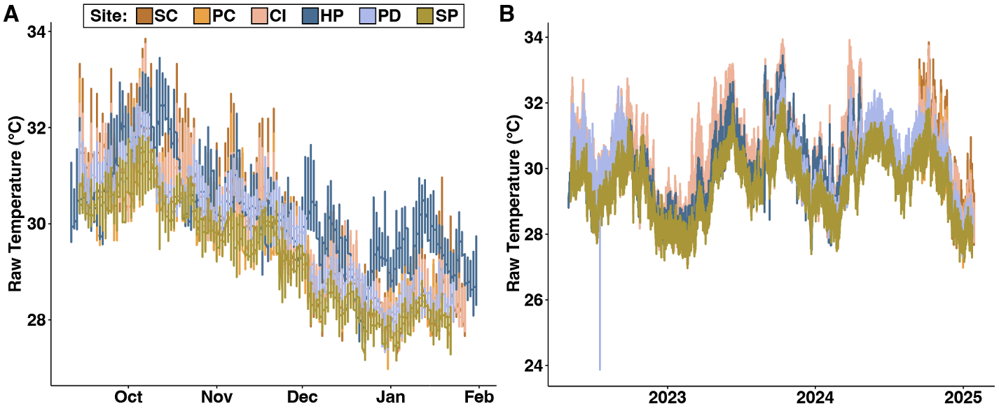
Fig. S7 Raw Temperature data collected from reef sites of Bahia Almirante, Bocas del Toro, Panamá. A) Raw temperature data used for site characterization for the months of Sept 2024-Feb 2025, except Hospital Point data, which are from Sept 2023-Feb 2024 due to an unrecovered logger in 2025. B) Raw temperature data used for calculating degree heating weeks (DHW). Site abbreviations are as follows: Sid Ciudad (SC), Punta Caracol (PC), Cristobal Island (CI), Hospital Point (HP), Punta Donato (PD), and STRI Point (SP). Hospital Point data used for calculating DHW from May 2022 - Oct 2023 was supplemented from Lucey et al. 2024

