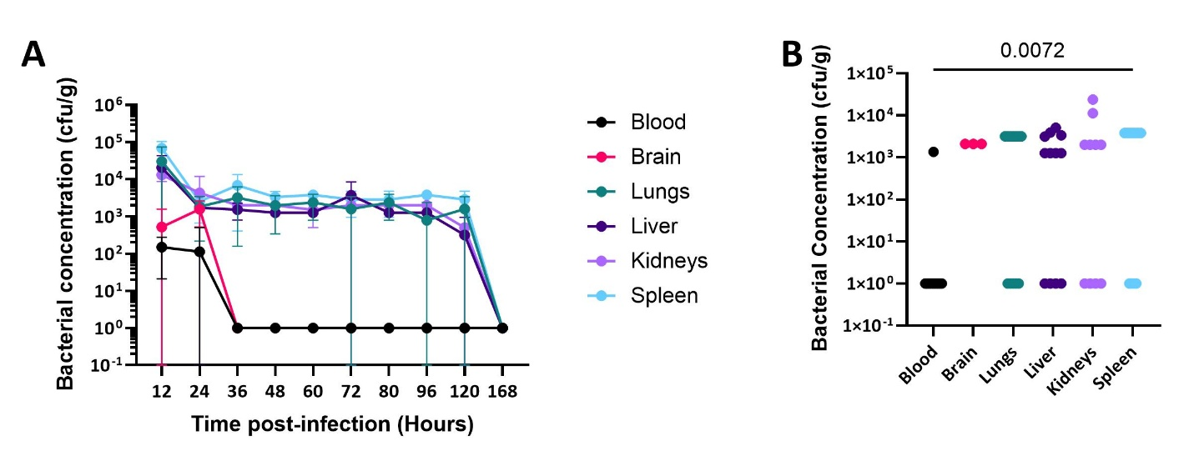
Supplemental Figure 1: Bacterial burden in female mice after sub-lethal infection of K. pneumoniae.
Female mice aged 6-weeks-old were injected intraperitoneally with a sub-lethal dose of K. pneumoniae. A) Every 12h post infection mice were euthanized, and brain, lungs, liver, kidneys and spleen were collected and processed to evaluated bacterial burden as cfu/g of organ. Blood was collected in heparin and processed to evaluate bacterial burden as cfu/mL (n=4-8, 2 repeats). B) 24h post infection the brain was also collected (n=4-12, 1-3 repeats). Significant comparisons from a Kruskal-Wallis test with Dunn’s multiple comparison test are displayed as a line with exact p value denoted. The lower limit of detection (LLOD) for each organ is as follows: blood 450 cfu/mL, brain 4,330 cfu/mL, lung 6340 cfu/g, liver 2540 cfu/g, kidneys 4,010 cfu/g, and spleen 7670 cfu/g; organs with detectable bacteria below the LLOD were set to half the LLOD.
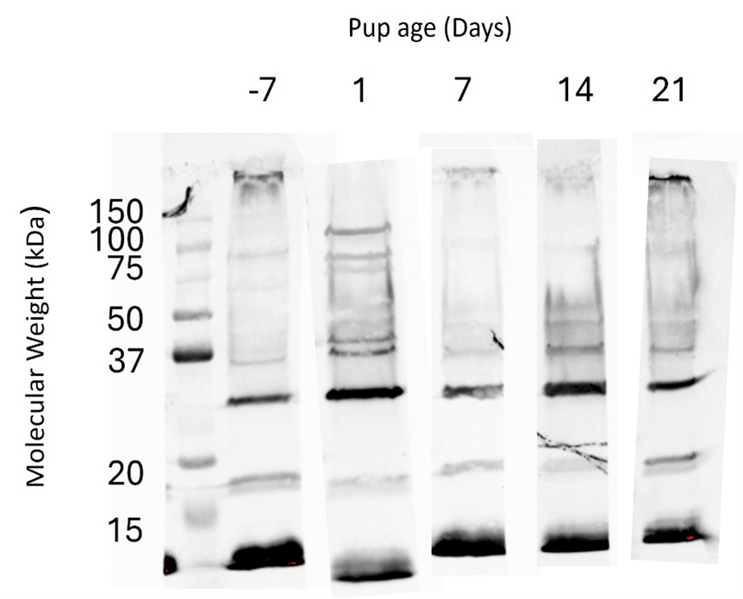
Supplemental Figure 2: Sub-lethal infection elicits an IgG response that reacts to a broad range of K. pneumoniae antigens.
Female mice aged 6 weeks were injected with 3.9x10⁶ cfu of K. pneumoniae by IP injection. Serum was collected from dams 7 days prior to birth and 1-, 7-, 14-, and 21-days post birth. A 15% SDS Page gel was run with 15ug of K. pneumoniae lysate beside the Kaleidoscope prestained protein ladder. Membranes were cut to include one ladder lane and one lysate lane per membrane piece. Mouse sera from each time point was pooled and incubated with the membranes overnight. Membranes were incubated with IRDye conjugated anti-mouse IgG diluted 1:2000 for an hour. Membranes were imaged using the iBright1500.

Supplemental Figure 3: Sub-lethal infection of dams with K. pneumoniae reduces bacterial burden 24h after a sub-lethal dose of K. pneumoniae in female pups 42 days old.
Female pups aged 6-weeks-old born from dams that had been infected with a sub-lethal dose of K. pneumoniae or given PBS subcutaneously (negative control) were injected with a sub-lethal dose of K. pneumoniae. 24h after infection, pups were euthanized. A) Blood was collected in heparin and processed to evaluate bacterial burden as cfu/mL (n=5-9). B) Lungs, C) liver, and D) spleen were collected and processed to evaluated bacterial burden as cfu/g of organ (n=5-9). Comparisons from a Mann-Whitney test are displayed as a line with exact p value denoted. The LLOD for each organ is as follows: blood 450 cfu/mL, lung 6340 cfu/g, liver 2540 cfu/g, spleen 7670 cfu/g; organs with detectable bacteria below the LLOD were set to half the LLOD. Organs that grew no colonies were set to 1 cfu/mL or cfu/g.

