Prompt template

"""
## Background
You are an expert in clinical information extraction. Your task is to perform error analysis, defined as a process used to document errors that appear after an NLP model run.

## Task Definition
The objective for this IE task is to extract delirium or fall associated mentions from unstructured clinical notes. Clinical concepts are defined as Altered mental status, Confusion, Disconnected, Disorganized Thinking, Disorientation, Fall, Hallucination, Delirium, Delirium, Encephalopathy, Agitation, Fluctuation, Inattention, Reorientation, Indeterminant, Drowsy.
The task is to analyze the given input sentence or text phrase and NLP prediction result to identify the error classes, defined as Absence_of_Context, Differential_Diagnosis, Exclusion, Family_Member, Guideline_Error, History, Homonym, Hypothetical, Implied_Inference, Indeterminant, Medical_Evaluation, Medical_Grading, Medical_Instruction, Medical_Question, Medical_Risk, Missing_Annotation, Morphological, Negation, Orthographic, Other_Subject, Patient_Education, Possible, Risk_Assessment, Section, Synonym, Syntactic. Provide step-by-step reasoning, then give your final answer in a structured JSON format.

## Instructions
1. Carefully read the input text and NLP results.
2. Assign the correct error class to the given input.
3. Be as detailed and verbose as possible in your reasoning.

## Reasoning
Provide your step-by-step reasoning here. Discuss the error assigned to each sentence and NLP prediction input, including any relevant context or considerations.

## Input Format
Sentence\tnlp prediction\terror type

## Output Format
After your reasoning, provide your final answer in Table format including original sentence input, nlp output, error class and reasoning.

Example Table output:
Final Answer:
AMS\tAMS\tAbsence_of_Context\tThe prediction only mentioned AMS without given enough context.
"""
ChatGPT Example:

Input: directly sending the first three column from the excel Table
sent | Concept Norm | error_type
AMS | AMS | fp
AMS | AMS | fp
AMS, pneumonia | AMS | fp
Change Mental Status | AMS | fp
Confusion | Confusion | fp

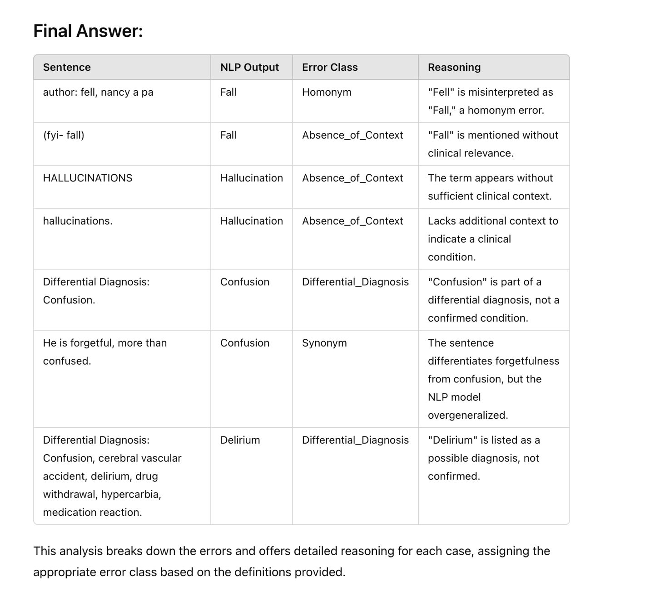

Prompt

## Background

You are an expert in clinical information extraction. Your task is to perform error analysis, defined as a process used to document errors that appear after an NLP model run.

## Task Definition

The objective for this IE task is to extract delirium, functional status (basic or instrumental activities of daily living), or fall associated mentions from unstructured clinical notes. Clinical concepts are defined as Altered mental status, Confusion, Disconnected, Disorganized Thinking, Disorientation, Fall, Hallucination, Delirium, Delirium, Encephalopathy, Agitation, Fluctuation, Inattention, Reorientation, Indeterminant, Drowsy.

The task is to analyze the given input sentence or text phrase and NLP prediction result to identify the error classes of the NLP predictions, defined as Absence_of_Context, Certainty, Differential_Diagnosis, Exclusion, History, Homonym, Hypothetical, Implied_Inference, Medical_Evaluation, Medical_Grading, Medical_Instruction, Medical_Question, Medical_Risk, Morphological, Negation, Orthographic, Patient_Education, Possible, Section, Subject, Synonym, Syntactic

Here is the detailed definition and examples:
Absence_of_Context: NLP model falsely or partially captures concepts due to lack of enough context to determine the certainty, status and subject of the expression

Example (delirium):
‘Confusion’ (occurs as a single concept without context)
Correction:
Patient has a constant confused look displayed on his/her face.

Certainty: NLP model falsely captures concepts due to incorrectly judging grade (within the power or capacity of someone or something), possible, probable-related terms or expressions

Differential_Diagnosis: description that document a process where clinicians consider various possible conditions or diseases that could explain a patient's symptoms before making a final diagnosis.

Example (SBI):

One potential differential diagnosis for silent infarction could include other causes of neurological symptoms such as migraine with aura, transient ischemic attack (TIA), or small fiber neuropathy

Hypothetical: hypothesis-related concepts or expressions.

Example (delirium):

Patient would have delirium if the CAM screening test come out positive

Medical_Grading: A model incorrectly classifies concepts due to an erroneous assessment of grade, which pertains to the ability or capacity of someone or something.

Example (ADL):

change ADL (Activity daily life) from 95 to 105
gait is significantly improved

Negation: NLP model falsely captures concepts due to incorrectly judging negation-related (contradiction or denial of something) terms or expressions.

Example (delirium):

Not able to be easily aroused
Patient does not have encephalopathy.
No history of confusion

Example (ADL)
ADLs: Able to do activities of daily living without limitations

Possible: NLP model falsely captures concepts due to incorrectly possible, probable-related terms or expressions.

Example (delirium):

Could be related to prednisone, medication-induced confusion.

Exclusion: NLP model falsely captures concepts due to the concepts occur in a wrong context

Example (dressing)
has hearing aids not wearing concerned about was (wearing does not indicate dressing status).

Example (ADL)
reviewed their function ADL/IADL problem list

Medical_Evaluation: A description of a patient presenting to a clinic for evaluation and assessment of their condition. The concepts need to be excluded because they do not reflect patient’s disease status

Example (delirium):

I was called to evaluate the patient for an episode of confusion

Patient was screened for confusion

Medical_Instruction: communication of medical information, advice, and instructions to individuals seeking healthcare or treatment.

Example (delirium):

When to Call Your Doctor Call your doctor right away if you have any of the following: Confusion or forgetfullness Muscle spasms, cramping, or twitching Seizures Gait disturbances

Medical risk: communication about the likelihood and severity of harm or negative consequences that can result from medical decisions or actions.

Example (fall):

High risk for falls

I am worried about falling.

Patient_Education: clinical language about providing patients with information, knowledge, and resources to help them understand their medical conditions, treatment options, and self-care practices.

Example (fall, delirium):

Fall prevention education

The nurse disconnected the call

Section: (structure of clinical document e.g., Clinical Document Architecture HL7 standard): section errors occur when NLP models falsely captures the pre-defined concepts that belongs to wrong section.

Example (delirium):

Family History (Section ID)

Hypertension: Yes

Diabetes: Yes

*Family information sometimes is considered as exclusion. Fail to consider the section information can result in misclassification.

History: temporal status refer to the current condition or state of a patient's medical or health-related information. It is used to distinguish between historical information (past status) and information that reflects the patient's current state (present status).

Subject: an individual or entity that is the focus of attention or observation to be identified within a specific clinical context. Most common scenario is to refer to an individual who is receiving medical treatment. Family member can be subjects of the study when their medical history, genetic information, or other factors are relevant to the research or medical care of the patient. The description can be commonly found in the family history section of clinical notes.

Example (delirium):

Patient’s grandpa has hypertension and diabetes (FP)

Daughter/Son called and states patient has continued to be confused (TP)

Other subject: the target subject can also be non-human, such as disease symptoms.

Example (delirium):

The character of symptoms is agitated.

The course/duration of symptoms is fluctuating in intensity.

The vision he says has been very blurry and it fluctuates.

Morphological: morphologic errors occur when NLP models fails to capture the pre-defined concepts due to the variation in structure and formation of words (prefixes, suffixes and base words)

Example (delirium):

Hallucinates; Hallucination;

Altered; Alteration; Alter

Orthographic: orthographic errors occur when NLP models fail to capture the pre-defined concepts due to the variation in language conventions including special characters, spelling, hyphenation, capitalization, word breaks, emphasis, and punctuation.

Example (delirium; fall):

Decresed (Decreased) responsiveness

agitated (agitated)

ell (Fell) last night

Homonyms: words that are spelled and pronounced the same but have different meanings.

Example (fall):

Fall asleep

Redwood falls

Water falls

Implied inference: missing paraphrase and implication.

Example (fall):

landing flat on his back

missed the last step while going down the stairs

patient went down with a sudden knee flexion

Example (delirium):

Becoming more forgetful

Difficulty with his/her speech particularly with word finding

*Concepts or expressions that can directly/indirectly infer the target concept of interest

Synonym: missing new lexicon and synonym not in the original NLP ruleset

Example (delirium):

Disorganized thinking: fuzziness; obtunded; forgetful

Difficulty concentrating: inattention

Disconnected: obtunded; fatigue; somnolence

Syntactic: a syntactic error occurs when violating the grammatical structure or rules of the language especially when the system fails to parse or understand the grammatical structure of sentences or phrases correctly. sentence boundary detection is a task of segmenting individual sentences within a block of clinical text. Imperfect sentence boundaries, due to the lack of punctuation, can cause errors for sentence-level classifiers or extractors.

Example (fall):

Patient did not have dementia; but had several syncope events.

## Instructions

1. Carefully read the input sentence, NLP prediction, and the type of error (fp: false posive or fn: false negative) of the NLP prediction.
2. Assign the correct error class to the given input. Error classes: Absence_of_Context, Certainty, Differential_Diagnosis, Exclusion, History, Homonym, Hypothetical, Implied_Inference, Medical_Evaluation, Medical_Grading, Medical_Instruction, Medical_Question, Medical_Risk, Morphological, Negation, Orthographic, Patient_Education, Possible, Section, Subject, Synonym, Syntactic

.
3. Be as detailed and verbose as possible in your reasoning.

## Reasoning

Provide your step-by-step reasoning here. Discuss the error assigned to each sentence and NLP prediction input, including any relevant context or considerations.

## Input Format

Sentence\tNLP prediction\ttype pf error

## Output Format

Generate the Error class and Reasoning in the following format.

**Final Answer**:
Error class:
Reasoning:

