Supplementary information figures:

Suppl. 1: Ternary diagram showing the Zn, Sn and Pb contents of the Bohemian brass samples categorised according to the cultural groups.

Suppl. 2: The Zn content in the Bohemian brass samples plotted as A: histogram; B: boxplot according to dating; C: boxplot according to the cultural groups.

Suppl. 3: Overview of lead isotope systematics of the Bohemian brass objects categorised according to the cultural groups. 3. Source: this study.

Suppl. 4: Bi-plot of Zn verus Sn + Pb content of the earliest brass objects from the 1st century BC categorised according to dating. [16, 17, 60] + this study.

Suppl. 5: Bi-plot of PCA results of selected brass objects from Bohemia with the comparative datasets. Factor 1 versus Factor 2 categorised according to A: the cultural groups B: dating. Sources: [15, 16, 17, 60] +this study.

Suppl. 6: Euclidean (ED) and Mahalanobis (MD) distances of lead isotope ratios of various ore sources from Europe and the Bohemian brass objects categorised according to the cultural groups. Sources: see [2, 22, 27, 28, 35, 70, 76, 71].

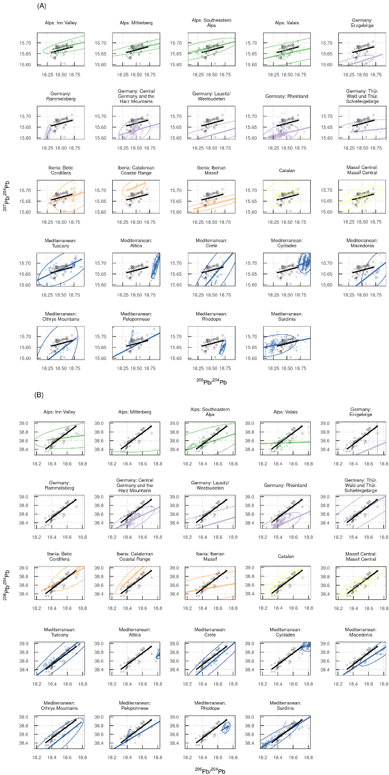
Suppl. 7: Comparison of slopes and linear models of the lead isotope systematics of possible ore sources and the Bohemian brass objects. Sources: see [2, 22, 27, 28, 35, 70, 76, 71].

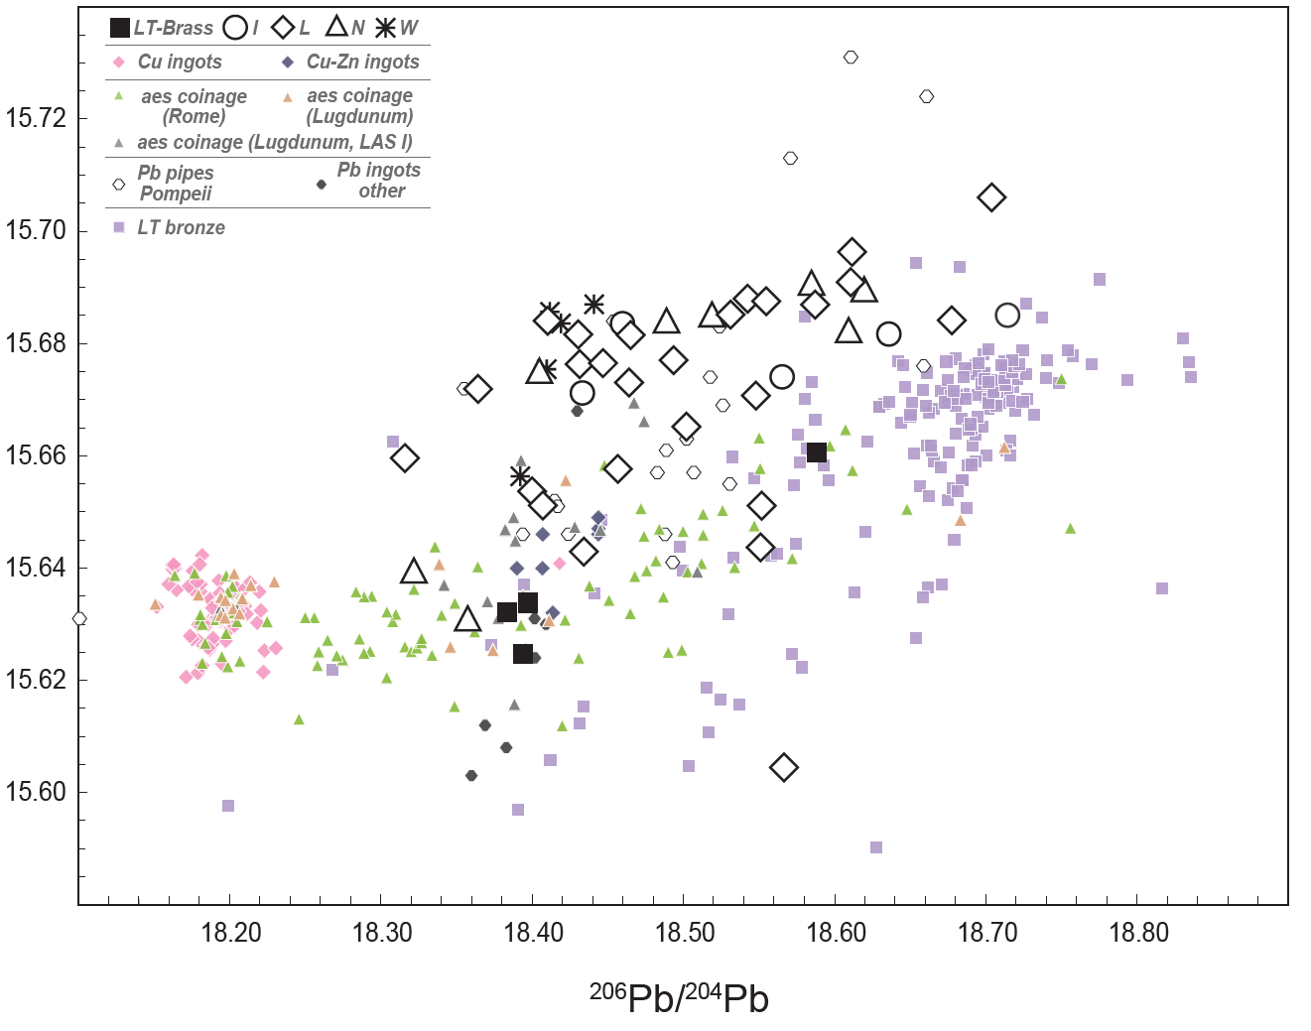
Suppl. 8: Overview of lead isotope systematics of various sets of artefacts from the Early Roman period and the Bohemian brass objects categorised according to cultural groups. Sources: see description in chapter 4.2 + this study.

