Supplemental Materials
for
Atomic-Scale Engineering of d-π-d Spin Interaction in Metal-Organic Architectures
Xue Zhang^{1,2†}, Xin Li^{1†}, Jie Li^{1†}, Haoyang Pan^{3†}, Yajie Zhang^{1*}, Gui-Lin Zhu⁴, Zhen Xu³, Ziyong Shen¹, Shimin Hou¹, Yaping Zang⁵, Bingwu Wang⁶, Kai Wu⁷, Shang-Da Jiang³, Ivano E. Castelli⁸, Lianmao Peng¹, Per Hedegård^{9*}, Song Gao^{10,3,6}, Jing-Tao Lü^{4*}, Yongfeng Wang^{1*}
¹ Center for Carbon-Based Electronics and Key Laboratory for the Physics and Chemistry of Nanodevices, School of Electronics, Peking University, Beijing, 100871, China.
² Spin-X Institute, School of Microelectronics, State Key Laboratory of Luminescent Materials and Devices, South China University of Technology, Guangzhou, 511442, China.
³ Spin-X Institute, School of Chemistry and Chemical Engineering, State Key Laboratory of Luminescent Materials and Devices, South China University of Technology, Guangzhou, 511442, China.
⁴ School of Physics, Huazhong University of Science and Technology, Wuhan, 430074, China.
⁵ BNLMS, Key Laboratory of Organic Solids, Institute of Chemistry, Chinese Academy of Sciences, Beijing, 100190, China.
⁶ BNLMS, Beijing Key Laboratory of Magnetoelectric Materials and Devices, College of Chemistry and Molecular Engineering, Peking University, Beijing, 100871, China.
⁷ BNLMS, College of Chemistry and Molecular Engineering, Peking University, Beijing, 100871, China.
⁸ Department of Energy Conversion and Storage, Technical University of Denmark, Kongens Lyngby, DK-2800, Denmark.
⁹ Niels Bohr Institute, University of Copenhagen, Copenhagen, DK-2100, Denmark.
¹⁰ Key Laboratory of Bioinorganic and Synthetic Chemistry of Ministry of Education, School of Chemistry, IGCME, GBRCE for Functional Molecular Engineering, Sun Yat-Sen University, Guangzhou, 510275, China

- Theoretical details
  - DFT calculations
All calculations are carried out based on the spin-polarized framework of DFT using Vienna Ab-initio Simulation Package (VASP).^{1,2} Details of the calculations are provided in the Methods section. Additionally, we calculated the deprotonation barrier of ReA molecule on Au(111) substrate is about 0.42 eV when there is a coordinated Fe atom, see Fig. S1. This indicates that the deprotonation process is likely to occur spontaneously at room temperature.
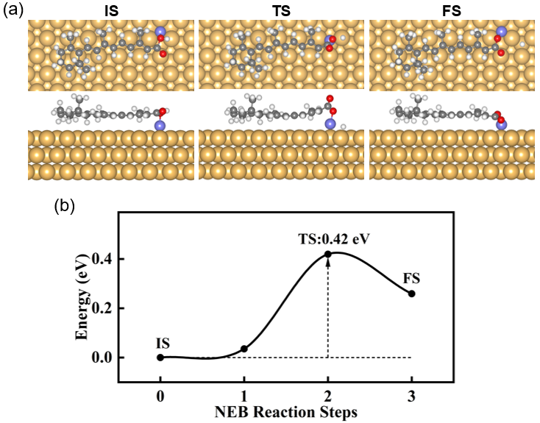
Fig. S1 DFT calculation of the deprotonation barrier of ReA on Au(111) when there is a Fe atom coordinated. (a) The computational configuration of the initial (left), transient (middle) and final (right) state during the deprotonation process. (b) Corresponding calculated energy of each state in (a).

  - Fitting the dI/dV spectra based on the scattering theory
We fit the dI/dV spectra measured on the ReA radicals according to the scattering theory.³ As detailed in Ref. 3, in the fitting process, the exchange energy (C) and the Kondo scattering term (J_{ρs}) between radicals and itinerant electrons in substrate are the main parameters, and the Coulomb scattering and effective temperature are also taken into account in fitting the spectra. Besides, a linear background is used to compensate for the influence of other electronic states. In the following table we show the J_{ρs} and C extracted from the fitting of the spectra shown in the main text.

Table S1. Kondo scattering term and exchange energy between radicals and Fe atoms obtained by fitting the spectra in the main text.
 | Fig.2(b) | Fig.2(e) | Fig.3(d)  W1 | Fig.3(d)  W2 | Fig.3(e) | Fig.3(f)  W1 | Fig.3(f)  B1 | Fig.5(c) | Fig.5(d)
Jρ_{s} | -0.668 | -1.389 | -2.285 | -1.382 | -0.400 | -0.328 | -0.162 | -0.357 | -2.342
C(meV) | 5.09 | 1.04 | 0.36 | 0.20 | 5.50 | 0.45 | 4.81 | 5.05 | 1.16

- Experimental details
  - Sample preparation
The sample preparation involved several steps. First, the Au(111) substrate underwent cycles of Ar+ sputtering and annealing to create atomically flat terraces. Fe atoms were first evaporated onto clean Au(111) surface at room temperature with considerably amount, as we could see Fe island on the elbow sites of the herringbone reconstruction. We then deposited ReA molecules onto the sample at room temperature as well. After ReA deposition, the sample was maintained at room temperature for one hour before being transferred to a 1.9 K environment for scanning and spectroscopic measurements. The AFM imaging was conducted at 4.8 K.
As observed in our experiments, the Fe-ReA coordination predominantly forms well-defined Fe₂(ReA)₄ tetramer structures, independent of the initial Fe:ReA ratio. In addition, there are some disordered coordinated structures deviating from the 2:4 stoichiometry, as shown in Fig. S2. These structures are characterized by linear Fe arrangements with parallel ReA molecules on both sides, however, representing minority species in our samples.

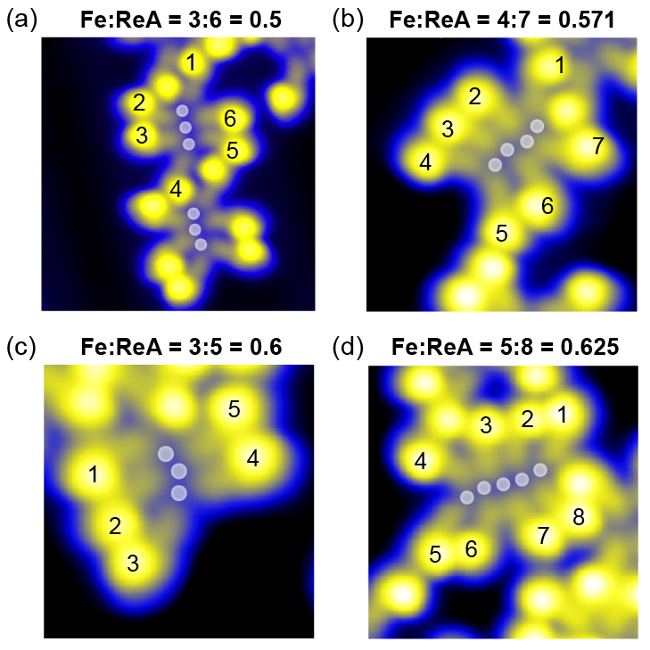
Fig. S2 Influence of the chemical stoichiometry of Fe and ReA molecules on coordination structures. (a-d) Representative coordination structures with Fe:ReA ratio of (a) 0.5, (b) 0.571, (c) 0.6, (d) 0.625, respectively. The Fe positions are indicated by gray dots and the coordinated ReA molecules are numbered from 1 to 8. STM parameters: V_{b} = -1 V, I_{set} = 50 pA.

  - Transformation of a neutral ReA molecule into a radical
We transformed a neutral ReA molecule into a radical by applying electrical pulses to the bulky 1,3,3-trimethylcyclohexene group (referred to as the head group), inducing a dehydrogenation process. Following this transformation, the head group appears brighter in the STM image. Figure S3(a) and S3(b) illustrate the changes in the STM topography before and after the transformation of a bridge-site and a wing-site ReA molecule, respectively. The tetramers shown in Fig. S3 are the same as those depicted in Fig. 2.
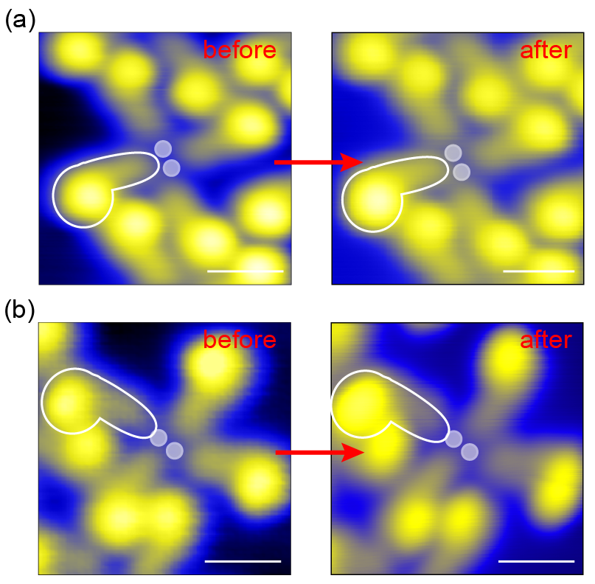
Fig. S3 Change in the topographic height of a ReA molecule in the Fe-coordinated tetramer before and after the transformation. (a) Transformation of a bridge-site ReA molecule. (b) Transformation of a wing-site ReA molecule. STM parameters: (a) left: V_{b} = 30 mV, I_{set} = 53 pA; right: V_{b} = 30 mV, I_{set} = 43 pA. (b) left: V_{b} = 100 mV, I_{set} = 20 pA; right: V_{b} = 30 mV, I_{set} = 53 pA.

We further transformed all four ReA molecules in a coordinated tetramer into radicals, as shown in Fig. S4(a). The dI/dV spectra measured on these four ReA radicals are presented in Fig. S4(b). As discussed in the main text, the magnetic coupling between the two wing-site ReA radicals via the two central Fe atoms is negligible. Consequently, the dI/dV spectrum of each wing-site ReA radical exhibits a single spin excitation step, which originates from the coupling with its coordinated Fe atom. In contrast, the two bridge-site ReA radicals are capable of coupling to each other through the two mutually coordinated Fe atoms. This interaction results in double spin excitation steps in the dI/dV spectra of both bridge-site ReA radicals, as indicated by the dashed red lines in Fig. S4(b). The inner step arises from the coupling between the bridge-site ReA radical and the two Fe atoms, while the outer step is attributed to the coupling between the two bridge-site ReA radicals.
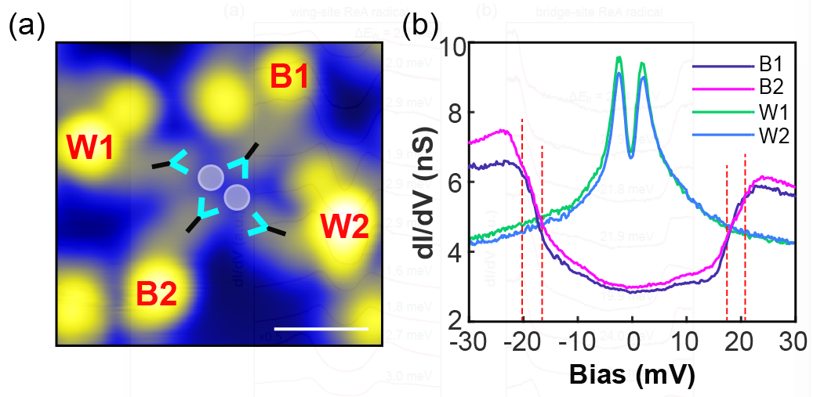
Fig. S4 Transforming all the four ReA molecules into radicals in a Fe-coordinated tetramer. (a) STM image of a tetramer where all the four ReA molecules were switched to be radicals. The Fe atoms (white circles) are overlapped on the images and the switched ReA molecules are marked by highlighting the schematic carboxyl groups (colored tridents). (b) dI/dV spectra measured on each transformed ReA molecule in (d). Scanning parameters: constant-current mode, V_{b} = 30 mV, I_{set} = 53 pA; dI/dV parameters: V_{b} = -30 mV, I_{set} = 200 pA, V_{mod} = 0.6 mV.

2.3 Spin excitation energy of different ReA radicals coupled to Fe in the coordinated tetramer
We observe that the spin excitation energy (ΔE) of a ReA radical coupled to Fe in the coordinated tetramer exhibits slight variations. For the wing-site ReA radical, ΔE_{W} typically falls within the range of 0.1 to 3 meV (Fig. S5(a)). In contrast, for the bridge-site ReA radical, ΔE_{B} generally ranges between 19 and 25 meV (Fig. S5(b)). We attribute this variation for each type of radical to subtle differences in molecular adsorption configurations, which may influence both the metal-organic interaction and the competition with molecule-substrate interaction. Despite these variations, the spin excitation energy of a wing-site ReA radical coupled to a single Fe atom consistently remains much smaller than that of a bridge-site ReA radical coupled to two Fe atoms.
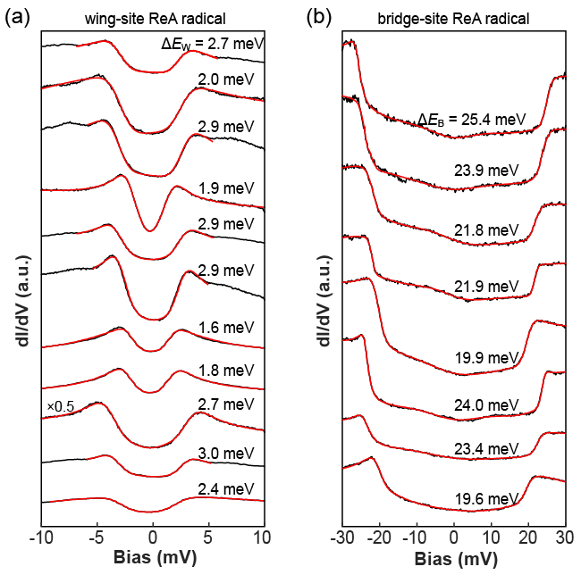
Fig. S5 Representative dI/dV spectra measured on different ReA radicals in the Fe-coordinated tetramers. (a) Wing-site, (b) Bridge-site. The black lines are experimental data, and the red lines are theoretical fits. The fitted spin excitation energy (ΔE_{W} and ΔE_{B}) is labelled aside each spectrum.

2.4 Delocalized spin distribution of a ReA radical
The spin distribution of a ReA radical in the coordinated tetramer is delocalized along the molecular skeleton. We conducted dI/dV measurements at different positions on both a wing-site and a bridge-site ReA radical, as illustrated in Fig. S6(a) and S6(b). Along the molecular skeleton, the spin excitation feature originating from d-π coupling exhibits an oscillatory trend for both wing-site and bridge-site ReA radicals. This observation aligns well with our DFT calculations of the spin density of a ReA radical, as shown in Fig. 1a.

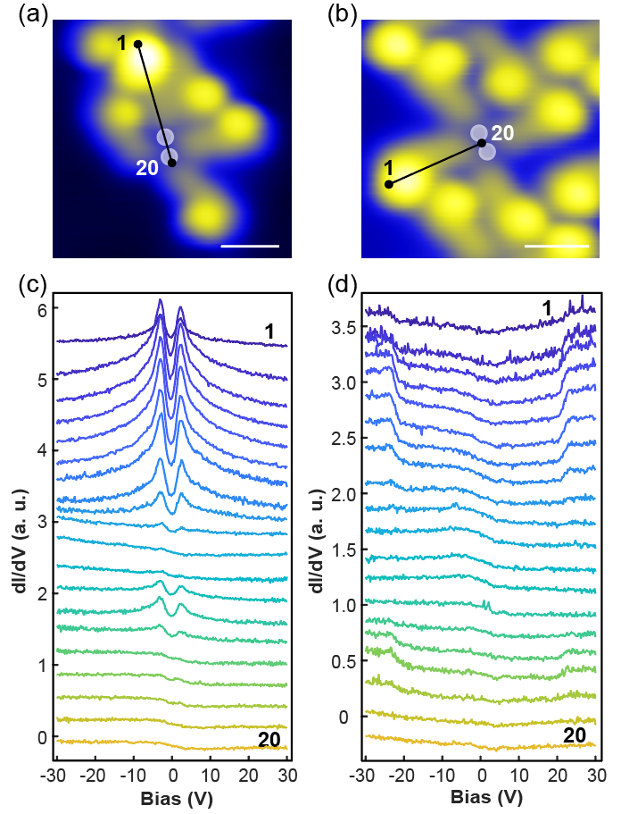
Fig. S6 dI/dV spectra measured at different positions on the ReA radical in the coordinated tetramer. (a, b) STM images of a coordinated tetramer in which a wing-site (a) and a bridge-site (b) was transformed into a radical, respectively. The black lines along the molecular skeleton indicate the positions where the dI/dV were measured. (c, d) dI/dV spectra measured at 20 points equidistantly along the black lines in (a) and (b), respectively. Scanning parameters: constant-current mode, V_{b} = 30 mV, I_{set} = 53 pA. dI/dV parameters: V_{b} = 30 mV, I_{set} = 200 pA, V_{mod} = 0.6 mV.

2.5 Tuning the competition between radical-Fe coupling and molecule-substrate interaction
In experiment, we utilized the tip to apply negative voltages ramping from -2 V to -3 V several times to the molecule to induce a physical adsorption configuration change. It can be seen that the molecule appears brighter at the head group after the perturbation (Fig. 5b). This suggests a change in the molecular skeleton which tunes the interaction between the molecular radical spin and the substrate. The corresponding measured excitation energy varies after each such manipulation, probably due to the subtle variation of the molecular adsorption configuration (Fig. S7). The conformational change of the molecule leads to enhanced molecule-substrate coupling. This strengthened molecule-substrate interaction results in pronounced substrate-induced spin screening of the radical, consequently diminishing the effective magnetic moment of the molecule and reducing the spin exchange energy with Fe. The manipulation aims to underline the importance of considering the influence of metal substrate on the d-pi coupling systems on surface.
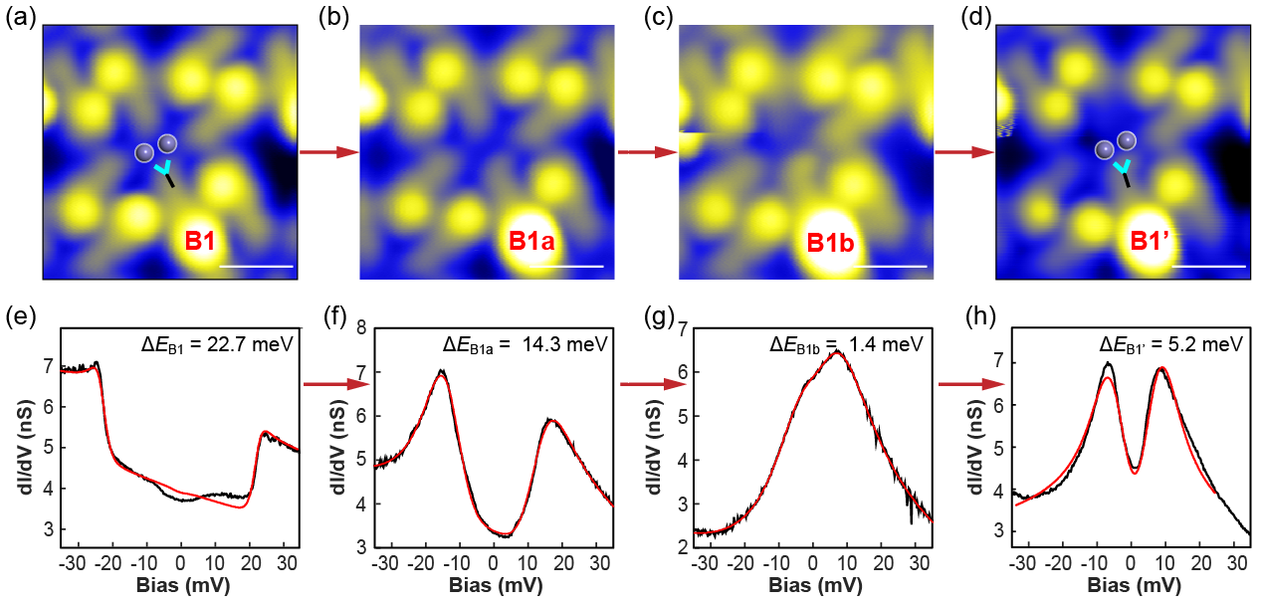
Fig. S7 Competition between radical-Fe coupling and molecule-substrate interaction. (a-d) STM images showing four consecutive perturbations on a bridge-site ReA molecule by applying ramped negative voltage. (e-h) Corresponding dI/dV spectra measured on the perturbed molecule. (a)(d)(e)(h) are the same images and spectra as Fig. 5.

2.6 Discussion on the dehydrogenation reaction pathways
Based on our analyses and relevant literature, two predominant reaction pathways are most likely following voltage pulse application: (1) our proposed dehydrogenation reaction at the -CH2- position of the bulky 1,3,3-trimethylcyclohexene group, and (2) the dissociation of an allylic hydrogen from the endocyclic bond of the isomerized ReA molecule, which leads to localized spin density at the cyclohexene group.⁴ Our spin-polarized measurements reveal delocalized magnetic states, which is consistent with our proposed -CH2 dehydrogenation mechanism.
We transformed neutral ReA molecules into radicals through dehydrogenation with a success rate of approximately 60%. Our DFT simulations and experimental STM images (Fig. S8) reveal two distinct structural changes in successfully transformed cases: (1) The head group appears consistently brighter due to the methyl group reorienting from a slightly tilted position to one perpendicular to the molecular plane; (2) The carbon chain backbone shows enhanced brightness, though with moderate intensity. For unsuccessful transformations (approximately 40% of cases), we observe varied STM topography of the bulky 1,3,3-trimethylcyclohexene group (denoted as head group) and no spin excitation features in dI/dV spectra, suggesting alternative reaction pathways. Our DFT-simulated STM images align well with these experimental observations, validating the structural changes observed. Here, we focus specifically on these successfully transformed radicals to investigate magnetic d-π coupling.
The electronic and magnetic properties also undergo significant changes during this transformation. Initially, the ReA molecule shows no magnetic moment. After dehydrogenation, it becomes a radical with a magnetic moment of 0.77 μB, where the spin is delocalized along the conjugated carbon chain. The moderate spin signal intensity observed in STM can be attributed to substrate effects - while an isolated dehydrogenated molecule in vacuum would have a magnetic moment of 1 μB, charge transfer with the substrate reduces it to 0.77 μB.

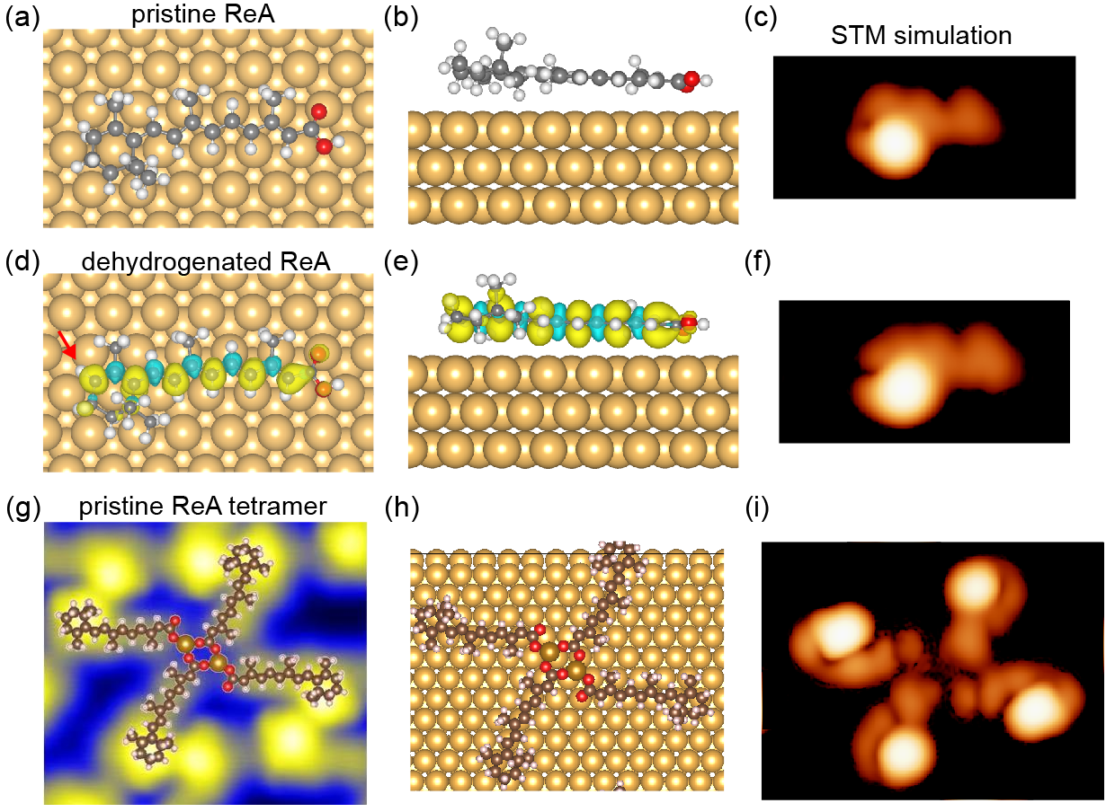
Fig. S8 Comparison of topographic image before and after dehydrogenation. (a-b) DFT calculated models of a pristine ReA molecule from top view and side view, respectively. (c) Simulated STM image based on (a) and (b). (d-e) DFT calculated model of a dehydrogenated ReA molecule from top view and side view, respectively. The dehydrogenation site is marked by the red arrow. The yellow and blue color indicate the up and down spin polarization. The isosurface value is set to 5×10⁻⁴ e/Bohr³. (f) Simulated STM image based on (d) and (e). (g-i) Experimental image, DFT optimized molecular model and simulated STM image of a ReA-Fe coordinated tetramer formed by four pristine ReA molecules.

References
[1] G. Kresse and J. Hafner, Phys. Rev. B 1993, 47, 558-561.
[2] G. Kresse and J. Furthmüller, Phys. Rev. B 1996, 54, 11169-11186.
[3] M. Ternes, New J. Phys. 2015, 17, 063016.
[4] M.-L. Bocquet, N. Lorente, R.Berndt, M. Gruber, Angew. Chem. Int. Ed. 2019, 58, 821-824.

