Supplementary Material

Hepatic arterial infusion chemotherapy via arterial infusion port combined with Atezolizumab and Bevacizumab for conversion therapy of advanced hepatocellular carcinoma:A case report and literature

review
Supplementary Figure 1. MR images of liver for two cycles of combination treatment. A, B, C: MR images of pre-treatment lesions. D, E, F: MR images after 2 cycles of combination treatment, the tumor in the right lobe of the liver significantly decreased compared with the front, the posterior portal vein branch invasion basically disappeared, and the right hepatic vein tumour thrombus significantly decreased than before.
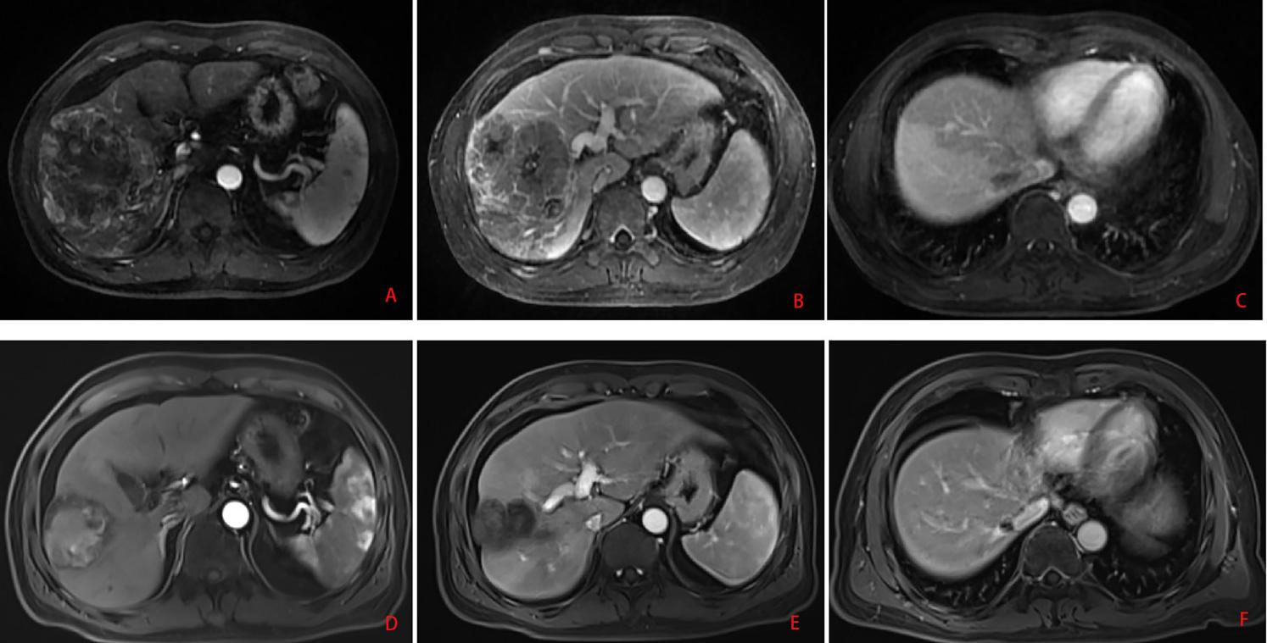

Supplementary Figure 2. Changes in AFP during the treatment process.
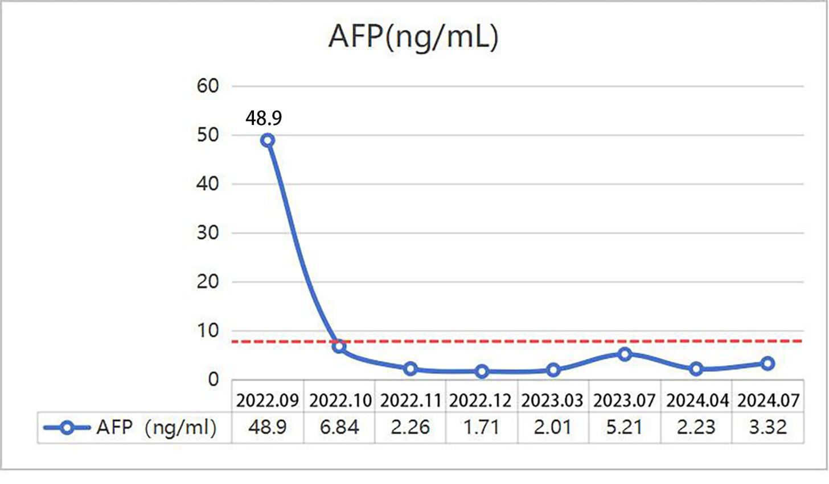

Supplementary Figure 3. Changes in PIVKA-II during the treatment process.
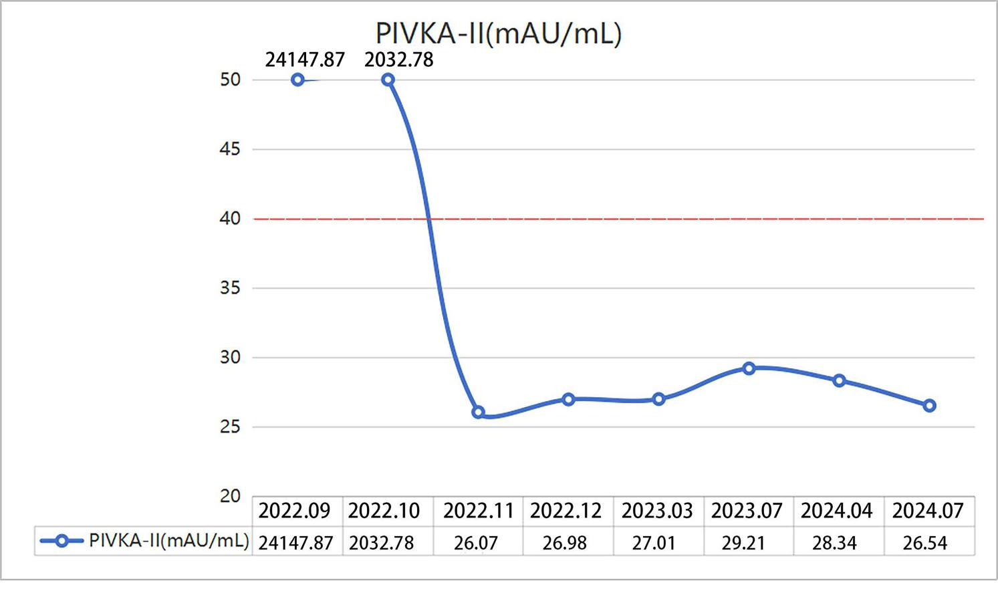
Table1.The result of blood test
Item | Before first HAIC  (2022.09) | Before second HAIC  (2022.10) | Before  third HAIC  (2022.11) | Before  fourth HAIC  (2022.12) | Four follow-up After surgery  (2023.03-2024.07) | Normal range | Unit
AFP | 48.9 | 6.84 | 2.26 | 1.71 | 2.01 ~ 5.21 | 0.00-7.00 | ng/ml
PIVKA-II | 24147.87 | 2032.78 | 26.07 | 26.98 | 27.01 ~ 29.21 | 0.00-40.00 | mAU/mL
AST | 52 | 38 | 26 | 26 | 25~29 | 15-40 | U/L
ALT | 70 | 40 | 40 | 32 | 26~33 | 9-50 | U/L
PT | 13.7 | 14.5 | 14.1 | 14.3 | 12.6~13.1 | 11.0-13.7 | s
TBIL | 16.7 | 13.4 | 8.7 | 9.8 | 10.2~13 | 0.0-26.0 | Umol/L
AFP: Alpha-fetoprotein; PIVKA-II:vitamin K absence or antagonist II; TBIL:Total bilirubin; PT:Prothrombin time; ALT:Alanine aminotransferase; AST:Aspartate transaminase.

