Supplementary Information
Programmable and somatosensory thermoresponsive soft robots
Antonia Georgopoulou^{1,2}, Malena Aguiriano Calvo^{1,3}, Lorenzo Lucherini¹, Sudong Lee³, Josie Hughes³, Esther Amstad^{1,2}
1) Soft Materials Laboratory, Institute of Materials (SMaL), École Polytechnique Fédérale de Lausanne, 1015 Lausanne, Switzerland.
2) Swiss National Center for Competence in Research (NCCR) Bio-inspired Materials, University of Fribourg, Chemin des Verdiers 4, 1700 Fribourg, Switzerland.
3) CREATE Lab, Institute of Mechanical Engineering, École Polytechnique Fédérale de Lausanne, 1015 Lausanne, Switzerland.
E-mail: esther.amstad@epfl.ch

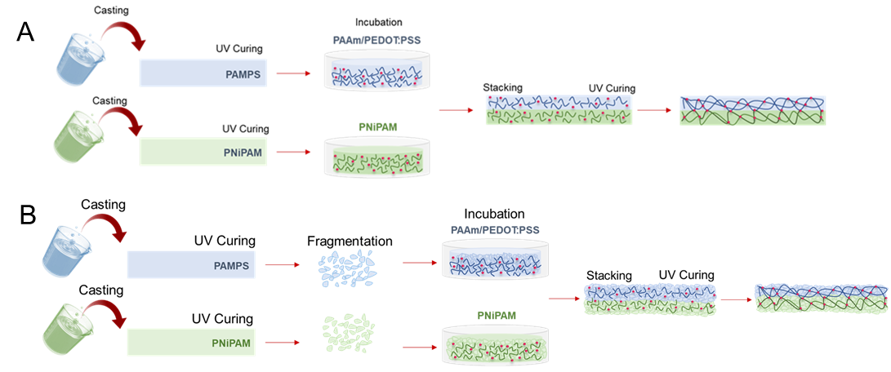
Fig. S1. Schematic illustration of the preparation of the actuators based on A. double network bulk and B. DNGH hydrogels.

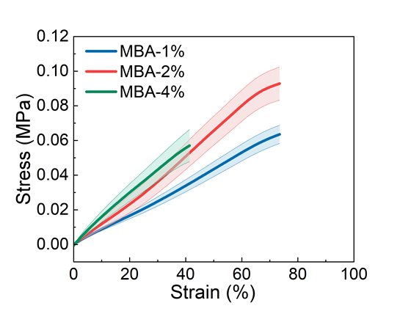
Fig. S2. Stress-strain curves of the DNGH-A composed of PNIPAM fragments containing 1 wt% (blue), 2 wt% (red) and 4 wt% (green) MBA crosslinker.

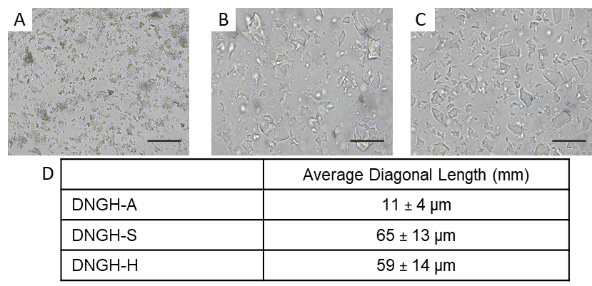
Fig. S3. Optical micrographs of A. PNIPAM microgels incubated in a NIPAM containing aqueous solution B. PAMPS microgels incubated in a AAm/PEDOT:PSS containing aqueous solution
C. PAMPS microgels incubated in an aqueous solution containing AAm, PEDOT:PSS and ZnCl₂ (Scale bars 100 µm). D. The average diagonal length derived from A,B,C.

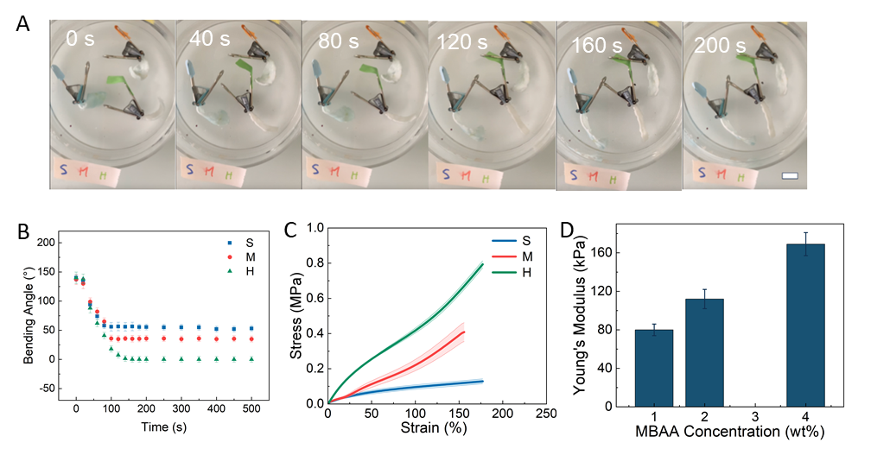
Fig. S4. A. Timelapse of composite strips immersed in 55°C water. The DNGH-S contains 2 wt% (S), 3.5 wt% (M) and 5 wt% (H) MBA crosslinker (scale bar 5 mm). B. Evolution of bending angle with time of composite strips immersed in 55°C water. The DNGH-S contain 2 wt% (blue), 3.5 wt% (red) and 5 wt% (green) MBA crosslinker. C. Stress-strain curves of DNGH-S containing 2 wt% (blue), 3.5 wt% (red) and 5 wt% (green) MBA crosslinker. D. The Young’s modulus as a function of the MBA crosslinker concentration in the microfragments.

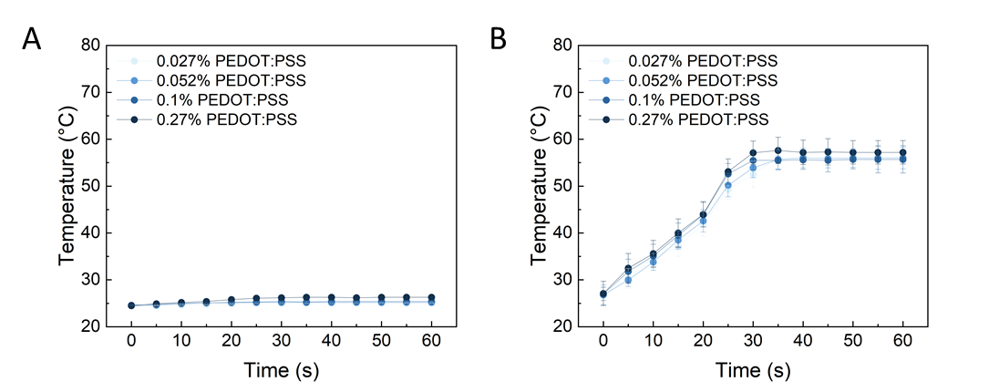
Fig. S5. Temperature evolution of single network bulk PAAm gels as a function of the PEDOT: PSS concentration within them if subjected to 5V A. without and B. with 40 wt% ZnCl₂.

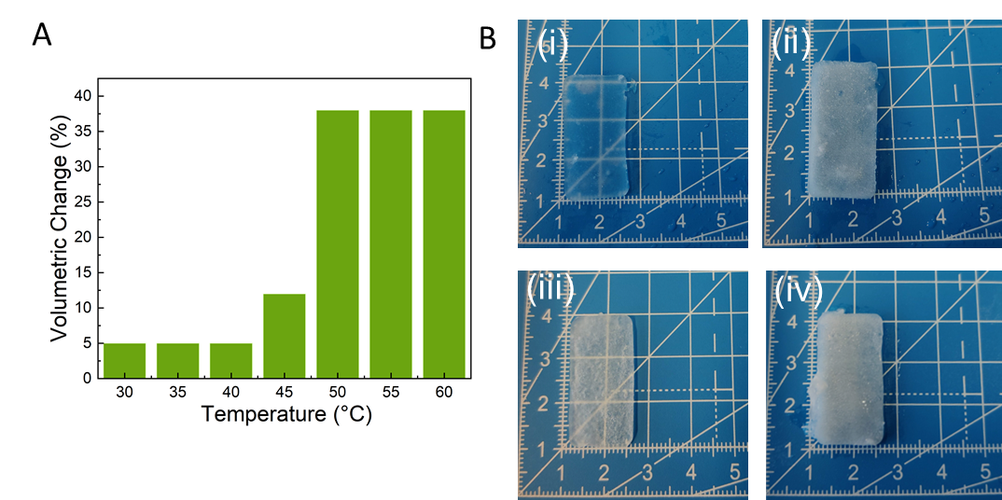
Fig. S6. A. Volumetric change of PNIPAM strips containing 1 wt% MBA crosslinker as a function of temperature. B. Photographs of PNIPAM strips with (i, ii) 1 wt% and (iii, iv) 4 wt% MBA crosslinker at (i, iii) 25°C and (ii, iv) 50°C.

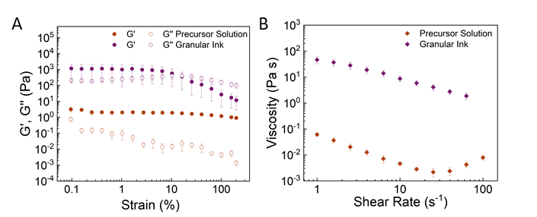
Fig. S7. Rheological properties of the PAAm precursor solution (orange), PAMPS/PAAm granular ink (purple) A. amplitude sweep and B. shear rate.

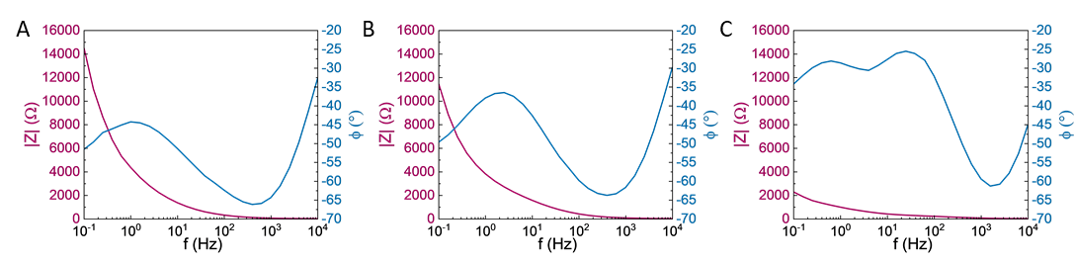
Fig. S8. Bode plots featuring the impedance (red) and phase (blue) obtained during impedance spectroscopy of A. PAMPS-PAAm DNGHs B. PAMPS-PAAm DNGHs functionalized with PEDOT:PSS (DNGH-S) C. PAMPS-PAAm DNGHs functionalized with PEDOT:PSS and Zn²⁺ (DNGH-H).
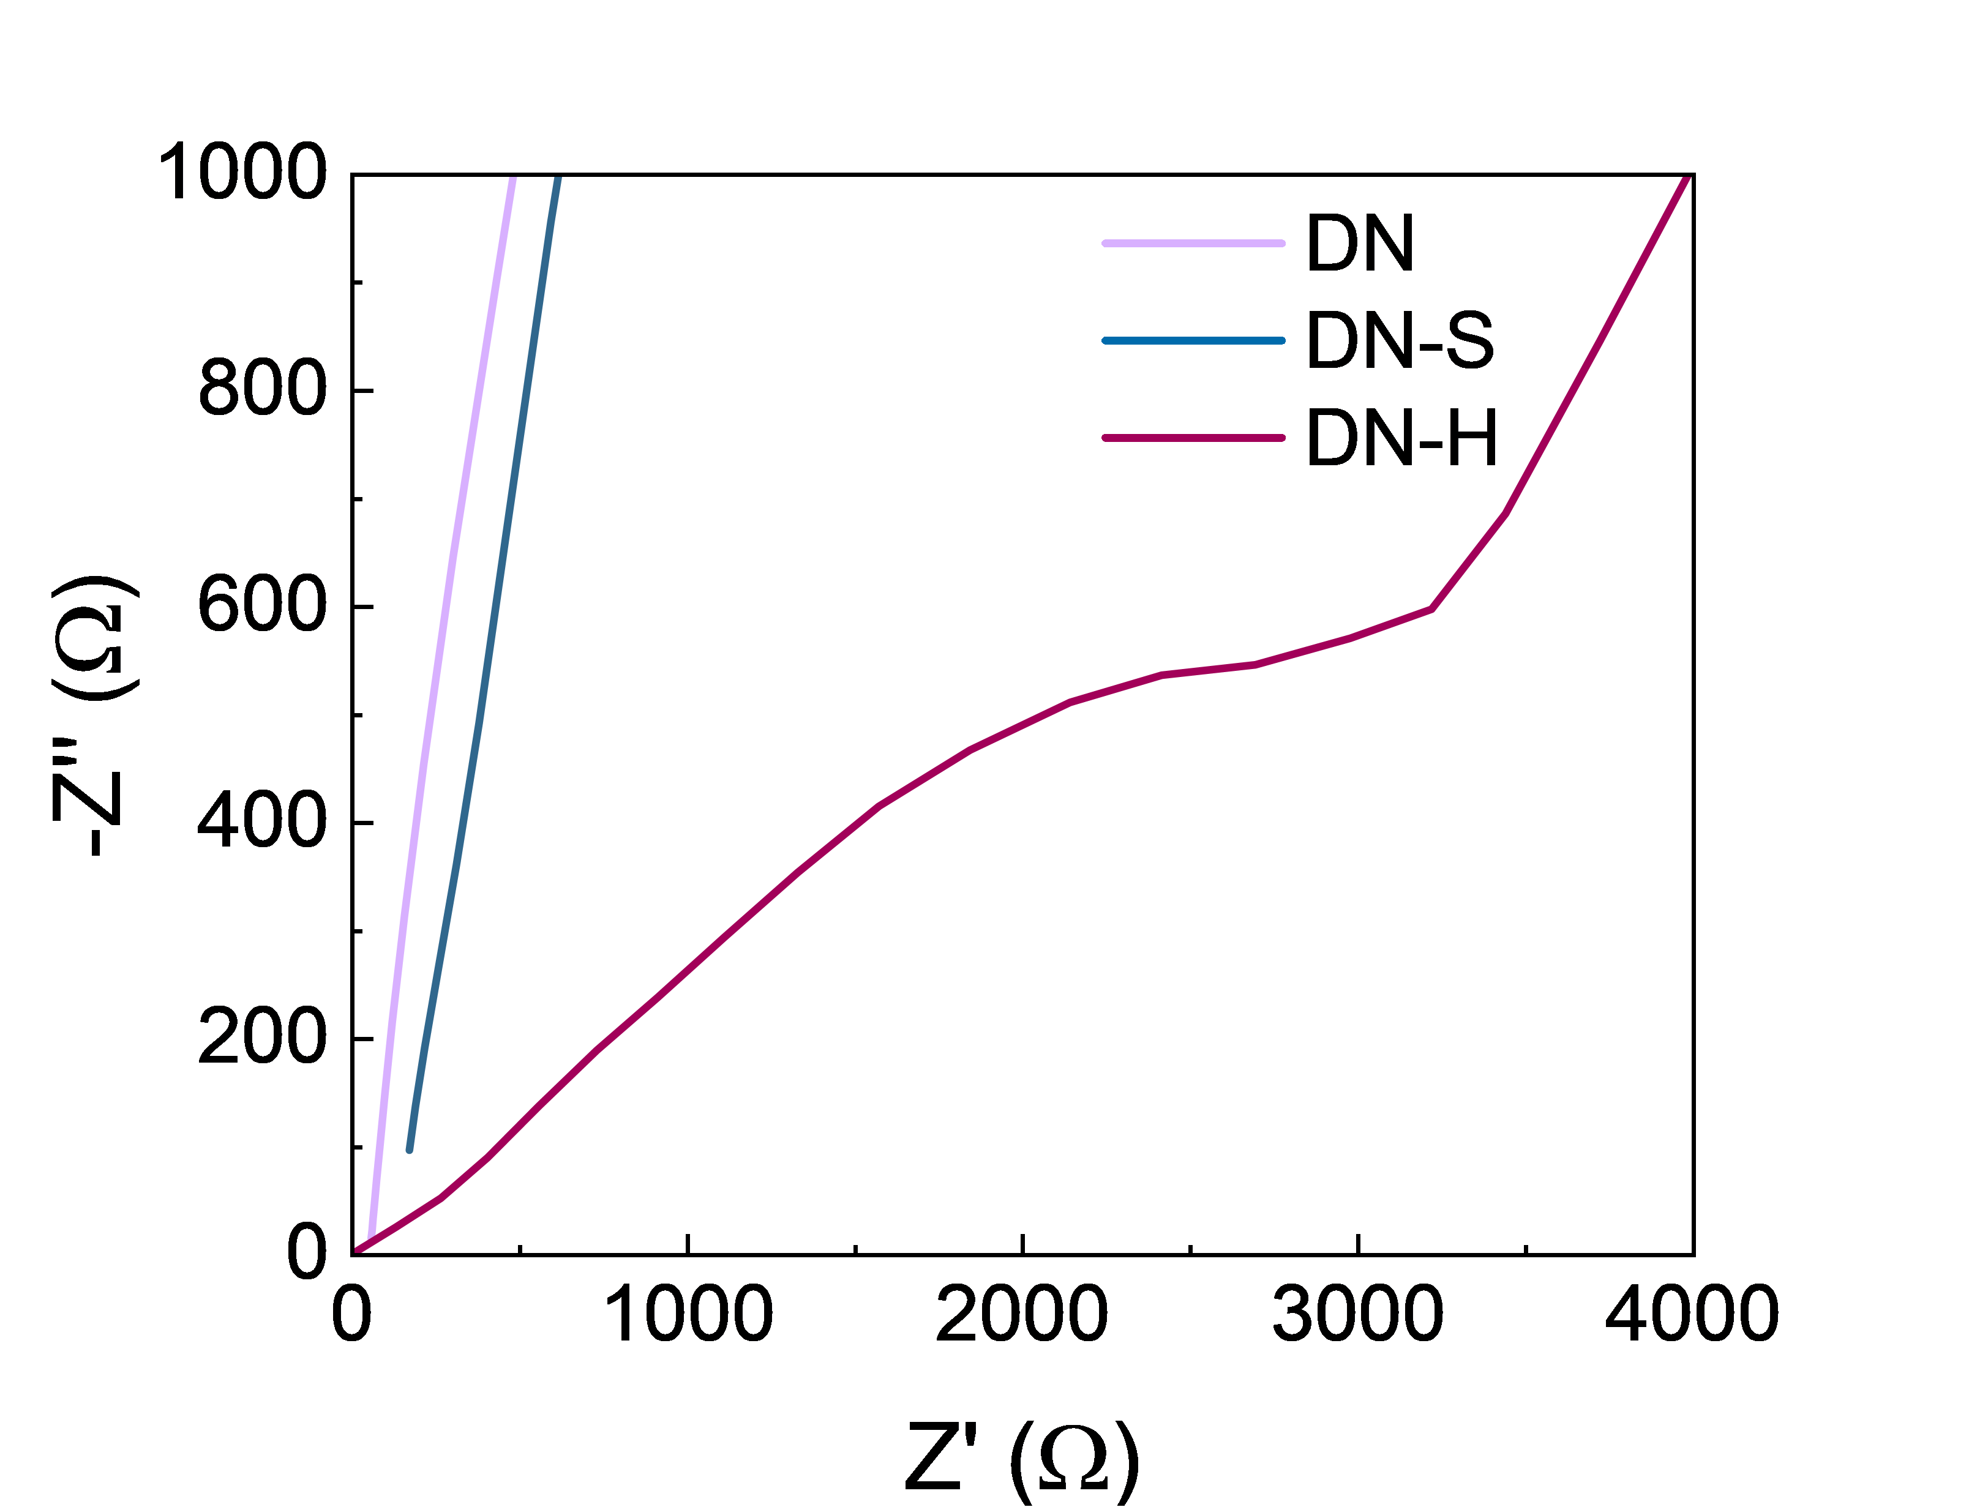
Fig. S9. Nyquist plots obtained with impedance spectroscopy for double network bulk (DN), bulk DN-H containing 40 wt% ZnCl₂ and 0.027 wt% PEDOT:PSS and DN-S containing 0.027 wt% PEDOT:PSS.

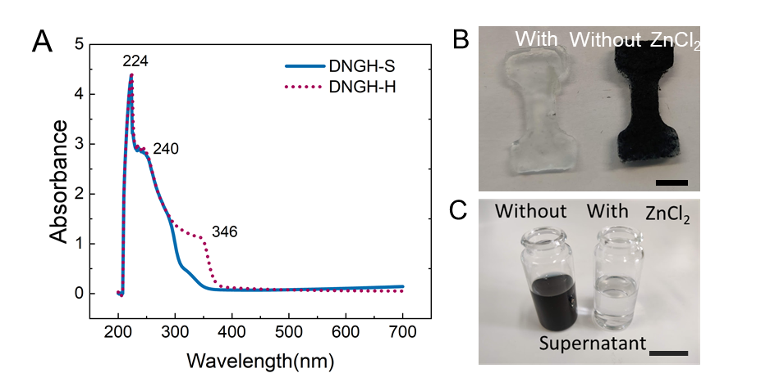
Fig. S10. A. UV-VIS Spectra of the supernatant of jammed microgels used to fabricate DNGH-S (blue) and DNGH-A (red). B. Photographs of DNGH-S (left) and DNGH-H (right)-scale bar 1 cm
C. Photograhs of the supernatant jammed microgels used to make DNGH-S (left) and DNGH-H (right)-scale bar 1 cm.

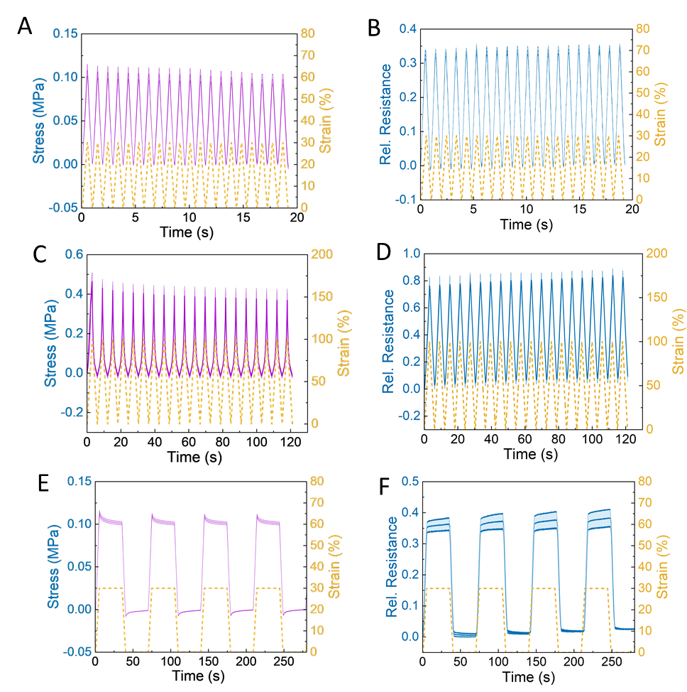
Fig. S11. Piezoresistive sensor signal (blue), mechanical stress (purple) and strain (yellow) during the mechanoelectrical characterization of the DNGH-S with 5 wt% MBA, involving: A. Stress response and B. Relative resistance response during 10 cycles between 0-30% strain. C. Stress response and
D. Relative resistance response during 10 cycles between 0-100% strain. E. Stress response and
F. Relative resistance response during 5 cycles between 0-30% strain at maximum and minimum strain.
Movie 1. DNGH bilayers at 55°C with DNGH-S containing contain 2 wt% (S), 3.5 wt% (M) and 5 wt% (H) MBA crosslinker.
Movie 2. DNGH gripper with closed-loop control picking up an orange and a strawberry. The gripper is programmed to pick up the smaller strawberry thanks to its somatosensory feedback.

