Supplementary Material
In silico analysis indicate putative action modes of At2g47590 (GERALT) and At4g25290 (TATOOINE) proteins, two outcast of Arabidospsis thaliana CryDASH protein family
Katarzyna Leja^{1,2}, Grzegorz Góralski³, Olga Sztatelman⁴, Katarzyna Walczewska-Szewc⁵, Wojciech Strzałka¹, Agnieszka Katarzyna Banaś¹, Joanna Grzyb^{6*}.

¹Department of Plant Biotechnology, Faculty of Biochemistry, Biophysics and Biotechnology, Jagiellonian University, Gronostajowa 7, 30-387 Kraków, Poland
²Doctoral School of Exact and Natural Sciences, Jagiellonian University, prof. S. Łojasiewicza 11, 30-348 Kraków, Poland; katarzyna.leja@doctoral.uj.edu.pl
³Plant Cytology and Embryology, Institute of Botany, Faculty of Biology, Jagiellonian University in Kraków, 9 Gronostajowa St., 30-387 Kraków, Poland
⁴Institute of Biochemistry and Biophysics Polish Academy of Sciences, Pawińskiego 5a, PL02106, Warsaw, Poland
⁵Institute of Physics, Faculty of Physics, Astronomy and Informatics, Nicolaus Copernicus University in Toruń, ul. Grudziądzka 5, 87-100 Toruń, Poland
⁶ Department of Biophysics, Faculty of Biotechnology, University of Wrocław, F. Joliot-Curie 14a, 50-383 Wrocław, Poland

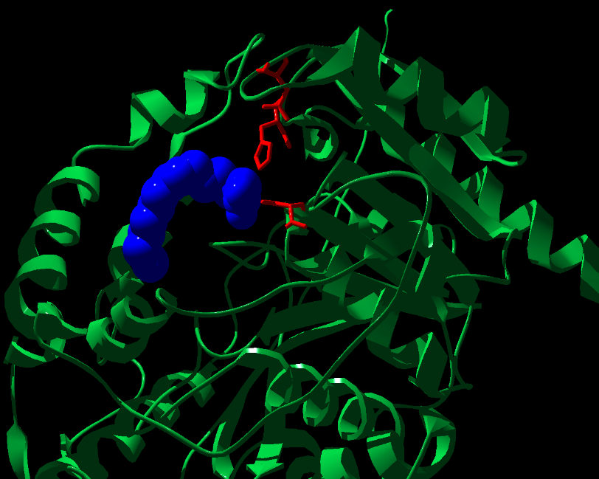
Figure S1. A fragment of TATOOINE structure (green ribbon) modeled with oleic acid (blue balls), obtained by AlphaFold3. Catalytic lipase triad amino acid residues presented as red sticks.
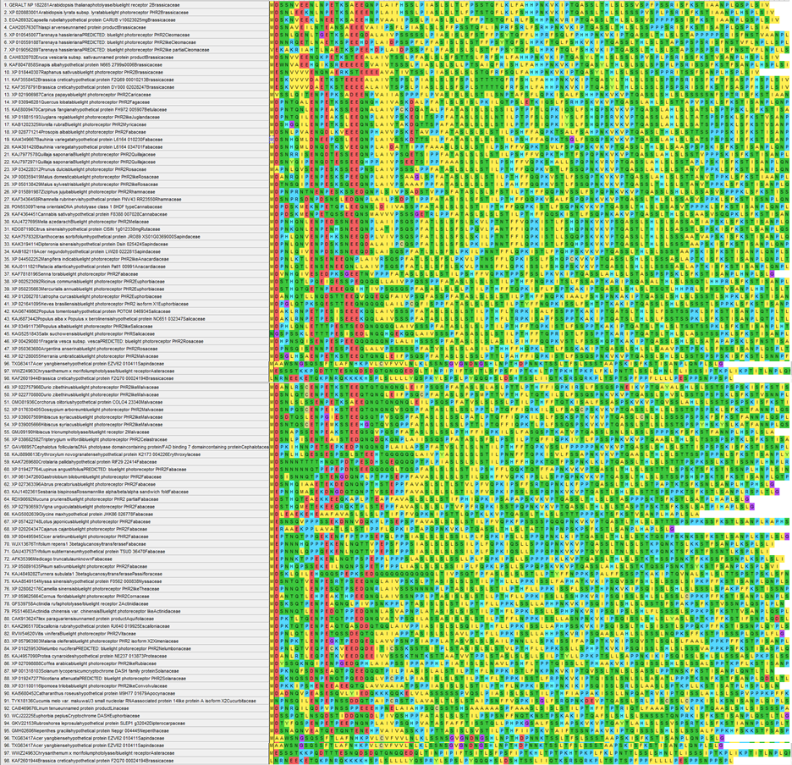

Figure S2. First 100 amino acids of GERALT sub branch proteins, colored by their physicochemical properties (acidic-red, basic - blue, neutral hydrophilic - green, hydrophobic - yellow). No alignment applied.

Table S1. The length [aa] of FAD-binding domains in selected CPF proteins, identified with PROSITe.

Selected PPL proteins in brackets, nominal position of domain amino acids | Crypto/Photolyase_FAD-like (IPR036134)[aa]
Arabidopsis thaliana AtGERALT (NP_182281.1)(323-429) | 106
Chlamydomonas reinhardtii PHR2 protein (XP_042918714.1)(364-503) | 139
Chrysanthemum morifolium (OP889330)(337-402) | 65
selected CRY-DASH proteins
Chlamydomonas reinhardtii CRY-DASH1 (XP_001701871.1)(375-557) | 182
Solanum lycopersicum CRY-DASH (NP_001296304.1)(298-549) | 251
Arabidopsis thaliana AtCRY3 (NP_568461.3)(227-518) | 242
Arabidopsis photolyases
Arabidopsis thaliana AtPHR1/UVR2 (NP_849651.1)(220-465) | 245
Arabidopsis thaliana AtUVR3 (NP_566520.1)(227-518) | 291

