Supplementary materials
Figure S1 Histogram of scores on trait anxiety subscale of STAI of participants belonging to low and high anxiety groups
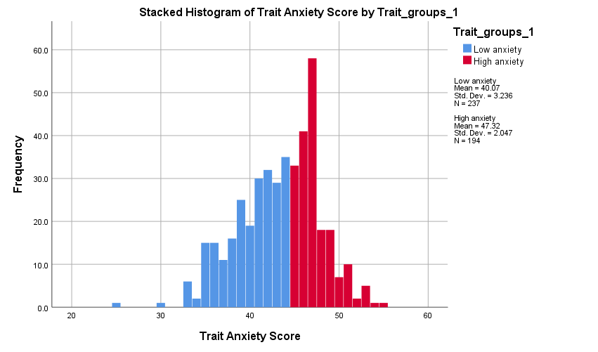
Table S1 Demographic characteristics of low and high anxiety groups
Variable | Low anxiety | High anxiety
Female gender | 47.3 | 53.1
Education level
No formal education | 0.8 | 0.5
O-levels | 22.4 | 13.4
A-levels | 22.8 | 24.7
Bachelor’s degree | 38 | 43.8
Postgraduate degree | 16 | 17.5

Table S2 Descriptive statistics on key study variables of low and high anxiety groups
Variable | Low anxiety |  |  |  | High anxiety
Variable | Mean | Std. dev. | Min | Max | Mean | Std. dev. | Min | Max
METV first correct answers | 6.69 | 2.55 | 1 | 14 | 6.68 | 2.59 | 0 | 16
Angry face first correct answers | 0.21 | 0.21 | 0 | 1 | 0.22 | 0.22 | 0 | 1
Trait anxiety | 40.07 | 3.24 | 25 | 44 | 47.32 | 2.03 | 45 | 55
State anxiety | 43.35 | 5.01 | 30 | 58 | 46.90 | 4.17 | 36 | 62
Depression (BDI-II) | 14.08 | 11.00 | 0 | 47 | 12.24 | 13.53 | 0 | 49

Figure S2 Histogram of scores on BDI-II of participants belonging to low mood and control groups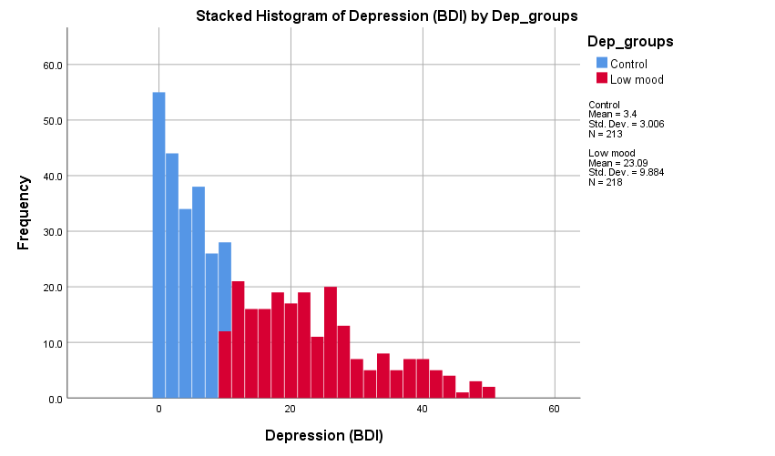
Table S3 Demographic characteristics of low mood and control groups
Variable | Low mood | Control
Female gender | 52.3 | 47.4
Education level
No formal education | 1.4
O-levels | 19.7 | 16.9
A-levels | 21.1 | 26.3
Bachelor’s degree | 42.7 | 38.5
Postgraduate degree | 15.1 | 18.3

Table S4 Descriptive statistics on key study variables of low mood and control groups
Variable | Low mood |  |  |  | Control
Variable | Mean | Std. dev. | Min | Max | Mean | Std. dev. | Min | Max
METV first correct answers | 7.12 | 2.38 | 1 | 16 | 6.24 | 2.67 | 0 | 14
Sad face first correct answers | 0.41 | 0.26 | 0 | 1 | 0.21 | 0.21 | 0 | 1
Mistaking happiness for neutrality | 0.05 | 0.21 | 0 | 1 | 0.03 | 0.17 | 0 | 1
Mistaking neutrality for sadness | 0.05 | 0.22 | 0 | 1 | 0.02 | 0.14 | 0 | 1
Trait anxiety | 42.83 | 5.20 | 25 | 54 | 43.86 | 3.71 | 33 | 55
State anxiety | 46.18 | 5.42 | 33 | 62 | 43.75 | 4.17 | 30 | 59
Depression (BDI-II) | 23.09 | 9.88 | 10 | 49 | 3.40 | 3.01 | 0 | 9

Table S5 Regression models predicting first attempt METV correct answers based on depression
Predictors | Unadjusted |  | Model 1 |  | Model 2
Predictors | b [95% CI] | p | b [95% CI] | p | b [95% CI] | p
Low mood group | 0.872 | <.001 | 0.498 | .057 | 0.505 | .055
Low mood group | [0.391, 1.352] | <.001 | [-0.016, 1-012] | .057 | [-0.012, 1.021] | .055
Age |  |  | -0.032 | <.001 | -0.032 | <.001
Age |  |  | [-0.049, -0.015] | <.001 | [-0.049, -0.015] | <.001
Gender |  |  | -0.141 | .562 | -0.136 | .576
Gender |  |  | [-0.616, 0.335] | .562 | [-0.613, 0.341] | .576
Education |  |  | 0.074 | .543 | 0.071 | .563
Education |  |  | [-0.165, 0.311] | .543 | [-0.170, 0.311] | .563
High anxiety group |  |  |  |  | 0.073 | 0.767
High anxiety group |  |  |  |  | [-0.410, 0.556] | 0.767

Table S6 Regression models predicting first attempt sad faces correct answers based on depression
Predictors | Unadjusted |  | Model 1 |  | Model 2
Predictors | b [95% CI] | p | b [95% CI] | p | b [95% CI] | p
Low mood group | 0.100 | <.001 | 0.085 | .002 | 0.086 | .002
Low mood group | [0.051, 0.149] | <.001 | [0.032, 0.138] | .002 | [0.032, 0.139] | .002
Age |  |  | -0.001 | .168 | -0.001 | .167
Age |  |  | [-0.003, 0.001] | .168 | [-0.003, 0.001] | .167
Gender |  |  | -0.020 | .421 | -0.020 | .428
Gender |  |  | [-0.069, 0.029] | .421 | [-0.069, 0.029] | .428
Education |  |  | 0.008 | .513 | 0.008 | .524
Education |  |  | [-0.016, 0.033] | .513 | [-0.017, 0.033] | .524
High trait anxiety group |  |  |  |  | 0.004 | .878
High trait anxiety group |  |  |  |  | [-0.046, 0.054] | .878

Table S7 Regression models predicting mistaking happy faces for neutral based on depression
Predictors | Unadjusted |  | Model 1 |  | Model 2
Predictors | Exp(B) [95% CI] | p | Exp(B) [95% CI] | p | Exp(B) [95% CI] | p
Low mood group | 0.597 | .327 | 0.546 | .283 | 0.536 | .273
Low mood group | [0.213, 1.673] | .327 | [0.181, 1.649] | .283 | [0.176, 1.633] | .273
Age |  |  | 1.007 | .703 | 1.007 | .713
Age |  |  | [0.972, 1.044] | .703 | [0.971, 1.043] | .713
Gender |  |  | 0.957 | .931 | 0.956 | .929
Gender |  |  | [0.351, 2.610] | .931 | [0.350, 2.607] | .929
Education |  |  | 1.172 | .546 | 1.116 | .561
Education |  |  | [0.700, 1.964] | .546 | [0.695, 1.958] | .561
High trait anxiety group |  |  |  |  | 0.842 | .741
High trait anxiety group |  |  |  |  | [0.304, 2.333] | .741

Table S8 Regression models predicting mistaking neutral faces for sad based on depression
Predictors | Unadjusted |  | Model 1 |  | Model 2
Predictors | Exp(B) [95% CI] | p | Exp(B) [95% CI] | p | Exp(B) [95% CI] | p
Low mood group | 0.357 | .082 | 0.256 | .031 | 0.253 | .031
Low mood group | [0.112, 1.138] | .082 | [0.074, 0.882] | .031 | [0.073, 0.882] | .031
Age |  |  | 1.029 | .123 | 1.029 | .124
Age |  |  | [0.992, 1.068] | .123 | [0.992, 1.068] | .124
Gender |  |  | 1.079 | .887 | 1.081 | .885
Gender |  |  | [0.379, 3.071] | .887 | [0.380, 3.076] | .885
Education |  |  | 1.315 | .329 | 1.314 | .332
Education |  |  | [0.759, 2.279] | .329 | [0.757, 2.279] | .332
High trait anxiety group |  |  |  |  | 0.926 | .886
High trait anxiety group |  |  |  |  | [0.323, 2.656] | .886

