Supplementary Information
Marine sediments harbor diverse archaea and bacteria with potentials for anaerobic hydrocarbon degradation via fumarate addition
Chuwen Zhang¹ #, Rainer U. Meckenstock², Shengze Weng¹, Guangshan Wei^{1, 4}, Casey R.J. Hubert³, Jiang-Hai Wang¹ *, Xiyang Dong¹ # *
¹ School of Marine Sciences, Sun Yat-Sen University, Zhuhai, 519082, China
² Environmental Microbiology and Biotechnology, University Duisburg-Essen, Essen, 45141, Germany
³ Department of Biological Sciences, University of Calgary, Calgary, AB T2N1N4, Canada
⁴ Key Laboratory of Marine Genetic Resources, Third Institute of Oceanography, Ministry of Natural Resources, Xiamen, 361005, China

# These authors contributed equally to this work.

* Correspondence can be addressed to:
Assoc Prof Xiyang Dong (dongxy23@mail.sysu.edu.cn);
Prof Jiang-Hai Wang (wangjhai@mail.sysu.edu.cn)
Supplementary Table 1. List of FaeA reference protein sequences.
Supplementary Table 2. NCBI Sequence Read Archive (SRA) information of sediment metagenomes retrieved from various marine ecosystems.
Supplementary Table 3. Genome statistics and completeness estimates of recovered archaeal and bacterial genomes.
Supplementary Table 4. Presence and absence of metabolism markers genes in 62 archaeal and bacterial genomes.
Supplementary Table 5. Information of BLASTp hits for FaeA.
Supplementary Table 6. Information of BLASTp hits for FAE-activating enzymes.
Supplementary Table 7. Presence and absence of genes involved in anaerobic hydrocarbon degradation in 62 archaeal and bacterial genomes.
Supplementary Table 8. Relative abundances of anaerobic hydrocarbon degraders at each sampling station.
Supplementary Table 9. Information of BLASTn hits for 16S rRNA genes retrieved from genomes that contain faeA.
Supplementary Table 10. Counts per million reads (CPM) of faeA in different metagenomic libraries.
Figure S1. Geographic distribution of sampling sites where metagenomics data was collected. Keys: Natural seeps (pink); Oil-polluted sediments (green); Subsurface sediments (blue); Hydrothermal fields (purple). Details for sampling locations can be found in Supplementary Table 2.
Figure S2. Multiple sequence alignments of FaeA protein sequences identified in this study with reference AssA, BssA and pyruvate formate lyases. Red arrows indicate motifs.
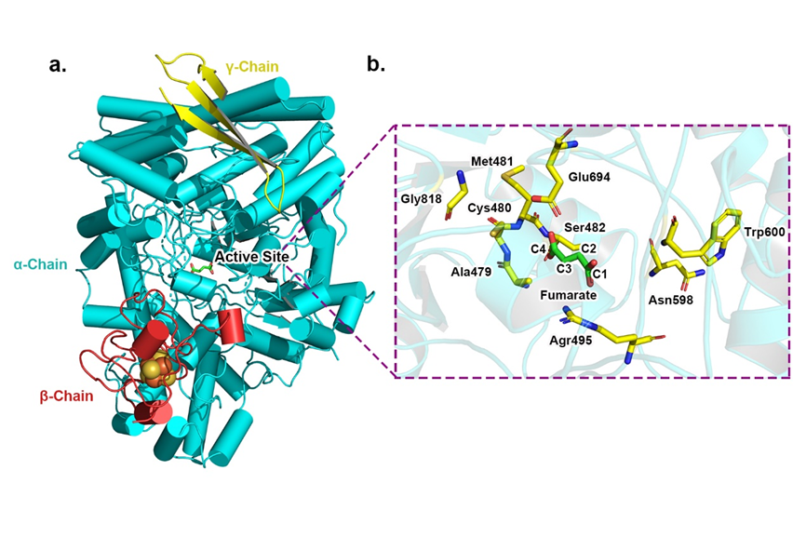
Figure S3. Structural modelling and active site of the Ass complex in Dehalococcoidia ScB_bin257. a, Models of AssA (blue), AssB (red) and AssC (yellow) in Dehalococcoidia ScB_bin257 superimposed onto Bss of Thauera aromatic (PDB ID:5BWE); b, The model of the active site of the AssA in Dehalococcoidia ScB_bin257 with superimposed fumarate (green and red) using Bss of Thauera aromatic (PDB ID:5BWE) as the template.
Figure S4. Multiple sequence alignments of FAE-activating enzymes identified in this study with reference sequences. Red arrows indicate motif ‘CxxCxxCxxxC’.
Figure S5. Maximum-likelihood tree of amino acid sequences of dissimilatory sulfite reductase A subunit (DsrA). The tree shows sequences from recovered genomes in this study (yellow shaded) alongside representative reference sequences (black). The tree was constructed using the JTT matrix-based model, used all sites, and was bootstrapped with 50 replicates and midpoint-rooted.
Figure S6. Presence and absence of enzymes in the Wood-Ljungdahl pathway for recovered archaeal genomes reported in this study. Filled circles represent gene presence.

