Supplementary Information
Adsorption mechanism in crystalline micropores: multimodal fluctuations, phase coexistence and phase transformations in nanoconfinement
Małgorzata Stankiewicz¹, Anthony Dorhauer,^{2,3} Kornel Roztocki⁴, Volodymyr Bon⁵, Bartosz Mazur¹, Carlos Wexler, ^{2,3} Stefan Kaskel⁵, Lucyna Firlej^{1,2,6}, Bogdan Kuchta^{1,2,7}*
- Faculty of Chemistry, Wroclaw University of Science and Technology, Wybrzeze Wyspianskiego 27, 50-370 Wroclaw, Poland
- Department of Physics and Astronomy, University of Missouri, Columbia, MO 65211, USA
- Materials Science and Engineering Institute, University of Missouri, Columbia, MO 65211, USA
- Faculty of Chemistry, Adam Mickiewicz University, Uniwersytetu Poznańskiego 8,
61-614 Poznań, Poland
- Department of Inorganic Chemistry, Faculty of Chemistry and Food Chemistry, Dresden University of Technology; Dresden, 10169, Germany
- Laboratoire Charles Coulomb, UMR CNRS 5221, University of Montpellier, Montpellier, France
- Laboratory MADIREL, Aix-Marseille University – CNRS, 13013 Marseille, France

Table of contents
- Structure model and force field ………………………………………………………………………. 1
- CO₂ numerical isotherms, fluctuations and free energy……………………………………. 4
- IRMOF-8/CO2
- IRMOF-10/CO2
- IRMOF-14/CO2
- Distribution of density ……………………………………………………………………………………. 7
- Instantaneous snapshots of fluctuations in a 3×3×1 Unit Cell ……………………….... 8
- Experimental setup ………………………………………………………………………………………… 9

Structure model and force field
The crystal structure of IRMOF-1 was obtained from the work of Eddaoudi [1] et al., with the corresponding CIF file available in the RASPA [2] simulation package. During all simulations, the framework was treated as rigid. Interactions between the framework and the adsorbate (CO₂ and methane) were modeled using the standard Lennard-Jones (LJ) 6-12 model. The LJ parameters for the MOF and adsorbate atoms (listed in Table S1) were taken from the DREIDING [3], UFF [4], and TraPPE [5] force fields. Charges were estimated using the PACMOF Python library—a pre‑trained Random Forest model that delivers DDEC‑level accuracy for MOF atomic charges at high throughput [6]. All interactions were truncated at a cutoff value of 14.0 Å (12.8 Å for IRMOF-1); tail corrections were applied only to gas–gas interactions. Lorentz–Berthelot mixing rules were applied for the MOF–adsorbate cross terms. The fugacity coefficient was calculated using the Peng-Robinson equation of state, as implemented in the RASPA software. The atom types in the IRMOF structures are defined as follows: Zn is the metal center; O1 is the central oxide ion in the Zn₄O cluster; O2 is the carboxylate oxygen from the linker coordinating to Zn. For IRMOF-1, C1 is the carboxylate carbon; C2 is the aromatic carbon in the para position relative to the carboxylate group; and C3 is the aromatic carbon in the meta position. Atom types in IRMOF-8, IRMOF-10, and IRMOF-14 are illustrated in Fig. S2.
Table S1. Lennard-Jones and electrostatic parameters used in GCMC simulations.
Table S2. Force Field Parameter Comparison for CO₂ Adsorption in IRMOF-1 at 218 K.
Sensitivity of GCMC simulations to interaction potentials
In GCMC simulations of adsorption, the choice of interaction potentials is critical for producing accurate and reliable predictions. These potentials define how adsorbate molecules interact with both the porous network and with each other. Even minor adjustments to key parameters such as Lennard-Jones (LJ) well depth (ε) and size parameter (σ), truncation/shift schemes, or atomic charges can lead to significant changes in adsorption isotherms. For instance, changes in LJ parameters directly influence the depth and position of the potential well, thereby modifying the interaction strength and the adsorption energy landscape. Adjustments to truncation and shifting rules further affect long-range interactions: “shifted” potentials ensure a smooth decay to zero at the cutoff, while “truncated” potentials may underestimate attractive forces near the cutoff radius, especially in larger pores. Electrostatic interactions are highly sensitive to assigned partial charges, especially for polar molecules like CO₂. The charge distribution on atoms like C_CO₂ and O_CO₂ influences not only the strength of the electrostatic component but also the spatial distribution of adsorbed molecules. These factors collectively affect the balance between adsorption and desorption across a range of pressures. In our simulations, noticeable shifts in adsorption isotherms were observed when comparing different parameter sets (our modified potential, those reported by Walton et al. (2007, adapted for use in RASPA), and those used by Datar, as well as in our earlier work (see Table S2) [7-10]. Even small changes in LJ parameters, charge assignments, or truncation rules led to clear differences in isotherms. This highlights the importance of careful parameters and validation against experimental data. Our observations are consistent with previous studies, which have demonstrated that adjusting force field parameters can substantially modify the adsorption behavior; for example, changes in LJ parameters and charge assignment have been shown to influence adsorption in MOFs [i, j, k]. These findings reinforce the need for systematic evaluation and validation of interaction potentials to ensure that GCMC simulations yield quantitatively accurate and physically meaningful results.
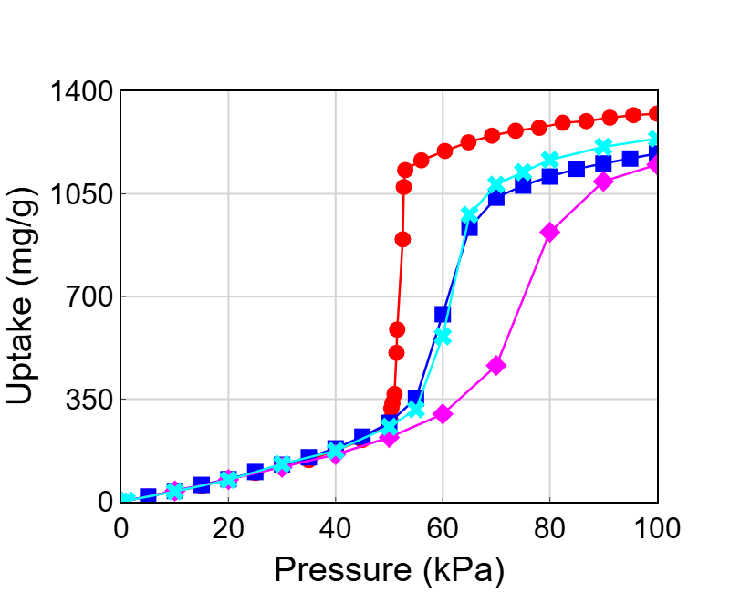
Figure S1. CO₂ isotherms in IRMOF-1 simulated at 218 K using 4 different Force Field parameters. Red circles: force field used in the current study. Blue squares: force field used in a previous study. Magenta diamonds: data from Datar et al. Cyan crosses force field used by Walton et al.

IRMOFs structures
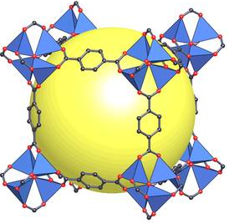 | 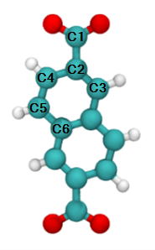 | 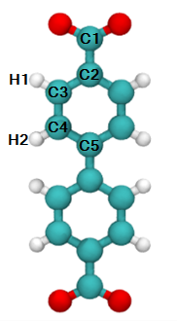 | 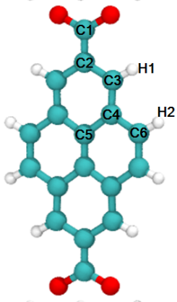
IRMOF-1  (a = 21.0915 A) | IRMOF-8  (a = 30.0915 A) | IRMOF-10  (a = 34.2807 A) | IRMOF-14  (a = 34.381 A)

Figure S2. The IRMOF-X (X = 1,8,10,14) unit cell structures.

CO₂ numerical isotherms, fluctuations and free energy.

IRMOF-8/CO2
A | B | C
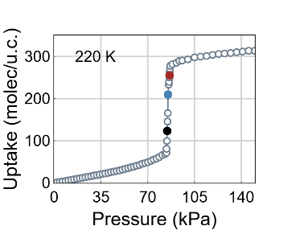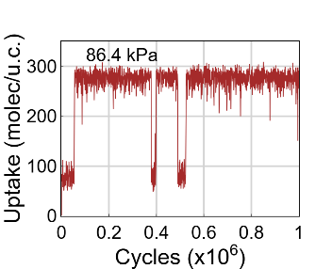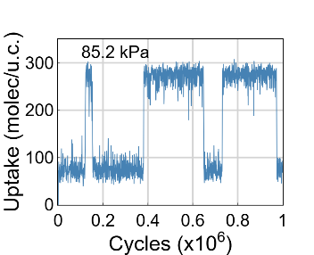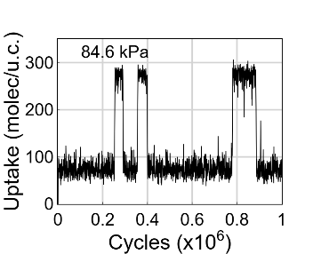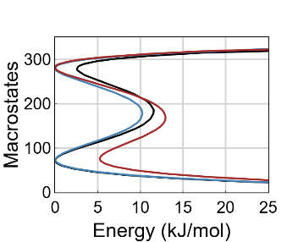 | 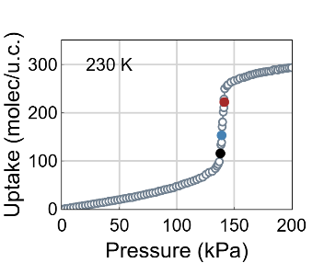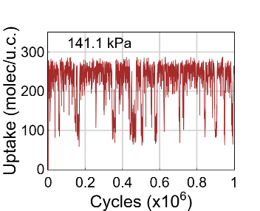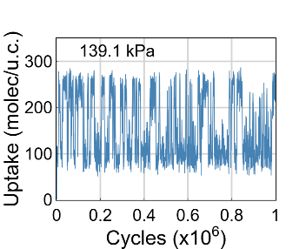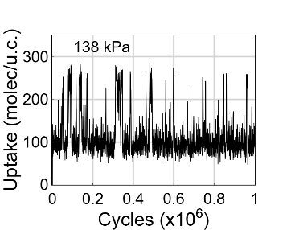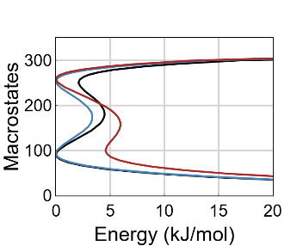 | 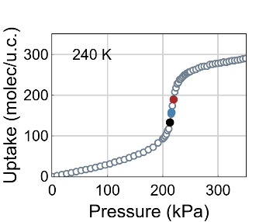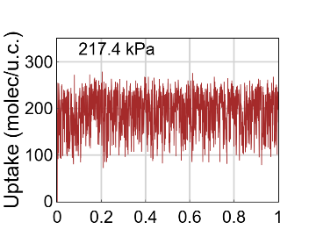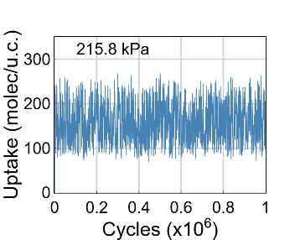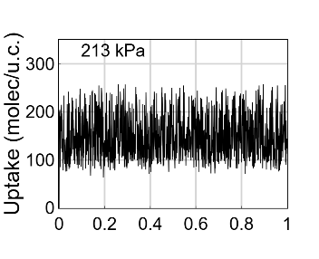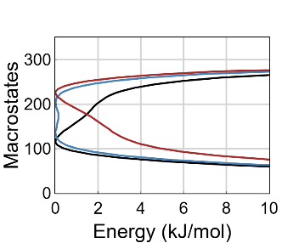

Figure S3. Free energies and the corresponding bimodal fluctuations of the CO₂ uptake in IRMOF-8 at T=220 K and 230 K, and 240 K.

IRMOF-10/CO2
A | B | C
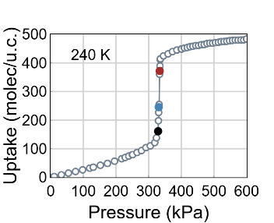  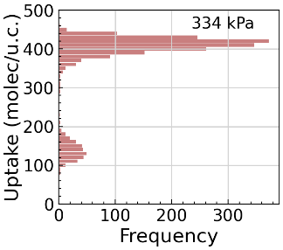  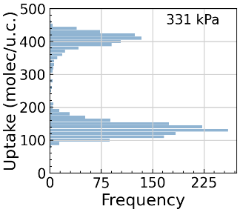  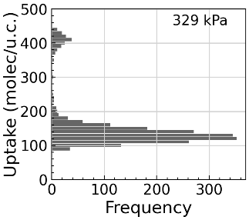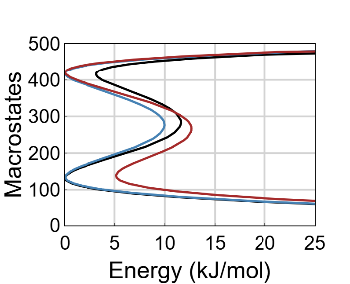 | 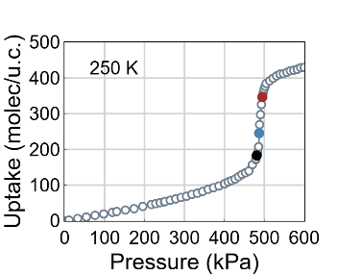  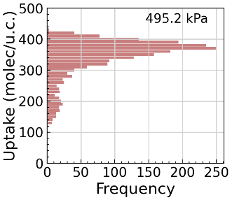  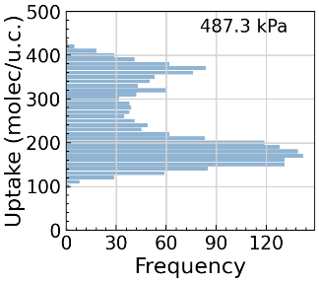  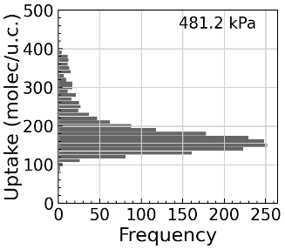  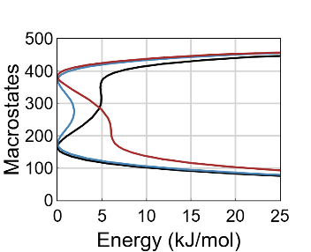 | 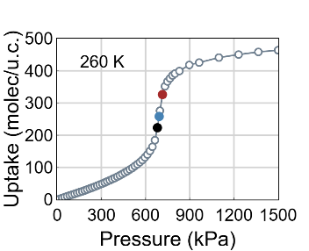  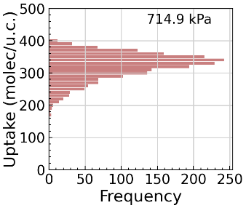  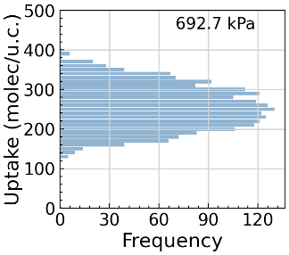  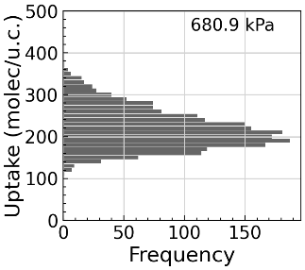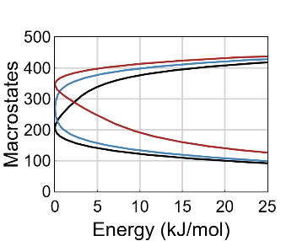

Figure S4. Free energies and the corresponding bimodal fluctuations of the CO₂ uptake in IRMOF-10 at T=240 K and 250 K, and 260 K. The fluctuations are not shown explicitly, only the distributions of the number of adsorbed molecules are shown.

IRMOF-14/CO2
A | B | C
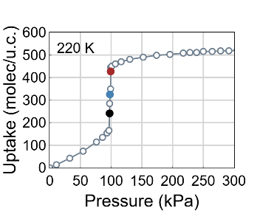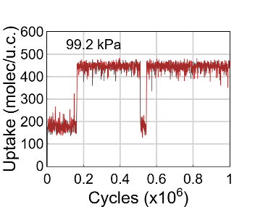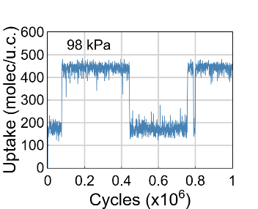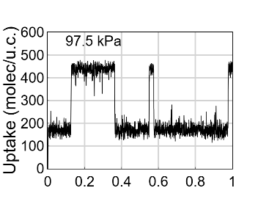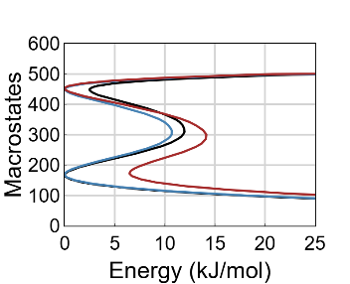 | 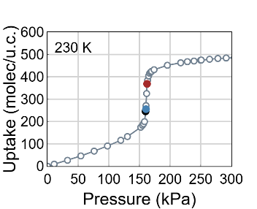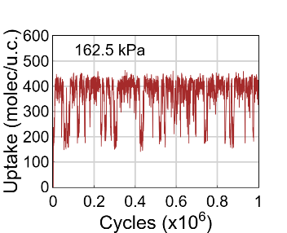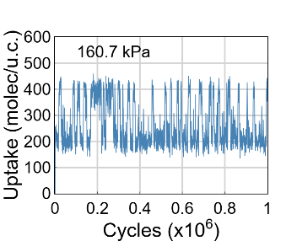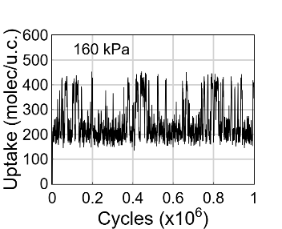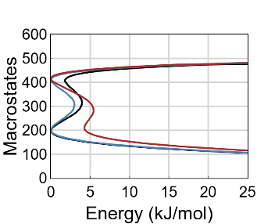 | 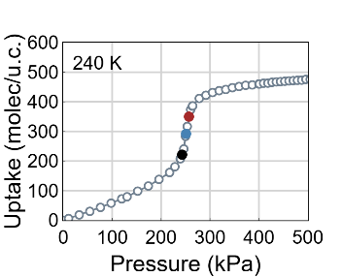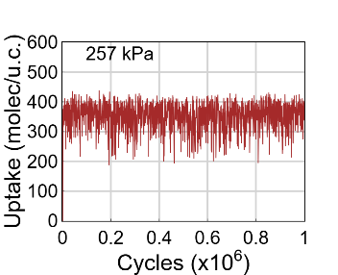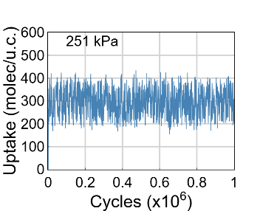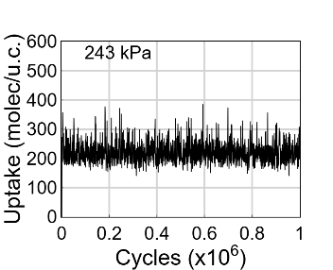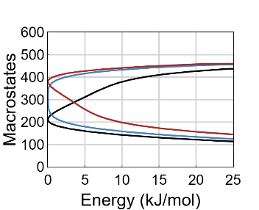

Figure S5. Free energy and the corresponding bimodal fluctuations of the CO₂ uptake in IRMOF-14 at T=220 K and 230 K and 240 K.

Distribution of density
A. 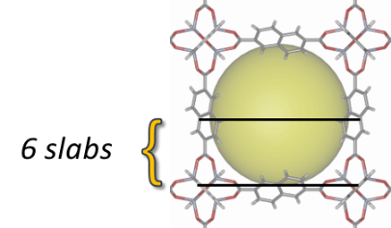
Slab 1 Slab 2 Slab 3 Slab 4 Slab 5 Slab 6
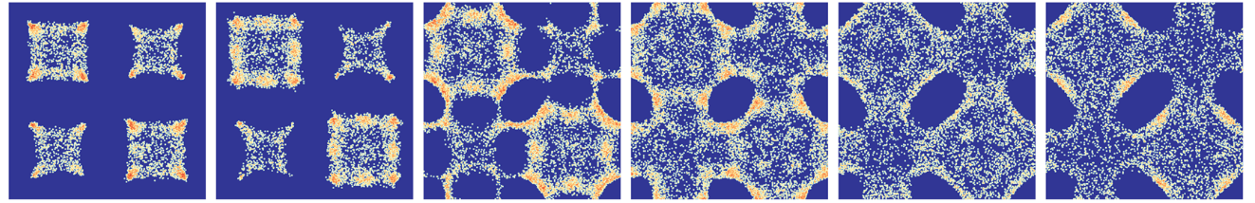
B. 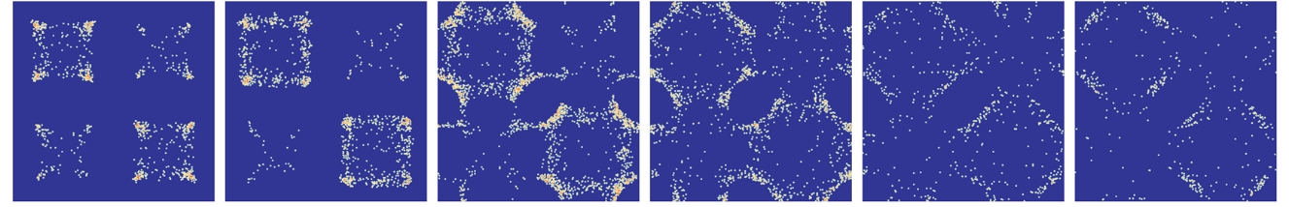
Slab 1 Slab 2 Slab 3 Slab 4 Slab 5 Slab 6
C. 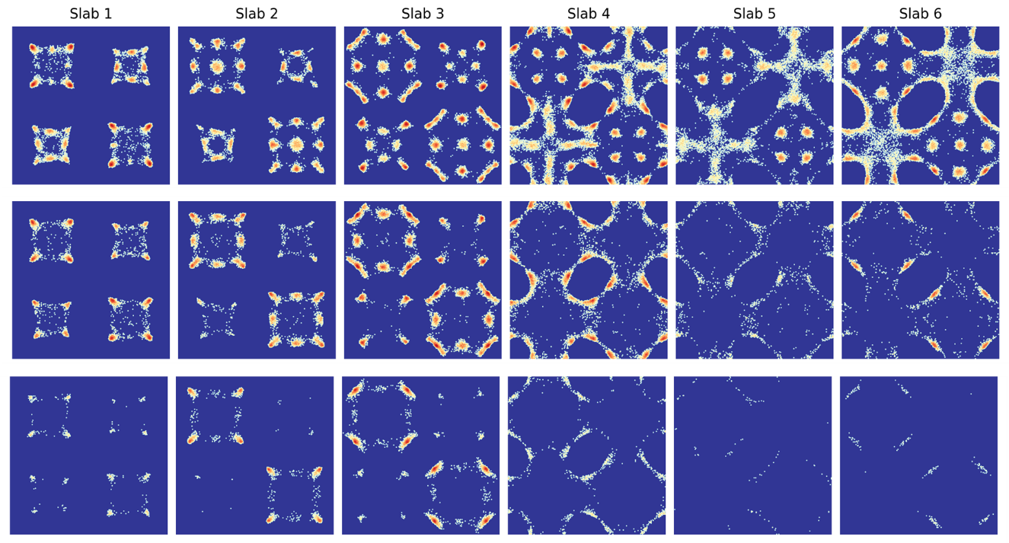
Figure S6. (A) Schematic representation of the IRMOF-8 pore, divided into 6 horizontal slabs across 4 adjacent pores. Slab 1 is positioned closest to the metal nodes, while Slab 6 lies near the center of the pore. This segmentation facilitates the analysis of vertical density variations during adsorption; (B) CO₂ adsorption in IRMOF-8 at 230 K at two selected pressures. The bottom six panels show the CO₂ density distribution at 100 kPa (low-pressure regime prior to the adsorption step), while the top six panels correspond to 139.1 kPa (midpoint of the adsorption step, see Figure 3SB). (C) CH₄ adsorption in IRMOF-8 at 115 K at three selected pressures. The bottom row shows the CH₄ density distribution at 9.79 kPa (low-pressure state), the middle row at 19.9 kPa (onset of the step), and the top row at 20.5 kPa (upper part of the step). These states correspond to the orange, blue, and red points on the isotherm and the corresponding free energy profiles (Figure 6A).

Instantaneous snapshots of fluctuations in a 3×3×1 Unit Cell
A. 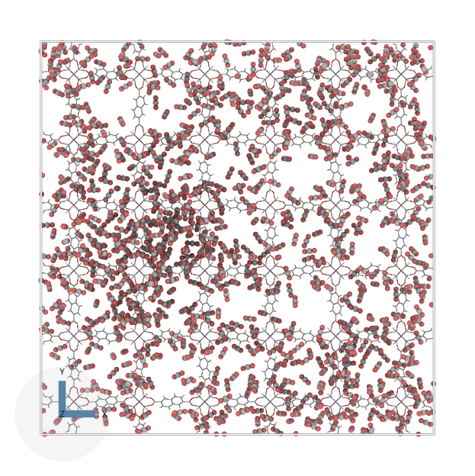 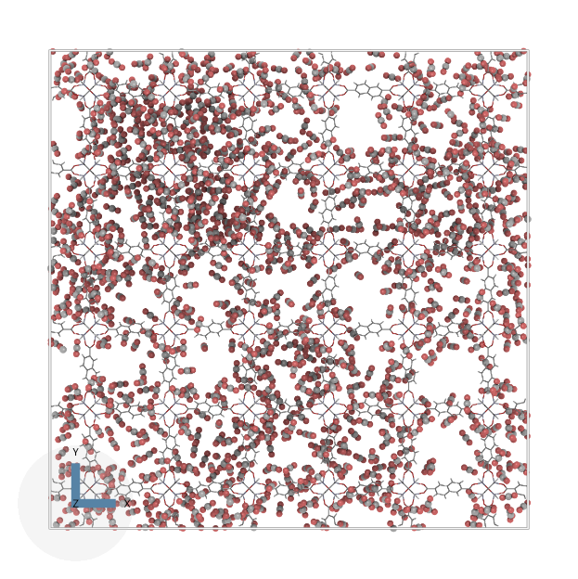
B. 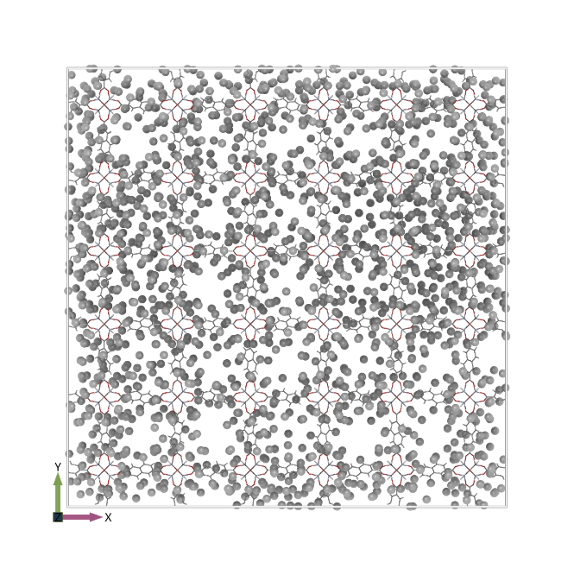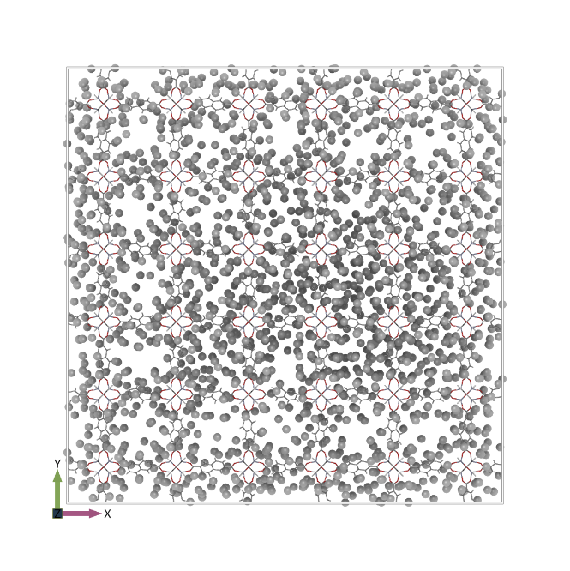
Figure S7. (A) CO₂ adsorption in IRMOF-8 at T = 110K and P = 1385 Pa (3×3×1 unit cells). The snapshots illustrate the spatial distribution of CO₂ molecules within the framework. Adsorption is clearly non-uniform, with localized regions of higher density and clustering observed from both perspectives. This inhomogeneous distribution may result from cooperative adsorption behavior and preferential site occupation within the pore network. (B) CH₄ adsorption in IRMOF-8 at 230 K, P = 141 kPa (3×3×1 unit cells). A less pronounced inhomogeneous distribution is observed, due to the pores being only partially filled and the accessible volume being reduced, limiting the ability of the gas to fluctuate within the equilibrium region, as shown in Fig. 6 (D).
Experimental setup
Comment on measurement accuracy
High precision in the adsorption measurements was ensured by carefully optimizing the experimental conditions. A sample mass of 32.2 mg was used, with a calibrated dead volume of 41.44 cm³ and a total surface area per adsorption cell was 121.2 m² (more than twice the recommended value). As a result, the recorded isotherms are smooth, free from outliers, indicating both excellent temperature stability and sufficient sample loading to accurately capture adsorption behavior.

1. Li, H., et al., Design and synthesis of an exceptionally stable and highly porous metal-organic framework. nature, 1999. 402(6759): p. 276-279.
2. Dubbeldam, D., et al., RASPA: molecular simulation software for adsorption and diffusion in flexible nanoporous materials. Molecular Simulation, 2016. 42(2): p. 81-101.
3. Mayo, S.L., B.D. Olafson, and W.A. Goddard, DREIDING: a generic force field for molecular simulations. Journal of Physical chemistry, 1990. 94(26): p. 8897-8909.
4. Rappé, A.K., et al., UFF, a full periodic table force field for molecular mechanics and molecular dynamics simulations. Journal of the American chemical society, 1992. 114(25): p. 10024-10035.
5. Martin, M.G. and J.I. Siepmann, Transferable potentials for phase equilibria. 1. United-atom description of n-alkanes. The Journal of Physical Chemistry B, 1998. 102(14): p. 2569-2577.
6. Kancharlapalli, S., et al., Fast and accurate machine learning strategy for calculating partial atomic charges in metal–organic frameworks. Journal of Chemical Theory and Computation, 2021. 17(5): p. 3052-3064.
7. Walton, K.S., et al., Understanding inflections and steps in carbon dioxide adsorption isotherms in metal-organic frameworks. Journal of the American Chemical Society, 2008. 130(2): p. 406-407.
8. Dubbeldam, D., et al., Exceptional negative thermal expansion in isoreticular metal-organic frameworks. Angewandte Chemie-International Edition, 2007. 46(24): p. 4496-4499.
9. Datar, A., M. Witman, and L.-C. Lin, Improving computational assessment of porous materials for water adsorption applications via flat histogram methods. The Journal of Physical Chemistry C, 2021. 125(7): p. 4253-4266.
10. Kuchta, B., et al., Adsorption‐Induced Structural Phase Transformation in Nanopores. Angewandte Chemie, 2017. 129(51): p. 16461-16464.

