Results from molecular docking assessments
Table S1. Molecular docking results of curcumin and 21 derivative compounds with GSK-3β (PDB ID: 1Q5K)
Compounds | Binding Affinity, kcal/mol | Inhibition constant (K_{i}), nM
TMU1 | -6.45 | 5.40
Curcumin | -7.44 | 1.02
2 | -8.77 | 0.06
3 | -9.42 | 1.04
4 | -9.07 | 1.01
5 | -5.98 | 223.89
6 | -9.08 | 0.28
7 | -5.39 | 281.04
8 | -4.12 | 629.76
9 | -5.98 | 727.29
10 | -10.31 | 0.03
11 | -5.09 | 19.29
12 | -5.37 | 956.65
13 | -5.23 | 133.67
14 | -5.5 | 480.41
16 | -6.79 | 266.83
17 | -8.09 | 23.10
18 | -8.73 | 12.77
19 | -4.45 | 627.64
20 | -8.16 | 3.37
21 | -8.10 | 1.15
22 | -8.97 | 0.27

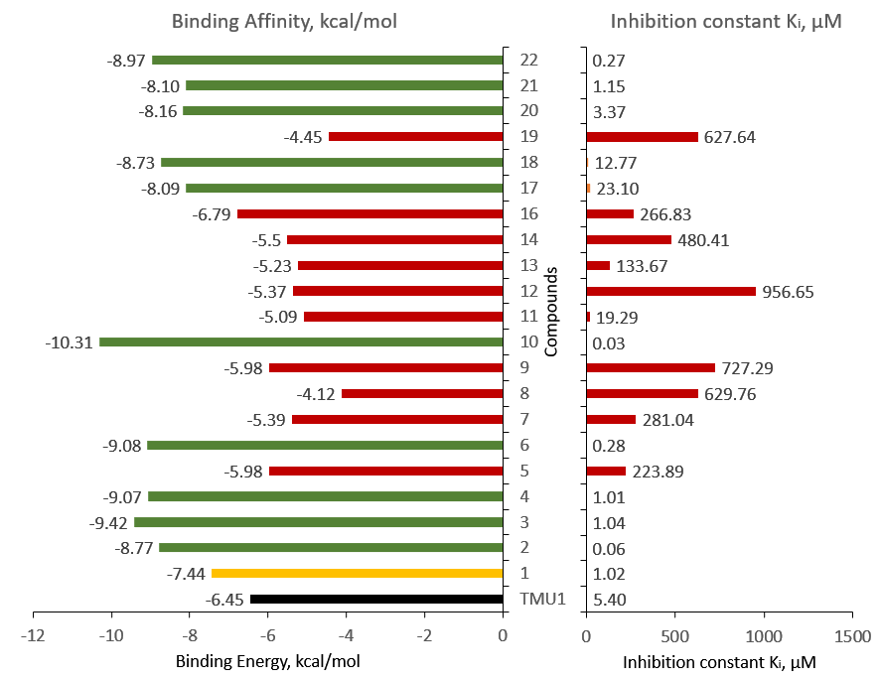
Figure S1. Graphic comparison of the binding affinity and inhibition constant from the docking of TMU1, curcumin and the derivatives to GSK-3β
Table S2. Visualisation of the docking of curcumin and the derivatives to GSK-3β, showing the intermolecular interactions between the ligand and the amino acid residues of the protein
Curcumin
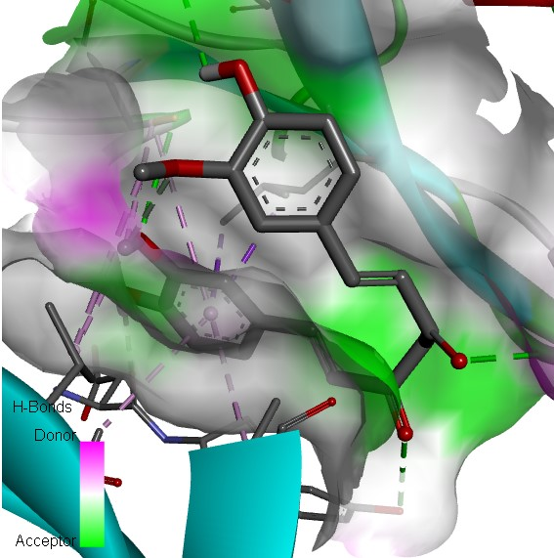 | 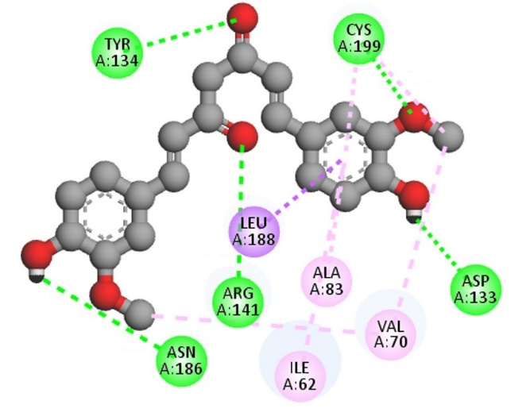
Derivative 2
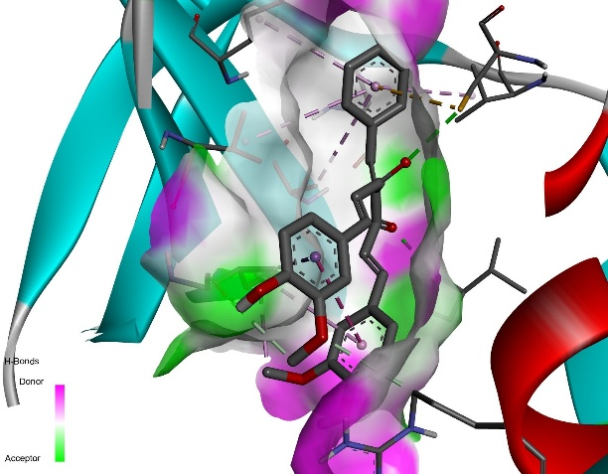 | 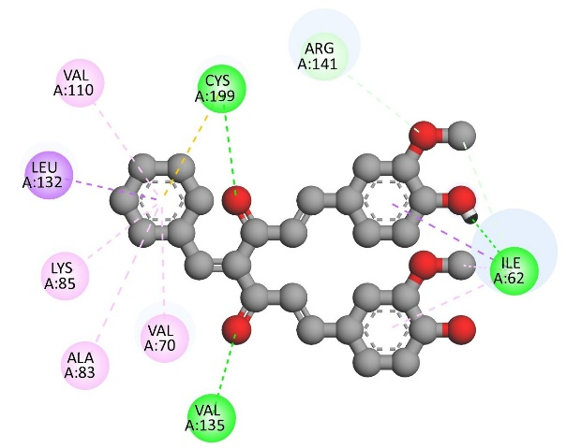
Derivative 3
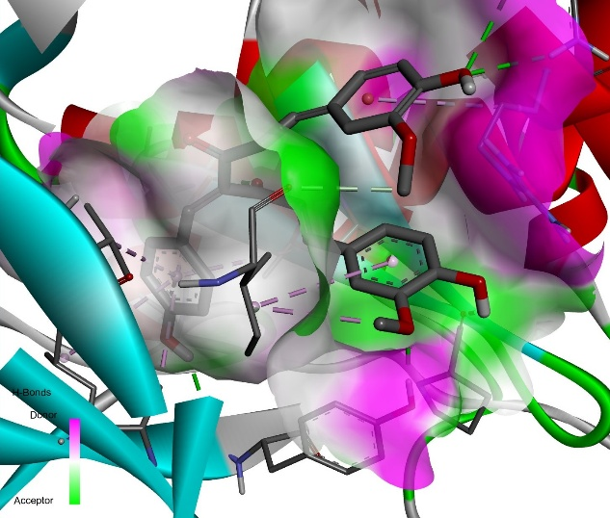 | 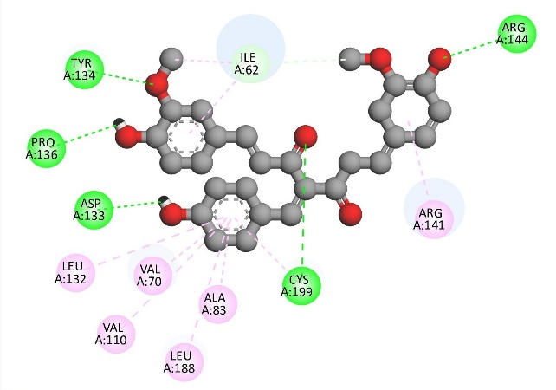

Derivative 4
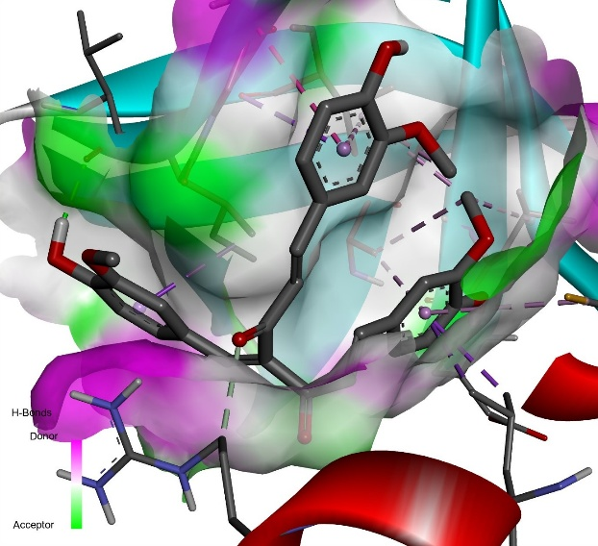 | 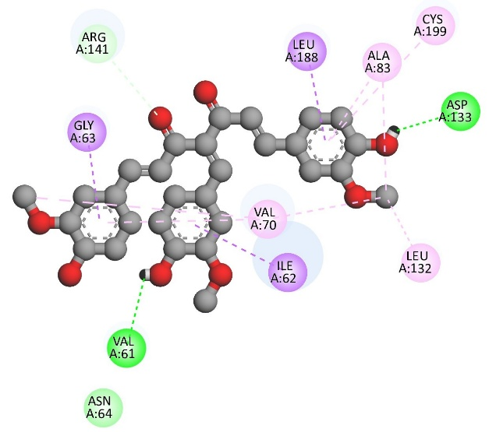
Derivative 6
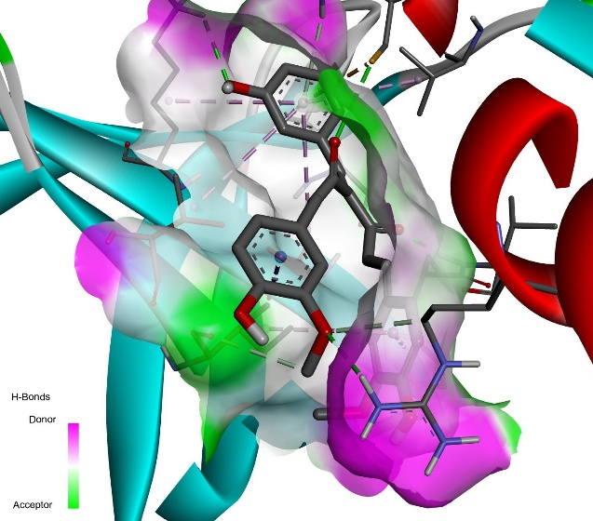 | 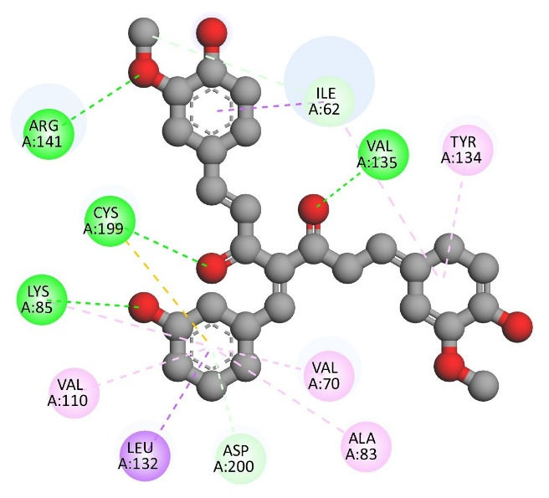
Derivative 10
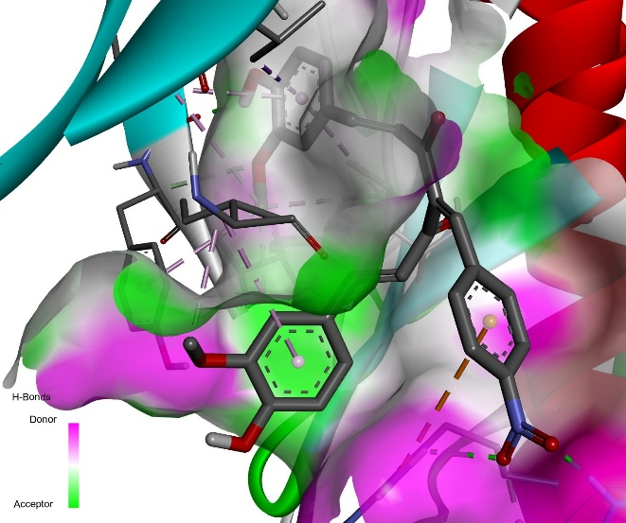 | 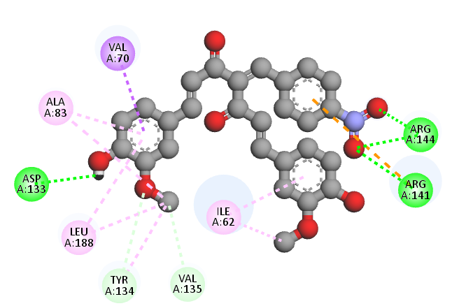

Derivative 17
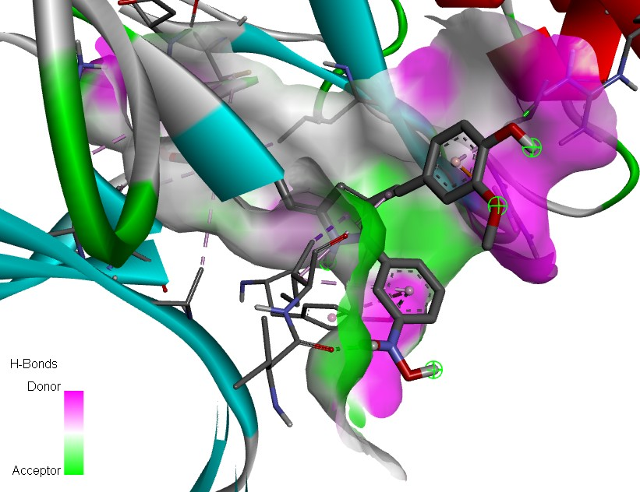 | 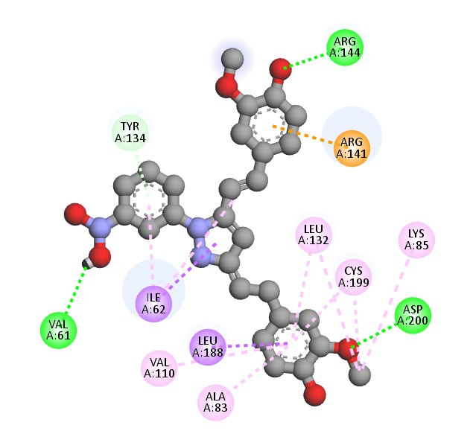
Derivative 18
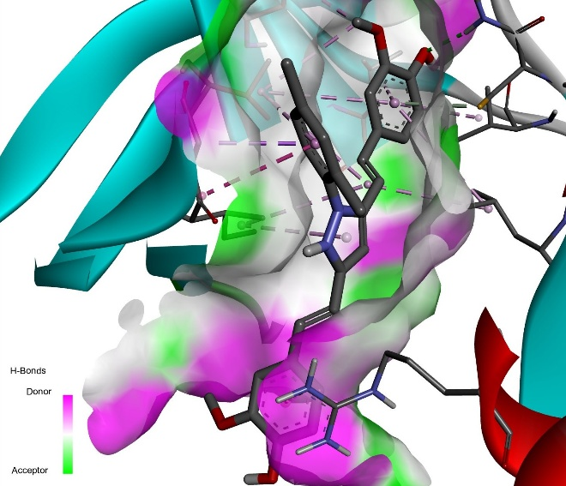 | 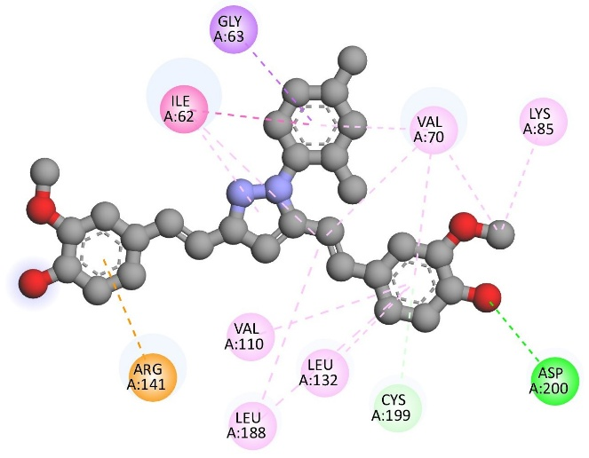
Derivative 20
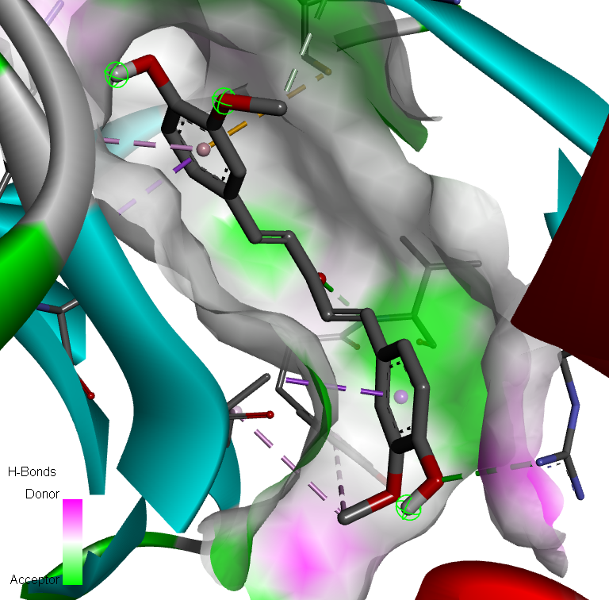 | 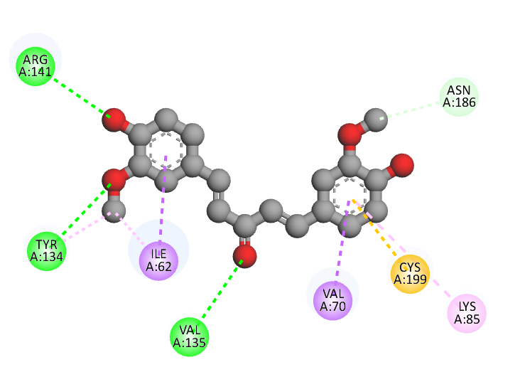

Derivative 21
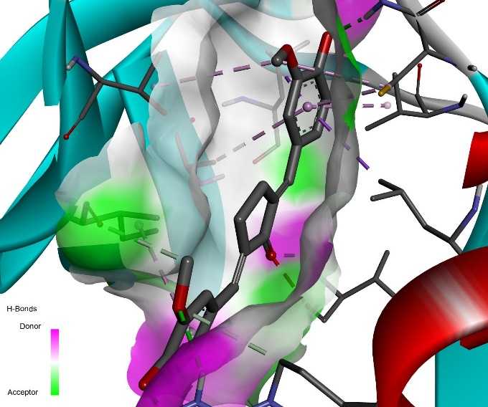 | 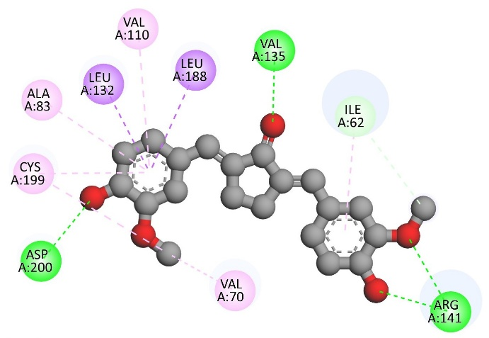
Derivative 22
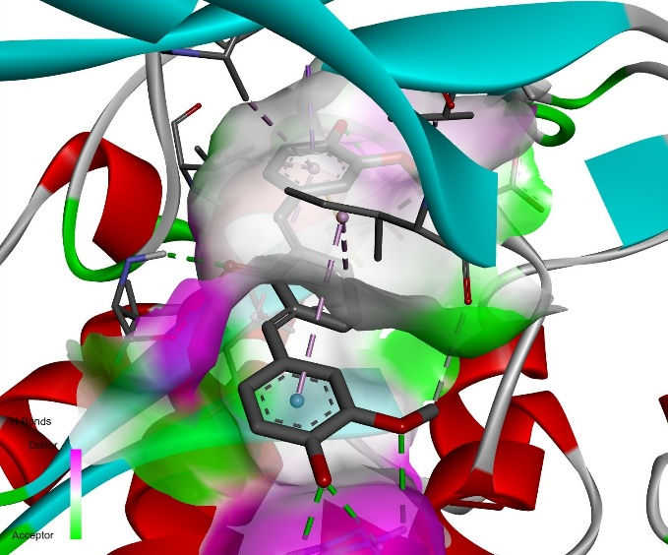 | 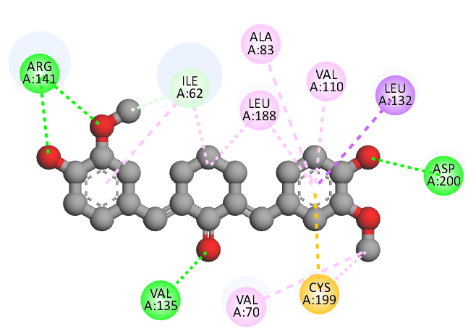
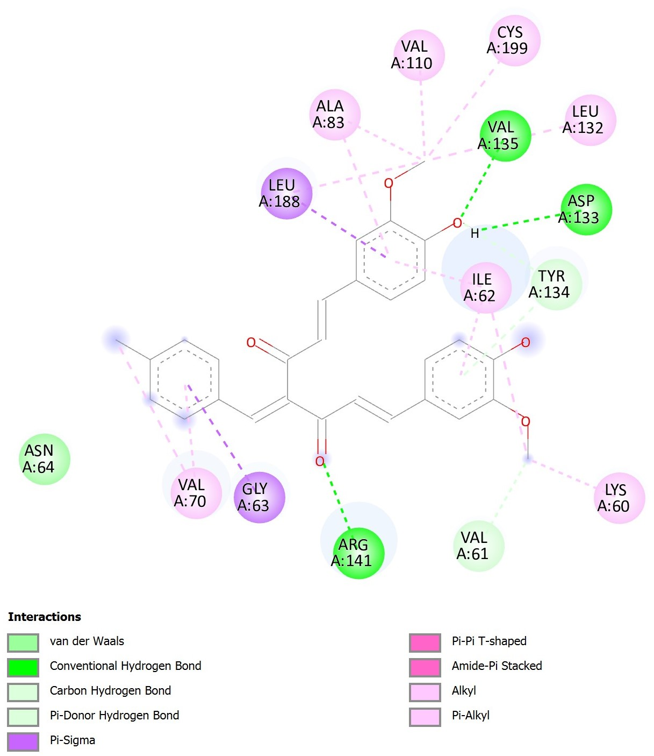
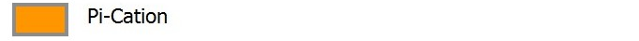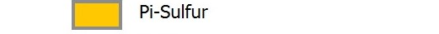

Calculation details of the electronic and global reactivity parameters from DFT calculations [1, 2]
- Ionisation potential $\left(IP\right)=-E_{HOMO}$

- Electron affinity $\left(EA\right)=-E_{LUMO}$

- Chemical potential (μ) represents the energy change of the system which can be defined as the ability of the system to gain electrons.
$$μ=-\frac{1}{2}(IP+EA)$$
It is correlated with the HOMO and LUMO energy gap, in which the smaller gaps indicate higher chemical reactivity. According to Koopmans’ theorem, $IP=-E_{HOMO}$ and $EA=-E_{LUMO}$
Therefore, $μ=\frac{1}{2}(E_{HOMO}+E_{LUMO}$)

- Chemical hardness (η), proposed by Parr and Pearson [3] is defined as follows:
$$η=\frac{1}{2}(IP-EA)$$
$$η=-\frac{1}{2}(E_{HOMO}-E_{LUMO})$$

- Electronegativity (ꭓ)
$$ꭓ=\frac{1}{2}(IP+EA)$$
$$ꭓ=-\frac{1}{2}(E_{HOMO}+E_{LUMO})$$

- Electrophilicity index (ω) determines the electrophilicity (ability to accept electrons) and nucleophilicity (ability to donate electrons) of a chemical system, which is defined by Parr et al. [3] as follows:
$$ω=\frac{μ^{2}}{2η}$$

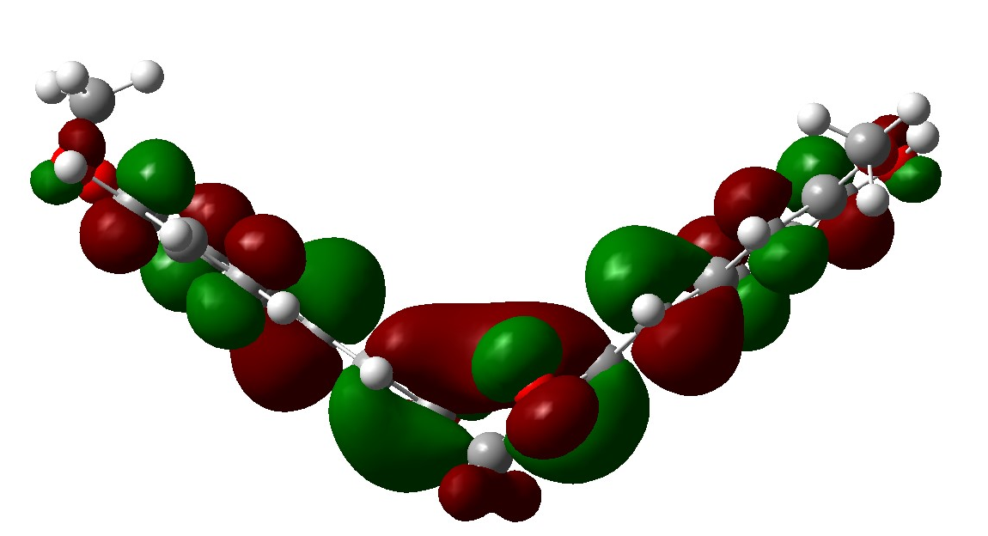 | LUMO    –2.3957 eV | 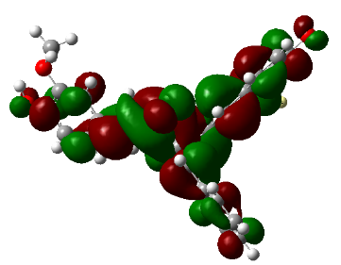 | LUMO  –2.3143eV
- - - - - - - - - - - - - - - - - - - - - | 3.5990 eV | - - - - - - - - - - - - - - - - - - - - | 3.6186 eV
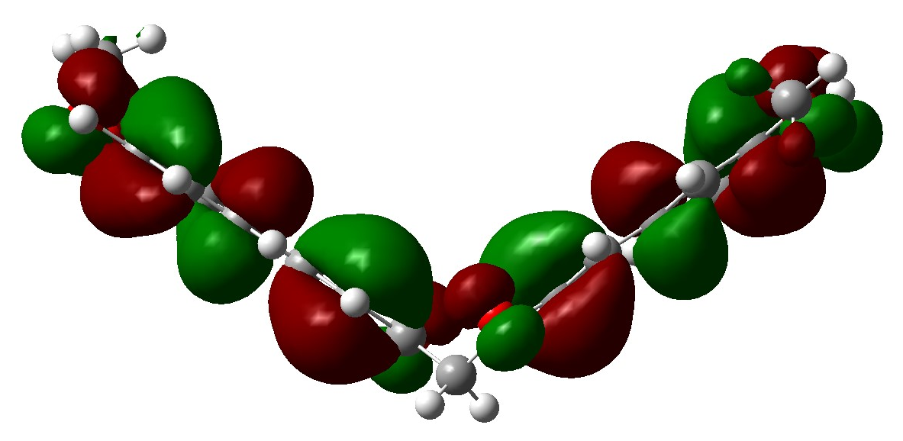 | HOMO  –5.9947 eV | 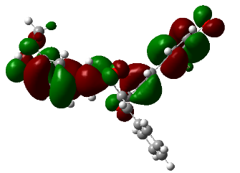 | HOMO  –5.9329 eV
Curcumin |  | Derivative 2
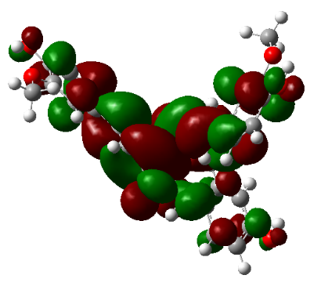 | LUMO  –2.2781 eV | 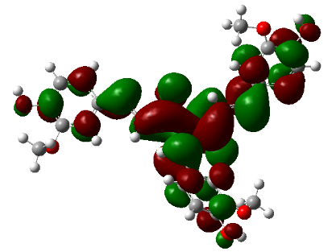 | LUMO  –2.3913 eV
- - - - - - - - - - - - - - - - - - - - - | 3.6145 eV | - - - - - - - - - - - - - - - - - - - - | 3.3984 eV
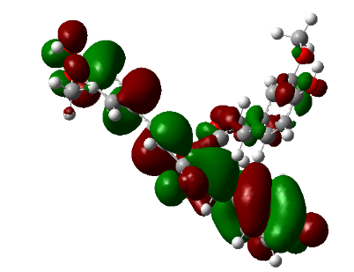 | HOMO  –5.8926 eV | 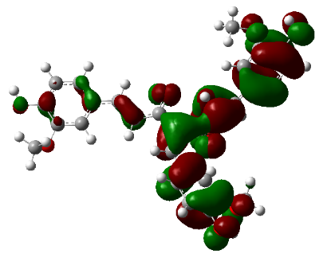 | HOMO  –5.7898 eV
Derivative 3 |  | Derivative 4
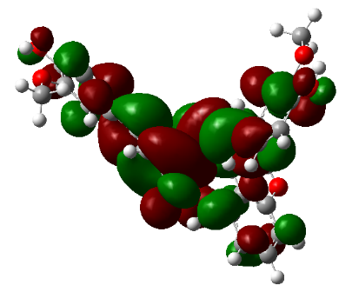 | LUMO  –2.3674 eV | 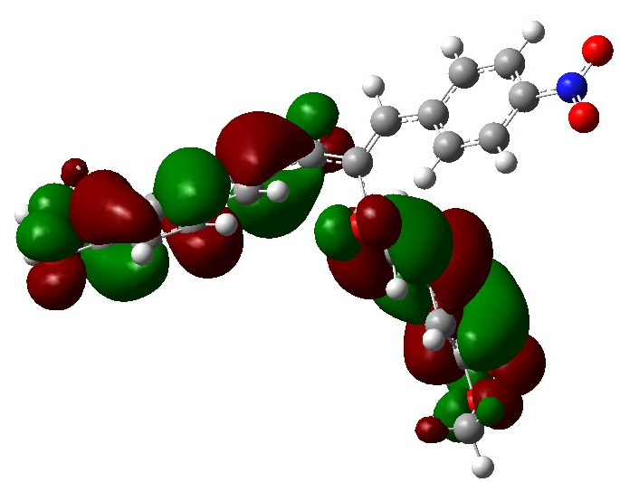 | LUMO  –2.9549 eV
- - - - - - - - - - - - - - - - - - - - - | 3.6107 eV | - - - - - - - - - - - - - - - - - - - - | 3.1916 eV
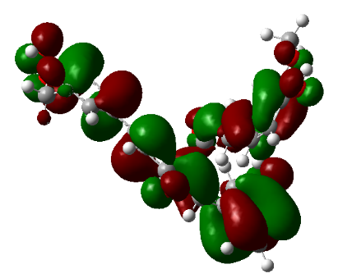 | HOMO  –5.9781 eV | 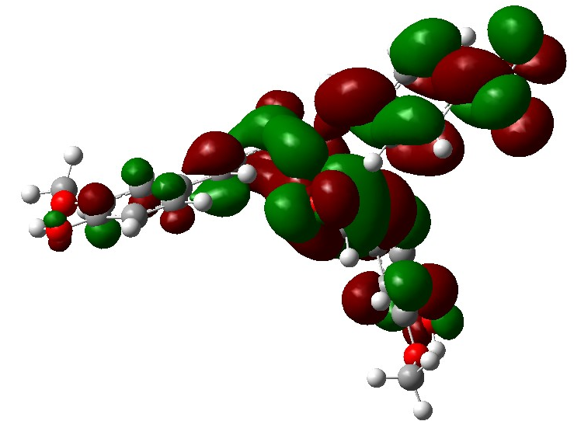 | HOMO  –6.1465 eV
Derivative 6 |  | Derivative 10
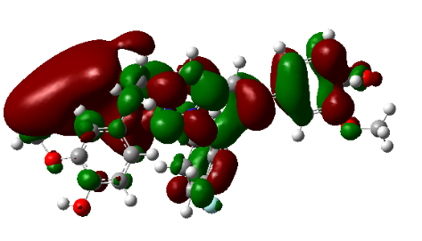 | LUMO  –1.7723 eV | 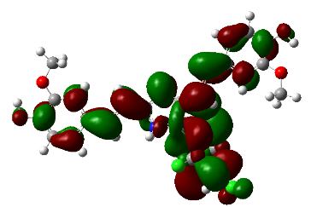 | LUMO  –2.9873 eV
- - - - - - - - - - - - - - - - - - - - - | 1.9813 eV | - - - - - - - - - - - - - - - - - - - - | 2.4977 eV
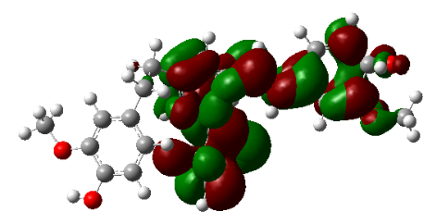 | HOMO  –3.7535 eV | 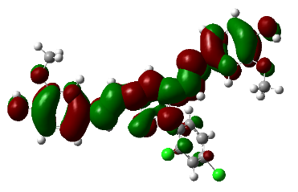 | HOMO  –5.4850 eV
Derivative 17 |  | Derivative 18
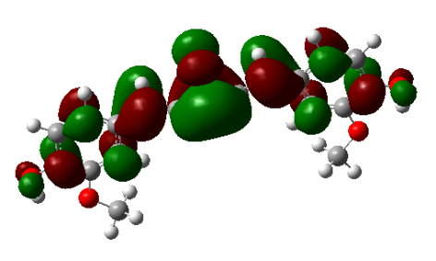 | LUMO  –2.4088 eV | 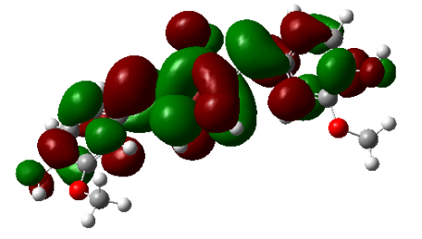 | LUMO  –2.1353 eV
- - - - - - - - - - - - - - - - - - - - - | 3.4175 eV | - - - - - - - - - - - - - - - - - - - - | 3.3046 eV
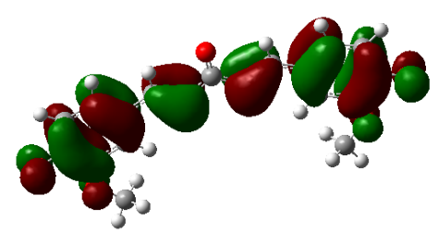 | HOMO  –5.8262 eV | 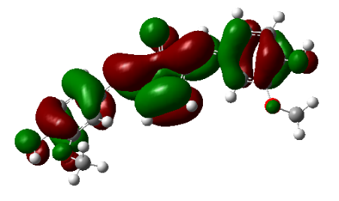 | HOMO  –5.4398 eV
Derivative 20 |  | Derivative 21
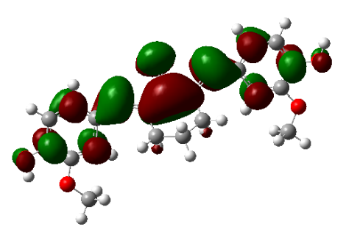 | LUMO  –2.2305 eV
- - - - - - - - - - - - - - - - - - - - - | 3.4556 eV
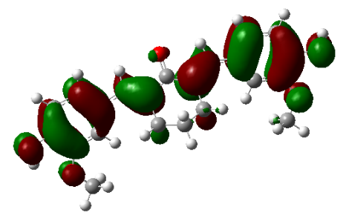 | HOMO  –5.6861 eV
Derivative 22
Figure S2. Frontier molecular orbitals (FMOs) which illustrate the HOMO-LUMO energy gap for curcumin and the derivatives compounds.

Scheme S1. Reaction mechanism of Scheme 1.

Scheme S2. Reaction mechanism of Scheme 2.

Scheme S3. Reaction mechanism of Scheme 3.

Derivative 2 – (1E,6E)-4-benzylidene-1,7-bis(4-hydroxy-3-methoxyphenyl)hepta-1,6-diene-3,5-dione
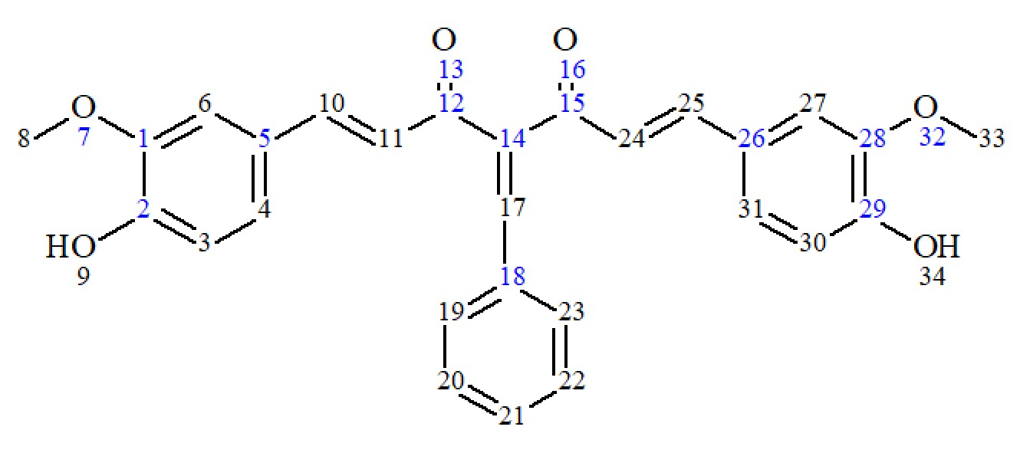
71% (bright orange crystals), m.p.: 190–192 ℃; ¹H-NMR (400 MHz, CDCl₃, 7.26 ppm) δ (ppm): 3.886–3.931 (2s, 6H, CH3 (8, 33)), 5.904 (s, 2H, OH (9, 34)), 6.746–6.788, 6.860–6.908 (2d, J=16.03 Hz, 2H, C=CH (11, 24)), 6.881–6. 929, 6.937–6.976 (2d, J=8.24 Hz, 2H, Ar–H (3, 30)), 6.952–6.956, 7.043–7.47 (2d, J=1.80 Hz, 2H, Ar–H (6, 27)), 7.001–7.026, 7.156–7.181 (2dd, J=1.8, 8.2 Hz, 2H, Ar–H (4, 31)), 7.322– 7.338 (m, 3H (20, 21, 22)), 7.432–7.473, 7.746–7.785 (2d, 16.0 Hz, 2H (10, 25)), 7.480–7.504 (m, 2H, Ar–H (19, 23)), 7.85 (s, 1 H, C=CH (17)).
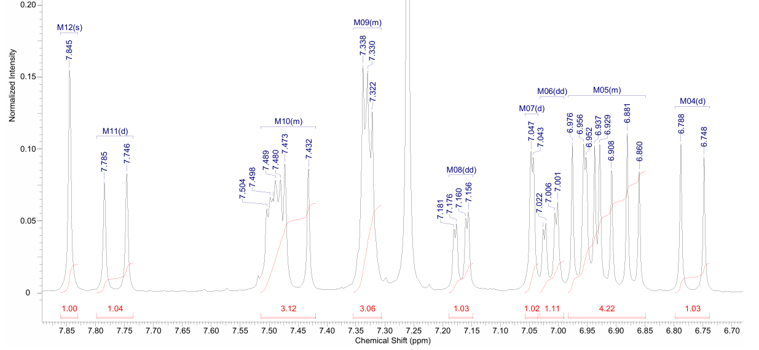
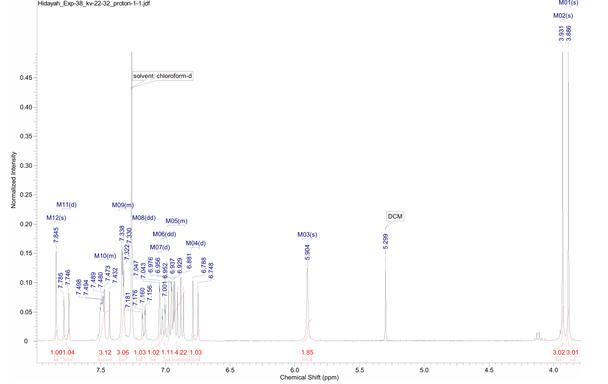
Figure S3. ¹H NMR data for the synthesised derivative 2.
Derivative 3 – (1E,6E)-1,7-bis(4-hydroxy-3-methoxyphenyl)-4-(4-hydroxybenzylidene)hepta-1,6-diene-3,5-dione
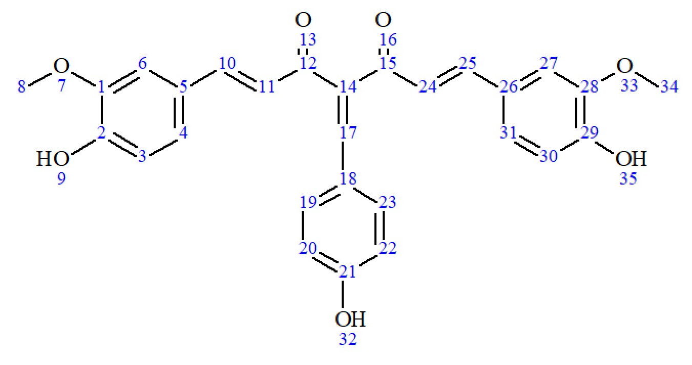
63% (bright orange crystals), m.p.: 242–243 ℃; ¹H-NMR (400 MHz, CDCl₃, 7.26 ppm) δ (ppm): 3.891–3.924 (2s, 6H, CH₃ (8, 34)), 5.654 (s, 1H, OH (32)), 5.905-5.922 (2s, 2H, OH (9, 35)), 6.763–6.785, 6.900–6.922 (2d, J=8.7 Hz, 2H, Ar–H (3, 30)), 6.775–6.818 (2d, J=16.03 Hz, 2H, C=CH (11, 24)), 6.866–6.921 (2d, J=8.24, 2H, Ar–H (6, 27)), 6.960–7.034 (2d, J=5.5 Hz, 2H, Ar–H (20, 22)), 7.022–7.166 (2dd, J=1.8, 8.2 Hz, 2H, Ar–H (4, 31)), 7.386–7.408 (d, J=16 Hz, 2H, Ar–H (19, 23)), 7.452–7.762 (2d, J=16 Hz, 2H, C=CH (10, 25)), 7.801 (s, 1H, C=CH (17)).
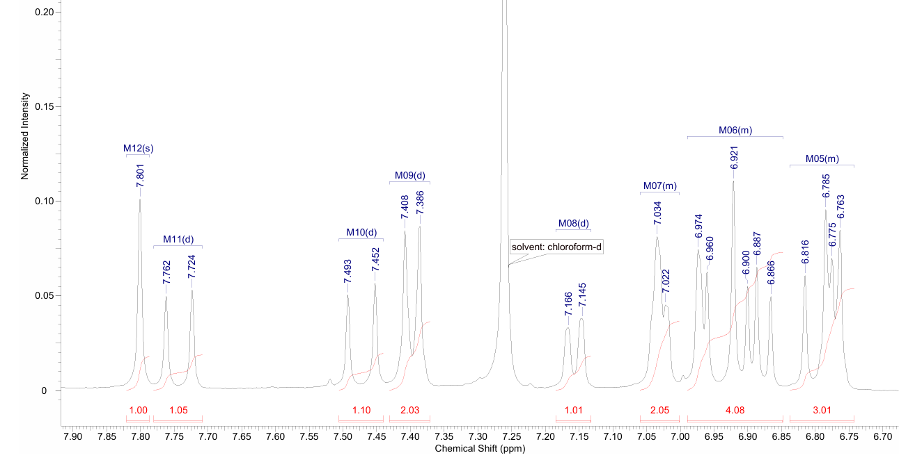
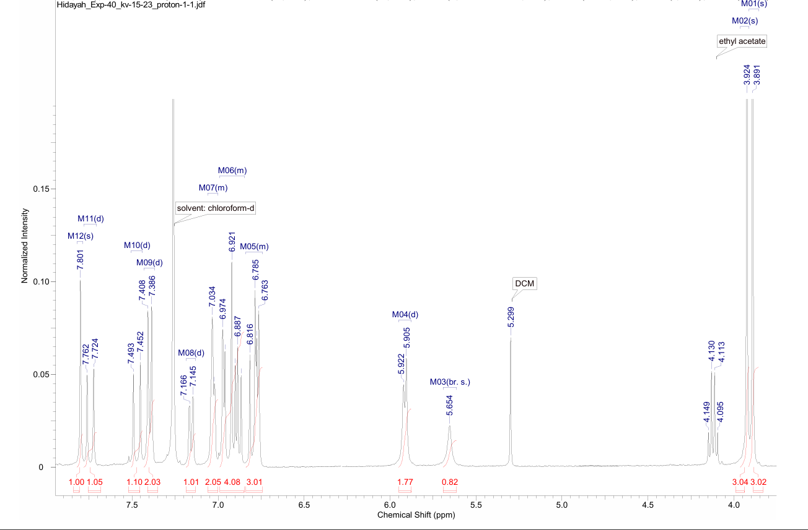
Figure S4. ¹H NMR data for the synthesised derivative 3.
Derivative 4 – (1E,6E)-4-(4-hydroxy-3-methoxybenzylidene)-1,7-bis(4-hydroxy-3-methoxyphenyl)hepta-1,6-diene-3,5-dione
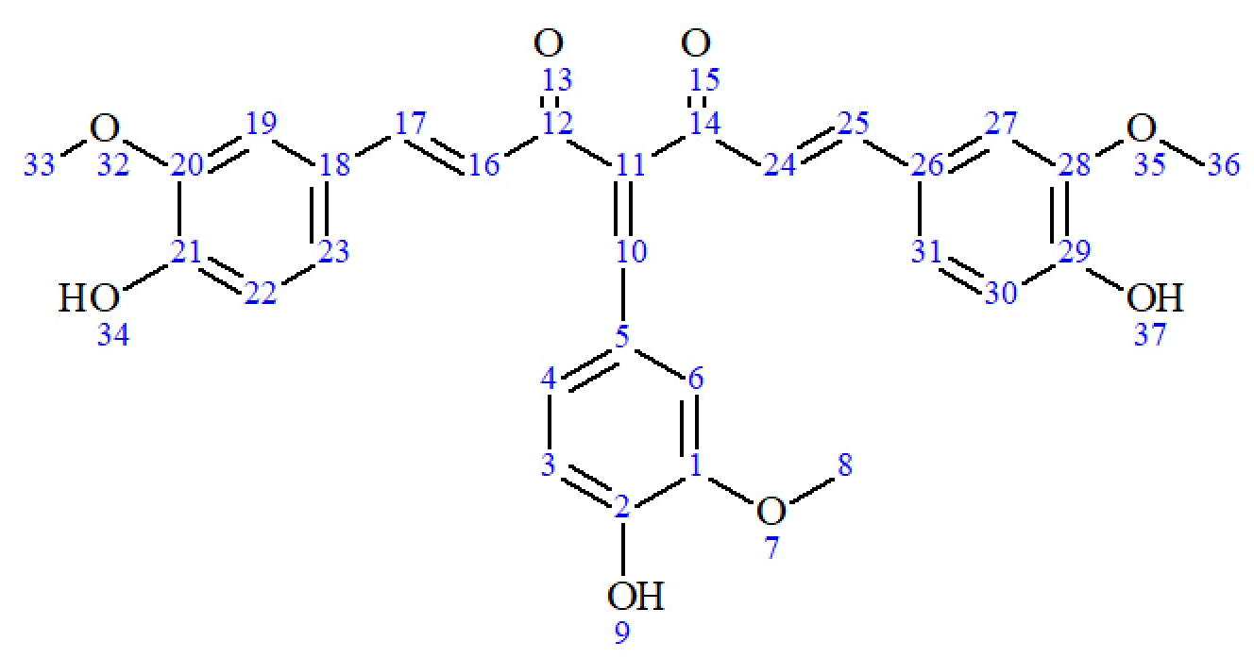
70% (bright orange crystals), m.p.: 231–233 ℃; ¹H-NMR (400 MHz, CDCl₃, 7.26 ppm) δ (ppm): 3.831 (s, 3H, CH₃ (8)), 3.892–3.928 (2s, 6H, CH₃ (33, 36)), 5.857 (s, 1H, OH (9)), 5.896–5.909 (2s, 2H, OH, (34, 37)), 6.778–6.818, 6.865–6.905 (2d, J = 16.03 Hz, 2H, C=CH (16, 24)), 6.885–6.891, 6.925–6.931 (2d, 2H 2.29 Hz, Ar–H (22, 30)), 6.871 –6.969 (m, 2H, Ar–H (19, 27)), 7.024–7.039 (m, 3H, Ar–H (3, 4, 6)), 7.077 –7.175 (2dd, 1.37, 8.24 Hz, 2H, Ar–H (23, 31)), 7.468–7.764 (2d, 16 Hz, 2H, C=CH (17, 25)), 7.794 (s, 1H, C=CH (10)).
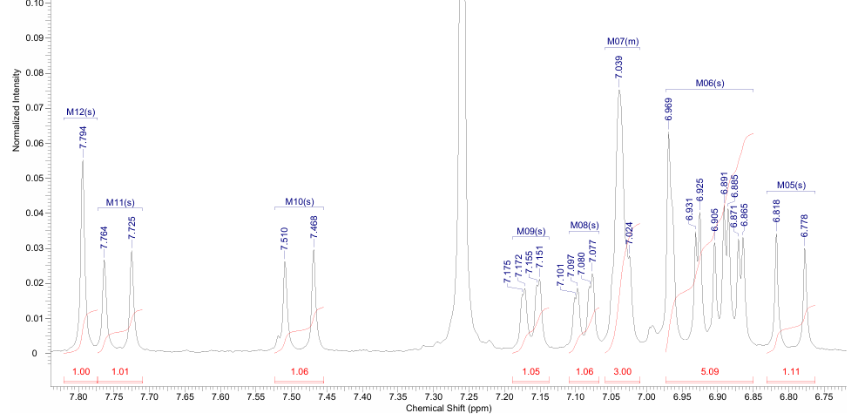
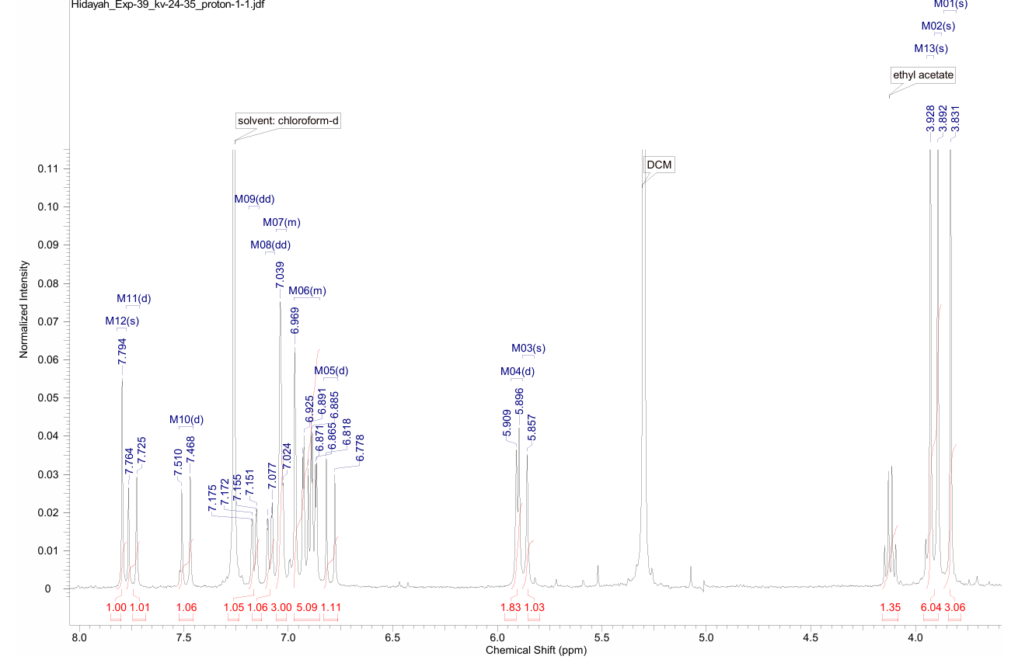
Figure S5. ¹H NMR data for the synthesised derivative 4.
Derivative 6 – (1E,6E)-1,7-bis(4-hydroxy-3-methoxyphenyl)-4-(3-hydroxybenzylidene)hepta-1,6-diene-3,5-dione
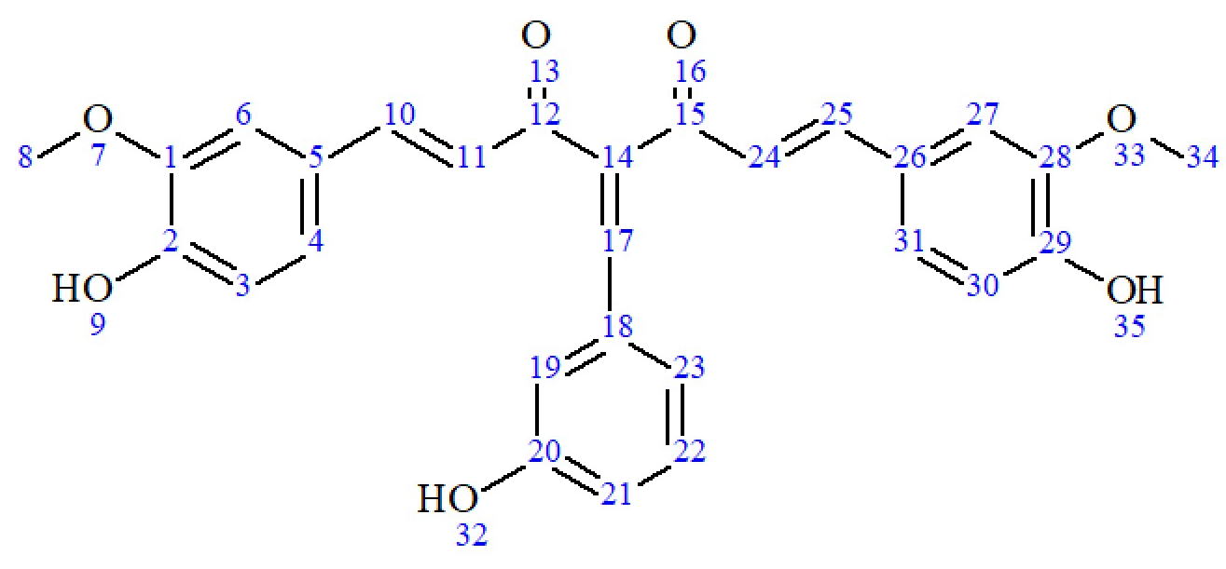
67% (bright orange crystals) , m.p.: 224–226 ℃; ¹H-NMR (400 MHz, CDCl₃, 7.26 ppm) δ (ppm): 3.877–3.924 (2s, 6H, CH₃ (8, 34)), 5.653 (s, 1H, OH (32)), 5.937 (s, 2H, OH (9, 35)), 6.743–6.783, 6.903–6.945 (2d, J=16 Hz, 2H, C=CH (11, 24)), 6.810–6.835 (dd, J=2.1, 8 Hz, 1H, Ar–H (21)), 6.853–6.923 (2d, J=8.24 Hz, 2H, Ar–H (6, 27)), 6.950–6.96, 7.024–7.054 (2d, J=4.58 Hz, 2H, Ar–H (3, 30)), 6.979 (m, 1H, Ar–H (22)), 6.994–7.019, 7.147–7.176 (2dd, J=1.83, 8.24 Hz, 2H, Ar–H (4, 31)), 7.038 (m, 1H, Ar–H (19)), 7.196–7.215 (d, J=8.24 Hz, 1H, Ar–H (23)), 7.422–7.781 (2d, J=16 Hz, 2H, C=CH (10, 25)), 7.781 (s, 1H, C=CH (17)).
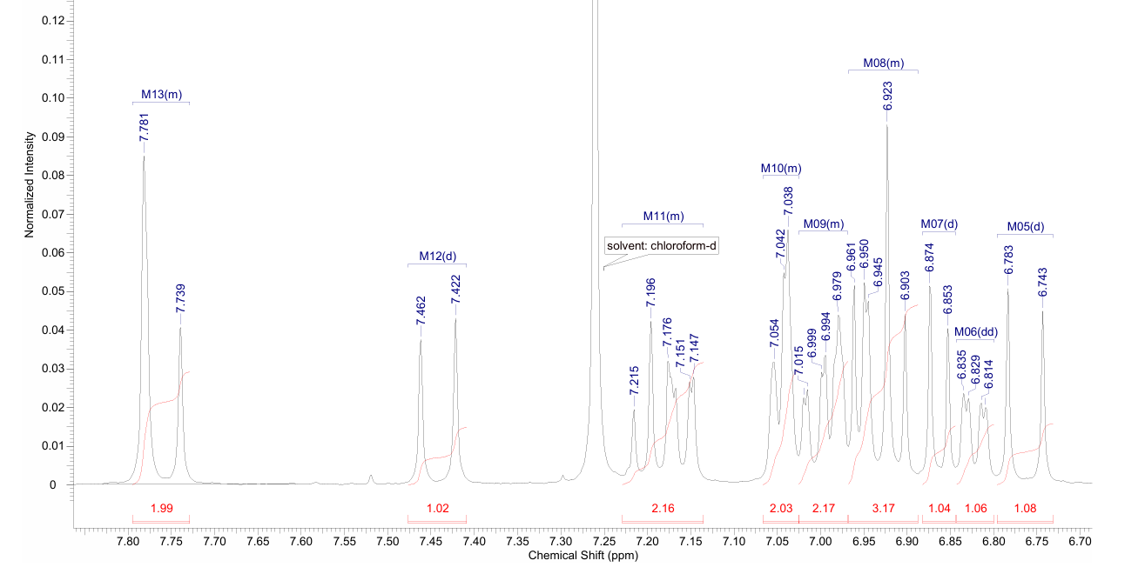
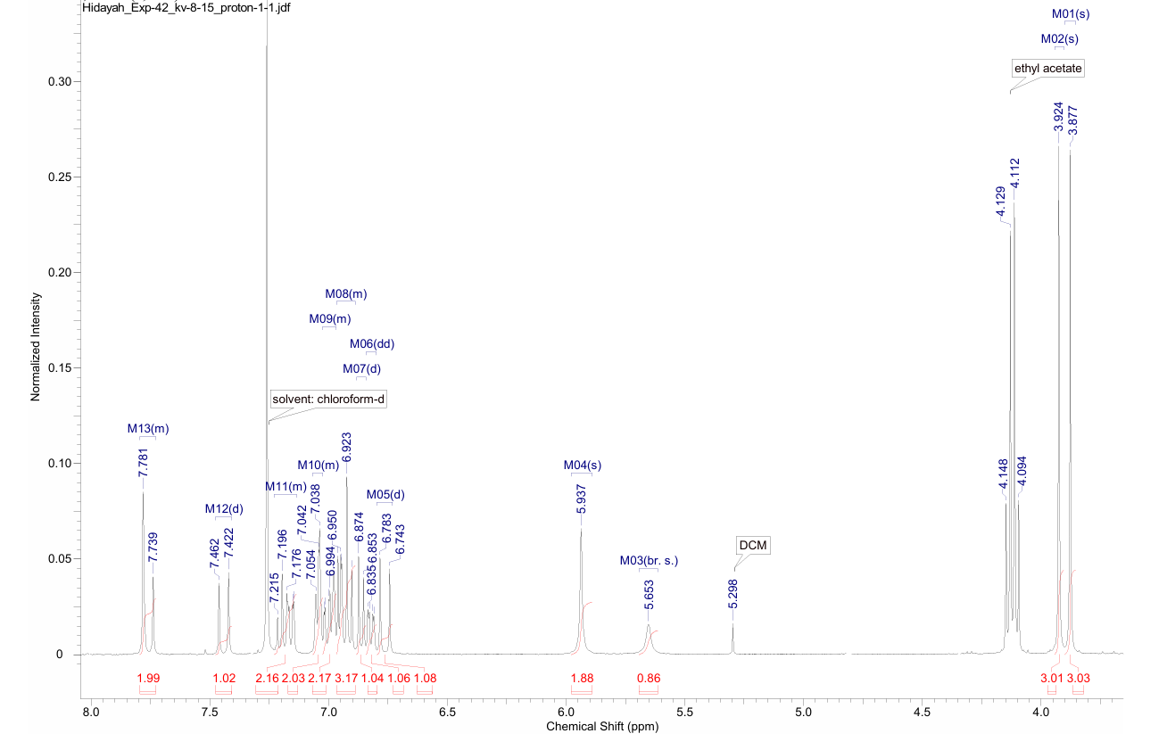
Figure S6. ¹H NMR data for the synthesised derivative 6.
Derivative 10 – (1E,6E)-1,7-bis(4-hydroxy-3-methoxyphenyl)-4-(4-nitrobenzylidene)hepta-1,6-diene-3,5-dione
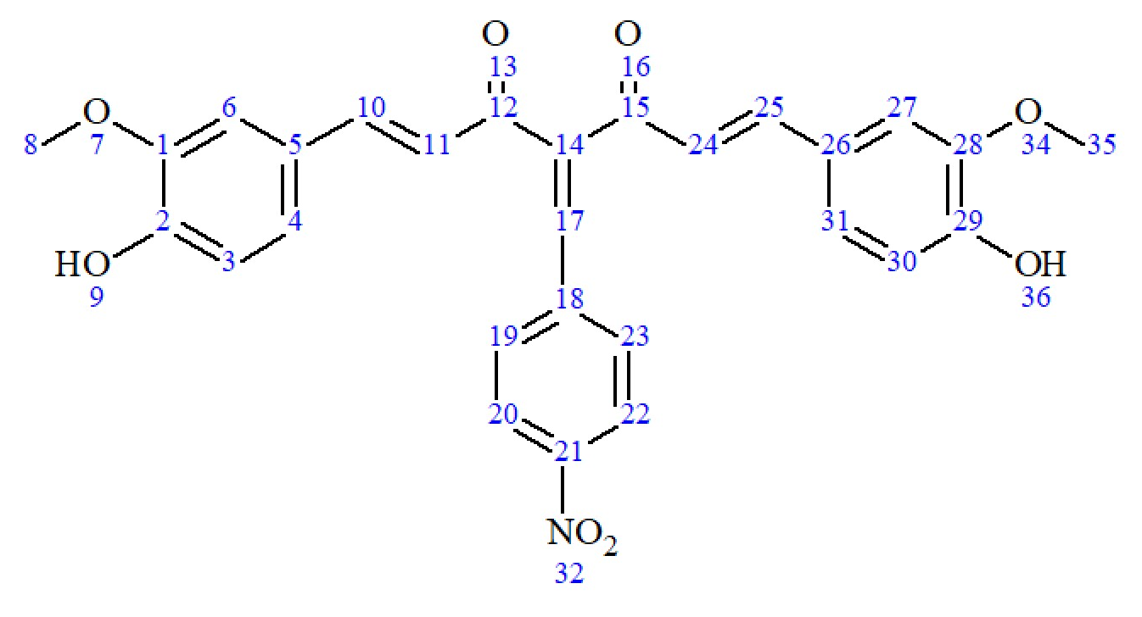
79% (bright orange crystals), m.p.: 244–245 ℃; ¹H-NMR (400 MHz, CDCl₃, 7.26 ppm) δ (ppm): 3.873–3.904 (2s, 6H, CH₃ (8, 35)), 6.110 (s, 2H, OH (9, 36)), 6.746–6.786, 6.873–6.913 (2d, J=16 Hz, 2H, C=CH (11, 24)), 6.853–6.929 (2d, J=7.8 Hz, 2H, Ar–H (6, 27)), 6.959–7.023 (d, J=11 Hz, 2H, Ar–H (3, 30)), 6.995–7.161 (2dd, J=7.8 Hz, Ar–H (4, 31)), 7.409–7.627, 7.770–7.808 (2d, J=16 Hz, 2H, 10, 25)), 7.605–7.627 (d, J=8.7 Hz, 2H, Ar–H (19, 23)), 7.796 (s, 1H (17)), 8.135–8.157 (d, J=8.7 Hz, 2H, Ar–H (20, 22)).
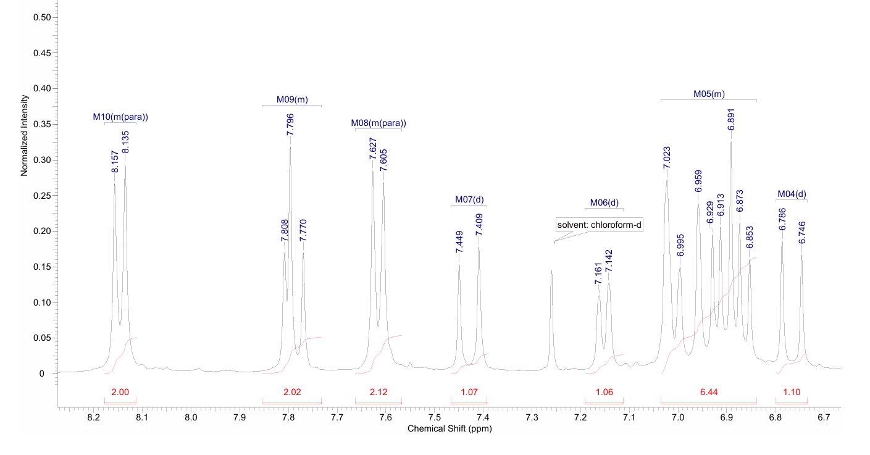
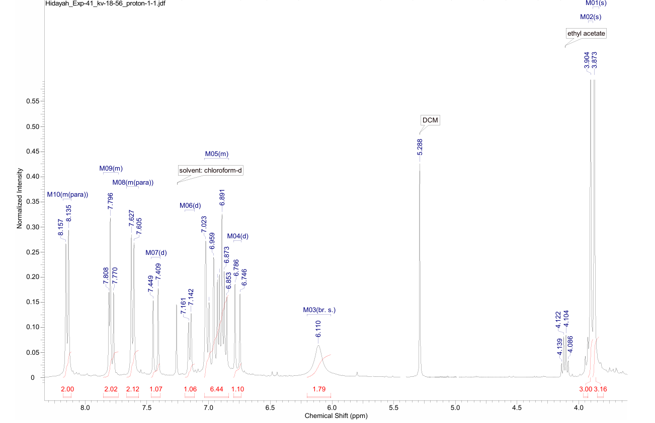
Figure S7. ¹H NMR data for the synthesised derivative 10.

Derivative 17 – 4,4'-((1E,1'E)-(1-(3-nitrophenyl)-1H-pyrazole-3,5-diyl)bis(ethene-2,1-diyl))bis(2-methoxyphenol)
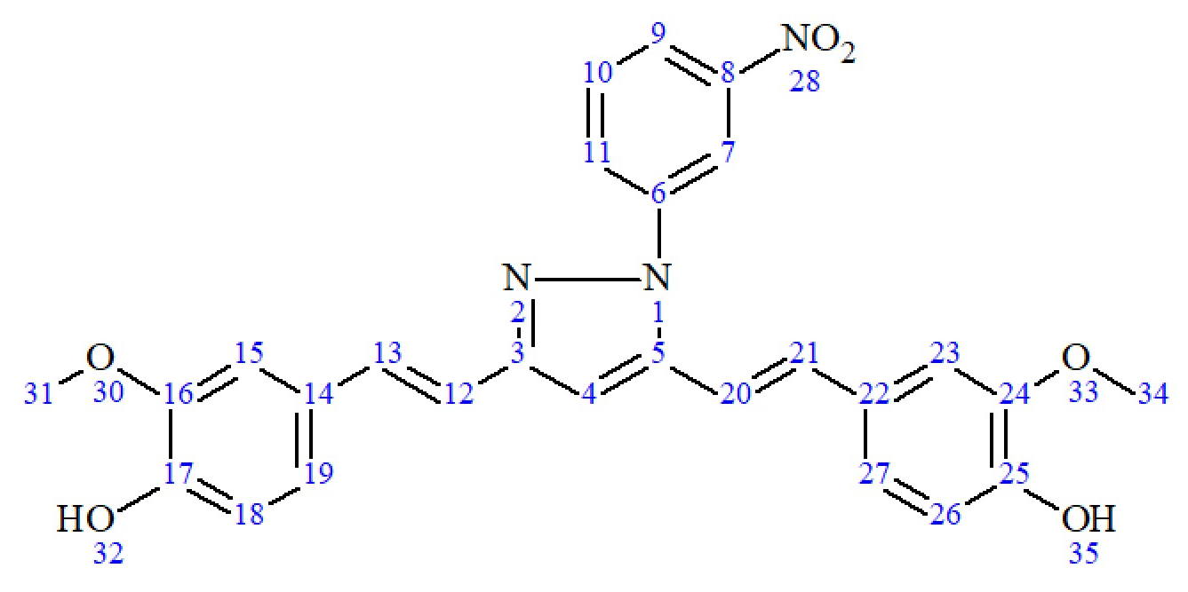
65% (brown solids), m.p.: 225–227 ℃; ¹H-NMR (400 MHz, CDCl₃, 7.26 ppm) δ (ppm): 3.912–3.945 (2s, 6H, CH₃ (31, 34)), 6.689–6.729 (d, J=16.1 Hz, 1H, C=CH (12)), 6.846 (s, 1H, C=CH (4)), 6.901–6.928 (2d, J=2.45 Hz, 2H, Ar–H (18, 26)), 6.934–6.939 (d, J=1.96 Hz, 1H, C=CH (23)), 6.970–7.039 (2dd, J=8.31, 1.96 Hz, 2H, Ar–H (19, 27)), 6.992–7.034 (d, J=16.1 Hz, 1H, Ar–H (20)),7.095–7.100 (d, J=1.96 Hz, 1H, Ar–H (15)), 7.105–7.192 (2d, J=16.4 Hz, 2H, C=CH (13, 21)), 7.670–7.711 (t, J=8.2, 1H, Ar–H (11)), 7.919–7.946 (ddd, J=8.1, 2.1, 0.9 Hz, 1H, Ar–H (9)), 8.238–8.264 (dt, J=8.3, 0.9 Hz, 1H, Ar–H (10)), 8.477–8.488 (t, J=2.1 Hz, 1H, Ar–H (7)).
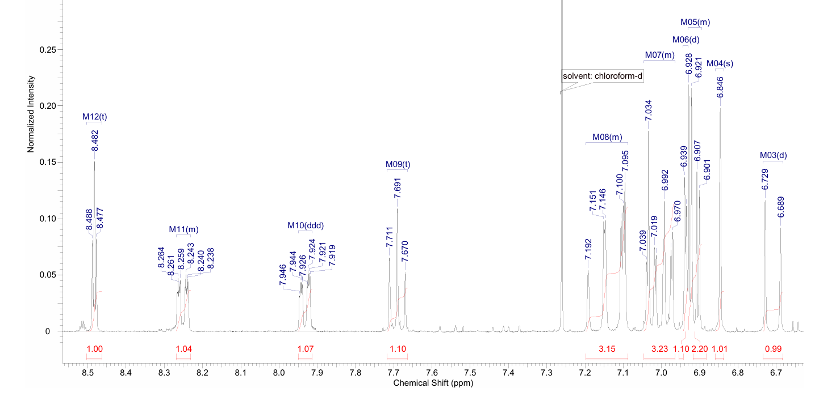
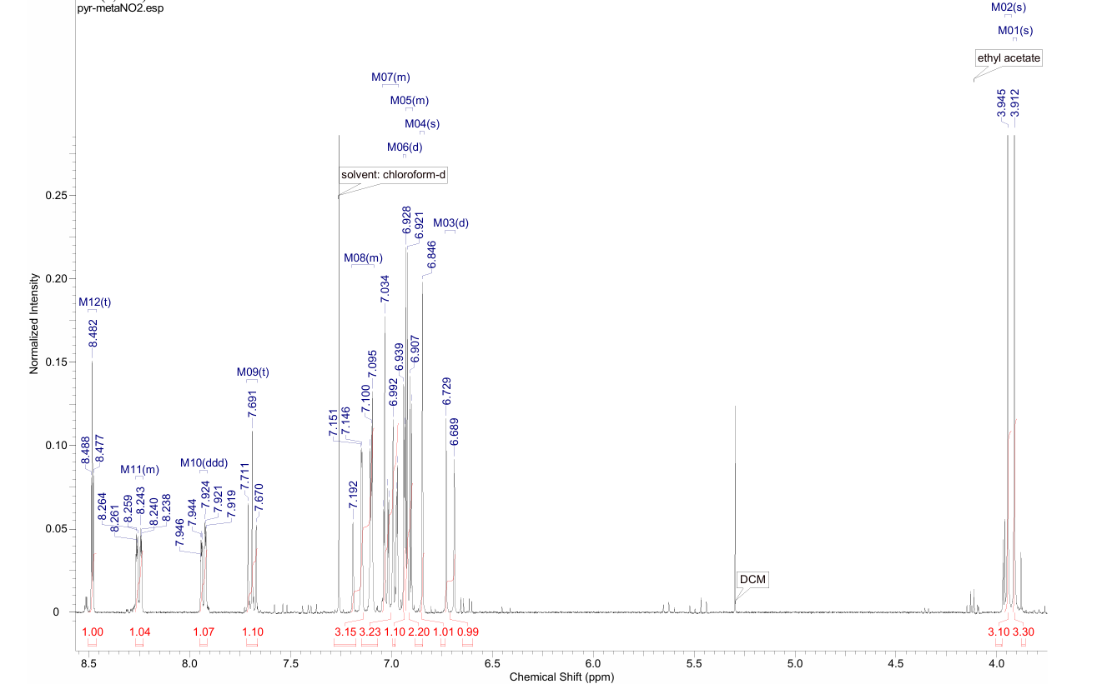
Figure S8. ¹H NMR data for the synthesised derivative 17.
Derivative 18 – 4,4'-((1E,1'E)-(1-(2,4-dichlorophenyl)-1H-pyrazole-3,5-diyl)bis(ethene-2,1-diyl))bis(2-methoxyphenol)
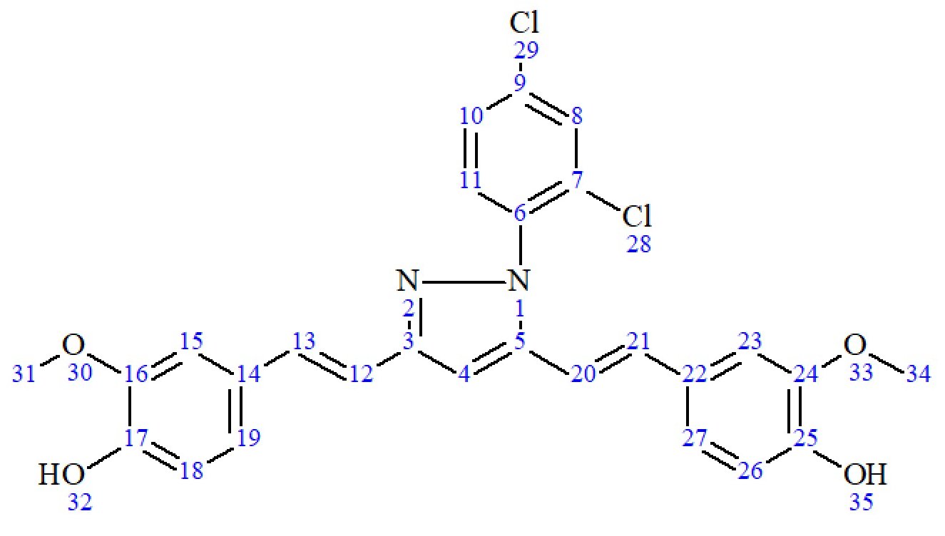
70% (brownish orange solids), m.p.: 209–212 ℃; ¹H-NMR (400 MHz, CDCl₃, 7.26 ppm) δ (ppm): 3.880–3.897 (2s, 6H, CH₃ (31, 34)), 6.312–6.352 (dd, J=16.14 0.49 Hz, 1H, C=CH (12)), 6.810 (s, 1H, C=CH (4)), 6.837–6.841 (d, J=1.71 Hz, 1H, C=H (20)), 6.857–6.904 (2d, J=11.00 Hz, 2H, Ar–H (18, 26)), 6.910–6.935, 6.983–7.008 (2dd, J=10.27, 1.47 Hz, Ar–H (19, 27)), 6.976–7.042 (2d, J=8.56 Hz, 2H, Ar–H (15, 23)), 7.058–7.063 (d, J=1.96 Hz, 1H, C=CH (13)), 7.122–7.163 (d, J=16 Hz, 1H, C=CH (21)), 7.388–7.415 (dd, J=8.56, 2.45 Hz, 1H, Ar–H (11)), 7.438–7.460 (dd, J=8.07, 0.49 Hz, 1H, Ar–H (10)), 7.584–7.591 (dd, J=2.20, 0.49 Hz, 1H, Ar–H (8)).
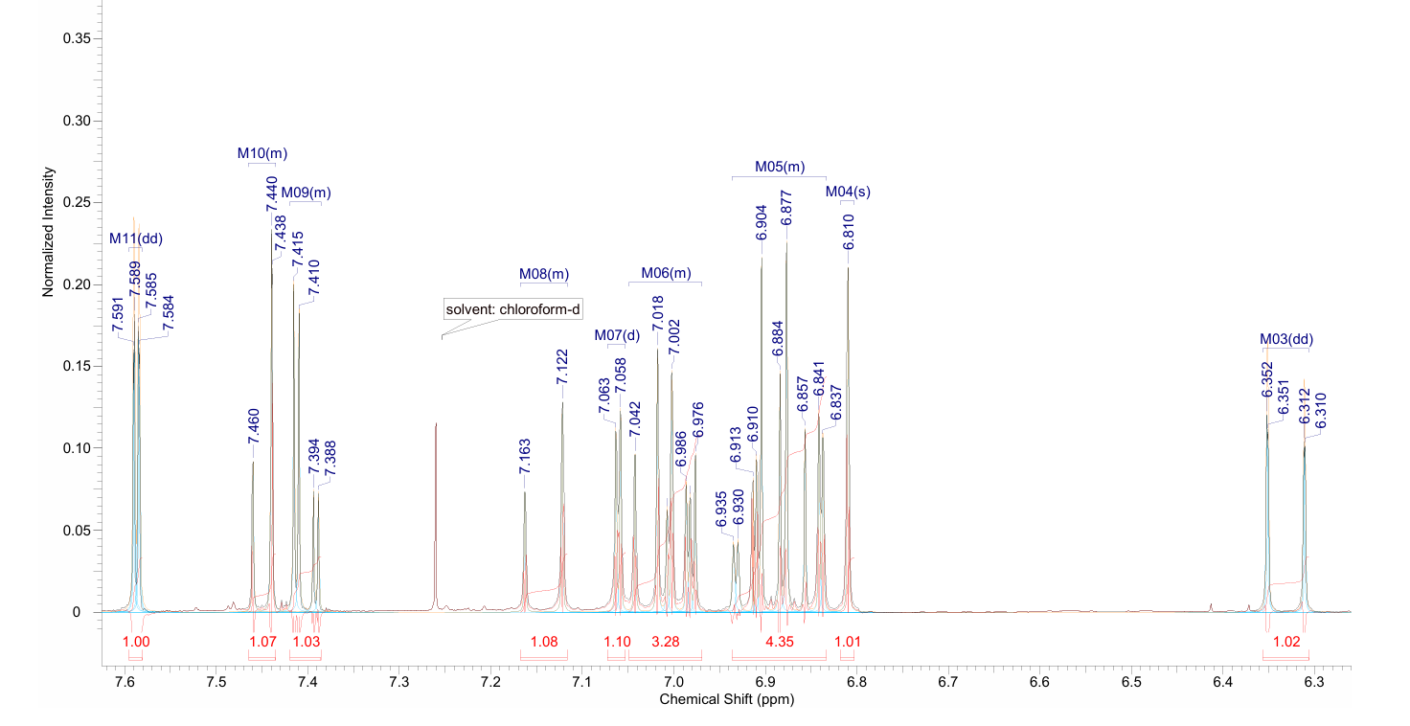
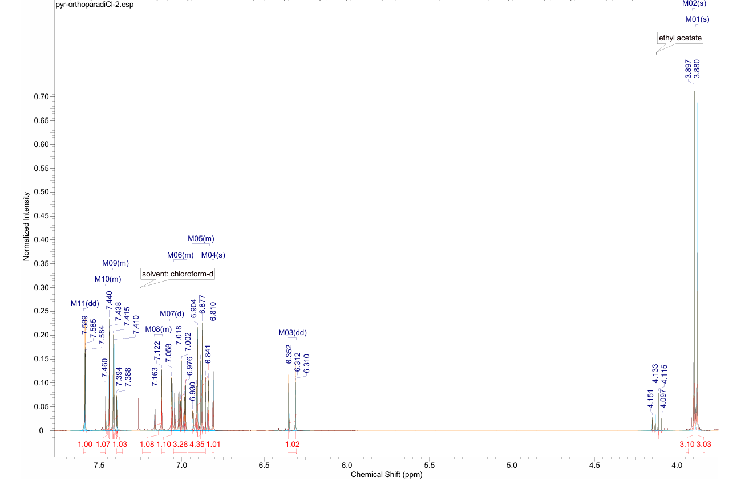
Figure S9. ¹H NMR data for the synthesised derivative 18.
Derivative 20 – (1E,4E)-1,5-bis(4-hydroxy-3-methoxyphenyl)penta-1,4-dien-3-one
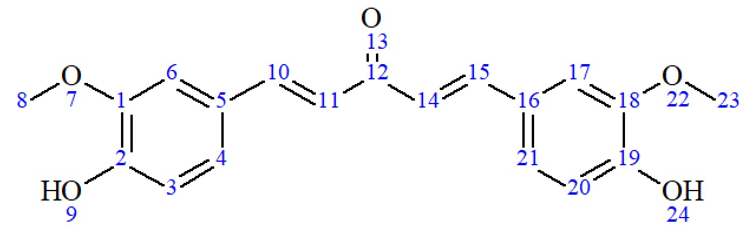
71% (pale yellow solids), m.p.: 212–213 ℃; 1H-NMR (400 MHz, CDCl3, 7.26 ppm) δ (ppm): 3.955 (s, 6H, CH3 (8, 23)), 5.967 (broad s, 2H, OH (9, 24)), 6.913–6.937 (d, J=9.62 Hz, 2H, Ar-H (3,20)), 6.956 (s, 2H, Ar-H (6, 17)), 7.11 (s, 2H, C=CH (11,14)), 7.170 - 7.192 (dd, 2H, Ar-H (4, 21)), 7.65–7.69 (2s, 2H, C=CH (10, 15)).

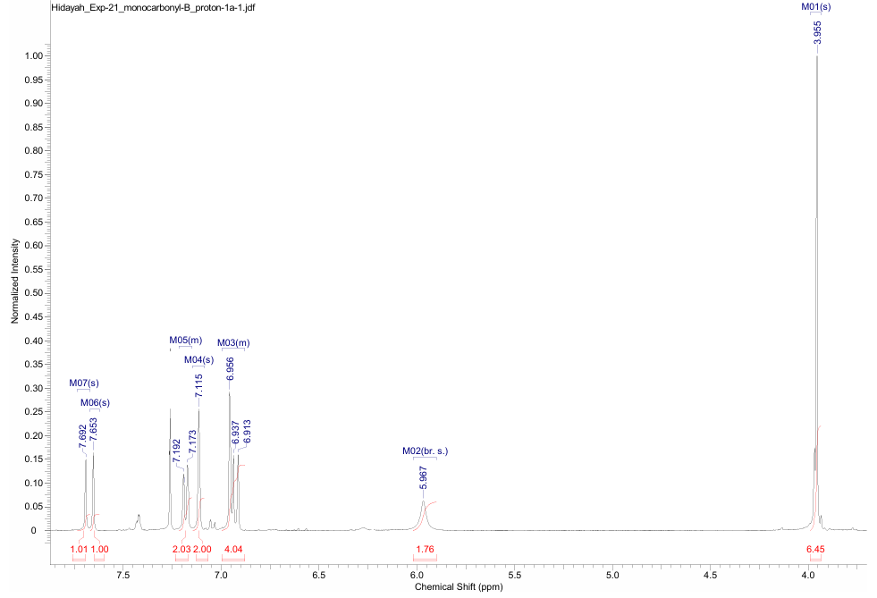
Figure S10. ¹H NMR data for the synthesised derivative 20.

Derivative 21 – (2E,5E)-2,5-bis(4-hydroxy-3-methoxybenzylidene)cyclopentanone
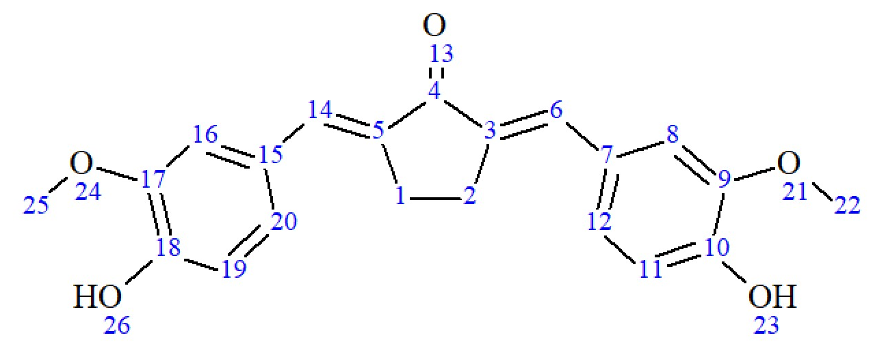
61% (greenish yellow solids), m.p.: 213–215 ℃; ¹H-NMR (400 MHz, CDCl₃, 7.26 ppm) δ (ppm): 3.093 (s, 4H, CH₂ (1, 2)), 3.939 (s, 6H, CH₃ (22, 25)), 6.262 (s, 2H, OH (23, 26)), 6.968–6.989 (d, J = 8.24 Hz, 2H, Ar-H (11, 19)), 7.101 (s, 2H, Ar-H (8, 16)), 7.181–7.202 (dd, J = 8.24 Hz, 2H, Ar-H (12, 20)), 7.520 (s, 2H, C=CH (6, 14)).
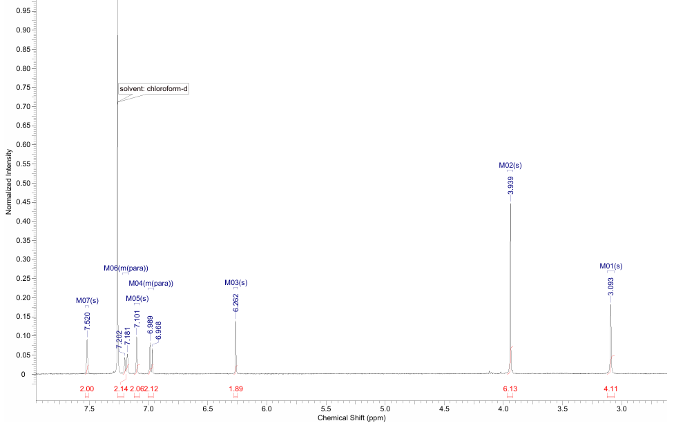
Figure S11. ¹H NMR data for the synthesised derivative 21.

Derivative 22 – (2E,6E)-2,6-bis(4-hydroxy-3-methoxybenzylidene)cyclohexanone
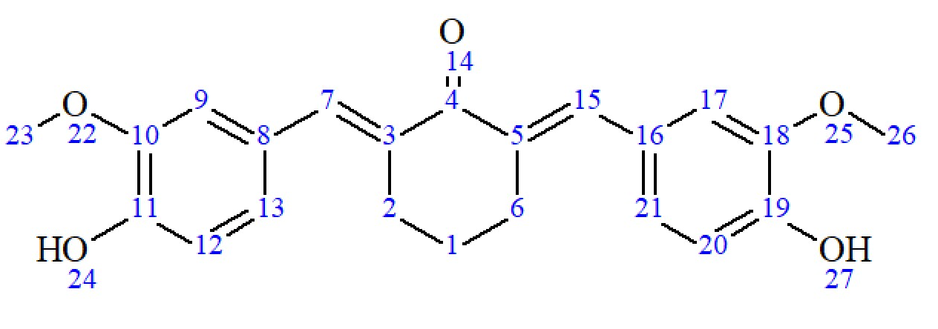
64% (greenish yellow solids), m.p.: 204–205 ℃; ¹H-NMR (400 MHz, CDCl₃, 7.26 ppm) δ (ppm): 1.782–1.845 (dt, J = 6.35, 12.48 Hz, 2H, CH₂ (1)), 2.909–2.946 (m, 4H, CH₂ (2, 6)), 3.916 (s, 6H, CH₃ (23, 26)), 5.912 (broad s, 2H, OH (24, 27)), 6.939–6.960 (d, J = 8.24 Hz, 2H, Ar-H (9, 17)), 6.987–6.992 (d, J = 1.83 Hz, 2H, Ar-H (12, 20)), 7.061–7.086 (dd, J = 1.83, 8.24 Hz, 2H, Ar-H (13, 21)), 7.74 (s, 2H, C=CH (7, 15))

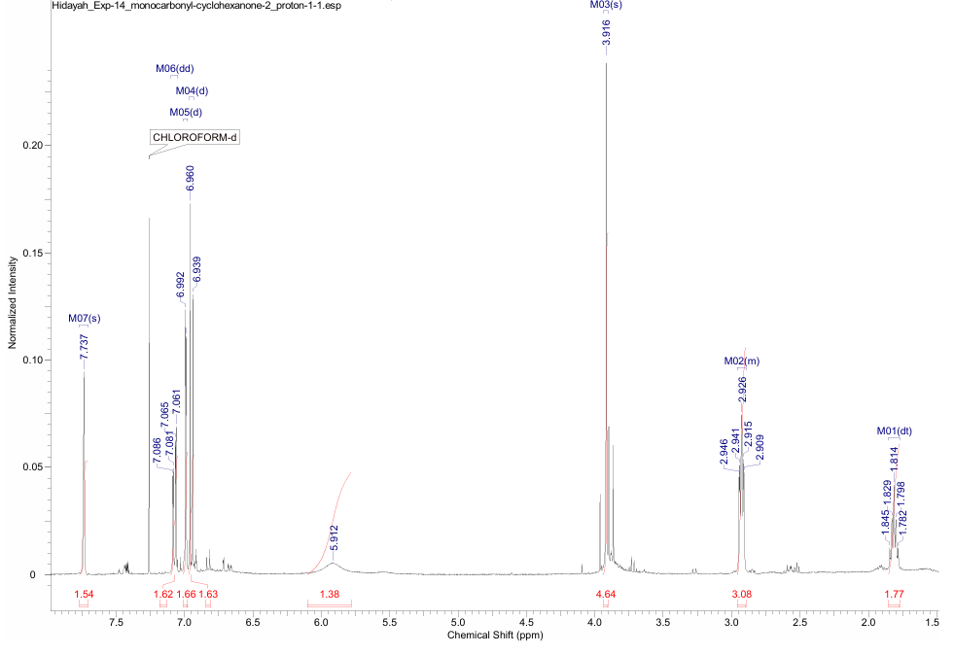
Figure S12. ¹H NMR data for the synthesised derivative 22.

Results from in vitro pLDH antiplasmodial assessments
Chloroquine against 3D7  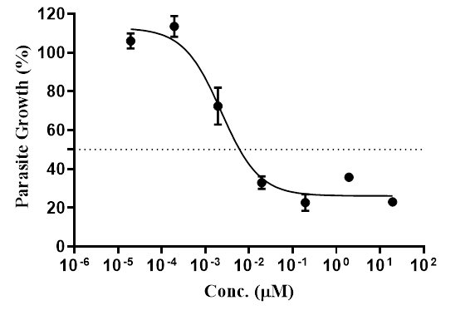 | Chloroquine against K1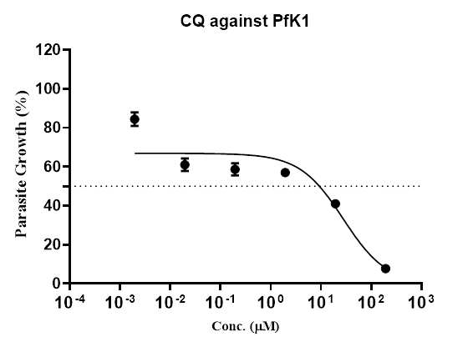
Curcumin against 3D7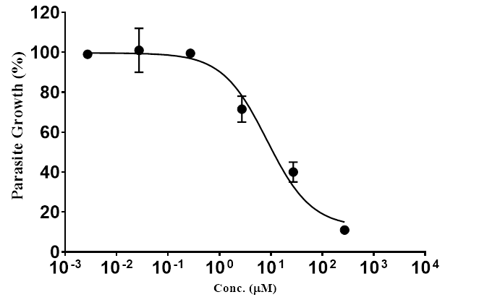 | Curcumin against K1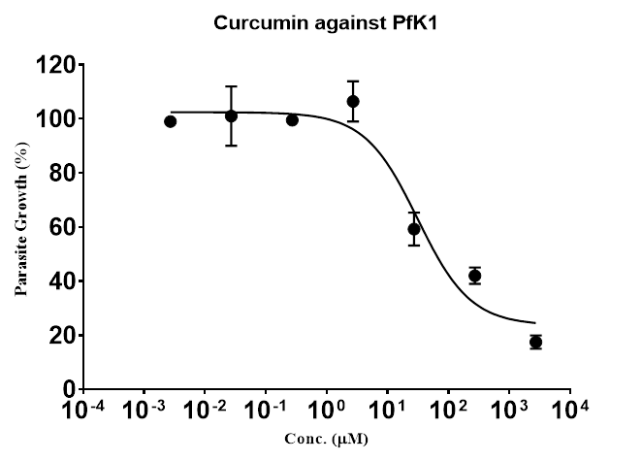
Derivative 2 against 3D7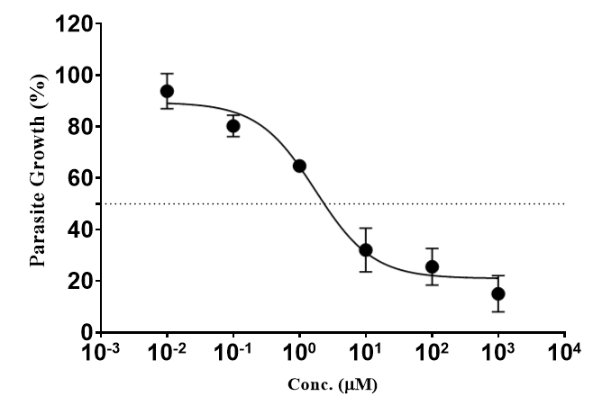 | Derivative 2 against K1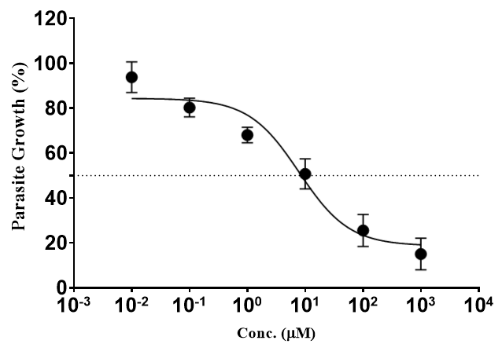
Derivative 3 against 3D7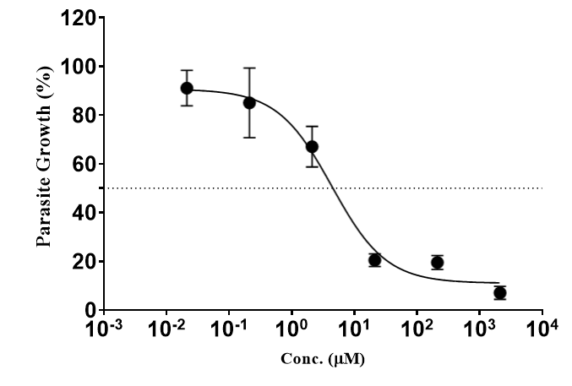 | Derivative 3 against K1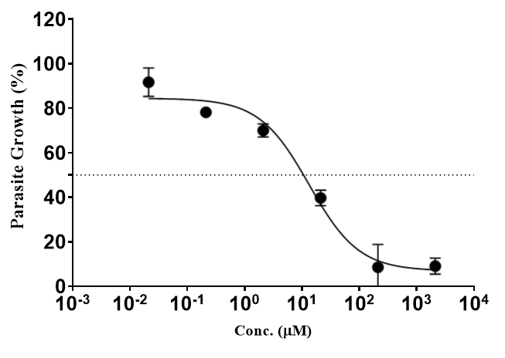
Derivative 4 against 3D7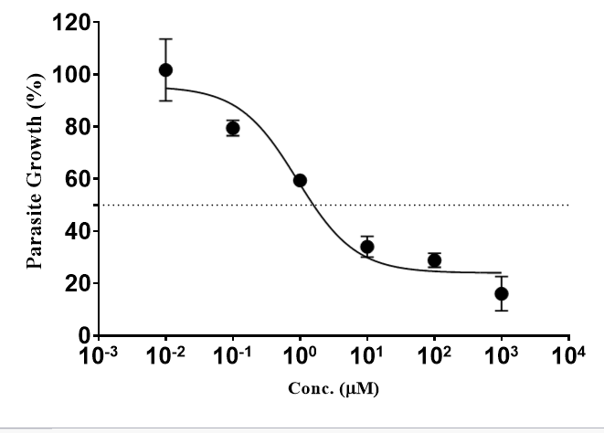 | Derivative 4 against K1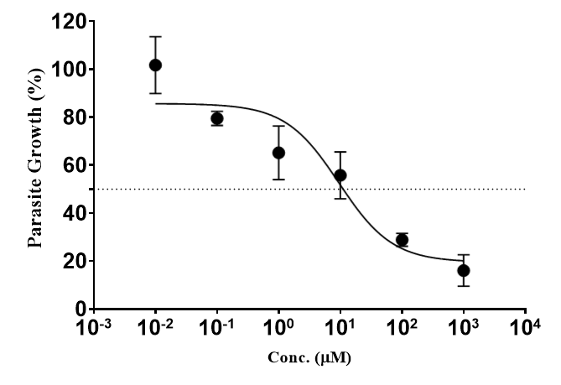
Derivative 6 against 3D7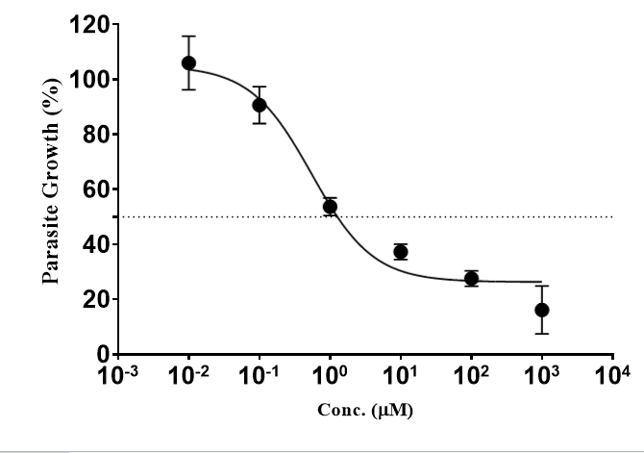 | Derivative 6 against K1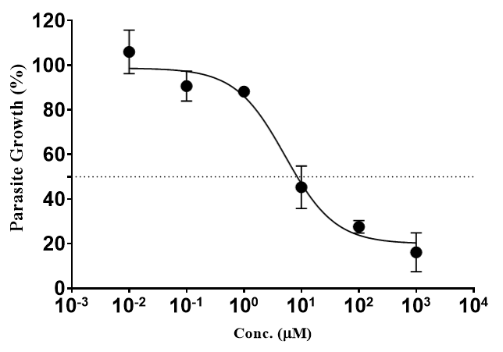
Derivative 10 against 3D7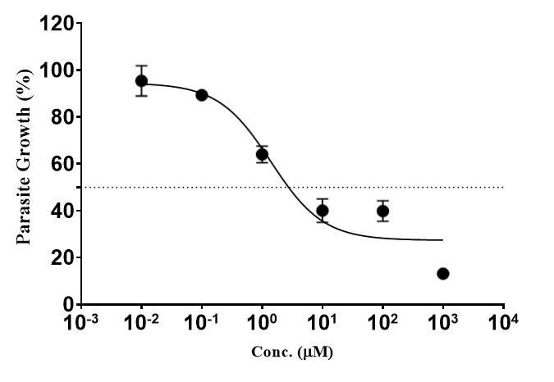 | Derivative 10 against K1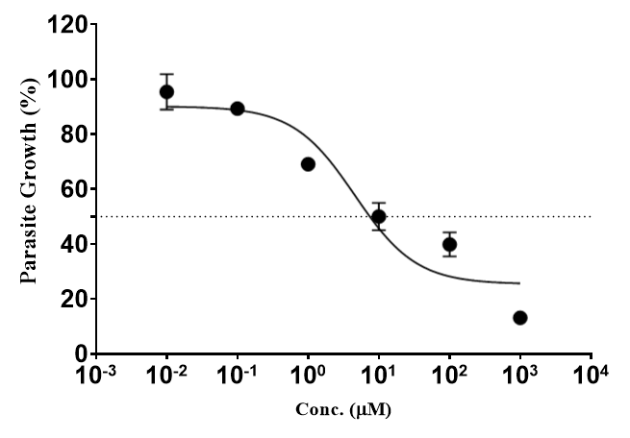
Derivative 17 against 3D7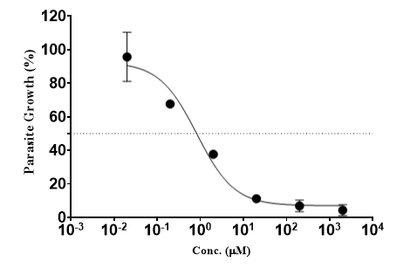 | Derivative 17 against K1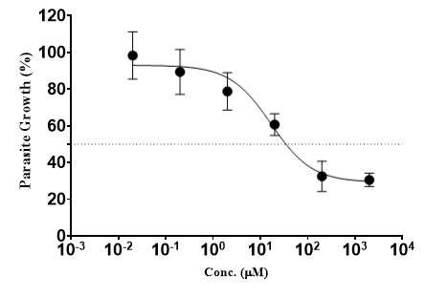
Derivative 18 against 3D7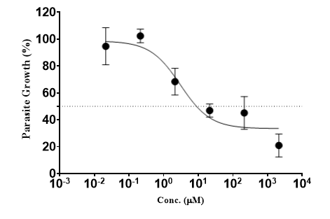 | Derivative 18 against K1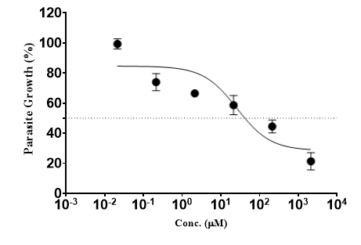
Derivative 20 against 3D7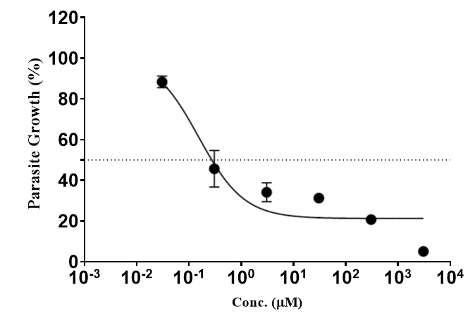 | Derivative 20 against K1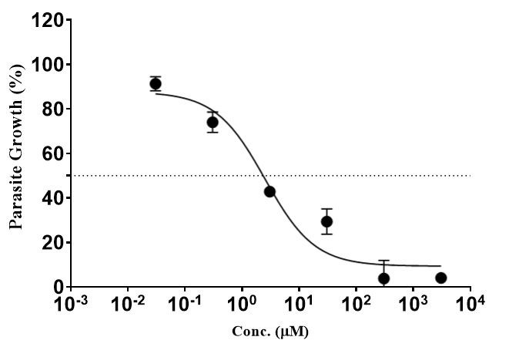
Derivative 21 against 3D7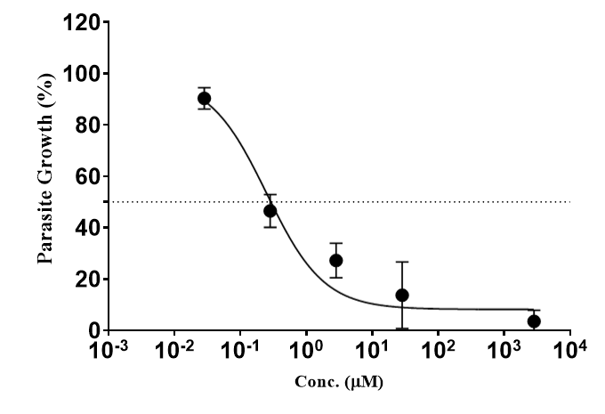 | Derivative 21 against K1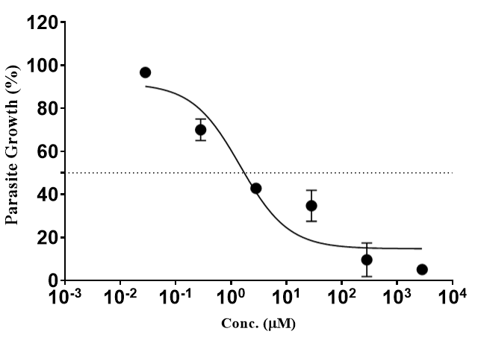
Derivative 22 against 3D7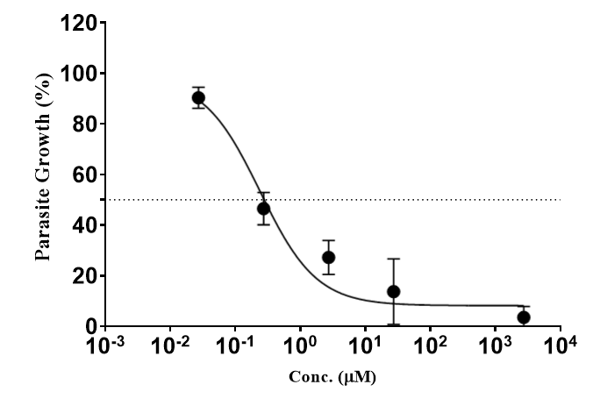 | Derivative 22 against K1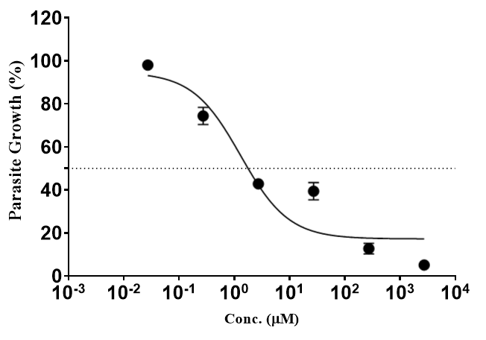
Figure S13. Figures showing the graphs of parasite growth against the concentration of compounds from pLDH assays.
Results from MTT cytotoxicity assessment
Table S3. MTT cytotoxicity data for derivative 2.
Concentration  (µg/mL) | Log (µg/mL) | Percentage (%) of Cell Viability
50.0 | 1.699 | 9.072383 | 9.585629 | 9.759227
25.0 | 1.398 | 9.359197 | 9.162956 | 9.208242
12.5 | 1.097 | 9.291267 | 9.766775 | 9.110122
6.25 | 0.799 | 10.29512 | 11.05744 | 10.72534
3.2 | 0.505 | 9.819609 | 10.04604 | 10.41588
1.6 | 0.204 | 10.76308 | 10.43852 | 10.70269
0.8 | -0.0969 | 10.81591 | 10.58948 | 11.18575
0.4 | -0.398 | 12.09148 | 12.44622 | 11.90279
0.2 | -0.699 | 12.64246 | 13.15571 | 11.31406

Figure S14. Figures showing the graphs of cell viability against log of concentration of derivative 2 from WRL-68 assay.

Table S4. MTT cytotoxicity data for derivative 3.
Concentration  (µg/mL) | Log (µg/mL) | Percentage (%) of Cell Viability
99.0 | 1.996 | 82.53506 | 82.18557 | 82.36031
49.5 | 1.695 | 80.31696 | 87.33908 | 83.82802
24.8 | 1.394 | 77.15918 | 79.82769 | 78.49344
12.4 | 1.093 | 89.41911 | 83.05709 | 86.2381
6.2 | 0.792 | 81.88995 | 89.40247 | 85.64621
3.1 | 0.491 | 88.93897 | 93.97099 | 91.45498
1.55 | 0.190 | 108.8459 | 99.2797 | 104.0628
0.77 | -0.114 | 104.9929 | 99.61399 | 102.3035
0.39 | -0.409 | 115.8242 | 103.0245 | 109.4243

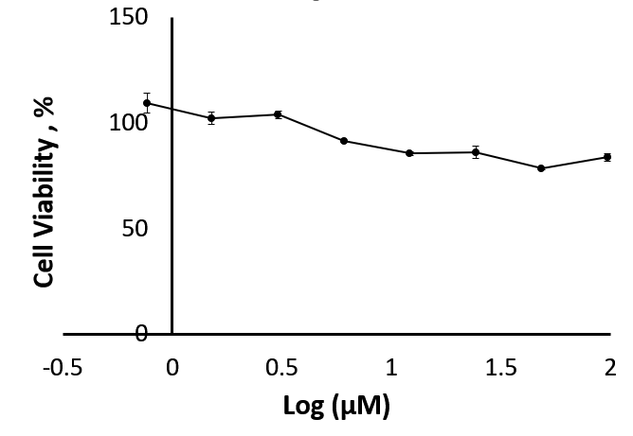
Figure S15. Figures showing the graphs of cell viability against log of concentration of derivative 3 from WRL-68 assay.

Table S5. MTT cytotoxicity data for derivative 4.
Concentration  (µg/mL) | Log (µg/mL) | Percentage (%) of Cell Viability
50.0 | 1.699 | 10.98371 | 11.02063 | 9.839193
25.0 | 1.398 | 9.974566 | 10.64528 | 9.728433
12.5 | 1.097 | 10.34377 | 10.9591 | 10.34992
6.25 | 0.799 | 10.2207 | 11.20523 | 12.02363
3.2 | 0.505 | 10.30685 | 12.15285 | 11.51905
1.6 | 0.204 | 11.48829 | 12.83587 | 11.80211
0.8 | -0.0969 | 12.09747 | 15.80178 | 12.04209
0.4 | -0.398 | 21.75821 | 19.48148 | 26.31169
0.2 | -0.699 | 48.65447 | 42.0827 | 45.59011

Figure S16. Figures showing the graphs of cell viability against log of concentration of derivative 4 from WRL-68 assay.

Table S6. MTT cytotoxicity data for derivative 6.
Concentration  (µg/mL) | Log (µg/mL) | Percentage (%) of Cell Viability
50.0 | 1.699 | 6.267621 | 6.484494 | 5.677727
25.0 | 1.398 | 5.19627 | 5.135545 | 5.217957
12.5 | 1.097 | 5.322056 | 5.630015 | 5.612665
6.25 | 0.799 | 5.812188 | 5.968337 | 5.36543
3.2 | 0.505 | 6.974626 | 6.653654 | 6.766428
1.6 | 0.204 | 7.013663 | 12.12318 | 7.278248
0.8 | -0.0969 | 9.650835 | 12.73043 | 9.14769
0.4 | -0.398 | 15.7146 | 16.23075 | 13.04706
0.2 | -0.699 | 26.85318 | 35.7493 | 33.04272

Figure S17. Figures showing the graphs of cell viability against log of concentration of derivative 6 from WRL-68 assay.

Table S7. MTT cytotoxicity data for derivative 10.
Concentration  (µg/mL) | Log (µg/mL) | Percentage (%) of Cell Viability
50.0 | 1.699 | 22.97457 | 23.5068 | 23.35896
25.0 | 1.398 | 22.98936 | 23.71378 | 22.22058
12.5 | 1.097 | 23.25547 | 24.36428 | 24.46777
6.25 | 0.799 | 23.81727 | 24.0686 | 22.88587
3.2 | 0.505 | 25.96097 | 26.34536 | 27.32111
1.6 | 0.204 | 28.01597 | 28.93258 | 27.66115
0.8 | -0.0969 | 28.356 | 28.68125 | 28.59255
0.4 | -0.398 | 31.84506 | 33.85571 | 35.37847
0.2 | -0.699 | 44.23418 | 40.81904 | 41.01124

Figure S18. Figures showing the graphs of cell viability against log of concentration of derivative 10 from WRL-68 assay.

Table S8. MTT cytotoxicity data for derivative 17.
Concentration  (µg/mL) | Log (µg/mL) | Percentage (%) of Cell Viability
99.0 | 1.996 | 80.30588 | 82.18557 | 81.24572
49.5 | 1.695 | 82.58138 | 87.33908 | 84.96023
24.8 | 1.394 | 81.16328 | 79.82769 | 80.49548
12.4 | 1.093 | 90.09949 | 83.05709 | 86.57829
6.2 | 0.792 | 91.57649 | 89.40247 | 90.48948
3.1 | 0.491 | 94.15525 | 93.97099 | 94.06312
1.55 | 0.190 | 94.94939 | 99.2797 | 97.11455
0.77 | -0.114 | 106.8461 | 99.61399 | 103.2301
0.39 | -0.409 | 114.661 | 103.0245 | 108.8427

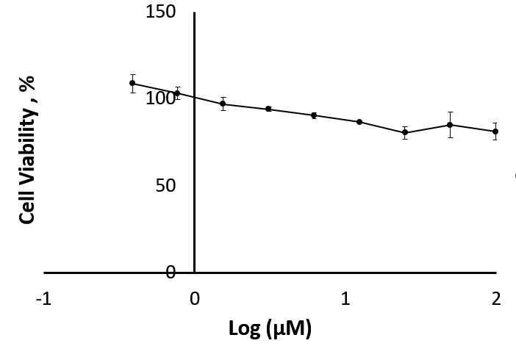
Figure S19. Figures showing the graphs of cell viability against log of concentration of derivative 17 from WRL-68 assay.

Table S9. MTT cytotoxicity data for derivative 18.
Concentration  (µg/mL) | Log (µg/mL) | Percentage (%) of Cell Viability
99.0 | 1.996 | 82.53506 | 94.59166 | 88.56336
49.5 | 1.695 | 80.31696 | 98.61904 | 89.468
24.8 | 1.394 | 77.15918 | 85.65303 | 81.4061
12.4 | 1.093 | 89.41911 | 87.86537 | 88.64224
6.2 | 0.792 | 81.88995 | 86.19386 | 84.0419
3.1 | 0.491 | 88.93897 | 91.99076 | 90.46486
1.55 | 0.190 | 108.8459 | 99.87048 | 104.3582
0.77 | -0.114 | 104.9929 | 96.13715 | 100.565
0.39 | -0.409 | 115.8242 | 103.1435 | 109.4838

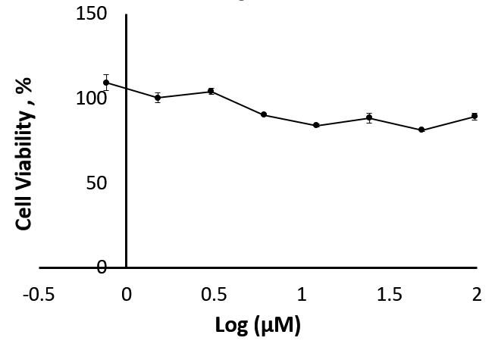
Figure S20. Figures showing the graphs of cell viability against log of concentration of derivative 18 from WRL-68 assay.

Table S10. MTT cytotoxicity data for derivative 20.
Concentration  (µg/mL) | Log (µg/mL) | Percentage (%) of Cell Viability
50.0 | 1.699 | 9.681929 | 9.635331 | 9.391989
25.0 | 1.398 | 9.930449 | 9.412699 | 9.319504
12.5 | 1.097 | 10.78991 | 9.547314 | 9.712994
6.25 | 0.799 | 10.89864 | 9.635331 | 9.951159
3.2 | 0.505 | 11.46817 | 10.53622 | 10.67083
1.6 | 0.204 | 27.02656 | 23.77509 | 29.55836
0.8 | -0.0969 | 84.01015 | 84.25867 | 84.04639
0.4 | -0.398 | 89.26531 | 91.97315 | 85.38219
0.2 | -0.699 | 93.50569 | 96.05302 | 92.85332

Figure S21. Figures showing the graphs of cell viability against log of concentration of derivative 20 from WRL-68 assay.

Table S11. MTT cytotoxicity data for derivative 21.
Concentration  (µg/mL) | Log (µg/mL) | Percentage (%) of Cell Viability
50.0 | 1.699 | 13.40775 | 14.13001 | 14.50427
25.0 | 1.398 | 13.75575 | 13.83454 | 14.28102
12.5 | 1.097 | 13.92646 | 14.15627 | 13.29613
6.25 | 0.799 | 15.56796 | 19.40906 | 13.42745
3.2 | 0.505 | 19.78332 | 20.28234 | 22.17991
1.6 | 0.204 | 39.86868 | 41.19501 | 34.50427
0.8 | -0.0969 | 55.96848 | 48.54235 | 51.66776
0.4 | -0.398 | 62.00263 | 54.97702 | 53.79514
0.2 | -0.699 | 70.72226 | 66.57255 | 64.93762

Figure S22. Figures showing the graphs of cell viability against log of concentration of derivative 21 from WRL-68 assay.

Table S12. MTT cytotoxicity data for derivative 22.
Concentration  (µg/mL) | Log (µg/mL) | Percentage (%) of Cell Viability
50.0 | 1.699 | 8.844359 | 8.799747 | 7.92981
25.0 | 1.398 | 10.23849 | 9.033961 | 9.184527
12.5 | 1.097 | 9.703143 | 9.006078 | 9.128762
6.25 | 0.799 | 9.217986 | 8.582263 | 8.007881
3.2 | 0.505 | 27.16322 | 24.38612 | 25.09434
1.6 | 0.204 | 63.17081 | 79.52116 | 82.84477
0.8 | -0.0969 | 90.75227 | 95.65403 | 94.19856
0.4 | -0.398 | 97.07605 | 96.62435 | 102.6135
0.2 | -0.699 | 101.1079 | 103.9519 | 105.7308

Figure S23. Figures showing the graphs of cell viability against log of concentration of derivative 22 from WRL-68 assay.

Results of ITC haemin binding assessments
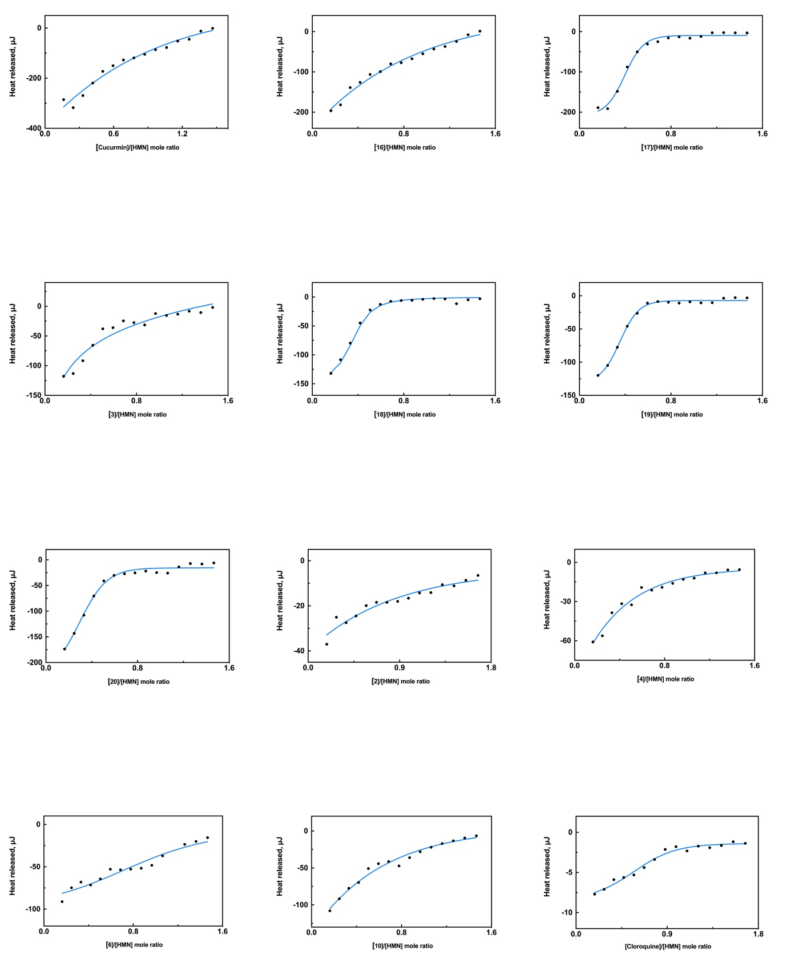  [Chloroquine]/[HMN] mole ratio | [Curcumin]/[HMN] mole ratio
[1]/[HMN] mole ratio | [2]/[HMN] mole ratio
[3]/[HMN] mole ratio | [4]/[HMN] mole ratio
[5]/[HMN] mole ratio | [6]/[HMN] mole ratio
[7]/[HMN] mole ratio | [8]/[HMN] mole ratio
[9]/[HMN] mole ratio | [10]/[HMN] mole ratio
Figure S24. Isothermal titration calorimetry profiles of the interaction between (A) HMN with antimalarial compounds were acquired in a 10 mM sodium phosphate buffer (pH 7.4) at 37 °C.

Results from in vitro yeast-based GSK-3β inhibition
We used a previously developed yeast-based assay with a temperature-sensitive strain expressing human GSK-3. This yeast cannot grow at 37 °C without functional GSK-3, but grows normally at 28 °C. When a GSK-3 inhibitor is present, growth at 37 °C is reduced, resulting in a larger zone of inhibition compared to 28 °C. In our experiment, none of the test compounds showed inhibitory activities, as no zones of inhibition were observed for all compounds except for derivative 20. The positive control, TDZD-8 showed clear GSK-3β inhibition, with a zone of 18.00 ± 1.66 mm at 37 °C and 16.67 ± 1.41 mm at 28 °C.
Table S13. Observation on the zone of inhibition produced by derivative 20, the only active compound identified in this study
Monocarbonyl curcumin derivative 20
28 ℃ |  |  | 37 ℃
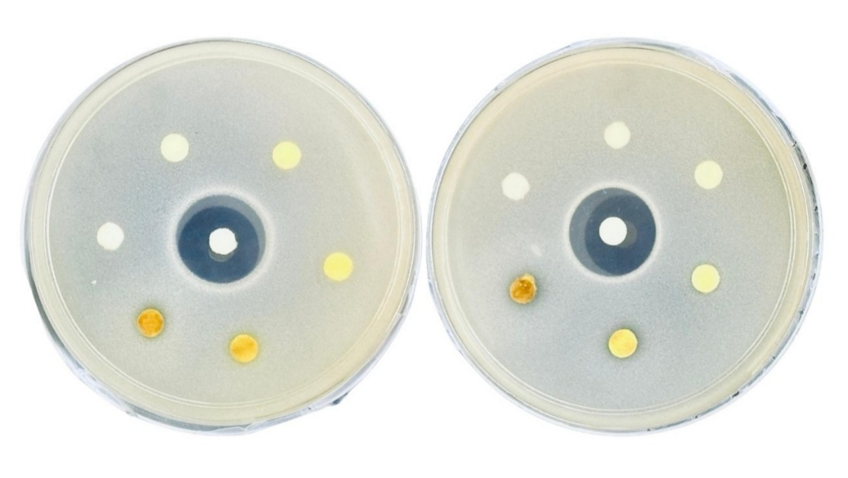
Position | Sample | Inhibition zone, mm |  |  | Remarks
Position | Sample | 28 ℃ |  | 37 ℃ | Remarks
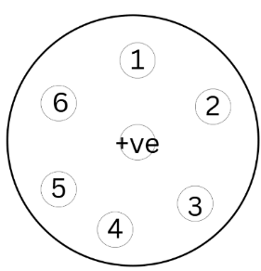 | 1) 0.0002 M | 7.50±0.71 |  | 8.00±0.00 | Selective inhibition of GSK-3β at 0.02 M
 | 2) 0.002 M | 7.00±0.00 (p) |  | 8.00±0.00 | Selective inhibition of GSK-3β at 0.02 M
 | 3) 0.02 M | 0.00±0.00 |  | 7.00±0.00 | Selective inhibition of GSK-3β at 0.02 M
 | 4) 0.05 M | 0.00±0.00 |  | 0.00±0.00 | Selective inhibition of GSK-3β at 0.02 M
 | 5) 0.5 M | 0.00±0.00 |  | 0.00±0.00 | Selective inhibition of GSK-3β at 0.02 M
 | 6) DMSO | 0.00±0.00 |  | 0.00±0.00 | Selective inhibition of GSK-3β at 0.02 M
 | (+ve) TDZD-8  (0.02 M) | 16.67±1.41 |  | 18.00±1.66 | Non-selective inhibition of GSK-3β
Note: (p) = Partial inhibition

