SUPPLEMENTARY MATERIAL

SELECTIVE ELECTROCHEMICAL SENSOR FOR BPA DETECTION IN WASTEWATER USING MOLECULARLY IMPRINTED POLYMERS ON SUSTAINABLE MAGNETIC GRAPHENE OXIDE
† Pablo Montoro-Lealª, † Maria Mar Lopez-Guerrero^{b,c}, † Lourdes Mena-Herrera^{c,d,e}, Elisa Vereda-Alonso^{b,c}, Antonio Ruiz-Sanchez^{b,c*}, Rebeca Jimenez-Perez^{b,c*}
ªRegional Institute for Applied Scientific Research (IRICA), University of Castilla-La Mancha, Ciudad Real, Spain.
^{b}Department of Analytical Chemistry, University of Malaga, Malaga, Spain.
^{c}Instituto Universitario de Materiales y Nanotecnología (IMANA), University of Malaga, Malaga, Spain.
^{d}Department of Organic Chemistry, University of Malaga, Malaga, Spain.
^{e}IBIMA, Plataforma Bionand, Parque Tecnologico de Andalucia, Malaga, Spain.

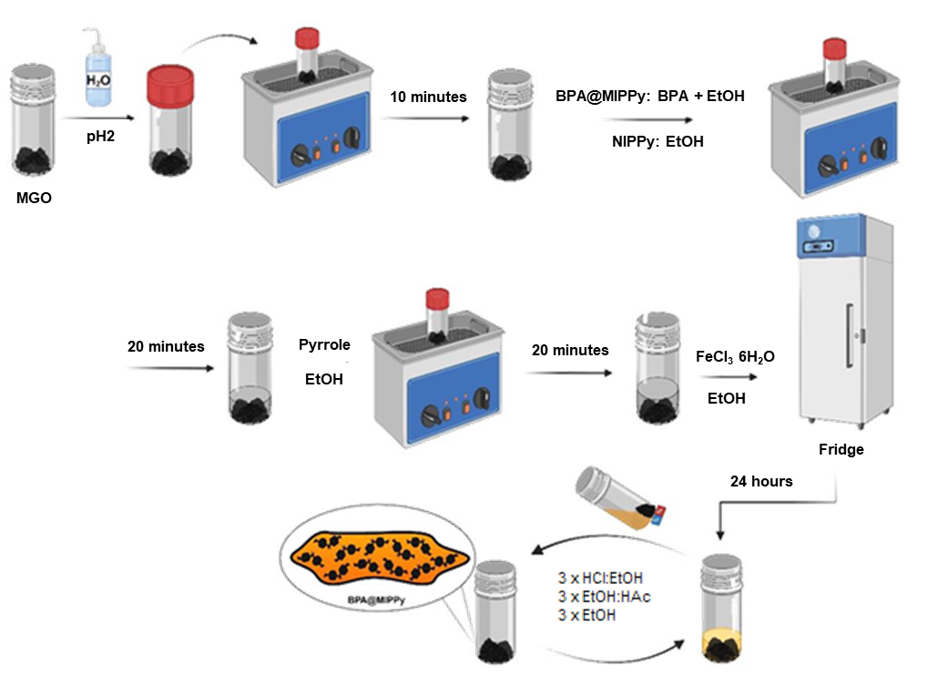
Figure S1. Synthesis of BPA@MIPPy and NIPPy
Table S1. Optimized parameters for the electrode surface modification
Parameters
pH | 0.5 | 1 | 2 | 3 | 4
µL of deposited material | 2.5 | 5 | 10 | 25 | -
Nº of layers (each 2.5 µL) | 1 | 2 | 3 | 5 | 7
µL Pyrrole/mL EtOH | 5 | 14 | 25 | 50 | 100
mg BPA/2.5 mL EtOH | 5.0 | 8.0 | 37.5 | 75 | 125
* The optimal values are highlighted in green.

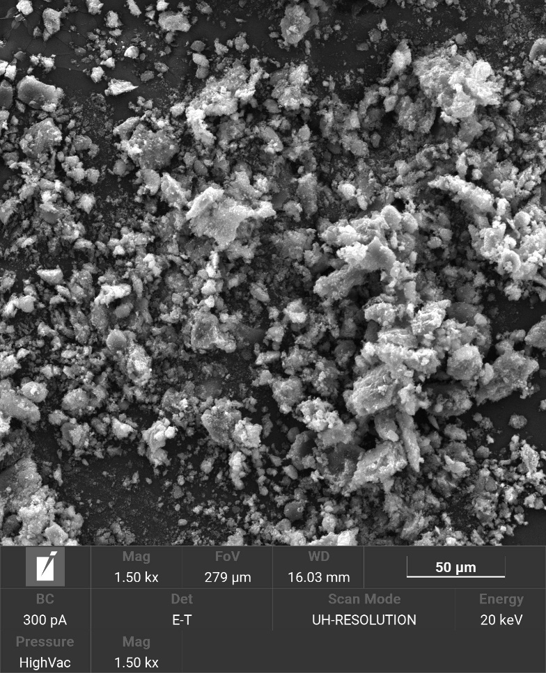A) | 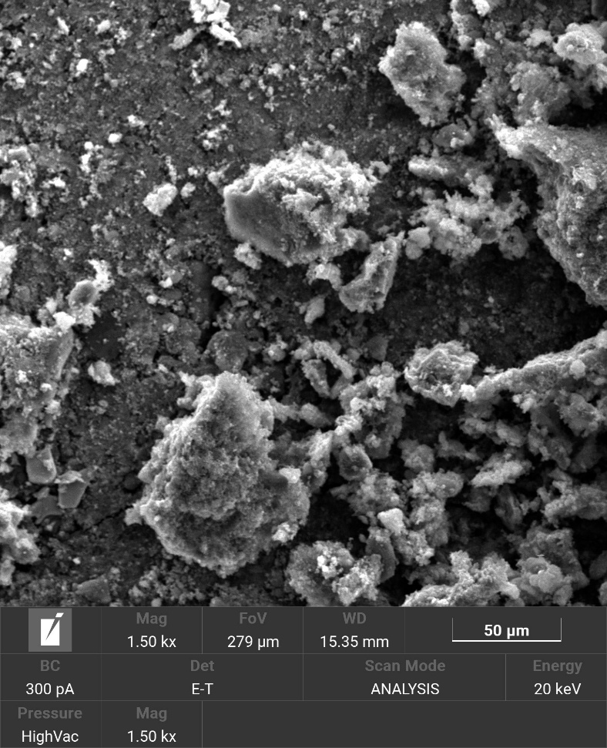B) | 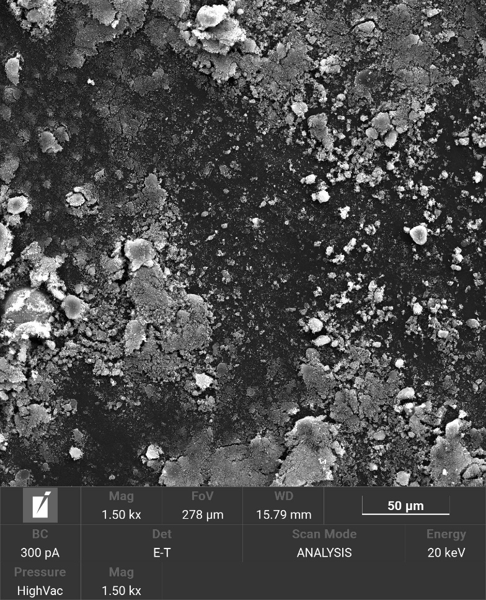C)
Figure S2. SEM images of A) MGO, B) BPA@MIPPy and C) NIPPy with a scale of 50 μm

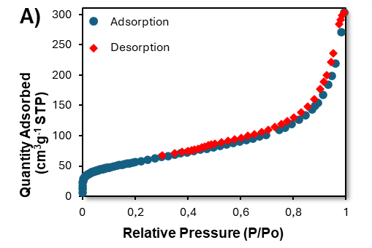
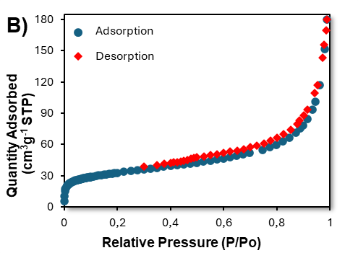 | 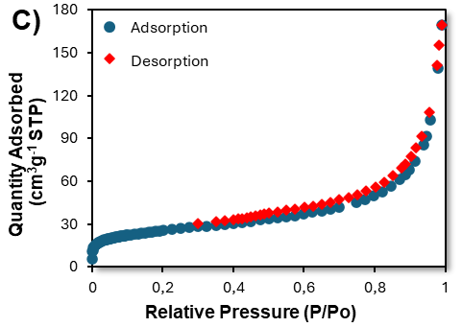
Figure S3. Nitrogen adsorption isotherm of materials synthesized A) MGO, B) BPA@MIPPy and C) NIPPy. (adsorption blue line, desorption red line)

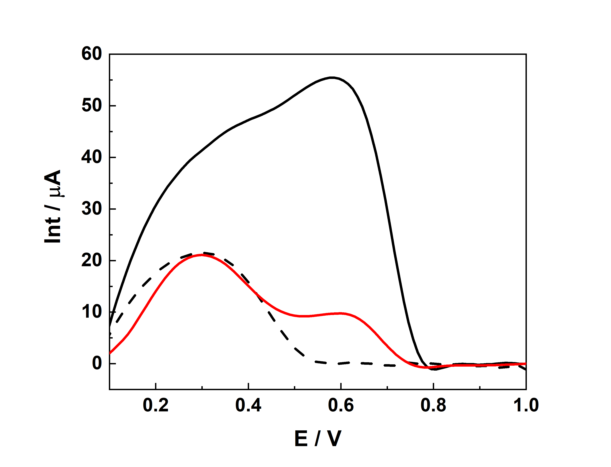
Figure S4. Differential pulse voltammetry of a) 0.1 M PB solution on BPA@MIPPy (dashed line); b) 5 μM BPA in 0.1 M PB solution on NIPPy (red line); c) 5 μM BPA in 0.1 M PB solution on BPA@MIPPy (black line).
Table S2. Comparative analysis of the electroanalytical performance of BPA@MIPPy for BPA detection in relation to other reported electrochemical (bio)sensors.
Electrode | Technique | Linear range µM | Limit of Detection (LOD) / µM | Limit of Quantification (LOQ) / µM | Ref.
POSS-OH/GCE  POSS-SH/GCE  POSS-vinyl/GCE | DPV | 0.749 – 7.49  0.749 – 8.99  0.749 – 7.49 | 3.97  0.14  0.08 | 13.23  0.46  0.27 | [1]
CB/AuSNPs/SNGCE | DPV | 0.5 – 15 | 0.06 | 0.20 | [2]
CAS-CB/GCE | LS | 0.49 – 24 | 0.25 | 0.83 | [3]
GO/FeNps | SWV | 15.0 – 120.0 | 12.05 | 36.51 | [4]
TETA-MWCNTs/GCE | SWV | 1.0 – 30 | 0.35 | 1.17 | [5]
Graphene/GCE | CV | 0.05 – 1 | 0.04 | 0.13 | [6]
Lac/Ag – ZnO/MWCNTs/CSPE | DPV | 0.5 – 2.99 | 0.06 | 0.20 | [7]
Carbon felt | CV | 10–150 | 0.55 | 1.83 | [8]
CB/μPAD | SWV | 0.1–0.9 | 0.030 | 0.10 | [9]
BPA@MIPPy | DPV | 0.1 – 5 | 0.029 | 0.097 | This Work

Table S3. Recovery analysis of BPA in real wastewater using BPA@MIPPy sensor.
Sample Condition | Added BPA (μM) | Measured Total BPA (μM) | Expected BPA (μM) | Recovery (%) | Relative Error (%)
Unspiked wastewater | 0 | 0.171 | — | — | —
Spiked wastewater | 2.000 | 2.195 | 2.171 | 101.1 | 1.7

[1] D. Ananthakrishnan, H. Venkatesvaran, A. Kannan, S. Gandhi, Simplistic one-pot synthesis of an inorganic–organic cubic caged material: a new interface for detecting toxic bisphenol-A electrochemically, New Journal of Chemistry 44 (2020) 20192–20202. https://doi.org/10.1039/D0NJ05142J.
[2] S. Jebril, L. Cubillana-Aguilera, J.M. Palacios-Santander, C. Dridi, A novel electrochemical sensor modified with green gold sononanoparticles and carbon black nanocomposite for bisphenol A detection, Materials Science and Engineering: B 264 (2021) 114951. https://doi.org/10.1016/j.mseb.2020.114951.
[3] L. Vieira Jodar, L.O. Orzari, T. Storti Ortolani, M.H.M.T. Assumpção, F.C. Vicentini, B.C. Janegitz, Electrochemical Sensor Based on Casein and Carbon Black for Bisphenol A Detection, Electroanalysis 31 (2019) 2162–2170. https://doi.org/10.1002/elan.201900176.
[4] S. Piña, P. Sepúlveda, A. García-García, A. Moreno-Bárcenas, C. Toledo-Neira, R. Salazar-González, Fast simultaneous electrochemical detection of Bisphenol-A and Bisphenol-S in urban wastewater using a graphene oxide-iron nanoparticles hybrid sensor, Electrochim Acta 468 (2023) 143164. https://doi.org/10.1016/j.electacta.2023.143164.
[5] M. Çakıcı, A.A. Avan, H. Filik, E. Kök Yetimoğlu, Individual and Simultaneous Electrochemical Detection of Bisphenol A and Bisphenol S in Food Samples Using Triethylenetetramine Functionalized Multi-Walled Carbon Nanotubes, Food Anal Methods 16 (2023) 225–237. https://doi.org/10.1007/s12161-022-02409-w.
[6] B. Ntsendwana, B.B. Mamba, S. Sampath, O.A. Arotiba, Electrochemical Detection of Bisphenol A Using Graphene-Modified Glassy Carbon Electrod, Int J Electrochem Sci 7 (2012) 3501–3512. https://doi.org/10.1016/S1452-3981(23)13972-1.
[7] K. Kunene, M. Sabela, S. Kanchi, K. Bisetty, High Performance Electrochemical Biosensor for Bisphenol A Using Screen Printed Electrodes Modified with Multiwalled Carbon Nanotubes Functionalized with Silver-Doped Zinc Oxide, Waste Biomass Valorization 11 (2020) 1085–1096. https://doi.org/10.1007/s12649-018-0505-5.
[8] M. Kim, Y.E. Song, J.-Q. Xiong, K.-Y. Kim, M. Jang, B.-H. Jeon, J.R. Kim, Electrochemical detection and simultaneous removal of endocrine disruptor, bisphenol A using a carbon felt electrode, Journal of Electroanalytical Chemistry 880 (2021) 114907. https://doi.org/10.1016/j.jelechem.2020.114907.
[9] D. Jemmeli, E. Marcoccio, D. Moscone, C. Dridi, F. Arduini, Highly sensitive paper-based electrochemical sensor for reagent free detection of bisphenol A, Talanta 216 (2020) 120924. https://doi.org/10.1016/j.talanta.2020.120924.

