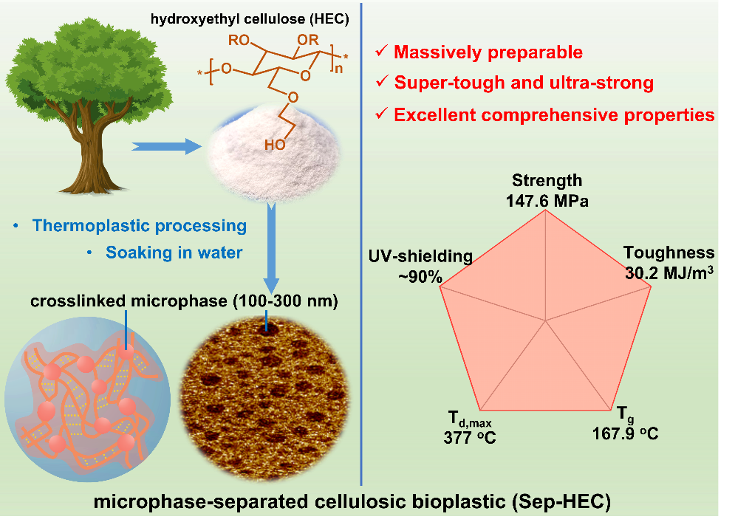
A microphase separation strategy is proposed to prepare high-performance sustainable cellulose-based bioplastics. The microphase separation structure can be constructed massively, and enables the cellulosic bioplastic to possess ultra-high strength (147.6±9.6 MPa), super toughness (30.2±2.1 MJ/m³), high transparency, excellent UV-shielding effect, excellent heat resistance and good solvent resistance. This work will promote the substitution of petroleum-based plastics by sustainable cellulosic bioplastics with endless sources.

