Supporting Information
Massively Preparable, Super-tough and Ultra-strong Cellulose-based Bioplastics Enabled by Microphase Separation
Xuhui Zhang, Bohan Lv, Chongyang Li, Hang Chen, Chunyi Gu, Jing Huang, Ting Li, Shibo Wang, Weifu Dong*
The Key Laboratory of Synthetic and Biological Colloids, Ministry of Education, School of Chemical and Material Engineering, Jiangnan University, 1800 Lihu Road, Wuxi 214122, China
*E-mail: wfdong@jiangnan.edu.cn

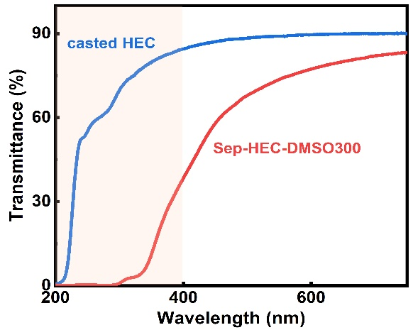
Figure S1. The UV-Vis transmittance spectra of casted HEC and Sep-HEC-DMSO300 to show the excellent UV shielding capability of Sep-HEC-DMSO300.

Figure S2. The dependence of weight (A) and derivative weight (B) on temperature for casted HEC and Sep-HEC-DMSO300 to show the high decomposing temperature of Sep-HEC-DMSO300.
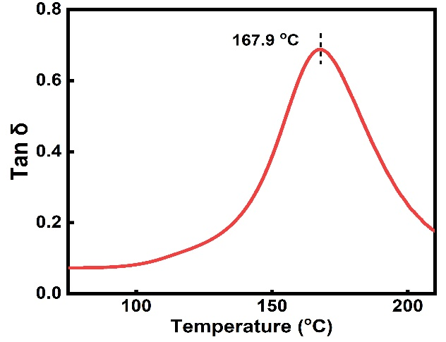
Figure S3. The relationship curve between tanδ and temperature for Sep-HEC-DMSO300 to show the high T_{g}.
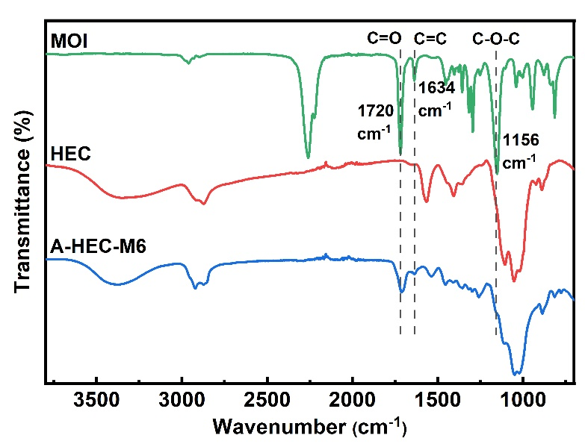
Figure S4. FTIR spectra of MOI, HEC and A-HEC-M6. A-HEC-M6 refers to HEC modified by MOI with a content of 6 mol% of the hydroxyl group in HEC.
Figure S5. FTIR spectra of PETMP, A-HEC-M6 and crosslinked HEC-M6/P6.
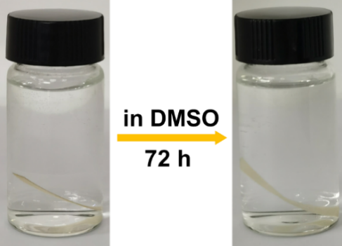
Figure S6. The images of C-HEC-M2/P2 before and after being soaked in DMSO.
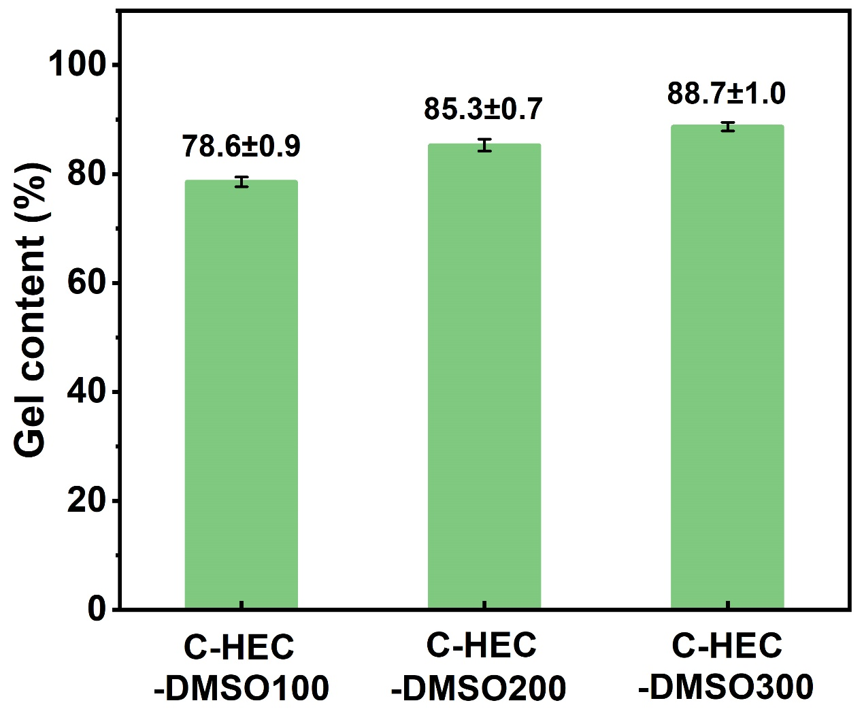
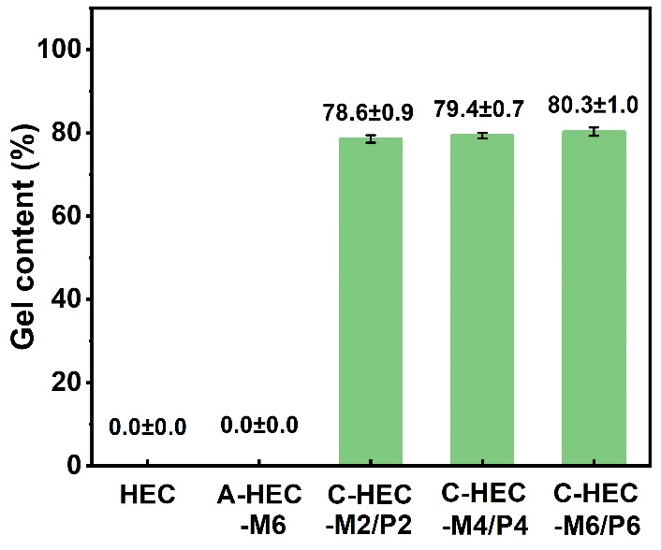
Figure S7. Gel content of HEC, A-HEC-M6 and C-HECs with different crosslinker contents. Herein, Mx represents the molar percentage of MOI to the hydroxyl groups in HEC while Py represents the molar percentage of thiol in PETMP to the hydroxyl groups in HEC. When not specifically emphasized, the amount of added DMSO is 100 wt% of the of HEC, nominated as DMSO100.
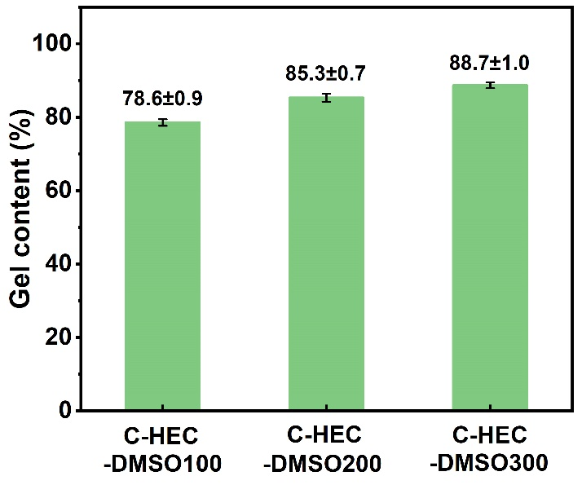
Figure S8. Gel content of C-HEC with various DMSO content. Both the content of MOI and thiols in PETMP are 2 mol% of the hydroxyl groups in HEC for different samples.
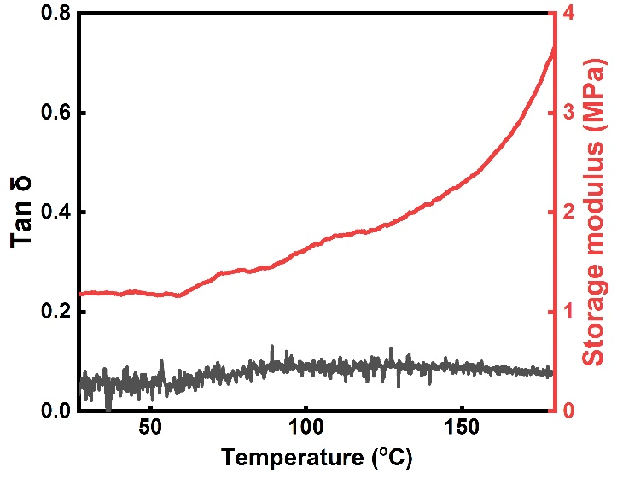
Figure S9. The dependence of tanδ and E’ on the temperature for C-HEC-M2/P2 with 100 wt% DMSO.
The low tanδ and low E’ indicate the rubber-like state and high movability of HEC chain-segment at temperature above 25 ºC. The slightly increased E’ should be attributed to the volatilization of DMSO. Since the molting point of DMSO is 18.4 ºC, it is hard to accurately measure the T_{g} of C-HEC-M2/P2 with 100 wt% DMSO, which should be lower than 18.4 ºC.

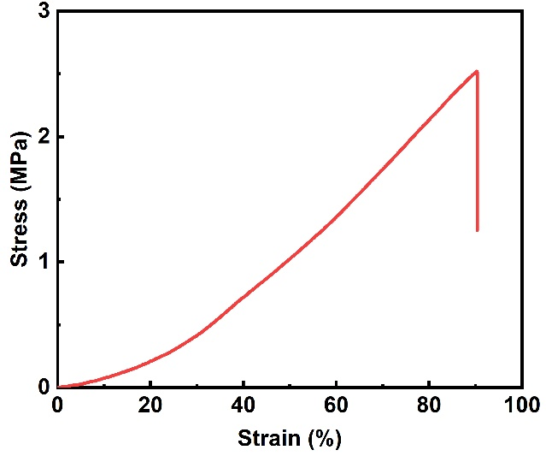
Figure S10. The stress-strain curve of C-HEC-M2/P2 with 100 wt% DMSO.
The low young’s modulus (550±47 kPa) and high elongation at break (90.5±4.1%) indicate the high movability of HEC chain-segment.

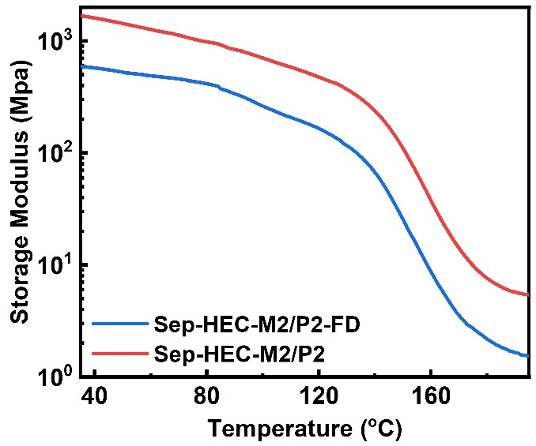
Figure S11. The relationship curves between storage modulus (E’) and temperature for Sep-HEC-M2/P2-FD and Sep-HEC-M2/P2.

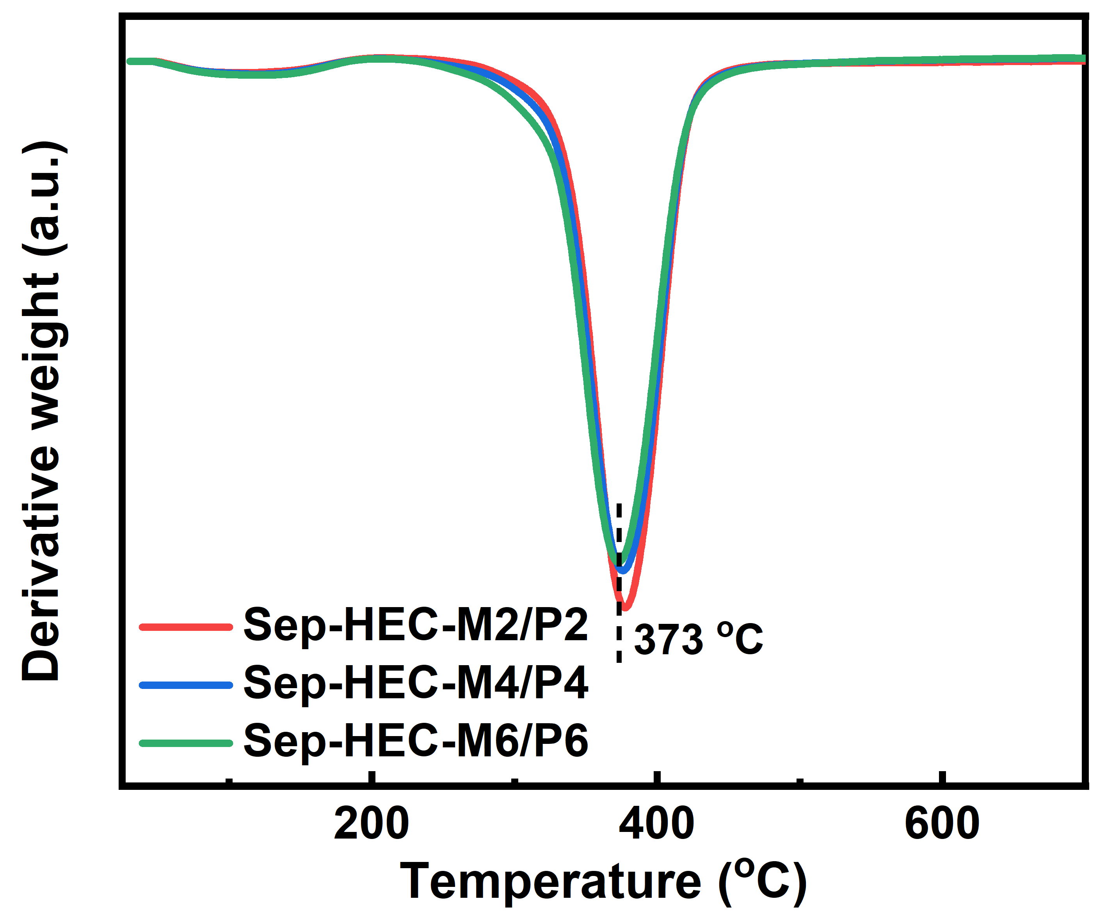
Figure S12. The dependence of derivative weight on temperature for Sep-HEC with various crosslinker content.

Table S1. Detailed mechanical properties of casted HEC and various Sep-HECs
Sample | Young’s  Modulus  (MPa) | Tensile  Strength  (MPa) | Elongation  at Break  (%) | Toughness  (MJ/m³)
casted HEC | 520±32 | 19.8±1.1 | 9.3±0.5 | 1.3±0.1
Sep-HEC-M2/P2 | 1450±84 | 100.1±8.7 | 39.4±2.3 | 28.2±1.8
Sep-HEC-M4/P4 | 1080±66 | 81.6±5.2 | 45.4±2.8 | 26.6±1.7
Sep-HEC-M6/P6 | 910±58 | 74.0±4.6 | 54.5±2.2 | 28.3±1.2
Sep-HEC-DMSO100 | 1450±84 | 100.1±8.7 | 39.4±2.3 | 28.2±1.8
Sep-HEC-DMSO200 | 1680±71 | 122.3±7.4 | 33.1±2.5 | 28.5±1.6
Sep-HEC-DMSO300 | 2330±116 | 147.6±9.6 | 30.9±1.8 | 30.2±2.1

