Comparison and Interpretation of Characteristics of Rhizosphere Microbiomes of Three Blueberry Varieties

Yan Zhang¹, Wei Wang¹, Zhangjun Shen¹, Jingjing Wang¹, Yajun Chen¹, Dong Wang¹, Gang Liu², Maozhen Han^{2*}

¹ School of Life Sciences, Hefei Normal University, Hefei, Anhui 230601, China.
² School of Life Sciences, Anhui Medical University, Hefei, Anhui 230032, China.
* Corresponding author E-mail: hanmz@ahmu.edu.cn

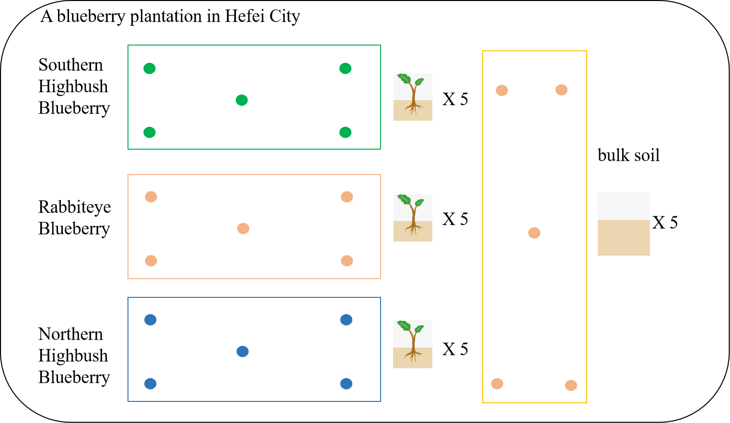
Supplementary Figure 1. Sampling schematic for collecting the rhizosphere soil samples of three blueberry varieties and bulk soil samples.
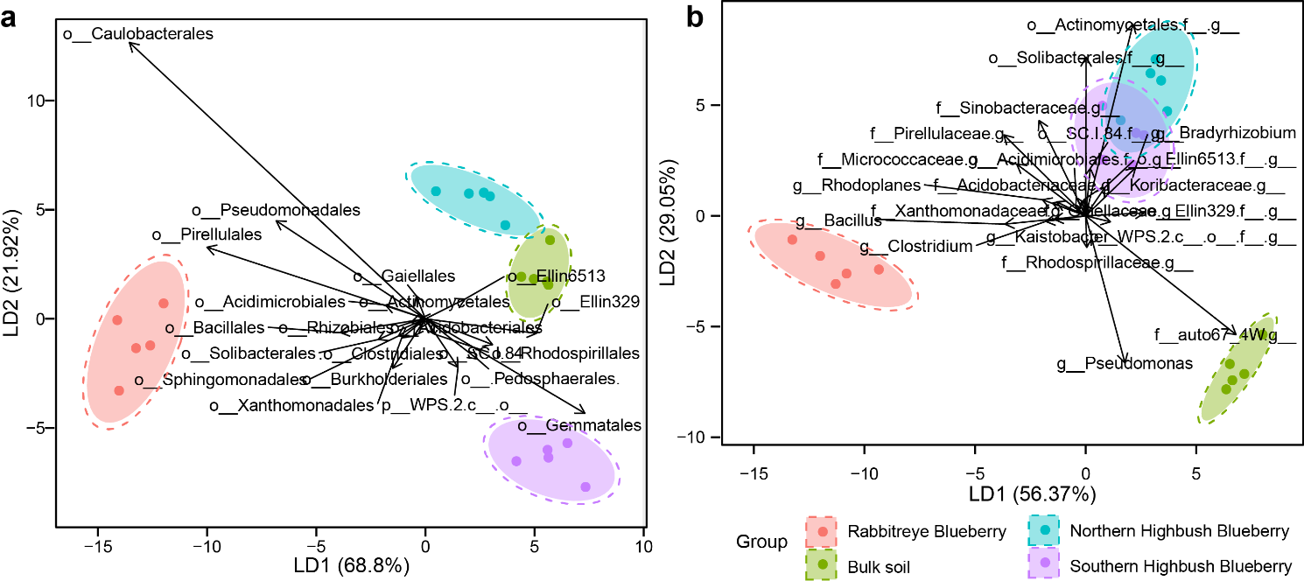
Supplementary Figure 2. Taxonomical composition of rhizosphere microbial communities in three blueberry varieties at the order and genus levels. Linear discriminant analysis was performed to maximize the separation of the rhizosphere microbial communities of three blueberry varieties and bulk soil based on the taxonomical composition at a: the order level and b: the genus level. The length and direction of the arrows represent the normalized scaling for each predominant phylum.

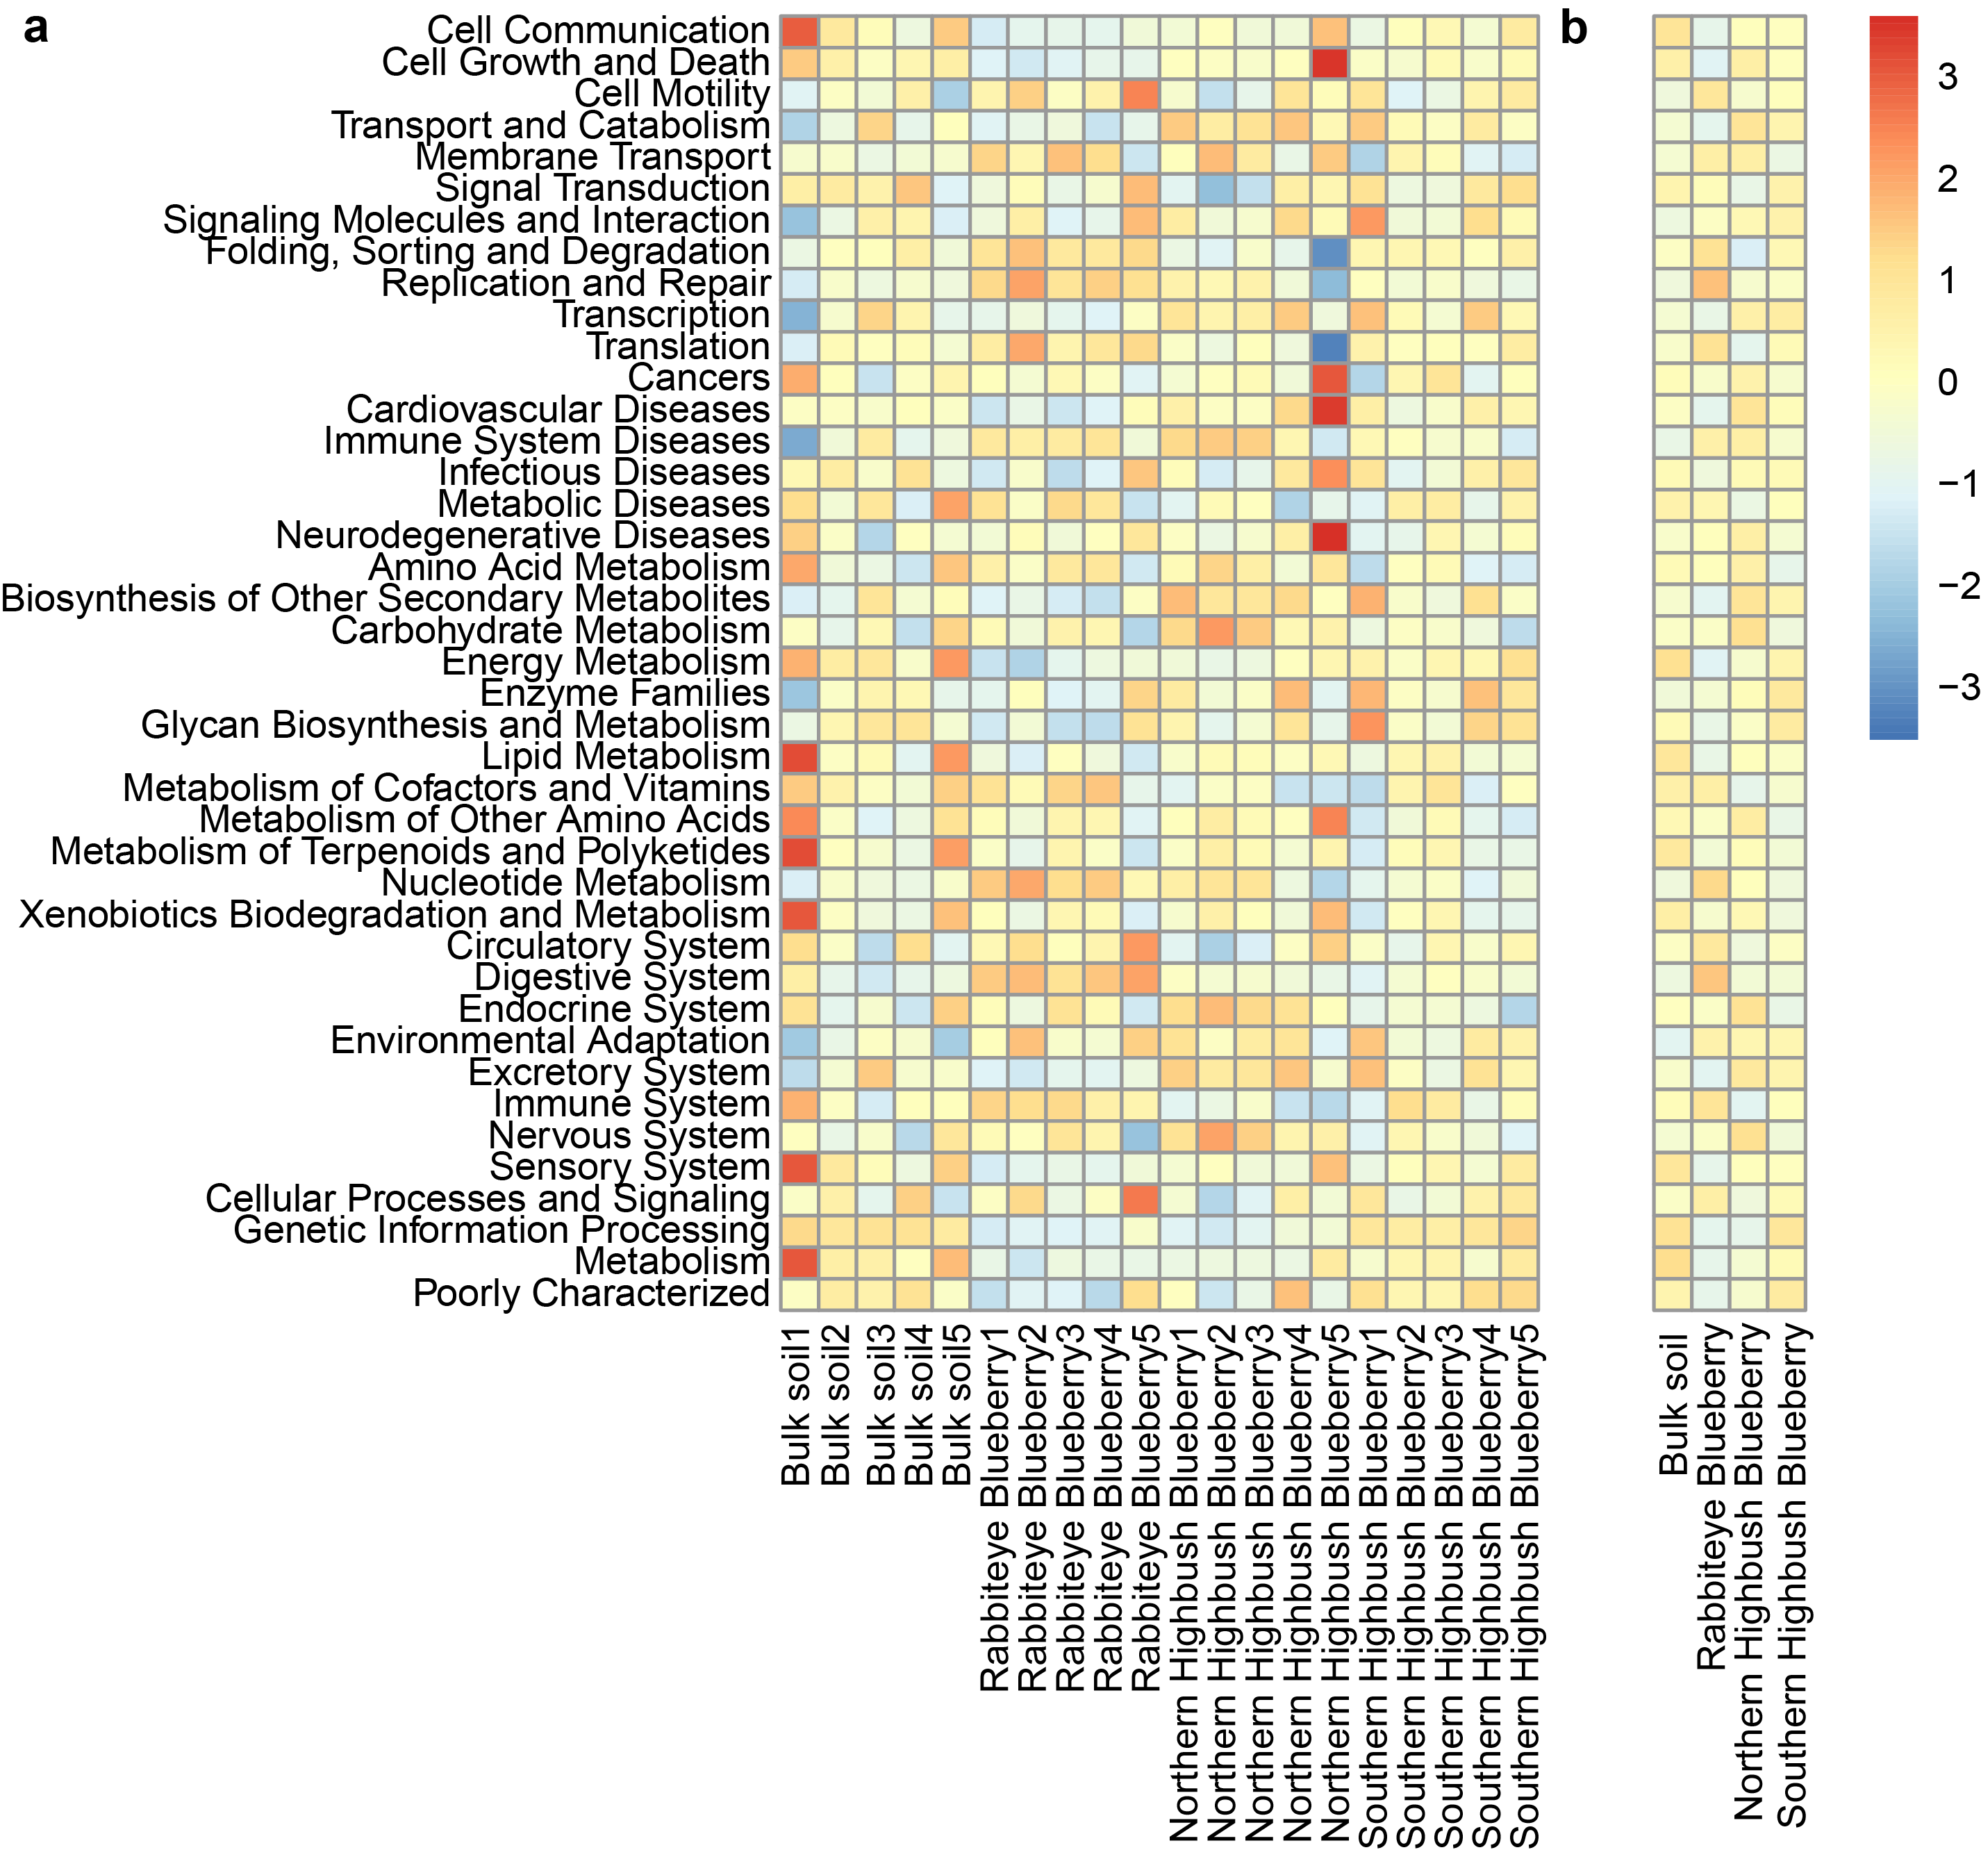
Supplementary Figure 3. Functional composition of rhizosphere microbial communities in three blueberry varieties at the level 2 of the KEGG database. a: The functional composition of each rhizosphere microbial community at the level 2 of the KEGG database. b: The average functional traits of each rhizosphere microbial community of the three blueberry varieties and bulk soil.

