Comparison and Interpretation of Characteristics of Rhizosphere Microbial Communities in Three Blueberry Varieties: the Benefits to Blueberry Production

Maozhen Han¹, Gang Liu¹, Yajun Chen², Jingjing Wang², Dong Wang², Yan Zhang^{2,*}

¹ School of Life Science, Anhui Medical University, Hefei, Anhui 230032, China.
² School of Life Sciences, Hefei Normal University, Hefei, Anhui 230601, China.
* Corresponding author E-mail: zhangyanwind@163.com

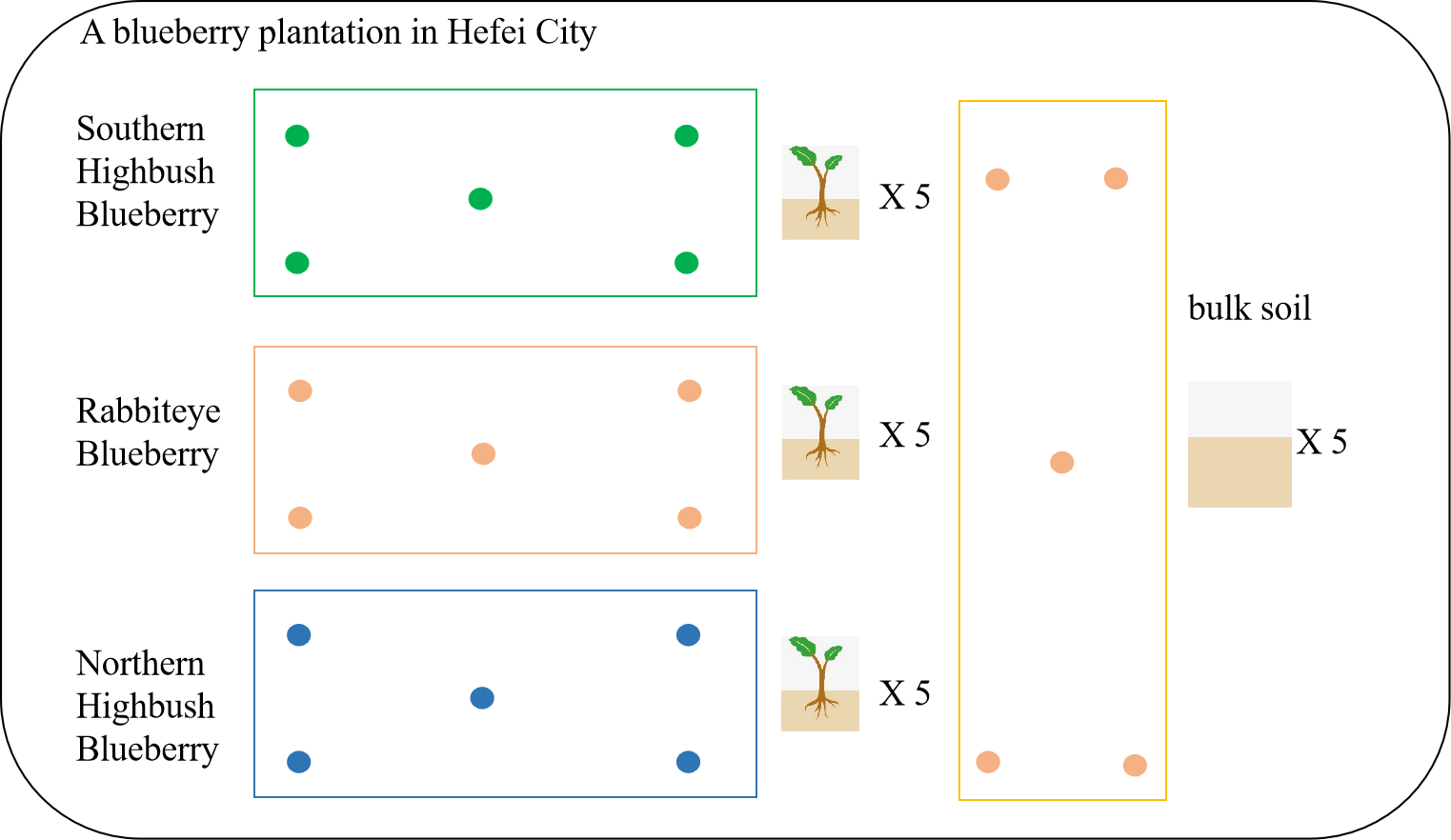
Supplementary Figure 1. Sampling schematic for collecting the rhizosphere soil samples of three blueberry varieties and bulk soil samples.
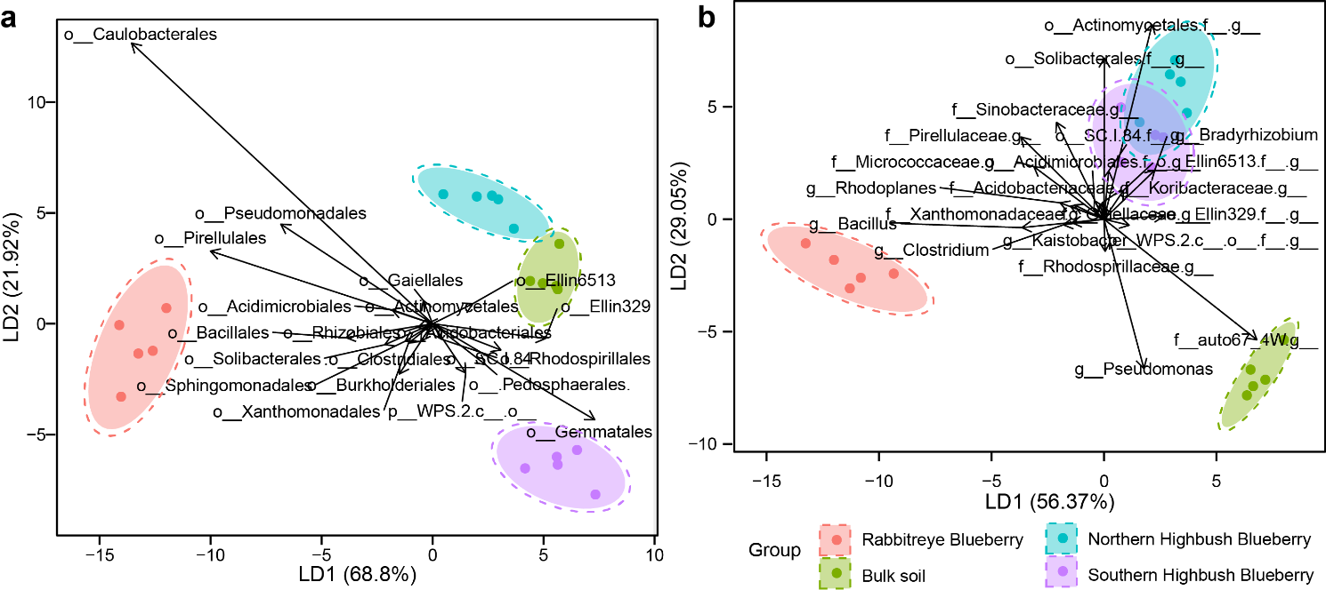
Supplementary Figure 2. Taxonomical composition of rhizosphere microbial communities in three blueberry varieties at the order and genus levels. Linear discriminant analysis was performed to maximize the separation of the rhizosphere microbial communities of three blueberry varieties and bulk soil based on the taxonomical composition at a: the order level and b: the genus level. The length and direction of the arrows represent the normalized scaling for each predominant phylum.

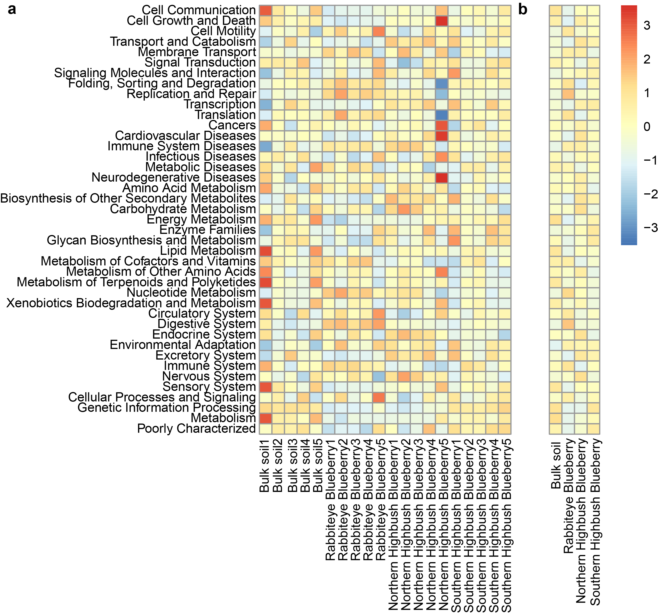
Supplementary Figure 3. Functional composition of rhizosphere microbial communities in three blueberry varieties at the level 2 of the KEGG database. a: The functional composition of each rhizosphere microbial community at the level 2 of the KEGG database. b: The average functional traits of each rhizosphere microbial community of the three blueberry varieties and bulk soil.

