Appendix 1：Morphology of raw material

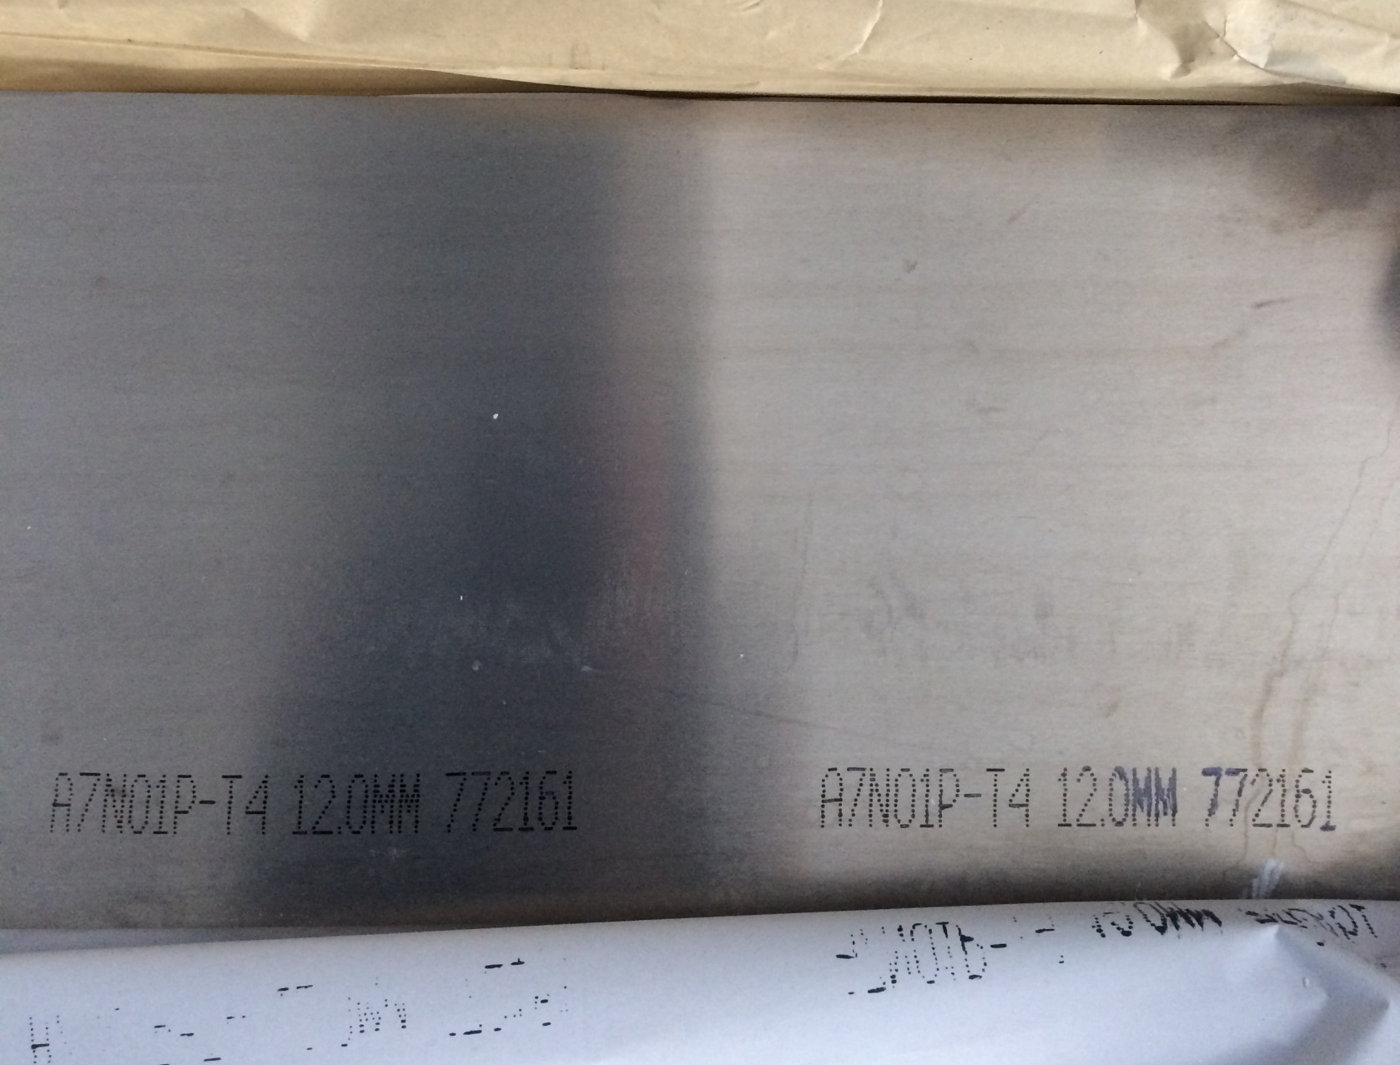

Appendix 2：Calibration certificate of testing machine

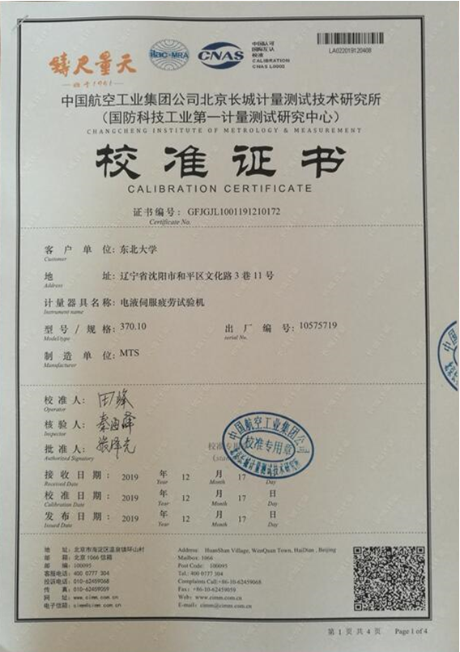
MTS hydraulic servo fatigue testing machine

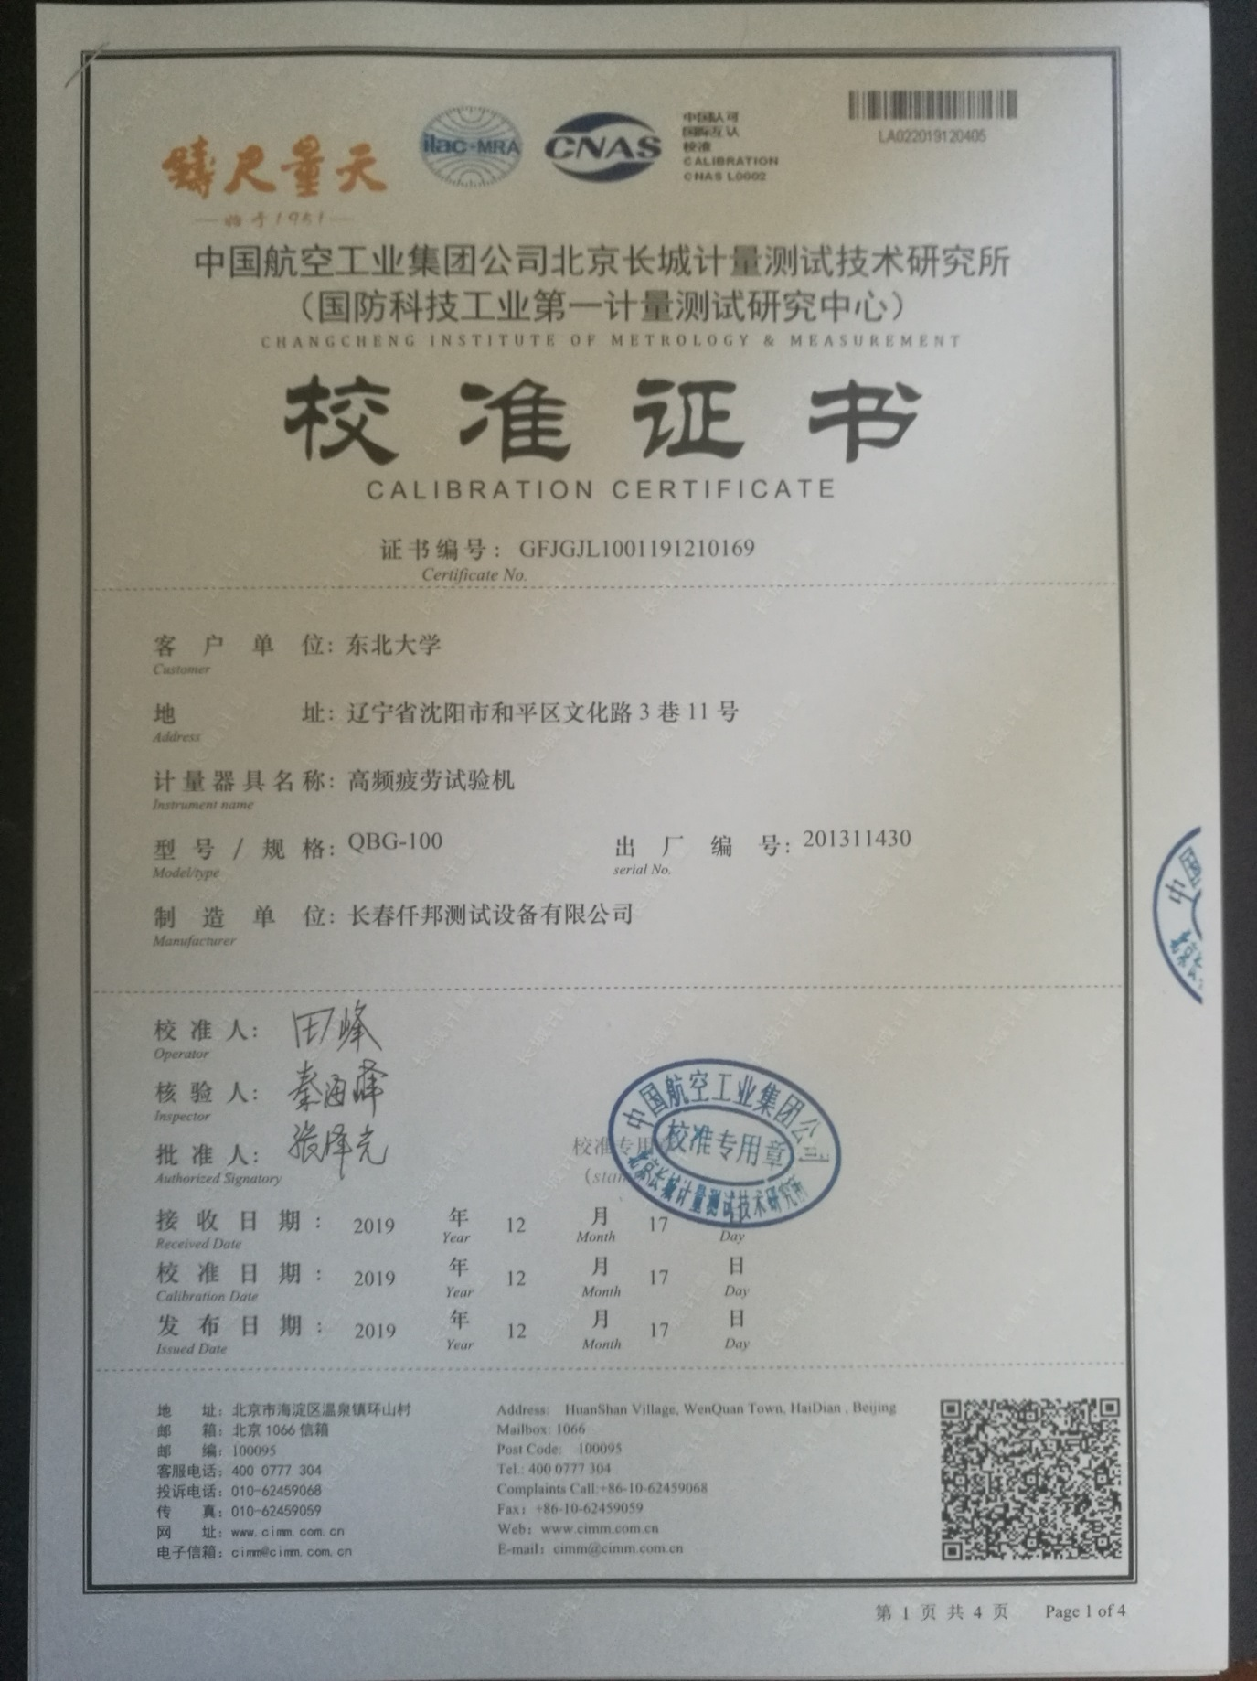
QBG electromagnetic resonance high frequency fatigue testing machine

