Supplementary Material
Table S1. ICD-9/-10 codes used for identification of psychiatric disorders
Psychiatric disorder category | Code type | Codes
Anxiety | ICD-9 | 309.0, 309.24, 309.28, 309.3, 309.4, 309.29, 309.82, 309.83, 309.89, 309.9,300.02, 300.3, 698.4, 306.3, 312.39, 300.09, 313.0, 313.1, 313.21, 313.22, 313.3, 313.89, 300.00, 313.9,313.23,308.3,309.2 , 300.23, 300.01, 309.81
 | ICD-10 | F43.20, F43.21, F43.22, F43.23, F43.24, F43.25, F43.29, F94.8, F94.9, F41.1, F42, F42.2, F42.8 ,F42.9 , F42.4, L98.1, F63.3, F94.2, F41.3, F41.8, F93.8, F41.9, F93.9, F94.0, F43.0, F94.1, F93.0, F40.10, F40.11, F41.0, F43.8, F43.10, F43.11, F43.12, F43.9
Behavioral | ICD-9 | 314.00, 314.01, 314.1, 314.2, 314.9, 312.00, 312.01, 312.02, 312.03, 312.10, 312.11, 312.12, 312.13, 312.20, 312.21, 312.22, 312.23, 312.81, 312.82, 312.4, 312.89 ,312.9, 313.81, 312.34, 312.35, 312.39, 312.30
 | ICD-10 | F90.0, F90.1, F90.2, F90.8, F90.9, F91.0, F91.1, F91.2, F91.8, F91.9, F91.3, F63.81, F98.8, F63.89, F98.9, F63.9
Mood | ICD-9 | 296.00, 296.01, 296.02, 296.03, 296.04, 296.05, 296.06, 296.40, 296.41, 296.42, 296.43, 296.44, 296.45, 296.46, 296.50, 296.51, 296.52, 296.53, 296.54, 296.55, 296.56, 296.60, 296.61, 296.62, 296.63, 296.64, 296.65, 296.66, 296.7, 296.89, 296.80, 301.13, 296.10, 296.11, 296.12, 296.13, 296.14, 296.15, 296.16, 296.81, 300.4, 296.20, 296.21, 296.22, 296.23, 296.24, 296.25, 296.26, 296.30, 296.31, 296.32, 296.33, 296.34, 296.35, 296.36, 296.82, 298.0, 309.1, 311, 301.12, 296.90, 296.99, 301.10
 | ICD-10 | F31.0, F31.10, F31.11, F31.12, F31.13, F31.2, F31.30, F31.31, F31.32, F31.4, F31.5, F31.60, F31.61, F31.62, F31.63, F31.64, F31.70, F31.71, F31.72, F31.73, F31.74, F31.75, F31.76, F31.77, F31.78, F31.81, F31.89, F31.9, F34.0, F30.10, F30.11, F30.12, F30.13, F30.2, F30.3, F30.4, F30.8, F34.1, F32.0, F32.1, F32.2, F32.3, F32.4, F32.5, F32.9, F33.0, F33.1, F33.2, F33.3, F33.40, F33.41, F33.42, F33.9, F32.8, F32.89, F33.8, F34.81, F34.9, F39, F34.8, F34.89,

Figure S1. Time to diagnosis of behavioral disorder (n=943 participants; n=21 events; risk=2.7 cases per 1,000 person-years)
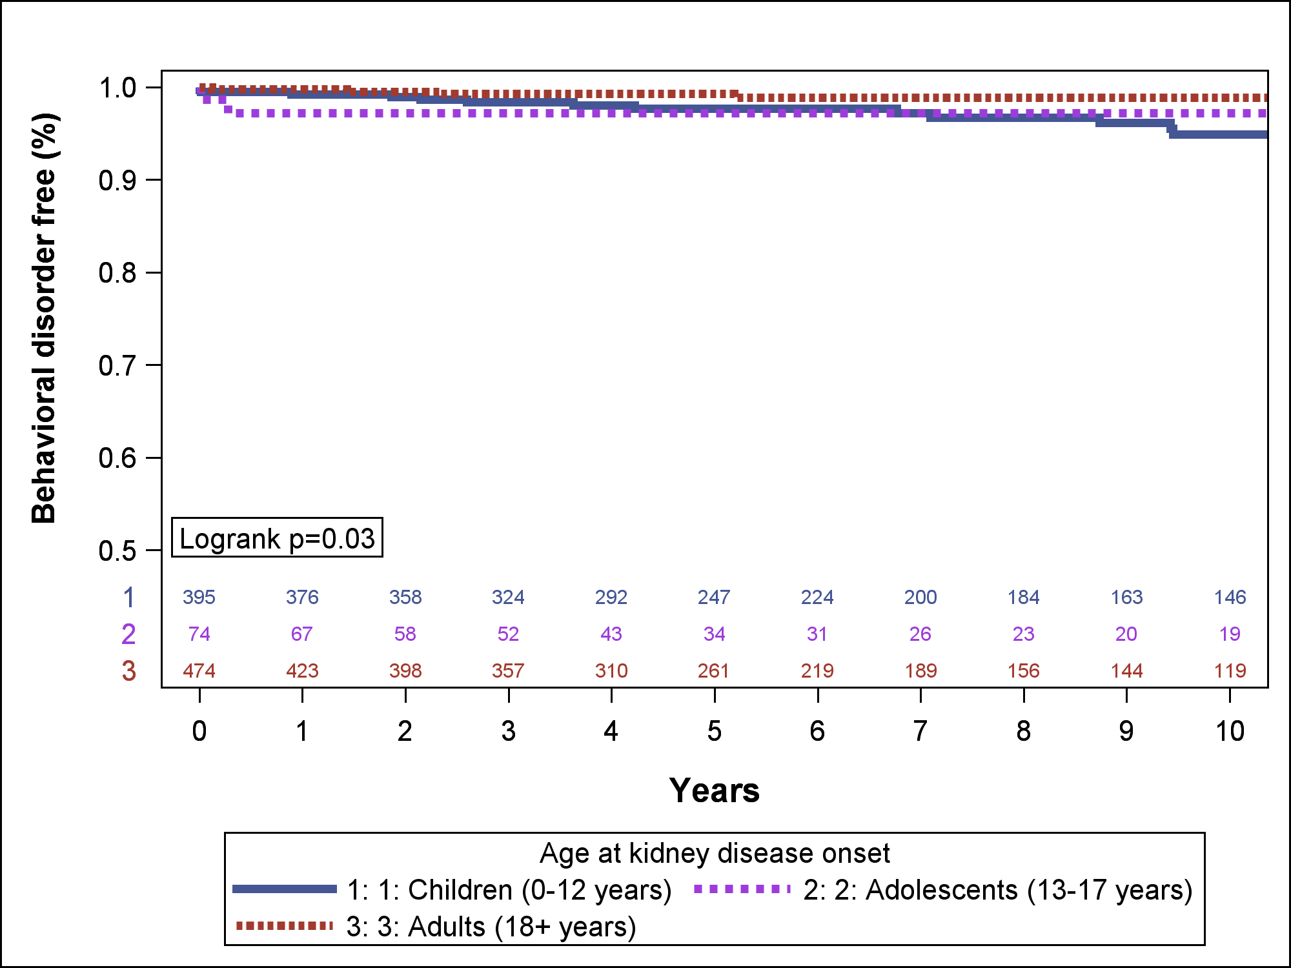

Table S2. Predictors of diagnosis of any psychiatric disorders. Results of unadjusted time-varying cox-proportional hazards models (n=943 participants; n=109 events)
Unadjusted models | Psychiatric Disorder  Hazard ratio | 95% confidence interval | p-value
Age |  |  | <0.001
Children (0-12 years) | 0.67 | 0.41 to 1.11 | 0.12
Adolescents (13-17 years) | 2.27 | 1.40 to 3.69 | 0.001
Adults (18+ years) | REF | REF | REF
Female vs. male | 1.33 | 0.91 to 1.94 | 0.14
Race |  |  | 0.07
White | REF | REF | REF
Black | 0.80 | 0.41 to 1.54 | 0.50
Asian | 0.38 | 0.18 to 0.79 | 0.01
Other | 0.87 | 0.50 to 1.52 | 0.62
Hispanic vs. non-Hispanic | 0.75 | 0.44 to 1.27 | 0.28
Diagnosis |  |  | 0.07
FSGS | 1.72 | 0.82 to 3.64 | 0.15
Minimal Change | 2.41 | 1.15 to 5.05 | 0.02
Membranous Nephropathy | 1.71 | 0.69 to 4.21 | 0.25
NS-not biopsied | REF | REF | REF
IgA Nephropathy | 0.94 | 0.39 to 2.27 | 0.89
Other | 1.68 | 0.74 to 3.82 | 0.22
eGFR per 30ml/min/1.73m² | 1.08 | 0.98 to 1.20 | 0.10
UPCR per 1 log | 1.08 | 0.97 to 1.22 | 0.17
Steroid treatment | 1.97 | 1.34 to 2.90 | 0.001
Steroid dose per mg/kg/day | 1.57 | 0.98 to 2.51 | 0.06
Cumulative months of steroid treatment | 1.42 | 0.31 to 6.47 | 0.65
CNI treatment | 1.44 | 0.90 to 2.32 | 0.13
CTX treatment | 0.72 | 0.26 to 1.94 | 0.51
MMF treatment | 1.35 | 0.81 to 2.25 | 0.26
Rituximab treatment | 2.39 | 1.10 to 5.19 | 0.03
Cumulative months of non-steroid IST treatment | 1.87 | 0.33 to 10.66 | 0.48
Number of IST treatments (per 1 medication) | 1.17 | 1.03 to 1.34 | 0.02
Abbreviations: CNI, Calcineurin inhibitors; CTX, Cytoxan; eGFR, estimated glomerular filtration rate; FSGS, focal segmental glomerulosclerosis; IQR, interquartile range; IST, immunosuppressive therapy; MMF, mycophenolate mofetil; NS, nephrotic syndrome; UPCR, urine protein: creatinine ratio

Table S3. Predictors of ESKD. Results of unadjusted time-varying cox-proportional hazards models (n=943 participants; n=329 events)
Unadjusted models | ESKD  Hazard ratio | 95% confidence interval | p-value
Onset of psychiatric disorder | 1.43 | 0.91 to 2.26 | 0.12
Age at kidney disease onset |  |  | <0.001
Children (0-12 years) | 0.46 | 0.35 to 0.59 | <0.001
Adolescents (13-17 years) | 1.03 | 0.70 to 1.51 | 0.89
Adults (18+ years) | REF | REF | REF
Female vs. male | 1.06 | 0.85 to 1.33 | 0.59
Race |  |  | 0.85
White | REF | REF | REF
Black | 1.16 | 0.80 to 1.68 | 0.44
Asian | 0.96 | 0.69 to 1.32 | 0.79
Other | 1.02 | 0.72 to 1.45 | 0.90
Hispanic vs. non-Hispanic | 1.30 | 0.99 to 1.71 | 0.06
Diagnosis |  |  | <0.001
FSGS | 6.05 | 3.24 to 11.30 | <0.001
Minimal Change | 1.45 | 0.71 to 2.98 | 0.31
Membranous Nephropathy | 3.19 | 1.54 to 6.60 | 0.002
NS-not biopsied | REF | REF | REF
IgA Nephropathy | 4.70 | 2.46 to 8.97 | <0.001
Other | 3.62 | 1.85 to 7.07 | <0.001
eGFR at onset per 30ml/min/1.73m² | 0.59 | 0.54 to 0.64 | <0.001
UPCR at onset per 1 log | 1.11 | 1.02 to 1.20 | 0.01
Steroid treatment | 0.34 | 0.27 to 0.43 | <0.001
CNI treatment | 0.63 | 0.48 to 0.81 | <0.001
CTX treatment | 0.37 | 0.22 to 0.61 | <0.001
MMF treatment | 0.53 | 0.40 to 0.69 | <0.001
Rituximab treatment | 0.49 | 0.33 to 0.73 | <0.001
Number of IST treatments (per 1 medication) | 0.69 | 0.63 to 0.76 | <0.001
Abbreviations: ESKD, end stage kidney disease; CNI, Calcineurin inhibitors; CTX, Cytoxan; eGFR, estimated glomerular filtration rate; FSGS, focal segmental glomerulosclerosis; IQR, interquartile range; IST, immunosuppressive therapy; MMF, mycophenolate mofetil; NS, nephrotic syndrome; UPCR, urine protein: creatinine ratio

