Supplementary Information
Supplementary Information to “Three-dimensional Imaging of Nanoplasma by Ion Nanoscopy”
X.Han et al.
SUPPLEMENTARY DISCUSSION 1
We show the typical field distributions for three different combinations of the laser wavelength and nanosphere diameter: 800-nm wavelength and 40-nm diameter, 800-nm wavelength and 100-nm diameter, and 400-nm wavelength and 100-nm diameter. 1) In the case of 40-nm TiO₂ spheres exposed to the 800-nm laser field, both of the external and internal fields show no forward-backward asymmetry, as shown in Supplementary Figs. 1a and 1b. 2) In the case of 100-nm TiO₂ spheres exposed to the 800-nm laser field, the internal field shows an enhancement in forward direction due the nano-focusing effect, while the external field exhibits no forward-backward asymmetry (Supplementary Figs. 1c and 1d). 3) In the case of 100-nm TiO₂ spheres exposed to the 400-nm laser field, which has already been discussed and shown in Figs. 4a and 4c in the main text, both the external and the internal fields are enhanced along the forward direction of laser propagation. The discriminations in the forward-backward asymmetries for internal and external fields suggest a great opportunity to distinguish role of the internal and external fields in plasma generation.
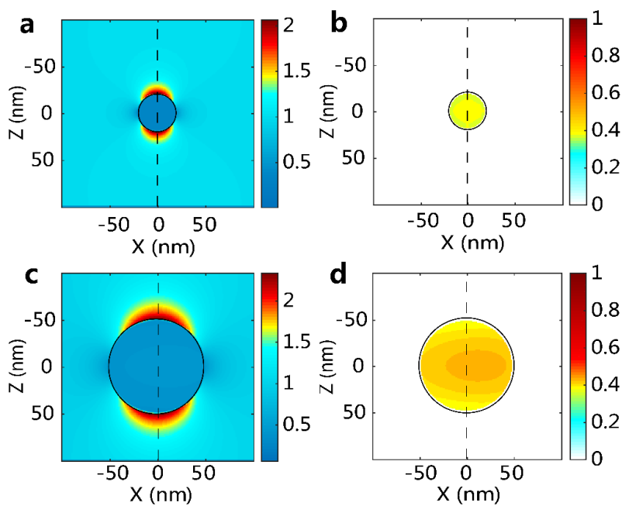
Supplementary Figure 1: The internal and external field distributions of the 40-nm and the 100-nm TiO₂ spheres radiated by the 800-nm laser. a The external and b internal linearly polarized electric field distribution in the x-z plane for the 40-nm TiO2 spheres. The 800-nm laser propagates from left to right, and the scattering field intensities are normalized to the incident field intensity. The black circle in each figure represents the nanosphere surface. c The external and d internal linearly polarized electric field distribution in the x-z plane for the 100-nm TiO2 spheres.
SUPPLEMENTARY DISCUSSION 2
We explore the ion momentum distributions and their angular ion yields with different laser intensities to study the effect of laser intensity on the plasma formation. In detail, a series 2D slice images are sampled near-single intensity, which is achieved by collected the images with similar ion counts. With the tomographic technique, the corresponding 3D ion momentum distributions are then reconstructed and we display their projections on the y-z plane in Supplementary Fig. 2. We scan the relative laser intensities with ion counts spanning from 500 to 1700. The corresponding angular resolved ion yields are shown in Supplementary Fig. 3 by the normalized angular integration from the momentum projections. With the different ion counts (laser intensity), we compare the ion yields and clearly find the different asymmetries of ion distributions, which will be quantitatively analyzed in SUPPLEMENTARY DISCUSSION 3.
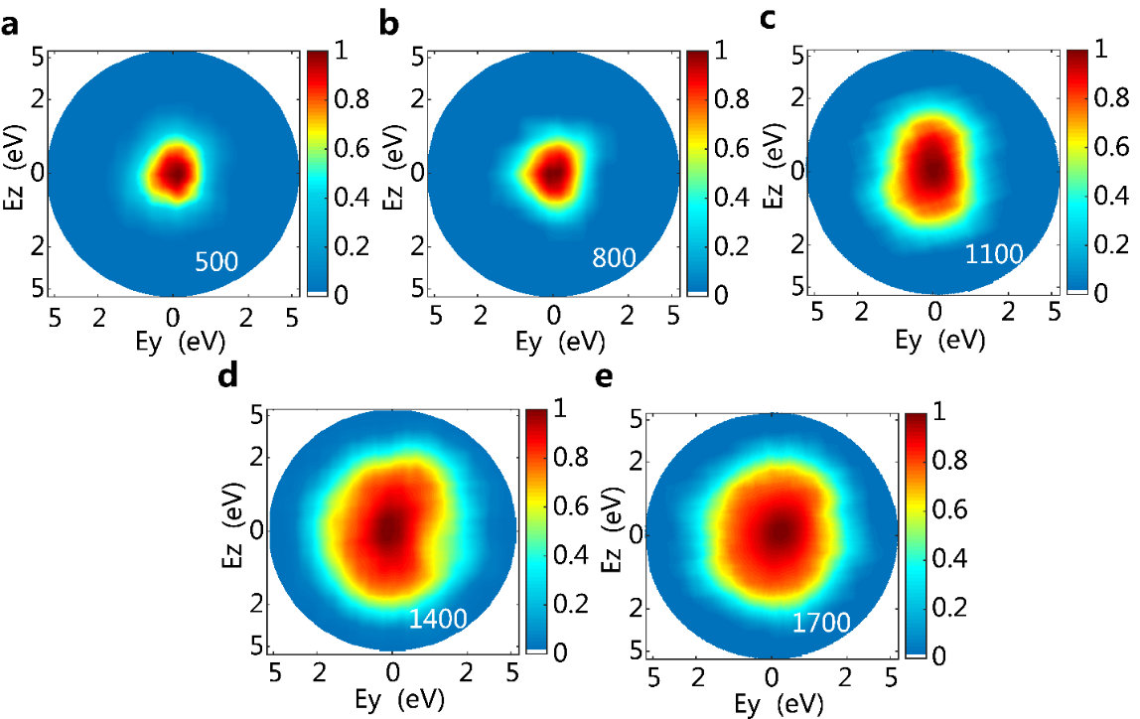
Supplementary Figure 2: The projections of the 3D ion momentum distributions on the y-z plane for different laser intensities. The number of ion count serves as a guide for intensity. a-e The projections of the reconstructed ion momentum distribution on the y-z plane with the ion counts ranging from 500 to 1700 (increasing laser intensity).
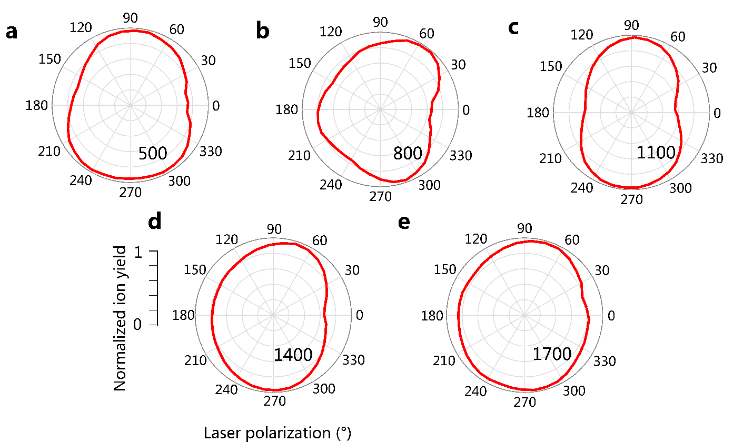
Supplementary Figure 3: The ion yields on the y-z plane for different laser intensities. a-e The normalized ion yields on the y-z plane with the ion counts ranging from 500 to 1700.
SUPPLEMENTARY DISCUSSION 3
To quantitatively analyze the variation of the ion distributions with the increasing laser intensity, we record ion momentum distributions for nine different ion counts (intensities). We then characterize the nine momentum distributions by a vertical to horizontal ratio γ_{y-z} in the y-z plane, which is defined as the quotient of ion yields parallel to and perpendicular to the z-axis, and the results are summarized in Supplementary Fig. 4. The recorded ion distributions start from ion count of 500, which corresponds to the lowest laser intensity used in our experiment. We don’t use lower laser intensity because the noisy signal from background becomes non-negligible. For the lowest laser intensity, the ratio γ_{y-z} is approximately 1.3. With the increasing laser intensity and ion count accordingly, the ratio γ_{y-z} increases, while the ion distribution becomes more asymmetrical. When the ion count approaches 1100, the maximal γ_{y-z} appears. The maximal γ_{y-z} is greater than 1.4, stressing a significant dipolar enhancement, which can only be induced by external field. However, when we further increase laser intensity, the ratio γ_{y-z} gradually decreases. The ratio γ_{y-z} is 1.1 for highest laser intensity in our experiment with the ion count of 1700. The reduction of asymmetry indicates that the intense collision averaging appears, which was also reported by Antonsson et al¹. This collision occurs only inside the nanoparticle, thus, with this laser intensity (ion count 1700), the surface-localized plasma has already soon replaced by the hot dense plasma inside the nanoparticle, where the internal field plays the dominant role.
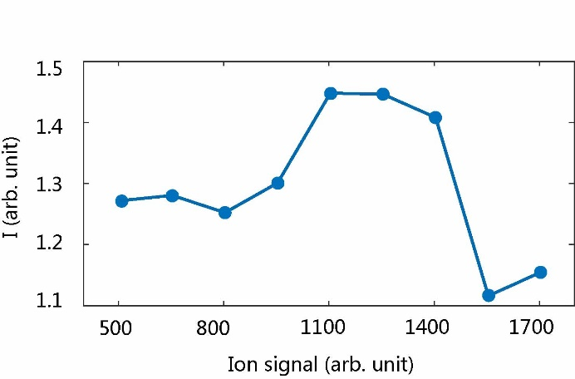
Supplementary Figure 4: Vertical to horizontal ratio γ_{y-z} for different laser intensities. We define the vertical to horizontal ratio γ_{y-z} to quantify the asymmetries of the ion distribution, γ_{y-z} = I_{z}/I_{y}, where I_{z} and I_{v} are the ion yields parallel to and perpendicular to the z-axis, respectively. A series of γ_{y-z} ratios were calculated with the ion counts ranging from 500 to 1700.

SUPPLEMENTARY DISCUSSION 4
The plasma imaging of the high laser intensity (ion count 1700) can provide more direct evidence to show the dominant role of the internal field in the hot dense plasma generation. Similar to Fig. 3c in the main text, in the LP laser field, we image the 3D ion yield with the higher intensity (ion count 1700) over a unit sphere, as shown in Supplementary Fig. 5a. Comparing to the dipole-like hotspots of ion yield along the laser polarization direction in Fig. 3c of the main text, the ion yield shown in Supplementary Fig. 5a has only a single hotspot in the forward direction of laser propagation. To gain a more direct insight and compare the obtained ion yield imaging with the field distribution in the x-z plane (Figs. 4a and 4c in the main text), we displayed a 2D view (Supplementary Fig. 5b) from the y-direction. The single hotspot of the ion yield agrees well with the internal field instead of the dipole-like external field. It therefore confirms that the internal field plays a dominant role in hot dense plasma generation when the laser intensity becomes strong enough to open the ion-ion bonds inside the nanosphere, which has also been reported by the 2D plasma explosion imaging².
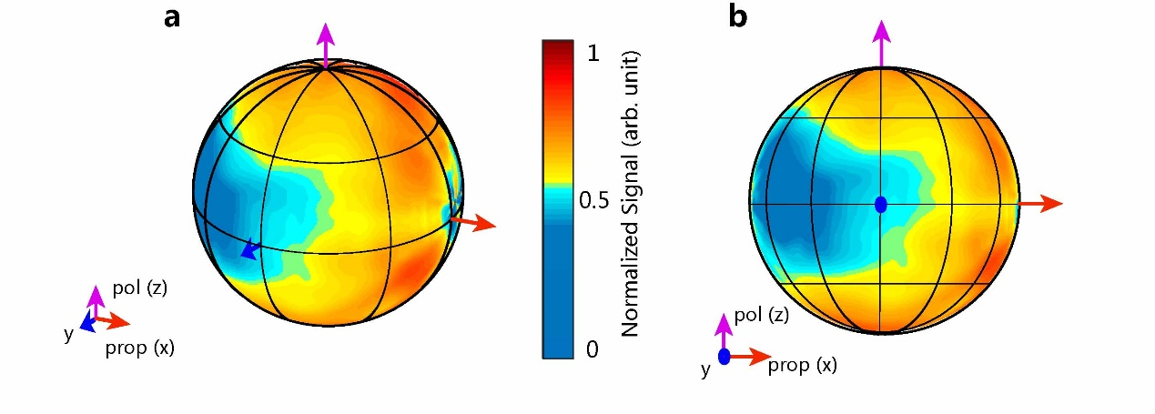
Supplementary Figure 5: 3D ion yield imaging for higher laser intensities. a In the LP laser field, the 3D ion yield over a unit sphere with the ion count 1700. b The 2D view from the y-direction of the 3D ion yield.
Supplementary References:
1 Antonsson, E. et al. Size-dependent ion emission asymmetry of free NaCl nanoparticles excited by intense femtosecond laser pulses. Physical Chemistry Chemical Physics 21 (2019).
2 Hickstein, D. D. et al. Mapping Nanoscale Absorption of Femtosecond Laser Pulses Using Plasma Explosion Imaging. ACS Nano 8 (2014).

