Table S1: End digits for systolic BP against end digits for diastolic BP (count and %)
End digit of systolic BP | End digit of diastolic BP
End digit of systolic BP | 0 | 1 | 2 | 3 | 4 | 5 | 6 | 7 | 8 | 9 | Total
0
  5877
  10.87
  384
  0.71
  1030
  1.90
  351
  0.65
  980
  1.81
  840
  1.55
  736
  1.36
  365
  0.68
  1137
  2.10
  409
  0.76
  12109
  22.39
1
  367
  0.68
  346
  0.64
  314
  0.58
  283
  0.52
  332
  0.61
  251
  0.46
  341
  0.63
  279
  0.52
  333
  0.62
  293
  0.54
  3139
  5.81
2
  1334
  2.47
  357
  0.66
  916
  1.69
  315
  0.58
  748
  1.38
  402
  0.74
  606
  1.12
  376
  0.70
  811
  1.50
  307
  0.57
  6172
  11.41
3
  379
  0.70
  326
  0.60
  333
  0.62
  337
  0.62
  337
  0.62
  338
  0.63
  334
  0.62
  347
  0.64
  370
  0.68
  353
  0.65
  3454
  6.39
4
  1166
  2.16
  291
  0.54
  662
  1.22
  347
  0.64
  844
  1.56
  351
  0.65
  592
  1.09
  363
  0.67
  758
  1.40
  365
  0.68
  5739
  10.61
5
  972
  1.80
  327
  0.60
  388
  0.72
  318
  0.59
  372
  0.69
  689
  1.27
  380
  0.70
  329
  0.61
  423
  0.78
  367
  0.68
  4565
  8.44
6
  1000
  1.85
  343
  0.63
  646
  1.19
  342
  0.63
  644
  1.19
  363
  0.67
  680
  1.26
  386
  0.71
  688
  1.27
  330
  0.61
  5422
  10.03
7
  443
  0.82
  314
  0.58
  341
  0.63
  303
  0.56
  395
  0.73
  303
  0.56
  325
  0.60
  387
  0.72
  384
  0.71
  318
  0.59
  3513
  6.50
8
  1431
  2.65
  324
  0.60
  799
  1.48
  386
  0.71
  718
  1.33
  416
  0.77
  654
  1.21
  336
  0.62
  1035
  1.91
  404
  0.75
  6503
  12.03
9
  431
  0.80
  305
  0.56
  361
  0.67
  309
  0.57
  348
  0.64
  322
  0.60
  314
  0.58
  314
  0.58
  396
  0.73
  357
  0.66
  3457
  6.39
Total
  13400
  24.78
  3317
  6.13
  5790
  10.71
  3291
  6.09
  5718
  10.57
  4275
  7.91
  4962
  9.18
  3482
  6.44
  6335
  11.72
  3503
  6.48
  54073
  100.00

Table S2: Diastolic BP differences in mmHg (baseline – final readings)
Stratification | N | Mean | SD | Median | IQR | Range
None (Overall) | 399  [3484] | 4.23  [1.88] | 8.68  [11.61] | 4  [1] | -1 to 10  [-6 to 10] | -24 to 29  [-44 to 51]
Age <65 | 211  [1049] | 3.94  [3.16] | 8.36  [12.13] | 3  [2] | -1 to 10  [-4 to 11] | -22 to 26  [-36 to 44]
Age 65+ | 188  [2435] | 4.55  [1.33] | 9.03  [11.34] | 4.5  [1] | -1 to 11  [-6 to 8] | -24 to 29  [-44 to 51]
Male | 217  [1639] | 4.25  [1.45] | 8.77  [11.69] | 4  [1] | -1 to 10  [-6 to 9] | -24 to 29  [-40 to 41]
Female | 182  [1845] | 4.19  [2.27] | 8.60  [11.53] | 4  [1] | -1 to 10  [-5 to 10] | -19 to 26  [-44 to 51]
SIMD<5 (more deprived) | 70  [811] | 3.69  [2.26] | 8.23  [11.85] | 2.5  [2] | -2 to 9  [-6 to 10] | -14 to 26  [-44 to 47]
SIMD 5+ (more affluent) | 329  [2673] | 4.34  [1.77] | 8.78  [11.54] | 4  [1] | -1 to 10  [-6 to 9] | -24 to 29  [-40 to 51]
SBP<135 | 209  [1365] | 1.45  [-2.21] | 7.47  [10.07] | 1  [-2] | -3 to 7  [-9 to 4] | -21 to 23  [-40 to 33]
SBP 135 or above | 190  [2119] | 7.28  [4.52] | 8.91  [11.78] | 8  [4] | 1 to 13  [-3 to 12] | -24 to 29  [-44 to 51]
SBP 140 or above | 138  [1658] | 8.38  [5.48] | 8.70  [11.97] | 8  [5] | 3 to 14  [-2 to 13] | -24 to 29  [-44 to 51]
SBP 145 or above | 92  [1132] | 9.83  [7.36] | 8.37  [12.31] | 10  [8] | 4 to 15.5  [0 to 15] | -16 to 29  [-44 to 51]
SBP 150 or above | 62  [894] | 11.06  [8.47] | 8.86  [12.32] | 12  [8.5] | 6 to 17  [0 to 17] | -16 to 29  [-40 to 51]
Numbers are shown as Telemonitoring [Comparator]

Table S3: Linear mixed effects model results for systolic BP reduction
 | Coefficient | 95% CI | P-value
All patients | 3.417 | 1.724 to 5.109 | <0.0001
Age<65 only | 1.616 | -0.732 to 3.965 | 0.177
Age>=65 only | 4.845 | 2.429 to 7.262 | <0.0001
Patients with systolic BP<135 only | 4.064 | 1.825 to 6.302 | 0.0004
Patients with systolic BP>=135 only | 1.494 | -1.391 to 4.379 | 0.310
systolic BP>=135 and Age>=65 | 3.150 | -0.979 to 7.278 | 0.135
Patients with systolic BP>=140 only | -0.287 | -3.697 to 3.124 | 0.869
Patients with systolic BP>=145 only | -0.150 | -4.271 to 3.971 | 0.943
Patients with systolic BP>=150 only | -1.633 | -6.500 to 3.235 | 0.510

Table S4: Sensitivity analyses for matching analysis of diastolic BP
 | Matching criterion for Systolic BP | Adjustment to surgery Systolic BP readings* | N | Diastolic BP
 |  |  |  | Mean difference | 95% confidence interval | P-value
1 | Nearest SBP with end digit 0 or 5 | 0 | 212 | 3.07 | 1.43 to 4.71 | <0.001
2 | Nearest SBP with end digit 0 or 5 | -7 | 201 | 0.01 | -1.76 to 1.79 | 0.987
3 | Nearest SBP with end digit 0 or 5 | -10 | 211 | -0.02 | -1.62 to 1.58 | 0.981
4 | Exact SBP matching | 0 | 119 | 3.55 | 1.41 to 5.70 | 0.001
5 | Exact SBP matching | -5 | 120 | -1.68 | -3.96 to 0.59 | 0.146
6 | Exact SBP matching | -7 | 128 | -0.96 | -3.15 to 1.23 | 0.386
7 | Exact SBP matching | -10 | 123 | 1.28 | -0.85 to 3.42 | 0.236
8 | Nearest SBP with end digit 0 | -5 | 208 | -0.61 | -2.34 to 1.12 | 0.486
9 | Nearest SBP with end digit 0 | -7 | 209 | -0.68 | -2.37 to 1.02 | 0.430
*Adjustment was applied to matching values as well as final values. Final surgery DBP was consistently adjusted by -5 except in the analyses with no adjustment to SBP, in which case the adjustment to final DBP was also 0.

Figure S1: End digits of surgery measured diastolic BP in comparator patients
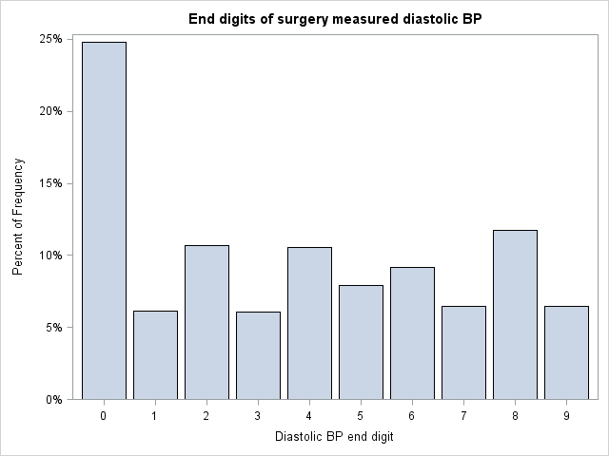

Figure S2: Forest plot showing between-group differences in change of diastolic BP for telemonitored BP – surgery measured BP in comparator patients.
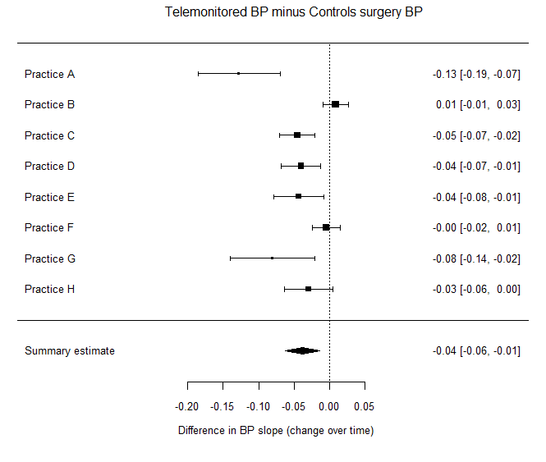

Figure S3: Forest plot showing between-group differences in change of diastolic BP for surgery measured BP (telemonitoring – comparator)
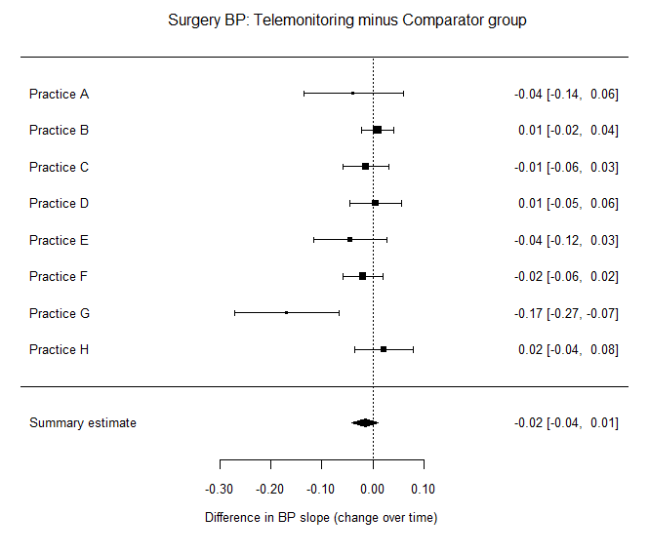
Figure S4: Forest plot showing between-group differences in change of diastolic BP for surgery measured BP (telemonitoring – comparator)
