Chart 2
A pie- chart representing the data in percentages of the positive samples per sampling zone and the total negative samples

Diagram 1
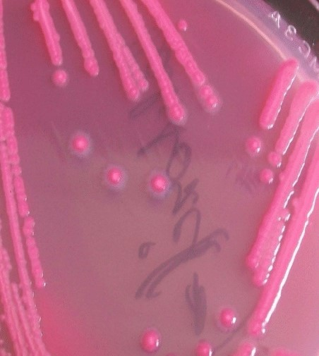
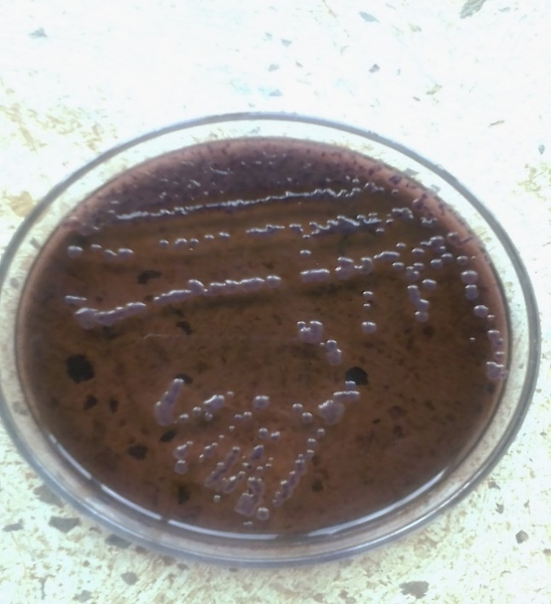
(a) E. coli on Nutrient agar (b) E. coli on MacConkey agar
Chart 3
A pie- chart representing the data in percentages of the positive samples per sampling zone and the total negative samples

Diagram 2. S. aureus on Staph 110 agar
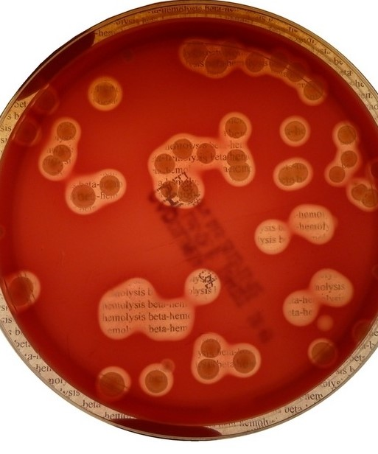

Chart 4
A pie- chart representing the data in percentages of the positive samples per sampling zone and the total negative samples

Diagram 3. Salmonella spp on Salmonella- Shigella agar
