An Efficient Polyacrylonitrile Fiber-Based Acid-Base Bifunctional Catalyst for Aqueous One-Pot Cascade Reactions

Yongqiang Chen,ª Pengyu li,^{*a, b} Yahui Yuan,ª Senhao Wang,ª Shushen Zhi,ª Chengxiao Yang,ª Yuanyuan Liu,ª and Mingli Jiao^{*a, b}
ª School of Materials, Electronics and Energy Storage, Centre for Advanced Materials Research, Zhongyuan University of Technology, Zhengzhou, 450007, PR China. E-mail: pyli＠zut.edu.cn, jml@zut.edu.cn
^{b} Henan International Joint Laboratory of New Chemical Materials and Nanomachining, Zhengzhou 451191, PR China

*Corresponding Author:
*E-mail: pyli@zut.edu.cn (P. Li),
*E-mail: jml@zut.edu.cn (M. Jiao).

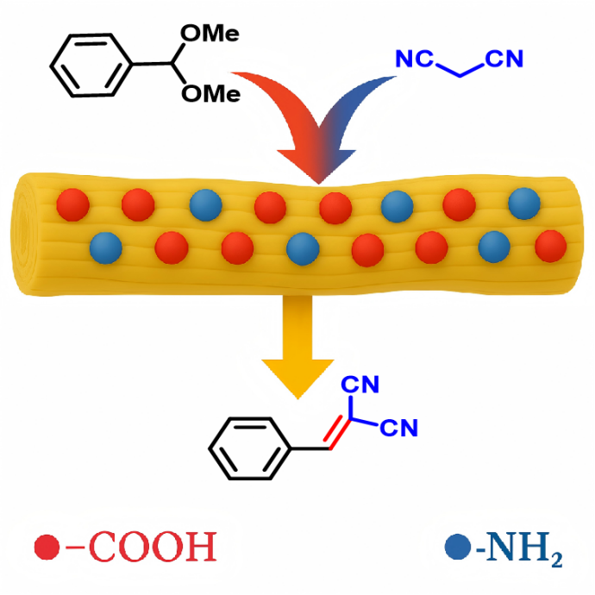
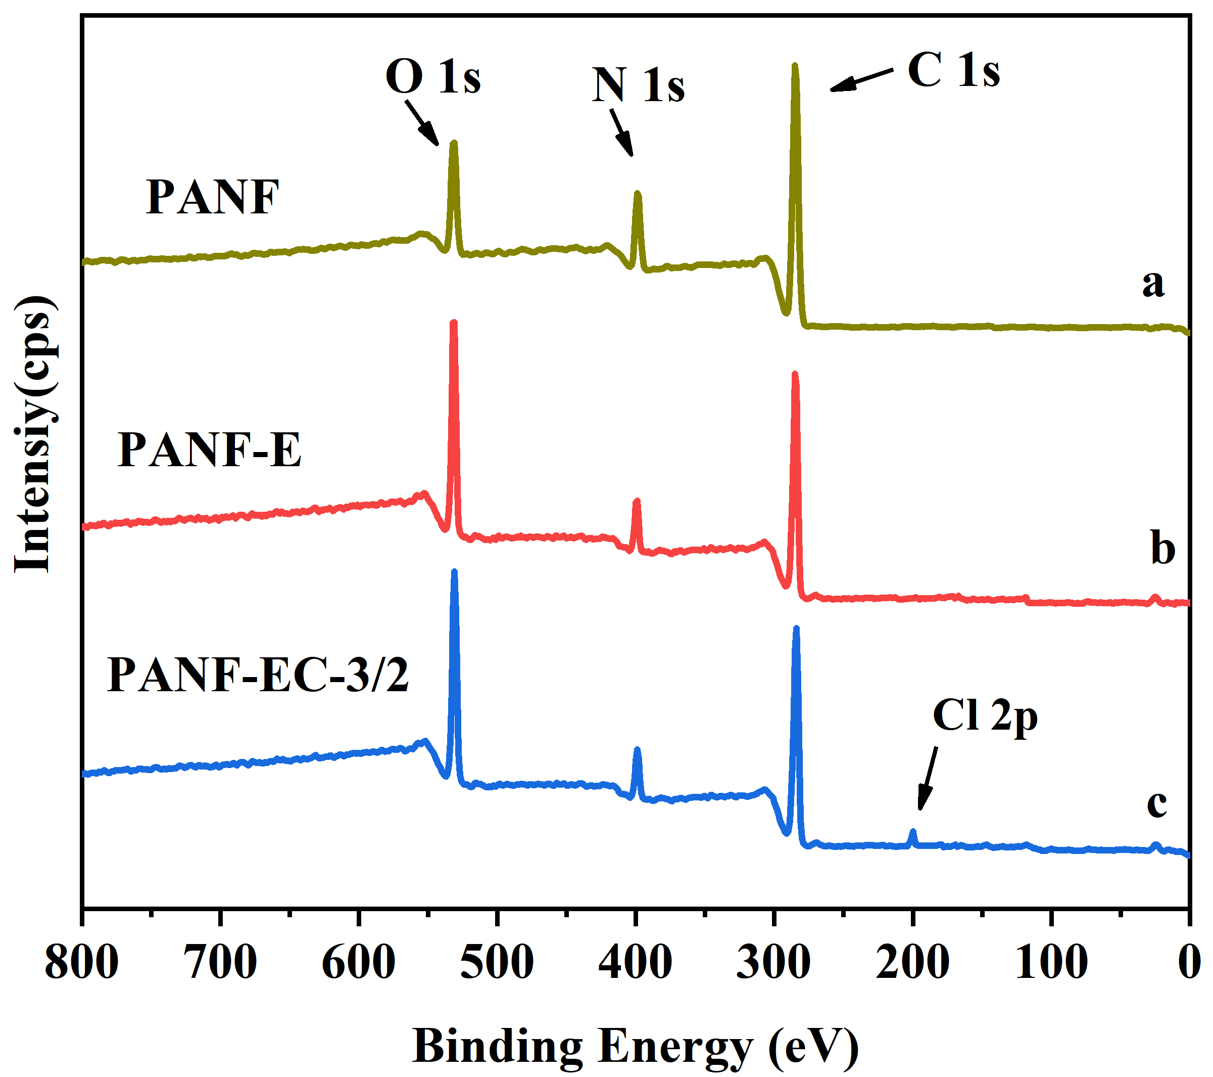
Figure S1. XPS survey spectra of PANF, PANF-E, and PANF-EC-3/2 fibers showing the presence of characteristic elements including C 1s, N 1s, O 1s, and Cl 2p.

1 ¹H NMR and ¹³C NMR data of different products
Benzylidenemalononitrile C1
¹H NMR (300 MHz, Chloroform-d) δ 7.99 – 7.84 (m, 2H), 7.78 (s, 1H), 7.64 (s, 1H), 7.56 (d, J = 7.8 Hz, 2H).
¹³C NMR (75 MHz, CDCl₃) δ 159.65, 134.35, 130.65, 130.45, 129.36, 113.41, 112.25, 82.62.

4-Bromobenzylidenemalonodinitrile C2
¹H NMR (300 MHz, Chloroform-d) δ 7.85 – 7.74 (m, 2H), 7.71 (d, J = 4.6 Hz, 2H), 7.68 (d, J = 1.8 Hz, 1H).
¹³C NMR (75 MHz, CDCl₃) δ 159.00, 133.60, 132.34, 130.45, 130.19, 113.99, 112.87, 84.00.

2-(4-chlorobenzylidene)malononitrile C3
¹H NMR (300 MHz, Chloroform-d) δ 7.93 – 7.79 (m, 2H), 7.74 (d, J = 4.7 Hz, 1H), 7.53 (t, J = 6.6 Hz, 2H).
¹³C NMR (75 MHz, CDCl₃) δ 158.86, 141.69, 132.39, 130.62, 129.81, 113.99, 112.89, 83.86.

2-(4-Methoxyphenylmethylene)malononitrile C4
¹H NMR (300 MHz, Chloroform-d) δ 8.00 – 7.86 (m, 2H), 7.65 (s, 1H), 7.12 – 6.93 (m, 2H), 3.91 (d, J = 1.8 Hz, 3H).
¹³C NMR (75 MHz, CDCl₃) δ 164.51, 158.58, 133.15, 123.69, 114.82, 114.13, 113.05, 78.16, 55.50.

2-(2-bromobenzylidene)malononitrile C5
¹H NMR (300 MHz, Chloroform-d) δ 7.94 (d, J = 16.3 Hz, 2H), 7.89 – 7.59 (m, 2H), 7.54 – 7.32 (m, 1H).
¹³C NMR (75 MHz, CDCl₃) δ 158.65, 137.78, 133.97, 133.08, 131.61, 129.17, 124.16, 113.72, 112.54, 85.18.

2-(2-bromobenzylidene)malononitrile C6
¹H NMR (300 MHz, Chloroform-d) δ 8.22 (s, 1H), 8.12 (dd, J = 7.3, 2.2 Hz, 1H), 7.92 – 7.67 (m, 1H), 7.49 (tt, J = 6.9, 4.0 Hz, 2H).
¹³C NMR (75 MHz, CDCl₃) δ 159.18, 135.42, 134.41, 131.19, 130.23, 128.79, 126.84, 113.56, 112.25, 86.39.

(E)-ethyl 2-cyano-3-phenylacrylate C7
¹H NMR (400 MHz, Chloroform-d) δ 8.40 – 8.16 (m, 1H), 7.96 (dt, J = 7.0, 3.6 Hz, 2H), 7.61 – 7.41 (m, 3H), 4.36 (pd, J = 7.0, 2.7 Hz, 2H), 1.37 (tt, J = 7.0, 3.3 Hz, 3H).
¹³C NMR (101 MHz, CDCl₃) δ 162.42, 162.39, 155.00, 154.97, 154.94, 133.28, 131.48, 131.46, 131.05, 131.03, 129.26, 115.45, 103.04, 103.02, 62.70, 62.68, 14.14.

ethyl (E)-3-(4-bromophenyl)-2-cyanoacrylate C8
¹H NMR (400 MHz, Chloroform-d) δ 8.17 (s, 1H), 7.84 (d, J = 8.5 Hz, 2H), 7.63 (d, J = 8.5 Hz, 2H), 4.38 (q, J = 7.1 Hz, 2H), 1.39 (t, J = 7.1 Hz, 3H).
¹³C NMR (101 MHz, CDCl₃) δ 162.30, 153.57, 132.78, 132.34, 130.39, 128.35, 115.34, 103.79, 62.99, 14.25.

ethyl (E)-3-(4-chlorophenyl)-2-cyanoacrylate C9
¹H NMR (400 MHz, Chloroform-d) δ 8.20 – 8.14 (m, 1H), 7.91 (ddd, J = 8.6, 5.0, 2.9 Hz, 2H), 7.45 (qd, J = 4.8, 2.4 Hz, 2H), 4.36 (pd, J = 7.1, 3.6 Hz, 2H), 1.37 (ddd, J = 7.3, 5.7, 2.7 Hz, 3H).
¹³C NMR (101 MHz, CDCl₃) δ 162.18, 153.37, 153.34, 153.32, 139.54, 132.22, 129.91, 129.68, 129.66, 115.26, 103.54, 62.86, 14.16.

(E)-2-cyano-3-(4-methoxyphenyl)acrylate C10
¹H NMR (400 MHz, Chloroform-d) δ 8.15 (d, J = 3.8 Hz, 1H), 7.98 (dd, J = 9.1, 3.3 Hz, 2H), 6.97 (dd, J = 9.1, 3.2 Hz, 2H), 4.35 (qd, J = 7.1, 3.4 Hz, 2H), 3.87 (d, J = 3.3 Hz, 3H), 1.37 (td, J = 7.3, 3.6 Hz, 3H).
¹³C NMR (101 MHz, CDCl₃) δ 163.56, 154.12, 133.40, 133.38, 124.15, 115.98, 114.54, 99.16, 62.18, 55.39, 13.97.

ethyl (E)-3-(3-bromophenyl)-2-cyanoacrylate C11
¹H NMR (300 MHz, Chloroform-d) δ 8.16 (s, 1H), 8.06 – 7.88 (m, 2H), 7.67 (dd, J = 8.1, 1.8 Hz, 1H), 7.38 (t, J = 7.9 Hz, 1H), 4.38 (q, J = 7.1 Hz, 2H), 1.39 (t, J = 7.1 Hz, 3H).
¹³C NMR (75 MHz, CDCl₃) δ 161.99, 153.14, 136.00, 133.85, 133.32, 130.81, 129.00, 123.29, 114.99, 104.63, 63.03, 14.19.

ethyl (E)-3-(2-bromophenyl)-2-cyanoacrylate C12
¹H NMR (300 MHz, Chloroform-d) δ 8.61 (s, 1H), 8.15 (dd, J = 7.8, 1.7 Hz, 1H), 7.68 (dd, J = 7.9, 1.4 Hz, 1H), 7.40 (dtd, J = 23.6, 7.6, 1.5 Hz, 2H), 4.39 (q, J = 7.1 Hz, 2H), 1.40 (t, J = 7.2 Hz, 3H).
¹³C NMR (75 MHz, CDCl₃) δ 161.71, 161.67, 153.83, 153.79, 133.71, 133.68, 133.61, 133.58, 131.61, 131.58, 130.09, 130.06, 128.07, 128.03, 126.57, 126.53, 114.72, 114.69, 106.34, 106.31, 62.98, 62.95, 14.16, 14.12.

2 ¹H NMR and ¹³C NMR spectra of different products
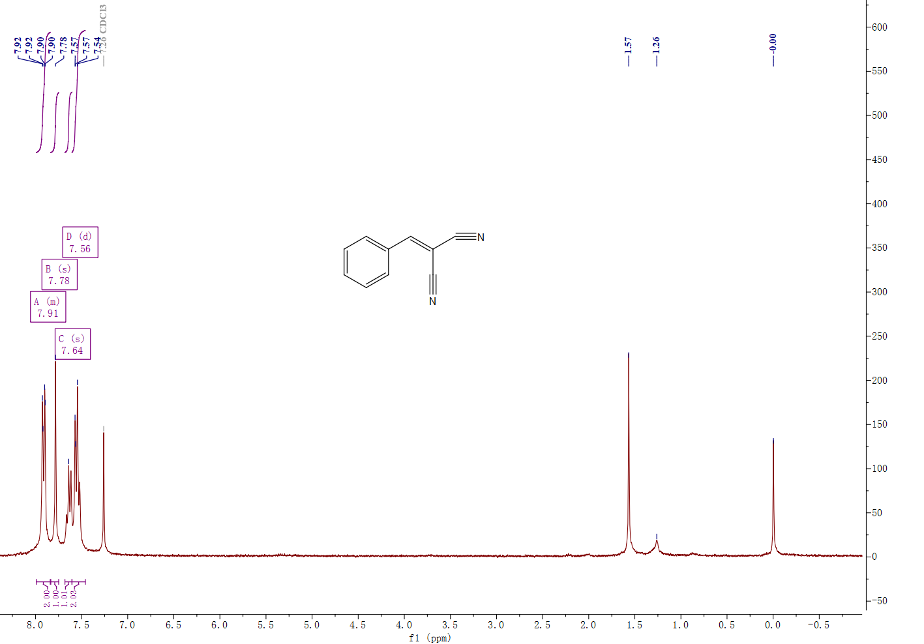
Figure S2. ¹H NMR (300 MHz, Chloroform-d) spectrum of benzylidenemalononitrile C1.
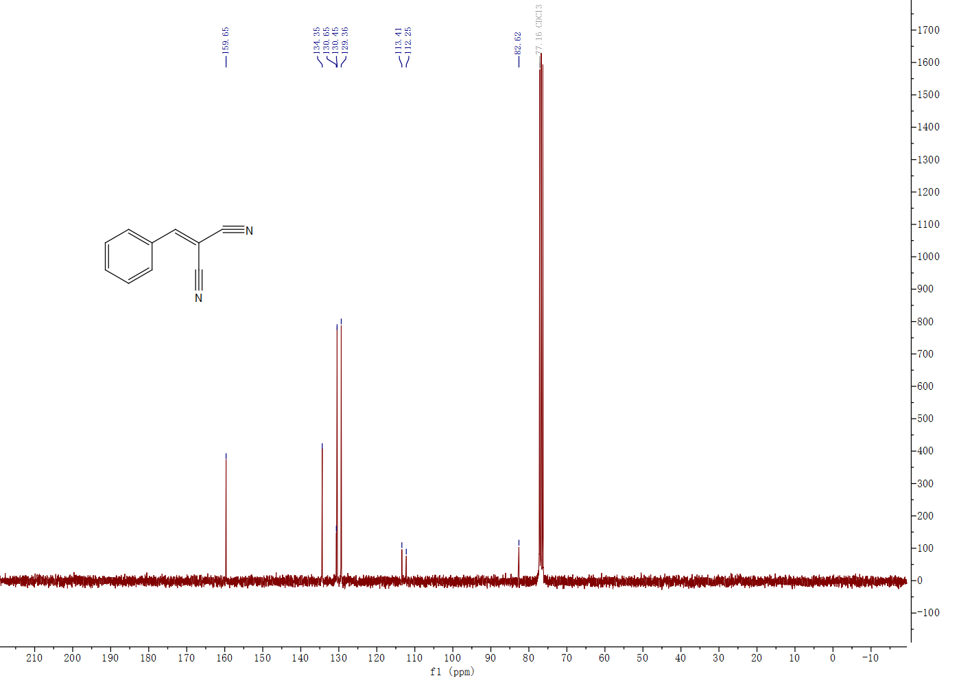
Figure S3. ¹³C NMR (75 MHz, CDCl₃) spectrum of benzylidenemalononitrile C1.
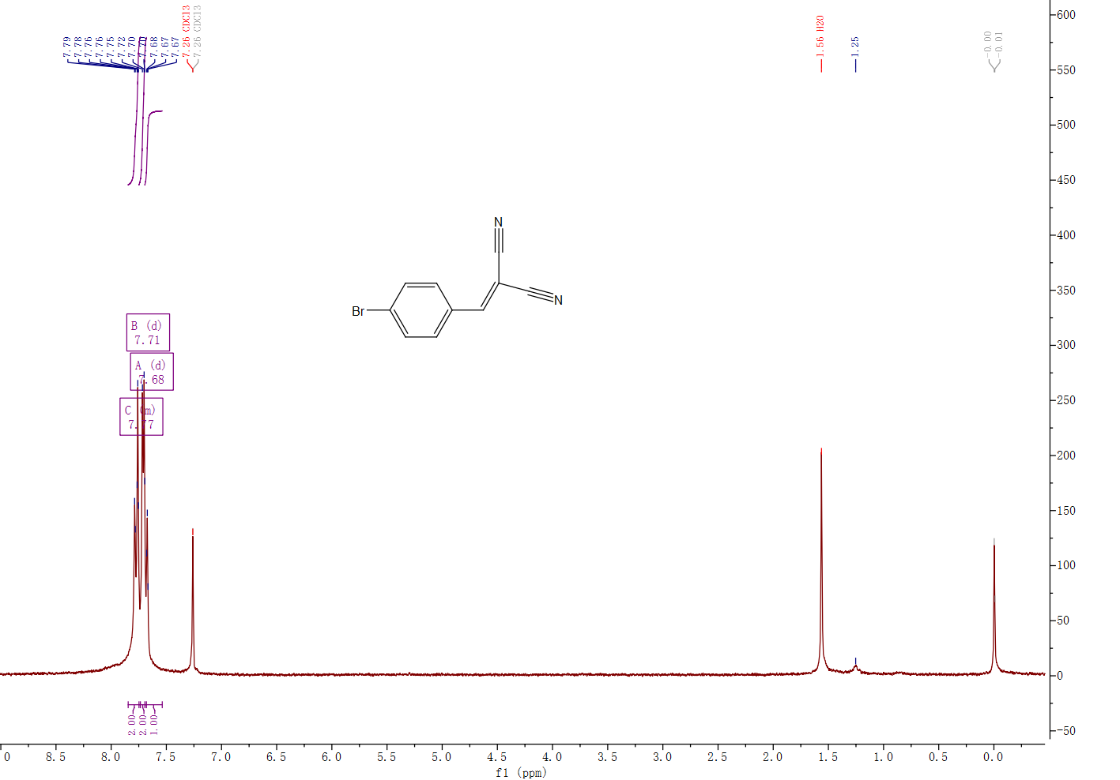
Figure S4. ¹H NMR (300 MHz, Chloroform-d) spectrum of 4-Bromobenzylidenemalonodinitrile C2.

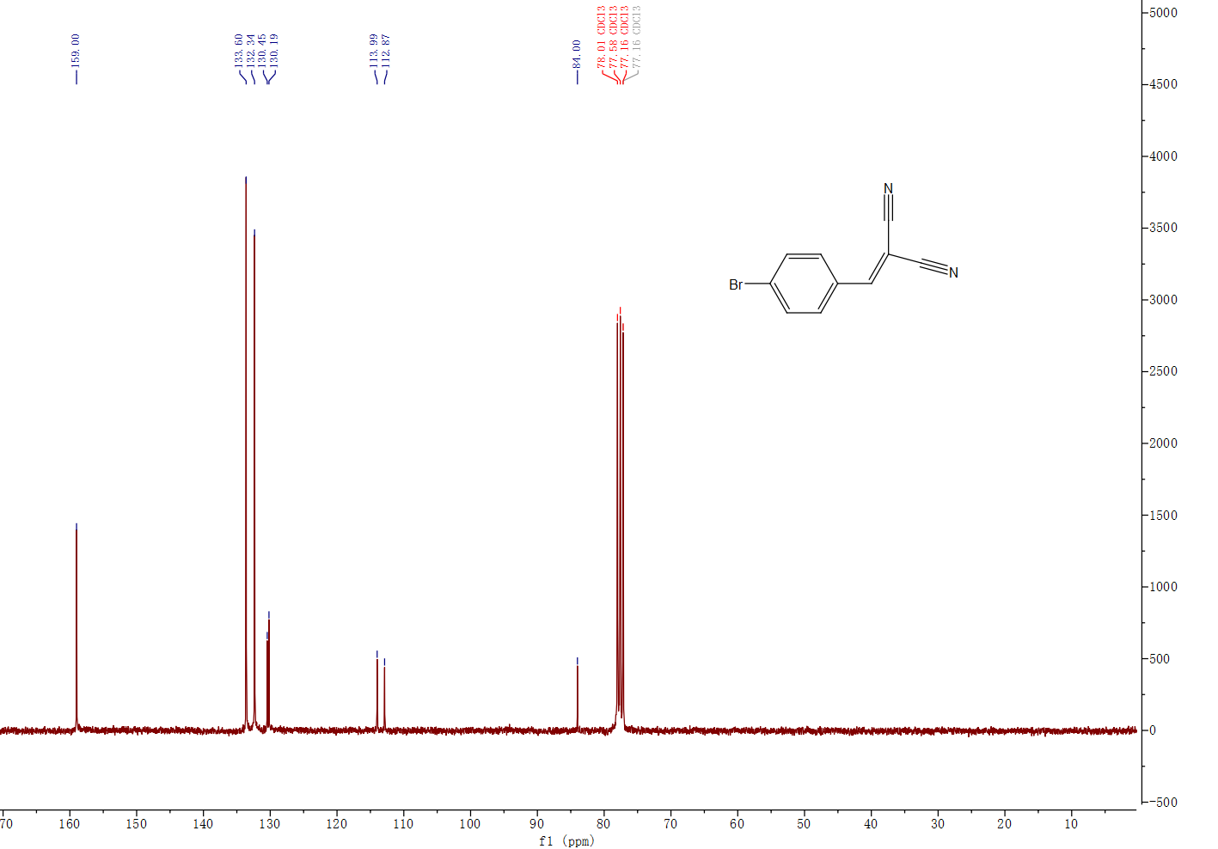
Figure S5. ¹³C NMR (75 MHz, CDCl₃) spectrum of 4-Bromobenzylidenemalonodinitrile C2.
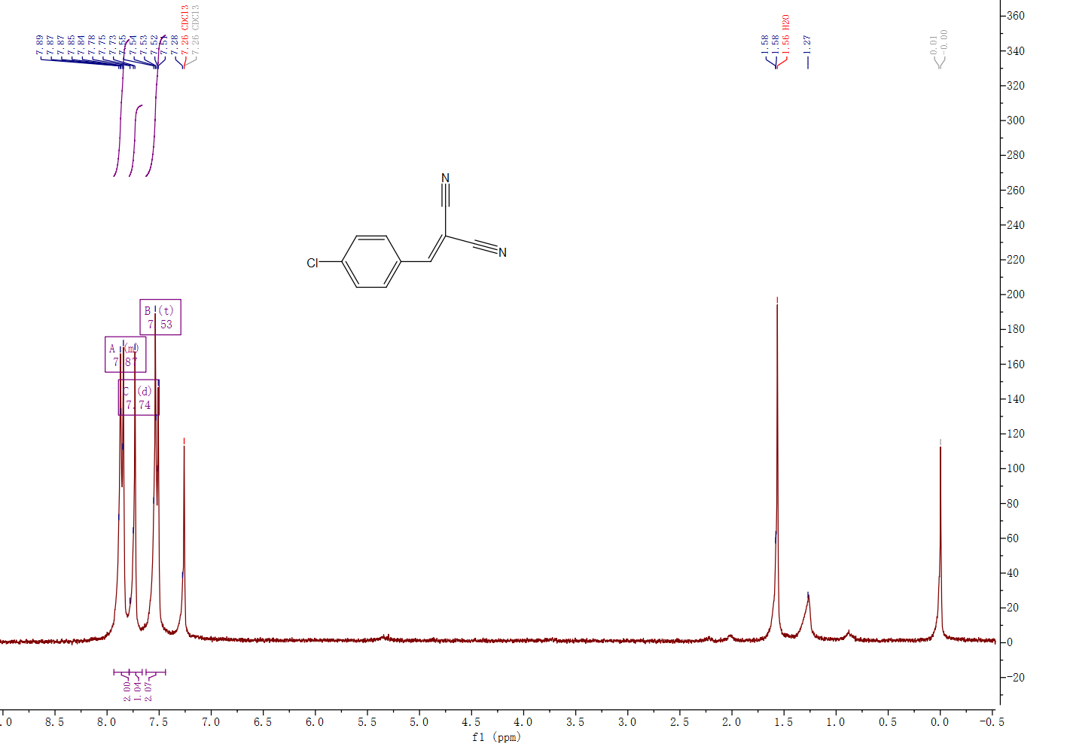
Figure S6. ¹H NMR (300 MHz, Chloroform-d) spectrum of 2-(4-chlorobenzylidene)malononitrile C3.

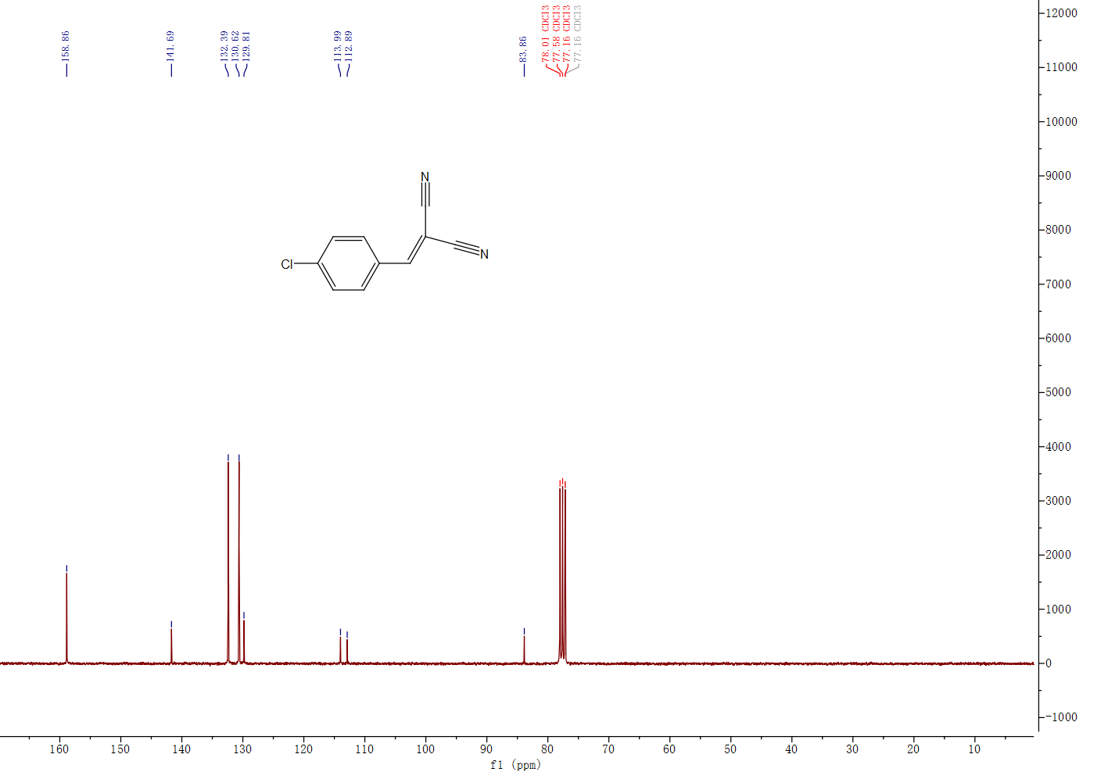Figure S7. ¹³C NMR (75 MHz, CDCl₃) spectrum of 2-(4-chlorobenzylidene)malononitrile C3.
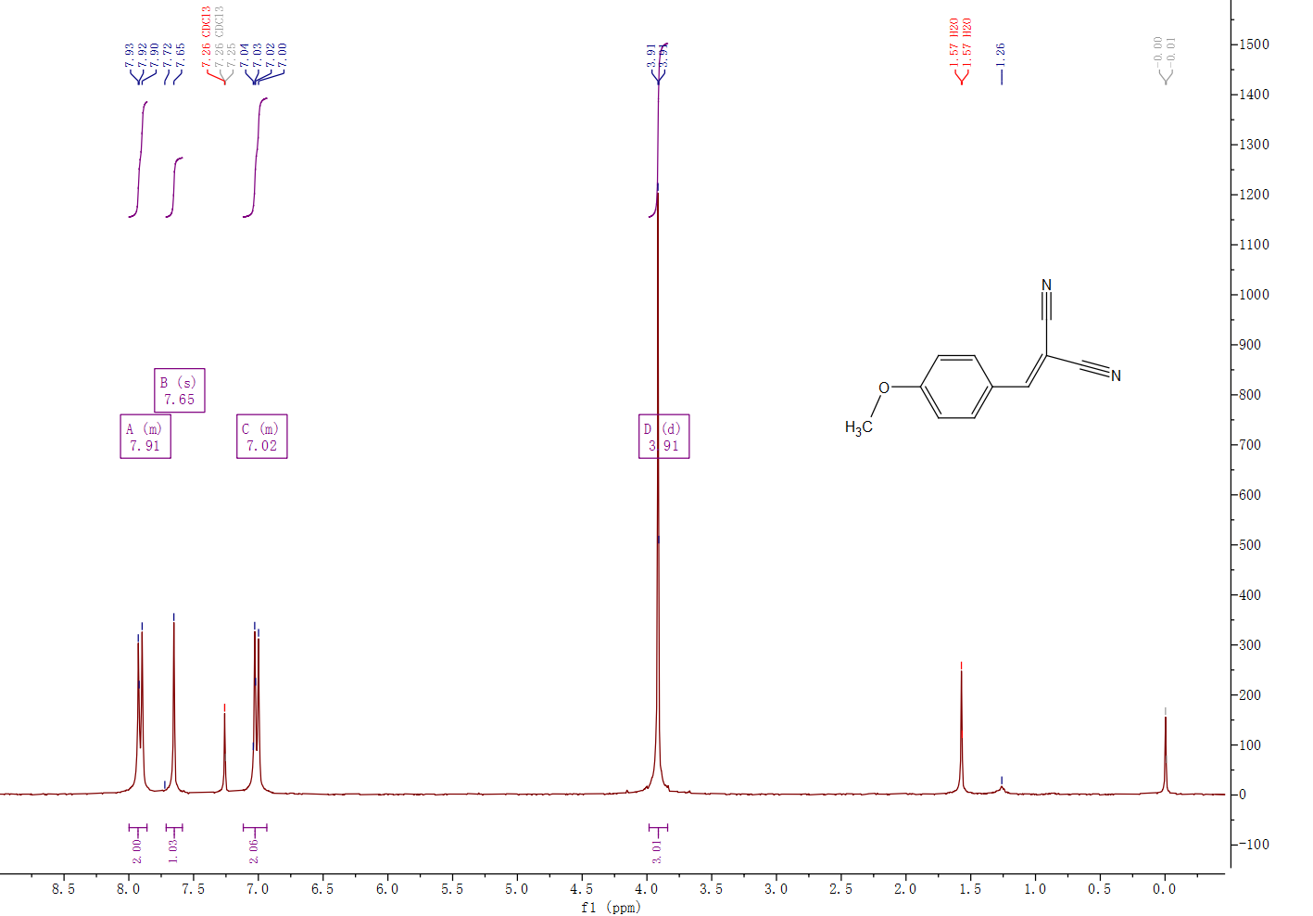
Figure S8. ¹H NMR (300 MHz, Chloroform-d) spectrum of 2-(4-Methoxyphenylmethylene)malononitrile C4.
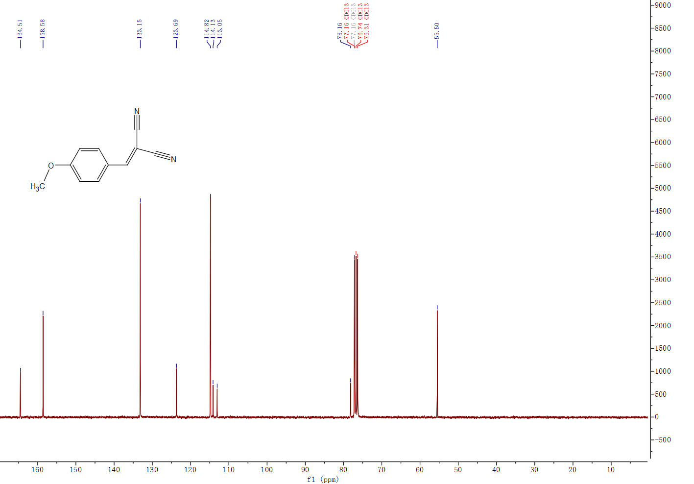Figure S9. ¹³C NMR (75 MHz, CDCl₃) spectrum of 2-(4-Methoxyphenylmethylene)malononitrile C4.
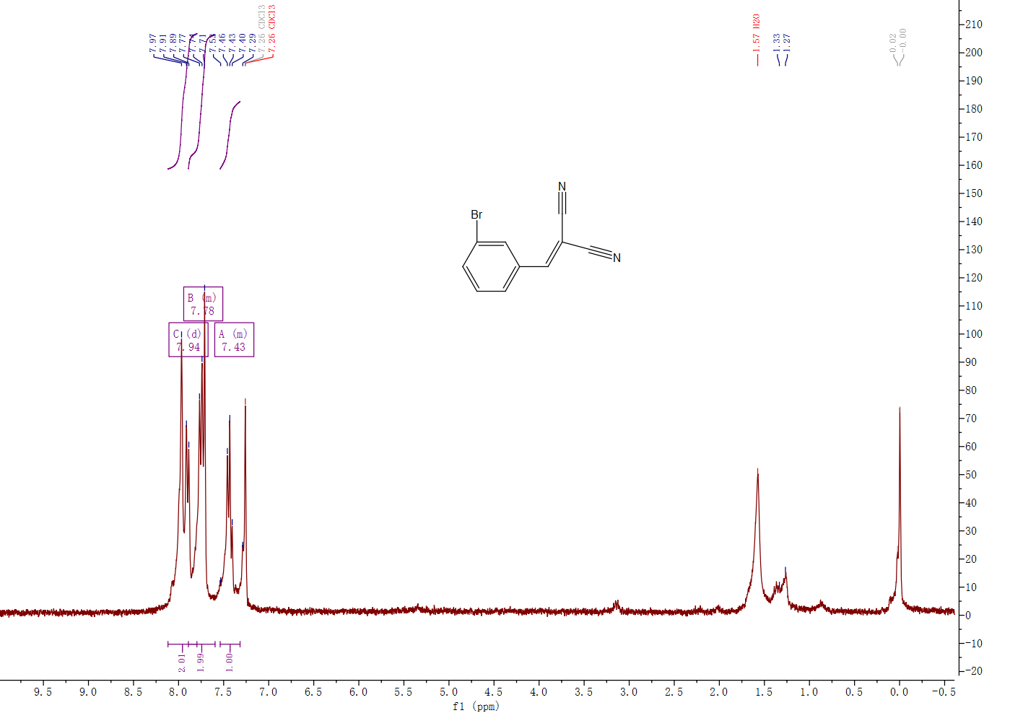
Figure S10. ¹H NMR (300 MHz, Chloroform-d) spectrum of 2-(3-bromobenzylidene)malononitrile C5.
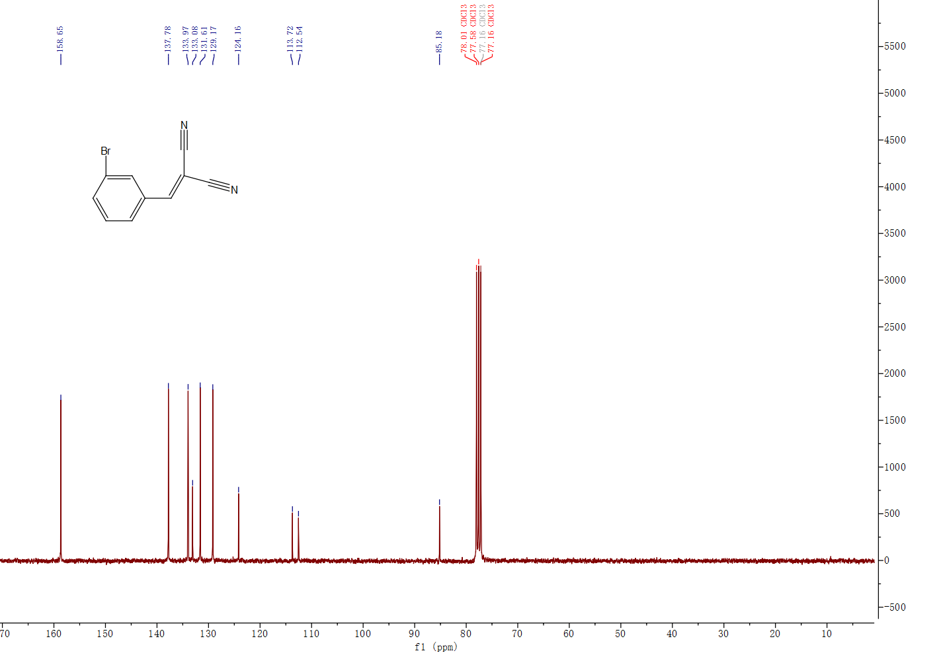Figure S11. ¹³C NMR (75 MHz, CDCl₃) spectrum of 2-(3-bromobenzylidene)malononitrile C5.
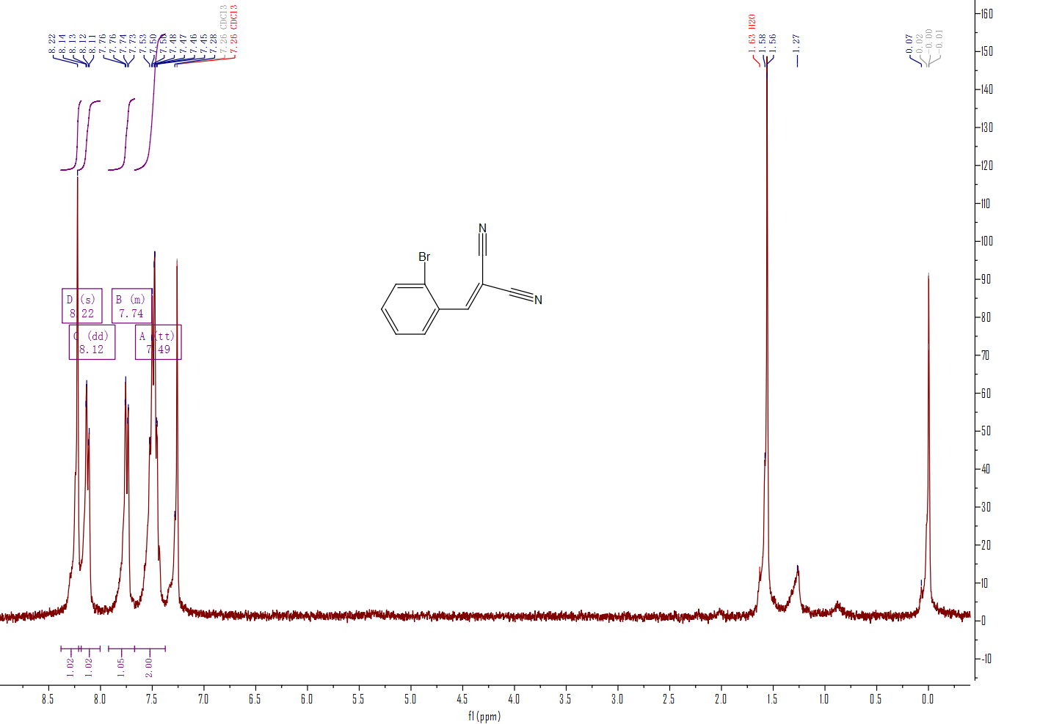
Figure S12. ¹H NMR (300 MHz, Chloroform-d) spectrum of 2-(2-bromobenzylidene)malononitrile C6.
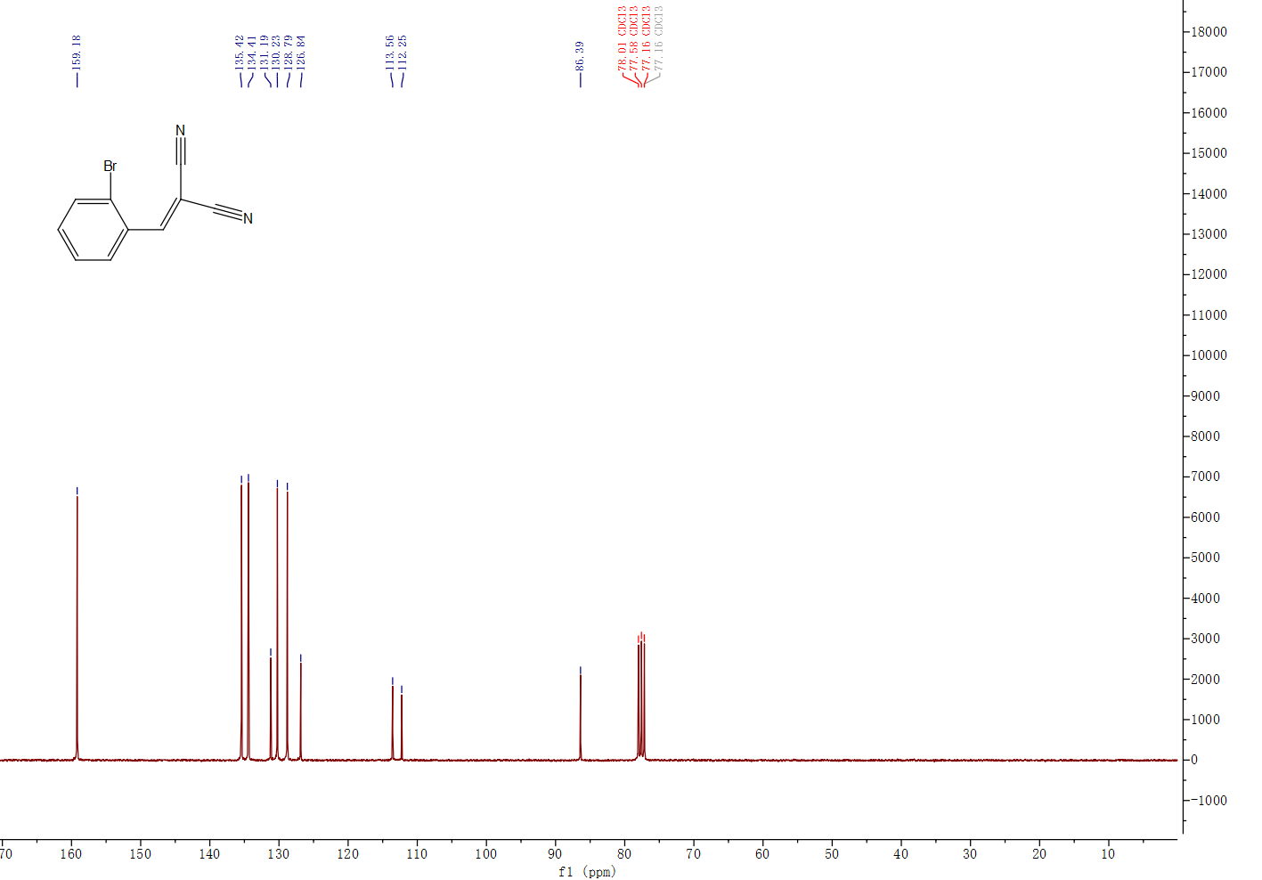Figure S13. ¹³C NMR (75 MHz, CDCl₃) spectrum of 2-(2-bromobenzylidene)malononitrile C6.
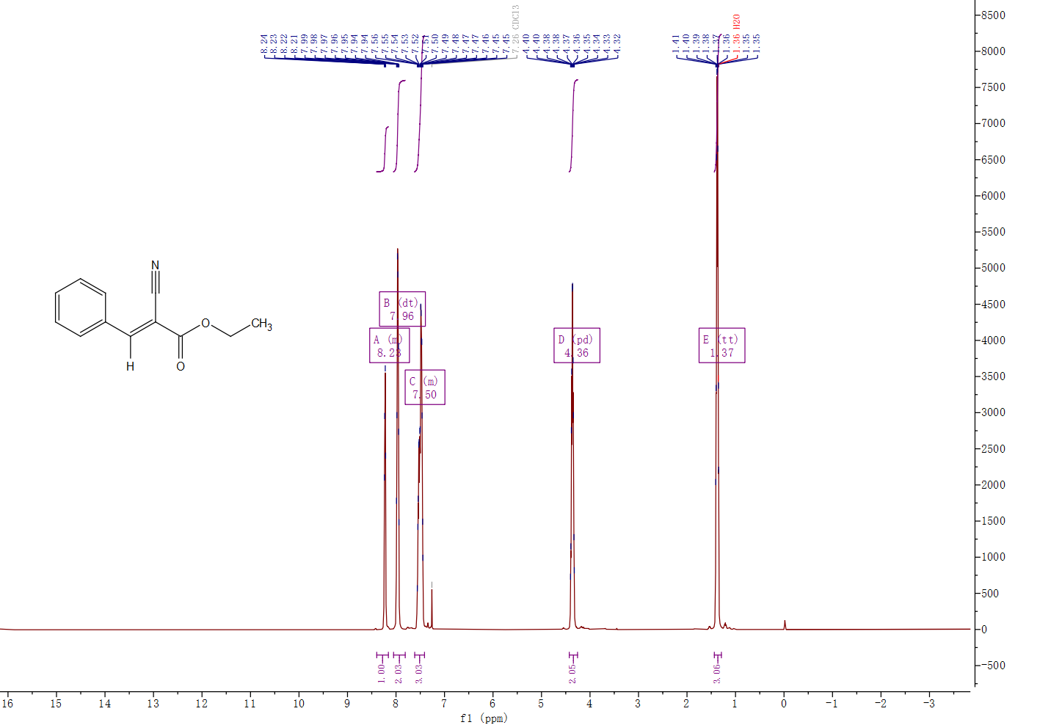
Figure S14. ¹H NMR (400 MHz, Chloroform-d) spectrum of (E)-ethyl 2-cyano-3-phenylacrylate C7.
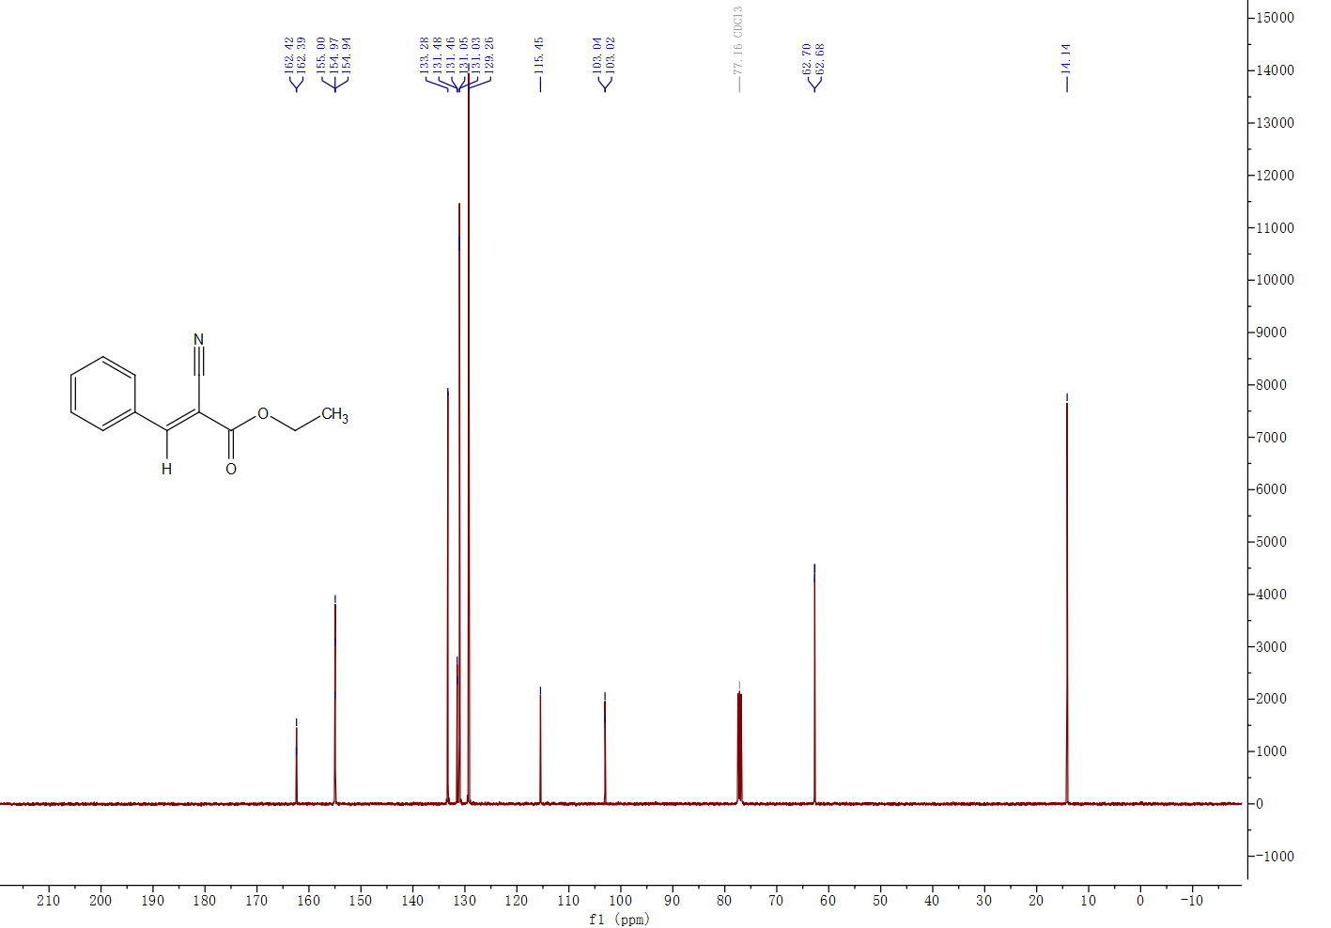
Figure S15. ¹³C NMR (101 MHz, CDCl₃) spectrum of (E)-ethyl 2-cyano-3-phenylacrylate C7.
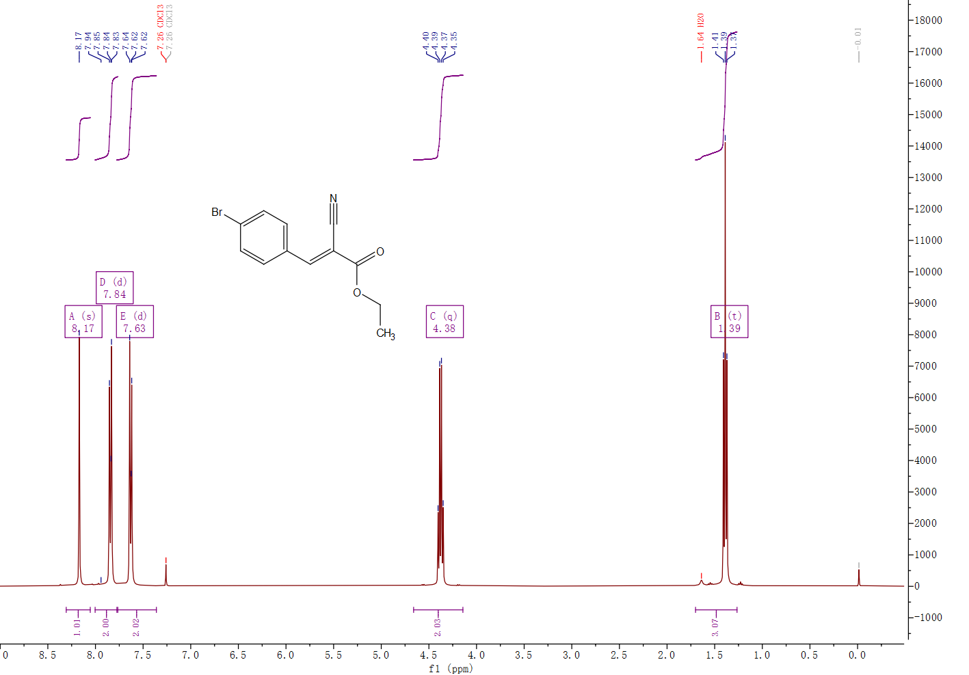
Figure S16. ¹H NMR (400 MHz, Chloroform-d) spectrum of ethyl (E)-3-(4-bromophenyl)-2-cyanoacrylate C8.
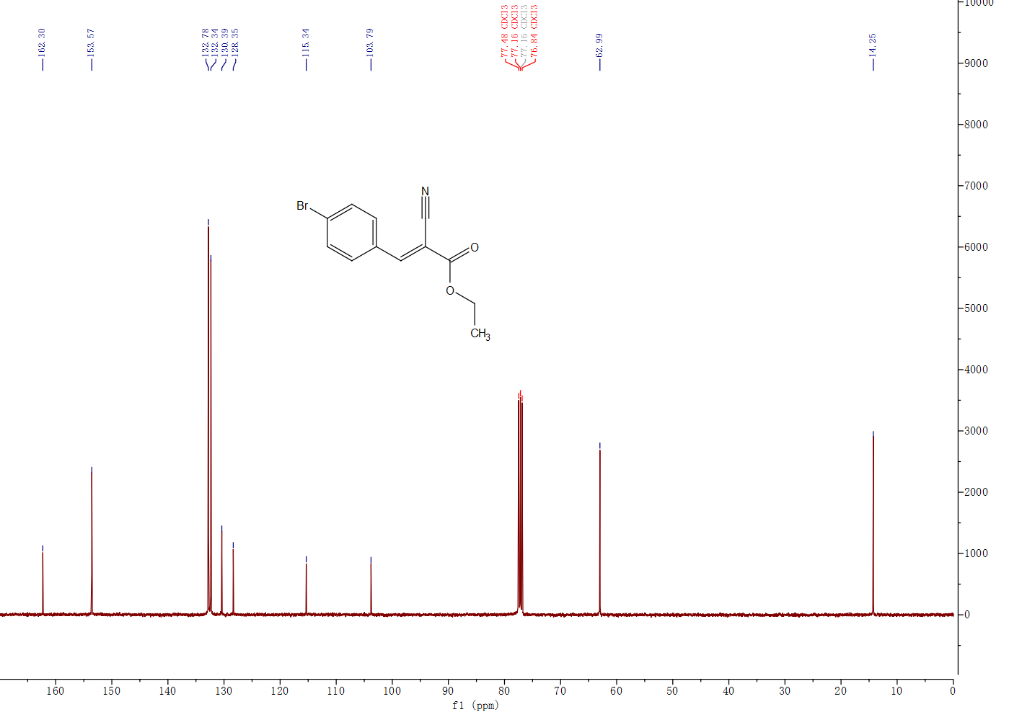Figure S17. ¹³C NMR (101 MHz, CDCl₃) spectrum of ethyl (E)-3-(4-bromophenyl)-2-cyanoacrylate C8.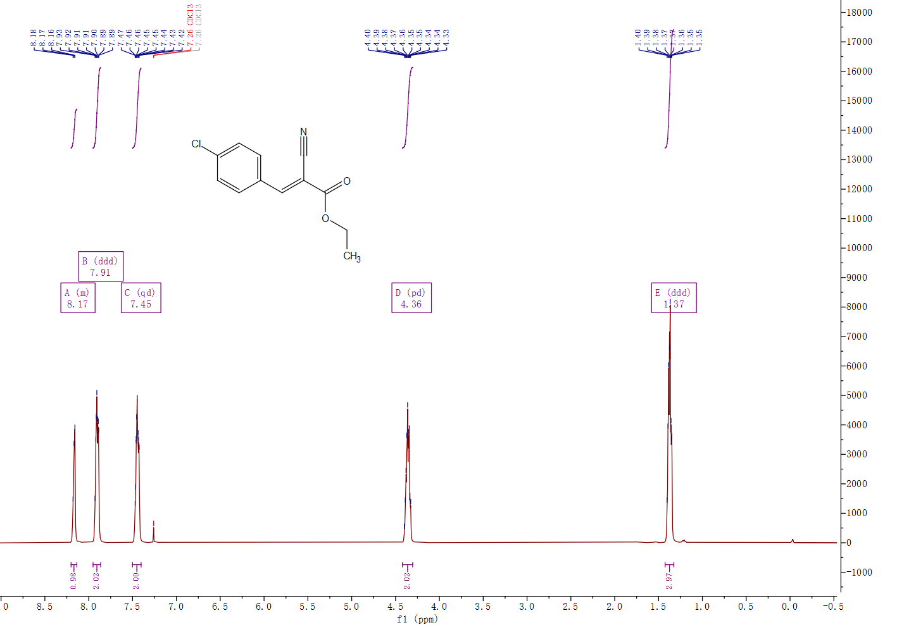
Figure S18. ¹H NMR (400 MHz, Chloroform-d) spectrum of ethyl (E)-3-(4-chlorophenyl)-2-cyanoacrylate C9.
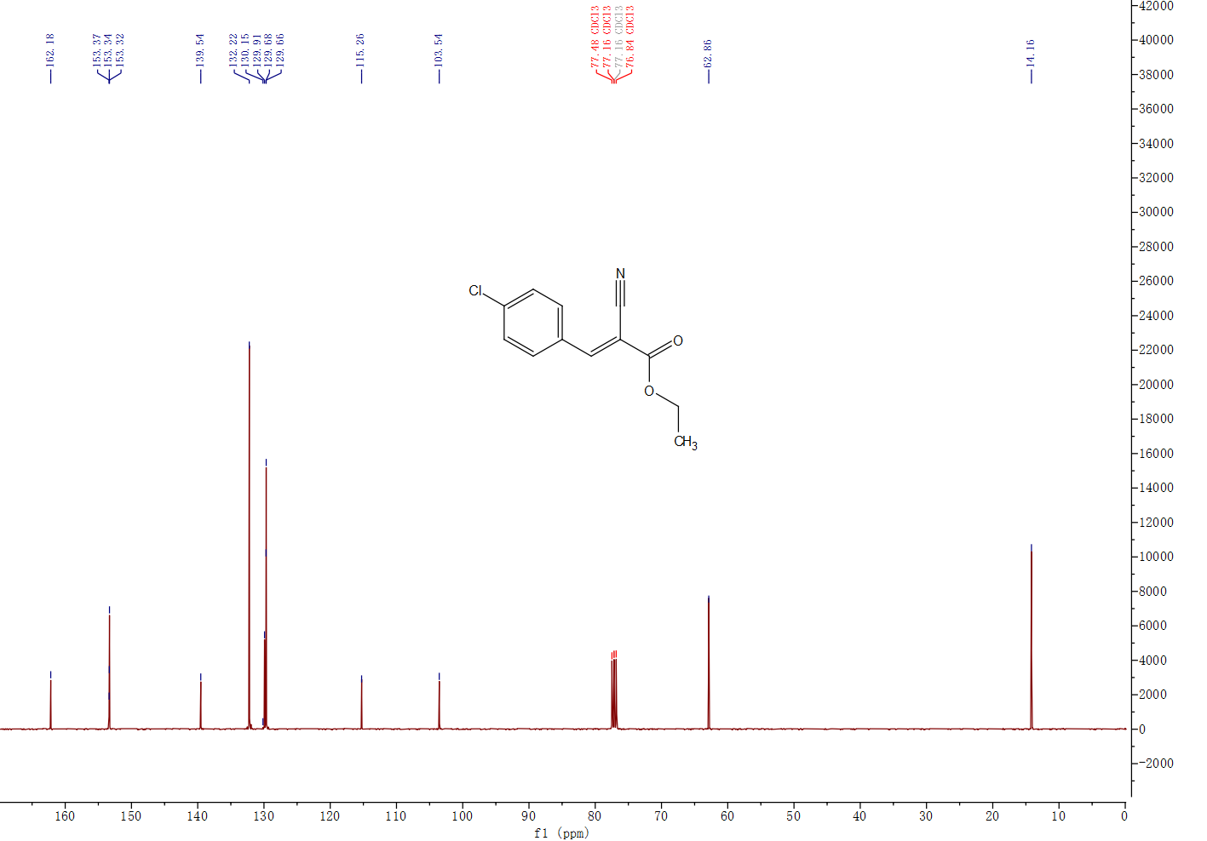Figure S19. ¹³C NMR (101 MHz, CDCl₃) spectrum of ethyl (E)-3-(4-chlorophenyl)-2-cyanoacrylate C9.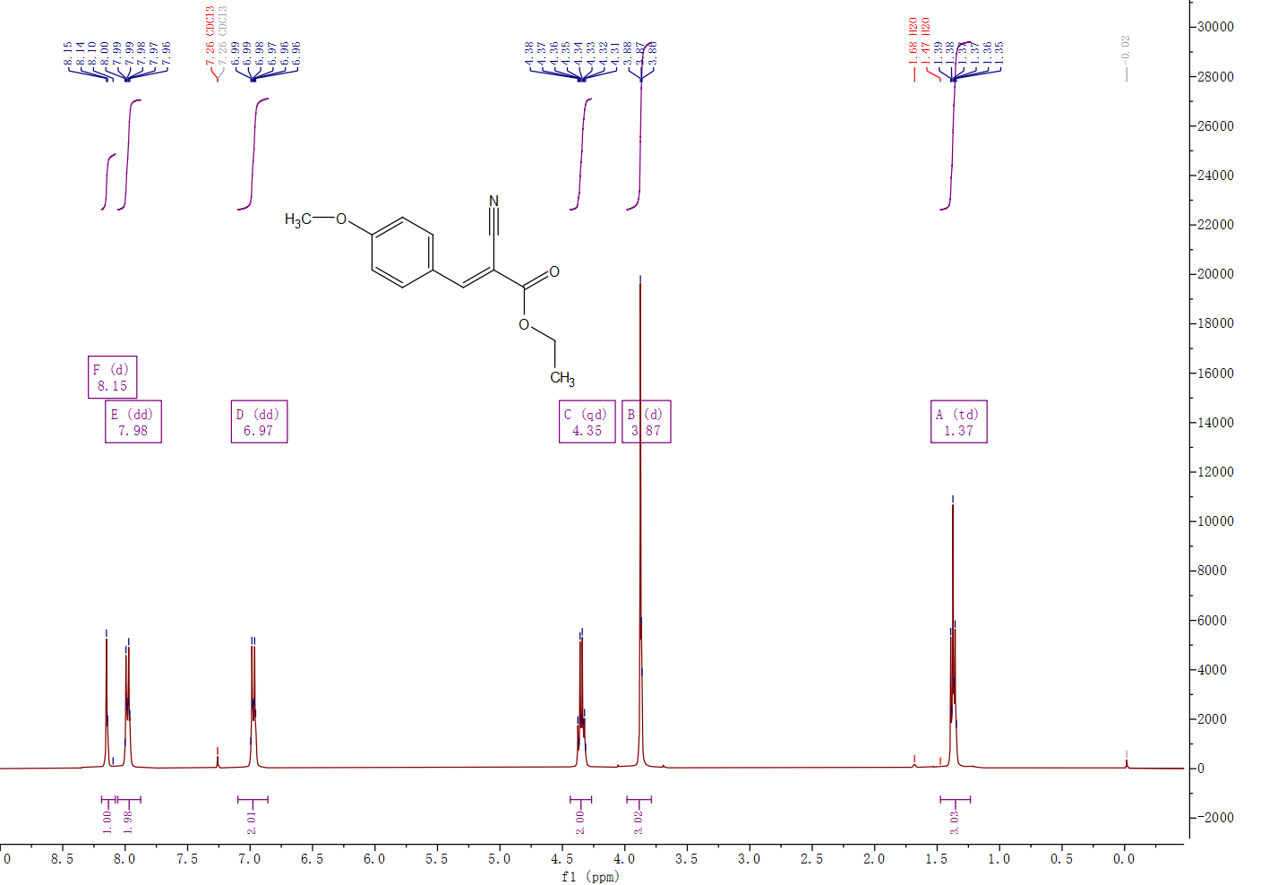
Figure S20. ¹H NMR (400 MHz, Chloroform-d) spectrum of (E)-2-cyano-3-(4-methoxyphenyl)acrylate C10.
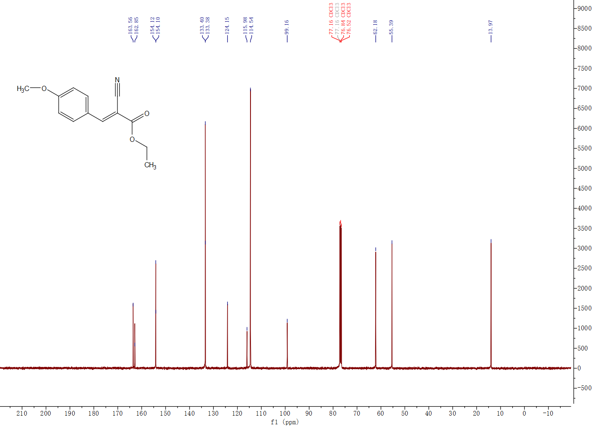
Figure S21. ¹³C NMR (101 MHz, CDCl₃) spectrum of (E)-2-cyano-3-(4-methoxyphenyl)acrylate C10.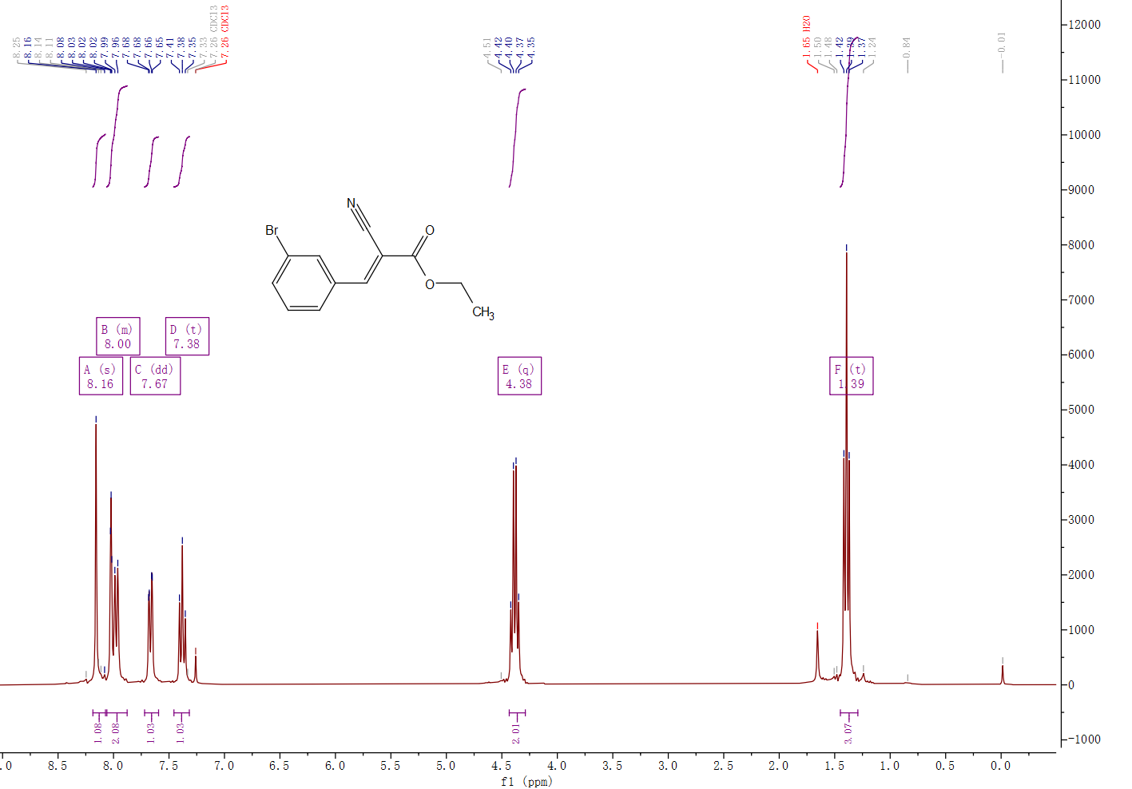
Figure S22. ¹H NMR (300 MHz, Chloroform-d) spectrum of ethyl (E)-3-(3-bromophenyl)-2-cyanoacrylate C11.
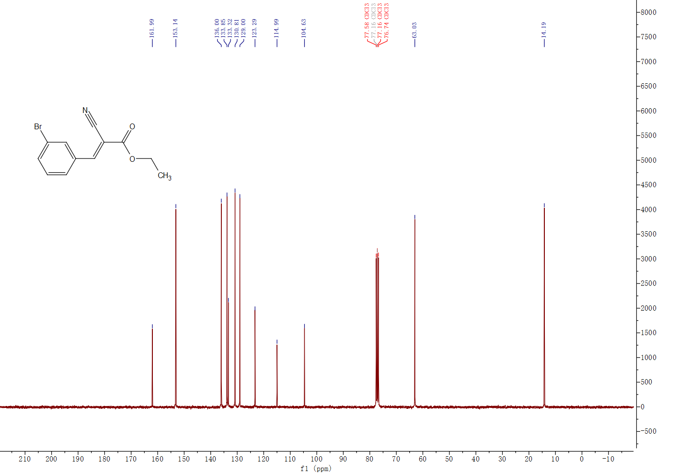Figure S23. ¹³C NMR (75 MHz, CDCl₃) spectrum of ethyl (E)-3-(3-bromophenyl)-2-cyanoacrylate C11.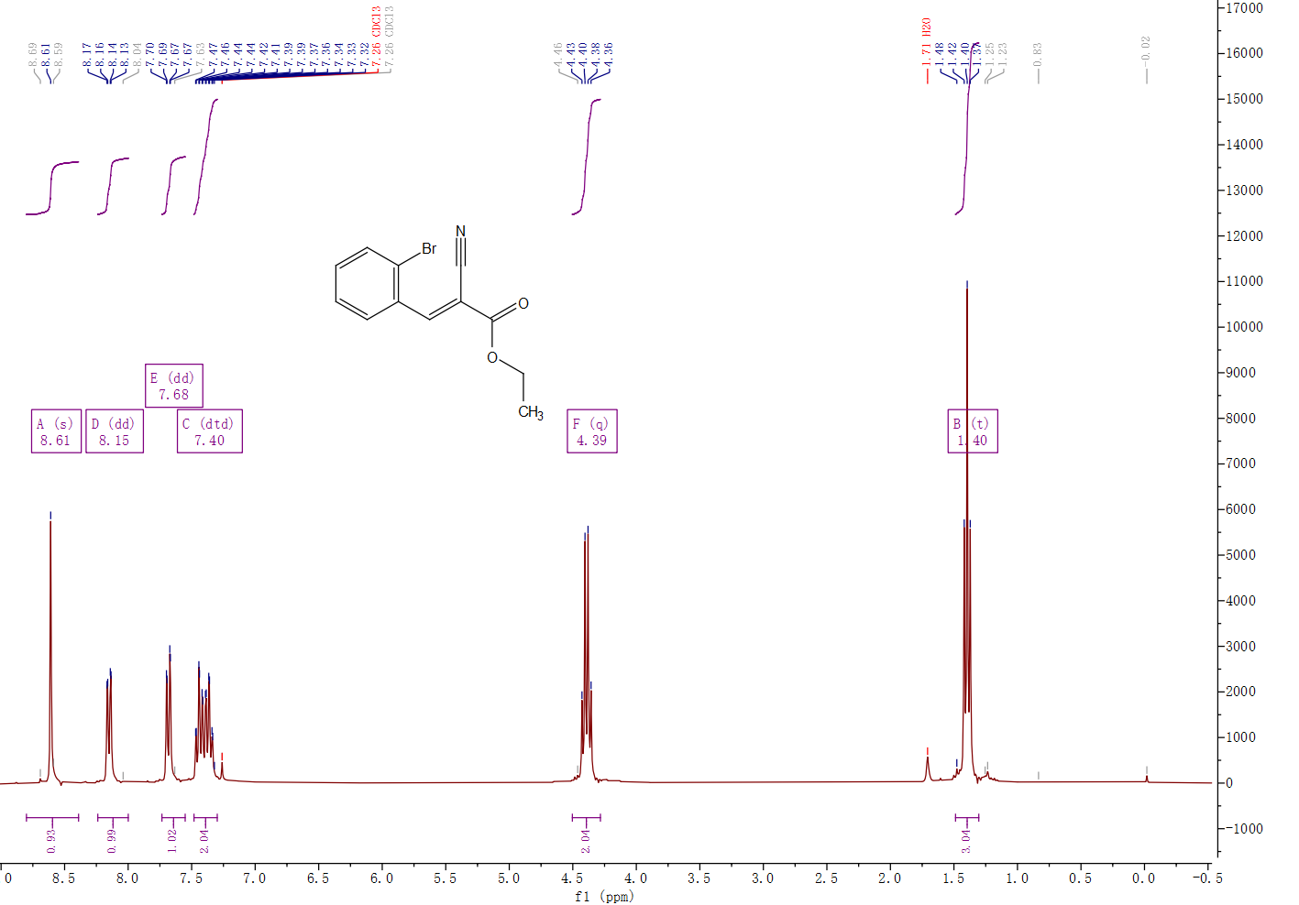
Figure S24. ¹H NMR (300 MHz, Chloroform-d) spectrum of ethyl (E)-3-(2-bromophenyl)-2-cyanoacrylate C12.
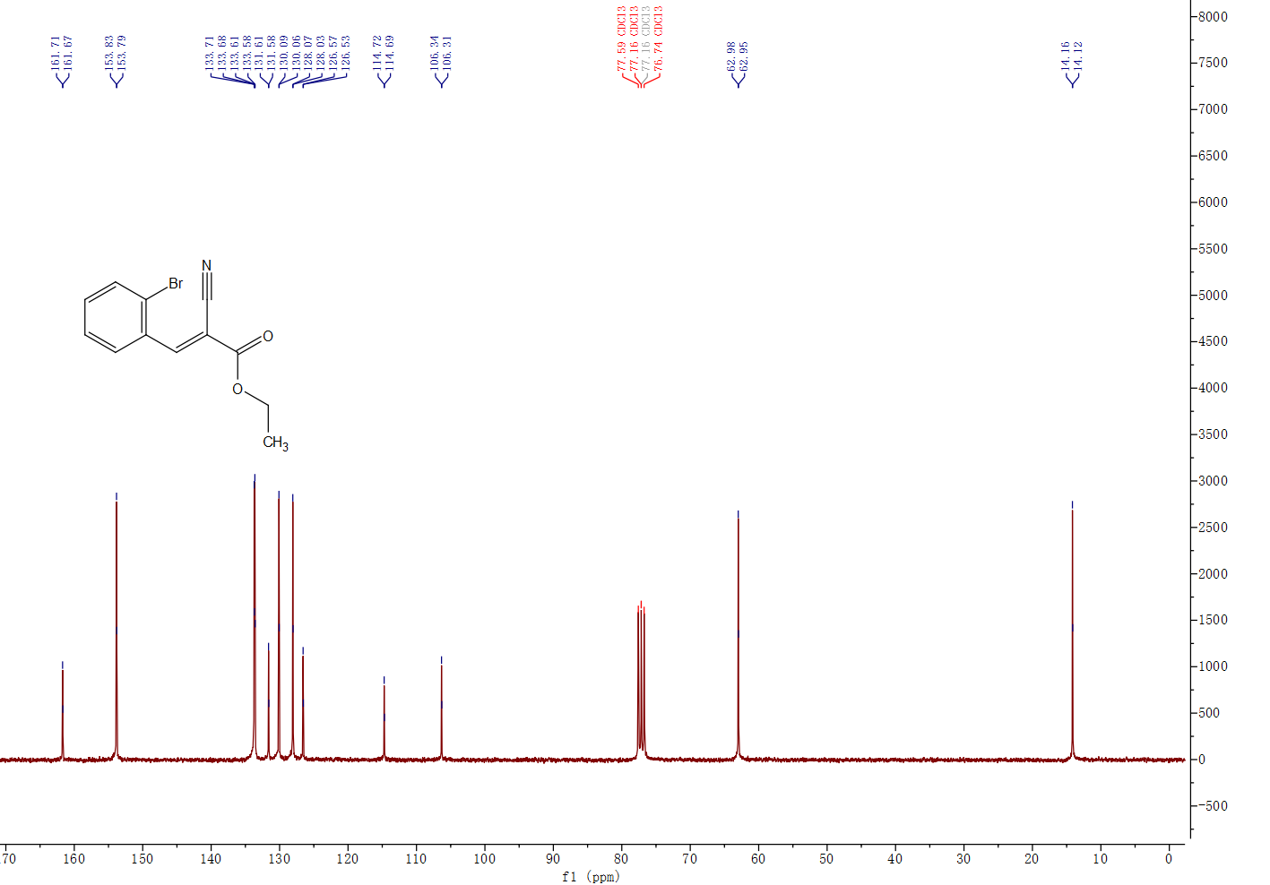
Figure S25. ¹³C NMR (75 MHz, CDCl₃) spectrum of ethyl (E)-3-(2-bromophenyl)-2-cyanoacrylate C12.

