Supporting Information
for
Production of bioethanol from wheat straw via optimization of co-culture conditions of Bacillus licheniformis and Saccharomyces cerevisiae
Shweta Sharma*, Paras Kumar Jha*, Dr. Amit Panwar*#

1. Preparation of Culture Medium-
1.1 Yeast growth media-
YEPD media (Yeast Extract 10g/L, dextrose 20g/L and Peptone 20 g/L) was prepared by adding 1 g yeast extract, 2g dextrose, 2g peptone in 100 ml of distilled water. This composition was used throughout the experiment for the growth of S. cerevisiae (Michael P. Washburn et al., 2002)

1.2 Bacillus growth media-
Nutrient broth media (13 g/l) was prepared by adding 1.3 g nutrient broth in 100 ml distilled water. This composition was used throughout the experiment for growth of Bacillus licheniformis (Ghaly et al., 2007).

1.3 Pure stock culture preparation –
Media was sterilized in an autoclave at 15 psi, 121ºC for 18 minutes. Lyophilized culture of B. licheniformis and S. cerevisiae was inoculated into the media and was incubated at 30⁰C for 24 hours at 121 rpm in an incubator shaker. After 24 hours, YPD Agar and Nutrient Agar plates were prepared and streaking of fresh cultures was carried out to obtain isolated colonies.
1.4. Maintenance and Propagation of Culture-
The yeast and bacterial cultures were maintained by sub-culturing them after every 15 days on YPD agar plates made by adding 1g yeast extract, 2g peptone, 2g dextrose and 2 gm agar in 100 ml distilled water, followed by an incubation for 24 hours at 30ºC and thereafter stored in a refrigerator at 4ºC till further use.
Maintenance conditions – Growth condition: Aerobic at 121rpm, temperature 30⁰C.
2 Glucose and bioethanol production in treated and untreated wheat straw medium
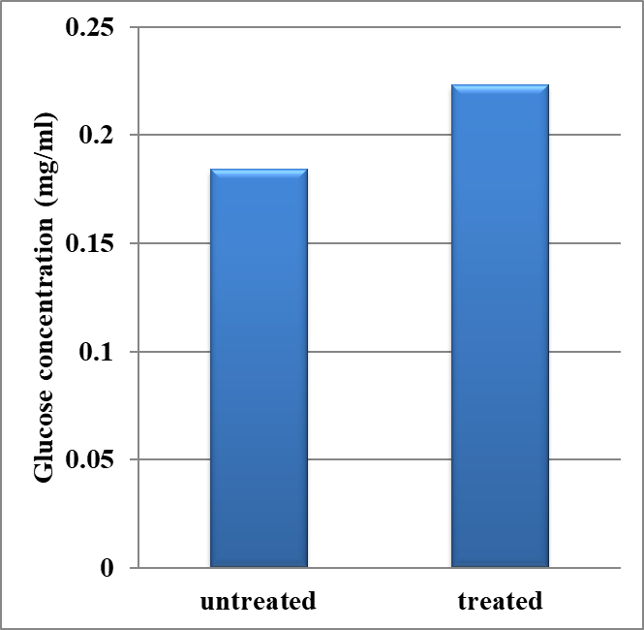
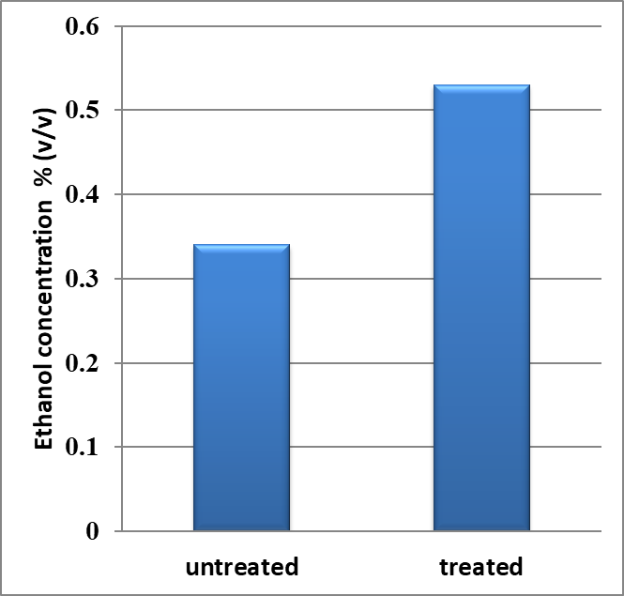
Figure S1 Glucose and bioethanol production in untreated and treated wheat straw medium

3 Effect of pre-treatment on glucose and ethanol production
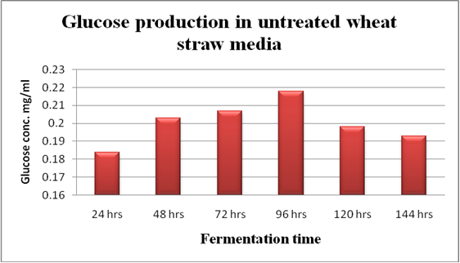

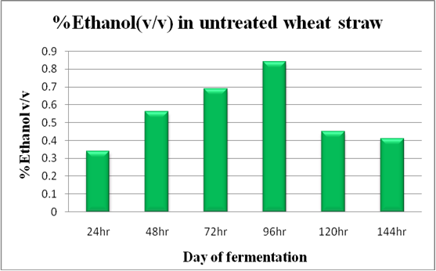
Figure S2 - Glucose and bioethanol production in untreated wheat straw at different fermentation time.

4 Optimization of time for co-culture
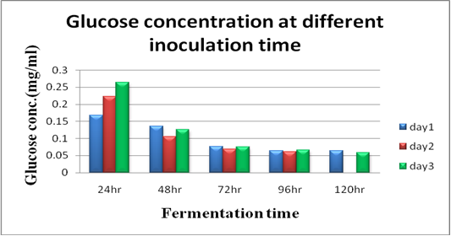

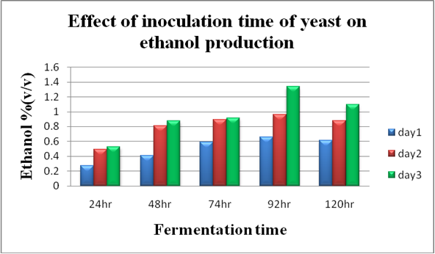
Figure S3 – The effect of inoculation time on glucose and ethanol production.

5 Ethanol standard curve by caputi method-

Figure S4 – Ethanol standard curve for bioethanol estimation

6 Glucose standard curve prepared by using DNS method

Figure S5 – Glucose standard curve for glucose estimation

7 GC analysis for bioethanol yield quantification
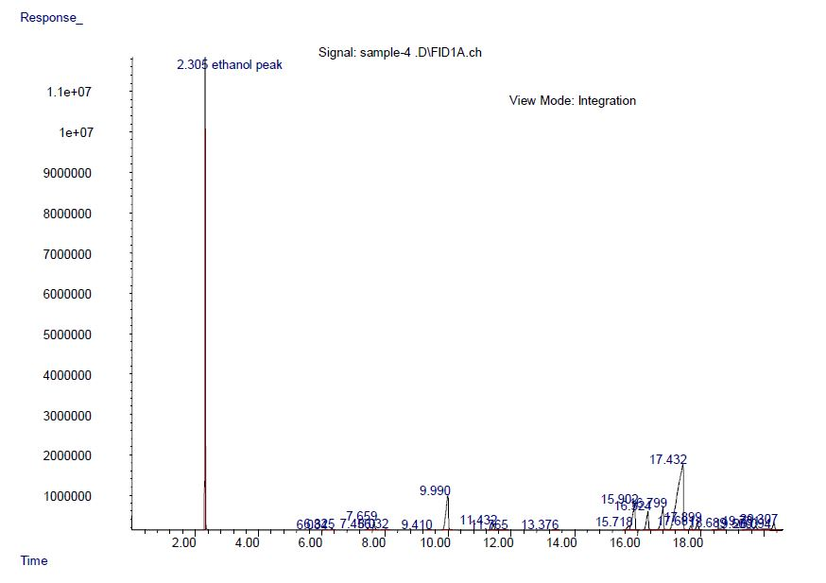
Figure S6 – GC chromatogram of bioethanol produced in fermenter after 120 hours of SSF

