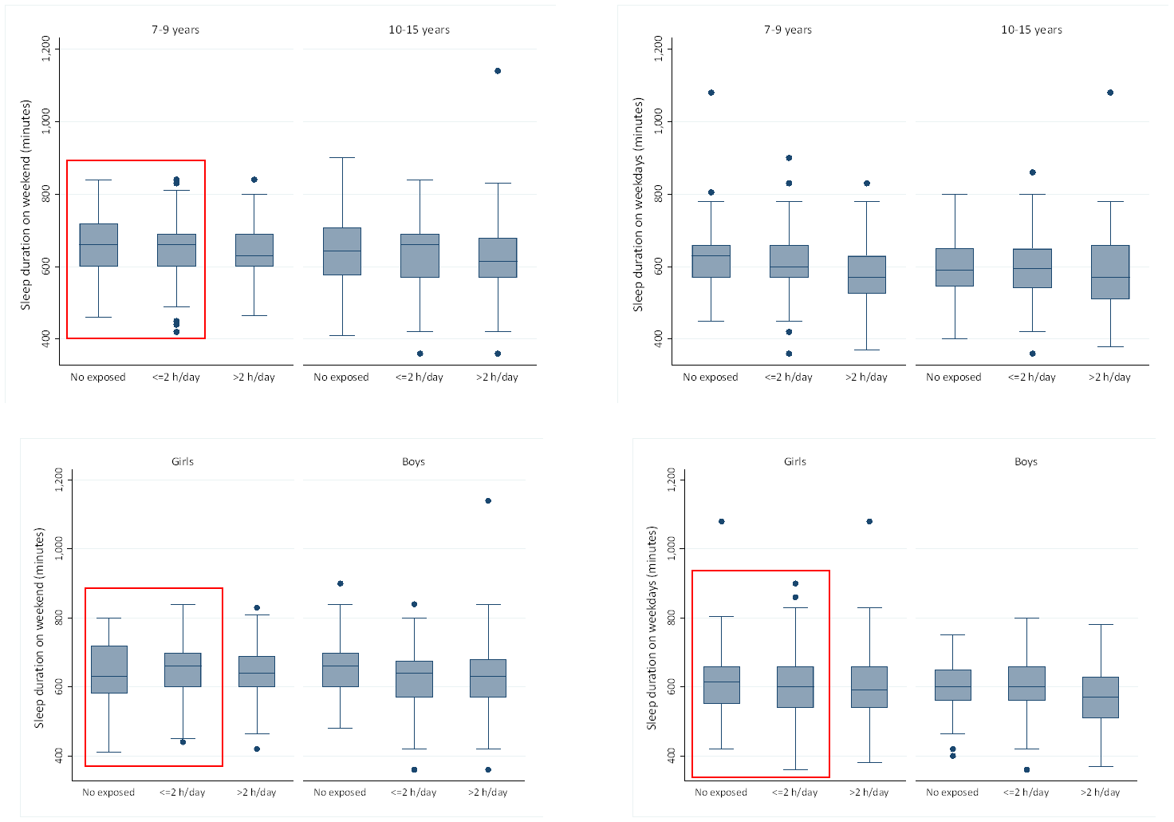
Figure 3 (Suppl.). Graphic representations of associations between screen time exposure and sleep duration on weekdays and weekend, stratified by gender and age range.

