Supporting Information
Pincer Nickel(II) Catalyzed Oxidative Carbonylation of Amines: A Phosgene-Free Synthesis for Isocyanates and Ureas

Peter Szwedo¹, Raja Shekhar Kondrapolu¹, Pradip Munshi²*, & Anindya Ghosh¹*

¹Department of Chemistry, University of Arkansas at Little Rock, 2801 South University Avenue, Little Rock, AR 72204, USA
²CISCHEM, Centre for Innovation and Sustainable Chemistry, Kalpvruksh Complex, Vadodara, Gujarat 390021, India.

*corresponding author
E-mail: axghosh@ualr.edu, Phone: 501 569 8827, Fax: 501 569 8838

Gas Chromatography-Mass Spectrometry
1-isocyanatopropane S1
1-isocyanatobutane S2
1-isocyanatopentane S3
1-isocyanatohexane S4
1-isocyanatoheptane S5
1-isocyanatoocatane S6
1-isocyanatononane S7
1-isocyanatodecane S8
Isocyanatocyclohexane S9
(isocyanatomethyl)benzene S10
1-( isocyanatomethyl)-4-methylbenzene S11
1-( isocyanatomethyl)-4-methoxybenzene S12
(3-isocyanatopropyl)benzene S13
1-chloro-4-(isocyanatomethyl)benzene S14
1-fluoro-4-(isocyanatomethyl)benzene S15
(1-isocyanatoethyl)benzene S16
1,3-dipropylurea S17
1,3-dibutylurea S18
1,3-dipentylurea S19
1,3-dihexylurea S20
1,3-diheptylurea S21
1,3-dioctylurea S22
1,3-dinonylurea S23
1,3-didecylurea S24
1,3-dicyclohexyllurea S25
1,3-dibenzylurea S26
1,3-bis(4-methylbenzyl)urea S27
1,3-bis(4-methoxybenzyl)urea S28
1,3-bis(3-phenpropyl)urea S29
1,3-bis(4-chlorobenzyl)urea S30
1,3-bis(4-fluorobenzyl)urea S31
1,3-bis(1-phenylethyl)urea S32
Other Instrumentation
Ligand FT-IR S33
Ligand ¹H NMR and ¹³C NMR S34
Ligand ¹H NMR and ¹³C NMR S35
Metal Complex ESI-MS (negative mode) S36
Metal Complex FT-IR S37
Metal Complex ¹H NMR S38

Gas Chromatography-Mass Spectrometry

S1: 1-isocyanatopropane
S2: 1-isocyanatobutane
S3: 1-isocyanatopentane
S4: 1-isocyanatohexane
S5: 1-isocyanatoheptane
S6: 1-isocyanatoocatane
S7: 1-isocyanatononane
S8: 1-isocyanatodecane
S9: isocyanatocyclohexane
S10: (isocyanatomethyl)benzene
S11: 1-( isocyanatomethyl)-4-methylbenzene
S12: 1-(isocyanatomethyl)-4-methoxybenzene
S13: (3-isocyanatopropyl)benzene
S14: 1-chloro-4-(isocyanatomethyl)benzene
S15: 1-fluoro-4-(isocyanatomethyl)benzene
S16: (1-isocyanatoethyl)benzene
S17: 1,3-dipropylurea
S18: 1,3-dibutylurea
S19: 1,3-dipentylurea
S20: 1,3-dihexylurea
S21: 1,3-diheptylurea
S22: 1,3-dioctylurea
S23: 1,3-dinonylurea
S24: 1,3-didecylurea
S25: 1,3-dicyclohexylurea
S26: 1,3-dibenzylurea
S27: 1,3-bis(4-methylbenzyl)urea
S28: 1,3-bis(4-methoxybenzyl)urea
S29: 1,3-diphenylpropylurea
S30: 1,3-bis(4-chlorobenzyl)urea
S31: 1,3-bis(4-fluorobenzyl)urea
S32: 1,3-bis(1-phenylethyl)urea

Other Instrumentation

S33: FT-IR of NNN Ligand
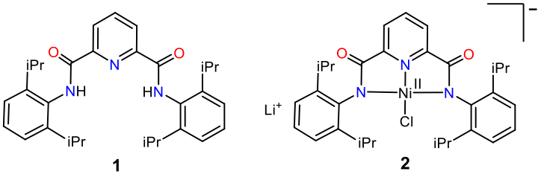

S34: ¹H NMR of NNN Ligand
¹H NMR (400 MHz, DMSO-d₆) δ 8.33 (d, J = 7.8 Hz, 2H), 8.29 – 8.20 (m, 1H), 7.35 – 7.27 (m, 2H), 7.20 (d, J = 7.8 Hz, 4H), 3.06 (h, J = 6.9 Hz, 4H), 1.21 – 1.04 (m, 25H).

S35: ¹³C NMR of NNN Ligand

¹³C NMR (101 MHz, DMSO-D₆) δ 163.18, 148.96, 146.71, 140.75 132.82, 128.60, 125.43, 123.63, 28.88, 23.77.

S36: ESI-MS (negative mode) of nickel (II) complex

S37: FT-IR of nickel (II) complex

S38: ¹H NMR of nickel (II) complex

