FIGURE S1

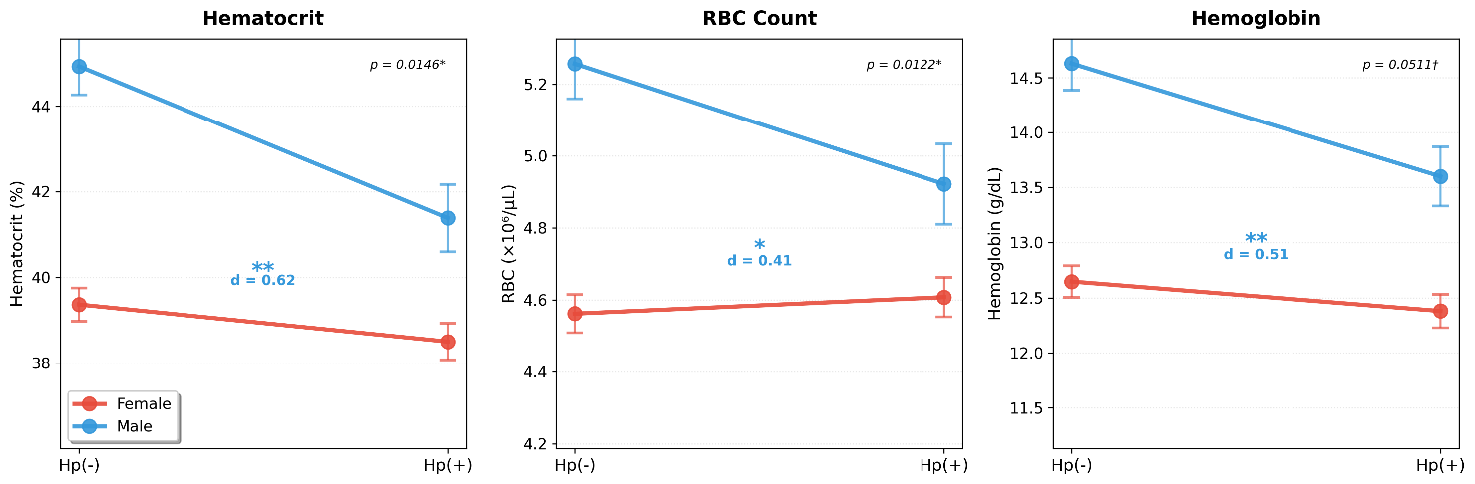

FIGURE S1. Sex × H. pylori interaction effects on hematological parameters. Non-parallel lines indicate significant sex × H. pylori interactions for hematocrit (p = 0.0146) and RBC count (p = 0.0122), with a near-significant interaction for hemoglobin (p = 0.0511). Error bars represent SEM. *p < 0.05, **p < 0.01, ***p < 0.001 for within-sex comparisons; †p < 0.10. d = Cohen's effect size.

FIGURE S2

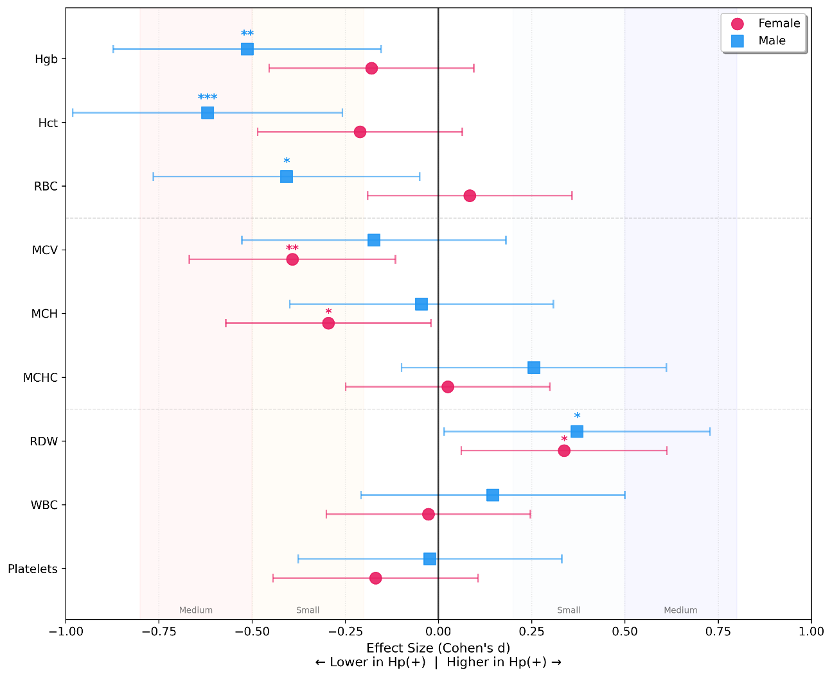
FIGURE S2. Forest plot of sex-stratified effect sizes (Cohen's d) for complete blood count parameters in H. pylori infection. Points represent effect sizes with 95% confidence intervals (horizontal lines). Negative values indicate lower values in H. pylori-positive compared to H. pylori-negative participants; positive values indicate higher values in H. pylori-positive participants. Circles represent females (pink), squares represent males (blue). *p < 0.05, **p < 0.01, ***p < 0.001. A vertical line at zero indicates no effect. Shaded regions indicate small (0.2-0.5) and medium (0.5-0.8) effect sizes.

TABLE S1

TABLE S1. WHO Anemia Prevalence and Types by Sex and H. pylori Status
 | Female |  |  | Male
Parameter | Hp(-) | Hp(+) | p-value | Hp(-) | Hp(+) | p-value
Anemia prevalence, n (%) | 25 (24.5) | 32 (31.1) | 0.372 | 7 (11.5) | 20 (32.3) | 0.010
Microcytic | 7 (28.0) | 16 (50.0) |  | 2 (28.6) | 7 (35.0)
Normocytic | 17 (68.0) | 15 (46.9) |  | 3 (42.9) | 13 (65.0)
Macrocytic | 1 (4.0) | 1 (3.1) |  | 2 (28.6) | -
WHO anemia criteria: Males Hgb <13.0 g/dL, Females Hgb <12.0 g/dL. Anemia types: Microcytic <80 fL, Normocytic 80-95 fL, Macrocytic >95 fL.
Data presented as n (%). Anemia prevalence calculated as % of total participants; anemia types calculated as % of anemic participants only. Bold p-values indicate p<0.05.

