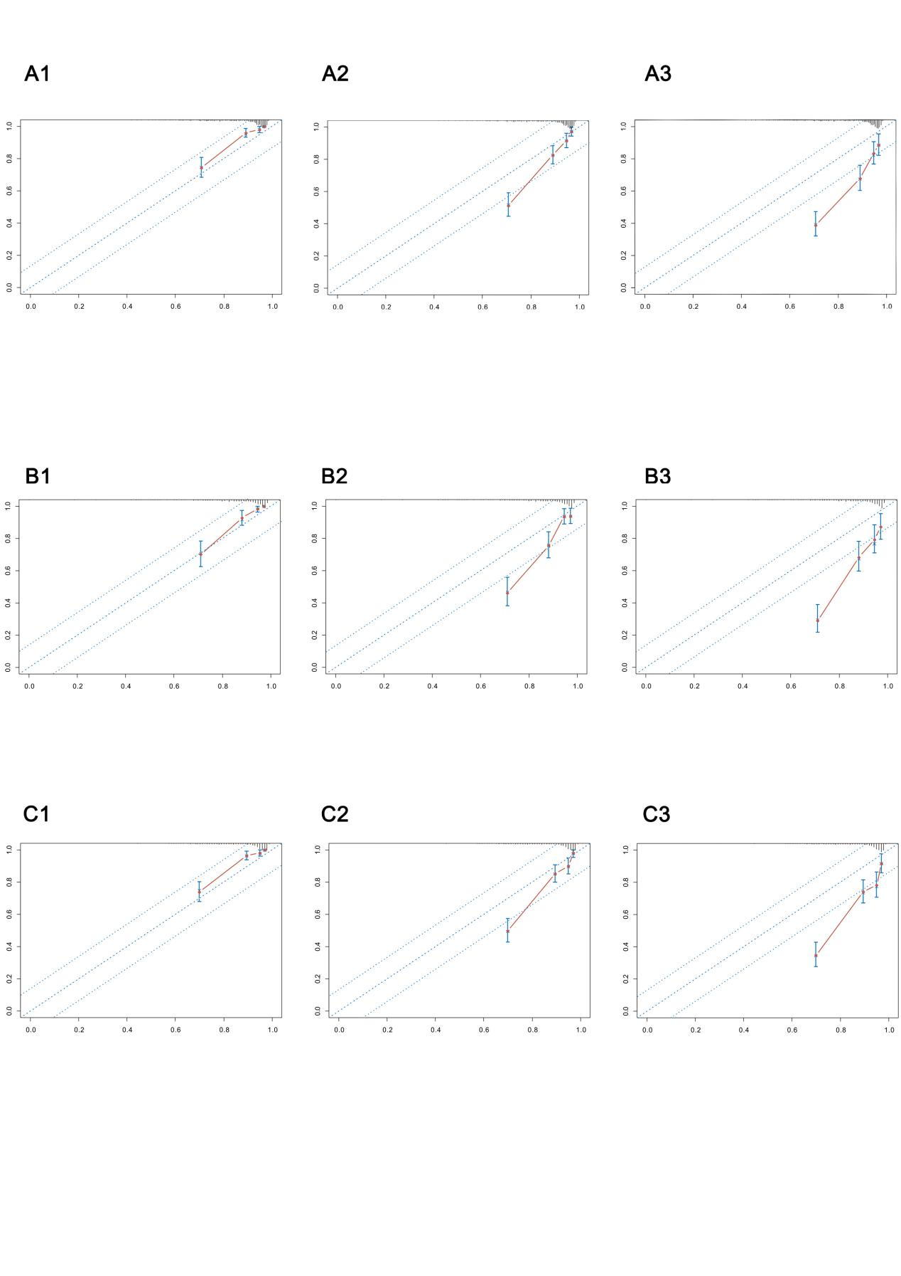
Figure S1. The calibration plots of nomograms. A1-A3: calibration plots of nomogram for RCC patients based on GLS2 expression (1-year-OS; 3-year-OS; 5-year-OS); B1-B3: calibration plots of nomogram for ccRCC patients based on E2F family members (1-year-OS; 3-year-OS; 5-year-OS); C1-C3: calibration plots of nomogram for RCC patients based on E2F family members (1-year-OS; 3-year-OS; 5-year-OS).
Figure S2. The methylation level of GLS2 promoter and its’ role in ccRCC.

