Supplemental data for
A highly thermotolerant laccase produced by Cerrena unicolor strain CGMCC 5.1011 for complete and stable malachite green decolorization
Yanhua Yao¹, Guimei Zhou¹, Yonghui Lin², Xinqi Xu^{1*}, Jie Yang^{1*}

¹Fujian Key Laboratory of Marine Enzyme Engineering, College of Biological Sciences and Technology, Fuzhou University, Fuzhou, Fujian 350116, China
²GRG Metrology & Test Fuzhou Co., Ltd., Fuzhou, Fujian 350003, China

Table S1 Primers used in this study.
Primer | Oligonucleotide sequence | Note
Lac1-F | 5’-CATGAAGAGACACACCTCCATAG-3’ | Amplification of Lac1 cDNA and DNA
Lac1-R | 5’-CTACAAGTCCTTGCTATCTAGTGC-3’ | Amplification of Lac1 cDNA and DNA
Lac2-F | 5’-ATGGGCGTGGGTCTACTCTC-3’ | Amplification of Lac2 cDNA and DNA
Lac2-R | 5’-TCATGATGCACTGGTCTGAGC-3’ | Amplification of Lac2 cDNA and DNA
Lac3-F | 5’-TGTTTAACTTTTATTCTTTGCTAAGTTTCG-3’ | Amplification of Lac3 cDNA and DNA
Lac3-R | 5’-TTACTGGTCAGCGGAGTCAAG-3’ | Amplification of Lac3 cDNA and DNA
Lac4-F | 5’-ATGCTTTGGCGTACCACTCTCAC-3’ | Amplification of Lac4 cDNA and DNA
Lac4-R | 5’-TCATGTATCACCTGGGCTCAAG-3’ | Amplification of Lac4 cDNA and DNA
Lac5-F | 5’-CGATGGTATATAAGACGATGATGGGATTGAACTC-3’ | Amplification of Lac5 cDNA and DNA
Lac5-R | 5’-GTTTAAATAGCAGTTCCTTTCTTAGGCTTGAC-3’ | Amplification of Lac5 cDNA and DNA
Lac6-F | 5’-AATGGTCTTCAGCGCTGCATTC-3’ | Amplification of Lac6 cDNA and DNA
Lac6-R | 5’-CGTTTACTTGTCACCGTCAGC-3’ | Amplification of Lac6 cDNA and DNA
Lac7-F | 5’-ATGTACTACTGGTCTCCACTAGG-3’ | Amplification of Lac7 cDNA and DNA
Lac7-R | 5’-GATGTCCTTCAATGCAGCCTTC-3’ | Amplification of Lac7 cDNA and DNA
Lac8-F | 5’-GCACAATGTTGTTCTGCTCTGC-3’ | Amplification of Lac8 cDNA and DNA
Lac8-R | 5’-GCTACTTGTCACCGTCATCG-3’ | Amplification of Lac8 cDNA and DNA
Lac9-F | 5’-ATGTGGTCCTCCTCCCTCGC-3’ | Amplification of Lac9 cDNA and DNA
Lac9-R | 5’-TTACGCCTTGGGCTTCAGGAGA-3’ | Amplification of Lac9 cDNA and DNA
Lac10-F | 5’-ATGGGCGTGGGTCTACTCTCA-3’ | Amplification of Lac10 cDNA and DNA
Lac10-R | 5’-CTACACACCGGTCTGGGTTGG-3’ | Amplification of Lac10 cDNA and DNA
Lac11-F | 5’-GATGTCTCTTCTTCGTAGCTTGAC-3’ | Amplification of Lac11 cDNA and DNA
Lac11-R | 5’-ATGCTCAAGGCCACGTCCATTC-3’ | Amplification of Lac11 cDNA and DNA
Lac12-F | 5’-GATGGGCCTGCTTTTTCATTTATCCACTC-3’ | Amplification of Lac12 cDNA and DNA
Lac12-R | 5’-CCGATGTACTACTGGTCTCCACTAG-3’ | Amplification of Lac12 cDNA and DNA
TAIL-AD1 | 5’-TGWGNAGWANCASAGA-3’ | Degenerate primers for TAIL-PCR
TAIL-AD2 | 5’-AGWGNAGWANCAWAGG-3’ | Degenerate primers for TAIL-PCR
TAIL-AD3 | 5’-STTGNTASTNCTNTGC-3’ | Degenerate primers for TAIL-PCR
TAIL-AD4 | 5’-NTCGASTWTSGWGTT-3’ | Degenerate primers for TAIL-PCR
TAIL-AD5 | 5’-NGTCGASWGANAWGAA-3’ | Degenerate primers for TAIL-PCR
TAIL-AD6 | 5’-WGTGNAGWANCANAGA-3’ | Degenerate primers for TAIL-PCR
TAIL-AD7 | 5’-WTCTGNCTWANTANCT-3’ | Degenerate primers for TAIL-PCR
Lac3 SP1 | 5’-cattgacaaccacaccatgaccatcatcg-3’ | Amplification of 3’-flanking sequence of Lac3
Lac3 SP2 | 5’-caccgctaaccagactgtcgacaactactg-3’ | Amplification of 3’-flanking sequence of Lac3
Lac3 SP3 | 5’-ccaccagcactgctgctctcgaccagactgc-3’ | Amplification of 3’-flanking sequence of Lac3
Lac5 SP1 | 5’-accaaacggaatcggtatcgtttgttatg-3’ | Amplification of 5’-flanking sequence of Lac5
Lac5 SP2 | 5’-cgacaacggtctgggcgagaacatggtac-3’ | Amplification of 5’-flanking sequence of Lac5
Lac5 SP3 | 5’-cacagtactgcgtggataaatgactatgg-3’ | Amplification of 5’-flanking sequence of Lac5

Table S2 sequencing output data quality assessment.
Sample | Raw Reads | Clean reads | Clean bases | Error (%) | Q20 (%) | Q30 (%) | GC (%)
5.1011 | 59856856 | 58154292 | 8.72 G | 0.02 | 97.53 | 93.23 | 51.51

Table S3 Statistics on success rate of gene annotation in seven databases.
Database | Number of Genes | Percentage (%)
NR | 23628 | 79.71
NT | 4166 | 14.05
KO | 6818 | 23
SwissProt | 15353 | 51.79
PFAM | 19074 | 64.34
GO | 19097 | 64.42
KOG | 9833 | 33.17
All databases | 2296 | 7.74
At least one database | 24905 | 84.01

Table S4 Amino acid sequence identities of Cerrena laccases.
 |  | C. unicolor 5.1011 |  |  |  |  |  |  |  |  |  | Cerrena sp. HYB07
 |  | Lac2 | Lac4 | Lac5 | Lac6 | Lac7 | Lac8 | Lac9 | Lac10 | Lac11 | Lac12 | lac1 | lac2 | lac3 | lac4 | lac5 | lac6 | lac7 | lac8 | lac9 | lac10 | lac11 | lac12 | lac13
C. unicolor 5.1011 | Lac1 | 59.2 | 69.8 | 65.9 | 73.8 | 69.3 | 73.2 | 23.0 | 60.0 | 60.7 | 46.6 | 85.1 | 68.8 | 66.0 | 69.8 | 64.5 | 55.4 | 74.1 | 69.4 | 63.0 | 69.0 | 60.7 | 46.2 | 68.0
C. unicolor 5.1011 | Lac2 |  | 66.2 | 66.5 | 60.9 | 59.4 | 58.4 | 22.9 | 90.2 | 57.0 | 37.2 | 59.2 | 65.7 | 55.7 | 65.5 | 62.9 | 56.2 | 61.4 | 58.4 | 62.7 | 62.7 | 79.5 | 59.0 | 56.6
C. unicolor 5.1011 | Lac3 |  | 62.9 | 57.8 | 66.5 | 60.9 | 61.7 | 25.1 | 56.6 | 57.3 | 41.8 | 63.5 | 60.7 | 86.7 | 63.0 | 57.0 | 53.0 | 65.9 | 63.7 | 57.2 | 56.8 | 57.6 | 41.8 | 59.2
C. unicolor 5.1011 | Lac4 |  |  | 72.2 | 72.3 | 67.1 | 71.8 | 21.2 | 67.6 | 84.5 | 43.5 | 68.1 | 74.2 | 63.5 | 93.0 | 67.5 | 57.8 | 72.3 | 67.2 | 69.9 | 68.4 | 69.7 | 68.1 | 65.8
C. unicolor 5.1011 | Lac5 |  |  |  | 66.7 | 63.4 | 67.7 | 23.3 | 69.2 | 62.5 | 39.5 | 64.9 | 77.6 | 60.0 | 72.8 | 73.7 | 58.9 | 67.9 | 63.6 | 78.4 | 73.8 | 68.1 | 64.5 | 60.3
C. unicolor 5.1011 | Lac6 |  |  |  |  | 73.3 | 77.3 | 23.4 | 63.0 | 63.8 | 49.8 | 73.9 | 70.3 | 69.8 | 72.3 | 67.2 | 57.8 | 86.1 | 76.2 | 66.6 | 65.3 | 64.4 | 79.8 | 70.1
C. unicolor 5.1011 | Lac7 |  |  |  |  |  | 73.8 | 25.0 | 60.6 | 58.2 | 65.3 | 69.5 | 65.0 | 62.2 | 68.1 | 62.5 | 54.7 | 75.0 | 70.2 | 64.5 | 60.6 | 58.2 | 74.6 | 80.2
C. unicolor 5.1011 | Lac8 |  |  |  |  |  |  | 22.6 | 62.5 | 62.9 | 48.3 | 72.2 | 69.8 | 63.5 | 71.6 | 65.3 | 56.9 | 78.3 | 71.7 | 66.6 | 63.8 | 65.0 | 83.0 | 69.8
C. unicolor 5.1011 | Lac9 |  |  |  |  |  |  |  | 22.9 | 21.3 | 16.7 | 23.0 | 23.2 | 24.8 | 23.2 | 23.0 | 24.6 | 23.1 | 24.1 | 24.0 | 23.0 | 24.0 | 23.8 | 22.7
C. unicolor 5.1011 | Lac10 |  |  |  |  |  |  |  |  | 59.6 | 38.3 | 59.9 | 67.2 | 56.8 | 67.1 | 65.7 | 57.6 | 63.6 | 58.1 | 64.1 | 63.6 | 82.5 | 59.9 | 58.2
C. unicolor 5.1011 | Lac11 |  |  |  |  |  |  |  |  |  | 50.5 | 59.6 | 65.8 | 54.8 | 80.6 | 59.1 | 50.3 | 62.9 | 58.2 | 60.8 | 61.7 | 60.3 | 58.4 | 57.5
C. unicolor 5.1011 | Lac12 |  |  |  |  |  |  |  |  |  |  | 46.8 | 41.1 | 39.7 | 44.0 | 39.2 | 35.6 | 50.4 | 45.6 | 41.8 | 40.7 | 40.2 | 50.0 | 53.0

Table S5 Predicted salt bridges in the laccases.
Salt bridge No. | 5.1011 Lac2 | HYB07 Lac7
1 | 18ASP-153HIS | 18ASP-153HIS
2 | 22ARG-118ASP | 22ARG-118ASP
3 | 66HIS-426ASP | 66HIS-422ASP
4 | 121ARG-150ASP | 121ARG-150ASP
5 | 131ASP-196ARG | 131ASP-197ARG
6 | 138ASP-194ARG | 138ASP-195ARG
7 | 140ASP-198ARG | 140ASP-199ARG
8 | 196ARG-221GLU | 197ARG-222GLU
9 | 198ARG-221GLU | 199ARG-222GLU
10 | 213ASP-259ARG | 214ASP-260ARG
11 | 223ASP-242ARG | 224ASP-243ARG
12 | 223ASP-425ARG | 224ASP-421ARG
13 | 242ARG-426ASP | 243ARG-422ASP
14 | 302GLU-425ARG | 302GLU-421ARG
15 | 384GLU-440ARG | 381GLU-436ARG
16 | 404HIS-469GLU | 400HIS-465GLU
17 | 91ASP-490LYS | 175ARG-182ASP
18 | 280ARG-286ASP | 175ARG-288GLU
19 | 326HIS-340ASP

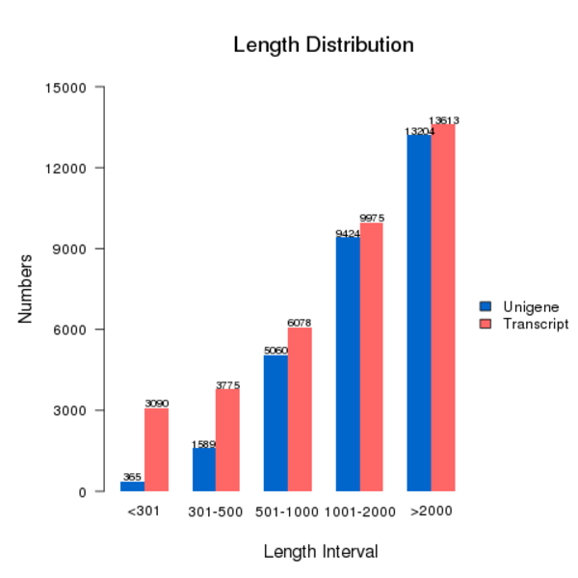
Fig. S1 Distribution of assembly length of the transcriptome of C. unicolor 5.1011.

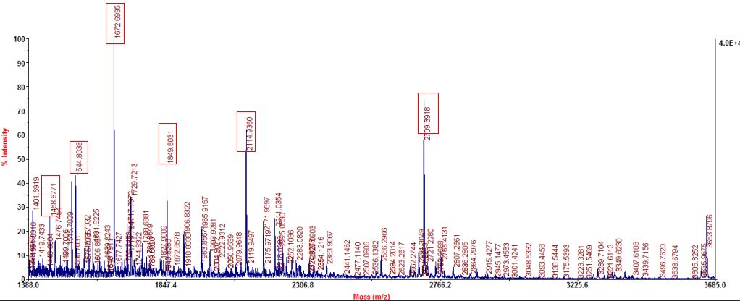
Fig. S2 The result of the MALDI-TOF MS/MS analysis of the purified Lac2 protein.
Lac2 was identified to be the protein product encoded by the Lac2 gene.

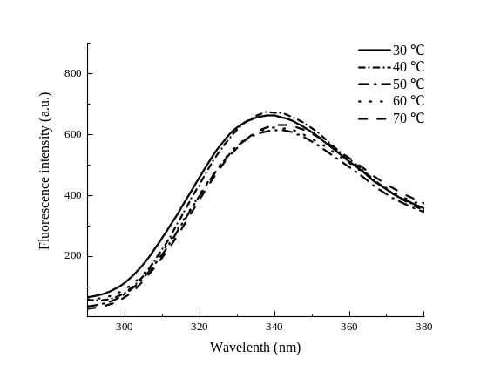 | 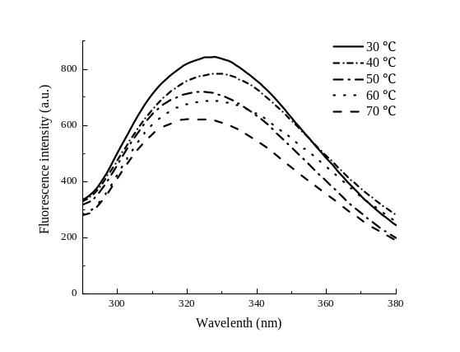
Fig. S3 Fluorescence spectra of Lac2 from C. unicolor 5.1011 (left) and Lac7 from Cerrena sp. HYB07 (right).
The laccases were incubated at 30-70 ºC for 1 h; and then the fluorescence spectra were collected with an F-7000 fluorescence spectrophotometer (Hitachi, Japan) after excitation at 280 nm.

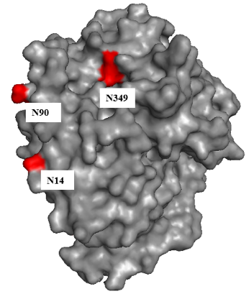
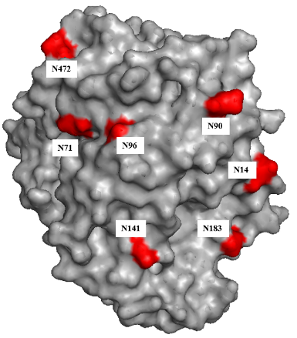
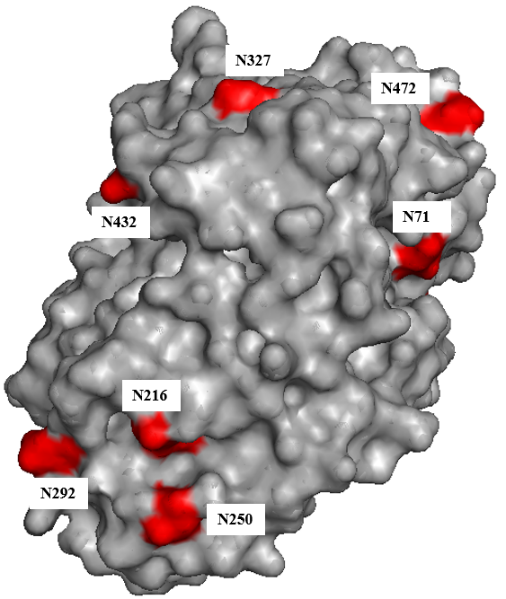
90º
180º

Fig. S4 3D structure display of putative Lac2 glycosylation sites

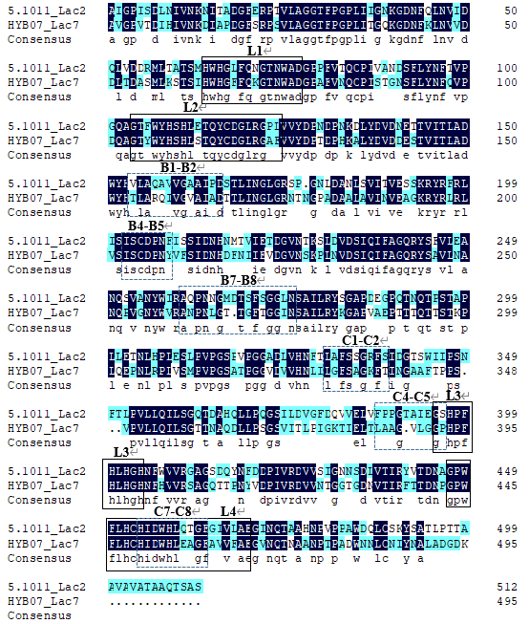
Fig. S5 Amino acid alignment of Lac2 of C. unicolor 5.1011 and Lac7 of Cerrena sp. HYB07.
The highly conserved laccase signature domains (L1-L4) are boxed in solid black lines. The substrate-binding loops are boxed with dotted lines.

