Supplementary Figure 1. Comparison of biomarker expression between CDS dogs with and without other neurological comorbidities in the replication cohort.
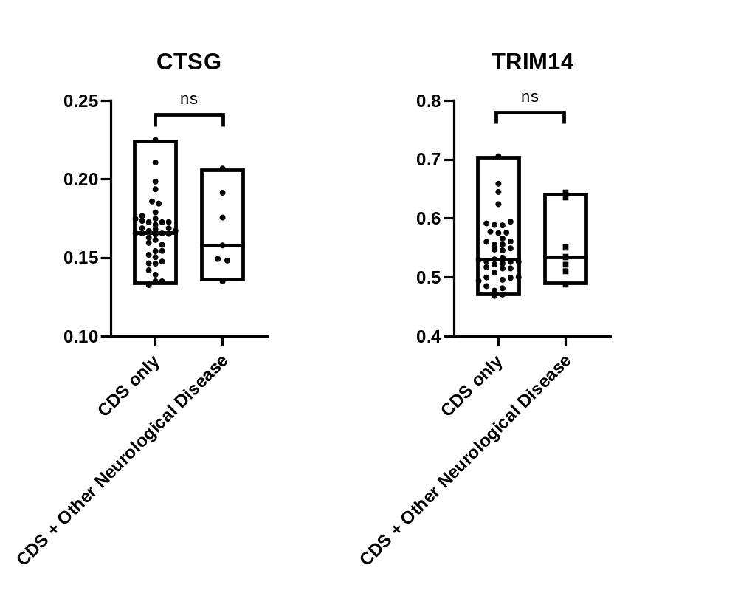
Floating bar charts showing the expression levels of candidate proteins CTSG and TRIM14 in CDS dogs with (n=7) or without (n=41) other neurological diseases. Each dot represents an individual sample. The Y-axis of each graph represents the log10-transformed value of the measured level of the target protein. No statistically significant difference was observed between the two groups for either marker (CTSG: p = 0.9824, TRIM14: p = 0.6765, two-tailed, ns = not significant).

Supplementary Figure 2. PCA of individual canine samples based on expression levels of DEPs.
Each point represents a single dog sample of discovery cohort, and point shapes indicate the corresponding breed: Maltese, Miniature Pinscher, Poodle, and Yorkshire Terrier. The first two principal components (Dim1 and Dim2) explain 84.1% and 6.4% of the total variance, respectively.
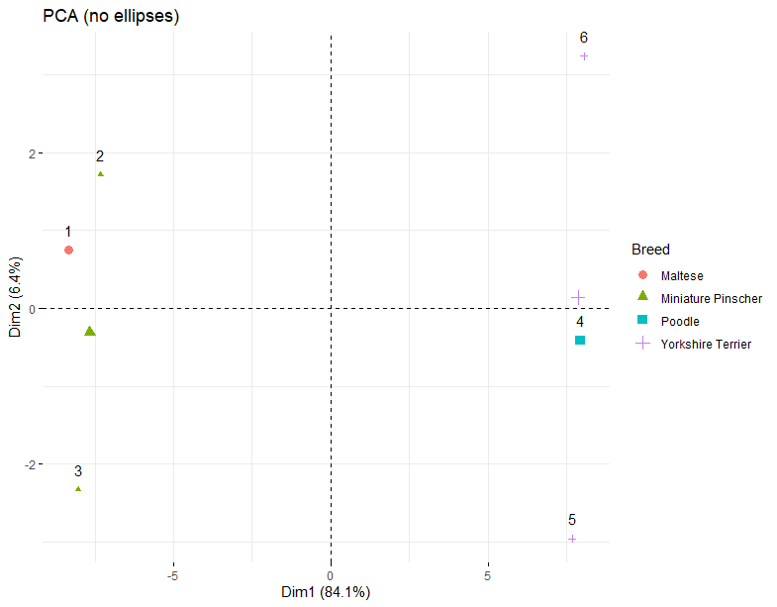
Figure caption: Note that although only six individual samples were analyzed, some PCA points may visually overlap or appear duplicated due to proximity in PC space or graphical rendering.

Supplementary Figure 3. PCA of Breed-Based Clustering on Expression of Candidate Marker Proteins
PCA of protein expression levels for TRIM14 and CTSG measured by ELISA across canine samples. Each point represents an individual sample, with colors indicating the corresponding breed. The first two principal components (PC1 and PC2) explain 79.41% and 20.59% of the total variance, respectively, highlighting the proteomic variation and potential breed-related clustering patterns.
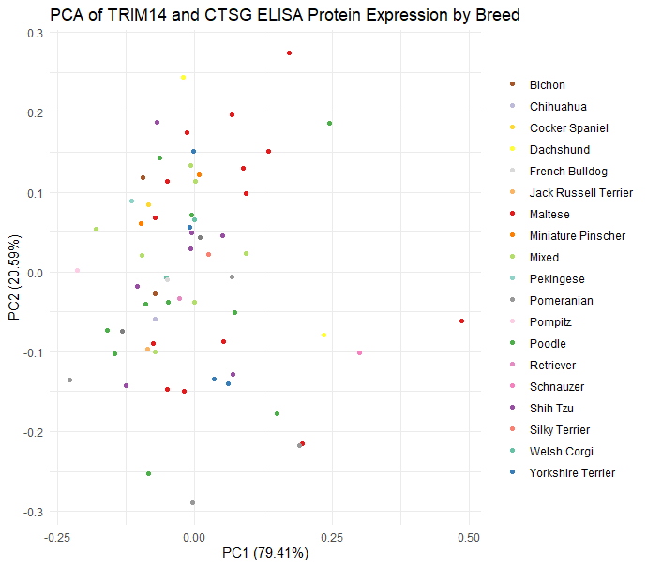

Supplementary Figure 4. Comparison of Clinical Variables Between the Discovery Cohort (n = 6) and the Replication Cohort (n = 65).
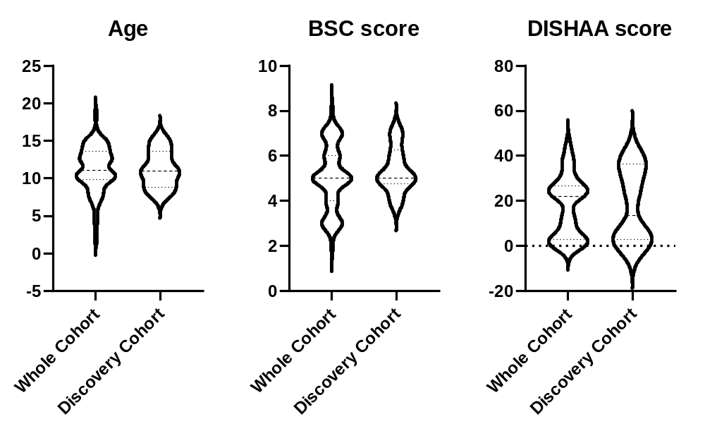Violin plots showing the distribution of clinical variables in the discovery and replication cohorts. In each graph, the Y-axis represents age in years, BSC score (on a 1–9 scale), and DISHAA score (on a 0–45 scale), respectively. Median and quartiles are marked with dotted lines. The replication and discovery cohorts had comparable mean ± SD values for age (11.29 ± 3.03 vs. 11.20 ± 2.58 years), BSC score (5.03 ± 1.42 vs. 5.33 ± 1.03), and DISHAA score (17.22 ± 13.53 vs. 17.83 ± 16.94), respectively. The results indicate comparable distributions across the two cohorts for all clinical variables analyzed.

Supplementary Figure 5. Detected membrane image of DB results
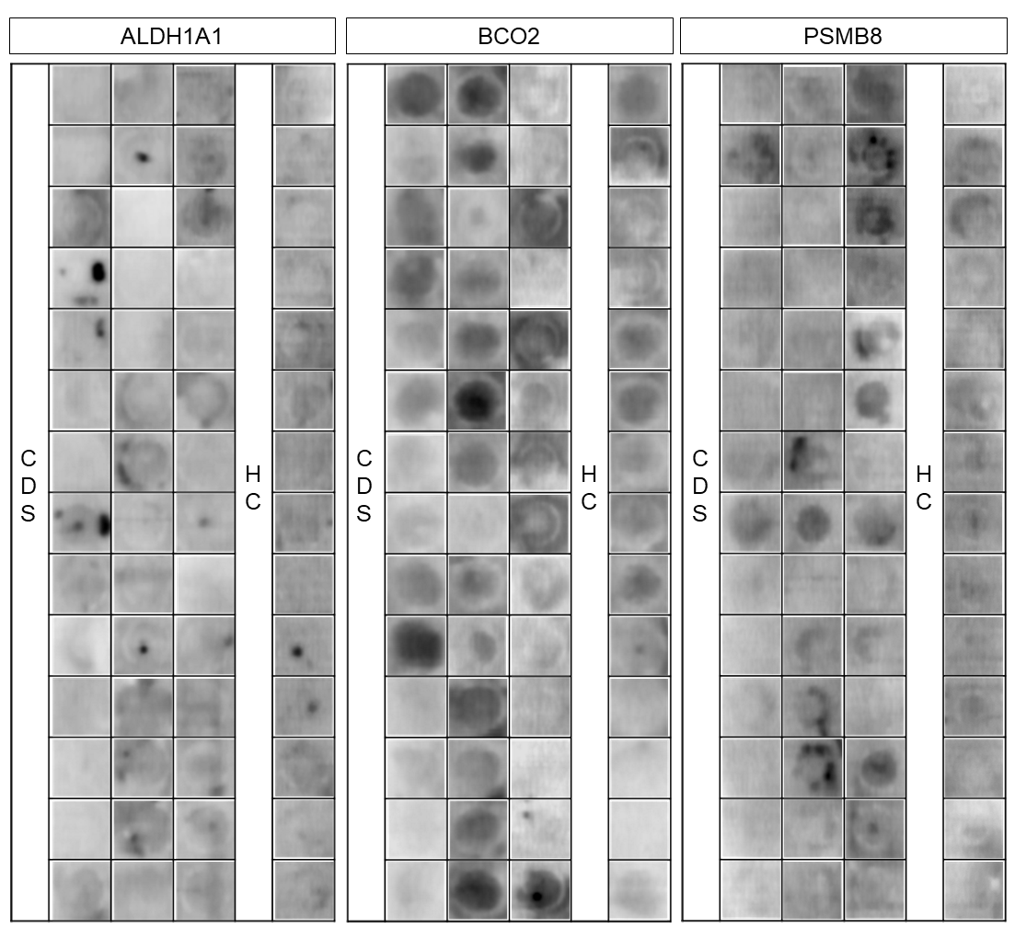
Membrane image of n=56 (n=42 in CDS group, n=14 in HC group, extreme 10% of each group were excluded from total cohort of n=62) Each cell represents the detected image of a single loaded sample. Cropped gel images are shown. Full-length, uncropped versions of each gels are provided in Supplementary Figure S1 in accordance with the journal’s image integrity policy.
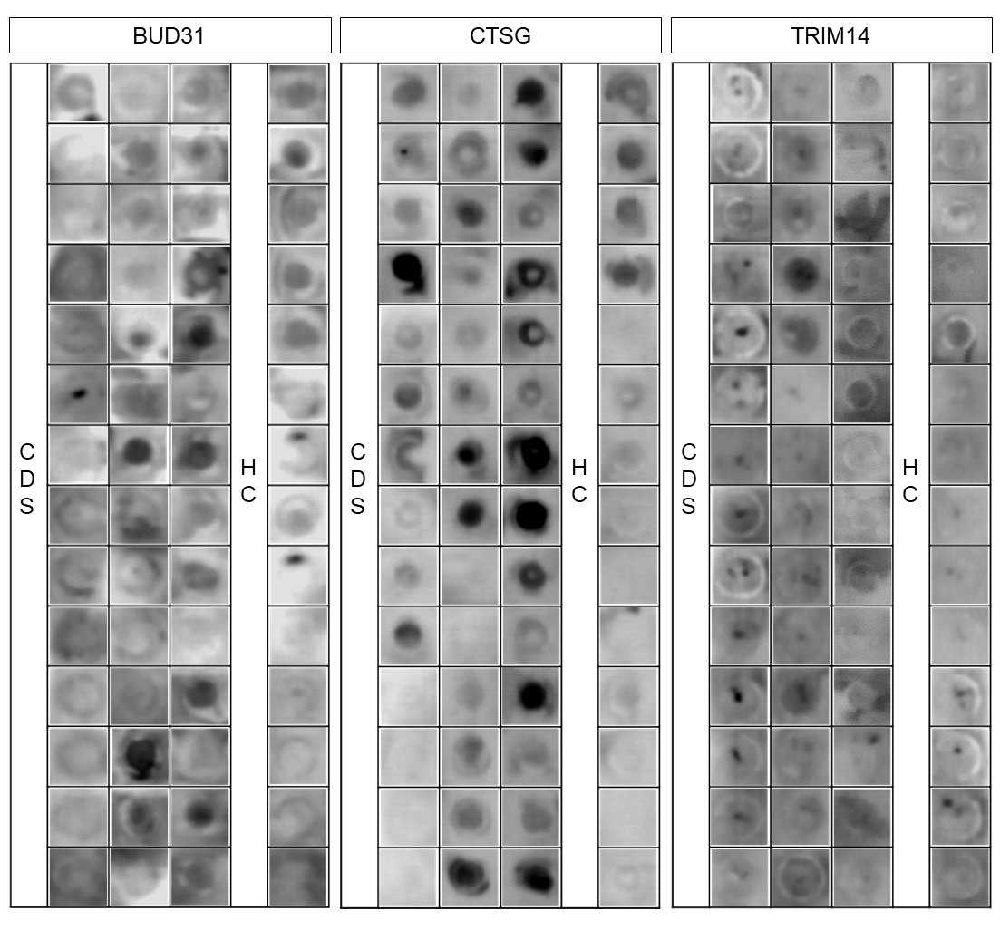
Supplementary Figure 6. Normality tested in DB quantification datasets
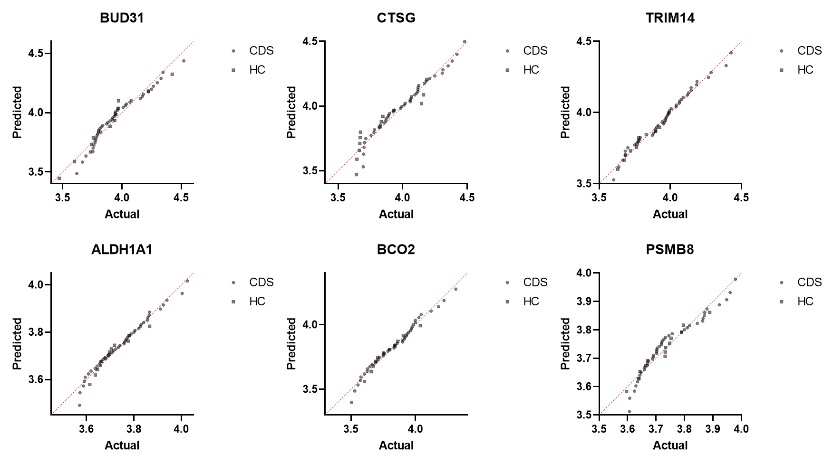
Quantile-Quantile (Q-Q) plots showing the results of normality tests for dot blot quantification datasets of each candidate biomarker protein. Each dot represents an individual sample, with the x-axis indicating the observed values and the y-axis indicating the expected theoretical quantiles under a normal (or log-normal) distribution. The red dashed line represents the line of identity (y = x), indicating perfect agreement between observed and theoretical distributions. Deviation from this line suggests a departure from the assumed distribution.
Supplementary Figure 7. Normality tested in ELISA datasets of CTSG and TRIM14
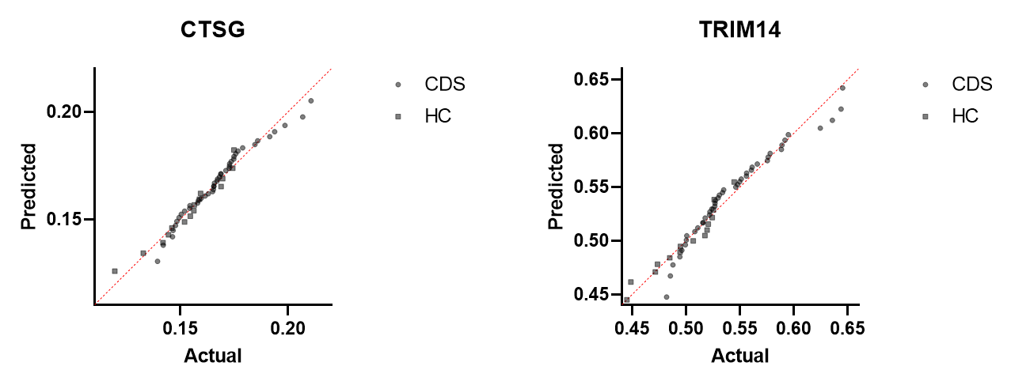
Q-Q plots showing the results of normality tests for ELISA datasets resulted from two candidate biomarker proteins. Each dot represents an individual sample, with the x-axis indicating the observed values and the y-axis indicating the expected theoretical quantiles under a normal (or log-normal) distribution. The red dashed line represents the line of identity (y = x), indicating perfect agreement between observed and theoretical distributions. Deviation from this line suggests a departure from the assumed distribution.

