Supplementary Information

Reaction Mechanism and Role of Chlorine in Ethylene Epoxidation revealed by in situ XPS
Man Guo^{1,2,#}, Nanchen Dongfang^{3,#}, Frank Krumeich⁴, Marcella Iannuzzi³, Jeroen A. van Bokhoven^{1,2}, Luca Artiglia^{1,*}
¹ PSI Center for Energy and Environmental Science, Paul Scherrer Institute, 5232 Villigen, Switzerland.
² Institute for Chemical and Bioengineering, Department of Chemistry and Applied Biosciences, ETH Zurich, 8093 Zurich, Switzerland.
³ Department of Chemistry, University of Zurich, 8057 Zurich, Switzerland.
⁴ Laboratory of Inorganic Chemistry, Department of Chemistry and Applied Biosciences, ETH Zurich, 8093 Zurich, Switzerland.
# Contributed equally to the writing of the manuscript.

Supplementary Figure 1. Adsorption-desorption isotherms of N₂ at 77 K for α-Al₂O₃ and Ag/Al₂O₃.

Supplementary Table 1. Brunauer-Emmett-Teller (BET) surface areas of the α-Al₂O₃ support and Ag/Al₂O₃ catalyst.
Sample | α-Al₂O₃ | Ag/Al₂O₃
Surface area (m²/g) | 5.2 | 4.6

Supplementary Figure 2. XRD patterns of Ag/Al₂O₃ catalyst and α-Al₂O₃.

Supplementary Figure 3. Al 2p spectra (normalized by intensity) of Ag/Al₂O₃, collected at different temperatures during exposure to a C₂H₄:O₂ (2:1) gas mixture (1 mbar), either in the absence or presence of 2 ppm vinyl chloride (KE=300 eV).

Supplementary Figure 4. C 1s spectra (adventitious carbon contamination on “as introduced” Ag/Al₂O₃ samples) collected under HV conditions at room temperature prior to gas exposure, measured at kinetic energies of a, 100 eV and b, 300 eV. The brown and green curves correspond to the samples subsequently exposed in the absence and presence of 2 ppm vinyl chloride, respectively. The fitting parameters of adventitious carbon and carbonate species are listed in Supplementary Table. 2.

Supplementary Table 2. Fitting parameters of C 1s peaks in Supplementary Fig. 4
Species | KE (eV) | BE (eV) | FWHM (eV) | %L-G
Adventitious carbon | 100 | 285.3 | 1.6 | 10%
Adventitious carbon | 300 | 285.3 | 1.8 | 10%
Carbonate species | 100 | 289.6 | 1.4 | 10%
Carbonate species | 300 | 289.6 | 1.4 | 10%

Supplementary Figure 5. C 1s peaks evolution of Ag/Al₂O₃ acquired at a kinetic energy of 100 eV while exposing the sample to a C₂H₄:O₂ (2:1) mixture at 1 mbar a, in the absence and b, in the presence of 2 ppm VC over a temperature range of 150 °C to 400 °C. The fitting parameters are listed in Supplementary Table 3.
Supplementary Table 3. Fitting parameters of C 1s peaks (KE=100 eV).
 | BE (eV) | FWHM (eV) | %L-G | Assignment
C_{EPO-0} | 282.9 | 1.2 | 10% | CH_{y} (y=1-2)
C_{EPO-1} | 284.0 | 1.2 | 10% | C₂H_{x} (x=1-3)
C_{EPO-2} | 285.0 | 1.3 | 10% | Adventitious carbon,  long-chain carbonaceous species, weakly adsorbed ethylene
C_{EPO-3} | 287.3 | 1.2 | 10% | Adsorbed CO
C_{EPO-4} | 288.1 | 1.2 | 10% | Adsorbed EO
C_{EPO-5} | 289.6 | 1.4 | 10% | Carbonate
Gas phase C₂H₄ | ~286.0 | 0.8 | 10% | ——

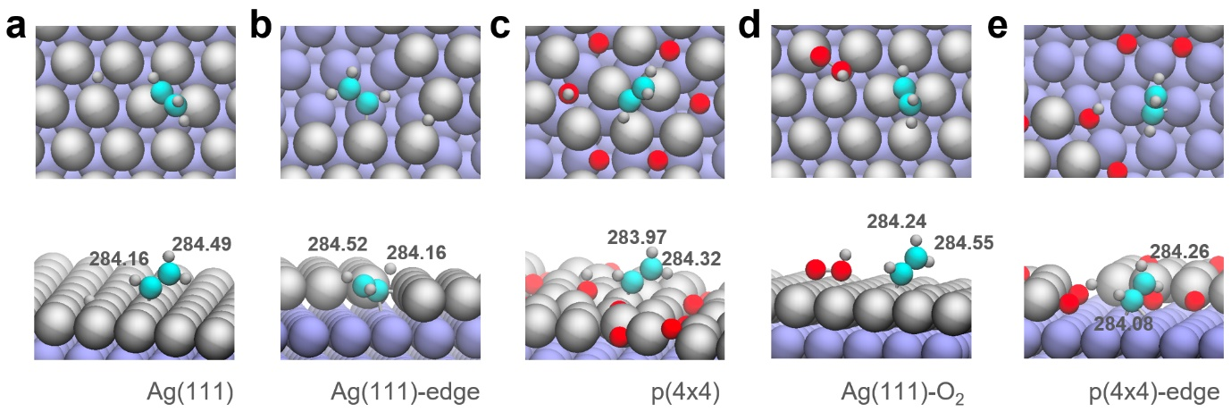
Supplementary Figure 6. Optimized structure and calculated BE of C₂H₃ species on various silver surfaces.

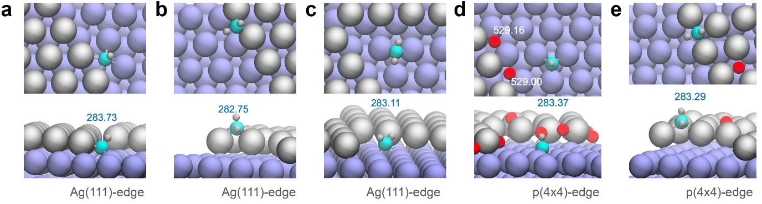
Supplementary Figure 7. Optimized structure and calculated BE of CH_{y} (y=1-2) species on various defective silver surfaces.

Supplementary Figure 8. C 1s spectra of Ag/Al₂O₃ collected at different temperatures during exposure to a C₂H₄:O₂ (2:1) gas mixture (1 mbar), either in the absence or presence of 2 ppm vinyl chloride (KE=300 eV).

Supplementary Figure 9. C 1s peaks evolution of Ag/Al₂O₃ acquired at a kinetic energy of 300 eV while exposing the sample to a C₂H₄:O₂ (2:1) mixture at 1 mbar a, in the absence and b, in the presence of 2 ppm vinyl chloride over a temperature range of 150 °C to 400 °C. The fitting parameters are listed in Supplementary Table 4.
Supplementary Table 4. Fitting parameters of C 1s peaks (KE=300 eV).
 | BE (eV) | FWHM (eV) | %L-G | Assignment
C_{EPO-0} | 282.9 | 1.3 | 10% | CH_{y} (y=1-2)
C_{EPO-1} | 284.0 | 1.2 | 10% | C₂H_{x} (x=1-3)
C_{EPO-2} | 285.0 | 1.3 | 10% | Adventitious carbon,  long-chain carbonaceous species,  weakly adsorbed ethylene
C_{EPO-3} | 287.3 | 1.2 | 10% | Adsorbed CO
C_{EPO-4} | 288.1 | 1.2 | 10% | Adsorbed EO
C_{EPO-5} | 289.6 | 1.4 | 10% | Carbonate
Gas phase C₂H₄ | ~286.0 | 1.0 | 10% | ——

Supplementary Figure 10. Normalized peak area of different C-related reaction intermediates on Ag/Ag₂O₃ as a function of temperature under in situ EPO conditions. (C₂H₄:O₂=2:1, 1 mbar, KE = 300 eV).

Supplementary Figure 11. Ag 3d spectra (normalized by intensity) of Ag/Al₂O₃ collected at different temperatures during exposure to a C₂H₄:O₂ (2:1) gas mixture (1 mbar), in the absence (lighter curves) and presence (darker curves) of 2 ppm vinyl chloride (KE=300 eV). The dashed lines represent reference spectra acquired at 400 ºC without VC.
Supplementary Figure 12. Ag 3d peaks evolution of Ag/Al₂O₃ acquired at a kinetic energy of 300 eV while exposing the sample to a C₂H₄:O₂ (2:1) mixture at 1 mbar a, in the absence and b, in the presence of 2 ppm vinyl chloride over a temperature range of 150 °C to 400 °C. The fitting parameters are listed in Supplementary Table 5.

Supplementary Table 5. Fitting parameters of Ag 3d peaks (KE=300 eV).
 | BE (eV) | FWHM (eV) | %L-G | Assignment
Ag₀ | 368.3 | 1.0 | 9% | Metallic Ag
Ag_{α+β} | 367.4 | 1.0 | 9% | Surface silver oxide
Ag_{γ} | 368.9 | 1.0 | 9% | Ag species coordinated to CH_{y}

Supplementary Figure 13. Fractions of different Ag species on Ag/Ag₂O₃ as a function of temperature under in situ EPO conditions. (C₂H₄:O₂=2:1, 1 mbar, KE = 300 eV).

Supplementary Figure 14. Cl 2p spectra of Ag/Al₂O₃ acquired at a kinetic energy of 300 eV while exposing the sample to C₂H₄:O₂=2:1, cofeeding 2 ppm vinyl chloride at 1 mbar.

Supplementary Figure 15. O 1s spectra (normalized by intensity) of Ag/Al₂O₃ collected at different temperatures during exposure to a C₂H₄:O₂ (2:1) gas mixture (1 mbar), in the absence or presence of 2 ppm vinyl chloride (KE=300 eV), respectively. The dashed lines represent reference spectra acquired from two samples under HV prior to gas exposure.

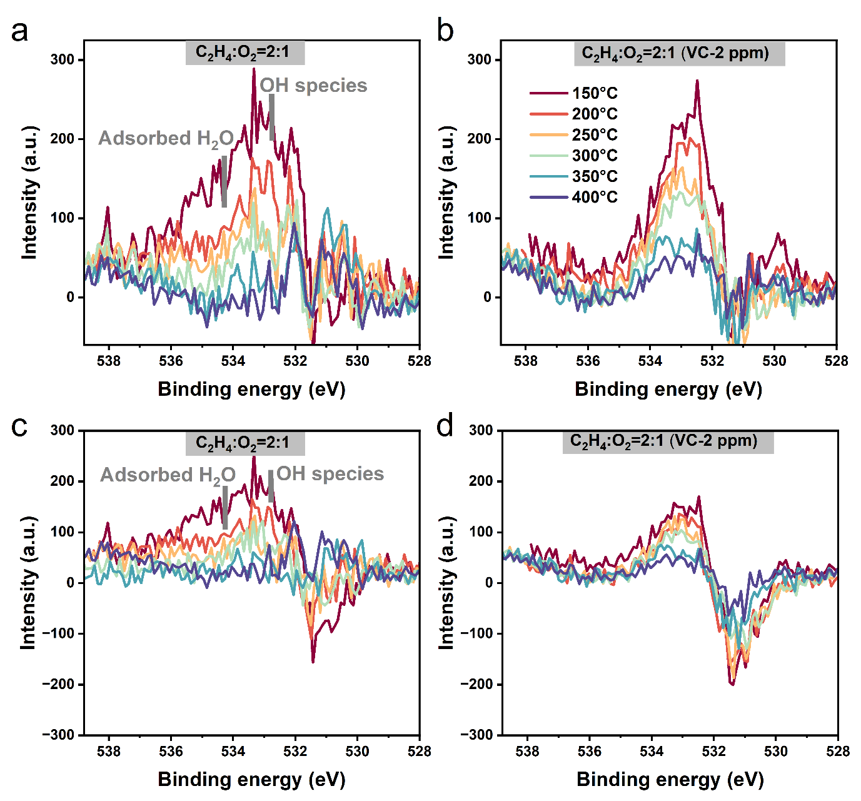
Supplementary Figure 16. O 1s difference spectra of Ag/Al₂O₃ acquired at a kinetic energy of 300 eV during exposure to a C₂H₄:O₂ (2:1) mixture at 1 mbar a, in the absence and b, in the presence of 2 ppm vinyl chloride over a temperature range from 150 °C to 400 °C. The spectrum collected under HV prior to gas exposure from each sample was used as a reference to generate the difference spectra. All spectra were normalized by intensity prior to subtraction. c-d, O 1s difference spectra obtained normalizing all O 1s spectra to the area prior to subtraction. Both methods show the presence of adsorbed hydroxyls and water under EPO conditions. Difference spectra obtained using area-normalized spectra highlight a negative contribution centered at 531.4 eV and corresponding to lattice oxygen from the Al₂O₃ support.

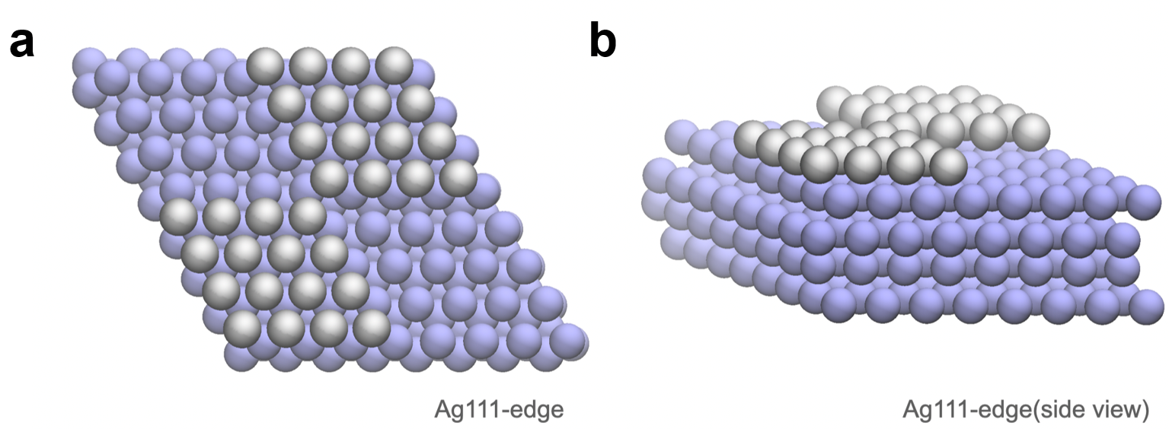
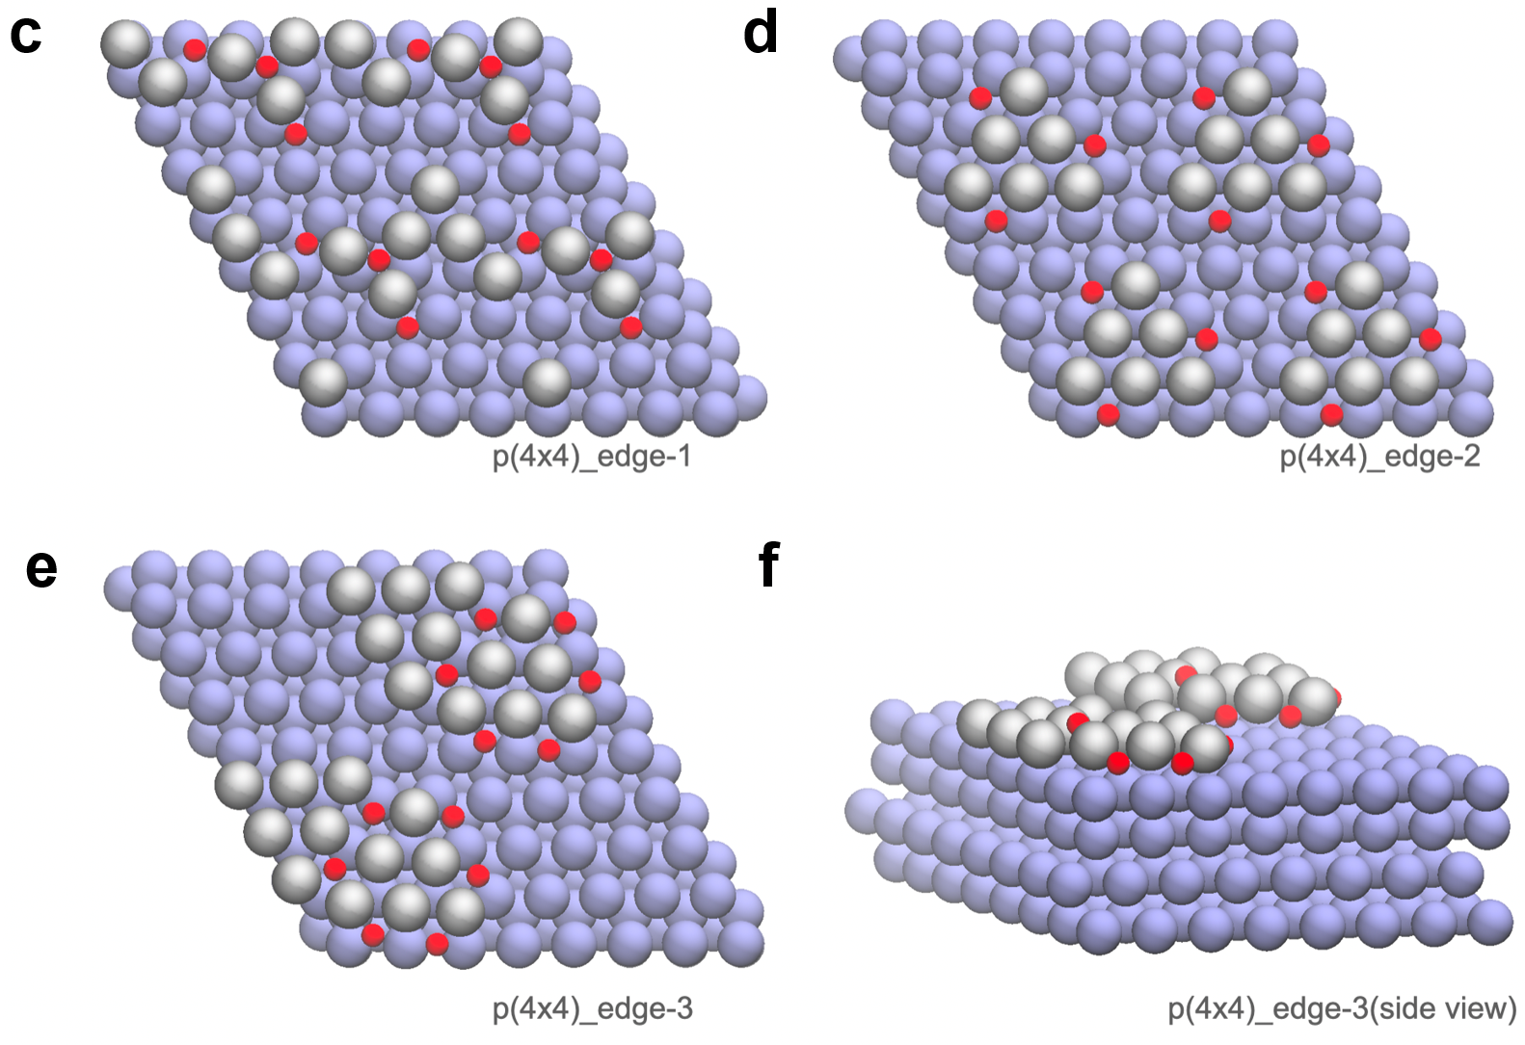
Supplementary Figure 17. a-b, Top view and side view of Ag(111) with edge sites. c–e, Top views of p(4×4)_edge-1 to p(4×4)_edge-3. f, Side view of p(4×4)_edge-3. Simulated O 1s binding energies for p(4×4)_edge-3 range from 528.96 to 529.21 eV. Color code: surface Ag, silver; subsurface Ag, purple; O, red.

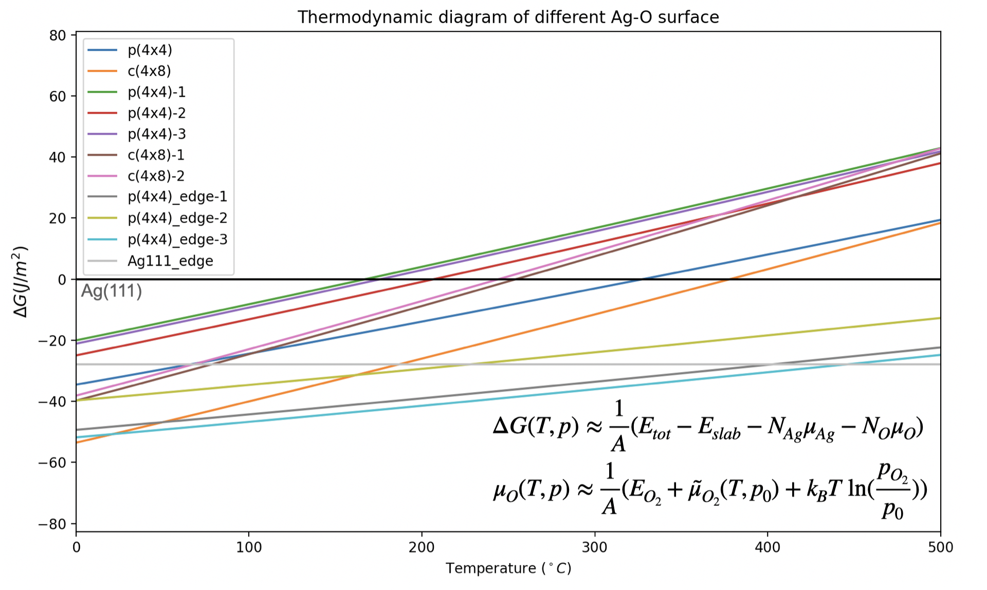
Supplementary Figure 18. Thermodynamic diagram of various silver surfaces, plotted based on the static thermodynamic function listed on the right corner, under a constant pressure of O₂. The structures of p(4×4)-1 to c(4×8)-2 are shown in Figure 4b–f of our previous work.¹

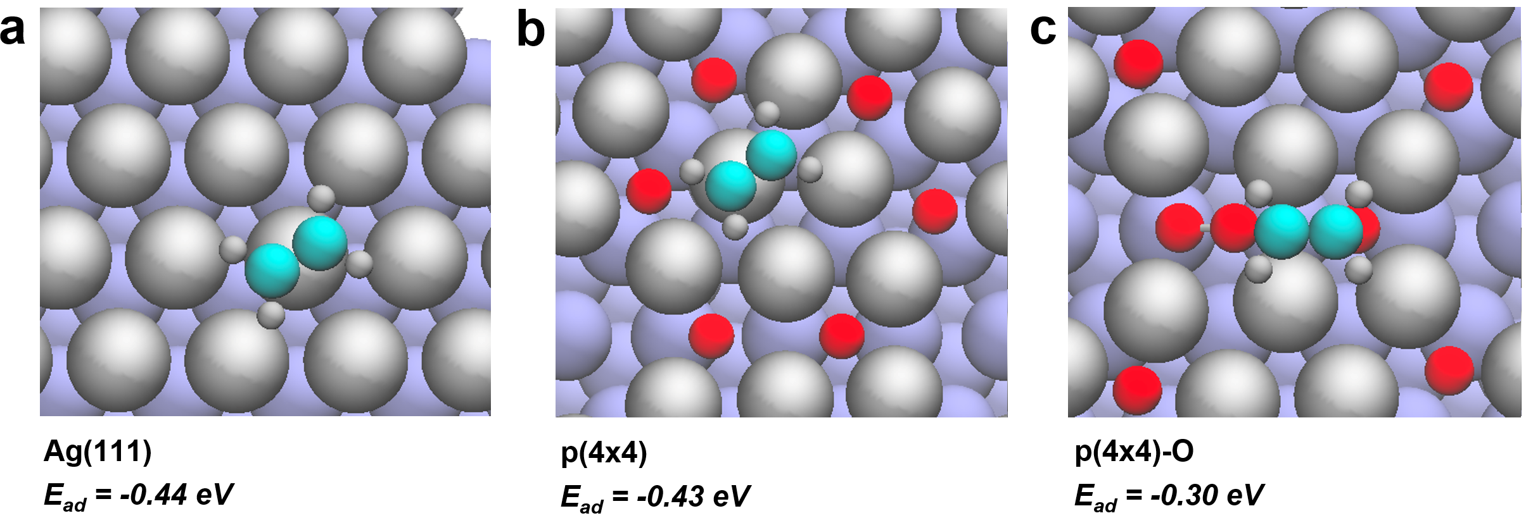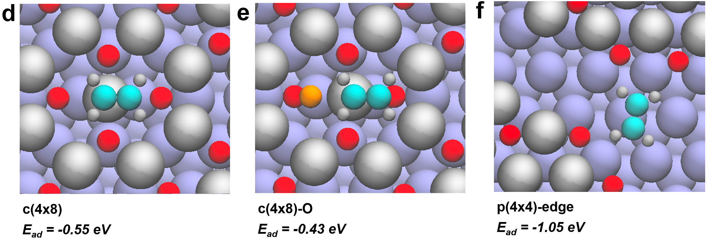
Supplementary Figure 19. Optimized configurations of C₂H₄ on various silver surfaces. The color code follows that of Supplementary Fig. 17, with dioxygen marked in orange.

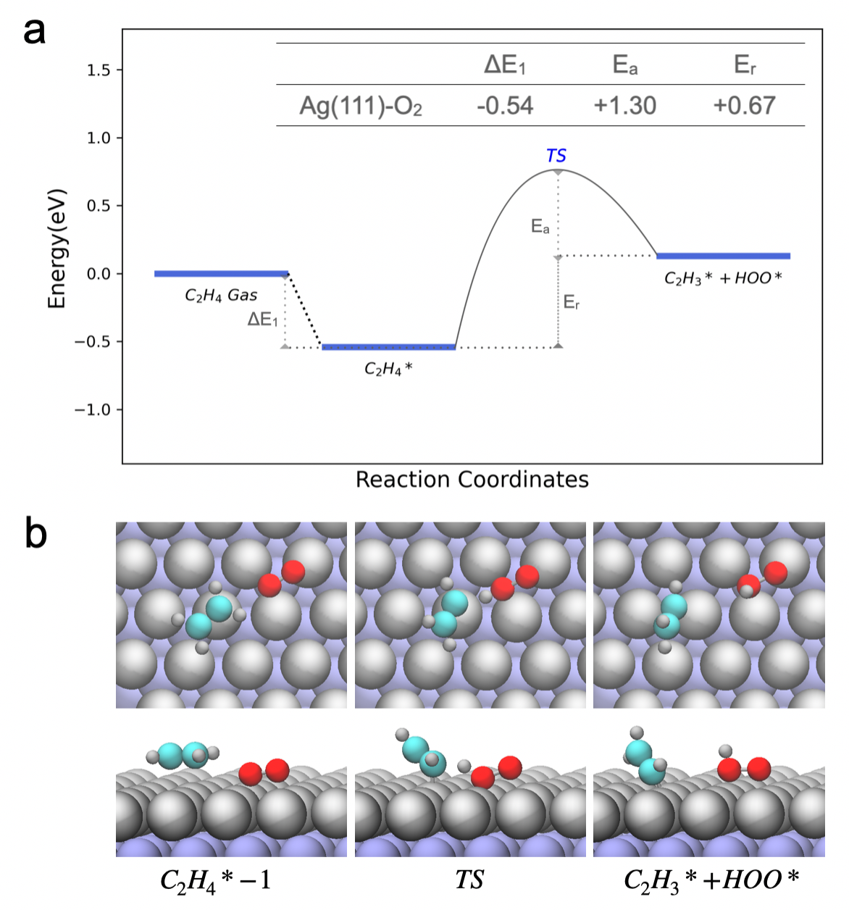
Supplementary Figure 20. a, Calculated energy profile for ethylene dehydrogenation on Ag(111) facet, facilitated by adsorbed dioxygen. Asterisk denotes adsorbate. b, Reaction snapshots along the pathway on Ag(111). The color code follows that of Supplementary Fig. 17, with carbon and hydrogen marked in blue and light grey, respectively.

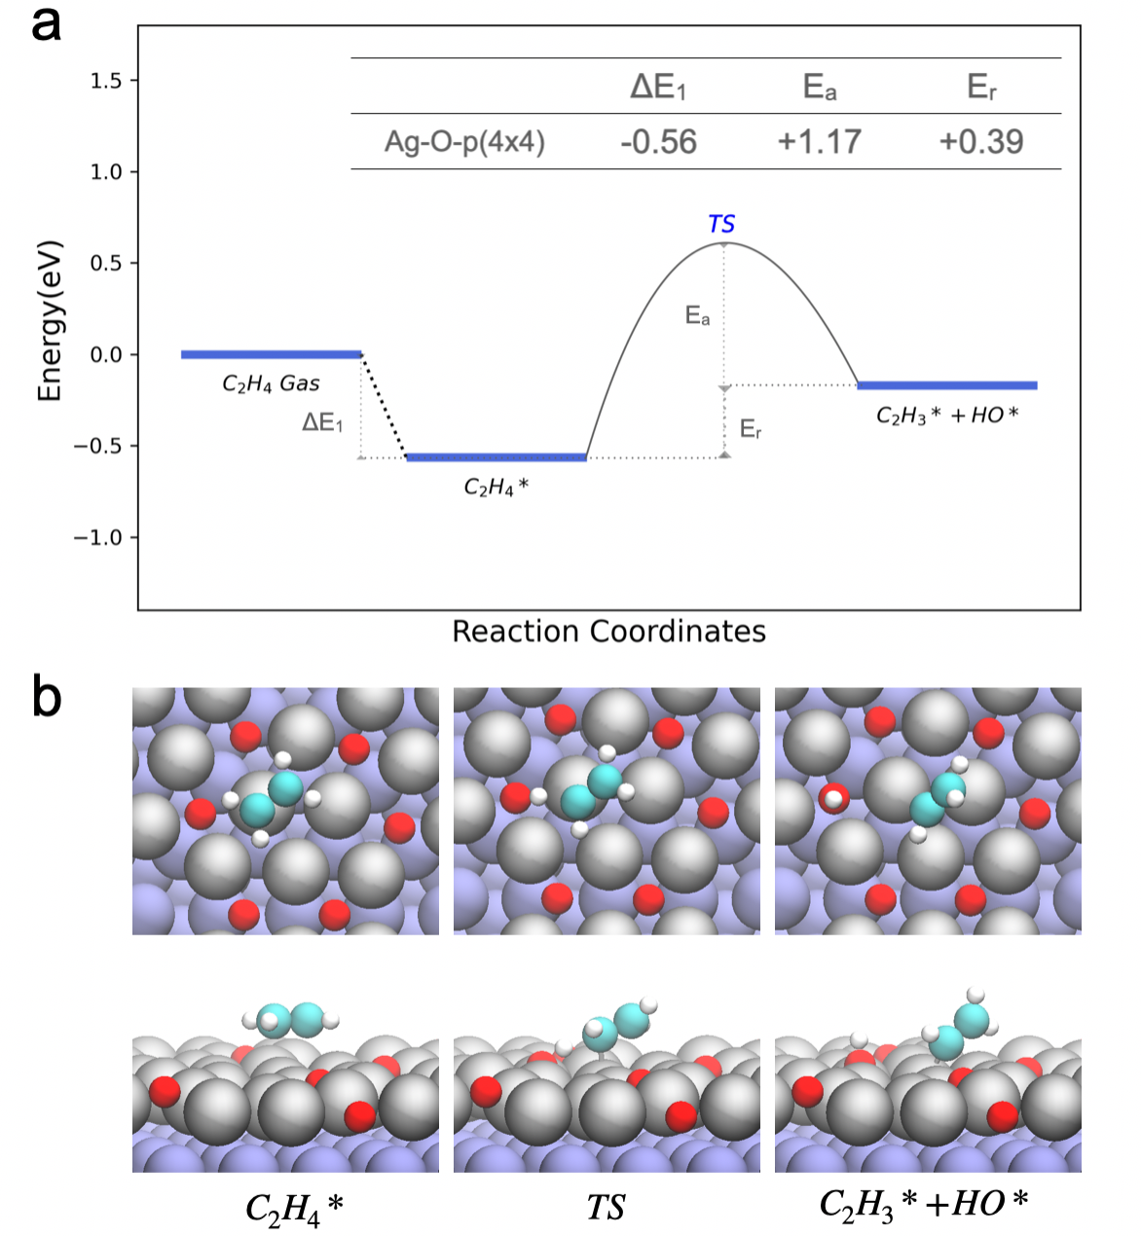
Supplementary Figure 21. a, Calculated energy profile for ethylene dehydrogenation on p(4x4) reconstructed surface, facilitated by lattice oxygen. Asterisk denotes adsorbate. b, Reaction snapshots along the pathway on p(4x4). The color code follows that of Supplementary Fig. 17, with carbon and hydrogen marked in blue and white, respectively.

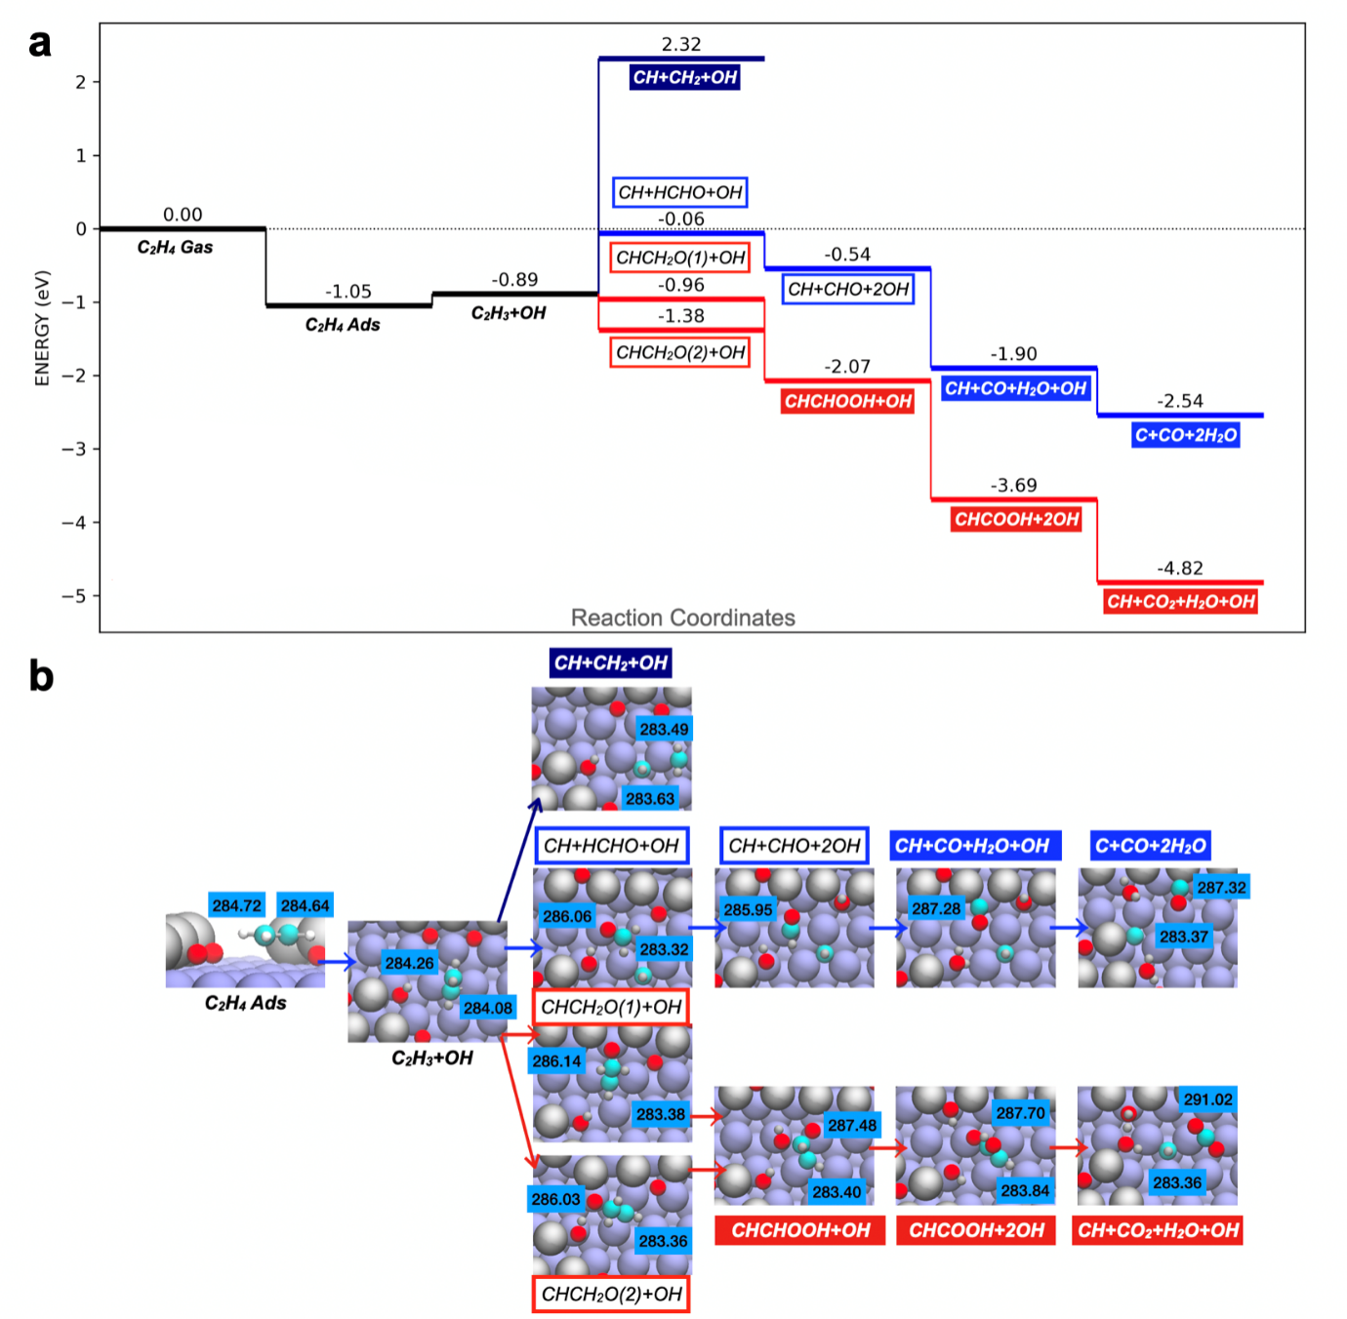
Supplementary Figure 22. a, Calculated energy profiles for three possible CO₂ formation pathways on a silver defect site via dehydrogenation. b, Reaction snapshots illustrating key intermediates along different pathways on the defect site.

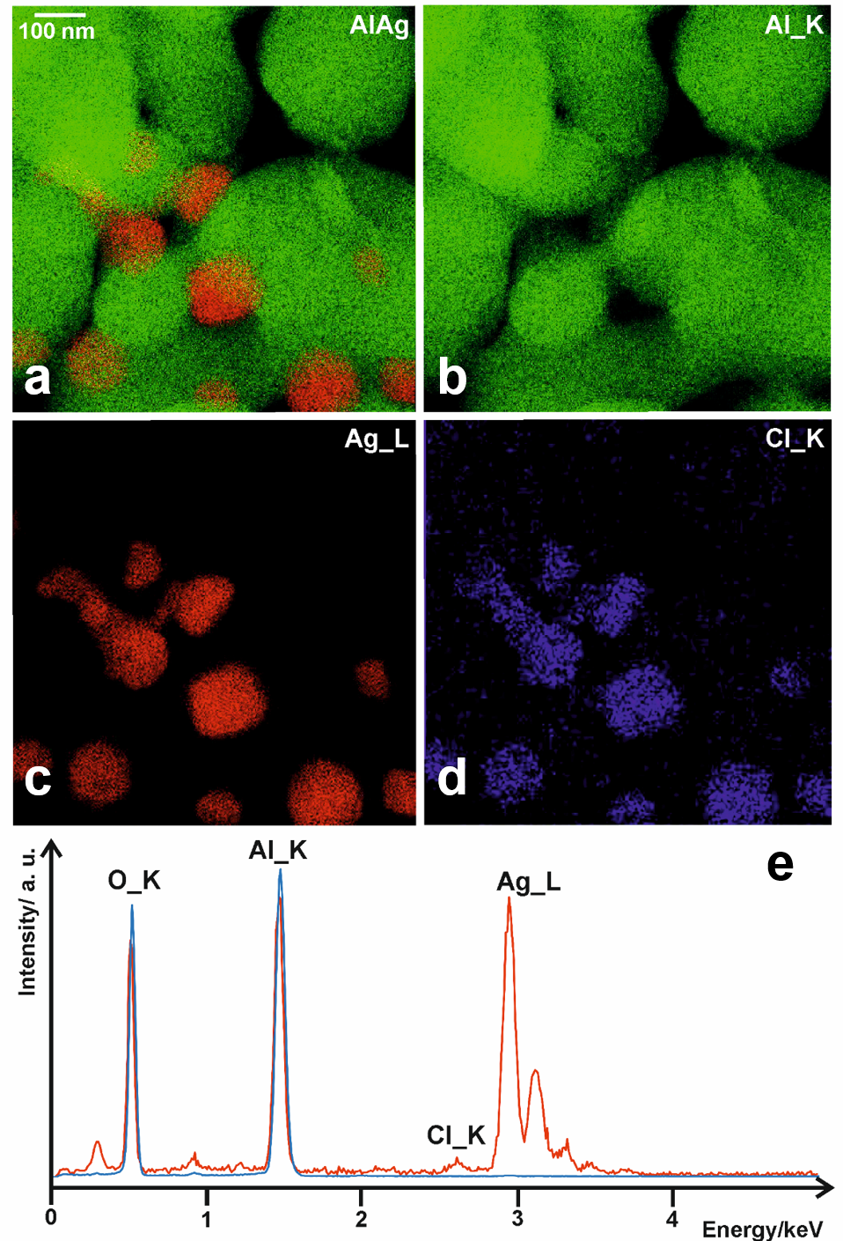
Supplementary Figure 23. a, EDX mapping of Al and Ag; b, Al; c, Ag; d, Cl of spent Ag/Al₂O₃ catalyst after exposure to steady-state ethylene oxidation at 230 °C for 48 hours (Reaction conditions: 15% C₂H₄, 3% O₂, 0.5 ppm vinyl chloride balanced by N₂, space velocity = 10000 ml·min⁻¹·g⁻¹). e, Selected regions of the EDX spectra for an Ag particle (red curve) and alumina (blue curve), confirming the presence of Cl at the Ag.

Supplementary Figure 24. XPS survey spectra of two Ag foil samples acquired under HV prior to gas exposure (photon energy: 1000 eV). The black and red curves correspond to the samples subsequently exposed to the EPO reaction mixture in the absence or presence of 10 ppm dichloroethane, respectively.

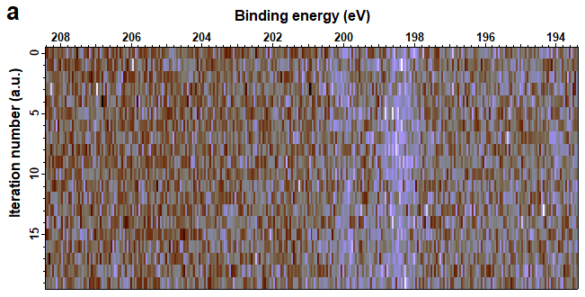
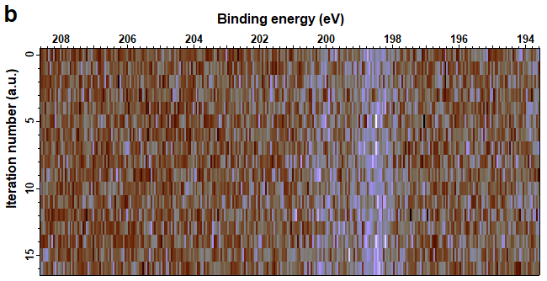
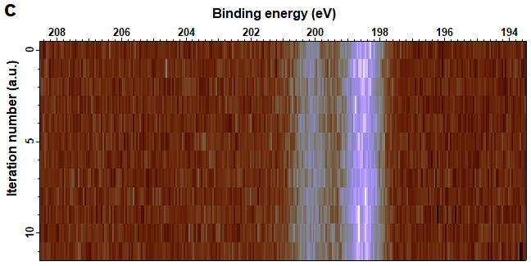
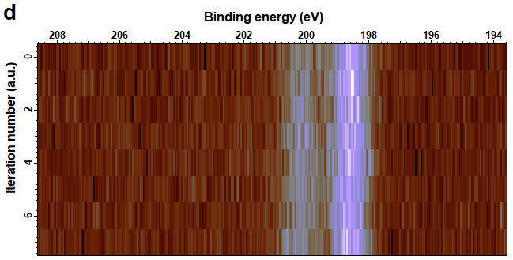
Supplementary Figure 25. Time-resolved evolution of Cl 2p spectra acquired at a kinetic energy of 480 eV during exposure of a silver foil sample to 10 ppm dichloroethane in a C₂H₄:O₂ =2:1 gas mixture (1 mbar) at various temperatures: a, 100 °C, b, 200 °C, c, 300 °C, and d, 400 °C.
Supplementary Figure 26. Intensity evolution of the Cl 2p signal at 198.5 eV (from Supplementary Fig. 23) as a function of iteration number at different temperatures. The Ag foil was exposed to 10 ppm dichloroethane in a C₂H₄:O₂ = 2:1 gas mixture (1 mbar), with four spectra acquired per iteration (KE=480 eV).

Supplementary Figure 27. Ag 3d spectra (normalized by intensity) of two Ag foil samples collected at different temperatures during exposure to a C₂H₄:O₂ (2:1) gas mixture (1 mbar), in the absence or presence of 10 ppm dichloroethane (KE=200 eV).

Supplementary Figure 28. C 1s spectra of two Ag foil samples collected at different temperatures during exposure to a C₂H₄:O₂ (2:1) gas mixture (1 mbar): a, in the absence and b, in the presence of 10 ppm dichloroethane (KE=200 eV).

Supplementary Figure 29. C 1s peaks evolution of Ag foil at a kinetic energy of 200 eV while exposing the sample to a C₂H₄:O₂ (2:1) mixture at 1 mbar a, in the absence and b, in the presence of 10 ppm dichloroethane over a temperature range of room temperature to 400 °C. The fitting parameters are listed in Supplementary Table 6.
Supplementary Table 6. Fitting parameters of C 1s peaks (KE=200 eV).
 | BE (eV) | FWHM (eV) | %L-G | Assignment
C_{EPO-1} | 284.2 | 1.2 | 10% | C₂H_{x} (x=1-3)
C_{EPO-2} | 284.8 | 1.3 | 10% | Adventitious carbon,  long-chain carbonaceous species, weakly adsorbed ethylene
C_{EPO-3} | 287.3 | 1.5 | 10% | Adsorbed CO
C_{EPO-4} | 288.0 | 1.1 | 10% | Adsorbed EO
C_{EPO-5} | 288.8 | 1.5 | 10% | Carbonate
Gas phase C₂H₄ | 285.1-286.1 | 1.0 | 10% | ——

Supplementary Figure 30. Normalized peak area of different C-related reaction intermediates on Ag foil as a function of temperature under in situ EPO conditions. (C₂H₄:O₂=2:1, 1 mbar, KE = 200 eV).

Supplementary Figure 31. O 1s spectra of two Ag foil samples acquired at different temperatures during exposure to a C₂H₄:O₂ (2:1) gas mixture (1 mbar): a, in the absence and b, in the presence of 10 ppm dichloroethane (KE=200 eV).

Supplementary Figure 32. O 1s peaks evolution of Ag foil at a kinetic energy of 200 eV while exposing the sample to a C₂H₄:O₂ (2:1) mixture at 1 mbar a, in the absence and b, in the presence of 10 ppm dichloroethane over a temperature range of room temperature to 400 °C. The fitting parameters are listed in Supplementary Table 7.
Supplementary Table 7. Fitting parameters of O 1s peaks (KE=200 eV).
 | BE (eV) | FWHM (eV) | %L-G | Assignment
O_{C1} | 533.7 | 1.4 | 25% | Adsorbed H₂O
O_{C2} | 532.8 | 1.5 | 25% | Carbonate species
O_{C3} | 532.1 | 1.5 | 25% | Hydroxyl species
O_{S} | 531.5 | 1.4 | 25% | Subsurface oxygen in dioxygen species formed on reconstructed surface
O_{T} | 530.7 | 1.4 | 25% | Top oxygen in dioxygen species formed on  reconstructed surface
O_{L} | 529.3 | 1.3 | 25% | Lattice oxygen on reconstructed Ag surface

Supplementary Figure 33. Normalized peak area of different O species on Ag foil as a function of temperature under in situ EPO conditions. (C₂H₄:O₂=2:1, 1 mbar, KE = 200 eV).

Supplementary Figure 34. Cl 2p spectra of Ag foil acquired at a kinetic energy of a, 200 eV and b, 480 eV while exposing the sample with 10 ppm dichloroethane. c, Normalized Cl 2p spectra on Ag foil acquired at a kinetic energy of 480 eV (C₂H₄:O₂=2:1, 1 mbar).

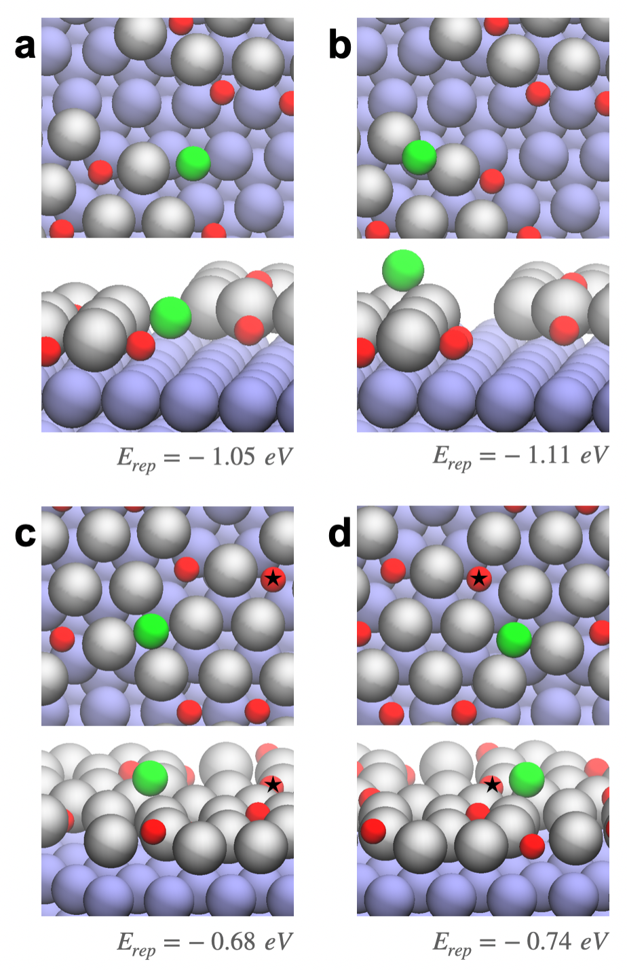
Supplementary Figure 35. DFT calculated energy for the replacement of lattice O by atomic Cl on different sites with respect to the O₂ and Cl₂ in gas phase. a and b show the replacement occurring at p(4×4)-edge sites, while c and d depict replacement on the p(4×4) reconstructed surface. The replacement energy is calculated as: $E_{rep}= E_{sub-Cl}- E_{sub-O}-\frac{1}{2}E_{{Cl}_{2}}+\frac{1}{2}E_{O_{2}}$, where E_{sub–Cl} and E_{sub–O} represent the total energies of the surface with Cl and O, respectively.

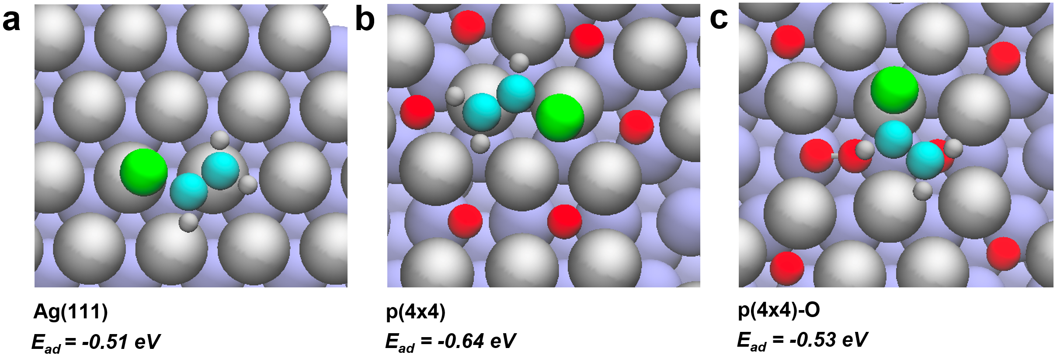
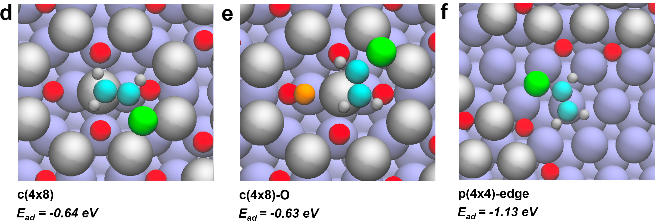
Supplementary Figure 36. Optimized configurations of VC on various Ag surfaces. The color code follows that of Supplementary Fig. 19, with dioxygen and chlorine marked in orange and green, respectively.

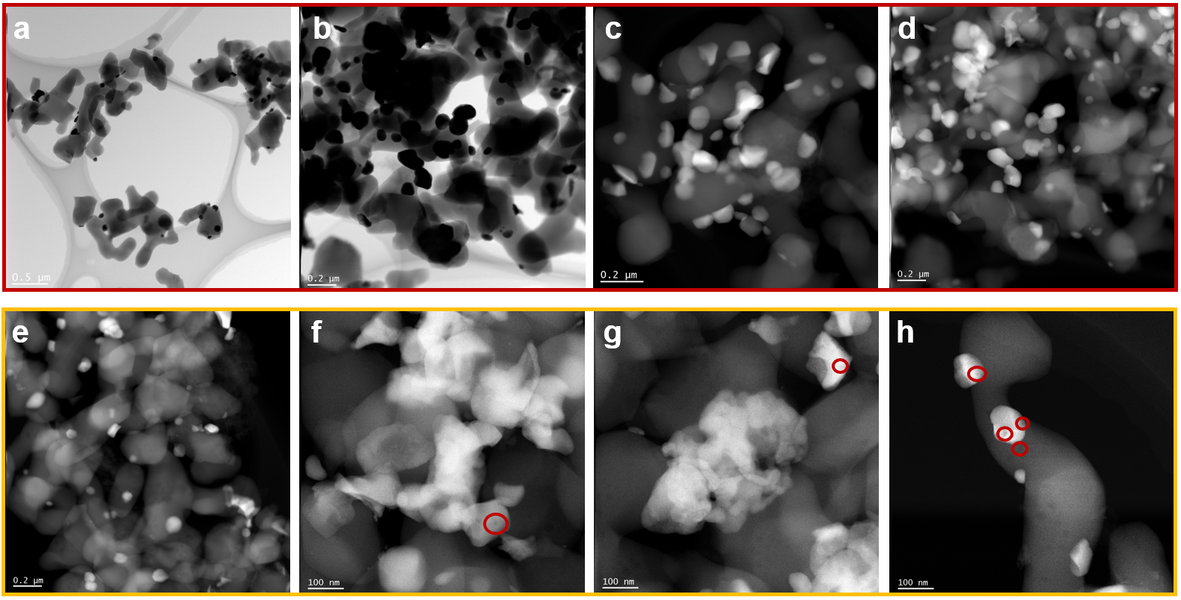
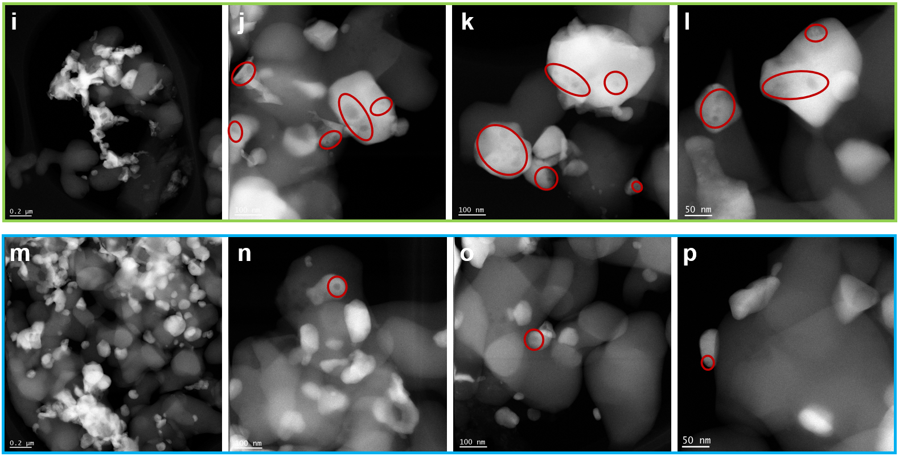
Supplementary Figure 37. TEM images of Ag/Al₂O₃: a, fresh catalyst; b, spent catalyst after 3 h reaction at 200 °C with 0.5 ppm vinyl chloride; c, spent catalyst after 3 h at 230 °C without 0.5 ppm vinyl chloride; d, spent catalyst after 3 h at 230 °C with 0.5 ppm vinyl chloride. (Reaction conditions: 15% C₂H₄, 3% O₂ balanced by N₂, space velocity = 10000 ml·min⁻¹·g⁻¹). Some of the voids in the Ag particles are marked by red circles.

Supplementary Figure 38. a, TPSR profiles of Ag/Al₂O₃ during co-feeding of 5.0 % C₂H₄ and 7.5% O₂ in Ar. b, TPSR profiles of Ag/Al₂O₃ under 7.5% O₂ balanced in Ar conditions following a pretreatment with 5% C₂H₄/7.5% O₂ in Ar at room temperature. (Space velocity = 6000 ml·min⁻¹·g⁻¹)
To further confirm the existence of distinct mechanisms, temperature-programmed surface reaction (TPSR) experiments were conducted on the Ag/Al₂O₃ catalyst, as shown in Supplementary Fig. 38. In a preliminary experiment, the temperature of the catalytic bed was gradually increased from room temperature while feeding an EPO reaction mixture (5% C₂H₄ + 7.5% O₂ in Ar). Both carbon dioxide and EO were detected starting around 160 °C. In a subsequent experiment, the Ag/Al₂O₃ catalyst was first exposed to 7.5% oxygen in argon at room temperature, then heated to 400 °C and held until neither carbon dioxide nor water were detected, confirming a surface free of reactive carbon species. After cooling to room temperature, 5% ethylene was introduced for 10 minutes, followed by purging with 7.5% oxygen in argon until the ethylene signal completely disappeared. Upon gradually increasing the temperature, carbon dioxide formation was observed above 150 °C, while no EO was detected throughout the entire process. These results indicate that ethylene was preferentially activated (dehydrogenation and C-C bond cleavage, as shown in Fig. 2) to form carbon dioxide precursors at room temperature, and that EO and carbon dioxide are not generated from a common intermediate.

Supplementary References
1. Guo M, Dongfang N, Iannuzzi M, van Bokhoven JA, Artiglia L. Structure and Reactivity of Active Oxygen Species on Silver Surfaces for Ethylene Epoxidation. ACS Catal 2024, 14: 10234-10244.

