Supplementary file- Figures

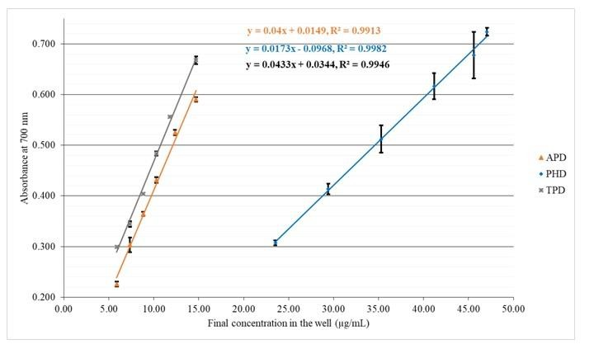
Figure.1 Dose responsive curves of ferric ion reducing power assay for PHD and two individual decoctions; APD and TPD. Each value is expressed as mean ± standard deviation (n=3)]

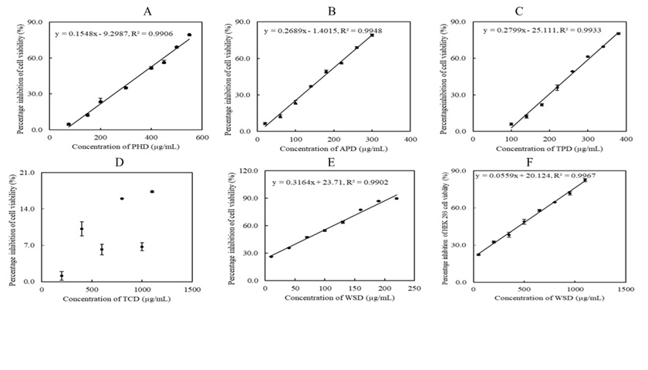 Figure 2. The cytotoxicity effects of polyherbal decoction and individual component decoctions. A) PHD, B) APD, C) TPD, D) TCD, E) WSD, F) WSD HEK293 cells.

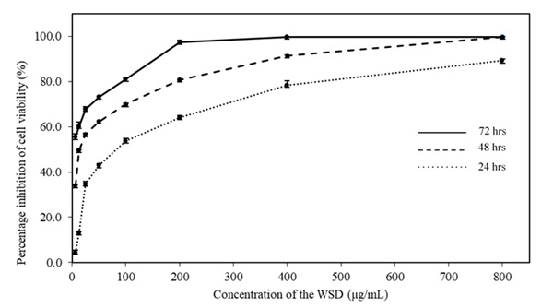
Figure 3. Cytotoxicity effects of WSD at 24 h, 48 h and 72 h against HCT 116 cells.

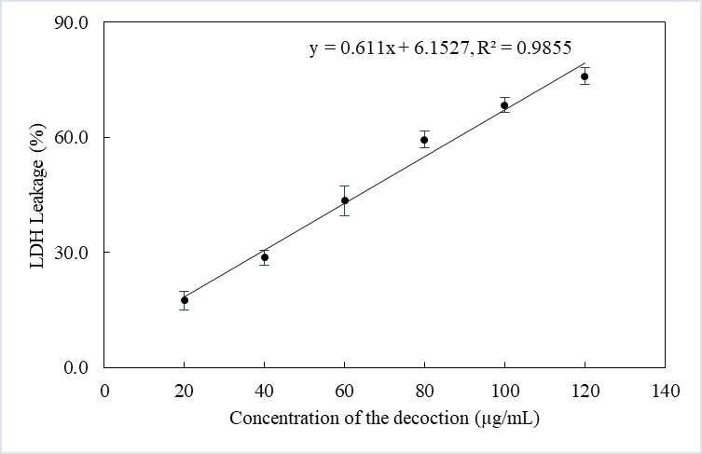
Figure 4. Dose dependent curve of LDH leakage.

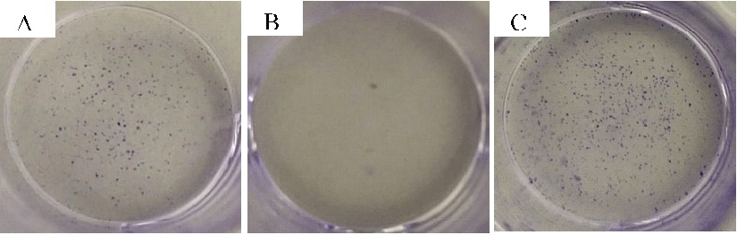
Figure 5. Colony formation of HCT 116 cells upon treatment and after 7 days. A) WSD treated cells, B) Positive control, C) Negative control.

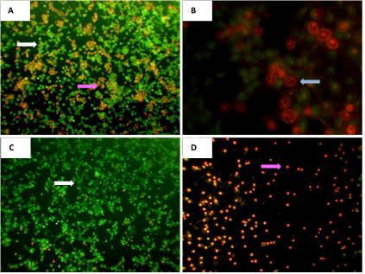
Figure 6. A) Emits orange-red fluorescence upon Ethidium bromide intercalation with DNA in HCT 116 cells; indicating late apoptotic cells and dead cells, B) Fragmented nuclei C) Negative control (untreated cells) D) positive control.
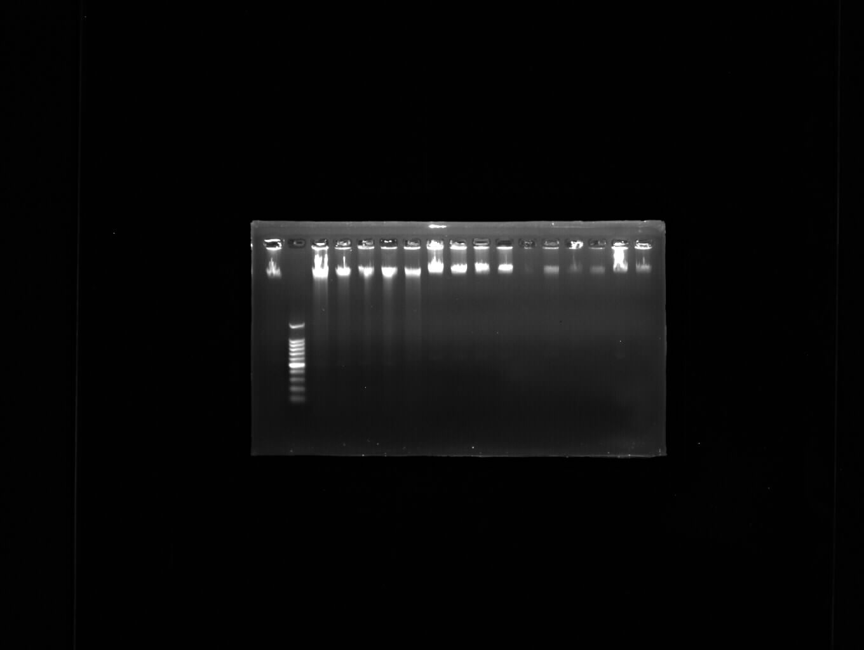

1 2 3 4 5 6 7 8
Figure 7. Analysis of genomic DNA fragmentation. DNA fragmentation was assessed on 2% agarose gel electrophoresis and ethidium bromide staining. Lane 1: Negative control (1), Lane 2: 100bp ladder, Lane 3:Positive control (1), Lane 4: Positive control (2), Lane 5: WSD treated cells (24 hrs)-(1), Lane 6: WSD treated cells (24 hrs)-(2), Lane 7: WSD treated cells (24 hrs)-(3), Lane 8: Negative control (2)

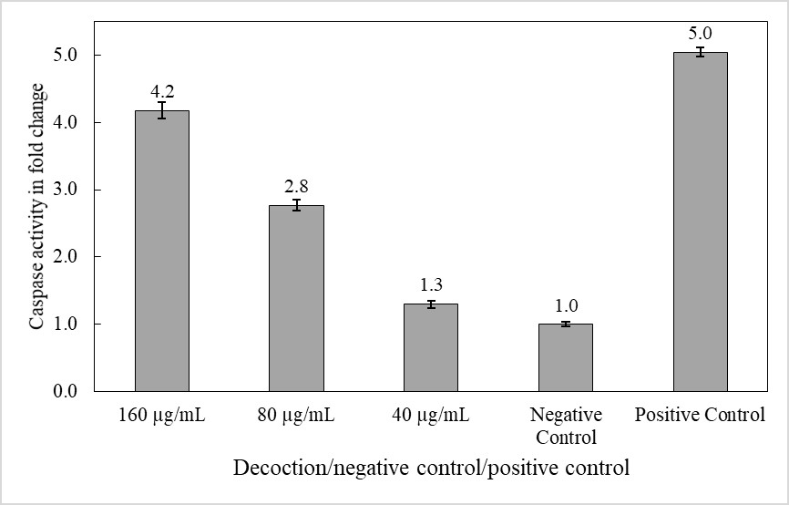
Figure 8. Caspase activity of decoction, negative control and positive control.

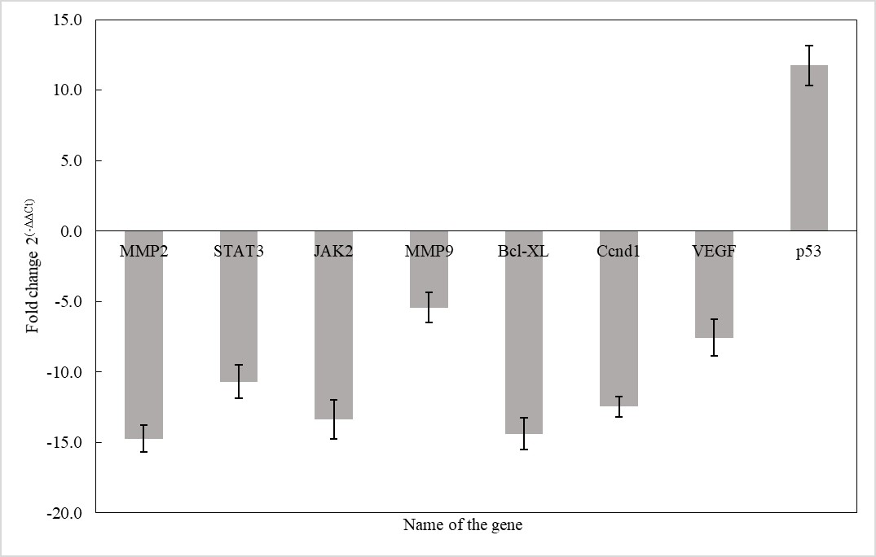
Figure 9. Expression of fold change in MMP2, STAT3, JAK2, MMP9, Bcl-XL, Ccnd1, VEGF and p53.

