Supplementary Material

Contents:
Supplementary Fig. 1：Distribution of missing clinical data of 844 patients
Supplementary Table 1：Demographic, clinical characteristics and surgery-related factors of the training cohort by AKI category
Supplementary Table 2：Demographic, clinical characteristics and surgery-related factors of the validation cohort by AKI category

Supplementary Fig. 1：Distribution of missing clinical data of 844 patients

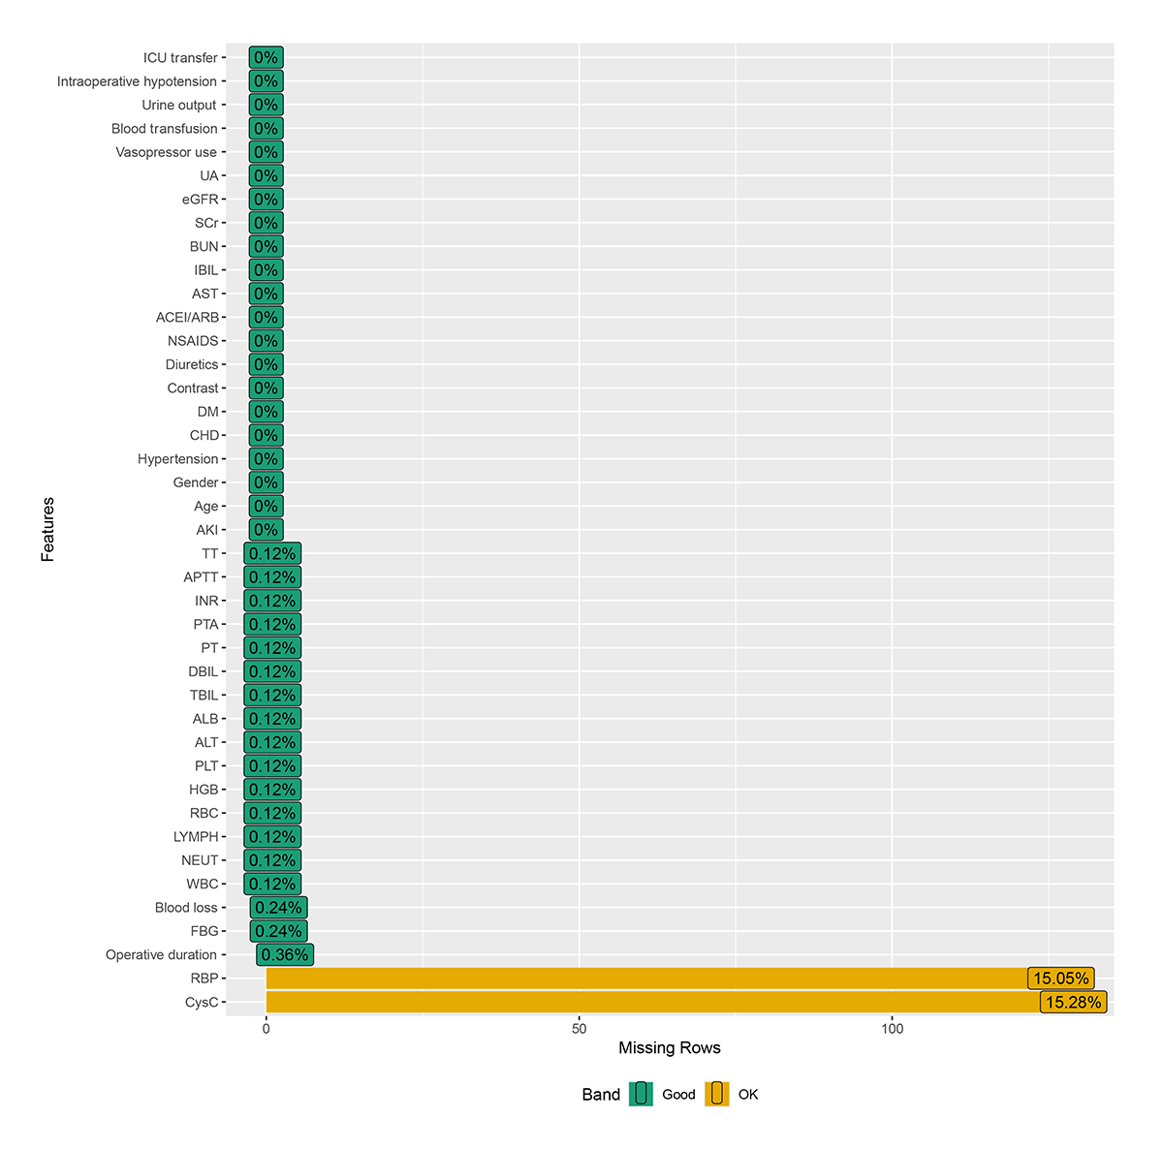
ICU, intensive care unit; UA, uric acid; eGFR, estimated glomerular filtration rate; SCr, serum creatinine; BUN, blood urea nitrogen; IBIL, indirect bilirubin; AST, aspartate aminotransferase; ACEI/ARB, angiotensin-converting enzyme inhibitors and angiotensin receptor blockers; NSAIDs, non-steroidal anti-inflammatory drugs; DM, diabetes mellitus; CHD, coronary heart disease; AKI, acute kidney injury; TT, thrombin time; APTT, partial thromboplastin time; INR, international normalized ratio; PTA, prothrombin time activity; PT, prothrombin time; DBIL, direct bilirubin; TBIL, total bilirubin; ALB, albumin; ALT, alanine aminotransferase; PLT, platelets; HGB, hemoglobin; RBC, red blood cells; LYMPH, lymphocytes; NEUT, neutrophil; WBC, white blood cells; FBG, fibrinogen; RBP, retinol-binding proteins; CysC, cystatin C.

Supplementary Table 1. Demographic, clinical characteristics and surgery-related factors of the training cohort by AKI category
Variables | All (n = 590) | Non-AKI Group  (n = 521) | AKI Group  （n=69） | P value
Baseline variables
Age (years) | 61.00 (51.00, 67.00) | 61.00 (51.00, 67.00) | 61.00 (53.00, 69.00) | 0.142
Sex, (%) |  |  |  | 0.576
Man | 345 (58.47%) | 302 (57.97%) | 43 (62.32%)
Women | 245 (41.53%) | 219 (42.03%) | 26 (37.68%)
Coexisting conditions
Hypertension, (%) | 161 (27.29%) | 137 (26.30%) | 24 (34.78%) | 0.179
Coronary heart disease, (%) | 41 (6.95%) | 35 (6.72%) | 6 (8.70%) | 0.612
Diabetes mellitus, (%) | 103 (17.46%) | 87 (16.70%) | 16 (23.19%) | 0.244
Medication history
Contrast | 482 (81.69%) | 422 (81.00%) | 60 (86.96%) | 0.300
Diuretics | 49 (8.31%) | 40 (7.68%) | 9 (13.04%) | 0.199
NSAIDs | 103 (17.46%) | 94 (18.04%) | 9 (13.04%) | 0.390
ACEI/ARB | 149 (25.25%) | 128 (24.57%) | 21 (30.43%) | 0.365
Laboratory parameters
WBC (10⁹/L) | 6.16 (4.97, 7.34) | 6.14 (5.00, 7.30) | 6.5 (4.89, 8.09) | 0.396
NEUT (10⁹/L) | 3.88 (2.98, 5.14) | 3.85 (2.98, 5.05) | 4.19 (2.94, 5.64) | 0.216
LYMPH (10⁹/L) | 1.42 (1.10, 1.81) | 1.43 (1.11, 1.81) | 1.34 (1.04, 1.75) | 0.306
RBC (10^{12/}L) | 4.06 (3.61, 4.40) | 4.04 (3.66, 4.39) | 4.10 (3.46, 4.51) | 0.579
HGB (g/L) | 124.00 (111.00, 135.00) | 124.00 (112.00, 135.00) | 126.00 (107.00, 136.00) | 0.770
PLT (10⁹/L) | 233.50 (186.25, 293.00) | 233.00 (186.00, 291.00) | 245.00 (190.00, 297.00) | 0.407
ALT (U/L) | 110.10 (31.55, 217.30) | 108.70 (32.00, 216.00) | 125.00 (27.00, 233.70) | 0.662
AST (U/L) | 78.95 (29.70, 160.88) | 79.00 (30.00, 158.00) | 75.90 (27.10, 189.00) | 0.659
ALB (g/L) | 37.60 (33.90, 40.80) | 37.70 (33.90, 40.80) | 36.60 (33.80, 40.70) | 0.501
TBIL (μmol/L) | 67.40 (13.12, 177.90) | 57.70 (13.10, 171.90) | 130.60 (22.90, 219.80) | 0.007
DBIL (μmol/L) | 46.20 (4.82, 130.62) | 40.50 (4.70, 125.10) | 98.70 (9.30, 156.00) | 0.006
IBIL (μmol/L) | 18.05 (7.32, 45.77) | 16.60 (7.30, 44.20) | 30.40 (8.50, 57.70) | 0.017
BUN (mmol/L) | 4.55 (3.65, 5.50) | 4.56 (3.64, 5.50) | 4.50 (3.67, 5.55) | 0.951
SCr (μmol/L) | 53.00 (45.00, 62.00) | 53.00 (45.00, 62.00) | 54.00 (44.00, 64.00) | 0.394
eGFR [ml●min⁻¹●(1.73m²)⁻¹] | 104.88 (96.80, 114.15) | 105.42 (97.21, 114.60) | 102.39 (95.04, 110.55) | 0.046
UA (μmol/L) | 213.00 (162.00, 269.75) | 215.00 (163.00, 271.00) | 198.00 (159.00, 256.00) | 0.387
RBP (mg/L) | 28.65 (23.00, 35.20) | 28.60 (23.00, 35.20) | 28.80 (21.90, 36.00) | 0.605
CysC (mg/L) | 0.90 (0.79, 1.01) | 0.89 (0.79, 1.00) | 0.92 (0.81, 1.11) | 0.028
PT (s) | 11.90 (11.20, 12.80) | 11.90 (11.20, 12.80) | 11.90 (11.30, 12.70) | 0.517
PTA(%) | 115.50 (97.00, 139.00) | 115.00 (97.00, 139.00) | 117.00 (98.00, 139.00) | 0.487
INR(INR) | 0.93 (0.85, 1.02) | 0.93 (0.85, 1.02) | 0.93 (0.84, 1.01) | 0.442
APTT (s) | 33.15 (30.40, 36.38) | 33.30 (30.40, 36.50) | 32.50 (30.10, 34.70) | 0.213
FBG(g/L) | 3.96 (3.28, 4.81) | 3.95 (3.27, 4.79) | 4.07 (3.38, 4.91) | 0.622
TT(s) | 17.10 (16.10, 18.20) | 17.10 (16.10, 18.30) | 17.20 (16.00, 18.00) | 0.659
Intraoperative variables
Vasopressor use, (%) | 46 (7.80%) | 39 (7.49%) | 7 (10.14%) | 0.592
Blood transfusion, (%) | 278 (47.12%) | 248 (47.6%) | 30 (43.48%) | 0.606
Blood loss (ml) | 300.00 (200.00, 500.00) | 300.00 (200.00, 500.00) | 400.00 (200.00, 600.00) | 0.107
Urine output (ml) | 800.00 (500.00, 1000.00) | 800.00 (500.00, 1100.00) | 700.00 (500.00, 1000.00) | 0.321
Operative duration (min) | 372.5 (315.00, 451.50) | 375.00 (315.00, 450.00) | 355.00 (305.00, 495.00) | 0.931
Intraoperative hypotension, (%) | 74 (12.54%) | 60 (11.52%) | 14 (20.29%) | 0.061
Postoperative variables
ICU transfer, (%) | 114 (19.32%) | 83 (15.93%) | 31 (44.93%) | ＜0.001
NSAIDs, non-steroidal anti-inflammatory drugs; ACEI/ARB, angiotensin-converting enzyme inhibitors and angiotensin receptor blockers; WBC, white blood cells; NEUT, neutrophil; LYMPH, lymphocytes; RBC, red blood cells; HGB, hemoglobin; PLT, platelets; ALT, alanine aminotransferase; AST, aspartate aminotransferase; ALB, albumin; TBIL, total bilirubin; DBIL, direct bilirubin; IBIL, indirect bilirubin; BUN, blood urea nitrogen; SCr, serum creatinine; eGFR, estimated glomerular filtration rate; UA, uric acid; RBP, retinol-binding proteins; CysC, cystatin C; PT, prothrombin time; PTA, prothrombin time activity; INR, international normalized ratio; APTT, partial thromboplastin time; FBG, fibrinogen; TT, thrombin time; ICU, intensive care unit.

Supplementary Table 2. Demographic, clinical characteristics and surgery-related factors of the validation cohort by AKI category
Variables | All (n = 254) | Non-AKI Group  (n = 225) | AKI Group  （n=29） | P value
Baseline variables
Age (years) | 59.50 (51.00, 66.00) | 60.00 (51.00, 66.00) | 59.00 (51.00, 67.00) | 0.547
Sex, (%) |  |  |  | 0.278
Man | 147 (57.87%) | 127 (56.44%) | 20 (68.97%)
Women | 107 (42.13%) | 98 (43.56%) | 9 (31.03%)
Coexisting conditions
Hypertension, (%) | 62 (24.41%) | 56 (24.89%) | 6 (20.69%) | 0.790
Coronary heart disease, (%) | 17 (6.69%) | 15 (6.67%) | 2 (6.90%) | 1.000
Diabetes mellitus, (%) | 38 (14.96%) | 34 (15.11%) | 4 (13.79%) | 1.000
Medication history
Contrast | 208 (81.89%) | 185 (82.22%) | 23 (79.31%) | 0.899
Diuretics | 28 (11.02%) | 22 (9.78%) | 6 (20.69%) | 0.107
NSAIDs | 41 (16.14%) | 35 (15.56%) | 6 (20.69%) | 0.433
ACEI/ARB | 57 (22.44%) | 51 (22.67%) | 6 (20.69%) | 0.997
Laboratory parameters
WBC (10⁹/L) | 6.08 (4.89, 7.47) | 6.05 (4.91, 7.48) | 6.34 (4.35, 7.44) | 0.797
NEUT (10⁹/L) | 3.82 (2.88, 5.03) | 3.76 (2.89, 5.04) | 3.97 (2.78, 4.97) | 0.681
LYMPH (10⁹/L) | 1.46 (1.11, 1.90) | 1.46 (1.14, 1.89) | 1.48 (1.05, 1.96) | 0.775
RBC (10^{12/}L) | 4.05 ± 0.57 | 4.05 ± 0.57 | 4.05 ± 0.57 | 0.994
HGB (g/L) | 125.50 (113.00, 135.00) | 125.00 (113.00, 135.00) | 126.00 (113.00, 134.00) | 0.831
PLT (10⁹/L) | 235.00 (189.25, 289.00) | 236.00 (191.00, 294.00) | 207.00 (180.00, 283.00) | 0.112
ALT (U/L) | 109.60 (34.42, 238.98) | 114.00 (33.00, 248.10) | 94.00 (43.30, 140.50) | 0.364
AST (U/L) | 72.50 (27.02, 142.02) | 76.80 (26.70, 145.30) | 65.30 (32.90, 120.70) | 0.599
ALB (g/L) | 37.65 (34.80, 40.98) | 37.80 (34.80, 40.90) | 37.30 (35.10, 41.50) | 0.868
TBIL (μmol/L) | 46.55 (12.03, 159.73) | 45.60 (11.80, 159.50) | 56.80 (12.30, 165.90) | 0.407
DBIL (μmol/L) | 32.40 (3.90, 120.67) | 31.40 (3.90, 116.70) | 41.80 (3.90, 124.10) | 0.416
IBIL (μmol/L) | 15.70 (7.20, 41.10) | 14.70 (7.20, 41.10) | 21.10 (8.40, 41.80) | 0.444
BUN (mmol/L) | 4.72 (3.76, 5.74) | 4.68 (3.71, 5.63) | 5.49 (4.16, 6.48) | 0.031
SCr (μmol/L) | 54.00 (46.00, 62.00) | 54.00 (46.00, 61.00) | 55.00 (44.00, 67.00) | 0.749
eGFR [ml●min⁻¹●(1.73m²)⁻¹] | 105.12 (96.97, 113.83) | 104.74 (97.11, 113.80) | 106.45 (95.73, 116.12) | 0.855
UA (μmol/L) | 221.50 (167.00, 281.75) | 217.00 (167.00, 281.00) | 230.00 (182.00, 314.00) | 0.282
RBP (mg/L) | 30.00 (24.00, 36.00) | 29.80 (23.00, 35.50) | 32.00 (26.40, 37.40) | 0.107
CysC (mg/L) | 0.87 (0.79, 0.99) | 0.86 (0.78, 0.97) | 0.98 (0.83, 1.09) | 0.008
PT (s) | 11.90 (11.10, 12.60) | 11.90 (11.10, 12.60) | 11.70 (11.10, 12.90) | 0.829
PTA(%) | 119.00 (103.25, 144.00) | 119.00 (104.00, 144.00) | 120.00 (102.00, 140.00) | 0.998
INR(INR) | 0.91 (0.84, 0.99) | 0.91 (0.84, 0.98) | 0.91 (0.83, 0.99) | 0.844
APTT (s) | 33.00 (29.80, 36.08) | 32.90 (29.80, 35.80) | 34.53 (31.40, 37.00) | 0.070
FBG(g/L) | 3.94 (3.06, 4.79) | 3.94 (3.06, 4.80) | 3.72 (3.13, 4.33) | 0.621
TT(s) | 17.01 ± 1.47 | 16.99 ± 1.48 | 17.15 ± 1.40 | 0.559
Intraoperative variables
Vasopressor use, (%) | 21 (8.27%) | 18 (8.00%) | 3 (10.34%) | 0.717
Blood transfusion, (%) | 115 (45.28%) | 101 (44.89%) | 14 (48.28%) | 0.883
Blood loss (ml) | 300.00 (200.00, 500.00) | 300.00 (200.00, 500.00) | 300.00 (200.00, 500.00) | 0.814
Urine output (ml) | 700.00 (500.00, 1000.00) | 700.00 (500.00, 1000.00) | 700.00 (400.00, 1000.00) | 0.469
Operative duration (min) | 362.50 (320.00, 459.25) | 360.00 (320.00, 450.00) | 440.00 (340.00, 535.00) | 0.038
Intraoperative hypotension, (%) | 28 (11.02%) | 27 (12.00%) | 1 (3.45%) | 0.219
Postoperative variables
ICU transfer, (%) | 43 (16.93%) | 29 (12.89%) | 14 (48.28%) | ＜0.001
NSAIDs, non-steroidal anti-inflammatory drugs; ACEI/ARB, angiotensin-converting enzyme inhibitors and angiotensin receptor blockers; WBC, white blood cells; NEUT, neutrophil; LYMPH, lymphocytes; RBC, red blood cells; HGB, hemoglobin; PLT, platelets; ALT, alanine aminotransferase; AST, aspartate aminotransferase; ALB, albumin; TBIL, total bilirubin; DBIL, direct bilirubin; IBIL, indirect bilirubin; BUN, blood urea nitrogen; SCr, serum creatinine; eGFR, estimated glomerular filtration rate; UA, uric acid; RBP, retinol-binding proteins; CysC, cystatin C; PT, prothrombin time; PTA, prothrombin time activity; INR, international normalized ratio; APTT, partial thromboplastin time; FBG, fibrinogen; TT, thrombin time; ICU, intensive care unit.

