Long-term anthropogenic impacts result in widespread changes of plant species composition in Southern Atlantic Forest: evidences from systematic survey

Fernanda Ribeiro da Silva¹*, André L. Giles¹, André Gasper²,³, Alexander Vibrans²,³, Marcio Baldissera Cure⁴, A. Catarina C. Jakovac¹
¹Laboratory of Ecology and Restoration of Forest Ecosystems, ReFlor, University of Santa Catarina (UFSC), Trindade, Florianópolis, SC 88040-900, Brazil.
²Departamento de Engenharia Florestal, Universidade Regional de Blumenau, Rua São Paulo, 3250, 89030-000, Blumenau, SC, Brazil
³ Herbário Dr. Roberto Miguel Klein, Universidade Regional de Blumenau, Rua Antonio da Veiga, 140,89030-903, Blumenau, SC, Brazil

⁴ Secretaria de Educação do Estado de Santa Catarina, UD Escolar Quilombola Vidal Martins. Rodovia João Gualberto Soares, 9543. São João do Rio Vermelho, CEP 88060-000, Florianópolis, SC, Brazil

Table 1. Results of Generalized Model
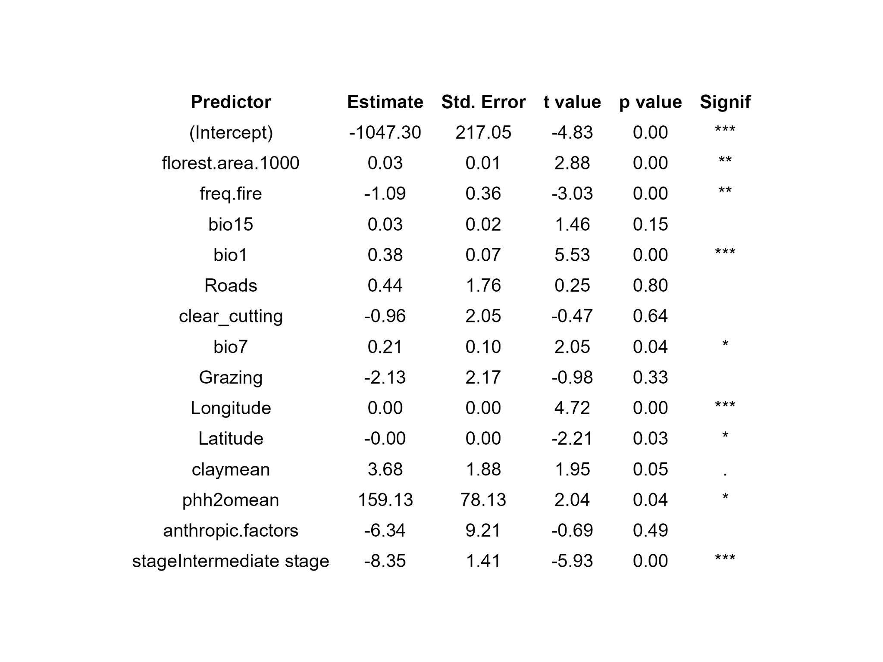

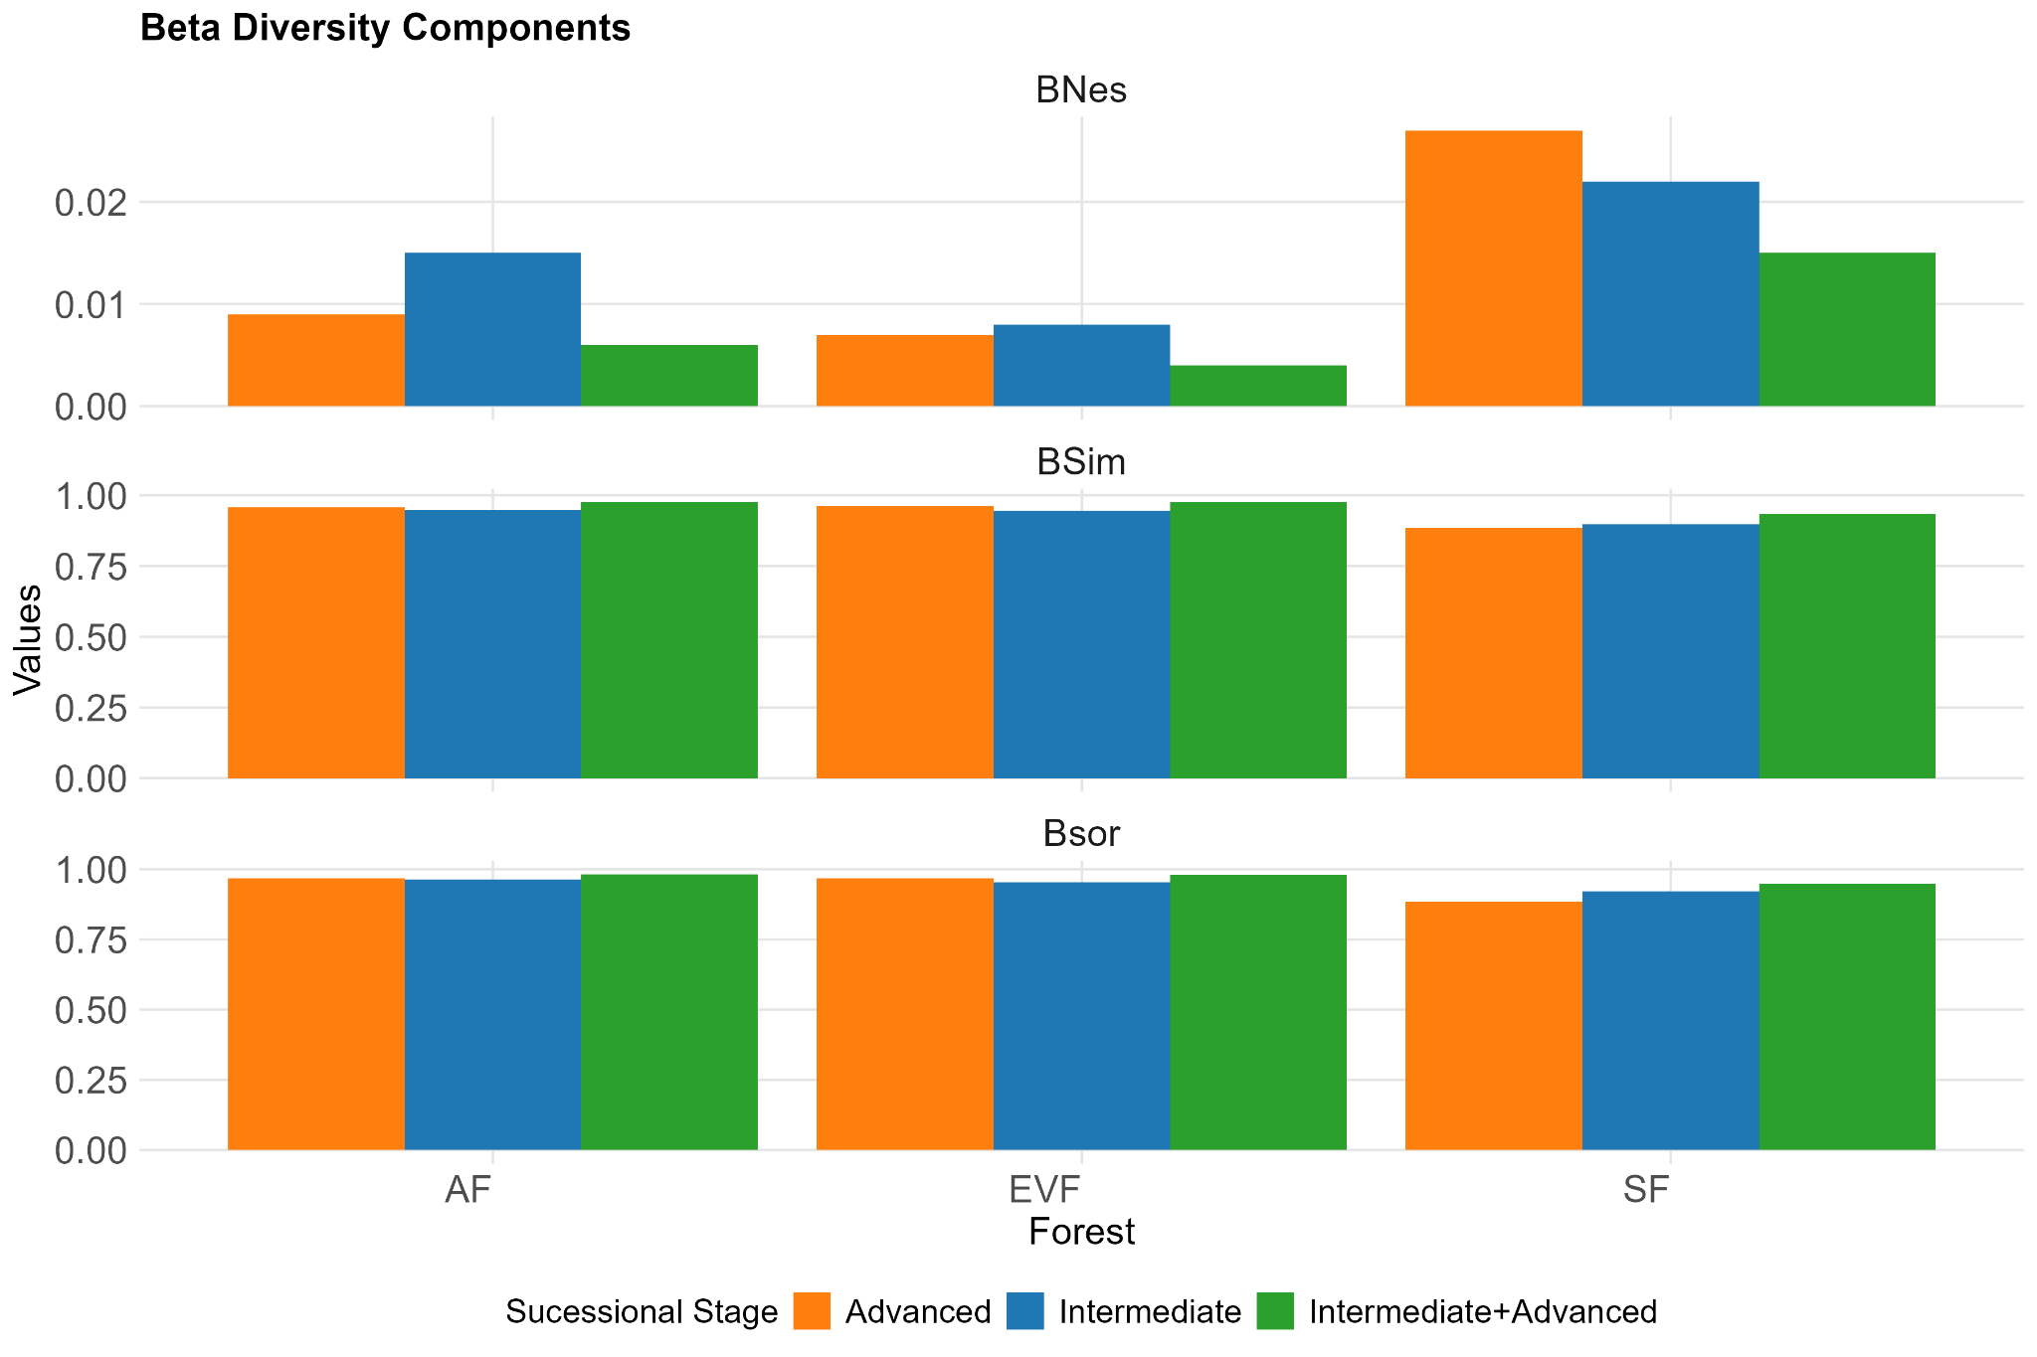
Figure S1- Beta-diversity components for the three forest formations, based on species presence. βSor (overall dissimilarity in species composition), βSim (species turnover between sites), βNes (nestedness, when assemblages are subsets of species from richer sites). Colors indicate successional stages (orange = advanced, blue = intermediate, green = intermediate + advanced) in the three forest formations (EVF = Evergreen Forest, AF = Araucaria Forest, SF = Seasonal Forest). Note that the y-axis scale for βNes differs from the others.

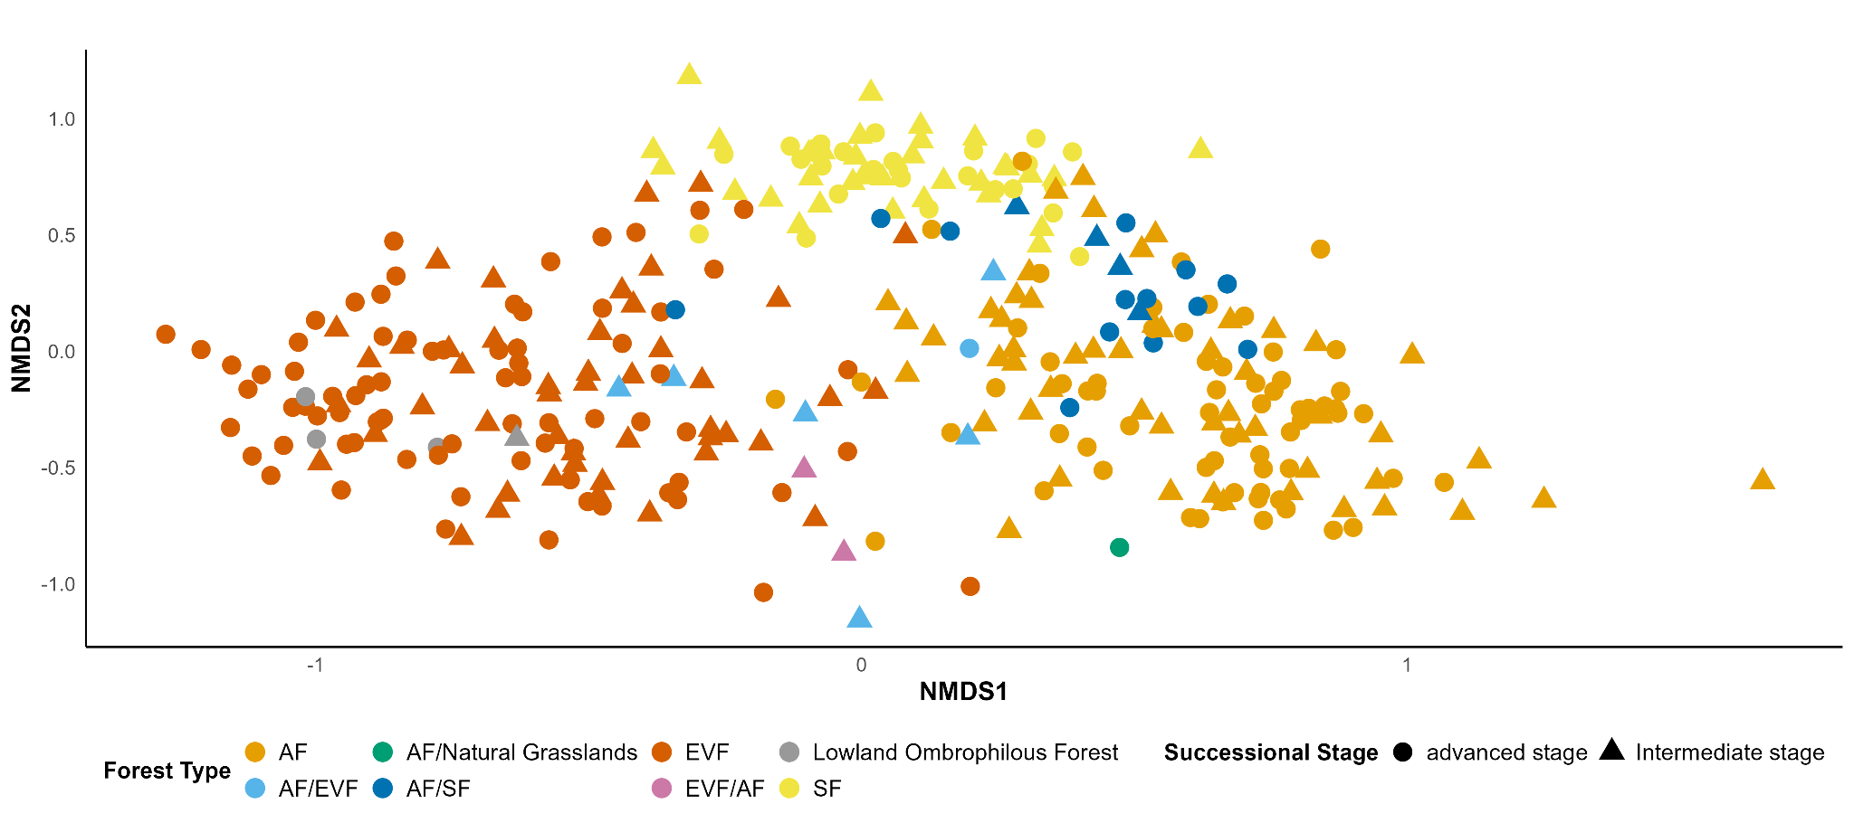
Figure S2. NMDS Ordination of Successional Transitions and Subformations in the South Atlantic Forest.

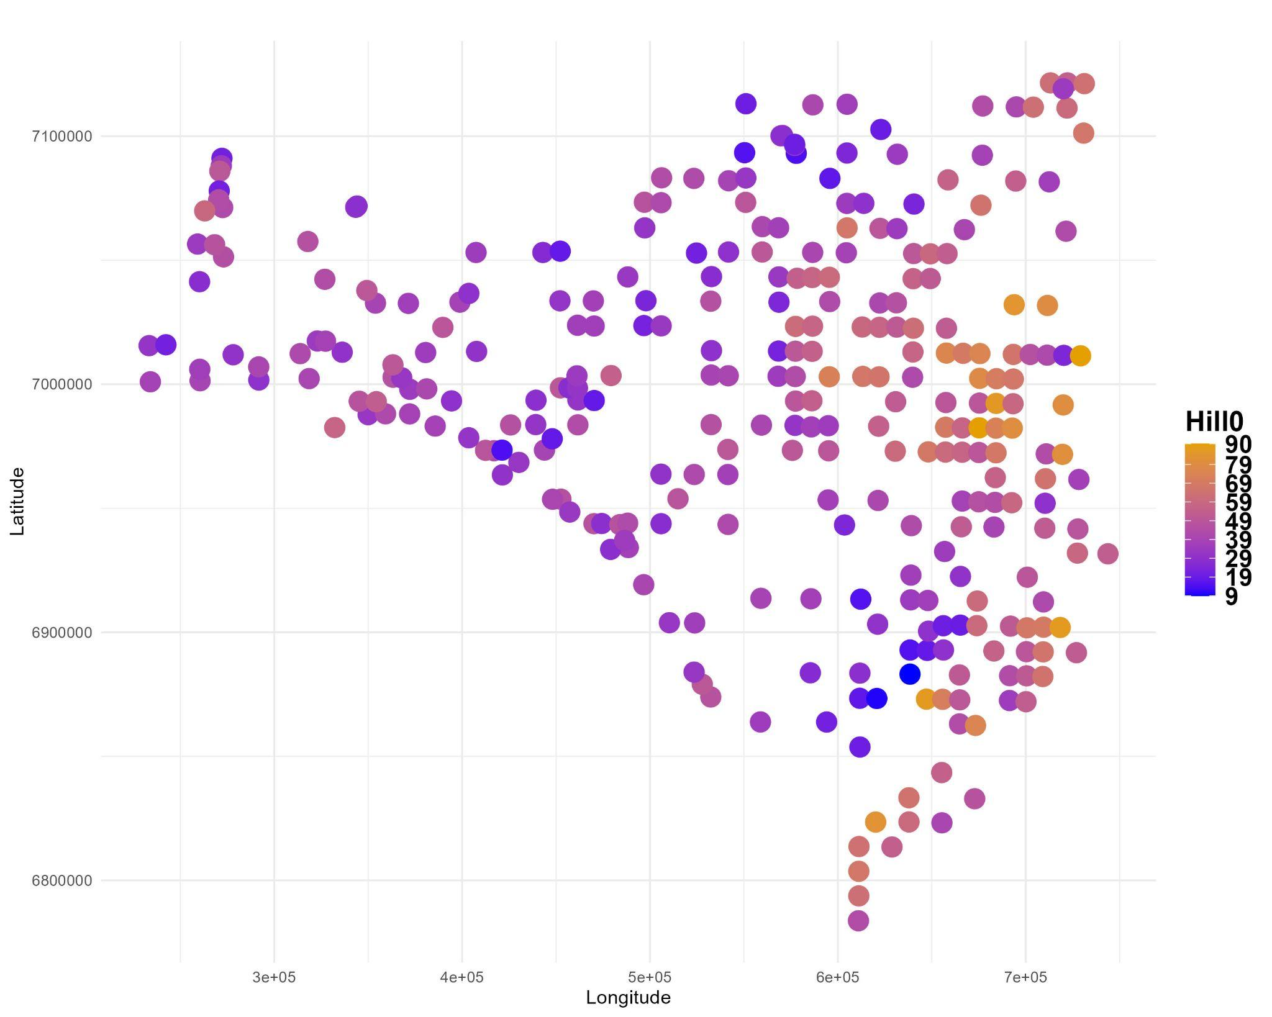
Figure S3. Map of species richness (Hill0) in sampling units. Points represent sampling units. Colors represent variation on species richness among sampling units.
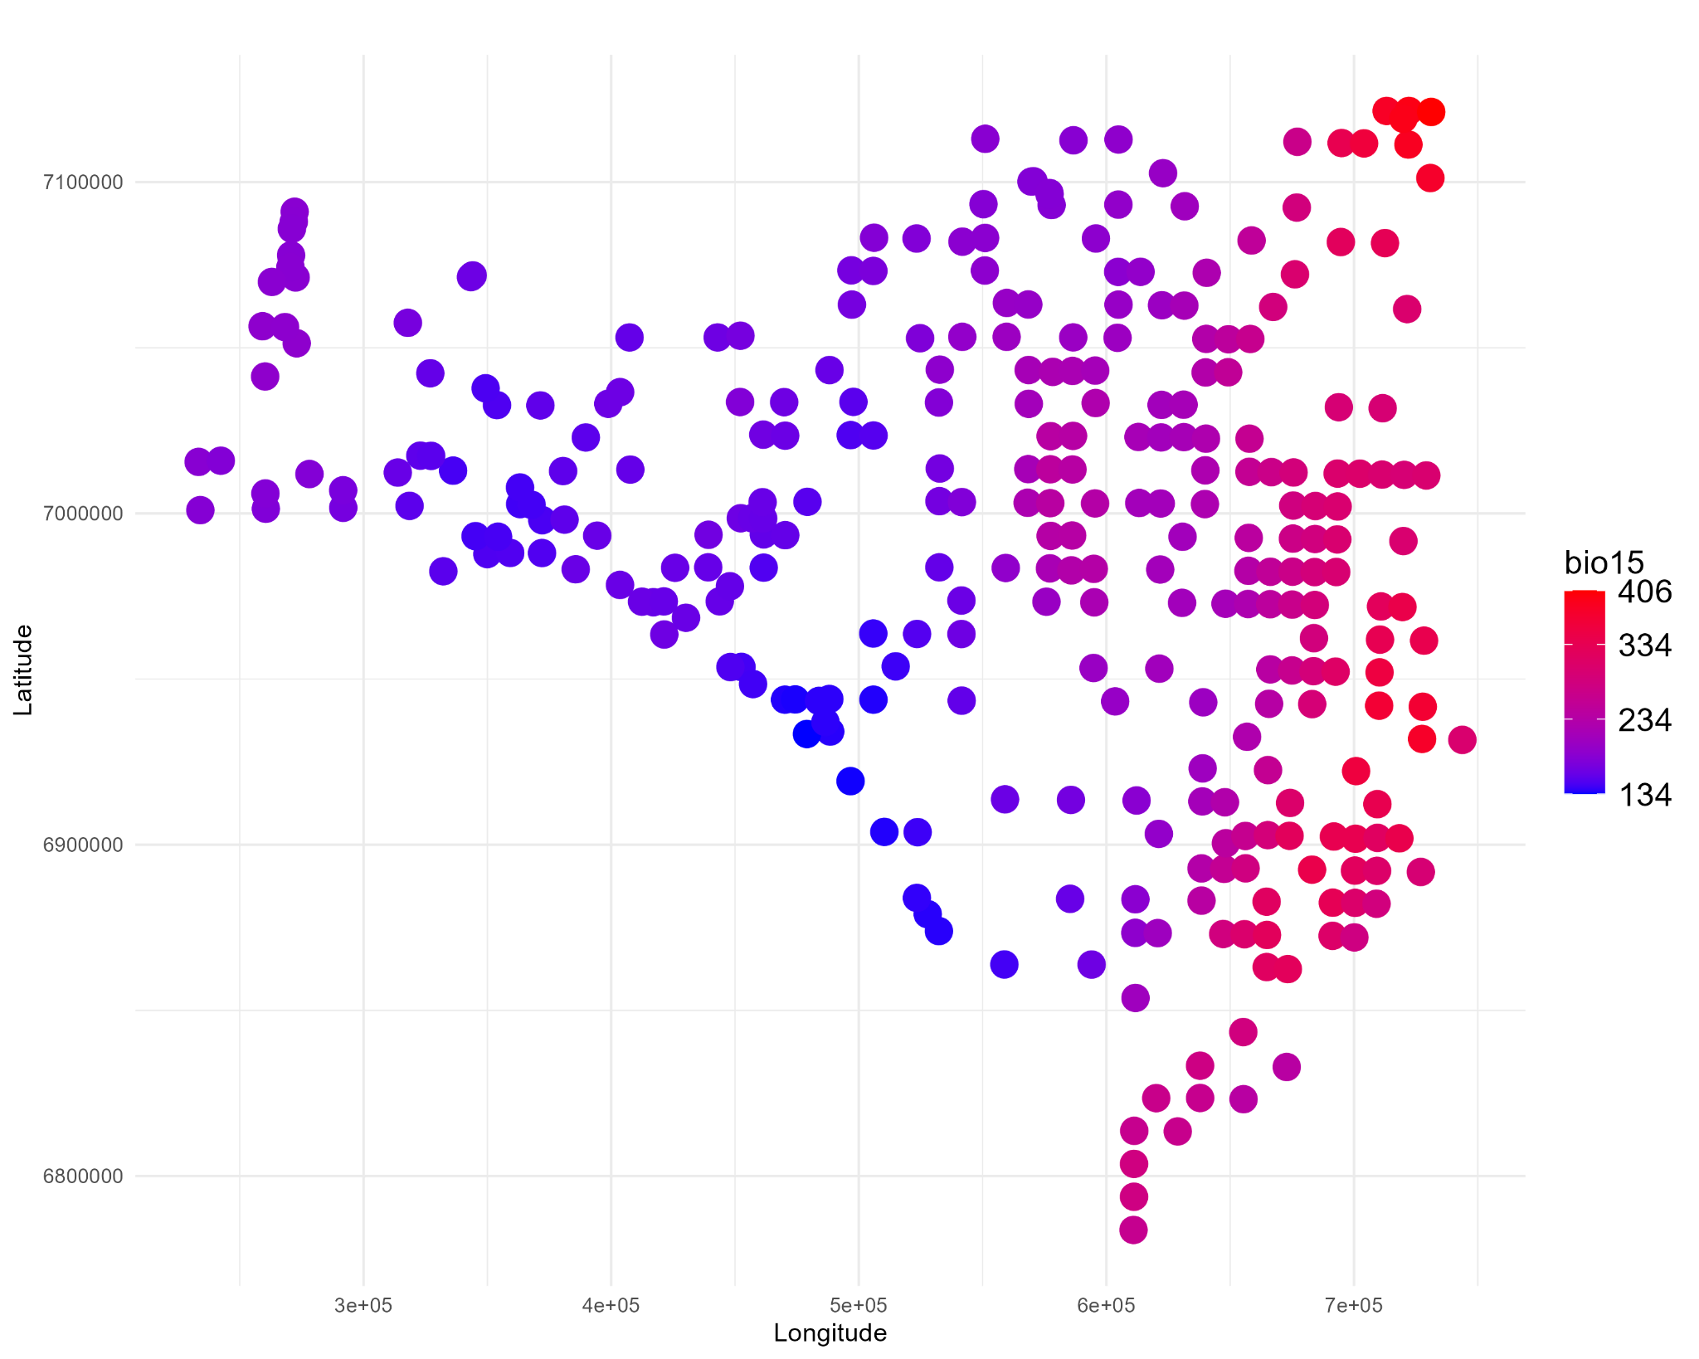
Figure S4. Precipitation seasonality (bio15) in sampling units. Points represent sampling units. Colors represent variation on precipitation seasonality among sampling units. The more red, the more precipitation seasonality.

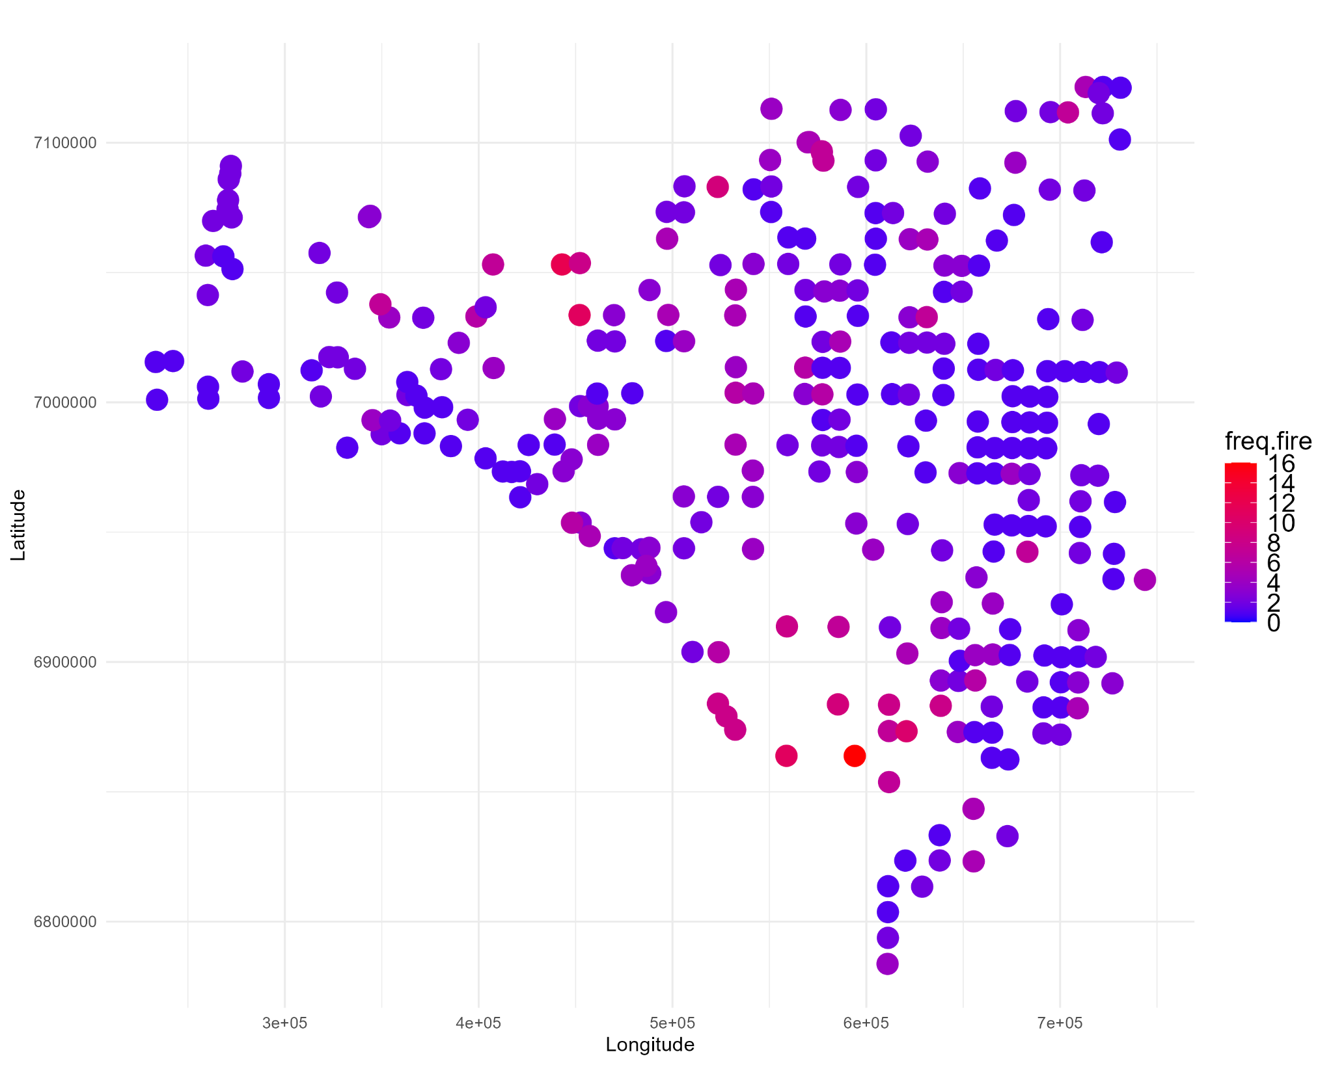
Figure S5. Fire frequency in a 5000m² buffer radius landscape. Points represent sampling units. Colors represent variation on fire frequency among sampling units. As red, more fire frequency.

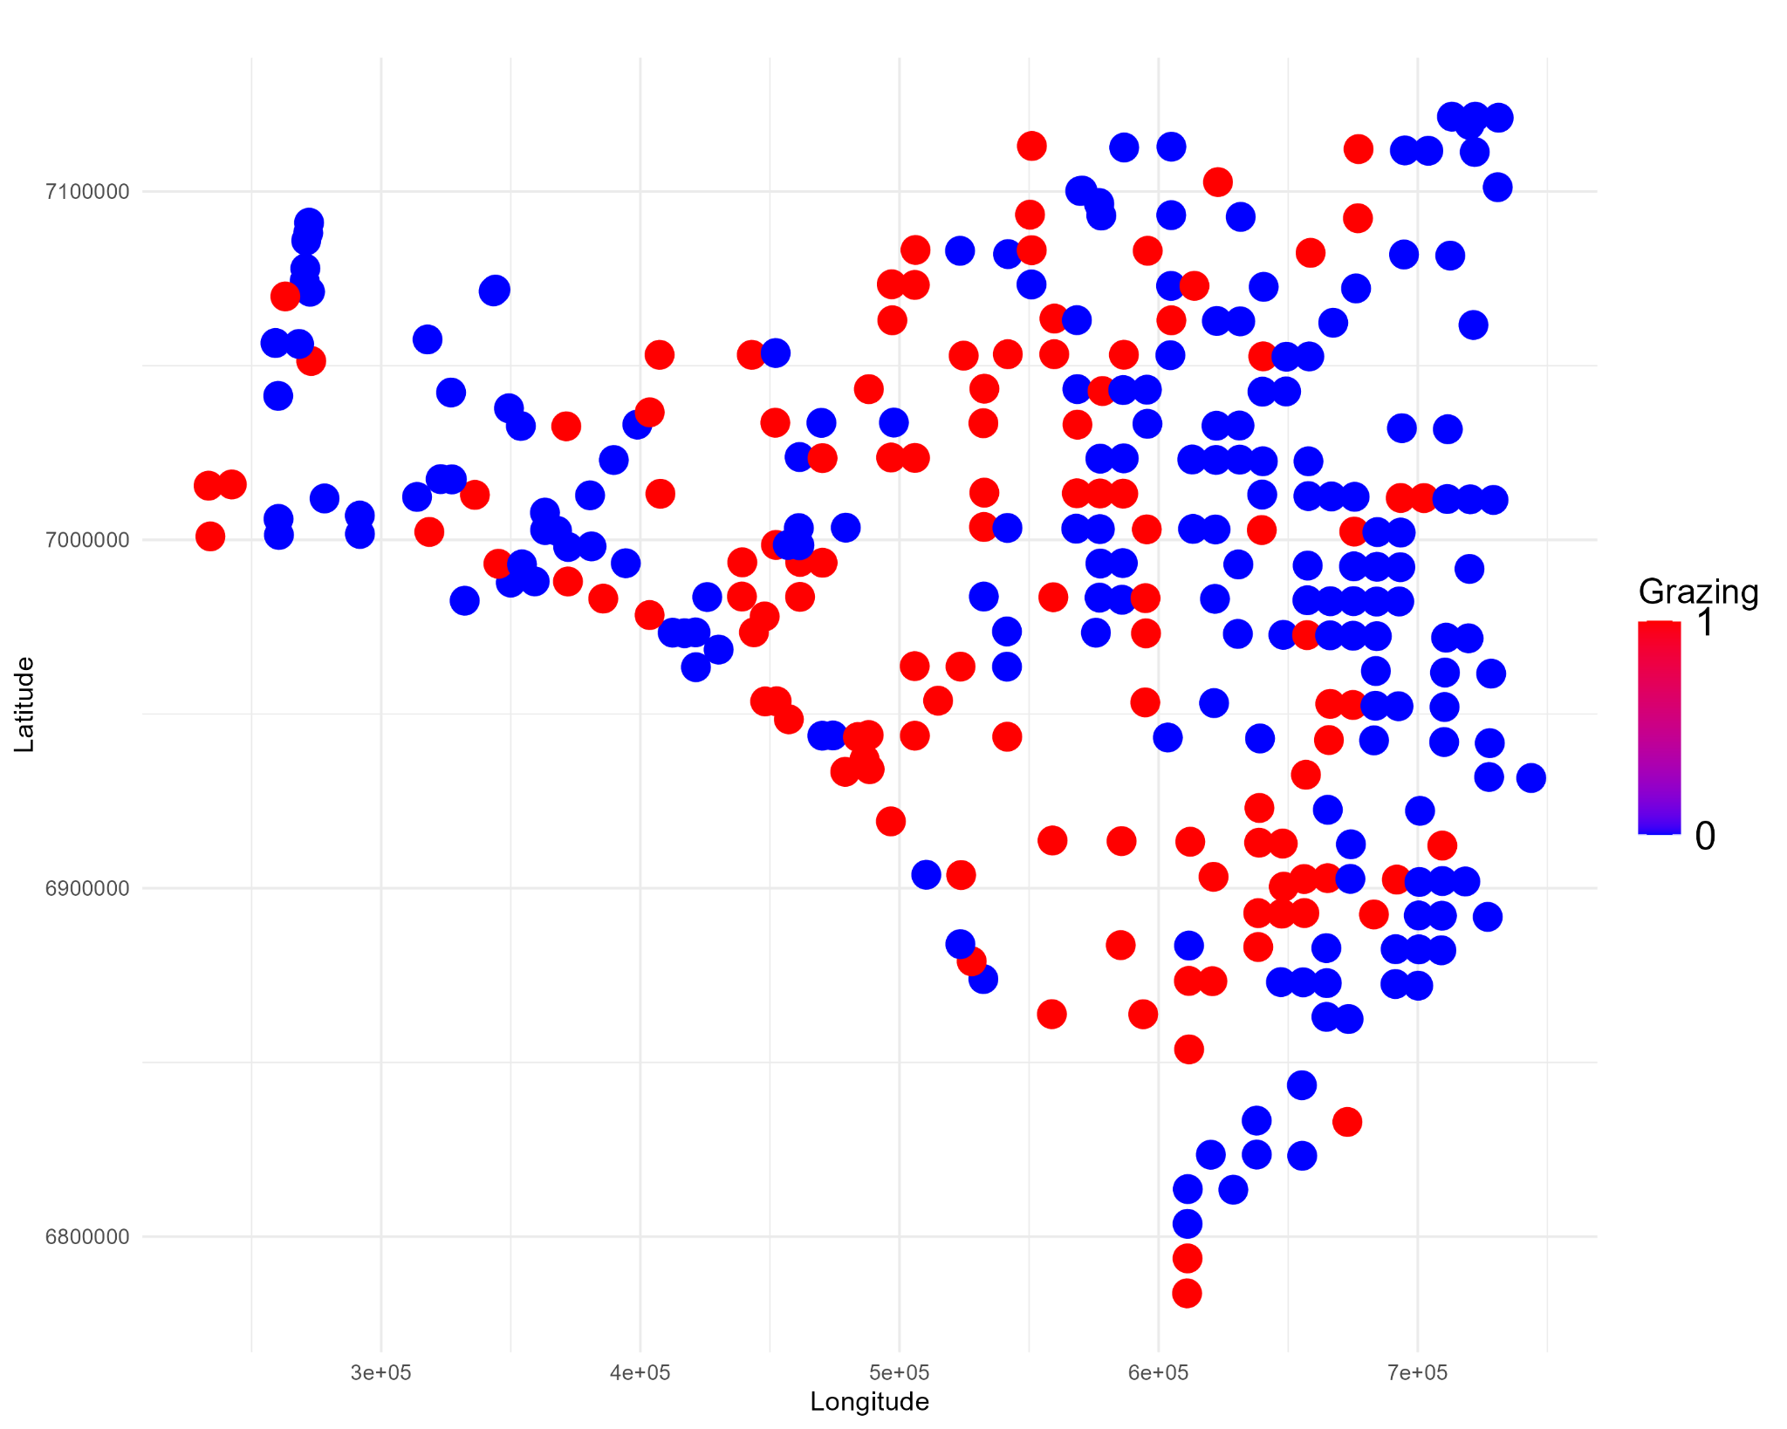
Figure S6. Map of presence of cattle-grazing in the sampling units. Points represent each sampling unit. Red represents plots with grazing and blue without grazing.

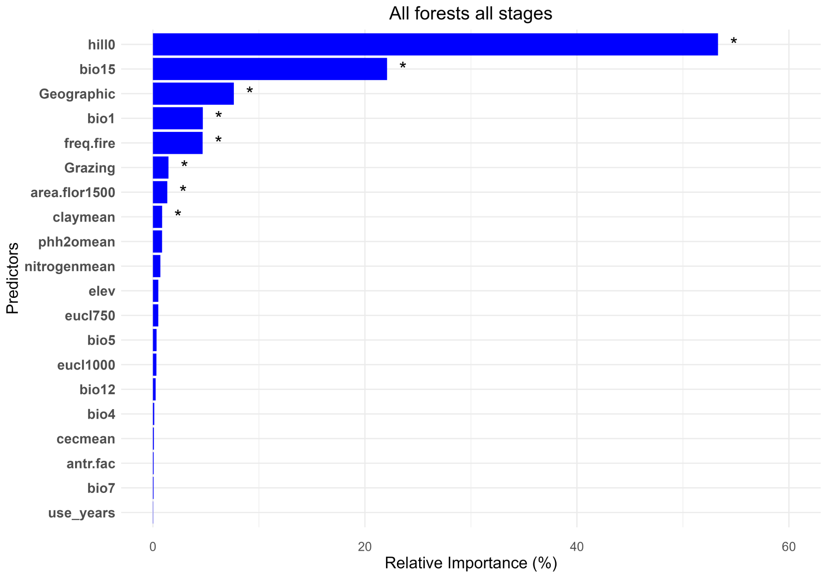

Figure S7. Relative importance of predictors from GDM (Generalized dissimilarity model) for three forest formations (Evergreen forest, Araucaria Forest and Seasonal Forest) in advanced and intermediate successional stages. Asterisks represent significant predictors (p<0.01).

