List of Supplementary Material
Fig. S1 Spatial distribution of NDVI and NDBI indices across Madhya Pradesh
Fig. S2 Regression coefficients representing the directional influence of NDBI, NDVI, and LST on dumpsite classification

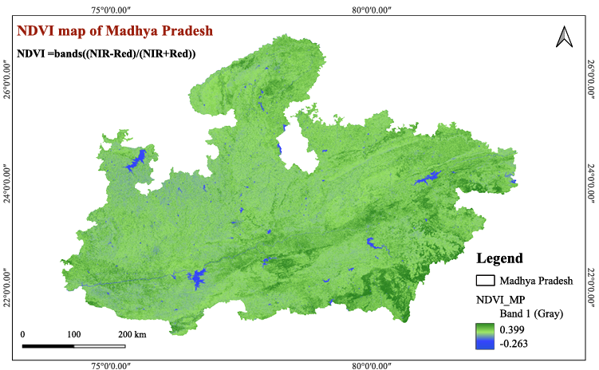
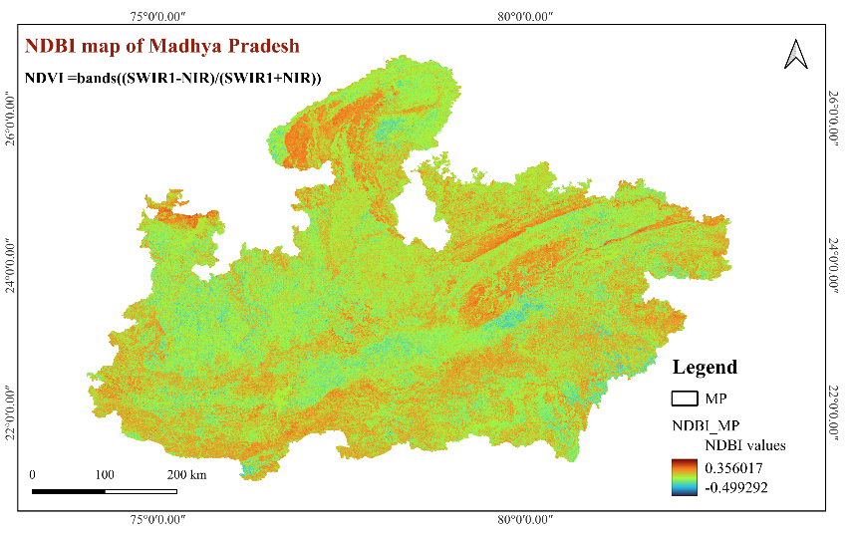
Fig. S1 Spatial distribution of NDVI and NDBI indices across Madhya Pradesh

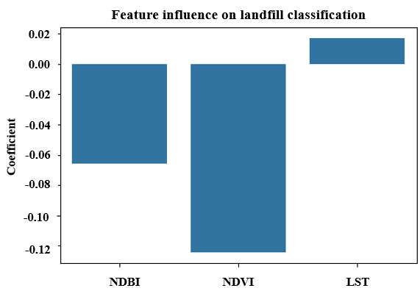
Fig. S2 Regression coefficients representing the directional influence of NDBI, NDVI, and LST on dumpsite classification

