SUPPLEMENTARY INFORMATION

High-efficiency production of the bisabolene from waste cooking oil by metabolically engineered Yarrowia lipolytica
Yakun Zhaoª, Kun Zhuª, Jian Liª, Yu Zhaoª, Shenglong Liª, Cuiying Zhangª, Dongguang Xiaoª, Aiqun Yu^{a*}

Table S1 Information on fatty acid composition of the waste cooking oil used in this study
Fatty acid | Waste cooking oil (g/100g)
C8:0 | 0.0406
C14:0 | 0.0520
C15:0 | 0.0021
C16:0 | 9.1128
C16:1 | 0.0592
C17:0 | 0.0704
C17:1 | 0.0286
C18:0 | 3.5801
C18:1n9t | 0.0953
C18:1n9c | 18.8678
C18:2n6c | 48.3580
C20:0 | 0.3847
C18:3n6 | 0.6781
C20:1 | 0.3990
C18:3n3 | 5.6221
C21:0 | 0.0386
C20:2 | 0.0492
C22:0 | 0.5505
C23:0 | 0.0616
C20:5n3 | 0.5014
C24:1 | 0.0364
Waste cooking oil was collected from the canteen of Tianjin University of Science and Technology, and the fatty acids of commercial vegetable oil and waste cooking oil were detected by Qingdao Sci-tech Innovation Quality Testing Co., Ltd.

Table S2 Primers used in PCR
Primer | Sequence (5’-3’)
α-F | ACAACCACACACATCCACAATGGCCGGTGTCTCTGCC
α-R | GGGACAGGCCATGGAGGTACCTTAGTGGTGATGGTGGTGGTGG
β-F | ACAACCACACACATCCACAATGGAACTCGTTGATACTCCCTC
β-R | GGGACAGGCCATGGAGGTACCTTAGTGATGATGATGGTGGTGG
γ-F | ACAACCACACACATCCACAATGTCTATCTCCTCTTCCCCCTC
γ-R | GGGACAGGCCATGGAGGTACCTTAGTGGTGATGGTGGTGGTGC
ACOAAT1-F | ACAACCACACACATCCACAATGCTACTCGACAGAAGAGACCTT
ACOAAT1-R | ACAAGTTCCGTAGTTGGATCCCTAATGCGACTCACTCTGCCCC
ACOAAT2-F | ACAACCACACACATCCACAATGGAGCCCGTCTACATTGTTTC
ACOAAT2-R | GGGACAGGCCATGGAGGTACCCTAACACTTCTCAACAATGATAGAGG
HMGS-F | ACAACCACACACATCCACAATGTCGCAACCCCAGAACG
HMGS-R | GGGACAGGCCATGGAGGTACCCTACTGCTTGATCTCGTACTTTCGTC
HMGR-F | ACAACCACACACATCCACAATGCTACAAGCAGCTATTGGAAA
HMGR-R | GGGACAGGCCATGGAGGTACCCTATGACCGTATGCAAATATTCGAA
MK-F | ACAACCACACACATCCACAATGGACTACATCATTTCGGCG
MK-R | GGGACAGGCCATGGAGGTACCCTAATGGGTCCAGGGACCGA
PMK-F | ACAACCACACACATCCACAATGCTACTTGAACCCCTTCTCG
PMK-R | GGGACAGGCCATGGAGGTACCCTAATGACCACCTATTCGGCTCC
PMVADO-F | ACAACCACACACATCCACAATGATCCACCAGGCCTCCA
PMVADO-R | GGGACAGGCCATGGAGGTACCCTACTTGCTGTTCTTCAGAGAACCA
IPPDI-F | ACAACCACACACATCCACAATGCTACTTGATCCACCGCC
IPPDI-R | GGGACAGGCCATGGAGGTACCCTAATGACGACGTCTTACAGCGA
GGPPS-F | ACAACCACACACATCCACAATGTCACTGCGCATCCTCAA
GGPPS-R | GGGACAGGCCATGGAGGTACCCTAATGGATTATAACAGCGCGGA
FPPS-F | ACAACCACACACATCCACAATGCTACTTCTGTCGCTTGTAAATC
FPPS-R | ACAAGTTCCGTAGTTGGATCCCTAATGTCCAAGGCGAAATTCGA
BDH2-F | CCATCCAGCCTCGCGTCGGTTAACTATCCTAGGAGGCCGTTGAGCAC
BDH2-R | ACGTCTTGCTGGCGTTCGATAAGCTGTCAAACATGAGAATTCG
Acrb-BDH-F | ATCCAGCCTCGCGTCGGTTCAAGGAATGGTGCATG
Acrb-BDH-R | CGGCCTCCTAGGATAGTTGTTTGACAGCTTATCATCG
CMQ-BDH-F | ATCCAGCCTCGCGTCGGTTCAAGGAATGGTGCATGCTGAG
CMQ-BDH-R | CGGCCTCCTAGGATAGTTCATCGATGATAAGCTGTCAAAC
pYL-F | CCTCGATCCGGCATGCACTGATCACG
pYL-R | TAGGCAACAGCGTTGGGAGAGCCCTTGAGG
DJY-F | AATCGCCGTGACGATCAGC
DJY-R | CTGTCGCTTGCGGTATTCGG
YZ-F  YZ-R | AATCGCCGTGACGATCAGC  TCGGACATGGTGATCATGC

Supplementary Methods
Preparation of Y. lipolytica Po1g KU70△ competent cell
1. Inoculate a colony of Y. lipolytica Po1g KU70△ strain from a fresh YPD plate in 10 mL YPD medium (1% yeast extract, 2% peptone, 2% dextrose and 50 mM citrate buffer pH 4.0) in a 250 mL flask. Incubate with shaking at 225 rpm and 30°C for 20 hours.
2. Pellet the cells by centrifuging 5 minutes at 5, 000 g at 4℃.
3. Wash the cells with 20 mL TE buffer and pellet the cells similarly as Step 2.
4. Resuspend the cells in 1 mL of 0.1 M lithium acetate (pH 6.0, adjusted with acetic acid) and incubate for 10 minutes at room temperature.
5. Aliquot the competent cells (100 µL) into sterile 1.5 mL tubes. Proceed to the transformation steps below immediately, or add glycerol to a final concentration of 25% (v/v) and store at -80°C for long-term storage.
Transformation of Y. lipolytica Po1g KU70△ cells
1. Gently mix 10 µL of denatured salmon sperm DNA (10 mg/mL) and 1-5 µg of the linearized plasmid together with 100 µL of competent cells, and incubate at 30°C for 15 minutes.
2. Add 700 µL of 40% PEG-4000 (dissolved in 0.1 M lithium acetate pH 6.0), mix well and incubate at 30°C for 60 minutes with shaking (225 rpm).
3. Heat shock the transformation mixture at 39°C for 60 minutes.
4. Add 1 mL YPD medium and recover for 2 hours at 30°C and 225 rpm.
5. Centrifuge at 10,000 g for 1 minute, remove the supernatant and resuspend the pellet in 1 mL of TE buffer.
6. Repellet the cells and discard the supernatant again.
7. Resuspend the pellet in 100 µL of TE buffer and plate onto selective plates (leucine-deficient plates).

Supplementary Figures

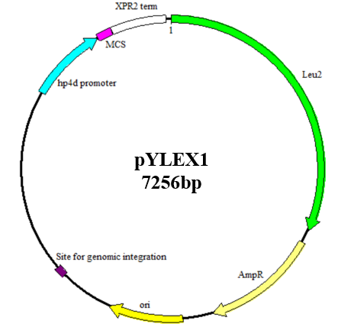
Figure S1 Map of the plasmid pYLEX1.
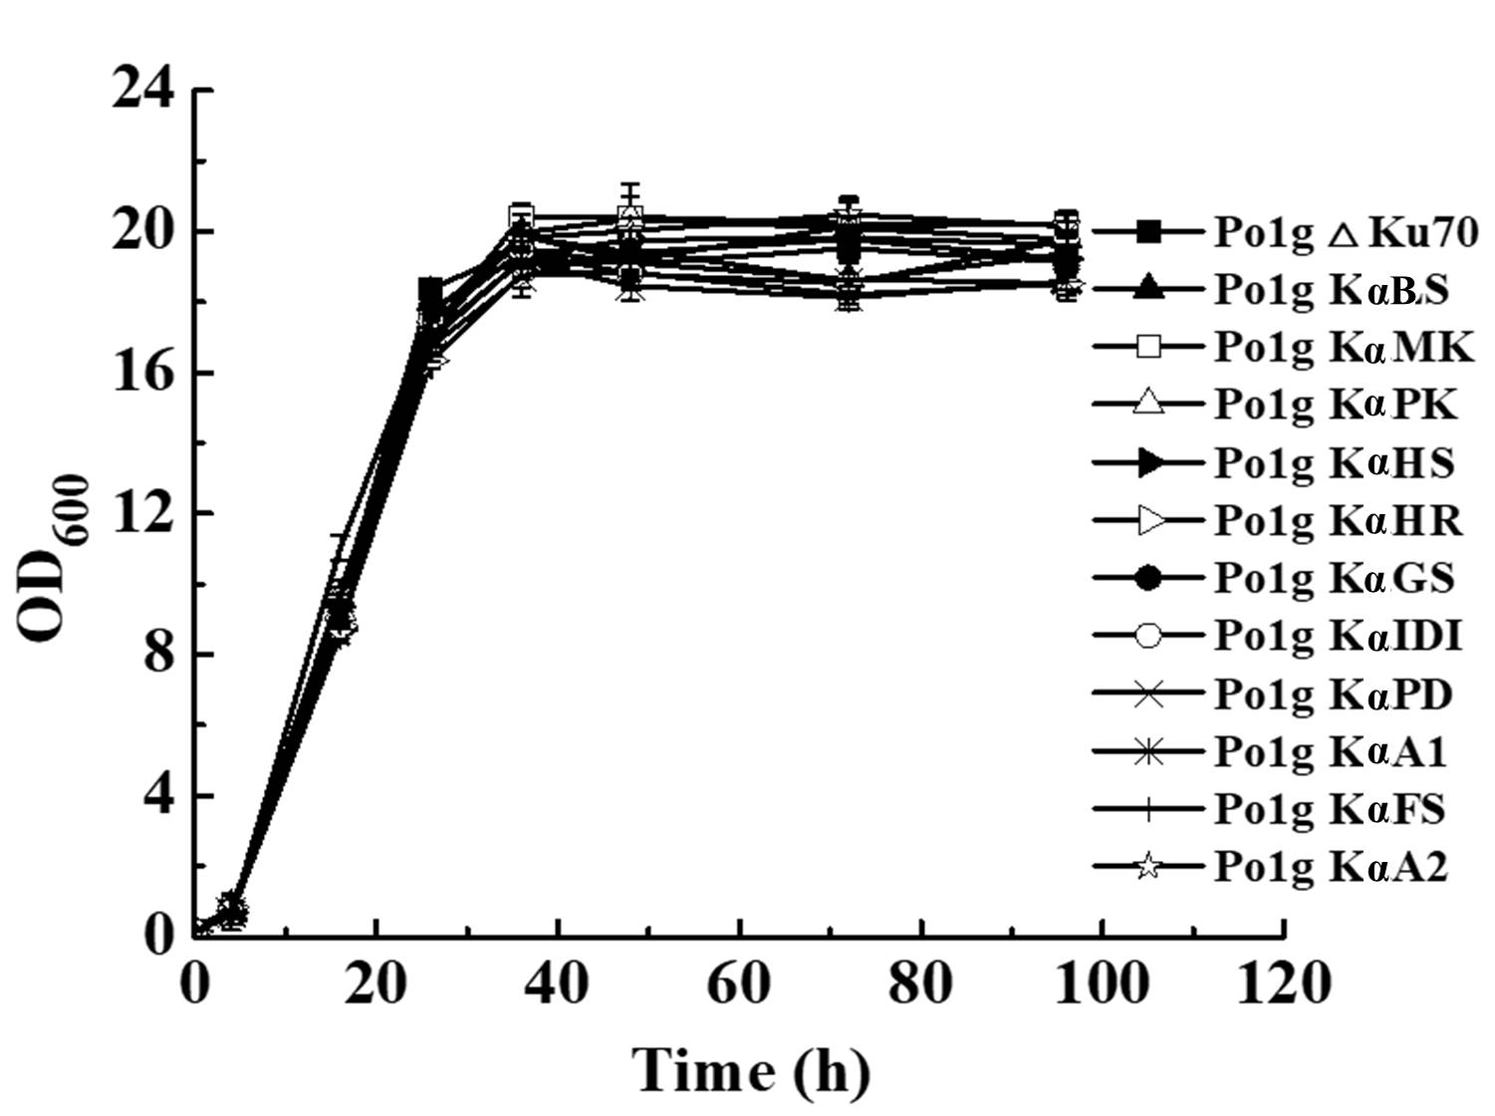
A
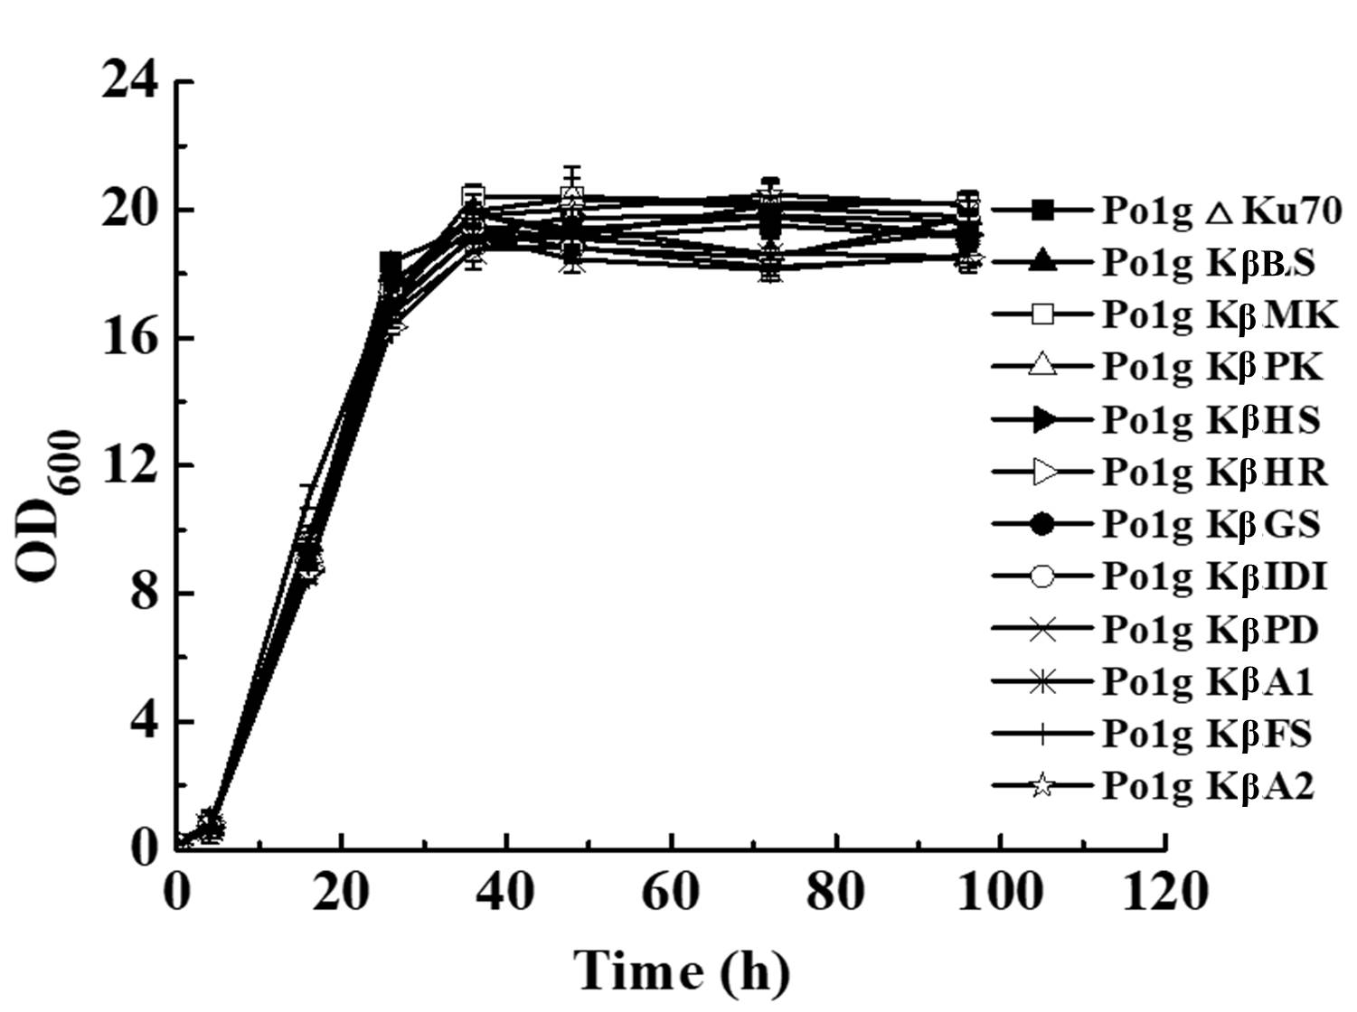
B
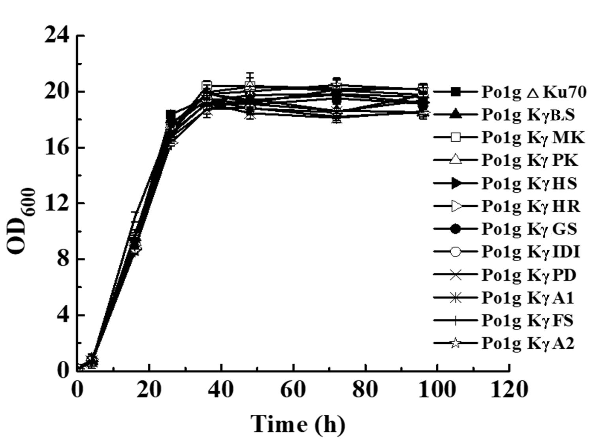
C
Figure S2 The OD₆₀₀ values of 30 engineered Y. lipolytica strains cultured in YPD medium (A: α-bisabolene production strains; B: β-bisabolene production strains; γ- bisabolene production strains). OD₆₀₀ were measured at 0, 4, 16, 26, 32, 48, 72, 96 and 120 h, respectively. The cultivation was performed at 28℃ and 220 rpm. All values presented are the mean of three biological replicates ± standard deviation.

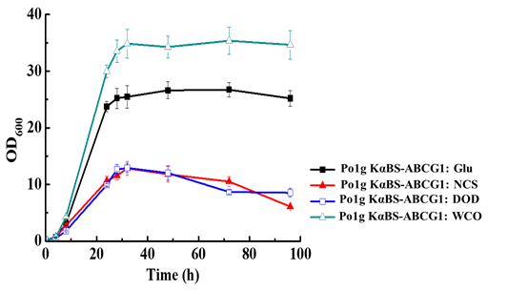
Figure S3 Effect of different carbon sources on growth of Y. lipolytica Po1g KαBS-ABCG1. Different carbon sources (glucose, waste cooking oil and n-dodecane) was added into the base medium, which included 1% yeast extract and 2% tryptone. OD₆₀₀ was measured at 4 h, 8 h, 24 h, 28 h, 32 h, 48 h, 72 h and 96 h. Glu: 2% glucose was added into the base medium; NCS: there was no addition of any external carbon sources in the base medium; DOD: n-dodecane was added into the base medium; WCO: 1.18% (w/v) waste cooking oil as a carbon source which has an equal amount of carbon units to that of 2% (w/v) glucose was added into the base medium. All values presented are the mean of three biological replicates ± standard deviation.

