Supplementary Material 1: Item wording reviewer input
Global INSPIRE v1 item 5: Feeling hopeful about my future
Revise suggestion | Reason
Believing in a positive future | Non-service user 1: This does not need to relate to myself. A positive future for me, includes the people in my life, not just myself.
Hoping for a positive future for myself | Service user 1: To emphasise the hope aspect.
Believing in a positive future for myself (2 reviewers) | Service user 2: The 3 other questions in the corresponding category seem to each capture a state of mind that involves a richer, deeper, more thorough and engaged belief that the future contains positive experiences. Whereas “Feeling hopeful about my future” seems to describe a comparatively fleeting state of mind. The words “feeling” and “hopeful” without some additional belief / a more substantial commitment seems emptier. And may not capture a committed feeling about the future. I think this revision overcomes this and would fit better with the other questions/ the overall category of ‘hope’.  Service user 2: This is in line with other hope category items whilst retaining difference from them.
Optimistic or Positive about my future | Non-service user 2: To frame the item in a positive way. Hope can be good or bad.
Believing in a positive future in my day-to-day life | Non-service user 3: No reason given
Global INSPIRE v1 item 5: Understanding my mental health experience
Revise suggestion | Reason
Understanding the normal fluctuations of mental health (positive and negative) and the reasons behind what influences this change | Non-service user 1: No reason given
Finding meaning in my mental health experiences (3 reviewers) | Service user 1: To emphasise the meaning aspect.  Service user 2: This seems to conceptually fit better with ‘Meaning’. The first example [Understanding my mental health] may be read as a more ‘medicalised’ understanding of MH, looking at cause and effect. The second one [Finding meaning in my mental health experiences] seems to capture better how important a person’s interpretation of (how they make sense of) their MH story is for recovery. This seems to fit better with the other items in the group. Further people may not fully understand their MH, or MH experience, but still be able to find meaning in it. Also some people may have a good understanding of their MH experience, but it may not be meaningful for them. And I think the second one avoids this confusion.  Service user 3: This is more definite, so easier to interpret, and reflects the narrative nature of constructing meaning.
Understanding my mental health | Non-service user 2: Wondering how much "experience" adds to the item
Understanding the status of my mental health | Non-service user 3: No reason given

Supplementary Material 2: Word sketches for the target words—“hope”, “believe”, and “understand”

“hope”
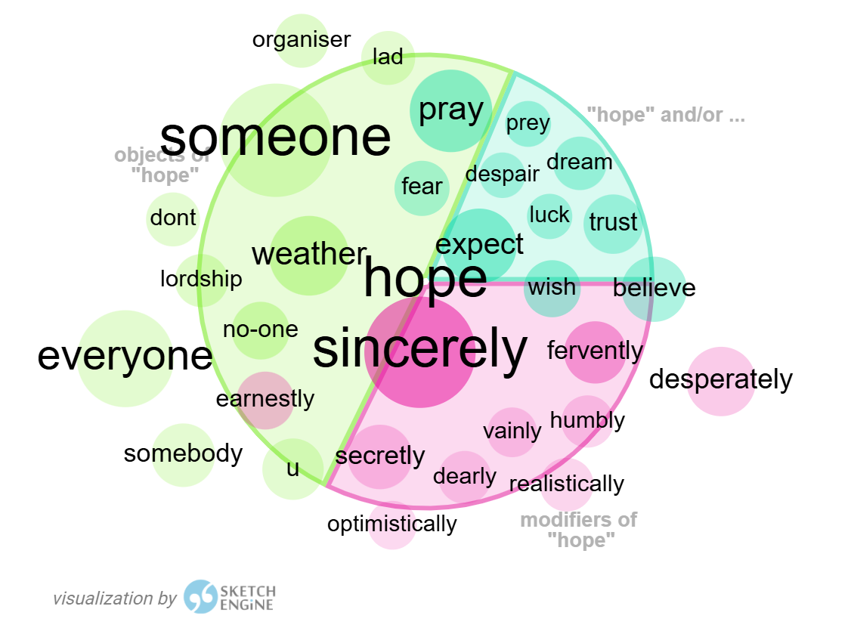

“believe”
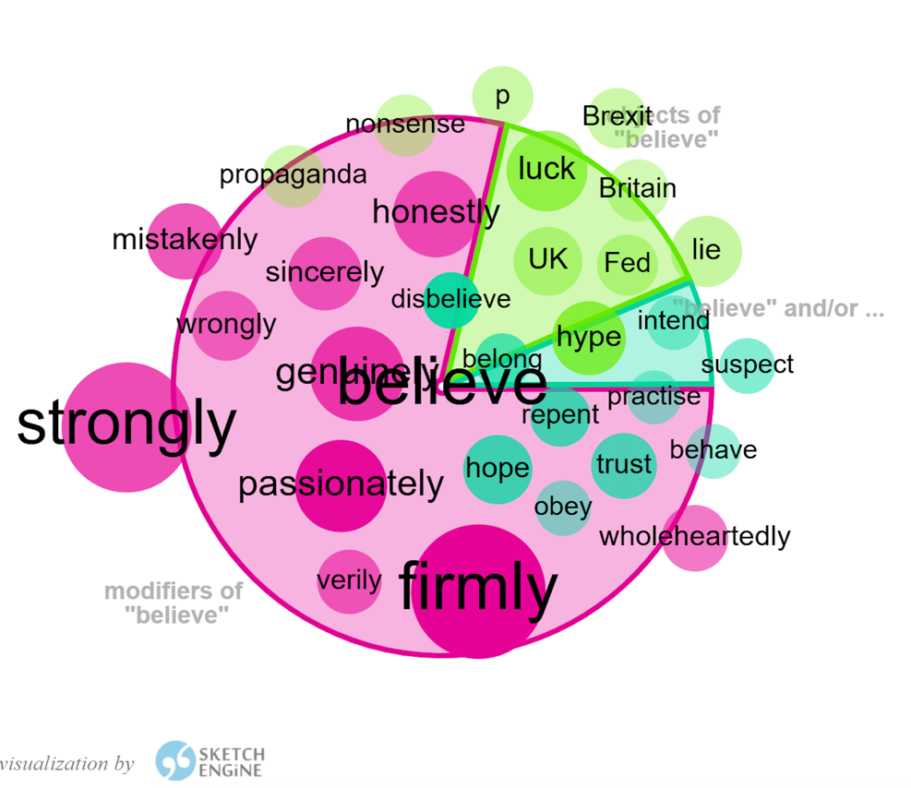

“understand”
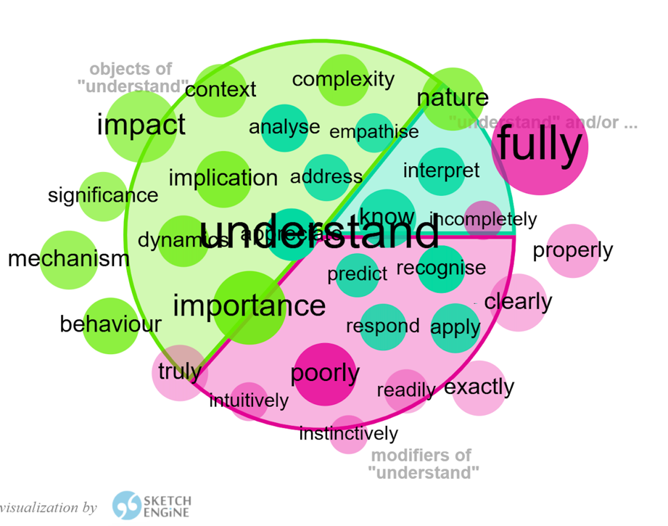

Supplementary Material 3: Path diagram for the Global INSPIRE v2 (British English)
