Supplementary information

Lineages to landscapes: Mitogenomic insights and climate refugia informing proactive conservation of the Endangered Tricarinate Hill Turtle (Melanochelys tricarinata) in the Indian Subcontinent

Imon Abedin¹, Angkasa Putra², Hye-Eun Kang³, Arunima Singh⁴, Shailendra Singh⁴, Won-Kyo Jung^{5,6,7}, Hyun-Woo Kim^{5,7,8}*, Shantanu Kundu^{2,9,10}*

¹Dibru-Saikhowa Conservation Society, Tinsukia 786147, India
²Interdisciplinary Program of Marine and Fisheries Sciences and Convergent Technology, Pukyong National University, Busan 48513, Republic of Korea
³Institute of Marine Life Science, Pukyong National University, Busan 48513, Republic of Korea.
⁴Turtle Survival Alliance Foundation India, Lucknow 226 012, India.
⁵Research Center for Marine Integrated Bionics Technology, Pukyong National University, Busan 48513, Republic of Korea
⁶Major of Biomedical Engineering, Division of Smart Healthcare and New-Senior Healthcare Innovation Center (BK21 Plus), Pukyong National University, Busan 48513, Republic of Korea
⁷Marine Integrated Biomedical Technology Center, National Key Research Institutes in Universities, Pukyong National University, Busan 48513, Republic of Korea
⁸Department of Marine Biology, College of Fisheries Science, Pukyong National University, Busan 48513, Republic of Korea.
⁹Ocean and Fisheries Development International Cooperation Institute, College of Fisheries Science, Pukyong National University, Busan 48513, Republic of Korea.
¹⁰International Graduate Program of Fisheries Science, Pukyong National University, Busan 48513, Republic of Korea.

*Corresponding author: kimhw@pknu.ac.kr (H.W.K) and shantanu1984@pknu.ac.kr, shantanu1984@gmail.com (S.K.)
Supplementary Figure S1 The correlation between the covariates chosen for the final model for M. tricarinata. The Pearson correlation coefficient is primarily used here. However, if the Spearman or Kendall correlation coefficient exceeds the Pearson correlation coefficient, an “s” or “k” will be displayed in the bottom-right corner of the variable box.
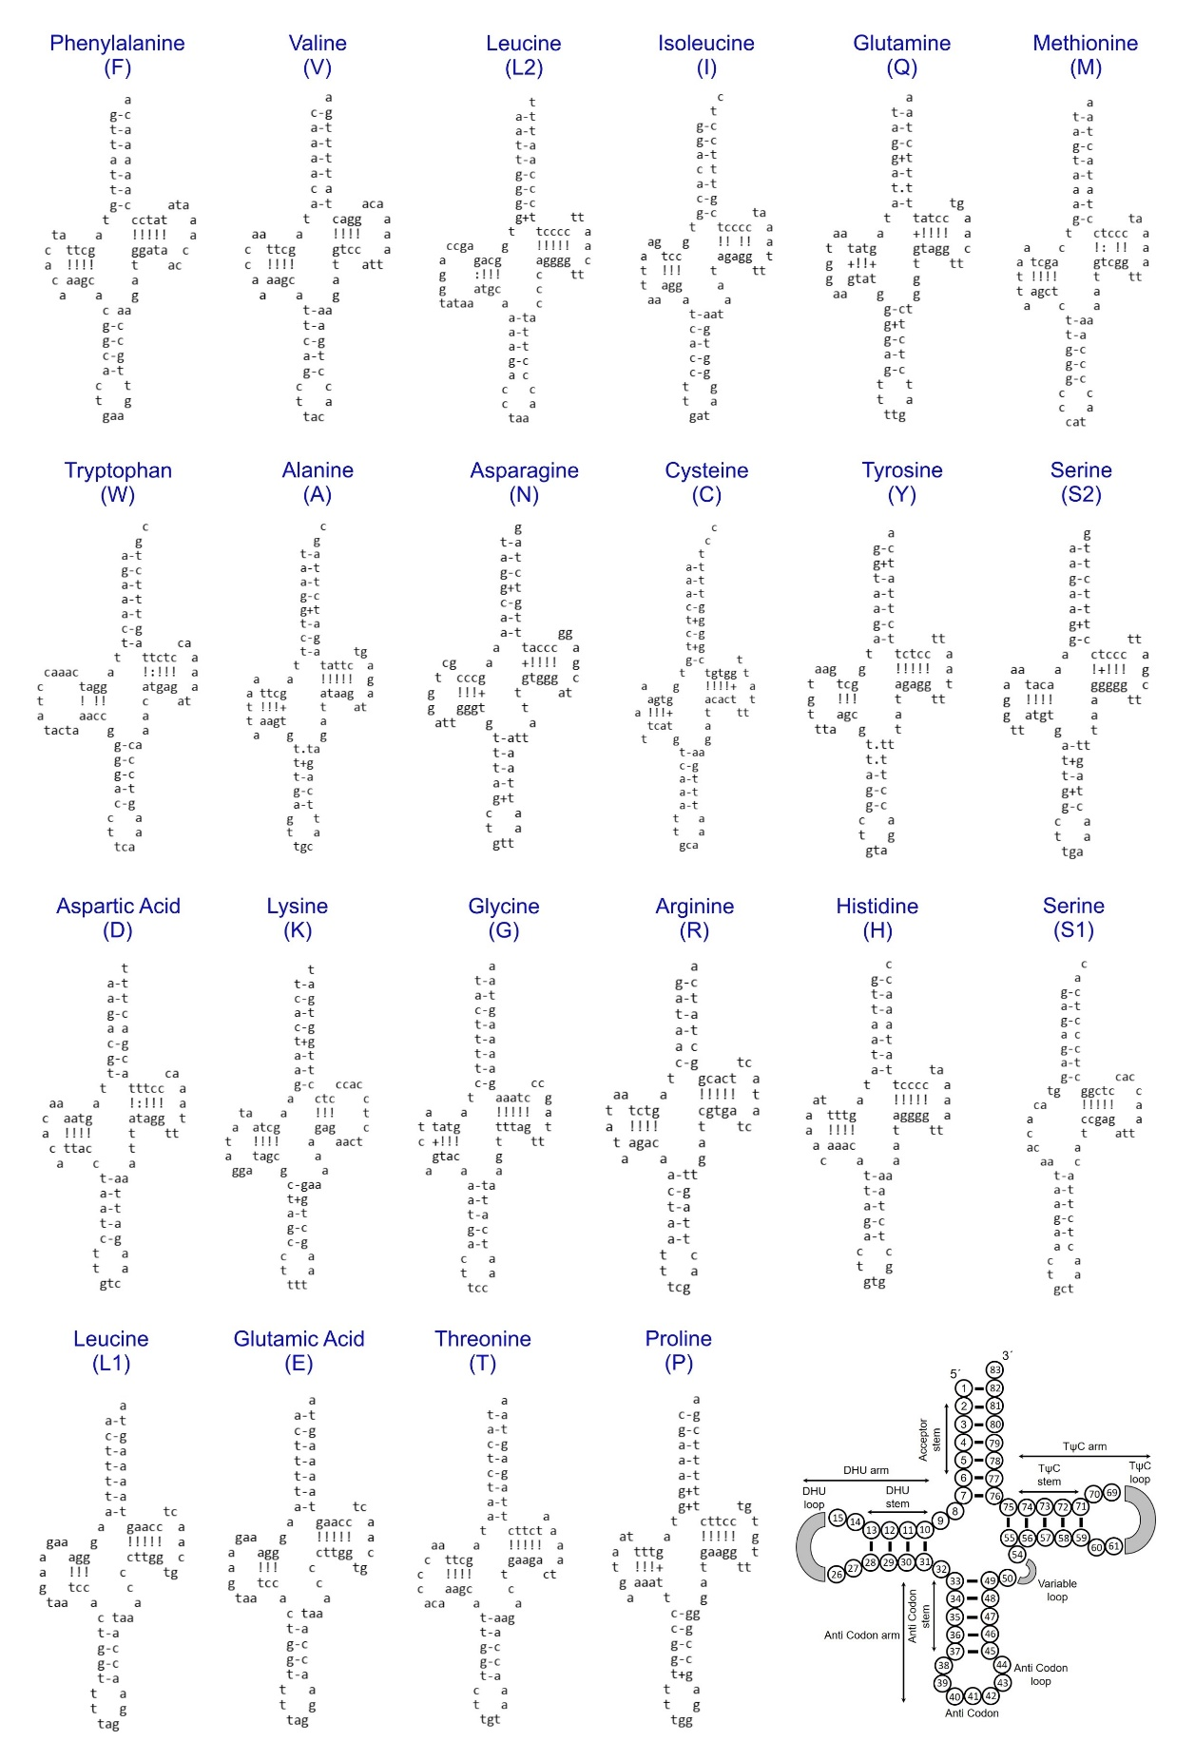
Supplementary Figure S2. The secondary structures of 22 transfer RNA genes (tRNAs) of M. tricarinata mitogenome display the structural variations. The last structure shows the nucleotide position and details of the tRNA stem-loop configuration. The wobble base pairs and anticodons are marked with red oval and blue rectangle, respectively.
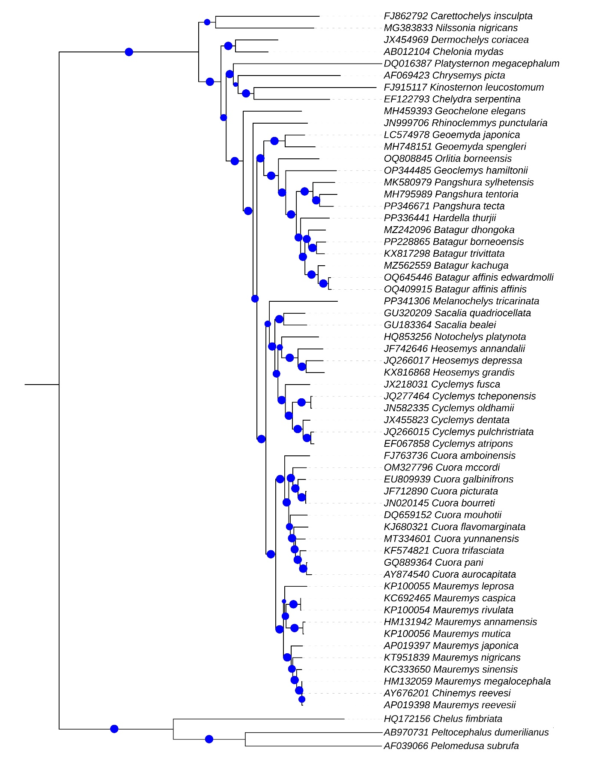
Supplementary Figure S3. The Maximum-Likelihood (ML) phylogenetic tree illustrates the major evolutionary relationships M. tricarinata and other Testudines. Bootstrap supports values are represented by blue circular dots of varying sizes superimposed on each node.
Supplementary Table S1. Details of the mitogenome sequences generated and acquired from GenBank database for this study.
Sl. No. | Sub-Order | Family | Subfamily | Species Name | Accession No. | Size (bp)
1 | Cryptodira | Geoemydidae | Geoemydinae | Melanochelys tricarinata | PP341306 | 16745
2 | Cryptodira | Geoemydidae | Geoemydinae | Chinemys reevesi | AY676201 | 16576
3 | Cryptodira | Geoemydidae | Geoemydinae | Cuora amboinensis | FJ763736 | 16708
4 | Cryptodira | Geoemydidae | Geoemydinae | Cuora aurocapitata | AY874540 | 16890
5 | Cryptodira | Geoemydidae | Geoemydinae | Cuora bourreti | JN020145 | 16649
6 | Cryptodira | Geoemydidae | Geoemydinae | Cuora flavomarginata | KJ680321 | 16721
7 | Cryptodira | Geoemydidae | Geoemydinae | Cuora galbinifrons | EU809939 | 17244
8 | Cryptodira | Geoemydidae | Geoemydinae | Cuora mccordi | OM327796 | 16551
9 | Cryptodira | Geoemydidae | Geoemydinae | Cuora mouhotii | DQ659152 | 16837
10 | Cryptodira | Geoemydidae | Geoemydinae | Cuora pani | GQ889364 | 16922
11 | Cryptodira | Geoemydidae | Geoemydinae | Cuora picturata | JF712890 | 16623
12 | Cryptodira | Geoemydidae | Geoemydinae | Cuora trifasciata | KF574821 | 16675
13 | Cryptodira | Geoemydidae | Geoemydinae | Cuora yunnanensis | MT334601 | 16023
14 | Cryptodira | Geoemydidae | Geoemydinae | Cyclemys atripons | EF067858 | 16500
15 | Cryptodira | Geoemydidae | Geoemydinae | Cyclemys dentata | JX455823 | 16489
16 | Cryptodira | Geoemydidae | Geoemydinae | Cyclemys oldhamii | JN582335 | 16656
17 | Cryptodira | Geoemydidae | Geoemydinae | Cyclemys pulchristriata | JQ266015 | 16527
18 | Cryptodira | Geoemydidae | Geoemydinae | Cyclemys tcheponensis | JQ277464 | 16593
19 | Cryptodira | Geoemydidae | Geoemydinae | Cyclemys fusca | JX218031 | 16491
20 | Cryptodira | Geoemydidae | Geoemydinae | Geoemyda japonica | LC574978 | 16820
21 | Cryptodira | Geoemydidae | Geoemydinae | Geoemyda spengleri | MH748151 | 17448
22 | Cryptodira | Geoemydidae | Geoemydinae | Heosemys annandalii | JF742646 | 16604
23 | Cryptodira | Geoemydidae | Geoemydinae | Heosemys depressa | JQ266017 | 16773
24 | Cryptodira | Geoemydidae | Geoemydinae | Heosemys grandis | KX816868 | 16581
25 | Cryptodira | Geoemydidae | Geoemydinae | Mauremys annamensis | HM131942 | 16844
26 | Cryptodira | Geoemydidae | Geoemydinae | Mauremys caspica | KC692465 | 16741
27 | Cryptodira | Geoemydidae | Geoemydinae | Mauremys japonica | AP019397 | 16443
28 | Cryptodira | Geoemydidae | Geoemydinae | Mauremys leprosa | KP100055 | 17067
29 | Cryptodira | Geoemydidae | Geoemydinae | Mauremys megalocephala | HM132059 | 16783
30 | Cryptodira | Geoemydidae | Geoemydinae | Mauremys mutica | KP100056 | 16775
31 | Cryptodira | Geoemydidae | Geoemydinae | Mauremys nigricans | KT951839 | 16779
32 | Cryptodira | Geoemydidae | Geoemydinae | Mauremys reevesii | AP019398 | 16784
33 | Cryptodira | Geoemydidae | Geoemydinae | Mauremys rivulata | KP100054 | 16766
34 | Cryptodira | Geoemydidae | Geoemydinae | Mauremys sinensis | KC333650 | 16458
35 | Cryptodira | Geoemydidae | Geoemydinae | Notochelys platynota | HQ853256 | 16981
36 | Cryptodira | Geoemydidae | Geoemydinae | Sacalia bealei | GU183364 | 16561
37 | Cryptodira | Geoemydidae | Geoemydinae | Sacalia quadriocellata | GU320209 | 16551
38 | Cryptodira | Geoemydidae | Batagurinae | Hardella thurjii | PP336441 | 16699
39 | Cryptodira | Geoemydidae | Batagurinae | Batagur affinis affinis | OQ409915 | 16625
40 | Cryptodira | Geoemydidae | Batagurinae | Batagur affinis edwardmolli | OQ645446 | 16630
41 | Cryptodira | Geoemydidae | Batagurinae | Batagur borneoensis | PP228865 | 16397
42 | Cryptodira | Geoemydidae | Batagurinae | Batagur dhongoka | MZ242096 | 15620
43 | Cryptodira | Geoemydidae | Batagurinae | Batagur kachuga | MZ562559 | 16517
44 | Cryptodira | Geoemydidae | Batagurinae | Batagur trivittata | KX817298 | 16463
45 | Cryptodira | Geoemydidae | Batagurinae | Geoclemys hamiltonii | OP344485 | 16509
46 | Cryptodira | Geoemydidae | Batagurinae | Orlitia borneensis | OQ808845 | 17588
47 | Cryptodira | Geoemydidae | Batagurinae | Pangshura sylhetensis | MK580979 | 16568
48 | Cryptodira | Geoemydidae | Batagurinae | Pangshura tecta | PP346671 | 16732
49 | Cryptodira | Geoemydidae | Batagurinae | Pangshura tentoria | MH795989 | 16657
50 | Cryptodira | Geoemydidae | Rhinoclemmydinae | Rhinoclemmys punctularia | JN999706 | 14154
51 | Cryptodira | Trionychidae | - | Nilssonia nigricans | MG383833 | 16796
52 | Cryptodira | Carettochelyidae | - | Carettochelys insculpta | FJ862792 | 16439
53 | Cryptodira | Kinosternidae | - | Kinosternon leucostomum | FJ915117 | 16559
54 | Cryptodira | Chelydridae | - | Chelydra serpentina | EF122793 | 16631
55 | Cryptodira | Dermochelyidae | - | Dermochelys coriacea | JX454969 | 16420
56 | Cryptodira | Cheloniidae | - | Chelonia mydas | AB012104 | 16497
57 | Cryptodira | Testudinidae | - | Geochelone elegans | MH459393 | 16446
58 | Cryptodira | Platysternidae | - | Platysternon megacephalum | DQ016387 | 19161
59 | Cryptodira | Emydidae | - | Chrysemys picta | AF069423 | 16866
60 | Pleurodira | Podocnemididae | - | Peltocephalus dumerilianus | AB970731 | 16601
61 | Pleurodira | Pelomedusidae | - | Pelomedusa subrufa | AF039066 | 16787
62 | Pleurodira | Chelidae | - | Chelus fimbriata | HQ172156 | 16661

Supplementary Table S2. Suitable habitat area (km²) for M. tricarinata across different extent under present and future climate scenarios.
Scenario | Training Extent | Within Forest Cover | IUCN Range
Present | 374657 | 238039 | 176117
SSP245 (2041-2060) | 306091 | 214332 | 121240
SSP245 (2061-2080) | 295691 | 204398 | 113923
SSP585 (2041-2060) | 256339 | 189705 | 110031
SSP585 (2061-2080) | 235637 | 172783 | 106437

