SUPPLEMENTARY FIGURES

Supplementary Figure 1: | Distribution of estimated annual sequenced specimens supplied by 20-member, optimised sentinel sets
Supplementary Figure 2: | Impact of restricting the number of teaching hospital groups on mean time to detection
Supplementary Figure 3: | Probability of detection within a month (cf monthly CDI cases per hospital group)

(a) 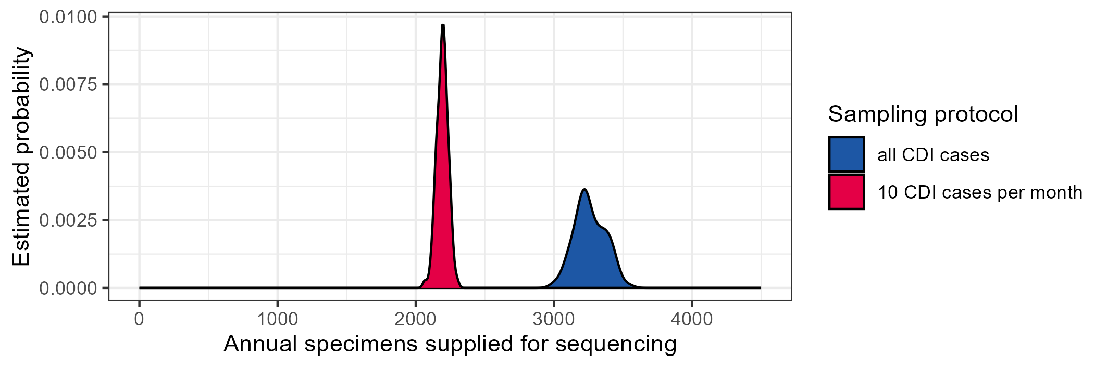
(b)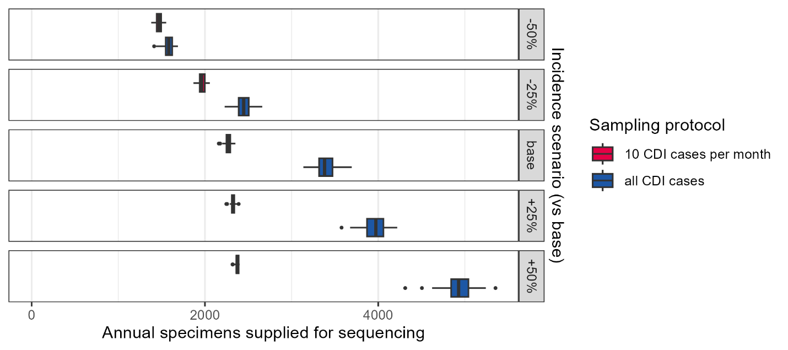
Supplementary Figure 1: Distribution of estimated annual sequenced specimens, supplied by 20-member optimised sentinel sets, under candidate protocols for (a) base analysis and (b) incidence scenarios
Estimated cases by hospital group randomly drawn (n=100) from normal distributions centred on the 3-year mean of reported cases.
Note: (b) boxplots show (IQR), whiskers (in black) at 1.5 IQR and outliers
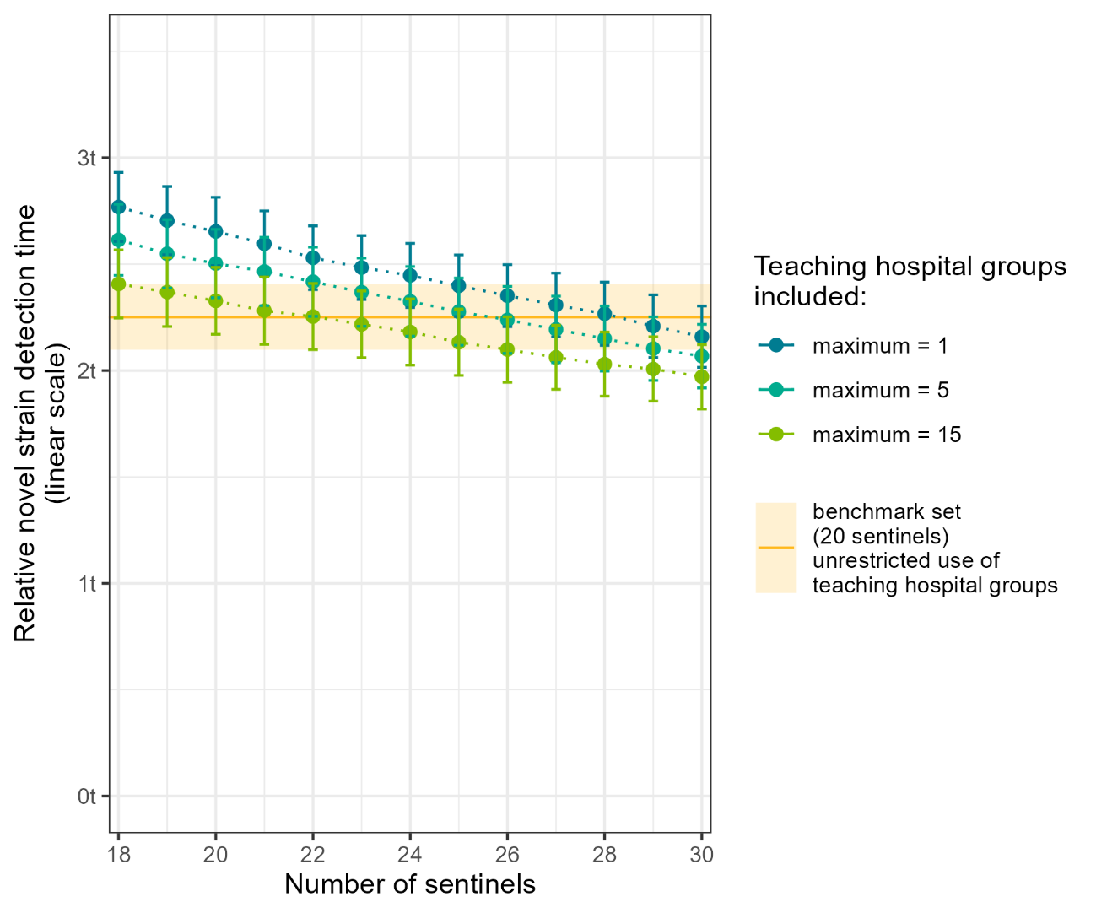
Supplementary Figure 2: Impact of restricting the number of teaching hospital groups on the mean time to detection vs unrestricted use by the benchmark set (S₀)
Detection time (mean +/-SD) by given size sentinel set taken from priority list obtained with a maximum of {15, 5, 1} teaching hospital groups used vs the benchmark 20-member sentinel set (S₀) which has no restriction on teaching type use

(a) | 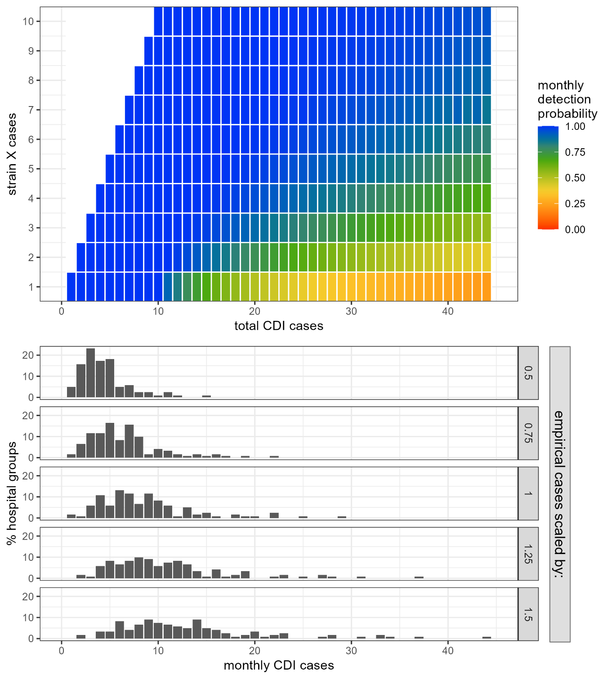
(b)
Supplementary Figure 3:
a) Probability of detection within a month: heat map by monthly CDI cases, strain X vs total
b) Histogram of monthly CDI cases per hospital group for each CDI total incidence scenario: empirical monthly CDI cases scaled by {0.5, 0.75, 1, 1.25, 1.50}

