Supplementary Information
From minor loci to major players? Satellite DNA diversification in Crepis sensu stricto.
Magdalena Senderowicz¹, Natalia Borowska-Żuchowska¹, Gülru Yücel^{1,2}, Teresa Nowak¹ Gbemisola Daini¹ and Bożena Kolano¹
¹Plant Cytogenetics and Molecular Biology Group, Institute of Biology, Biotechnology and Environmental Protection, Faculty of Natural Sciences, University of Silesia in Katowice, Katowice 40-032, Poland
²Faculty of Agriculture, Department of Agricultural Biotechnology, Ondokuz Mayıs University, Samsun 55200, Türkiye
*Correspondence should be addressed to Bozena Kolano, 28 Jagiellonska Street, Katowice 40-007, Poland Tel: +482009468; Email: bozena.kolano@us.edu.pl

Supplementary Table 1
PCR amplification and sequencing information
Region | MgCl2 concentration | Annealing temperature | Primer name and sequence (5’-3’)
pCcE9 | 2.5 mmol/L | 52 °C | Forward: TTTTGAGCTGTCGAGTGCCA  Reverse: CGGTGCAACTTTTCCCGATC
pCcD28 | 2.5 mmol/L | 52 °C | Forward: TTCAAGGATCGATTGGACGGC  Reverse: GGAAGGAGAACAACGTCTAAAGG
pCcH32 | 3 mmol/L | 55 °C | Forward: GTTGTCATTCAAACCCTAGTTCG  Reverse: GGTTGGAACTTCGGGATGG

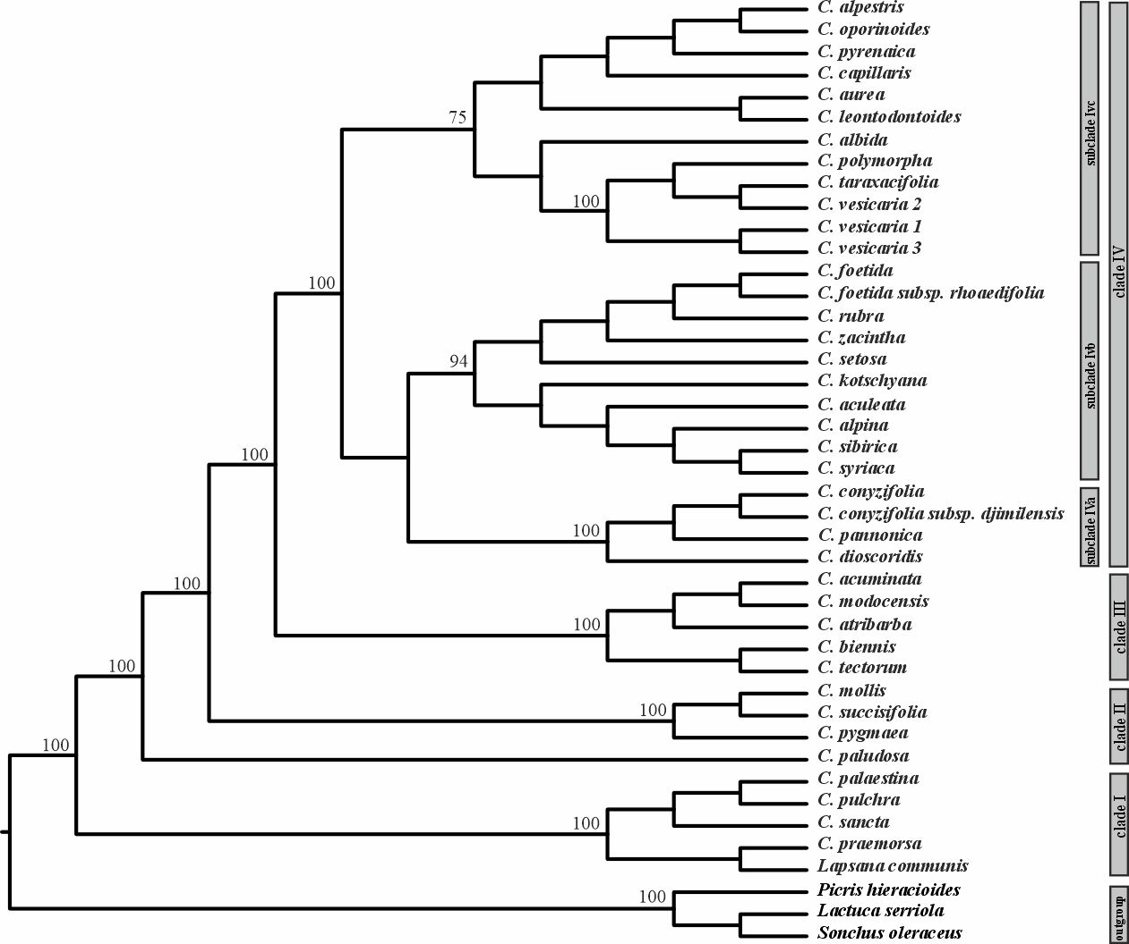Supplementary Fig. 1
Phylogenetic relationships among the analysed Crepis species based on the cpDNA data sets obtained in Senderowicz et al., 2021. Bootstrap support values are indicated at each node. The tree was rooted with Picris hieracioides, Lactuca serriola, and Sonchus oleraceus
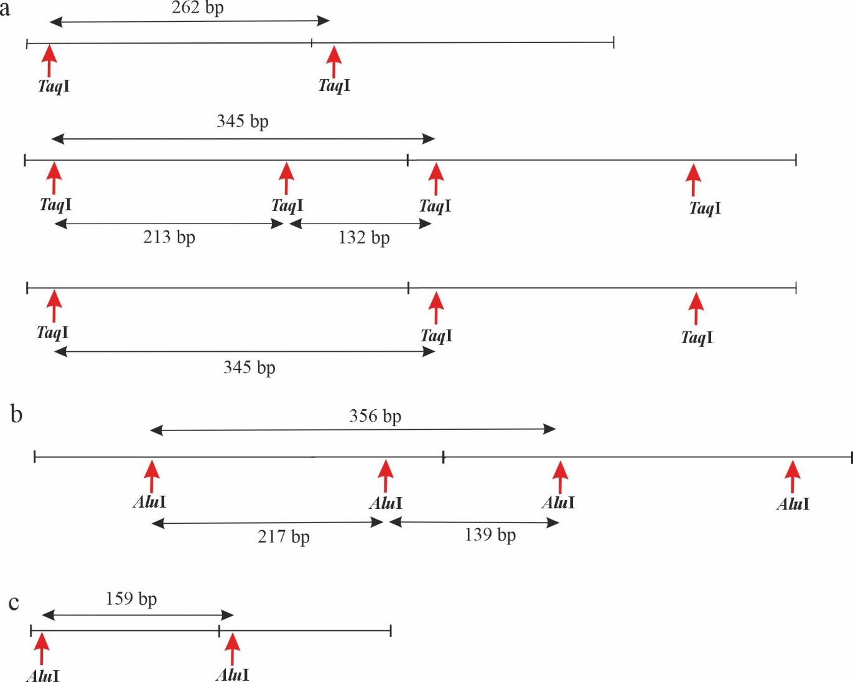
Supplementary Fig. 2
Most frequent restriction enzyme cleavage sites according to cloned sequence analysis. (A) pCcD29; One or two TaqI cleavage sites were present, depending on the variant. The monomer of 262 bp long represents sequences from cluster 1, while the monomer 345 bp long represents sequences from cluster 2 (Fig. 1D). (B) pCcE9 (C) pCcH32. Red arrows indicate sites recognised by the restriction enzymes (AluI or TaqI). The bars represent the lengths of the monomers after restriction

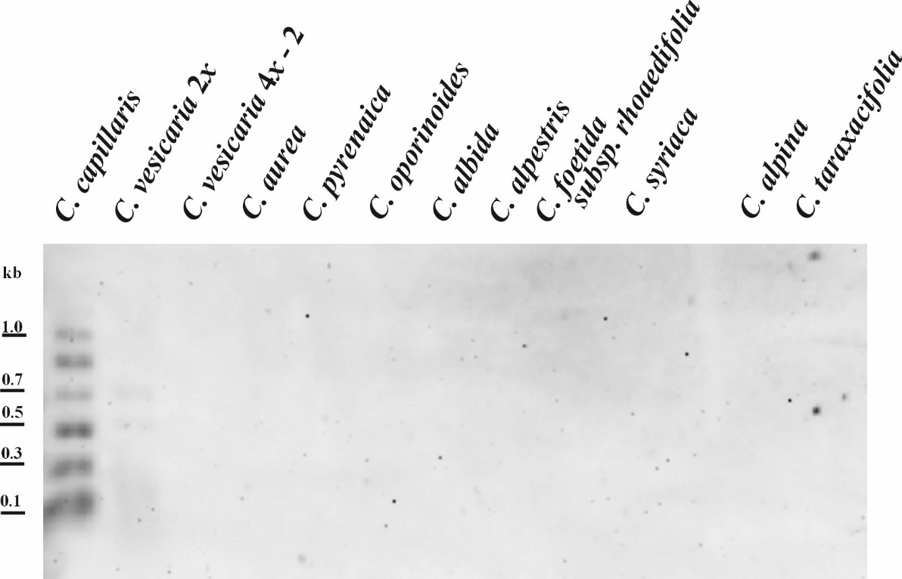
Supplementary Fig. 3
Southern hybridisation of cloned pCcH32 satDNA to genomic DNA of analysed species restricted with AluI (stringency 81 %)

