Sirt1 deficiency promotes age-related heart failure through enhancing ferroptosis via GATA4-HADHA-GPX4 axis
Yu Duan, PhD^{a,g}; Yingchun Luo, PhD^{a,g};Xuejie Han, PhDª;Hui Yu , PhD^{b}; Yun Zhou, PhDª; Yunlong Gao, PhD^{b}; Qian Xu, PhD^{c}; Ying Wei , PhD^{b}; Ruoxin Min, MD^{b}; Yong Hong, MD^{b}; Xuanrui Ji, PhD^{b}; Haibo Jia, PhD^{d*}; Yue Li, PhD^{a,e,f*} ; Yun Zhang, PhD^{a*}

ªDepartment of Cardiology, the First Affiliated Hospital, Harbin Medical University, Harbin 150001, China.
^{b}NHC Key Laboratory of Cell Transplantation, The First Affiliated hospital of Harbin Medical University, Harbin, Heilongjiang Province, 150001, China.
^{c}Anhui Provincial Center For Clinical Laboratories, The First Affiliated Hospital of USTC.
^{d}Department of Cardiology, 2nd Affiliated Hospital of Harbin Medical University, Harbin, 150001, PR China
^{e}Key Laboratory of Cardiac Diseases and Heart Failure, Harbin Medical University, Harbin 150001, China.
^{f}State Key Laboratory of Frigid Zone Cardiovascular Disease, Harbin Medical University, Harbin, Heilongjiang 150086, China.
^{g}These authors contributed equally.

*Corresponding auth：zhangyun263727@163.com (Yun Zhang), ly99ly@vip.163.com (Yue Li), jhb101180@163.com(Haibo Jia).

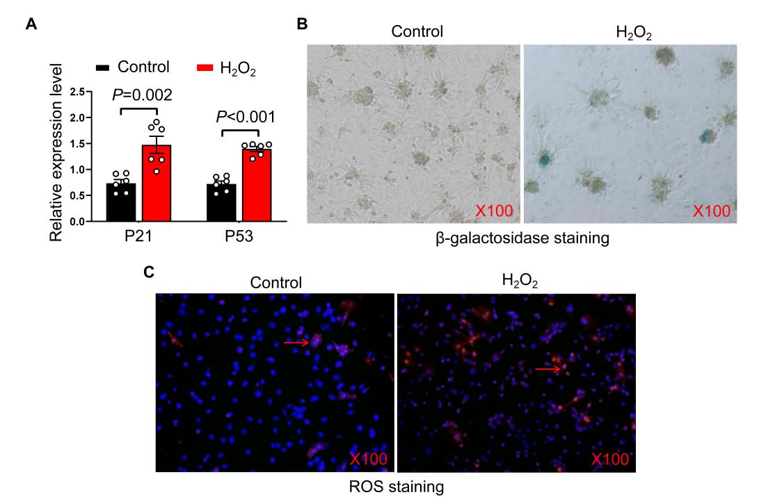
Figure.S1 Hydrogen peroxide induces senescence and oxidative stress in cardiomyocytes.
Cardiomyocytes were treated with H₂O₂ for 24 hours to establish senescent cardiomyocytes model.
- The relative expression of P21 and P53 in cardiomyocytes of Control group and H₂O₂ group (n=6 per group).
- Representative images of β-galactosidase staining in cardiomyocytes of Control group and H₂O₂ group.
- Representative images of ROS staining in cardiomyocytes of Control group and H₂O₂ group .
The data are given as mean ± SEM and compared by Student’s t test.

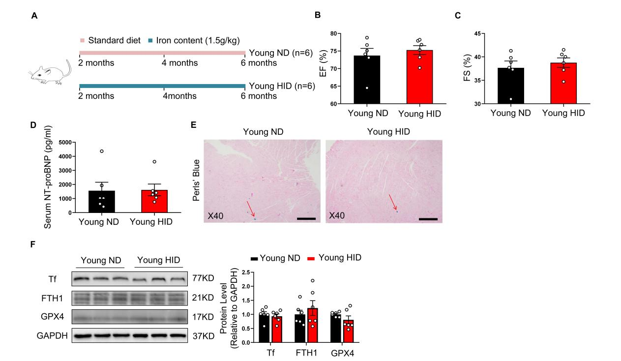
Figure-S2. HID diet did not exert influence on ferroptosis and cardiac function of young rats.
- Schematic illustration of the experimental design for ND or HID diet in young rats. 2 months old rats were randomly divided into two groups, receiving a standard diet(ND) or a high-iron diet (HID) for 4 months.
- The statistical data of cardiac ejection fraction (EF) of rats in Young ND group and Young HID group (n=6 per group).
- The statistical data of cardiac shortening (FS) of rats in Young ND group and Young HID group (n=6 per group).
- The level of NT-proBNP in rats from Young ND group and Young HID group (n=6 per group).
- Representative images of Perls’ Blue staining in ND-fed and HID-fed young rats.
- Representative bands and quantification of the expression of Tf, FTH1 and GPX4 in rats from Young ND group and Young HID group (n=6 per group).
The data are given as mean ± SEM and compared by Student’s t test.

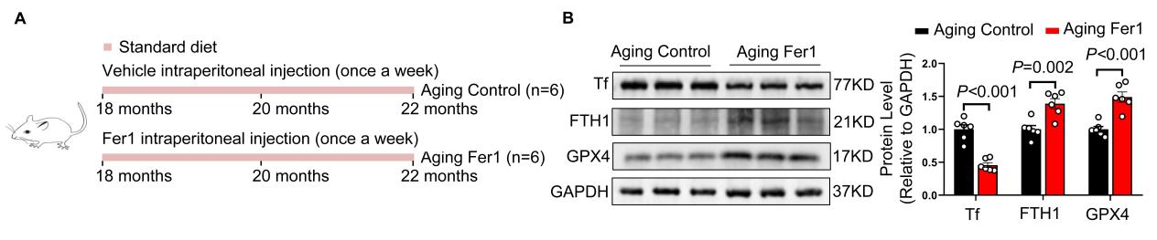
Figure-S3. Ferroptosis inhibitor protected aging rats from ferroptosis in ventricle.
- Schematic illustration of the experimental design for ferrostatin-1intervention. 18 months old rats were randomly divided into two groups, receiving control solvent or ferrostatin-1 through intraperitoneal injection, once a week, for 4 months.
- Representative bands and quantification of Tf, FTH1 and GPX4 in the heart of rats from Aging Control group and Aging Fer-1 group (n=6 per group).
The data are given as mean ± SEM and compared by Student’s t test.

Figure.S4 Silencing HADHA caused an increase in reactive oxygen species and mitochondrial dysfunction.
Cardiomyocytes were first transfected with plasmids to silence HADHA. After 24 hours, following a change of culture media, they were treated with H2O2 for 24 hours before conducting assays for relevant markers.
- Representative images of ROS staining and JC-1 staining in cardiomyocytes.
- The fluorescence intensity of ROS staining of cardiomyocytes (n=5 per group).
- The JC-1 polymer/monomer fluorescence ratio of cardiomyocytes (n=5 per group).
- The viability of cardiomyocytes (n=8 per group).
- The levels of ATP in cardiomyocytes (n=5 per group).
The data are given as mean ± SEM and compared by one way ANOVA.

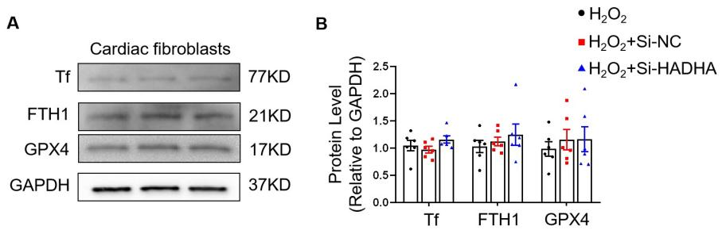
Figure.S5 Silencing HADHA has no impacts on ferroptosis in cardiac fibroblasts.
Cardiac fibroblasts were transfected with plasmids to silence HADHA. After 24 hours, following a change of culture media, the cells were treated with H₂O₂ for 24 hours before conducting assays for relevant markers.
- Representative bands of the expression of Tf, FTH1 and GPX4 in cardiac fibroblasts.
- Quantification of the expression of Tf, FTH1 and GPX4 in cardiac fibroblasts (n=6 per group).
The data are given as mean ± SEM and compared by one way ANOVA.

Figure.S6 Overexpression of HADHA leads to an decrease in reactive oxygen species and alleviates mitochondrial damage in cardiomyocytes.
Cardiomyocytes were first transfected with plasmids for overexpression of HADHA. After 24 hours, following a change of culture media, the cells were treated with H₂O₂ for 24 hours before conducting assays for relevant markers.
- Representative images of ROS staining in cardiomyocytes.
- The fluorescence intensity of ROS staining of cardiomyocytes (n=5 per group).
- The viability of cardiomyocytes (n=6 per group).
- The levels of GSH in cardiomyocytes (n=6 per group).
- The levels of ATP in cardiomyocytes (n=6 per group).
The data are given as mean ± SEM and compared by one way ANOVA.

Figure.S7 Supplementation of NAC protects D-galactose-induced aging rats from heart failure.
- Schematic illustration of the experimental design. We established a aging rat model with D-galactose (150mg/kg/day) via subcutaneous injection. Then rats were randomly divided into two groups, receiving control solvent (D-Gal Control group) or NAC (D-Gal NAC group) through drinking for 12 weeks.
- Representative bands and quantification of the expression of Tf, FTH1 and GPX4 in the heart of rats from D-Gal Control group and D-Gal NAC group (n=6 per group).
- Representative M-mode images of heart in from D-Gal Control group and D-Gal NAC group.
- The statistical data of left ventricular ejection fraction (EF) of rats from D-Gal Control group and D-Gal NAC group (n=8 per group).
- The statistical data of left ventricular fraction shortening (FS) of rats from D-Gal Control group and D-Gal NAC group (n=8 per group).
- The levels of plasma NT-ProBNP in rats from D-Gal Control group and D-Gal NAC group (n=8 per group).
- Representative images of HE staining of the left ventricle of rats from D-Gal Control group and D-Gal NAC group.
- Representative images of Masson staining of the left ventricle of rats from D-Gal Control group and D-Gal NAC group.
- The collagen volume fraction of the left ventricle of rats from D-Gal Control group and D-Gal NAC group (n=6 per group).
The data are given as mean ± SEM and compared by Student’s t test.

