Suppl Materials

Context-Dependent Placebo Hypoalgesia Through Observational Learning: The Role of Empathy in Virtual and Real-World Settings

Jewel N. White, PhD ^{1,2},³ Lakota Watson, MS³, Yang Wang¹, Giancarlo Colloca⁴, Jonathan Michael Heagerty, MS ⁵, Sida Li, MS ⁵, Barbara Brawn, MS ⁵, Amitabh Varshney, PhD ⁵, Roni Shafir, PhD ¹, Carmen-Édith Belleï-Rodriguez¹, PhD ^{1,6}, Luana Colloca¹*, MD, PhD ^{1,5}

- Department of Pain and Translational Symptom Science, University of Maryland School of Nursing, Baltimore | Placebo Beyond Opinions Center, University of Maryland School of Nursing, Baltimore, MD, United States
- Department of Anesthesiology, Perioperative and Pain Medicine, Stanford University School of Medicine, Stanford, CA, United States
- Graduate Program in Life Sciences, Program in Neuroscience, University of Maryland School of Medicine, Baltimore, MD, United States
- Information Technology PhD Program, Towson University, Towson, United States
- College of Computer, Mathematical, and Natural Sciences, University of Maryland College Park, College Park, MD, United States
- Faculty of Nursing, University of Montreal, Montreal, QC, Canada

Correspondence to: Luana Colloca, 655 W. Lombard St. Suite 733, Baltimore, MD 21201, Phone: 410-706-8244; Fax: 410-706-5427, Email: colloca@umaryland.edu

Flow-Chart
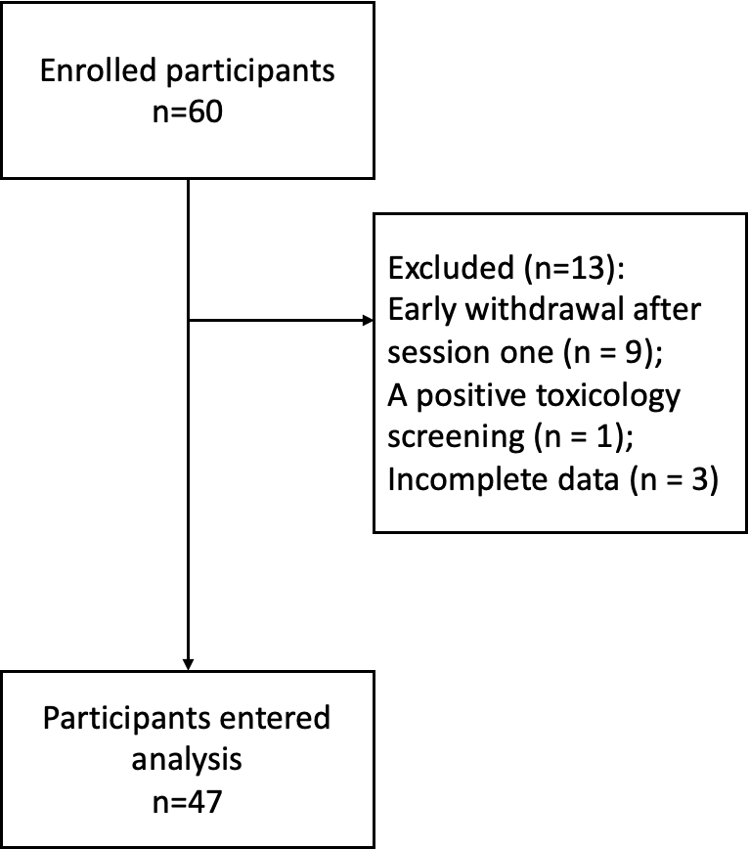

Thirteen participants were excluded from protocol for early withdrawal after session one (n = 9); a positive toxicology screening (n = 1); or incomplete data (n = 3; missing empathy responses).

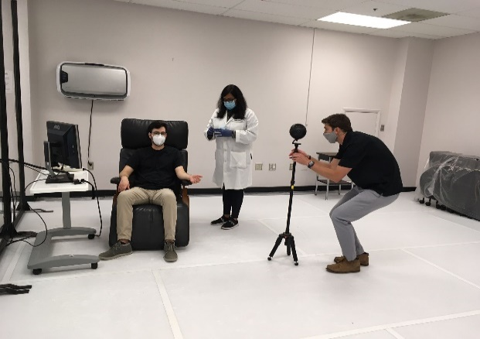
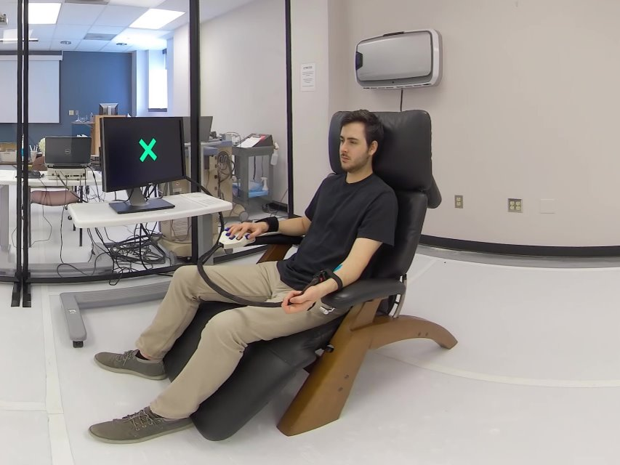
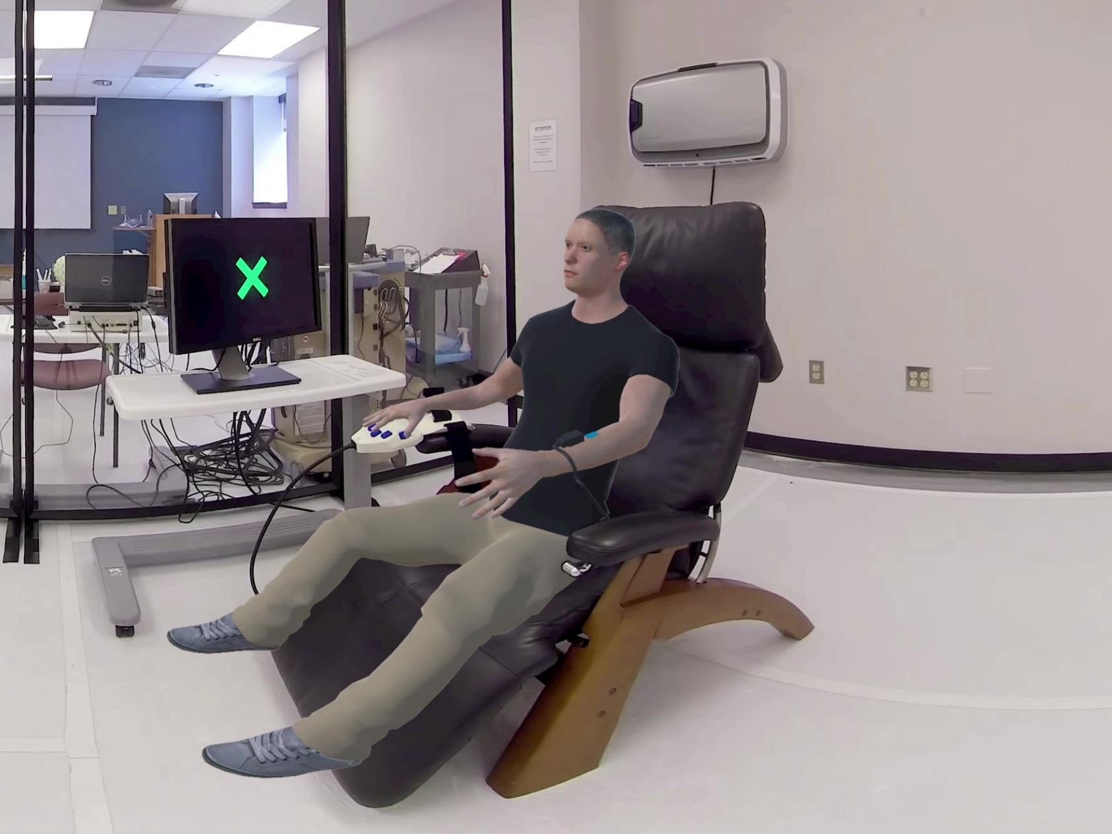
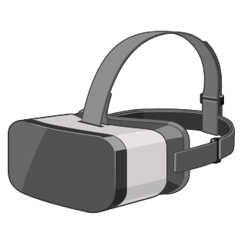
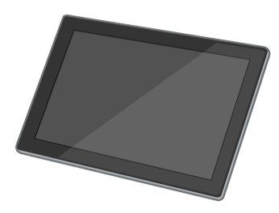
Suppl Figure 1. Experimental Procedure: State Empathy Manipulation and Socially Induced Placebo Hypoalgesia.
A. To create the avatar condition, a live video recording of the demonstrator was used to generate a 3D avatar using motion-capture and animation software. The resulting avatar realistically mirrored the demonstrator’s facial features and movements, ensuring visual and behavioral fidelity during the observation phase. Both the human demonstrator and his avatar were presented in two formats: a fully immersive 3D environment via virtual reality (VR) goggles (defined as immersive VR, where participants experienced the scenario within a 360-degree interactive digital space), and a standard 2D display on a tablet (defined as the real-world setting, where participants observed the same content on a flat screen without immersion). This design allowed for the comparison of empathy and placebo responses across immersive and non-immersive contexts.

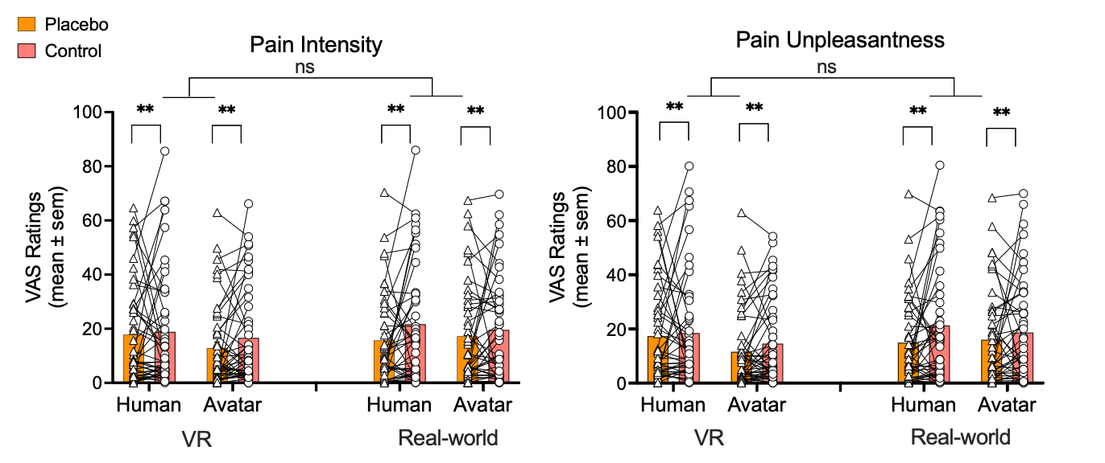
Suppl Figure 2. Effect of Treatment Condition on Empathy Toward Human vs. Avatar Pain. The graphs show the main effects of control and treatment conditions on cognitive (other-referred) empathy ratings (reported on a visual analogue scale (VAS) from 0 (no pain) to 100 (maximum tolerable pain)) for the human and avatar demonstrators in VR and real-world settings. Participants’ state cognitive empathy (i.e., empathy for the experience of the demonstrator) was assessed using questions 3 and 4. Data are mean ± SEM. ***p<0.001
A
B

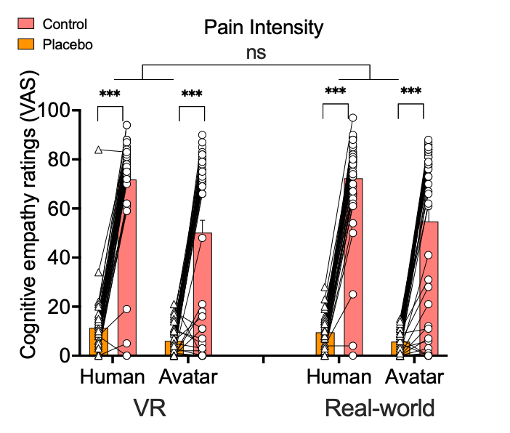
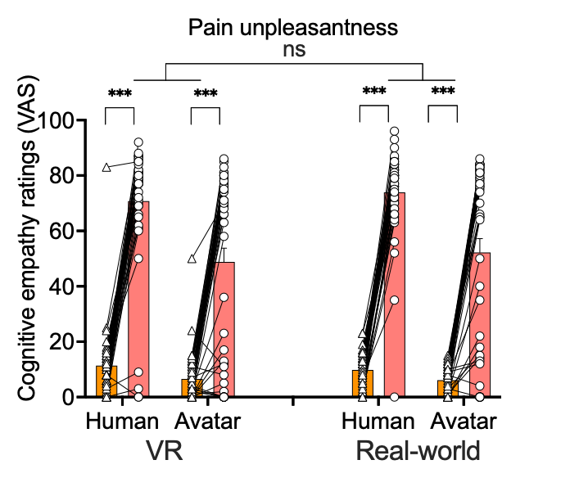
A
B

Suppl Figure 3. Observationally induced placebo effects on self-reported pain intensity and unpleasantness. Pain intensity (left) and pain unpleasantness (right) ratings are shown across four conditions: Human and Avatar demonstrators presented in Virtual Reality (VR) and Real-world settings, under both placebo (orange bars) and control (pink bars) cue conditions. Each dot represents an individual participant, and lines connect within-subject data across conditions. Mean VAS ratings (± SEM) are shown for pain ratings.
Significant placebo effects were observed in both demonstrator and setting conditions (p < .01), with no significant difference in placebo magnitude between VR and real-world settings. These results indicate that observationally induced placebo analgesia occurs regardless of demonstrator type or immersive context. ns = not significant; ** p < .01.

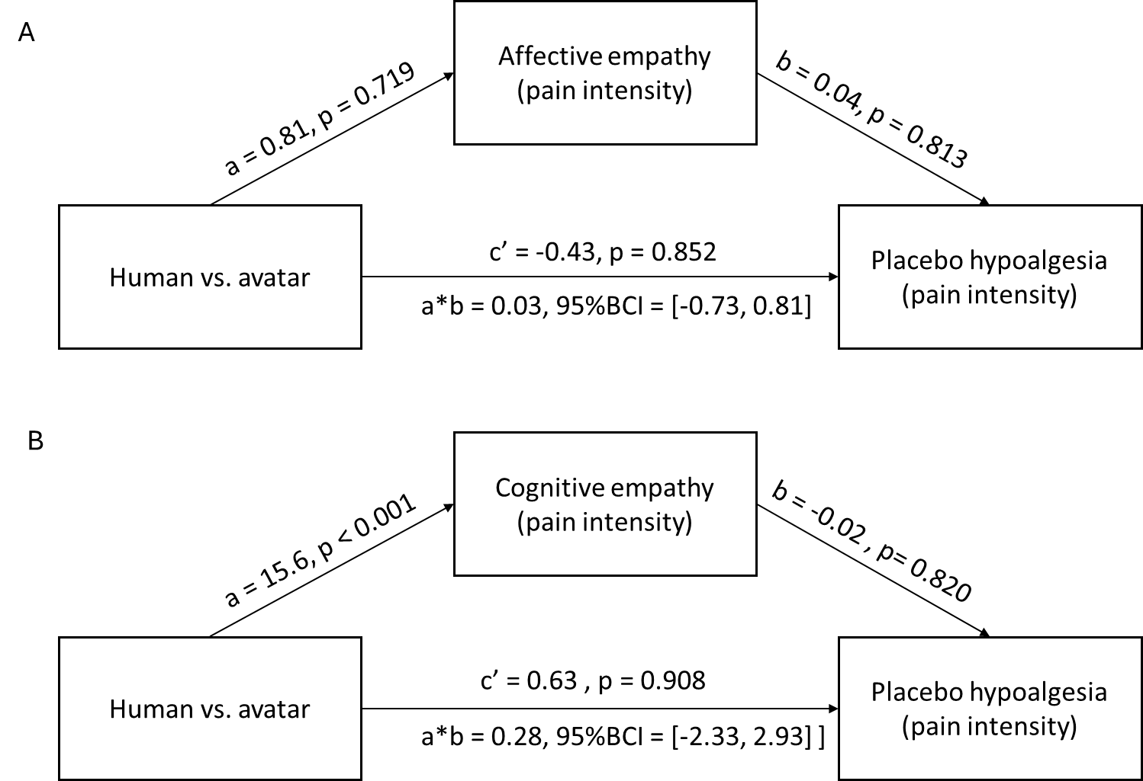

Figure S4. Mediation model of cognitive and affective state empathy pain intensity ratings on the influences of demonstrator types on observationally induced placebo hypoalgesia. (A). There was no mediation effect of cognitive state empathy pain intensity ratings on placebo hypoalgesia. (B). There was no mediation effect of affective state empathy pain intensity ratings on placebo hypoalgesia.

Experimental Variables

Analysis of control variables revealed that the level of pain intensity administered during the experiment significantly influenced the magnitude of placebo hypoalgesia for pain intensity (F_{1,2891.34} = 37.16, p < 0.001). Specifically, greater placebo effects were observed among participants exposed to higher-temperature painful stimuli.

Moreover, both the color of the placebo cream (F_{1,2891.34} = 66.93, p < 0.001) and the order of placebo treatment (F₁,₂₈₆₇.₉₇ = 107.15, p < 0.001) significantly modulated the placebo response. Green-colored creams elicited stronger hypoalgesic effects than blue creams (mean difference = 6.56, SEM = 0.80, p < 0.001). Similarly, participants who received the placebo treatment block first reported greater hypoalgesia than those who received the control block first (mean difference = 8.31, SEM = 0.80, p < 0.001).

The order of the demonstrator also influenced the magnitude of placebo effects (F_{1,2891.34} = 3.94, p = 0.047), with greater effects observed when the Human demonstrator preceded the Avatar (mean difference = 1.50, SEM = 0.76, p = 0.047). The order of VR exposure significantly influenced placebo hypoalgesia (F_{1,2891.34} = 10.73, p = 0.001), with greater placebo effects when VR was exposed first than the real-world setting being first (mean difference = 2.57, SEM = 0.78, p = 0.001).

In contrast, the location of the placebo creams on the forearm did not significantly influence placebo responding (p > 0.05). Similar findings were found with pain unpleasantness.

Mediation model

A mediation model was conducted with trait empathy (BES cognitive subscale, IRI personal distress subscale) as the independent variable, affective state empathy as the mediator, and placebo hypoalgesia as the dependent variable. Given that significant correlations were found for placebo effects induced by the Human demonstrator in the VR settings only, we limited the mediation analysis to this condition. The mediation analysis indicated that participant affective state empathy did not mediate the relationship between trait empathy and placebo hypoalgesia (BES cognitive empathy: a*b = 0.09, 95%BCI = [-0.23, 0.64]; IRI personal distress: a*b = 0.13, 95%BCI = [-0.22, 0.71]).

Table S1. The average and standard error of mean of each experimental condition for the state empathy and placebo hypoalgesia
 |  | VR human |  | VR avatar |  | Real-word human |  | Real-world avatar
 |  | mean | sem | mean | sem | mean | sem | mean | sem
Control condition | Affective empathy (pain intensity) | 6.04 | 15.65 | 9.36 | 21.92 | 10.78 | 22.08 | 7.22 | 20.85
Control condition | Affective empathy (pain unpleasantness) | 10.02 | 17.92 | 7.13 | 19.82 | 13.84 | 21.83 | 7.61 | 19.25
Control condition | Cognitive empathy (pain intensity) | 71.78 | 22.22 | 50.11 | 34.77 | 72.29 | 19.69 | 54.65 | 34.29
Control condition | Cognitive empathy (pain unpleasantness) | 70.78 | 22.79 | 48.81 | 34.21 | 73.93 | 15.73 | 52.22 | 34.04
Control condition | Pain Intensity | 18.46 | 21.30 | 16.63 | 17.94 | 19.85 | 21.87 | 18.32 | 19.27
Control condition | Pain Unpleasantness | 18.23 | 21.05 | 14.75 | 15.80 | 19.60 | 21.70 | 17.61 | 19.39
Placebo condition | Affective empathy (pain intensity) | 1.43 | 3.26 | 1.34 | 3.32 | 2.33 | 7.61 | 0.85 | 1.79
Placebo condition | Affective empathy (pain unpleasantness) | 1.74 | 3.78 | 1.28 | 3.29 | 1.70 | 4.52 | 1.02 | 2.29
Placebo condition | Cognitive empathy (pain intensity) | 11.30 | 12.90 | 6.04 | 5.82 | 9.50 | 6.32 | 5.74 | 4.57
Placebo condition | Cognitive empathy (pain unpleasantness) | 11.39 | 12.50 | 6.55 | 8.53 | 9.85 | 5.83 | 6.11 | 4.73
Placebo condition | Pain Intensity | 17.41 | 18.85 | 12.90 | 15.33 | 14.33 | 16.72 | 16.11 | 18.57
Placebo condition | Pain Unpleasantness | 17.10 | 17.96 | 11.73 | 14.31 | 13.79 | 15.90 | 15.12 | 17.64
SD = Standard deviation

