Introduction: Name, institute, and position
Welcome and brief explanation of the U-WaTCH project

Interview guide Note: Ask regularly for breaks

Topic 1: Personal well-being and introduction to PEM
1. Confirm the interviewee's consent to the recording, state the setting/location (interview via Zoom), date and time, and explain that the interview can be stopped at any time and none of the questions have to be answered.
2. How are you feeling at the moment?
3. Assess energy levels (from 0% – 100%)
4. What are your current symptoms related to your long COVID/ chronic inflammatory disease condition and how do they manifest themselves in your everyday life?
5. Do you have any other conditions and how have they developed over time?

Brief introduction to the topic of PEM or crash to ensure a shared understanding:
Definition: Post-exertional malaise (PEM) occurs after physical, mental, or emotional exertion, as well as due to external stimuli. Various symptoms such as pain, fatigue, flu-like symptoms (e.g., fever), cognitive problems (e.g., brain fog, concentration difficulties), sleep disorders, and circulatory problems worsen as a result.
6. I am not yet very familiar with the topic. Does this definition sound accurate to you?
7. Have you personally experienced a crash situation?

Topic 2: Course and characteristics of the crash
8. How often does this situation occur for you?
9. What symptoms do you typically experience during PEM or a crash?
Optional follow-up question:
a. Do you suffer from extreme exhaustion in such situations?
b. Do you suffer from concentration problems in such situations?
c. Do you suffer from headaches/ dizziness in such situations?
d. Do you suffer from other physical symptoms in such situations?
e. Do you suffer from sleep disorders in such situations?
f. Do you suffer from tingling nerves in such situations?
g. Do you suffer from (increased) psychological symptoms (anxiety, depression, etc.) in such situations?
10. Can you estimate how bad a crash will be before it happens?
a. If so, how can you tell?
11. Do you have mechanisms to help you recover from a crash

Topic 3: The crash process (reference to the use of the whiteboard)
The following questions aim to provide a better understanding of the process of a “typical” crash. (Also mention that the y-axis is 0% and 100%.)
12. Please describe a typical crash. How and when does your energy level change?
13. What are the first signs of a crash for you?
14. How long does a crash last?
15. How long does it take from the first signs to the worst phase of a crash?
16. So that I can better visualize your progression, I would ask you to record such a progression (draw the curve yourself using screen sharing).
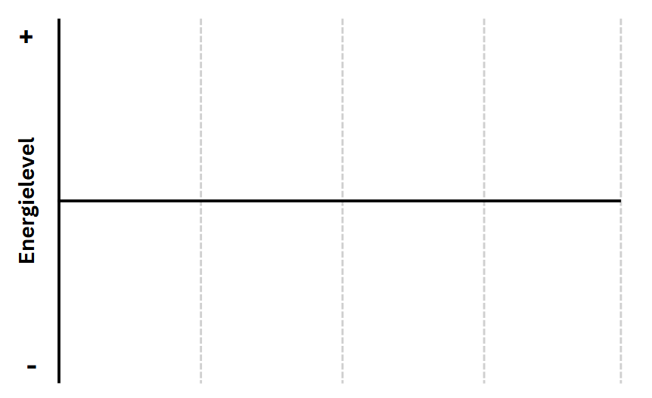
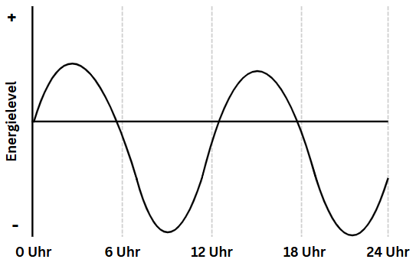
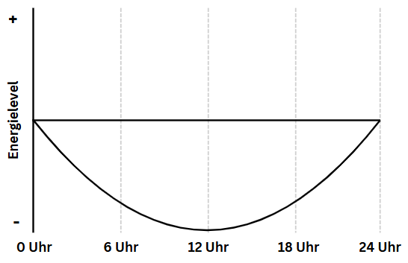
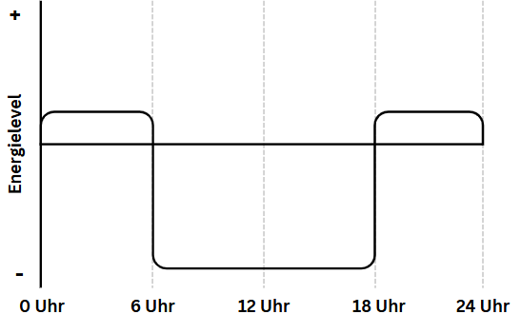
(if examples are needed:)

Important note: Close the whiteboard!
The following question is not asking respondents to complete a questionnaire during a crash. It aims to identify the latest possible time point for questionnaire completion.
17. At what point would you no longer be able to fill out a questionnaire? ◊ Point to the energy curve.
a. Optional: If the respondent gives the impression that they would be able to fill out a questionnaire during the crash ◊ Ask how much would be possible
18. What factors influence the severity of your crash?
19. If the question is too personal for you, you do not have to answer it: How do the symptoms affect your ability to cope with your daily tasks, your family and social life, and your leisure time?
a. Optional: Which crash consequences pose the greatest challenges for you?
20. Is there anything else you would like to tell us?
21. What is your current battery level (from 0% - 100%)?
Stop recording
Outlook U-WaTCH: Possible inclusion in the study

