Mechanistic Insights into Melanin induced PCR Inhibition and Its NanoPCR-Based Mitigation
Kamayani Vajpayeeª, Shriyansh Srivastava^{b}, Shivkant Sharma^{c}, Swadha Gupta^{d}, Ashutosh Srivastava^{b}, Vidhi Paidaª, Hirak Ranjan Dash^{e}, Anju Pappachan^{d}, Ritesh K Shuklaª
Supplementary File

Supplementary Figure S1: Crystal Structures of Taq Polymerase:
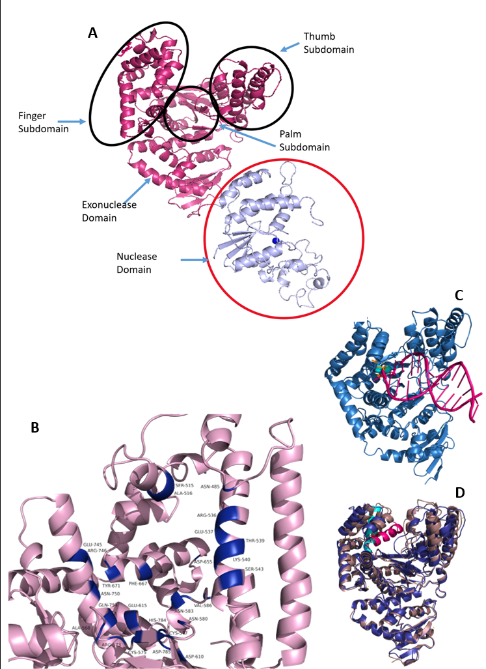
Figure panel illustrating different Structural Conformations (Open and Closed) and Functional Insights of Taq Polymerase: (A) Open conformation of Taq Polymerase (PDB ID: 1TAQ) showing the Subdomains of Taq Polymerase Enzyme. There are two major domains-Polymerase (pink) and Nuclease Domain (purple). The polymerase domain comprises three subdomains_ Finger, Thumb, and Palm Subdomain, as encircled in black. The Zn²⁺ ion associated with its respective domain is shown in blue. (B) Active site residues of 1TAQ (shown in blue) that were used to define the molecular docking grid for further simulations. (C) Closed conformation of Taq Polymerase (PDB ID: 3KTQ), with the overall protein structure shown in blue. Two Mg²⁺ ions are depicted in cyan, the DNA-primer complex in pink, and dCTP in orange. (D) Structural alignment of 1TAQ (blue) with 3KTQ (brown) highlighting a major conformational transition from the open to closed state. The O helix, which undergoes a significant shift, is indicated in blue in its original position and pink in its closed conformation state.

Supplementary Figure S2: Structure of Melanin as retrieved from PubChem (ID: 6325610).
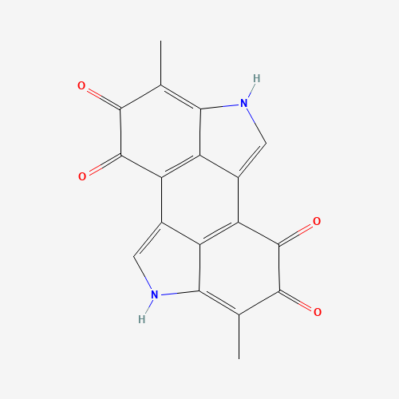
Figure depicting the Chemical structure of Melanin

Supplementary Table S1: List of Active site residues used for grid generation:
Residue | Position | Structural/Functional Correspondence
Asn485 | Palm | Stabilizes incoming dNTP
Ser515 | Palm | Part of catalytic core; interacts with primer terminus
Ala516 | Palm | Structural support near catalytic site
Arg536 | Fingers | Involved in nucleotide binding
Glu537 | Fingers | Stabilizes dNTP through ionic interactions
Thr539 | Fingers | Contributes to dNTP alignment
Lys540 | Fingers | dNTP coordination
Ser543 | Fingers | Structural stability; close to incoming nucleotide
Ala568 | Fingers | Structural role in dNTP channel
Arg573 | Fingers | Interacts with DNA backbone
Ser575 | Fingers | DNA interaction surface
Ser577 | Fingers | DNA backbone interaction
Asn580 | Fingers | Primer-template stabilization
Asn583 | Fingers | Stabilizes DNA duplex
Val586 | Fingers | Hydrophobic pocket near active site
Asp610 | Palm | Catalytic triad; coordinates Mg²⁺
Glu615 | Palm | Catalytic triad; coordinates Mg²⁺
Glu655 | Palm | Catalytic region; structural role
Phe667 | O-helix | Conformational switching; stabilizes closed complex
Tyr671 | O-helix | Key residue in helix repositioning during catalysis
Gln745 | Thumb | Binds duplex DNA
Arg746 | Thumb | DNA positioning and stabilization
Asn750 | Thumb | Structural support for DNA duplex
Gln754 | Thumb | DNA-binding interface
His784 | Thumb | DNA stabilization
Asp785 | Thumb | Structural support
Gln786 | Thumb | Maintains DNA trajectory

The table enlists the Active site residues that were used for grid generation. The catalytic residues are highlighted in yellow.
Supplementary Figure S3: Molecular Docking Analysis of the Taq Polymerase protein with the Melanin:

- Docked Pose of Melanin with Open conformation of Protein (1TAQ)

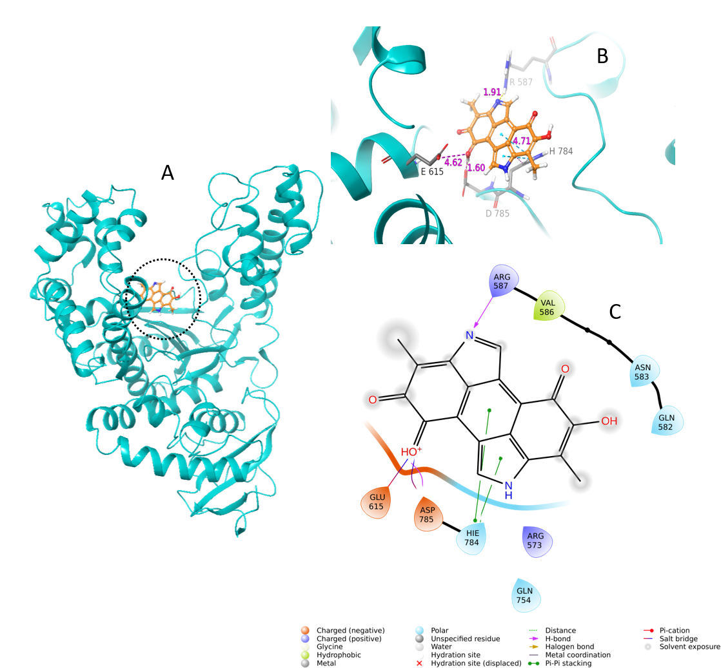
Molecular docking analysis of the 1TAQ with Melanin illustrating (A) Overview of the Docked complex showing melanin bound within the active site of the Taq polymerase enzyme; (B) Close up view of the binding pocket depicting the key amino acid residues interacting with melanin. Hydrogen bonds and other interactions are labelled with corresponding bond lengths in Å; (C) 2D Ligand interaction diagram illustrating the melanin’s interactions with surrounding amino acid residues, including hydrogen bonds, hydrophobic bonds, and pi-pi interactions.

- Docked Pose of Melanin with Closed conformation of Protein (3KTQ)
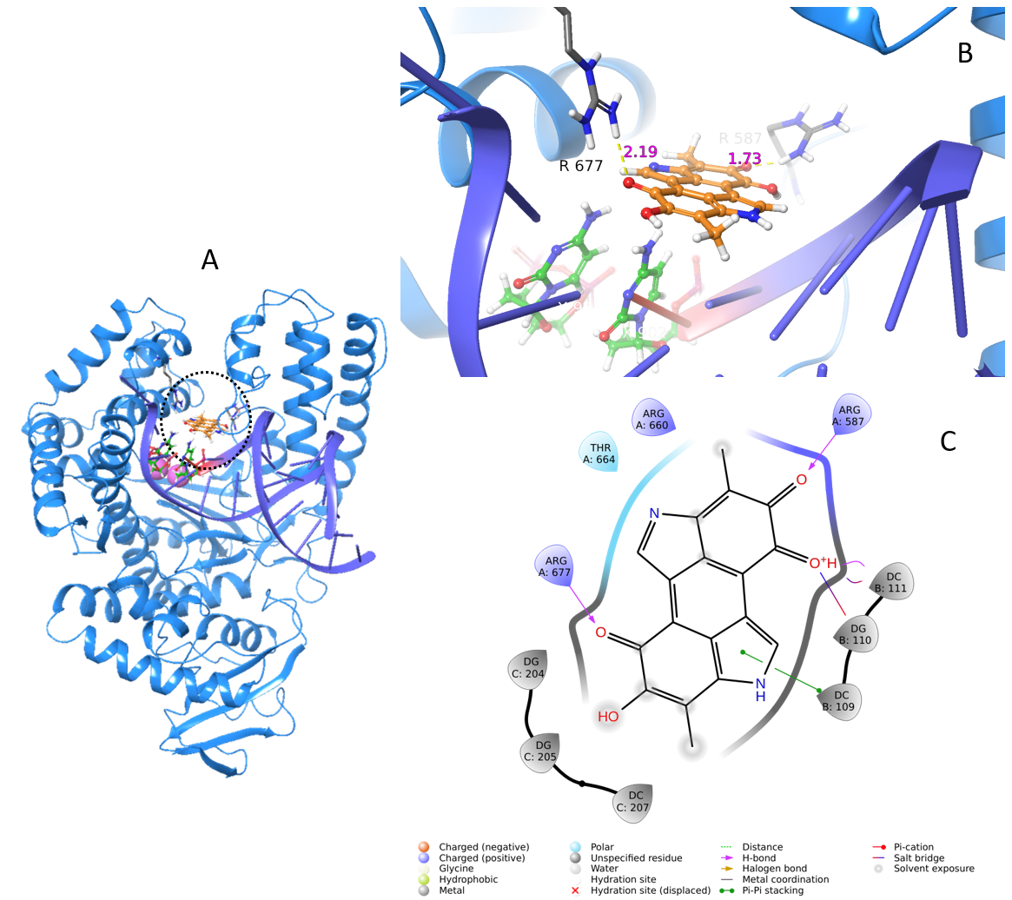
Molecular docking analysis of the 3KTQ with Melanin illustrating (A) Overview of the Docked complex showing melanin bound within the active site of the Taq polymerase enzyme; (B) Close up view of the binding pocket depicting the key amino acid residues interacting with melanin. Hydrogen bonds and other interactions are labelled with corresponding bond lengths in Å; (C) 2D Ligand interaction diagram illustrating the melanin’s interactions with surrounding amino acid residues, including hydrogen bonds, hydrophobic bonds, and pi-pi interactions.

- Docked pose of Melanin with Closed conformation of Enzyme having DNA-Primer moiety deleted.
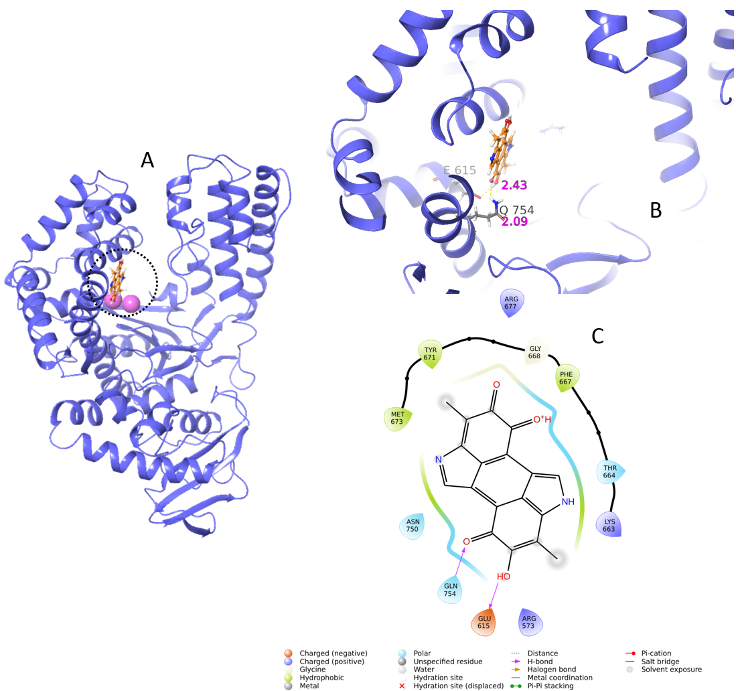
Molecular docking analysis of the 3KTQ with DNA- Primer complex deleted (magnesium ion present) with Melanin illustrating (A) Overview of the Docked complex showing melanin bound within the active site of the Taq polymerase enzyme; (B) Close up view of the binding pocket depicting the key amino acid residues interacting with melanin. Hydrogen bonds and other interactions are labelled with corresponding bond lengths in Å; (C) 2D Ligand interaction diagram illustrating the melanin’s interactions with surrounding amino acid residues, including hydrogen bonds, hydrophobic bonds, and pi-pi interactions.

- Docked pose of Melanin with Closed conformation of Enzyme having DNA-Primer and Mg²⁺ ions moiety deleted.

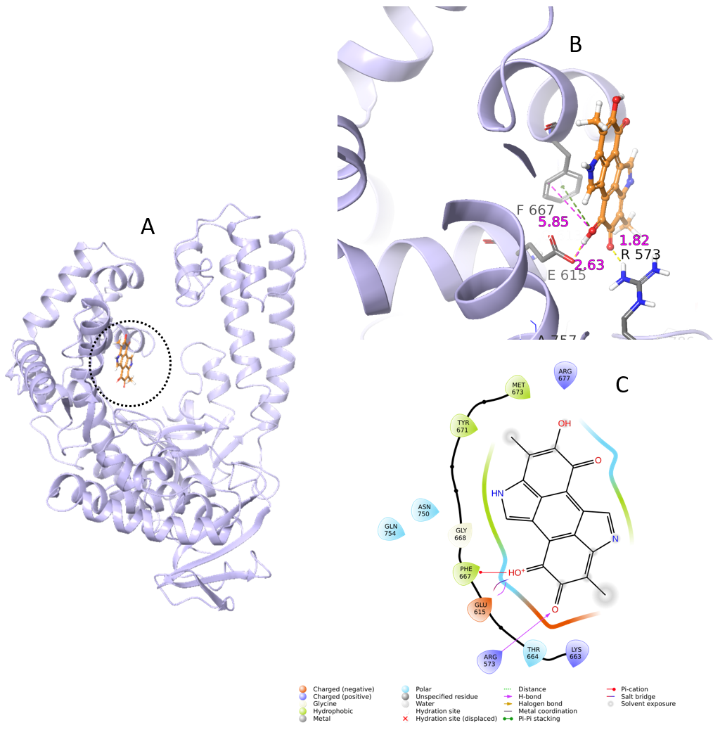
Molecular docking analysis of the 3ktq with DNA-Primer complex and magnesium ion deleted with Melanin illustrating (A) Overview of the Docked complex showing melanin bound within the active site of the Taq polymerase enzyme; (B) Close up view of the binding pocket depicting the key amino acid residues interacting with melanin. Hydrogen bonds and other interactions are labelled with corresponding bond lengths in Å; (C) 2D Ligand interaction diagram illustrating the melanin’s interactions with surrounding amino acid residues, including hydrogen bonds, hydrophobic bonds, and pi-pi interactions.

Supplementary Table S2: A list of Taq Polymerase crystal structures available on Protein Data Bank.
Identifier | Structure Data
Entity ID | DOI | PDB ID | Structure Title | Structure Keywords
1BGX_1 | 10.1073/pnas.95.21.12562 | 1BGX | TAQ POLYMERASE IN COMPLEX WITH TP7, AN INHIBITORY FAB | COMPLEX (POLYMERASE/INHIBITOR)
1JXE_1 |  | 1JXE | STOFFEL FRAGMENT OF TAQ DNA POLYMERASE I | NUCLEOTIDYLTRANSFERASE
1KTQ_1 | 10.1073/pnas.92.20.9264 | 1KTQ | DNA POLYMERASE | NUCLEOTIDYLTRANSFERASE
1QSS_3 | 10.1073/pnas.96.17.9491 | 1QSS | DDGTP-TRAPPED CLOSED TERNARY COMPLEX OF THE LARGE FRAGMENT OF DNA POLYMERASE I FROM THERMUS AQUATICUS | Transferase/DNA
1QSY_3 | 10.1073/pnas.96.17.9491 | 1QSY | DDATP-Trapped closed ternary complex of the large fragment of DNA Polymerase I from Thermus aquaticus | TRANSFERASE/DNA
1QTM_3 | 10.1073/pnas.96.17.9491 | 1QTM | DDTTP-TRAPPED CLOSED TERNARY COMPLEX OF THE LARGE FRAGMENT OF DNA POLYMERASE I FROM THERMUS AQUATICUS | TRANSFERASE/DNA
1TAQ_1 | 10.1038/376612a0 | 1TAQ | STRUCTURE OF TAQ DNA POLYMERASE | NUCLEOTIDYLTRANSFERASE
1TAU_3 | 10.1038/382278a0 | 1TAU | TAQ POLYMERASE (E.C.2.7.7.7)/DNA/B-OCTYLGLUCOSIDE COMPLEX | transferase/DNA
2KTQ_3 | 10.1093/emboj/17.24.7514 | 2KTQ | OPEN TERNARY COMPLEX OF THE LARGE FRAGMENT OF DNA POLYMERASE I FROM THERMUS AQUATICUS | TRANSFERASE/DNA
3KTQ_3 | 10.1093/emboj/17.24.7514 | 3KTQ | CRYSTAL STRUCTURE OF AN ACTIVE TERNARY COMPLEX OF THE LARGE FRAGMENT OF DNA POLYMERASE I FROM THERMUS AQUATICUS | TRANSFERASE/DNA
3LWL_1 | 10.1038/emboj.2010.64 | 3LWL | Structure of Klenow fragment of Taq polymerase in complex with an abasic site | TRANSFERASE/DNA
3LWM_1 | 10.1038/emboj.2010.64 | 3LWM | Structure of the large fragment of thermus aquaticus DNA polymerase I in complex with a blunt-ended DNA and ddATP | TRANSFERASE/DNA
3M8R_1 | 10.1002/anie.200905724 | 3M8R | Crystal structure of the large fragment of DNA polymerase I from Thermus aquaticus in a closed ternary complex with trapped 4'-ethylated dTTP | Transferase/DNA
3M8S_1 | 10.1002/anie.200905724 | 3M8S | Crystal structure of the large fragment of DNA polymerase I from Thermus aquaticus in a closed ternary complex with trapped 4'-methylated dTTP | Transferase/DNA
3OJS_1 | 10.1073/pnas.1013804107 | 3OJS | Snapshots of the large fragment of DNA polymerase I from Thermus Aquaticus processing C5 modified thymidines | Transferase/DNA
3OJU_1 | 10.1073/pnas.1013804107 | 3OJU | Snapshot of the large fragment of DNA polymerase I from Thermus Aquaticus processing c5 modified thymidies | Transferase/DNA
3PO4_1 | 10.1002/cbic.201000783 | 3PO4 | Structure of a mutant of the large fragment of DNA polymerase I from Thermus aquaticus in complex with a blunt-ended DNA and ddATP | TRANSFERASE/DNA
3PO5_1 | 10.1002/cbic.201000783 | 3PO5 | Structure of a mutant of the large fragment of DNA polymerase I from Thermus Auqaticus in complex with an abasic site and ddATP | TRANSFERASE/DNA
3PY8_1 | 10.1002/cbic.201000783 | 3PY8 | Crystal structure of a mutant of the large fragment of DNA polymerase I from thermus aquaticus in a closed ternary complex with DNA and ddCTP | Transferase/DNA
3RR7_1 | 10.1074/jbc.M111.334904 | 3RR7 | Binary Structure of the large fragment of Taq DNA polymerase bound to an abasic site | TRANSFERASE/DNA
3RR8_1 | 10.1074/jbc.M111.334904 | 3RR8 | Ternary Structure of the large fragment of Taq DNA polymerase bound to an abasic site and a ddGTP | TRANSFERASE/DNA
3RRG_1 | 10.1074/jbc.M111.334904 | 3RRG | Ternary Structure of the large fragment of Taq DNA polymerase bound to an abasic site and a ddGTP | TRANSFERASE/DNA
3RRH_1 | 10.1074/jbc.M111.334904 | 3RRH | Ternary Structure of the large fragment of Taq DNA polymerase bound to an abasic site and a ddTTP | TRANSFERASE/DNA
3RTV_1 | 10.1038/nchembio.966 | 3RTV | Crystal structure of the large fragment of DNA polymerase I from Thermus Aquaticus in a closed ternary complex with natural primer/template DNA | TRANSFERASE/DNA
3SV3_1 | 10.1038/nchembio.966 | 3SV3 | Crystal structure of the large fragment of DNA polymerase I from Thermus Aquaticus in a closed ternary complex with the artificial base pair dNaM-d5SICSTP | TRANSFERASE/DNA
3SV4_1 | 10.1038/nchembio.966 | 3SV4 | Crystal structure of the large fragment of DNA polymerase I from Thermus Aquaticus in an open binary complex with dT as templating nucleobase | TRANSFERASE/DNA
3SYZ_1 | 10.1038/nchembio.966 | 3SYZ | Crystal structure of the large fragment of DNA polymerase I from Thermus Aquaticus in an open binary complex with dNaM as templating nucleobase | TRANSFERASE/DNA
3SZ2_1 | 10.1038/nchembio.966 | 3SZ2 | Crystal structure of the large fragment of DNA polymerase I from Thermus Aquaticus in an open binary complex with dG as templating nucleobase | TRANSFERASE/DNA
3T3F_1 | 10.1074/jbc.M111.334904 | 3T3F | Ternary Structure of the large fragment of Taq DNA polymerase bound to an abasic site and dNTP | TRANSFERASE/DNA
4BWJ_1 | 10.1002/anie.201306655 | 4BWJ | KlenTaq mutant in complex with DNA and ddCTP | TRANSFERASE/DNA
4BWM_1 | 10.1002/anie.201306655 | 4BWM | KlenTaq mutant in complex with a RNA/DNA hybrid | TRANSFERASE/DNA/RNA
4C8K_1 | 10.1021/ja409609j | 4C8K | Crystal structure of the large fragment of DNA polymerase I from Thermus Aquaticus in a partially closed complex with the artificial base pair d5SICS-dNaMTP | TRANSFERASE/DNA
4C8L_1 | 10.1021/ja409609j | 4C8L | Binary complex of the large fragment of DNA polymerase I from Thermus Aquaticus with the artificial base pair dNaM-d5SICS at the postinsertion site (sequence context 1) | TRANSFERASE/DNA
4C8M_1 | 10.1021/ja409609j | 4C8M | Binary complex of the large fragment of DNA polymerase I from Thermus Aquaticus with the artificial base pair d5SICS-dNaM at the postinsertion site (sequence context 2) | TRANSFERASE/DNA
4C8N_1 | 10.1021/ja409609j | 4C8N | Binary complex of the large fragment of DNA polymerase I from Thermus Aquaticus with the artificial base pair dNaM-d5SICS at the postinsertion site (sequence context 3) | TRANSFERASE/DNA
4C8O_1 | 10.1021/ja409609j | 4C8O | Binary complex of the large fragment of DNA polymerase I from Thermus Aquaticus with the aritificial base pair dNaM-d5SICS at the postinsertion site (sequence context 2) | TRANSFERASE/DNA
4CCH_1 | 10.1021/ja409609j | 4CCH | Crystal structure of the large fragment of DNA polymerase I from Thermus Aquaticus in an open binary complex with d5SICS as templating nucleotide | TRANSFERASE/DNA
4DF4_1 | 10.1021/ja3017889 | 4DF4 | Crystal structure of the large fragment of DNA Polymerase I from Thermus aquaticus in a closed ternary complex with 7-(N-(10-hydroxydecanoyl)-aminopentinyl)-7-deaza-2 -dATP | TRANSFERASE/DNA
4DF8_1 | 10.1021/ja3017889 | 4DF8 | Crystal structure of the large fragment of DNA Polymerase I from Thermus aquaticus in a closed ternary complex with aminopentinyl-7-deaza-2-dATP | TRANSFERASE/DNA
4DFJ_1 | 10.1021/ja3017889 | 4DFJ | Crystal structure of the large fragment of DNA Polymerase I from Thermus aquaticus in a closed ternary complex with 5-(aminopentinyl)-dTTP | TRANSFERASE/DNA
4DFK_1 | 10.1021/ja3017889 | 4DFK | large fragment of DNA Polymerase I from Thermus aquaticus in a closed ternary complex with 5-(N-(10-hydroxydecanoyl)-aminopentinyl)-2-dUTP | TRANSFERASE/DNA
4DFM_1 | 10.1021/ja3017889 | 4DFM | Crystal structure of the large fragment of DNA polymerase I from Thermus aquaticus in ternary complex with 5-(aminopentinyl)-2-dCTP | TRANSFERASE/DNA
4DFP_1 | 10.1021/ja3017889 | 4DFP | Crystal structure of the large fragment of DNA Polymerase I from Thermus aqauticus in a ternary complex with 7-(aminopentinyl)-7-deaza-dGTP | TRANSFERASE/DNA
4DLE_1 |  | 4DLE | Ternary Structure of the large Fragment of Taq DNA Polymerase: 4-Fluoroproline Variant | Transferase/DNA
4DLG_1 |  | 4DLG | Ternary Structure of the large Fragment of Taq DNA polymerase | Transferase/DNA
4ELT_1 | 10.1039/c2cc34181f | 4ELT | Snapshot of the large fragment of DNA polymerase I from Thermus Aquaticus processing modified pyrimidines | TRANSFERASE/DNA
4ELU_1 | 10.1039/c2cc34181f | 4ELU | Snapshot of the large fragment of DNA polymerase I from Thermus Aquaticus processing modified pyrimidines | TRANSFERASE/DNA
4ELV_1 |  | 4ELV | Snapshot of the large fragment of DNA polymerase I from Thermus Aquaticus processing modified pyrimidines | TRANSFERASE/DNA
4KTQ_3 | 10.1093/emboj/17.24.7514 | 4KTQ | BINARY COMPLEX OF THE LARGE FRAGMENT OF DNA POLYMERASE I FROM T. AQUATICUS BOUND TO A PRIMER/TEMPLATE DNA | TRANSFERASE/DNA
4N56_3 | 10.1021/bi501198f | 4N56 | Binary complex structure of Klenow fragment of Taq DNA polymerase I707L mutant (Cs3C KlenTaq) with DNA | TRANSFERASE/DNA
4N5S_3 | 10.1021/bi501198f | 4N5S | Ternary complex structure of Klenow fragment of Taq DNA polymerase I707L mutant (Cs3C KlenTaq) with DNA and ddCTP | TRANSFERASE/DNA
4XIU_3 | 10.1021/bi501198f | 4XIU | Binary complex structure of Klenow fragment of Taq DNA polymerase I707L mutant with DNA containing TTT overhang | TRANSFERASE/DNA
5E41_1 | 10.1002/chem.201604515 | 5E41 | Crystal structure of the large fragment of DNA Polymerase I from Thermus aquaticus in a closed ternary complex with 5-(N-(10-hydroxydecanoyl)-aminopentenyl)-2'-deoxyuridine-triphosphate | TRANSFERASE
5KTQ_1 | 10.1002/pro.5560070505 | 5KTQ | LARGE FRAGMENT OF TAQ DNA POLYMERASE BOUND TO DCTP | TRANSFERASE
5NKL_1 | 10.1002/anie.201704190 | 5NKL | Crystal structure of the large fragment of DNA polymerase I from Thermus Aquaticus in a closed ternary complex with the artificial base pair dDs-dPxTP | TRANSFERASE
5O7T_1 | 10.1039/c7cc07173f | 5O7T | Crystal structure of KlenTaq mutant M747K in a closed ternary complex with a dG:dCTP base pair | TRANSFERASE
5OXJ_1 | 10.1039/c7cc07173f | 5OXJ | Crystal structure of KlenTaq mutant M747K in a closed ternary complex with a O6-MeG:BenziTP base pair | TRANSFERASE
5SZT_1 | 10.1002/chem.201604515 | 5SZT | Crystal structure of the large fragment of DNA Polymerase I from Thermus aquaticus in a closed ternary complex with 7-(N-(10-hydroxydecanoyl)-aminopentenyl)-7-deaza-2'-dATP | TRANSFERASE
5W6K_1 | 10.1093/nar/gky552 | 5W6K | Structure of mutant Taq Polymerase incorporating unnatural base pairs Z:P | DNA binding protein/DNA
5W6Q_1 | 10.1093/nar/gky552 | 5W6Q | Structural basis for recognition of artificial DNA by an evolved KlenTaq variant | DNA BINDING PROTEIN/DNA
5YTC_1 | 10.1002/anie.201807845 | 5YTC | Large fragment of DNA Polymerase I from Thermus aquaticus in a closed ternary complex with the unnatural base M-fC pair with dATP in the active site | TRANSFERASE/DNA
5YTD_1 | 10.1002/anie.201807845 | 5YTD | large fragment of DNA Polymerase I from Thermus aquaticus in a closed ternary complex with the natural base pair 5fC:dGTP | REPLICATION/DNA
5YTE_1 | 10.1002/anie.201807845 | 5YTE | Large fragment of DNA Polymerase I from Thermus aquaticus in a closed ternary complex with with natural dT:dATP base pair | REPLICATION/DNA
5YTF_1 | 10.1002/anie.201807845 | 5YTF | Structure of large fragment of DNA Polymerase I from Thermus aquaticus Host-Guest complex with the unnatural base M-fC pair with dA | TRANSFERASE/DNA
5YTG_1 | 10.1002/anie.201807845 | 5YTG | Structure of large fragment of DNA Polymerase I from Thermus aquaticus Host-Guest complex with the unnatural base I-fC pair with dA | TRANSFERASE/DNA
5YTH_1 | 10.1002/anie.201807845 | 5YTH | Structure of large fragment of DNA Polymerase I from Thermus aquaticus Host-Guest complex with the unnatural base M-fC pair with dG | TRANSFERASE/DNA
5Z3N_1 | 10.1002/anie.201807845 | 5Z3N | Structure of large fragment of DNA Polymerase I from Thermus aquaticus Host-Guest complex with the unnatural base 5fC pair with dA | REPLICATION/DNA
6FBC_1 | 10.1073/pnas.1811518115 | 6FBC | KlenTaq DNA polymerase processing a modified primer - bearing the modification at the 3'-terminus of the primer. | DNA BINDING PROTEIN
6FBD_1 | 10.1073/pnas.1811518115 | 6FBD | KlenTaq DNA polymerase processing a modified primer - bearing the modification upstream at the second primer nucleotide. | DNA BINDING PROTEIN
6FBE_1 | 10.1073/pnas.1811518115 | 6FBE | KlenTaq DNA polymerase processing a modified primer - bearing the modification upstream at the third primer nucleotide. | DNA BINDING PROTEIN
6FBF_1 | 10.1073/pnas.1811518115 | 6FBF | KlenTaq DNA polymerase processing a modified primer - bearing the modification upstream at the fourth primer nucleotide. | DNA BINDING PROTEIN
6FBG_1 | 10.1073/pnas.1811518115 | 6FBG | KlenTaq DNA polymerase processing a modified primer - bearing the modification upstream at the fifth primer nucleotide. | DNA BINDING PROTEIN
6FBH_1 | 10.1073/pnas.1811518115 | 6FBH | KlenTaq DNA polymerase processing a modified primer - bearing the modification upstream at the sixth primer nucleotide. | DNA BINDING PROTEIN
6FBI_1 | 10.1073/pnas.1811518115 | 6FBI | KlenTaq DNA polymerase in a closed, ternary complex with dGpNHpp bound in the active site | DNA BINDING PROTEIN
6Q4U_1 | 10.1002/anie.201900315 | 6Q4U | KlenTaq DNA pol in a closed ternary complex with 7-deaza-7-(2-(2-hydroxyethoxy)-N-(prop-2-yn-1-yl)acetamide)-2-dATP | DNA BINDING PROTEIN
6Q4V_1 | 10.1002/anie.201900315 | 6Q4V | KlenTaq DNA polymerase in complex with dATP | DNA BINDING PROTEIN
7OWF_1 | 10.1021/jacs.2c03454 | 7OWF | KlenTaq DNA polymerase in a ternary complex with primer/template and the fluorescent nucleotide analogue BFdUTP | TRANSFERASE
8XK7_1 | 10.1016/j.jmb.2024.168744 | 8XK7 | binary complex of DNA polymerase SFM4-3 recognising C2 methyoxy nucleotide | DNA BINDING PROTEIN

Supplementary Table S3: Statistical Analysis:
- TPH (Control, inhibitor treated, AuNPs, and AuBSA treated)
Friedman test
P value | <0.0001
Exact or approximate P value? | Approximate
P value summary | ****
Are means signif. different? (P < 0.05) | Yes
Number of groups | 4
Friedman statistic | 51.51
Data summary
Number of treatments (columns) | 4
Number of subjects (rows) | 28

- Dunn’s Multiple Comparison:
Number of families | 1
Number of comparisons per family | 3
Alpha | 0.05

Dunn's multiple comparisons test | Rank sum diff. | Significant? | Summary | Adjusted P Value
Control vs. Inhibited | -6.000 | No | ns | >0.9999
Control vs. AuNPs | -32.00 | Yes | ** | 0.0028
Control vs. Au:BSA | -62.00 | Yes | **** | <0.0001

Test details | Rank sum 1 | Rank sum 2 | Rank sum diff. | n1 | n2
Control vs. Inhibited | 45.00 | 51.00 | -6.000 | 28 | 28
Control vs. AuNPs | 45.00 | 77.00 | -32.00 | 28 | 28
Control vs. Au:BSA | 45.00 | 107.0 | -62.00 | 28 | 28

- TPH (Inhibitor treated, AuNPs, and AuBSA treated)
Table Analyzed | TPH_INHIBITOR
Friedman test
P value | <0.0001
Exact or approximate P value? | Approximate
P value summary | ****
Are means signif. different? (P < 0.05) | Yes
Number of groups | 3
Friedman statistic | 38.64
Data summary
Number of treatments (columns) | 3
Number of subjects (rows) | 28

- Dunn’s Multiple Comparison:
Number of families | 1
Number of comparisons per family | 2
Alpha | 0.05

Dunn's multiple comparisons test | Rank sum diff. | Significant? | Summary | Adjusted P Value
Inhibited vs. AuNPs | -17.00 | Yes | * | 0.0462
Inhibited vs. Au:BSA | -46.00 | Yes | **** | <0.0001

Test details | Rank sum 1 | Rank sum 2 | Rank sum diff. | n1 | n2
Inhibited vs. AuNPs | 35.00 | 52.00 | -17.00 | 28 | 28
Inhibited vs. Au:BSA | 35.00 | 81.00 | -46.00 | 28 | 28

- PHR (Control, inhibitor treated, AuNPs, and AuBSA treated)

Table Analyzed | PHR_CONTROL
Friedman test
P value | 0.2888
Exact or approximate P value? | Approximate
P value summary | ns
Are means signif. different? (P < 0.05) | No
Number of groups | 4
Friedman statistic | 3.758
Data summary
Number of treatments (columns) | 4
Number of subjects (rows) | 18

- Dunn’s Multiple Comparison:
Number of families | 1
Number of comparisons per family | 3
Alpha | 0.05

Dunn's multiple comparisons test |  | Significant? | Summary | Adjusted P Value
  Rank sum diff.
Control vs. Inhibited | -0.5000 | No | ns | >0.9999
Control vs. AuNPs | -13.00 | No | ns | 0.2799
Control vs. Au:BSA | -6.500 | No | ns | >0.9999

- PHR (Inhibitor treated, AuNPs, and AuBSA treated)

Table Analyzed | PHR_INHIBITOR
Friedman test
P value | 0.4111
Exact or approximate P value? | Approximate
P value summary | ns
Are means signif. different? (P < 0.05) | No
Number of groups | 3
Friedman statistic | 1.778
Data summary
Number of treatments (columns) | 3
Number of subjects (rows) | 18

- Dunn’s Multiple Comparison:

Number of families | 1
Number of comparisons per family | 2
Alpha | 0.05
Dunn's multiple comparisons test | Rank sum diff. | Significant? | Summary | Adjusted P Value
Inhibited vs. AuNPs | -8.000 | No | ns | 0.3648
Inhibited vs. Au:BSA | -4.000 | No | ns | >0.9999

Test details | Rank sum 1 | Rank sum 2 | Rank sum diff. | n1 | n2
Inhibited vs. AuNPs | 32.00 | 40.00 | -8.000 | 18 | 18
Inhibited vs. Au:BSA | 32.00 | 36.00 | -4.000 | 18 | 18

- Global Parameter (Control, inhibitor treated, AuNPs, and AuBSA treated)

Table Analyzed | Dye Channel_Control
Friedman test
P value | 0.0018
Exact or approximate P value? | Exact
P value summary | **
Are means signif. different? (P < 0.05) | Yes
Number of groups | 4
Friedman statistic | 11.64
Data summary
Number of treatments (columns) | 4
Number of subjects (rows) | 5

- Dunn’s Multiple Comparison:

Number of families | 1
Number of comparisons per family | 3
Alpha | 0.05
Dunn's multiple comparisons test | Rank sum diff. | Significant? | Summary | Adjusted P Value
Control vs. Inhibited | -4.000 | No | ns | 0.9816
Control vs. AuNPs | -9.000 | No | ns | 0.0825
Control vs. Au:BSA | -13.00 | Yes | ** | 0.0044

Test details | Rank sum 1 | Rank sum 2 | Rank sum diff. | n1 | n2
Control vs. Inhibited | 6.000 | 10.00 | -4.000 | 5 | 5
Control vs. AuNPs | 6.000 | 15.00 | -9.000 | 5 | 5
Control vs. Au:BSA | 6.000 | 19.00 | -13.00 | 5 | 5

- Global Parameter (Inhibitor treated, AuNPs, and AuBSA treated)

Table Analyzed | Dye Channel_Inhibitor
Friedman test
P value | 0.0394
Exact or approximate P value? | Exact
P value summary | *
Are means signif. different? (P < 0.05) | Yes
Number of groups | 3
Friedman statistic | 6.400
Data summary
Number of treatments (columns) | 3
Number of subjects (rows) | 5

- Dunn’s Multiple Comparison:
Number of families | 1
Number of comparisons per family | 2
Alpha | 0.05

Dunn's multiple comparisons test | Rank sum diff. | Significant? | Summary | Adjusted P Value
Inhibited vs. AuNPs | -4.000 | No | ns | 0.4118
Inhibited vs. Au:BSA | -8.000 | Yes | * | 0.0228

Test details | Rank sum 1 | Rank sum 2 | Rank sum diff. | n1 | n2
Inhibited vs. AuNPs | 6.000 | 10.00 | -4.000 | 5 | 5
Inhibited vs. Au:BSA | 6.000 | 14.00 | -8.000 | 5 | 5

