Online resource
The authors have supplied this Online Resource to offer further insights into the study.
Title: TIDE-YOLO: Lightweight Algorithm for Underwater Object Detection
Journal: Journal of Real-Time Image Processing
Author: Samuel Atta Antwi¹, Zhiyu Zhou¹
School of Computer Science and Technology, Zhejiang Sci-Tech University, Hangzhou 310018, China

Email: attaantwisam@gmail.com

Online Resource 1 Fig 1
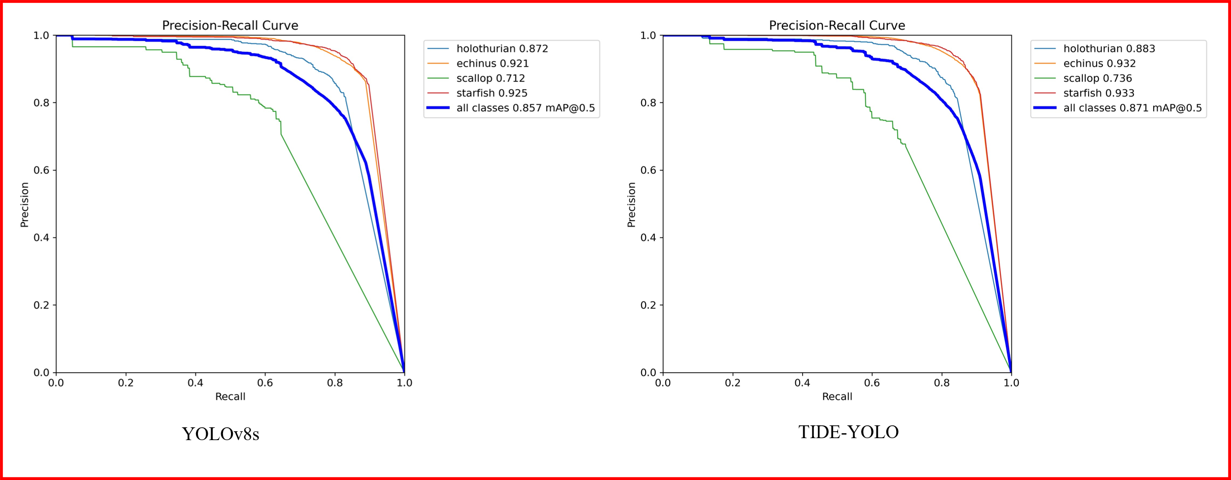
(a)
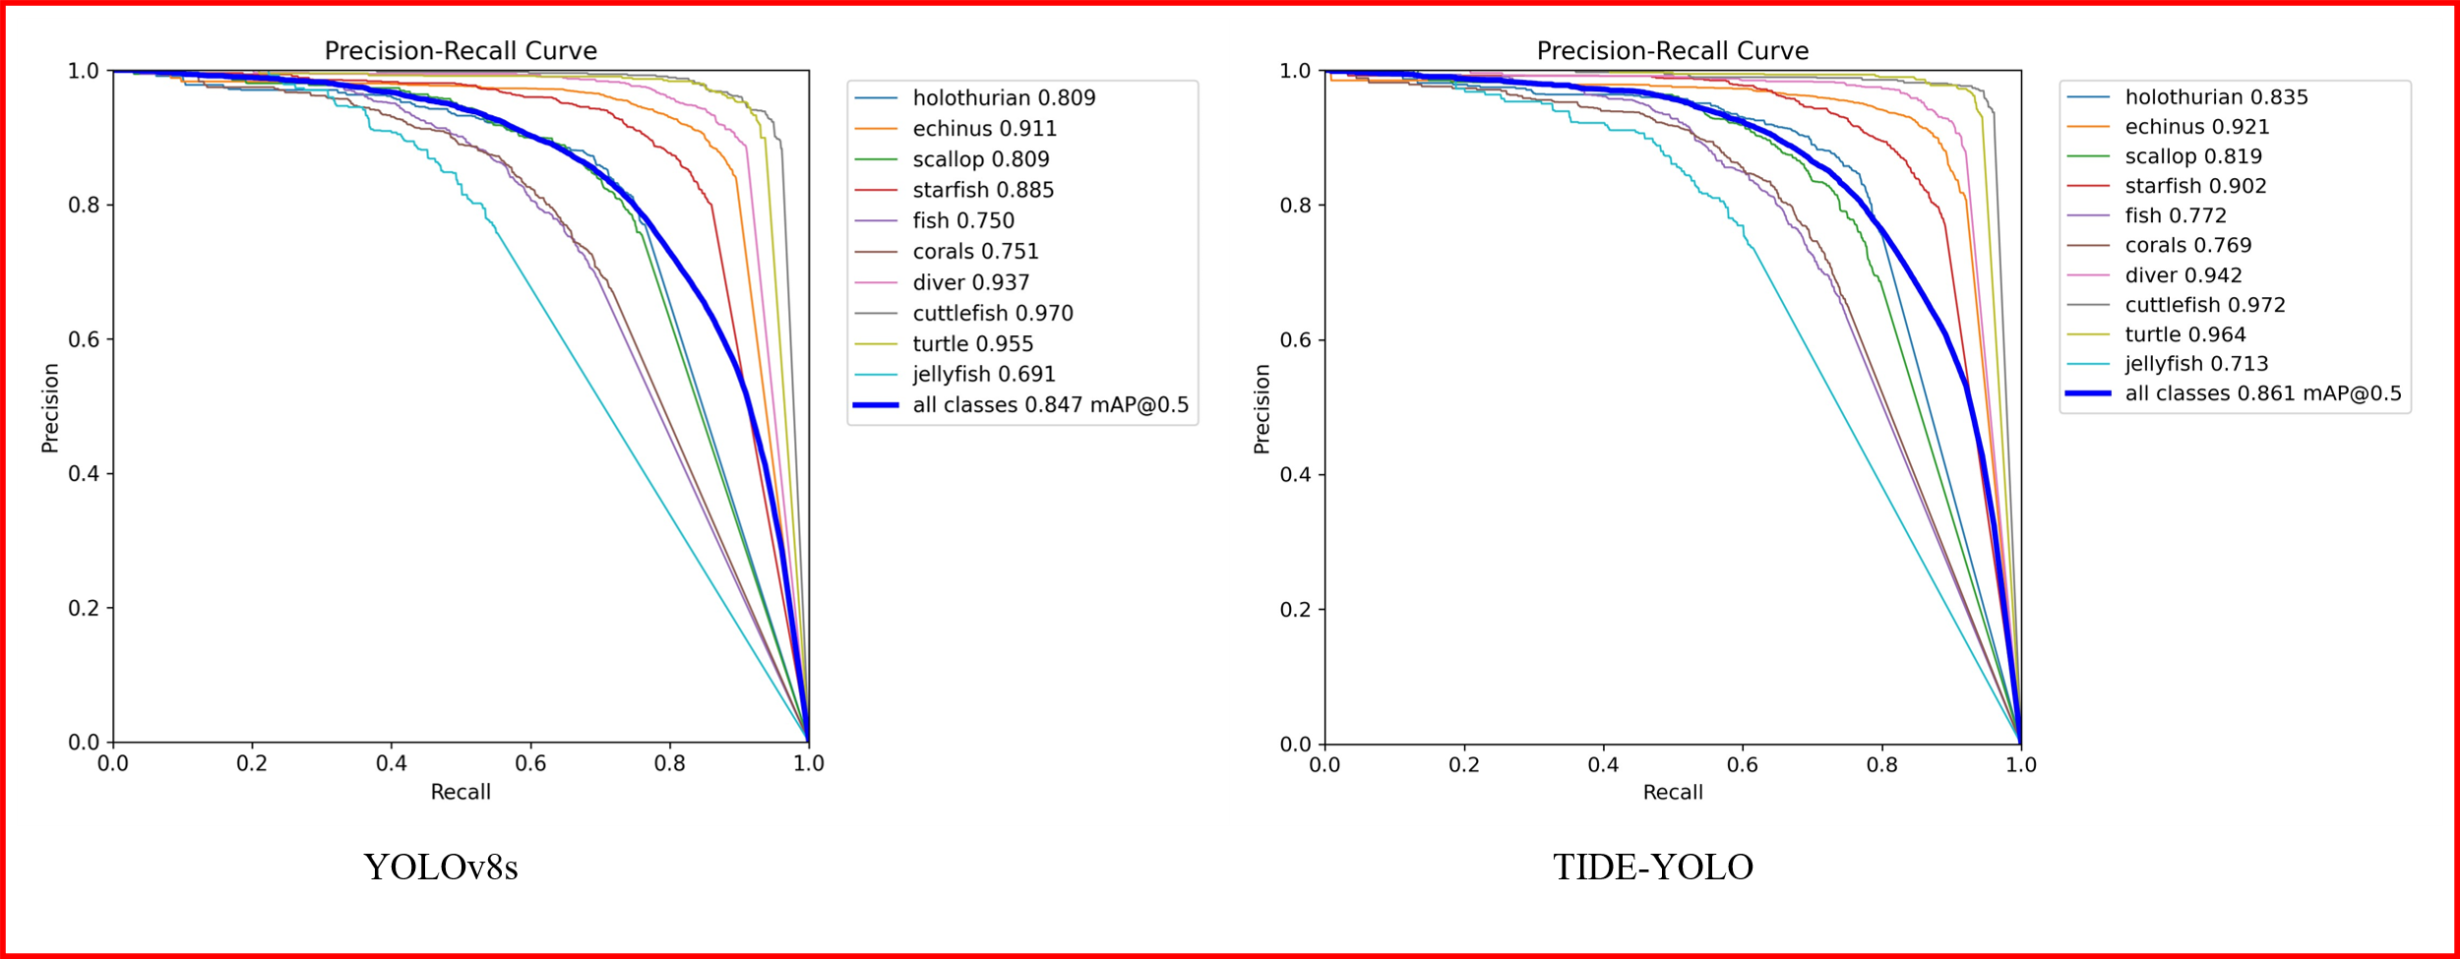
(b)
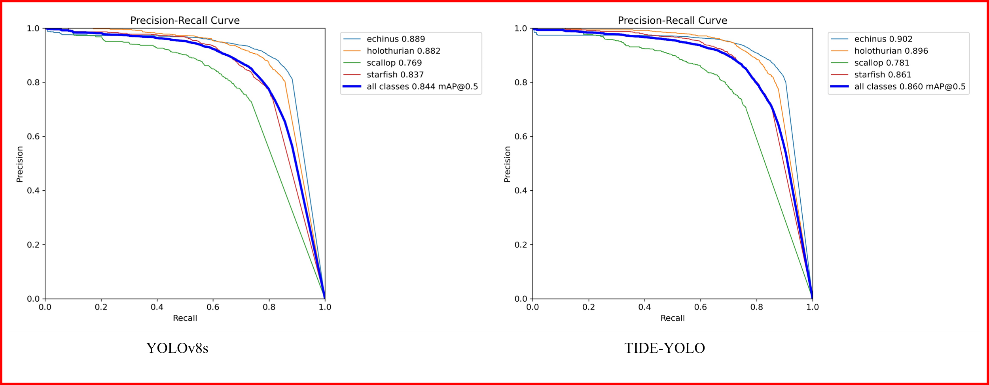
(c)
Fig. 1 A comparative analysis of the PR curves for YOLOv8s and TRIDENT-YOLO on (a)DUO dataset, (b) RUOD dataset, and (C) UTDAC2020 dataset
Online Resource 2
Table 1 Comparison of various methods on the DUO dataset
Model | AP (%) |  |  |  | mAP@0.5 | mAP@.5:.95 | GLOPS | Params  (M) | MS
Model | Holothurian | Echinus | Scallop | Starfish
Faster-RCNN | 55.5 | 62.4 | 38.7 | 62.5 | 75.9 | 39.3 | 63.2 | 41.14 | /
RetinaNet | 54.4 | 56.6 | 27.8 | 58.3 | 70.3 | 34.4 | 52.62 | 36.17 | /
RT-DETR(Res50) | 86.2 | 90.3 | 63.5 | 91.0 | 82.8 | 60.9 | 85.1 | 65.9 | /
YOLOv5s | 87.0 | 92.4 | 66.2 | 93.3 | 84.7 | 66.6 | 23.9 | 9.1 | 18.5
YOLOv5m | 88.7 | 92.9 | 69.4 | 93.7 | 86.2 | 68.9 | 64.5 | 25.0 | 50.5
YOLOv7 | 66.3 | 73.7 | 50.8 | 74.5 | 85.8 | 63.1 | 103.2 | 34.8 | 129.7
YOLOv8s | 87.2 | 92.1 | 71.2 | 92.5 | 85.7 | 67.6 | 28.7 | 11.1 | 22.5
YOLOv8m | 88.4 | 92.9 | 69.5 | 93.8 | 86.2 | 69.6 | 78.7 | 25.8 | 52.0
YOLOv10s | 86.7 | 93.2 | 67.9 | 93.5 | 85.3 | 67.5 | 24.8 | 8.06 | 16.5
YOLOv11s | 88.7 | 92.8 | 68.9 | 93.1 | 86.1 | 68.6 | 21.7 | 9.4 | 18.7
YOLOv7-CHS [1] | / | / | / | / | 84.1 | / | 40.3 | 31.98 | /
RHS-YOLOv8s [2] | / | / | / | / | 87.1 | 69.0 | 31.8 | / | /
RHS-YOLOv8m [2] | / | / | / | / | 87.9 | 70.6 | 76.1 | / | /
YOLO-GE [3] | / | / | / | / | 86.7 | 70.3 | / | / | /
Dynamic YOLO [4] | / | / | / | / | 86.7 | 68.6 | 12.51 | 8.21 | /
Boosting RCNN [5] | / | / | / | / | 85.5 | / | 168.1 | 48.11 | /
Mamba-YOLO-B [6] | 87.3 | 92.7 | 67.4 | 93.5 | 85.2 | 67.0 | 49.6 | 41.9 | /
UWNet [6] | 89.3 | 93.5 | 71.0 | 94.4 | 87.1 | 69.5 | 21.1 | 13.5 | /
Aqua-DETR [7] | 67.3 | 74.5 | 58.3 | 75.4 | 87.6 | / | 78.33 | 50.36 | /
Reference [8] | 55.9 | 61.6 | 41.4 | 65.4 | / | / | / | / | /
Ours (TIDE-YOLO) | 88.3 | 93.2 | 73.6 | 93.3 | 87.1 | 69.6 | 20.7 | 6.4 | 13.4

Online Resource 3
Table 2 Results comparison of various methods on the RUOD dataset
Model | P | R | mAP@0.5 | mAP@.5:.95 | GFLOPs | Params
YOLOv3-tiny | 83.8 | 72.2 | 80.0 | 52.1 | 18.9 | 12.7
YOLOv5s | 85.0 | 77.6 | 84.2 | 59.4 | 23.8 | 9.1
YOLOv6s | 84.1 | 77. | 83.2 | 59.2 | 44.2 | 16.3
YOLOv7-tiny | 85.2 | 80.3 | 80.7 | 56.3 | 13.2 | 6.5
YOLOv8s | 84.5 | 78.4 | 84.7 | 60.6 | 28.7 | 11.1
YOLOv8m | 86.1 | 79.1 | 85.6 | 61.9 | 79.1 | 25.8
YOLOv9s | 85.2 | 78.2 | 84.7 | 61.2 | 27.4 | 7.2
YOLOv10s | 84.3 | 77.9 | 84.8 | 61.3 | 24.8 | 8.06
RHS-YOLOv8s[2] | 85.2 | 79.1 | 86.2 | / | 31.8 | /
RDL-YOLO[9] | / | / | 85.10 | / | 6.9 | /
YOLO-TADR[10] | 95.33 | 55.64 | 72.1 | / | 23.9 | 40.9
Reference[8] | / | / | 82.6 | 54.7 | / | /
Bi2F-YOLO[11] | / | / | 86.8 | / | 98.9 | 32.31
YOLOv5Plus[12] | / | / | 80.5 | / | 8.4 | 28.9
YOLOv6Plus[12] | / | / | 79.1 | / | 12.9 | 46.7
YOLOv8Plus[12] | / | / | 80.9 | / | 8.9 | 31.4
UODN[13] | / | / | 86.3 | / | 43.9 | 19.0
Ours (TRIDENT-YOLO) | 85.7 | 79.2 | 86.1 | 62.0 | 20.6 | 6.4

Online Resource 4 Fig 2
To further demonstrate the model's effectiveness, underwater images were randomly selected from the DUO, RUOD, and UTDAC2020 datasets and tested across various scenarios. Fig. 2, Fig. 3, and Fig. 4 show the visualization outcomes for YOLOv8s, YOLOv10s and TIDE-YOLO.
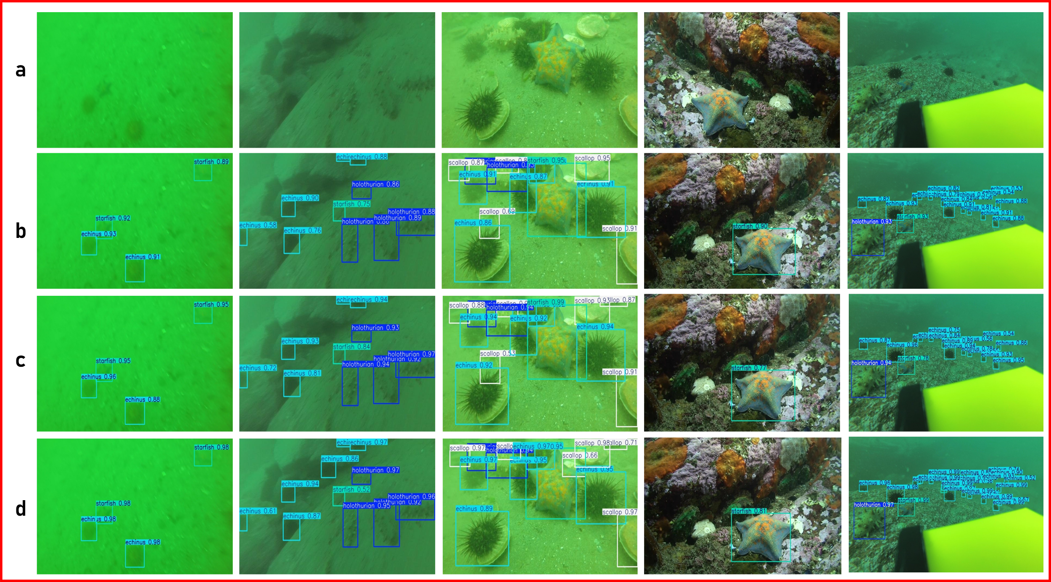
In some cases, the YOLOv8s model accurately identified all targets; however, it also had cases of false positive detections and inaccuracies in bounding box predictions, including overlaps. The TIDE-YOLO model showed improved detection accuracy, fewer omissions, and misdetections in various environments, as well as greater precision in bounding box predictions. The detection results further emphasize the enhanced efficiency of the TIDE-YOLO model.
Fig. 2 Detection performance comparison on the DUO dataset: (a) input image; (b) YOLOv8s; (c) YOLOv10s; (d) TRIDENT-YOLO

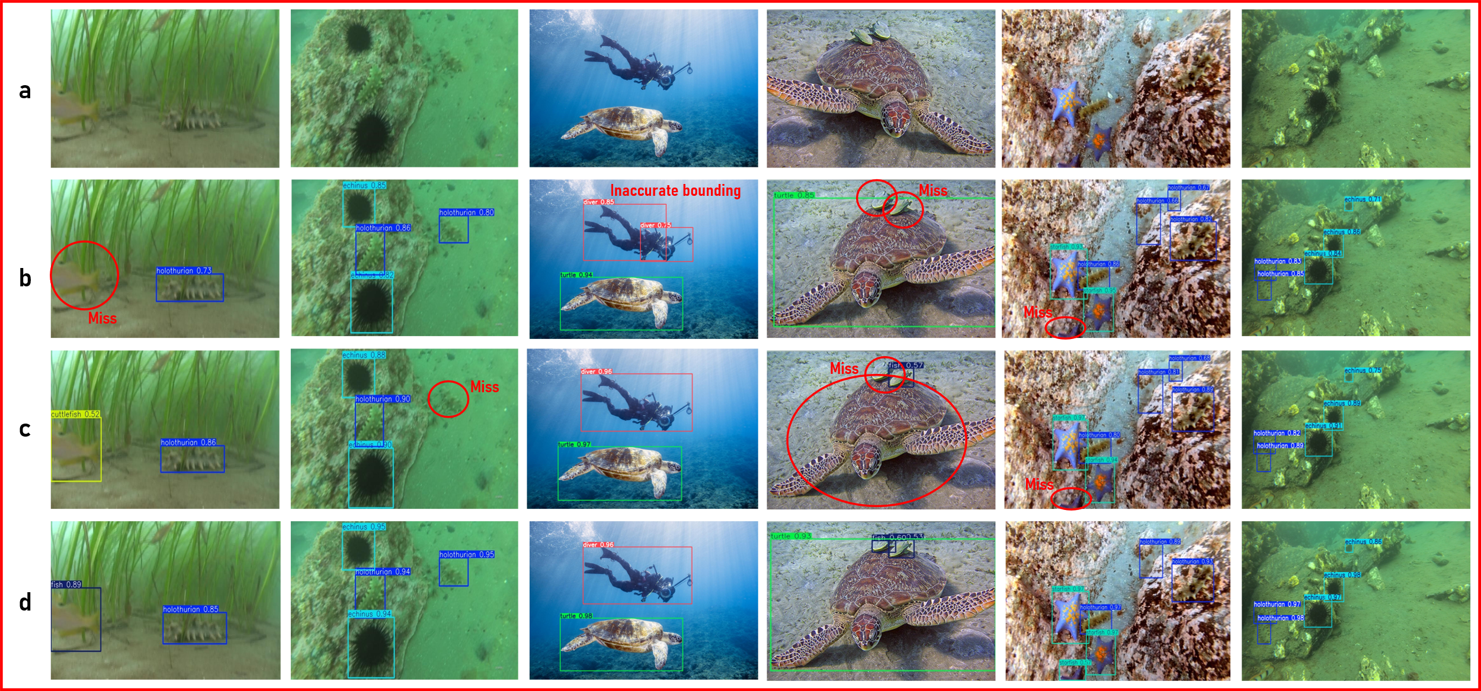
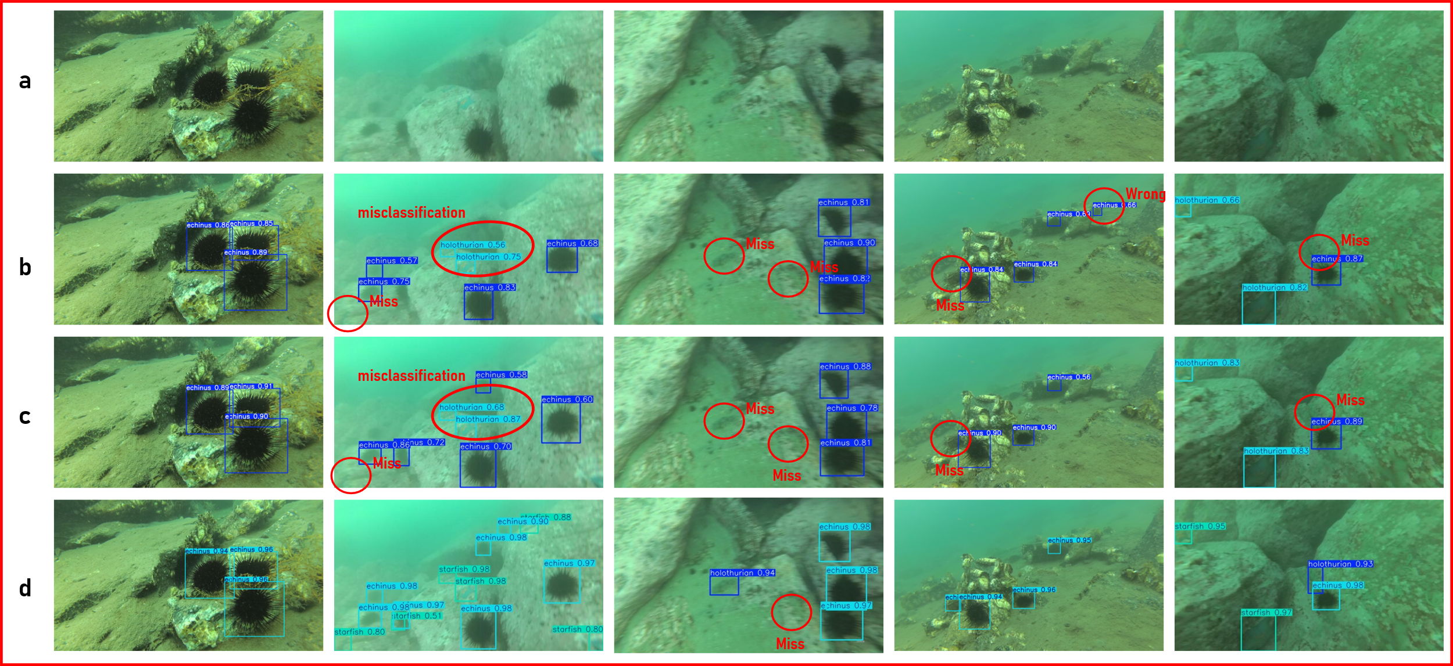
Fig. 3 Detection performance comparison on the RUOD dataset: (a) input image; (b) YOLOv8s; (c) YOLOv10s; (d) TRIDENT-YOLO
Fig. 4 Detection performance comparison on the UTDAC2020 dataset: (a) input image; (b) YOLOv8s; (c) YOLOv10s; (d) TRIDENT-YOLO
REFERENCE
1. Zhao L, Yun Q, Yuan F, Ren X, Jin J, Zhu X. YOLOv7-CHS: An Emerging Model for Underwater Object Detection. Journal of Marine Science and Engineering . 2023 Oct 9;11(10):1949.
2. Wei Y, Tao J, Wu W, Yuan D, Hou S. RHS-YOLOv8: A Lightweight Underwater Small Object Detection Algorithm Based on Improved YOLOv8. Applied Sciences . 2025 Mar 30;15(7):3778.
3. Li Q, Shi H. YOLO-GE: An Attention Fusion Enhanced Underwater Object Detection Algorithm. J Mar Sci Eng. 2024 Oct 21;12(10):1885.
4. Chen J, Er MJ. Dynamic YOLO for small underwater object detection. Artif Intell Rev. 2024 Jul 1;57(7):1–23.
5. Song P, Li P, Dai L, Wang T, Chen Z. Boosting R-CNN: Reweighting R-CNN samples by RPN’s error for underwater object detection. Neurocomputing. 2023 Apr 14;530:150–64.
6. Zhuang Y, Liu J, Zhao H, Ma L, Fang Z, Li L, et al. A deep learning framework based on structured space model for detecting small objects in complex underwater environments. Communications Engineering. 2025 Dec 1;4(1):1–11.
7. Xiao Z, Li Z, Li H, Li M, Liu X, Kong Y. Multi-Scale Feature Fusion Enhancement for Underwater Object Detection. Sensors . 2024 Nov 11;24(22):7201.
8. Lin X, Huang X, Wang L. Underwater object detection method based on learnable query recall mechanism and lightweight adapter. PLoS One. 2024 Feb 1;19(2):e0298739.
9. Song D, Huo H. Lightweight Underwater Target Detection Algorithm Based on YOLOv8n. Electronics . 2025 Apr 28;14(9):1810.
10. Zhou Z, Hu Y, Yang X, Yang J. YOLO-based marine organism detection using two-terminal attention mechanism and difficult-sample resampling. Appl Soft Comput. 2024 Mar 1;153:111291.
11. Liu X, Zhao K, Liu C, Chen L. Bi2F-YOLO: a novel framework for underwater object detection based on YOLOv7. Intelligent Marine Technology and Systems . 2025 Mar 26;3(1):1–12.
12. Li X, Zhao Y, Su H, Wang Y, Chen G. Efficient underwater object detection based on feature enhancement and attention detection head. Sci Rep. 2025 Dec 1;15(1):5973.
13. Zhou H, Kong M, Yuan H, Pan Y, Wang X, Chen R, et al. Real-time underwater object detection technology for complex underwater environments based on deep learning. Ecol Inform. 2024 Sep 1;82:102680.

