Pulmonary B lymphocytes ameliorate Alzheimer's disease-like neuropathology

Supplementary figures and supplementary figure Legends
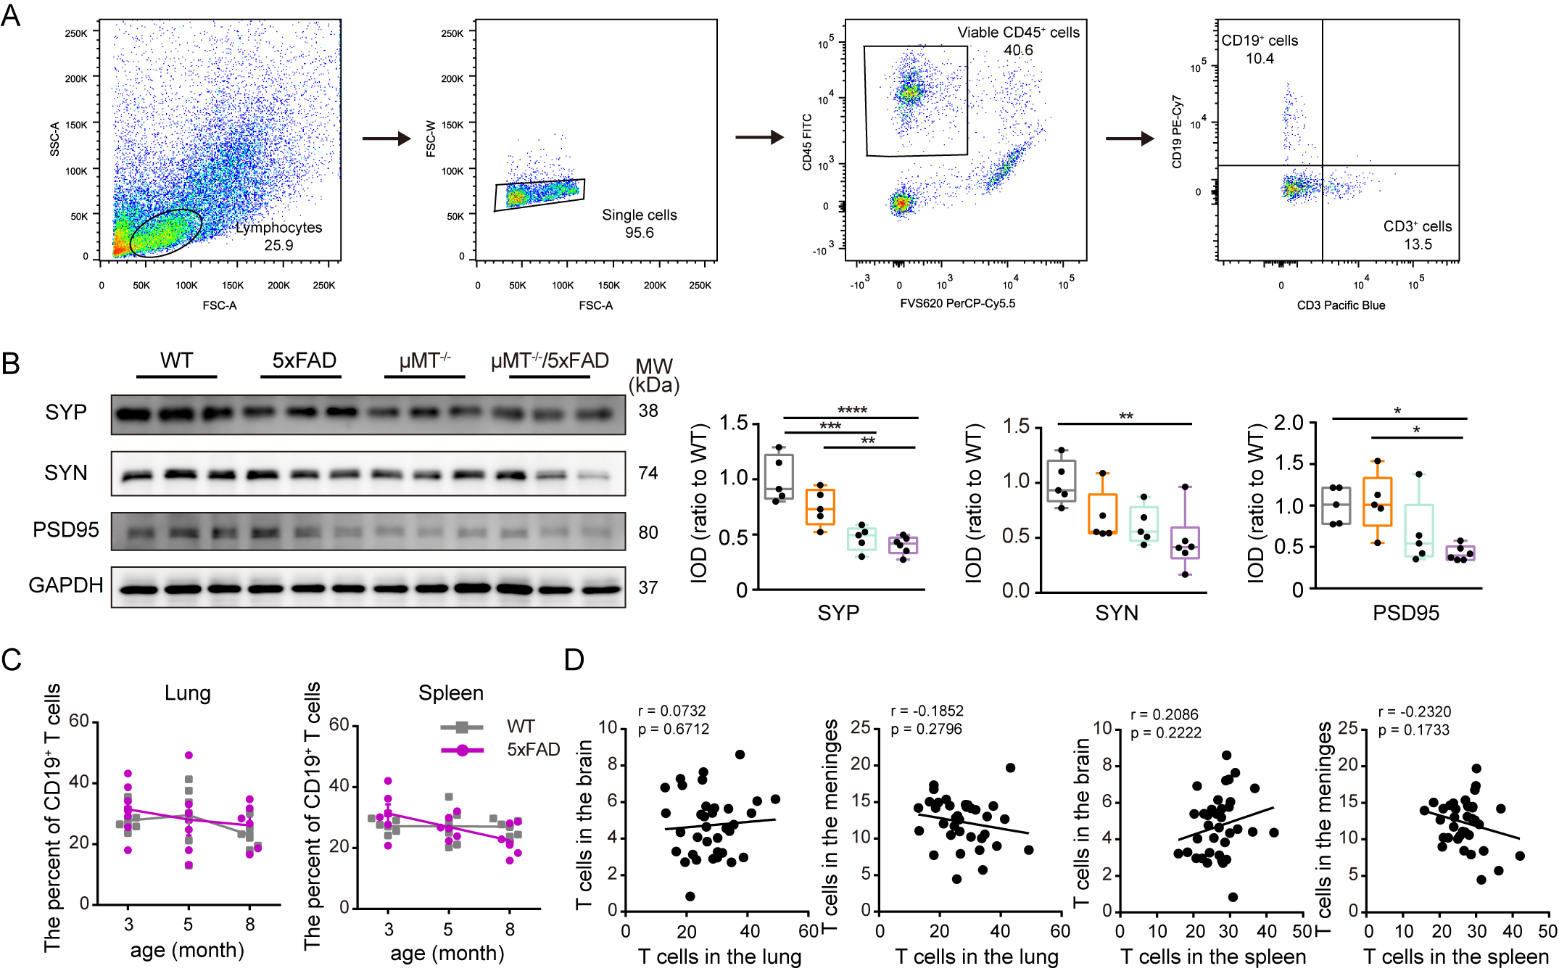
Supplementary Fig. 1. B lymphocytes deletion resulted in synapse impairment of 5xFAD mice at 3 months old. (A) Gating strategy used for determine CD19⁺ and CD3⁺ cells. (B) Representative bands and quantification of SYP, SYN and PSD95 in the frontal cortex. n = 5-6 per group. (C) Percentage of T lymphocytes in the lungs and spleen of 3-, 5- and 8-month-old 5xFAD mice. n = 6 per group. (D) Correlation analysis of T lymphocytes between the lungs and brain, and meninges, respectively, and between the spleens and brain, and meninges, respectively. *P < 0.05, **P < 0.01, ***P < 0.001, ****P < 0.0001. Data in B are analyzed by the Two-way ANOVA with Bonferroni’s post hoc test. Data in C are analyzed by repeated-measures ANOVA with Bonferroni’s post hoc test, correlation analysis in D by Pearson Correlation Coefficient.
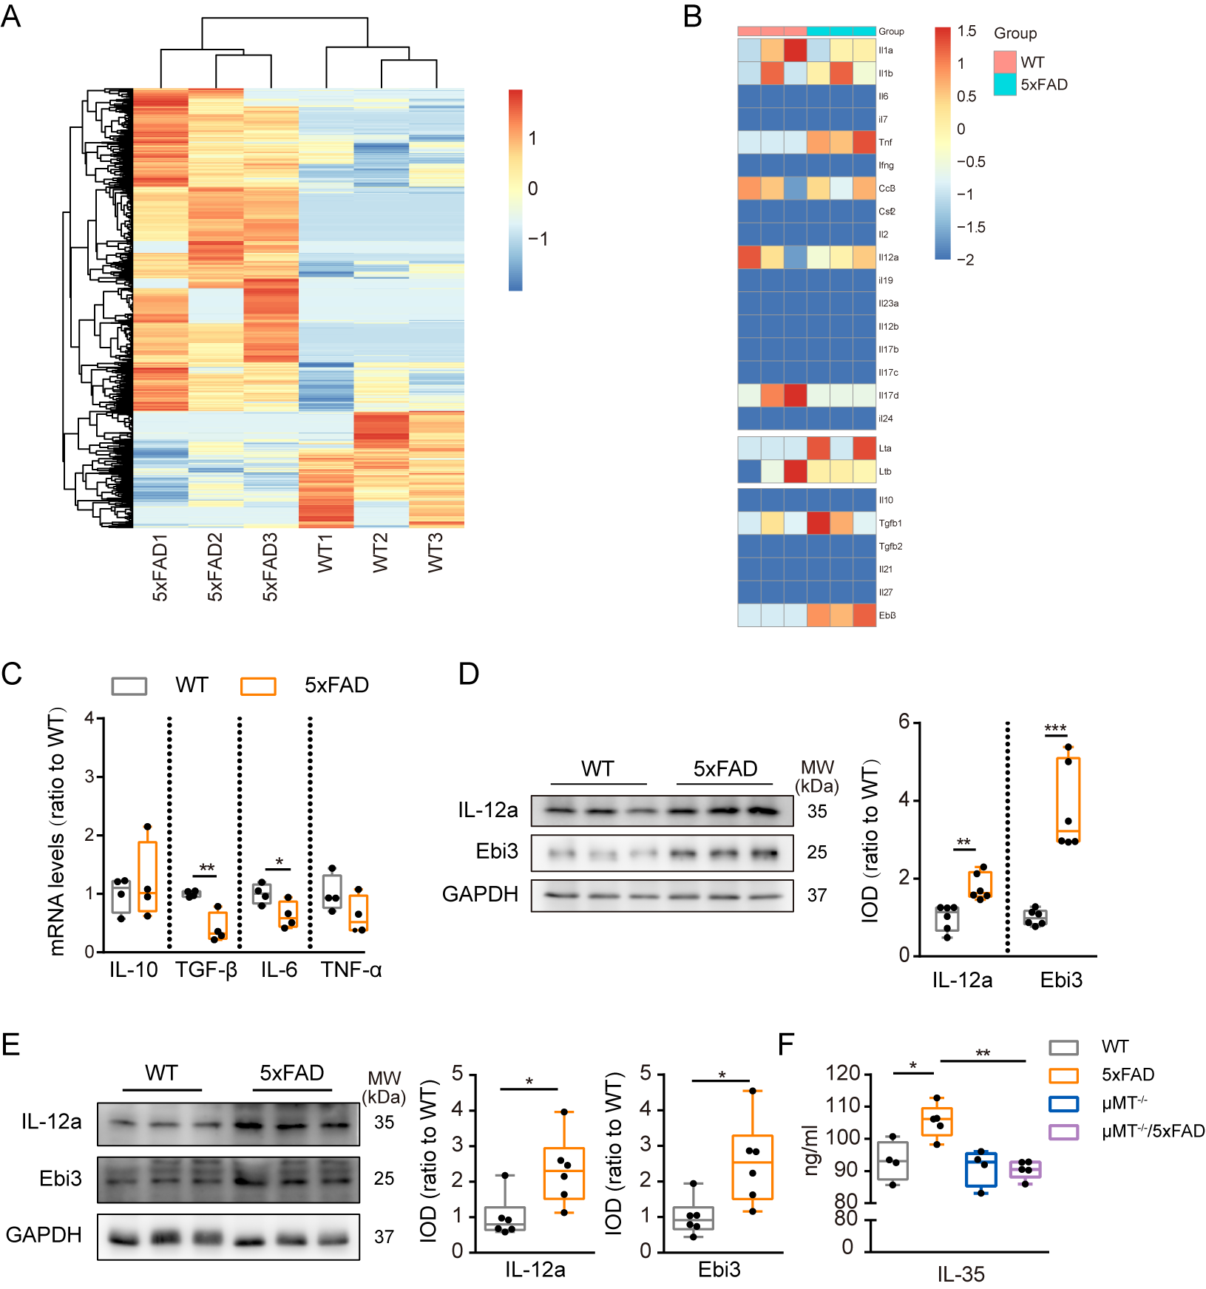
Supplementary Fig. 2. IL-35 was upregulated in 3-month-old 5xFAD mice. (A) Heat map of different up- and down-regulated genes in the pulmonary B cells of 3-month-old WT and 5xFAD mice. The color scale is the r-log-transformed values across samples. n = 3 per group. (B) Heat map showing relative expression level of genes encoding B cells-related cytokines. Color scale bar values represent standardized log-transformed values across samples. n = 3 per group. (C) QRT-PCR for IL-10, TGF-β, IL-6 and TNF-α of B cells in the lungs. n = 4 per group. (D) Western blot and quantification for IL-12a and Ebi3 in the lungs of 3-month-old mice. (F) Western blot and quantification for IL-12a and Ebi3 in the cortex of 3-month-old mice. (F) ELISA for IL-35 in the frontal cortex of WT, 5xFAD, μMT^{-/-} and μMT^{-/-}/5xFAD mice. n = 4-5 per group. Data represents as mean ± s.e.m. *P < 0.05, **P < 0.01, ***P < 0.001, ****P < 0.0001. Data in C-E were analyzed by Student’s t-test. Data in F were analyzed by the Two-way ANOVA with Bonferroni’s post hoc test.

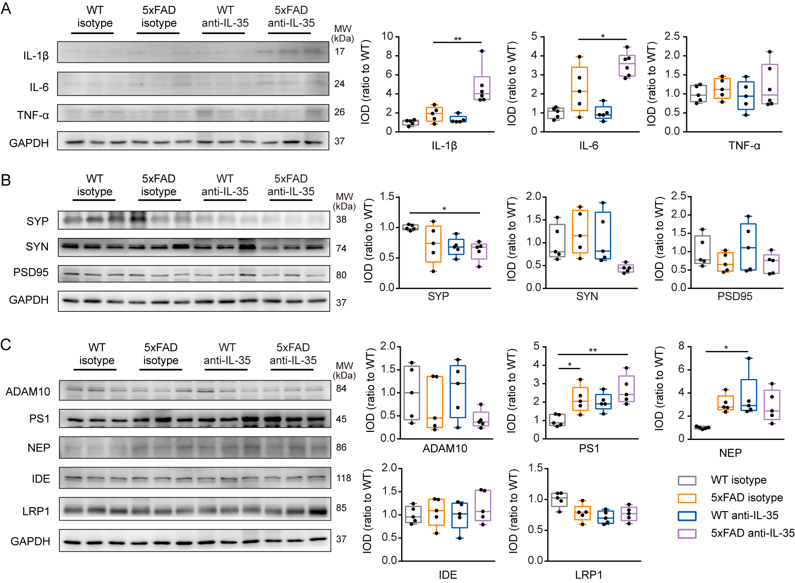
Supplementary Fig. 3. Synapses and Aβ metabolism related proteins in the frontal cortex of 3-month-old 5xFAD mice after neutralization of IL-35. Representative bands and quantification of western blot for interleukin-1β (IL-1β), interleukin-6 (IL-6) and tumor necrosis factor-α (TNF-α) (A), synaptophysin (SYP), synapsin (SYN) and postsynaptic density 95 (PSD95) (B), A disintegrin and metalloproteinase domain-containing protein 10 (ADAM10) and presenilin-1 (PS1), neprilysin (NEP), insulin-degrading enzyme (IDE) and low-density lipoprotein receptor-related protein 1 (LRP1) (C) in the frontal cortex of 5xFAD mice after neutralization of IL-35, respectively. n = 5 per group. *P < 0.05, **P < 0.01, ***P < 0.001, ****P < 0.0001. Data analyzed by the Two-way ANOVA with Bonferroni’s post hoc test.

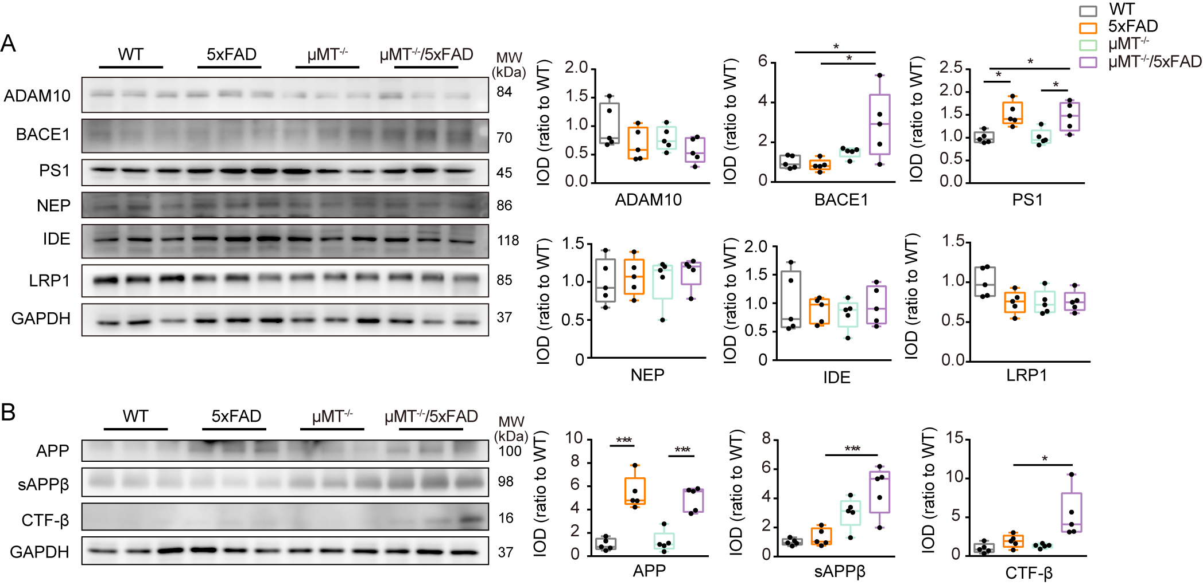
Supplementary Fig. 4. Expression levels of Aβ production and degradation related proteins in the frontal cortex of 3-month-old 5xFAD mice and μMT^{-/-}/5xFAD mice. Representative bands and quantification of Western blot for A disintegrin and metalloproteinase domain-containing protein 10 (ADAM10), β-site APP-cleaving enzyme 1 (BACE1), presenilin-1 (PS1), neprilysin (NEP), insulin-degrading enzyme (IDE) and low-density lipoprotein receptor-related protein 1 (LRP1) (A), and Aβ precursor protein (APP), soluble amyloid precursor protein β (sAPPβ), and C-terminal fragment β (CTF-β) (B) in the frontal cortex of WT, 5xFAD, μMT^{-/-} and μMT^{-/-}/5xFAD mice. n = 5 per group. *P < 0.05, **P < 0.01, ***P < 0.001, ****P < 0.0001. Data analyzed by ANOVA with Bonferroni’s post hoc test.

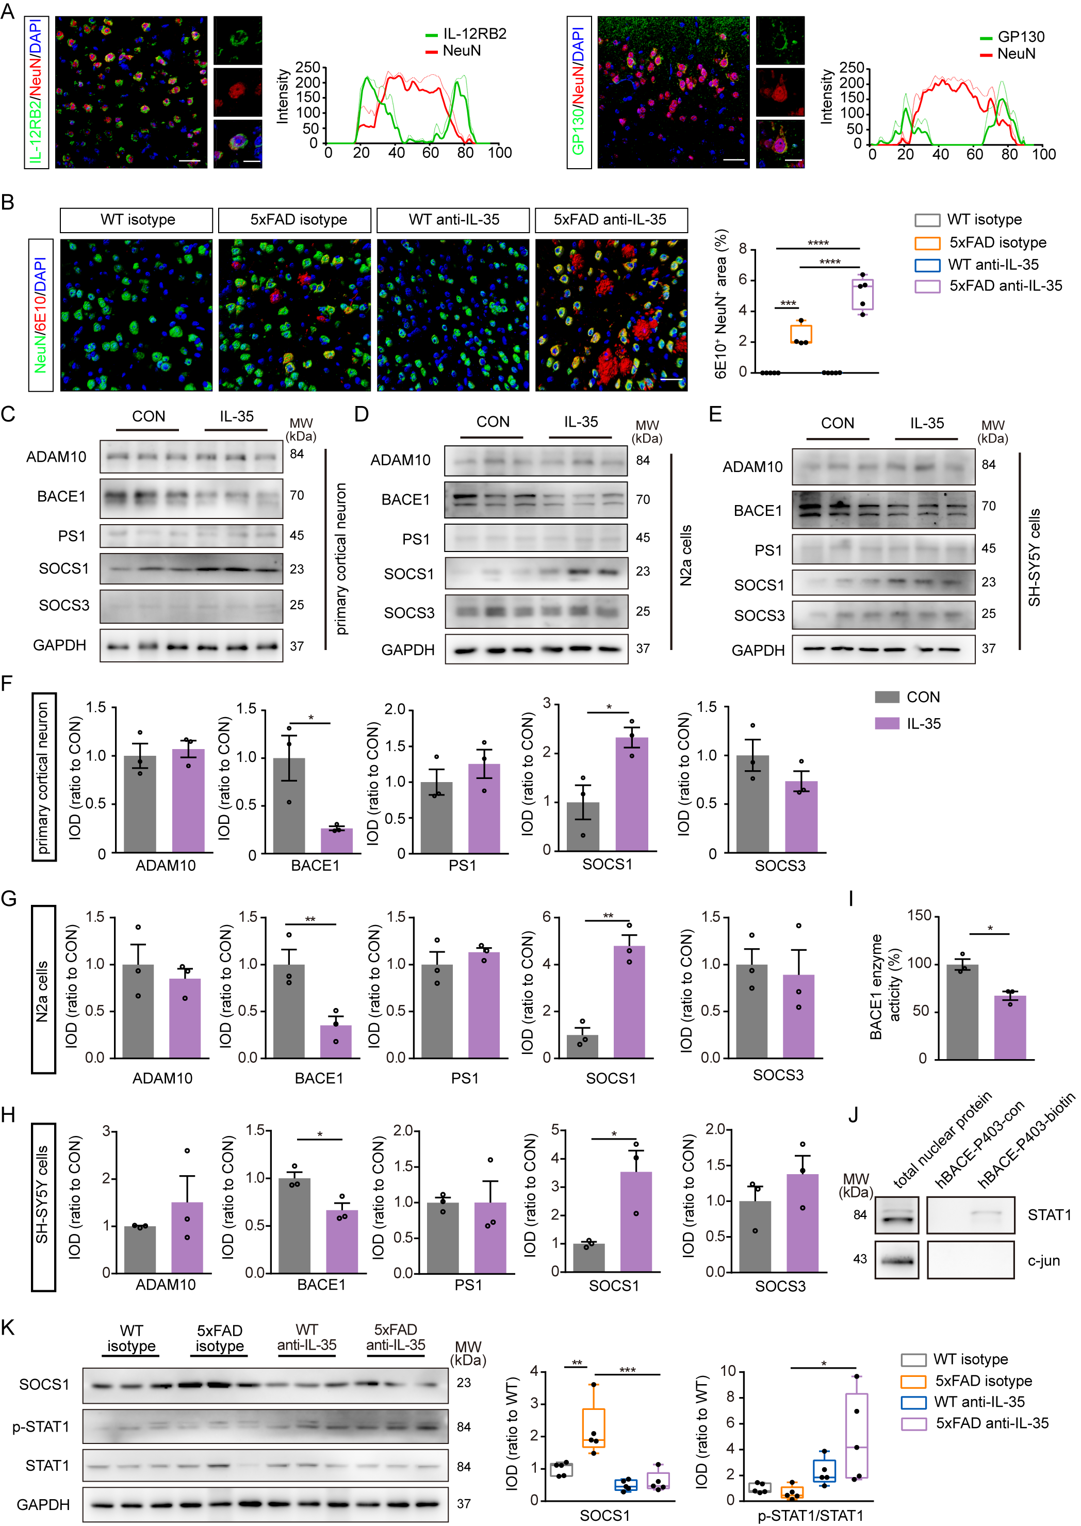
Supplementary Fig. 5. IL-35 inhibits BACE1 expression by SOCS1 pathway. (A) Representative images of IL-12RB2 or GP130 with NeuN, respectively, and analysis of their co-localization in the frontal cortex of 3-month-old mice. Scale bar = 30 μm. (B) Representative images and quantification of NeuN and 6E10 in the frontal cortex of 3-month-old mice after IL-35 neutralization. n = 4-5 per group. Scale bar = 30 μm. (C and F) Representative bands and quantification of Western blot for ADAM10, BACE1, PS1, SOCS1 and SOCS3 in the mouse primary neuron after IL-35 treatment. (D and G) Representative bands and quantification of western blot for ADAM10, BACE1, PS1, SOCS1 and SOCS3 in the N2a cell line after IL-35 treatment. (E and H) Representative bands and quantification of Western blot for ADAM10, BACE1, PS1, SOCS1 and SOCS3 in the SH-SY5Y cell line after IL-35 treatment. n = 3 per group. (I) Activity of BACE1 enzyme in primary cortical neurons after IL-35 treatment. n = 3 per group. (J) Representative bands of Western blot for STAT1 and c-jun after hBACE1-P403 pulldown in SH-SY5Y cells. (K) Representative bands and quantification of Western blot for SOCS1, p-STAT1 and STAT1 in 3-month-old mice after IL-35 neutralization. n = 5 per group. *P < 0.05, **P < 0.01, ***P < 0.001, ****P < 0.0001. Data in B, K by the Two-way ANVOA with Bonferroni’s post hoc test, and others by Student’s t-test.

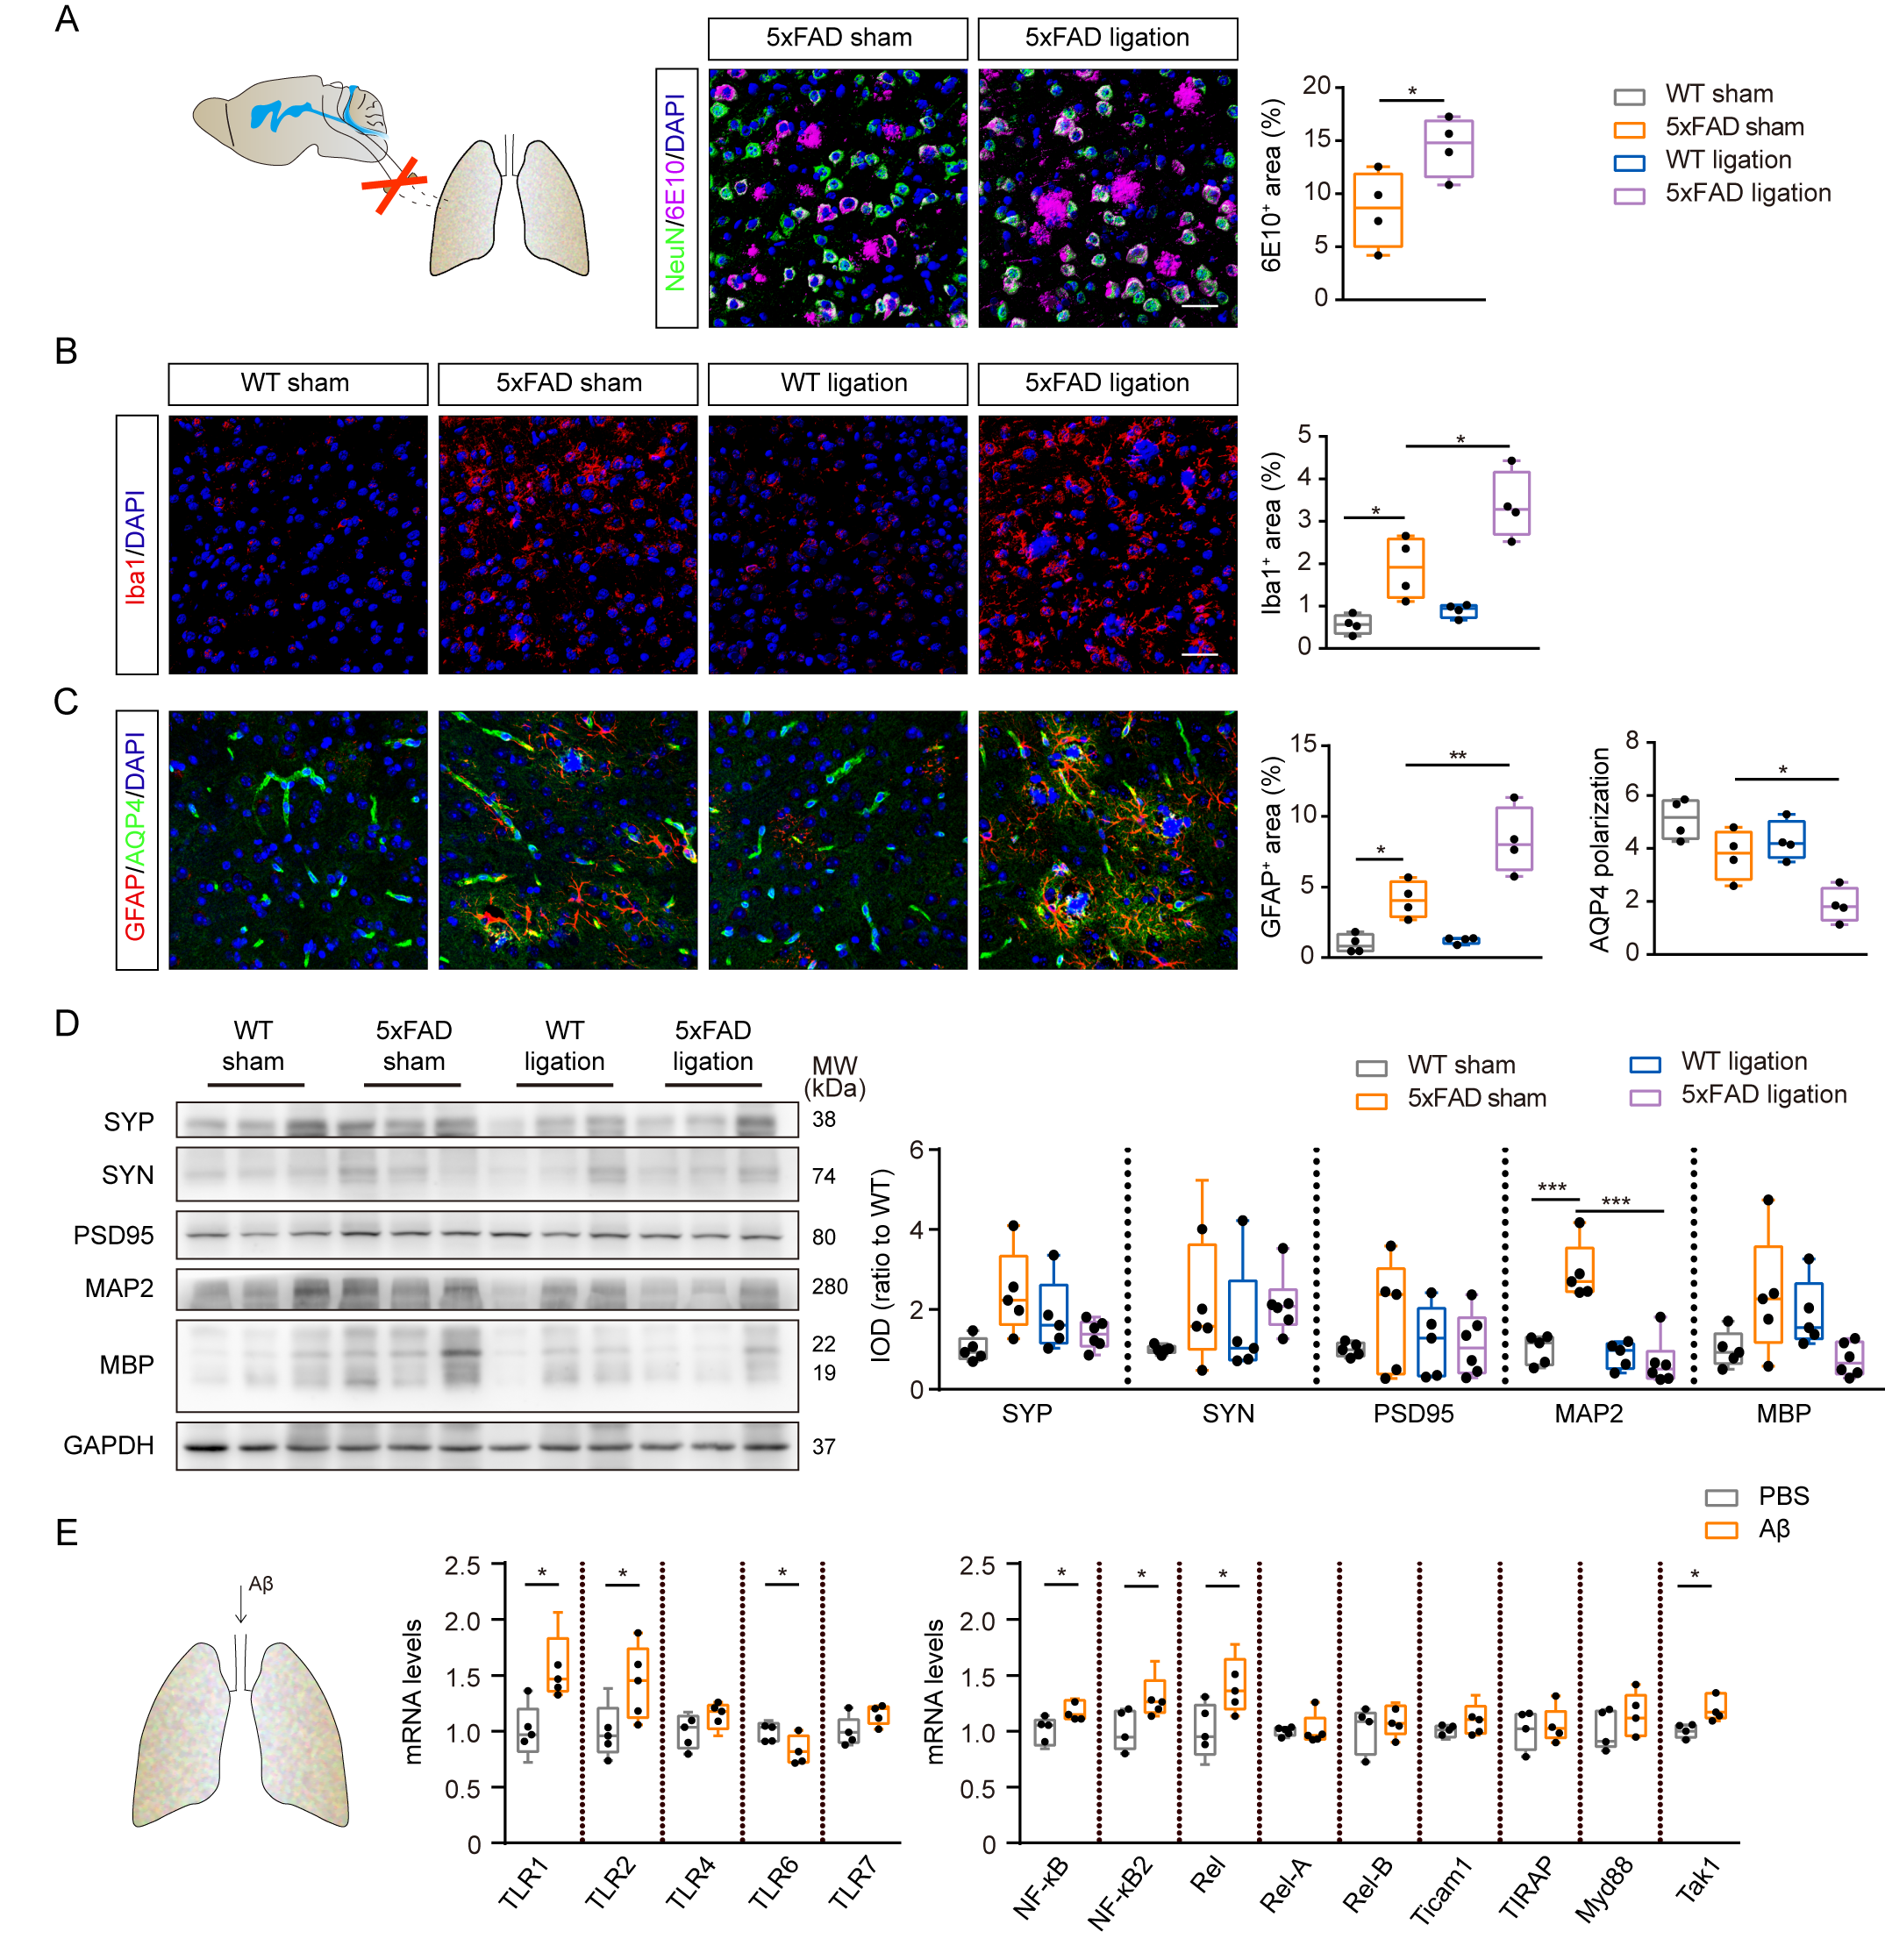
Supplementary Fig. 6. Aβ induced up-regulation of IL-35 in pulmonary B cells. (A) Representative images and quantification of NeuN and 6E10 in the frontal cortex of 3-month-old mice after dcLN ligation. n = 5 per group. Scale bar = 30 μm. (B) Representative images and quantification of iba1⁺ microglia in the frontal cortex of 3-month-old mice after dcLN ligation. n = 5 per group. Scale bar = 30 μm. (C) Representative images and quantification of GFAP⁺ astrocytes and aquaporin-4 polarization in the frontal cortex of 3-month-old mice after dcLN ligation. n = 5 per group. Polarization index equals peak vascular end foot fluorescence divided by 10 µm baseline. Scale bar = 30 μm. (D) Representative bands and quantification of western blot for SYP, SYN, PSD95, MAP2 and MBP in the lungs of WT and 5xFAD mice after dcLN ligation. n = 5-6 per group. (E) Q-PCR for toll-like receptors and NF-κB pathways relative genes in the pulmonary B cells after Aβ stimulation in 3-month-old WT mice. n = 5 per group. *P < 0.05, **P < 0.01, ***P < 0.001, ****P < 0.0001. Data in A and E by Student’s t-test, and in B-D by the Two-way ANOVA with Bonferroni’s post hoc test.

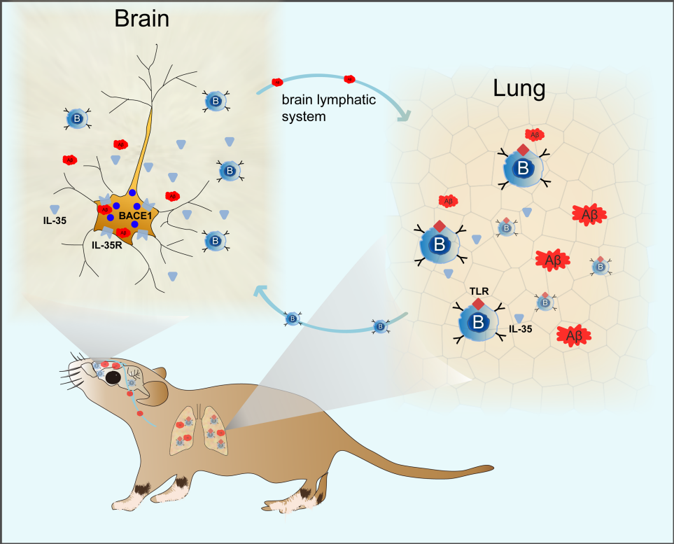
Supplementary Fig. 7. Involvement of the “lung-brain” axis in the Aβ related pathology. Brain derived Aβ are transported to the lungs, subsequently activating IL-35-produced B cells. These B cells migrate to the brain and down-regulate neuronal BACE1 expression via IL-35/SOCS1/STAT1 pathway, consequently inhibiting Aβ production.

Supplementary Table 1: Proteins showing significant interaction with the hBACE-P403
Gene name | Unique peptides | iBAQ | Gene name | Unique peptides | iBAQ
HNRNPU | 22 | 1440900 | DHX30 | 3 | 4401
SF3B1 | 22 | 173920 | EIF3B | 3 | 10509
MYH9 | 21 | 64441 | FAM120A | 3 | 14042
TOP2A | 14 | 231020 | FUS | 3 | 48259
SFPQ | 18 | 5260700 | GLG1 | 3 | 11998
DHX9 | 16 | 163150 | HNRNPC | 3 | 86476
TOP2B | 9 | 31314 | KIAA1429 | 3 | 17263
HNRNPM | 14 | 132660 | LIMA1 | 3 | 21406
RBM14 | 14 | 382730 | LMNA | 2 | 21422
RBM25 | 14 | 216930 | LMNB1 | 2 | 24441
SMARCA5 | 14 | 79395 | MYO1C | 3 | 10279
MATR3 | 13 | 240720 | NOLC1 | 3 | 93701
NONO | 11 | 839940 | NOP58 | 3 | 12966
RRBP1 | 13 | 198650 | NUMA1 | 3 | 44439
DDX21 | 12 | 398670 | PPP1R9B | 3 | 19248
HNRNPA2B1 | 12 | 871940 | PRPF6 | 3 | 1781.6
DDX17 | 7 | 162950 | PRPF8 | 3 | 3498.1
EFTUD2 | 11 | 101940 | RBM15 | 3 | 11797
KTN1 | 11 | 64793 | RBM27 | 2 | 13316
PNN | 11 | 179350 | RPL11 | 3 | 52910
PRPF40A | 11 | 301380 | RPL12 | 3 | 93175
SF3A1 | 11 | 196260 | RPL13a | 3 | 722670
SUPT16H | 11 | 100020 | RPL17 | 3 | 144900
DDX5 | 6 | 57185 | RPL22L1 | 3 | 98082
HNRNPK | 10 | 284980 | RPL34 | 3 | 458130
YBX1 | 7 | 1526400 | RPL5 | 3 | 79607
RPL7 | 9 | 928760 | RPS11 | 3 | 206930
CAPRIN1 | 8 | 553140 | RPS17 | 3 | 112030
DDX23 | 8 | 25919 | RPS25 | 3 | 546080
DDX46 | 8 | 38225 | RPS5 | 3 | 108230
HDLBP | 8 | 24703 | RPSA | 3 | 51340
HNRNPUL2 | 8 | 62974 | SART1 | 3 | 10578
RPL4 | 8 | 153480 | SEC63 | 3 | 20060
SF3B3 | 8 | 44688 | SLTM | 3 | 29685
STT3A | 8 | 193350 | SNRNP200 | 3 | 3760.4
THRAP3 | 7 | 44340 | SNRNP70 | 3 | 39146
UBTF | 8 | 35968 | SNRPN | 3 | 71955
ATP5B | 7 | 214160 | SRSF11 | 3 | 98209
DDX3X | 6 | 51039 | SRSF7 | 3 | 302470
HNRNPA1 | 7 | 325220 | TUBB | 3 | 43709
NCL | 7 | 547660 | UBAP2L | 3 | 13128
RBMX | 7 | 133980 | ZC3H18 | 3 | 25420
RPS4X | 7 | 107760 | ABCF2 | 2 | 6152.9
U2SURP | 7 | 58703 | ATAD3B | 2 | 10009
G3BP1 | 5 | 65255 | ATP2A2 | 2 | 3366.5
NOP2 | 6 | 177830 | BAZ1A | 2 | 2643.6
RPL32 | 6 | 341510 | CANX | 2 | 17917
RRP12 | 6 | 16204 | CCDC47 | 2 | 12657
SF3B2 | 6 | 95211 | CCNK | 2 | 21551
SND1 | 6 | 16807 | CHTOP | 2 | 93282
YTHDC1 | 6 | 66235 | COPA | 2 | 243.05
SLC25A5 | 3 | 315500 | CPSF1 | 2 | 2176
ASPH | 5 | 63703 | DHX37 | 2 | 6977.8
G3BP2 | 4 | 85634 | EIF3A | 2 | 0
RPL23A | 5 | 349300 | EIF3C | 2 | 209.09
RPS3A | 5 | 352830 | EWSR1 | 2 | 80264
RPS6 | 5 | 401620 | FBL | 2 | 27732
SEC61A1 | 5 | 107720 | FTSJ3 | 2 | 14603
SPECC1L-ADORA2A | 5 | 14535 | GTPBP4 | 2 | 4765.3
SRSF1 | 5 | 229330 | HNRNPAB | 2 | 41561
SRSF3 | 5 | 394380 | HNRNPL | 2 | 18926
ZFR | 5 | 35564 | HSP90AB1 | 2 | 7776.1
CDK11B | 4 | 14132 | IGF2BP3 | 2 | 11237
CWC22 | 4 | 19849 | ILF3 | 2 | 8526
DDX1 | 4 | 16816 | IMMT | 2 | 6016.2
HP1BP3 | 4 | 33285 | INTS3 | 2 | 4431.8
PHB | 4 | 470890 | IPO7 | 2 | 2085.7
PPP1R12A | 4 | 20478 | LUC7L3 | 2 | 51848
PRPF38B | 4 | 209740 | MPRIP | 2 | 4425.9
HNRNPA3 | 2 | 269270 | MYBBP1A | 2 | 115660
PSPC1 | 4 | 121950 | NEXN | 2 | 53617
RBM6 | 4 | 11619 | NOMO3 | 2 | 10774
RPS16 | 4 | 53319 | NOP14 | 2 | 2941.4
RPS2 | 4 | 153040 | PARP1 | 2 | 1278.9
SMC2 | 4 | 11234 | PAXBP1 | 2 | 11893
SRRM1 | 4 | 63756 | PDS5B | 2 | 1730.7
SRRT | 4 | 32763 | PUF60 | 2 | 19677
SRSF2 | 4 | 2129300 | RALY | 2 | 54821
SSRP1 | 4 | 31480 | RBM28 | 2 | 15855
YBX3 | 2 | 197990 | RBM3 | 2 | 139470
RPL7A | 10 | 1707700 | RPL10A | 2 | 26440
BCLAF1 | 3 | 25726 | RPL18A | 2 | 269240
RPS3 | 11 | 355780 | RPL27 | 2 | 2419000
ACTG1 | 6 | 823690 | RPL27A | 2 | 170230
RPL6 | 6 | 1015500 | RPL31 | 2 | 201180
RPL18 | 5 | 1799000 | RPL36A | 2 | 340300
RPS8 | 6 | 985120 | RPL9 | 2 | 39075
HSPA8 | 3 | 34141 | RPS19 | 2 | 32975
ATP5A1 | 6 | 47159 | RPS20 | 2 | 80242
VIM | 17 | 629400 | RPS27L | 2 | 116180
RPL15 | 8 | 1183400 | RPS7 | 2 | 62870
STAT1 | 10 | 69164 | SAFB | 2 | 20673
RPL3 | 8 | 373790 | SCAF4 | 2 | 3061.4
RPL13 | 5 | 1483700 | SERBP1 | 2 | 24924
HIST1H1E | 10 | 7643800 | SF3A2 | 2 | 55297
H1F0 | 5 | 569210 | SLC25A3 | 2 | 228090
SRSF6 | 3 | 618390 | STT3B | 2 | 3593.2
ACIN1 | 3 | 18395 | TARDBP | 2 | 51865
AEBP1 | 3 | 13788 | TRIM28 | 2 | 22597
ARHGEF2 | 3 | 5777.4 | U2AF1L5 | 2 | 98860
CDC5L | 3 | 11795 | UPF1 | 2 | 7050
CHERP | 3 | 25735 | WDR33 | 2 | 23457

Supplementary Table 2: antibody information
 |  |  |  | Dilution
Antibodies | Source | Catalog number | Host species&clone | WB | IHC | Flow
CD45-FITC | eBioscience | 11-0451 | rat monoclonal |  |  | 1:200
CD3-eF450 | eBioscience | 48-0032 | rat monoclonal |  |  | 1:200
CD19-PE-CY7 | eBioscience | 25-0193 | rat monoclonal |  |  | 1:200
6E10 | biolegend | 803001 | mouse monoclonal | 1:1000 | 1:500
GFAP | millipore | MAB360 | mouse monoclonal |  | 1:500
GFAP | abcam | ab4674 | chicken polyclonal |  | 1:500
Iba-1 | wako | 019-19741 | rabbit polyclonal |  | 1:500
Iba-1 | abcam | ab5076 | goat polyclonal |  | 1:500
SYP | millipore | MAB5258-I | mouse monoclonal | 1:1000
SYN | abcam | ab64581 | rabbit polyclonal | 1:1000
PSD95 | abcam | ab18258 | rabbit polyclonal | 1:1000
GAPDH | proteintech | 60004-1-Ig | mouse monoclonal | 1:3000
IL-12a | abcam | ab131039 | rabbit monoclonal | 1:1000
IL-12a | R&D | MAB1570 | mouse monoclonal |  | 1:250
Ebi3 | abcam | ab124694 | rabbit monoclonal | 1:1000
Ebi3 | santa cruz | sc-166158 | mouse monoclonal |  | 1:200
B220 | eBioscience | 14-0452 | rat monoclonal |  | 1:50
ADAM10 | millipore | AB19026 | rabbit polyclonal | 1:1000
BACE1 | millipore | MAB5308 | mouse monoclonal | 1:1000 | 1:200
BACE1 | CST | 5606 | rabbit monoclonal | 1:1000
PS1 | sigma | PRS4203 | rabbit polyclonal | 1:1000
sAPPα | IBL | 11088 | mouse monoclonal | 1:1000
sAPPβ | biolegend | 813401 | rabbit polyclonal | 1:1000
APP | sigma | sab4300464 | rabbit polyclonal | 1:1000
NEP | millipore | AB5458 | rabbit polyclonal | 1:1000
IDE | abcam | ab32216 | rabbit polyclonal | 1:1000
LRP1 | abcam | ab92544 | rabbit monoclonal | 1:1000
IL-12RB2 | LSBio | LS-C294829 | rabbit polyclonal | 1:1000 | 1:250
GP130 | Santa cruz | sc-376280 | mouse monoclonal | 1:1000 | 1:200
NenN | millipore | MAB377 | mouse monoclonal |  | 1:200
NenN | abcam | Ab177487 | rabbit monoclonal |  | 1:800
SOCS1 | CST | 3950 | rabbit polyclonal | 1:1000
SOCS3 | proteintech | 14025-1-AP | rabbit polyclonal | 1:1000
STAT1 | CST | 14994 | rabbit monoclonal | 1:1000 | 1:500
P-STAT1(Tyr701) | CST | 9167 | rabbit monoclonal | 1:1000
BAFF | R&D | MAB1357 | rat monoclonal | 1:1000
MAP2 | millipore | AB5622 | rabbit polyclonal | 1:1000
MBP | abcam | ab7349 | rat monoclonal | 1:1000
IL-1β | Millipore | AB1832P | rabbit polyclonal | 1:1000
IL-6 | Abcam | ab83339 | rabbit polyclonal | 1:1000
TNF-α | Abcam | ab9739 | rabbit polyclonal | 1:1000
AQP4 | Millipore | ab3594 | rabbit polyclonal |  | 1:400

Supplementary Table 3: qPCR primer information
Primer | Primer sequence (5' to 3' )
IL-12a-F | CATCGATGAGCTGATGCAGT
IL-12a-R | CAGATAGCCCATCACCCTGT
Ebi3-F | TGCTCTTCCTGTCACTTGCC
Ebi3-R | CGGGATACCGAGAAGCATGG
IL-10-F | GCCCTTTGCTATGGTGTCCTTTC
IL-10-R | TCCCTGGTTTCTCTTCCCAAGAC
TGF-β-F | TTGCTTCAGCTCCACAGAGA
TGF-β-R | TGGTTGTAGAGGGCAAGGAC
IL-6-F | GGAGCCCACCAAGAACGATA
IL-6-R | AGACAGGTCTGTTGGGAGTG
TNF-α-F | CAGGCGGTGCCTATGTCTC
TNF-α-R | CGATCACCCCGAAGTTCAGTAG
BAFF-F | ACACTGCCCAACAATTCCTG
BAFF-R | TCGTCTCCGTTGCGTGAAATC
TLR1-F | TGAGGGTCCTGATAATGTCCTAC
TLR1-R | AGAGGTCCAAATGCTTGAGGC
TLR2-F | GCAAACGCTGTTCTGCTCAG
TLR2-R | AGGCGTCTCCCTCTATTGTATT
TLR4-F | GCTTTCACCTCTGCCTTCAC
TLR4-R | GAAACTGCCATGTTTGAGCA
TLR6-F | TGAGCCAAGACAGAAAACCCA
TLR6-R | GGGACATGAGTAAGGTTCCTGTT
TLR7-F | ATGTGGACACGGAAGAGACAA
TLR7-R | GGTAAGGGTAAGATTGGTGGTG
NF-κB-F | TGGCTTTGCAAACCTGGGAA
NF-κB-R | AATACACGCCTCTGTCATCCGT
NF-κB2-F | GGCCGGAAGACCTATCCTACT
NF-κB2-R | CTACAGACACAGCGCACACT
Rel-F | AGAGGGGAATGCGGTTTAGAT
Rel-R | TTCTGGTCCAAATTCTGCTTCAT
Rel-A-F | GCCCAGACCGCAGTATCC
Rel-A-R | GTCCCGCACTGTCACCTG
Rel-B-F | CCGTACCTGGTCATCACAGAG
Rel-B-R | CAGTCTCGAAGCTCGATGGC
Ticam1-F | ACCTTCTGCGAGGATTTCCA
Ticam1-R | CGACAGTCGAAGTTGGAGGT
TIRAP-F | CCTCCTCCACTCCGTCCAA
TIRAP-R | CTTTCCTGGGAGATCGGCAT
Myd88-F | TCATGTTCTCCATACCCTTGGT
Myd88-R | AAACTGCGAGTGGGGTCAG
Tak1-F | GTCATCCAGCCCTAGTGTCAGAAT
Tak1-R | TTCTTTGGAGTTTGGGCACG
GAPDH-F | AGGTCGGTGTGAACGGATTTG
GAPDH-R | GGGGTCGTTGATGGCAACA

