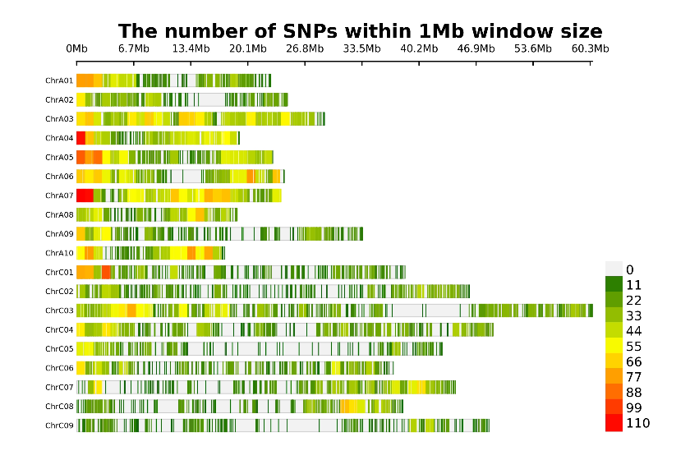

Figure S1. Chromosome-wise SNP density plot illustrating the number of SNPs within 1 Mb windows. The horizontal axis represents chromosome length in megabases (Mb), and variations in colour indicate SNP density levels

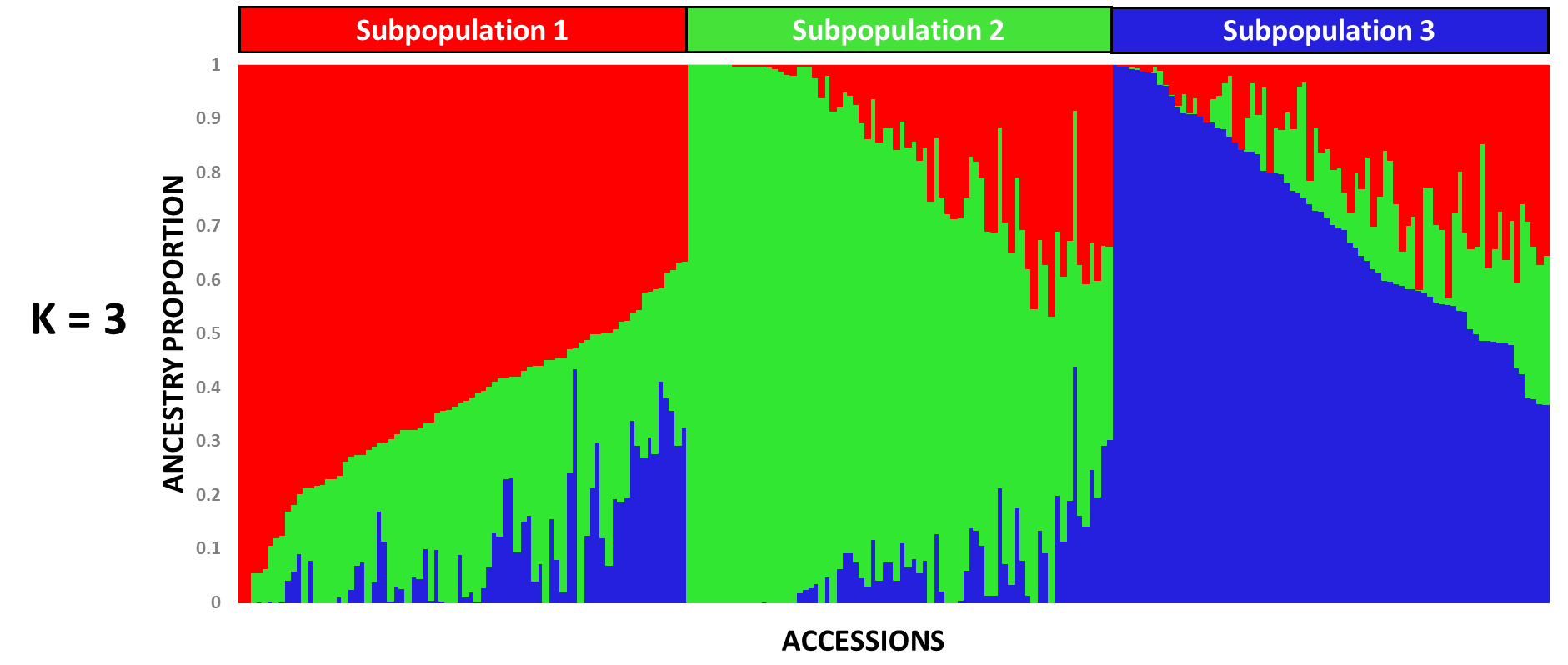

Figure S2. Estimated ancestry proportions of accessions at K = 3 based on STRUCTURE analysis

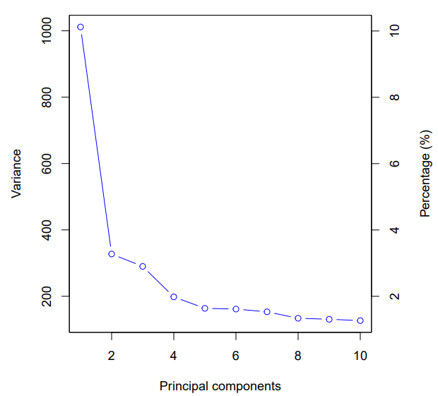

Figure S3. Scree plot showing the proportion of genetic variance explained by principal components derived from SNP-based PCA in the GWAS panel

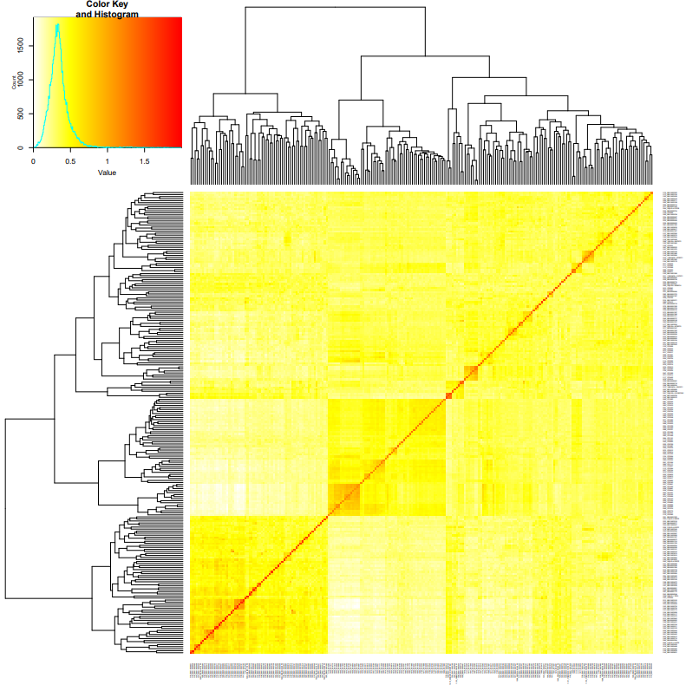

Figure S4. Heatmap representation of the kinship matrix illustrating genetic relatedness across the population. Darker regions indicate stronger genetic similarity between individual genotypes.
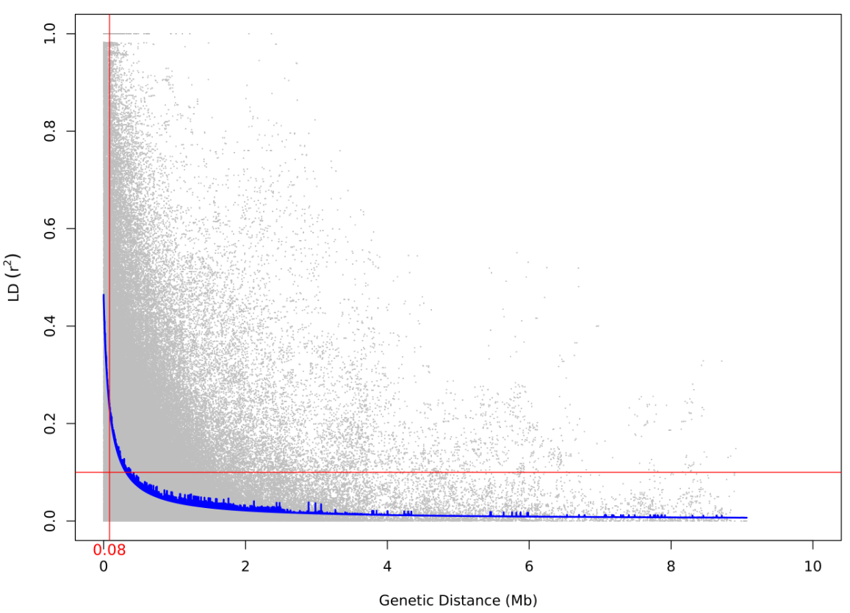

Figure S5. LD decay plot for A-subgenome, showing average r² values (y-axis) against physical distance between markers (Mb) on the x-axis, with half-decay observed at 0.08 Mb (~80 kb).

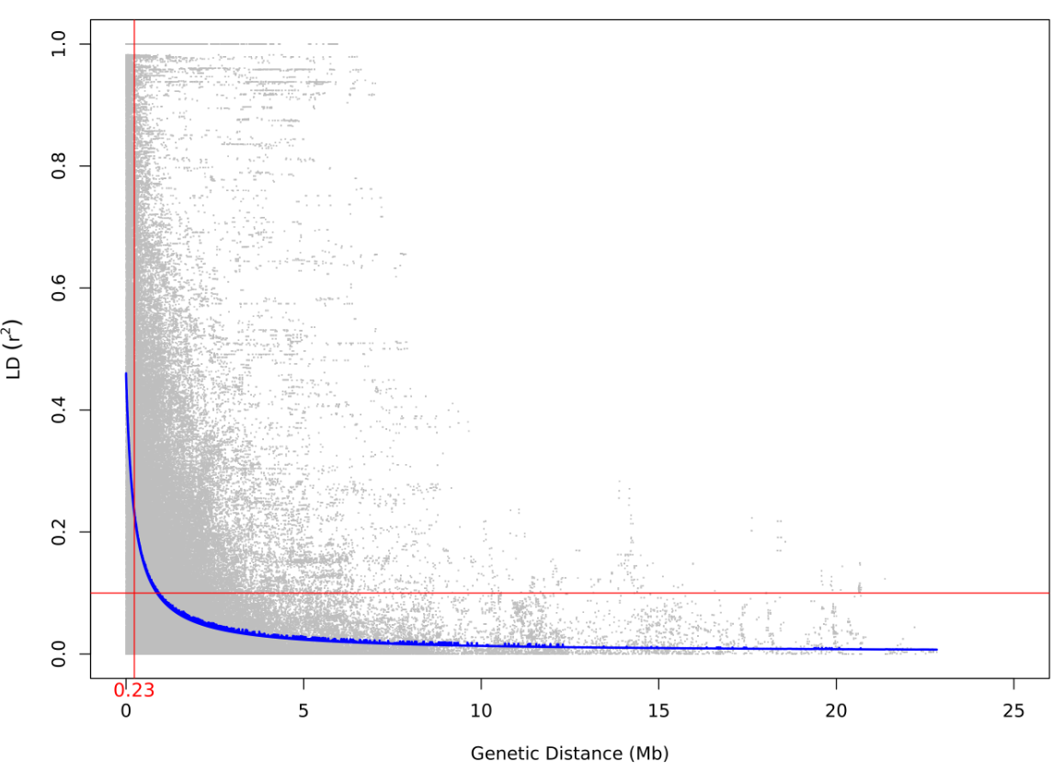

Figure S6. LD decay plot for C-subgenome, showing average r² values (y-axis) against physical distance between markers (Mb) on the x-axis, with half-decay observed at 0.23 Mb (~230 kb)

ChrA07 - Bn-A07-p244051 ChrC01 - Bn-scaff_22115_1-p155376
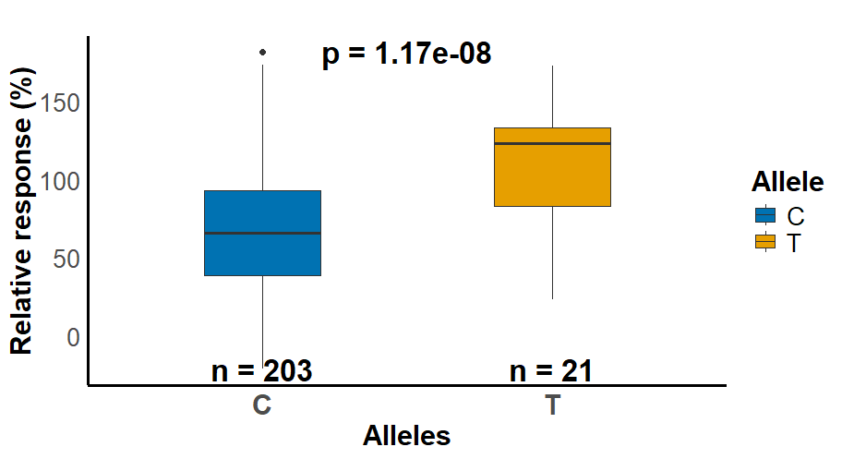
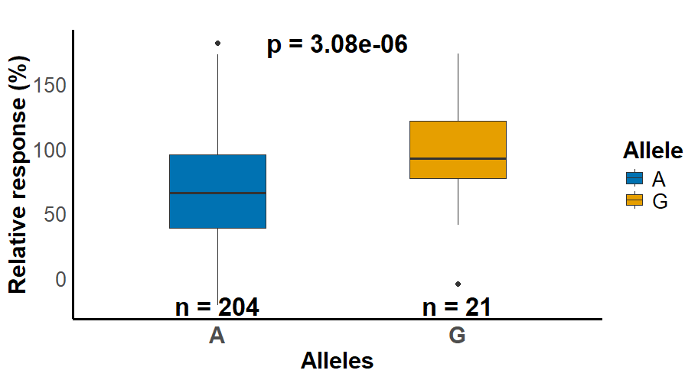

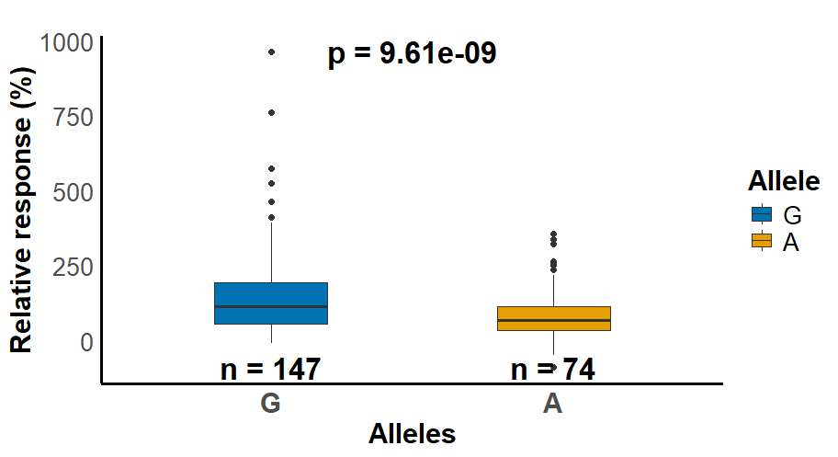
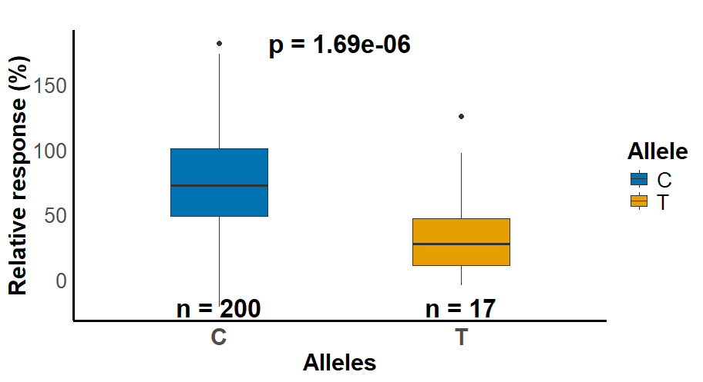
ChrC08 - Bn-C08-p8710166 ChrC02 - Bn-scaff_20942_1-p252525

Figure S7. Boxplots of the allelic effects of four SNPs that exceeded the genome-wide significant threshold (-log10 p ≥ 5.48) associated with osmopriming response

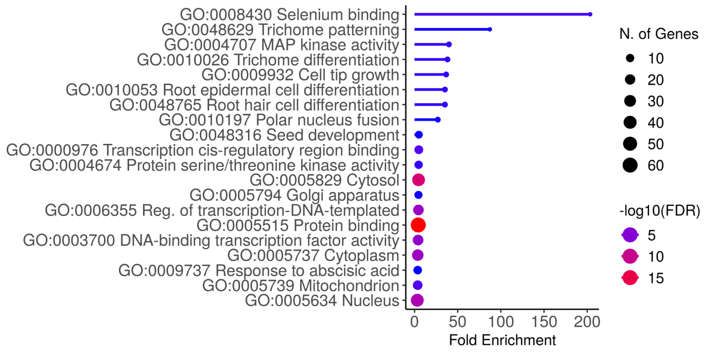

Figure S8. Top enriched GO terms for predicted candidate genes within the identified SNP loci associated with response to osmopriming as detected by the GWAS BLINK model significantly enriched at FDR < 0.05

