Supplementary figures and tables

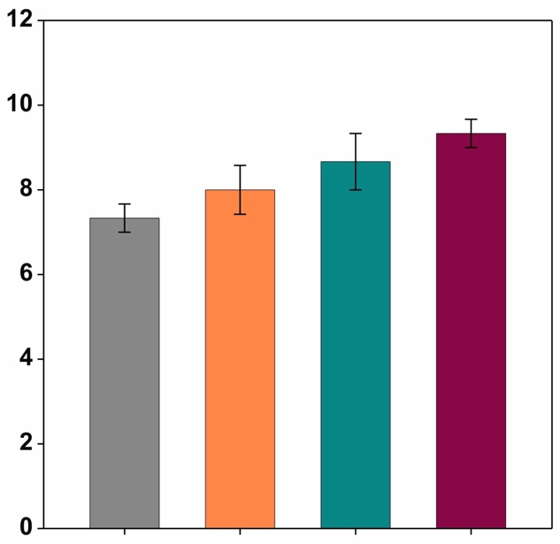
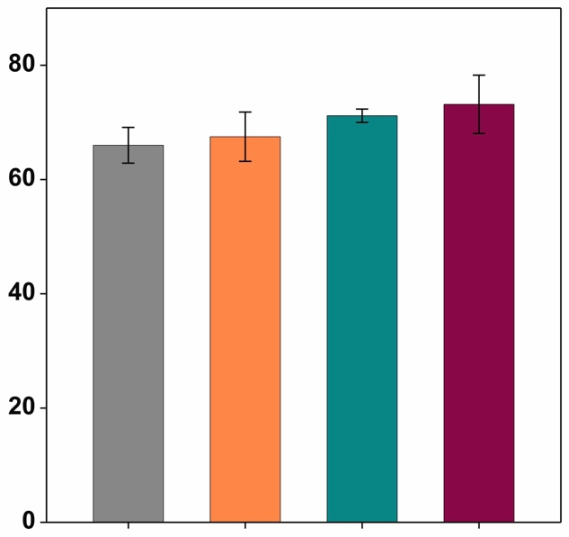
(b)
(a)
a
Plant height (cm)
a
a
a
a
a
Tiller number (plant⁻¹)
a
a

CLG
Control
Control
CLG
CLG + NPK
CLG + Compost
CLG + Compost
CLG + NPK

Legends: |  | Control (no amendment) |  | CLG + NPK (clay + lime + gypsum + N, P, K)
Legends: |  | CLG (clay + lime + gypsum) |  | CLG + Compost (clay + lime + gypsum + compost)
Fig. S1 Effect of soil amendments on wheat plant characteristics: (a) plant height and (b) tiller number at growth stage Z61 (beginning of anthesis), under four soil treatments. Same letters above bars indicate non-significant differences (p > 0.05) among treatments. Error bars are standard deviations (n=3). Four soil treatments: Control (no amendment), CLG (clay + lime + gypsum), CLG + NPK (clay + lime + gypsum + N, P, K fertilisers), and CLG + Compost (clay + lime + gypsum + compost).

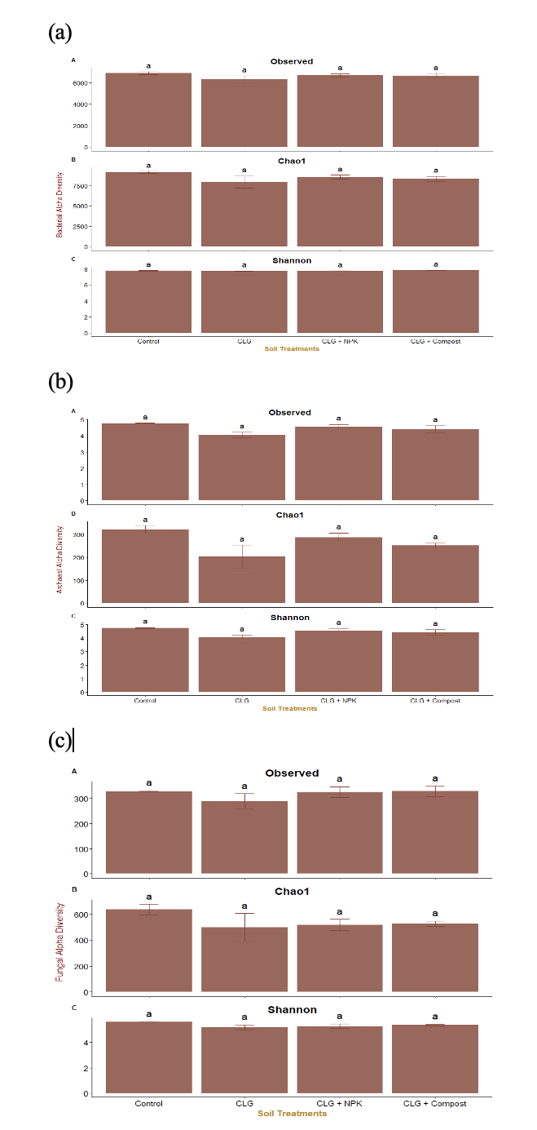

Fig. S2 Alpha diversity metrics of (a) bacteria, (b) archaea, and (c) fungi under four different soil treatments at growth stage Z61(beginning of anthesis). Values represent means ± SE of three replicates. Non-significant differences among the treatments were determined using a generalised least squares model, followed by Tukey’s test (P > 0.05), indicated by same letters.

Table S1 Soil chemical properties before seed sowing (baseline) and at growth stage Z61 (beginning of anthesis) under four different treatments.

Stage | Treatments | Soil chemical properties
Stage | Treatments | NH⁺-N  (mg kg^{–1}) | NO₃–-N  (mg kg^{–1}) | Colwell-P  (mg kg^{–1}) | Colwell-K  (mg kg^{–1}) | Sulphur  (mg kg^{–1}) | Organic C  (%) | EC  (dS m^{–1}) | pH  (CaCl₂) | pH  (H₂O) | DOC  (mg kg^{–1} C) | MBC  (mg C kg^{–1} soil)
Baseline  (20.2.24) | Control | 2.0±0.0 | 5.3±0.58 | 16.67±1.53 | 16±1.0 | 3.23±0.61 | 0.38±0.04 | 0.038±0.007 | 6.73±0.058 | 7.37±0.115 | – | –
Baseline  (20.2.24) | CLG | 1.67±0.57 | 6.0±1.0 | 28.33±5.51 | 20.33±1.53 | 5.87±1.07 | 0.42±0.06 | 0.05±0.007 | 7.0±1.0 | 7.93±0.057 | – | –
Baseline  (20.2.24) | CLG + NPK | 1.67±0.57 | 6.33±0.58 | 28.33±2.52 | 17.0±1.0 | 6.17±0.81 | 0.46±0.07 | 0.06±0.018 | 6.8±0.058 | 7.6±0.057 | – | –
Baseline  (20.2.24) | CLG + Compost | 3.0±1.0 | 7.33±0.58 | 29.33±4.16 | 21.33±1.53 | 10.77±2.32 | 0.65±0.09 | 0.08±0.012 | 6.94±0.058 | 7.67±0.057 | – | –
Baseline  (20.2.24) | ANOVA | 0.0293* | 0.028* | 0.0154* | 0.01* | 0.0045** | 0.017* | 0.018* | 0.003** | 0.0003*** | – | –
Z61 | Control | 0.02±0.01 | 0.61±0.015 | 19.67±1.15 | 84.67±3.79 | 6.97±2.67 | 0.33±0.015 | 0.048±0.004 | 6.±0.173 | 7.1±0.25 | 14.69±0.09 | 9.56±2.0
Z61 | CLG | 0.027±0.01 | 0.86±0.01 | 29.33±3.51 | 104.67±10.4 | 8.3±2.56 | 0.397±0.02 | 0.055±0.004 | 6.63±0.493 | 7.50±0.16 | 14.50±0.62 | 14.15±1.43
Z61 | CLG+ NPK | 0.03±0.01 | 0.82±0.00 | 30.33±6.43 | 123.67±4.16 | 10.7±2.01 | 0.427±0.03 | 0.075±0.001 | 6.83±0.058 | 7.62±0.30 | 18.76±0.23 | 16.70±3.17
Z61 | CLG + Compost | 0.047±0.01 | 0.93±0.01 | 40.67±7.23 | 130.67±5.86 | 15.5±2.72 | 0.52±0.132 | 0.074±0.002 | 6.87±0.058 | 7.91±0.07 | 31.24±1.27 | 21.71±3.75
Z61 | ANOVA | 0.018* | 1.71e⁻⁰⁷*** | 0.003** | 0.0003*** | 0.029* | 0.038* | 0.000314*** | 0.098^{NS} | 0.035* | 1.45e⁻⁰⁷*** | 0.0003***
Control no amendment; CLG clay + lime + gypsum; CLG + NPK clay + lime + gypsum + N, P, K fertilisers; and CLG + Compost clay + lime + gypsum + compost.
Data are means ± standard errors (n = 3); *** p < 0.001, ** p < 0.01, * p < 0.05, NS - not significant. Different letters within a column and stages indicate significant differences (p < 0.05) among treatments.

Table S2 Plant morpho-physiological parameters at growth stage Z23 (main stem and three tillers) and Z61 (beginning of anthesis) under four soil treatments.

Stage | Treatments | Plant morpho-physiological parameters
Stage | Treatments | Plant  height  (cm) | Tiller number (plant^{–1}) | Leaf  area  (cm²) | Chlorophyll  content  (SPAD reading) | Shoot dry  weight  (g plant^{–1}) | Root dry  weight  (g plant^{–1})
Z23 | Control | 31±1.0 | 3.67±0.58 | 57.89±4.17 | 33.98±2.2 | 1.18±0.095 | 0.517±0.119
Z23 | CLG | 33.67±0.577 | 4.67±0.58 | 99.11±7.52 | 38.25±1.44 | 1.61±0.191 | 0.603±0.012
Z23 | CLG NPK | 32.67±0.577 | 4.33±0.58 | 89.21±1.3 | 39.91±0.53 | 1.47±0.206 | 0.64±0.03
Z23 | CLG + Compost | 36.33±0.577 | 4.67±0.58 | 118.7±18.25 | 40.69±2.29 | 1.92±0.268 | 0.807±0.09
Z23 | ANOVA | 0.0007*** | 0.142 ^{NS} | 0.002** | 0.023* | 0.016* | 0.032*
Z61 | Control | 66±5.41 | 7.3±0.058 | 247.11±15.69 | 50.29±1.82 | 3.81±0.19 | 1.33±0.06a
Z61 | CLG | 67.5±7.47 | 8.0±1.0 | 301.87±10.26 | 52.47±1.54 | 4.30±0.39 | 1.67±0.08ab
Z61 | CLG+NPK | 71.17±2.02 | 8.67±1.15 | 318.13±3.65 | 52.52±1.03 | 4.29±0.14 | 1.64±0.08ab
Z61 | CLG + Compost | 73.17±8.84 | 9.33±0.58 | 332.43±11.45 | 55.05±1.09 | 4.81±0.08 | 2.02±0.11b
Z61 | ANOVA | 0.416^{NS} | 0.091^{NS} | 0.00015*** | 0.024* | 0.0134* | 0.007**
Control no amendment; CLG clay + lime + gypsum; CLG + NPK clay + lime + gypsum + N, P, K fertilisers; and CLG + Compost clay + lime + gypsum + compost.
Data are means ± standard errors (n = 3); *** p < 0.001, ** p < 0.01, * p < 0.05, NS - not significant. Different letters within a column and stages indicate significant differences (p < 0.05) among treatments.

