Molecular characterization of Tetragonia tetragonoides (Pall.) aquaporin (AQP) members and their roles in the response to combined high salinity–alkalinity–drought and heat stress
Lisha Cao^{1, 2, 3}, Fuying Xie^{1, 2, 3}, Lihua Chen^{1, 2, 3}, Zhengfeng Wang^{1, 5},
Mei Zhang^{1, 3, *}, Shuguang Jian^{1, 2, *}
1 Guangdong Provincial Key Laboratory of Applied Botany, South China Botanical Garden, Chinese Academy of Sciences, Guangzhou 510650, China.
2 University of the Chinese Academy of Sciences, Beijing 100039, China.
3 Center of Economic Botany, Core Botanical Gardens, Chinese Academy of Sciences, Guangzhou, 510650, China.
4 Southern Marine Science and Engineering Guangdong Laboratory (Guangzhou), Guangzhou, China
* Correspondence and requests for materials should be addressed to Mei Zhang (zhangmei@scbg.ac.cn) and Shuguang Jian (jiansg@scbg.ac.cn).
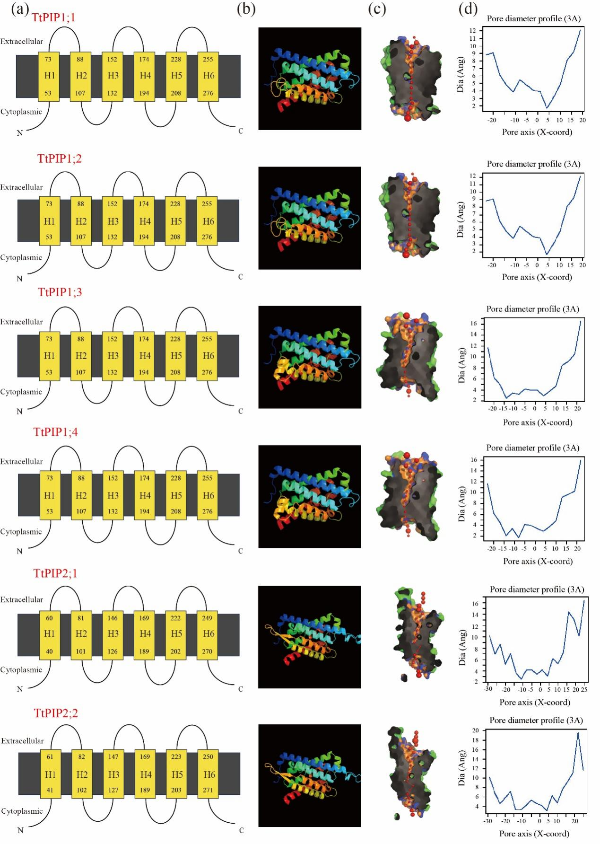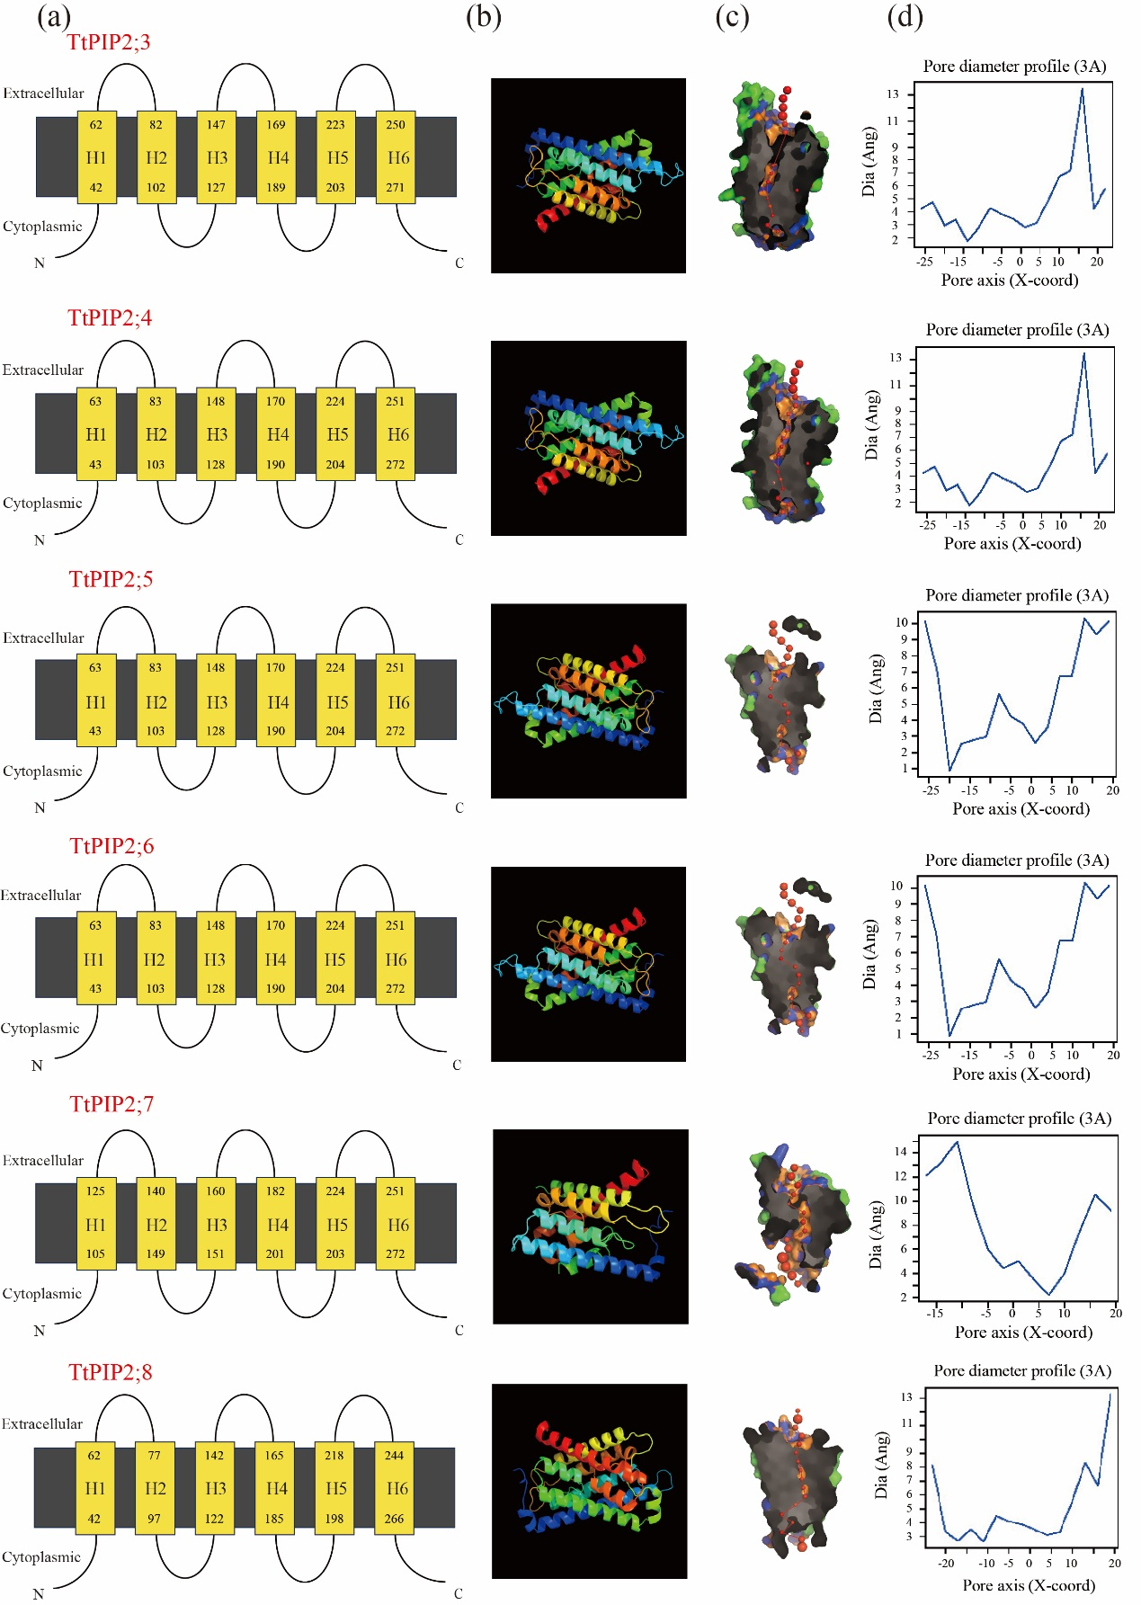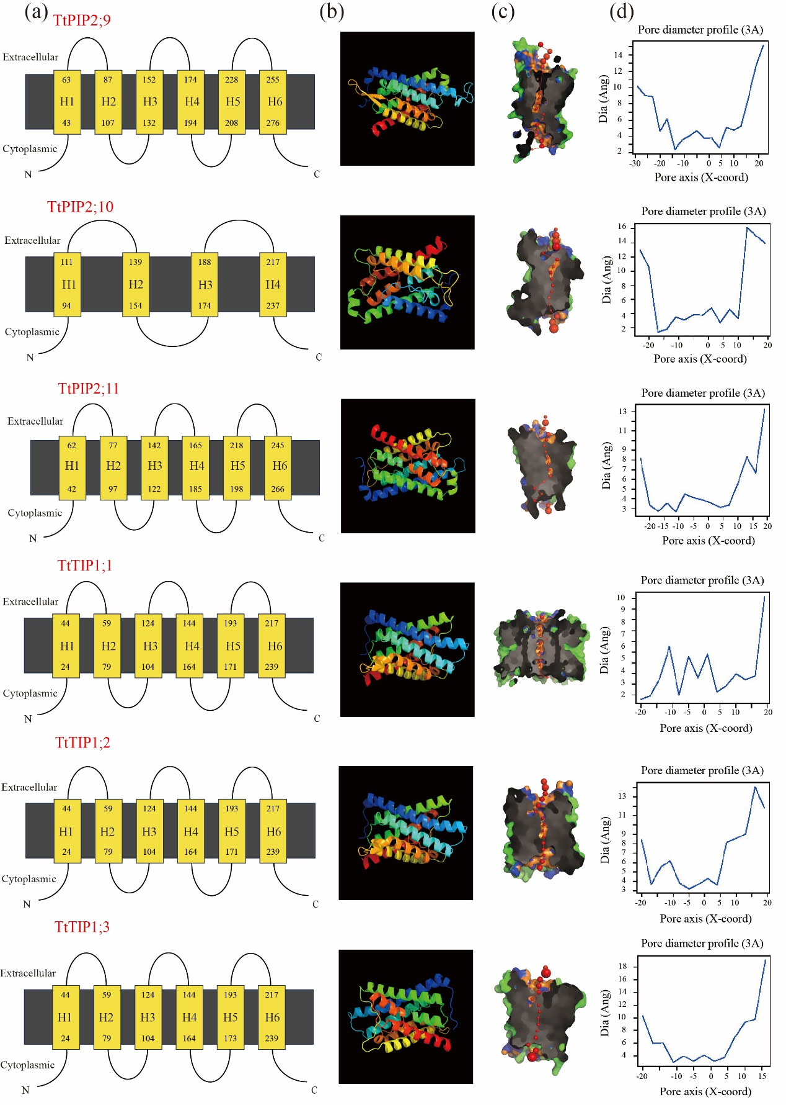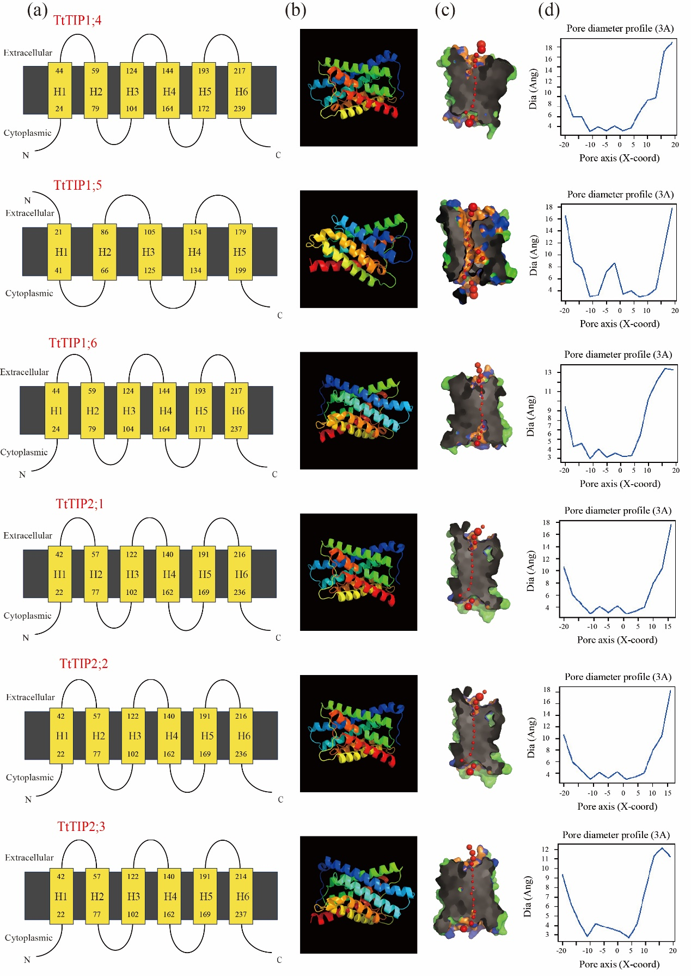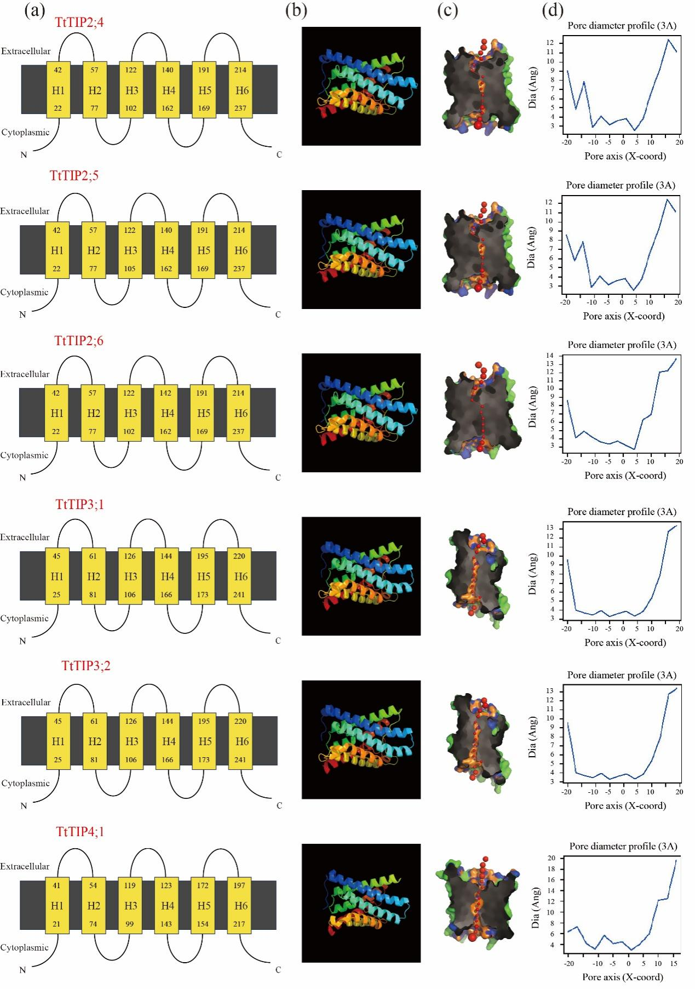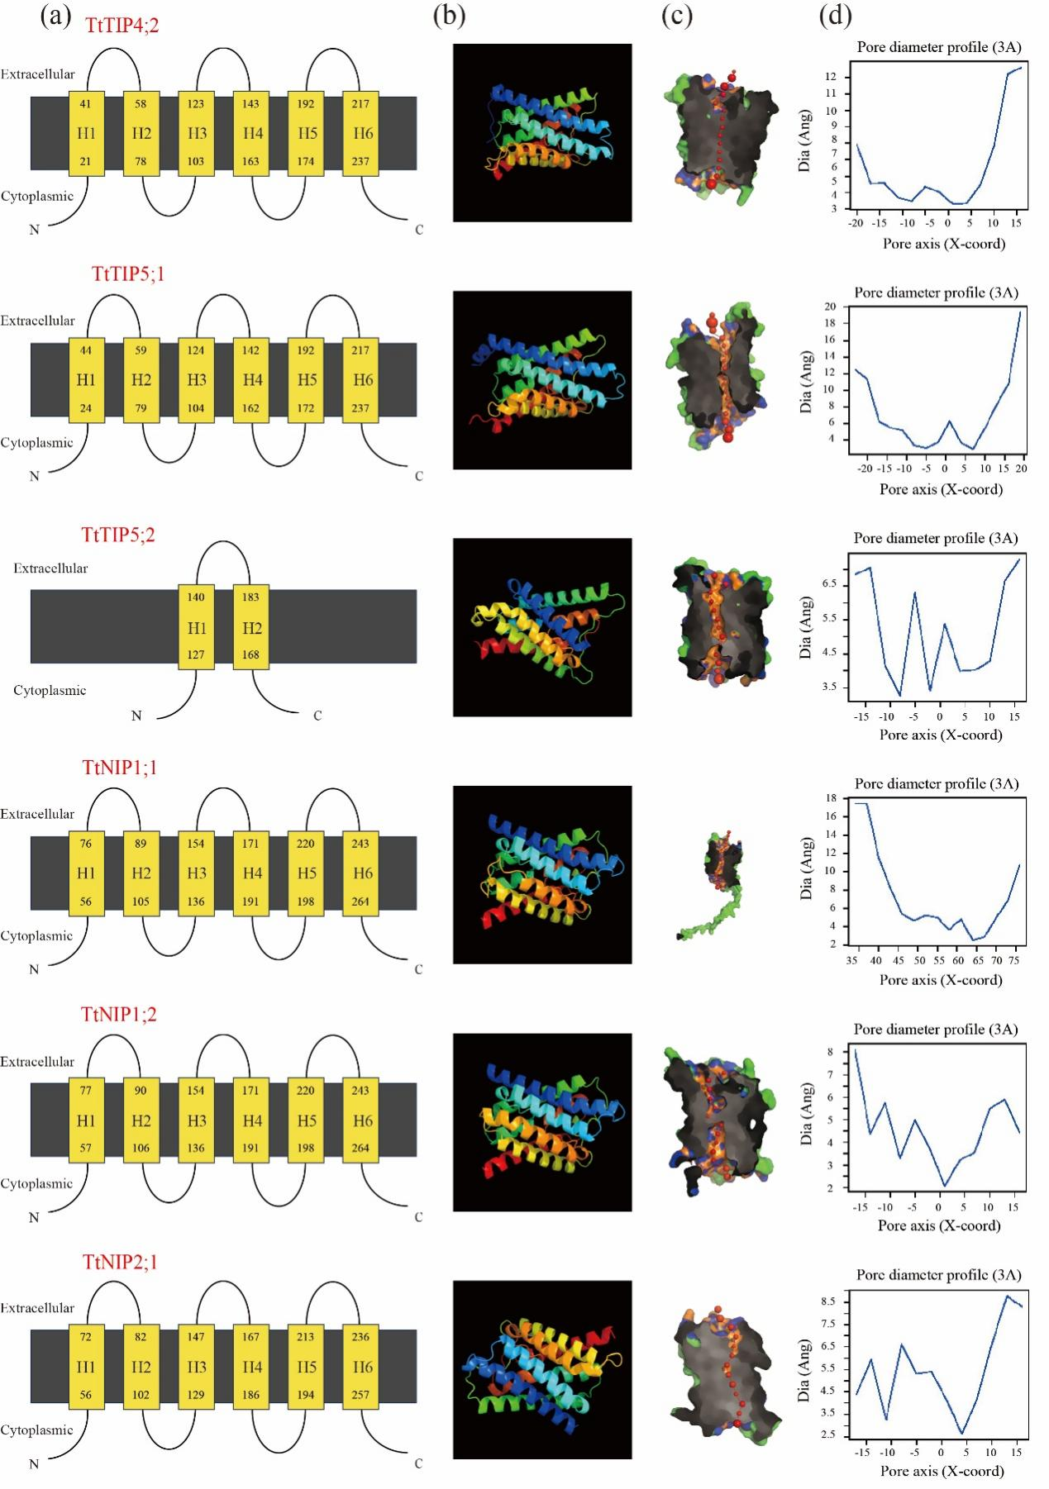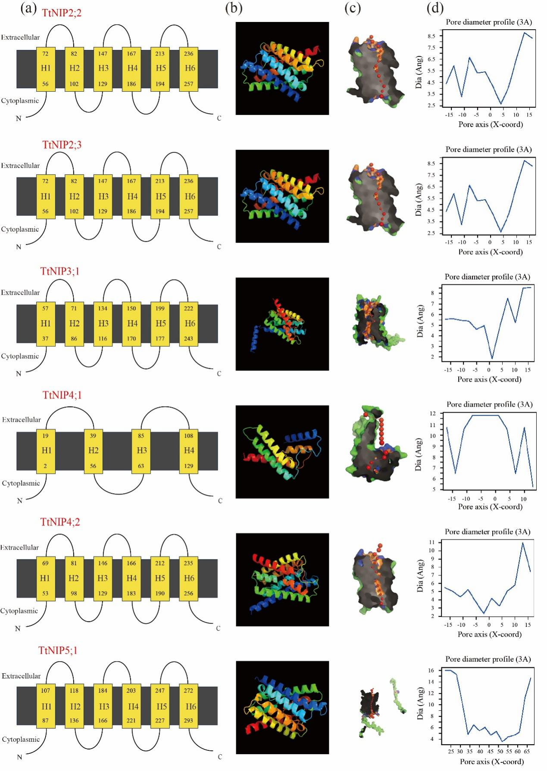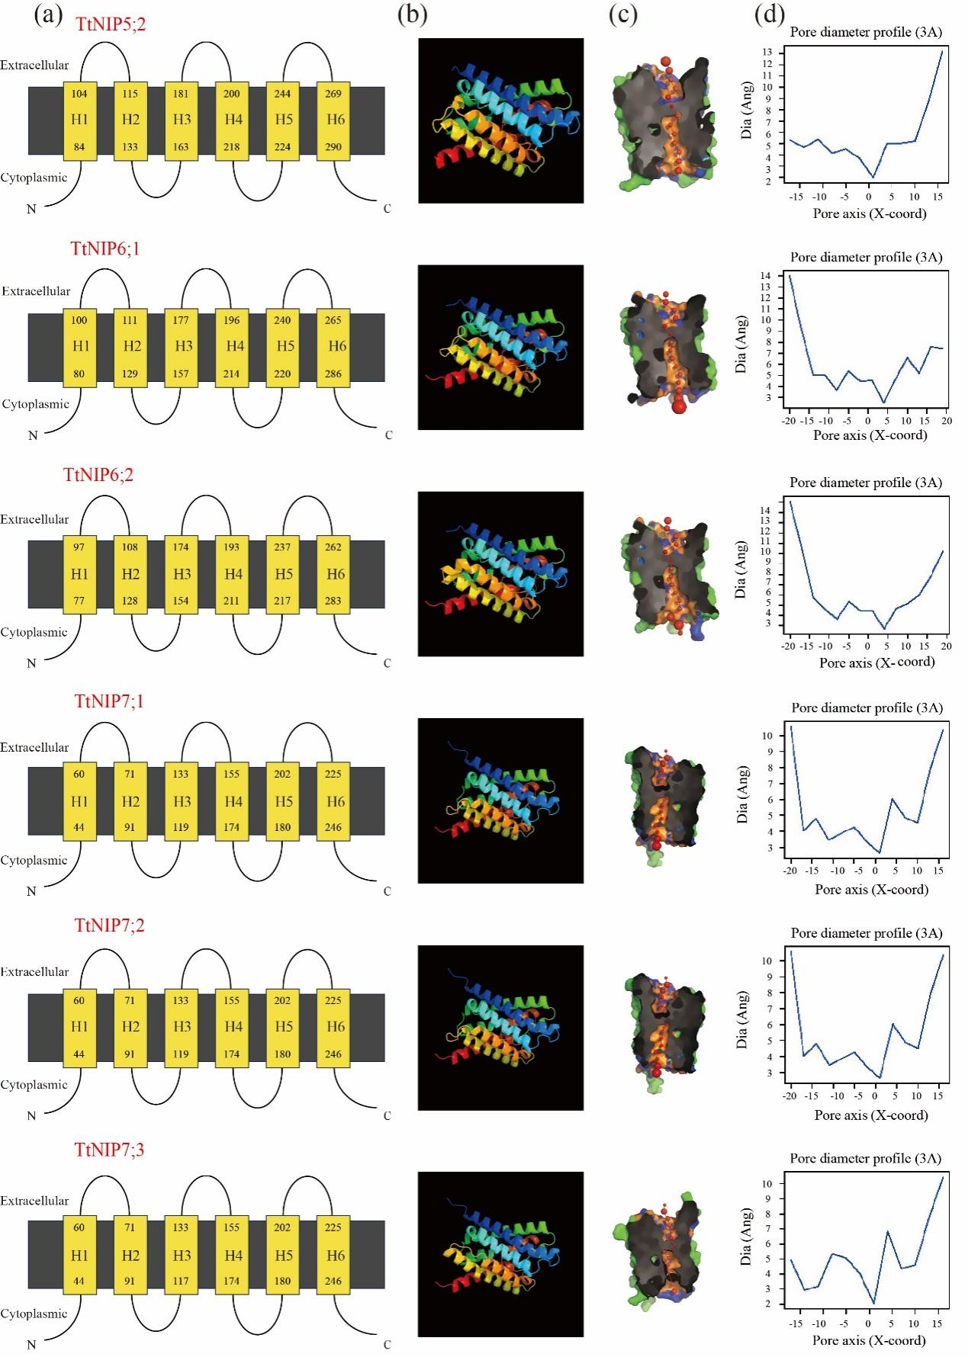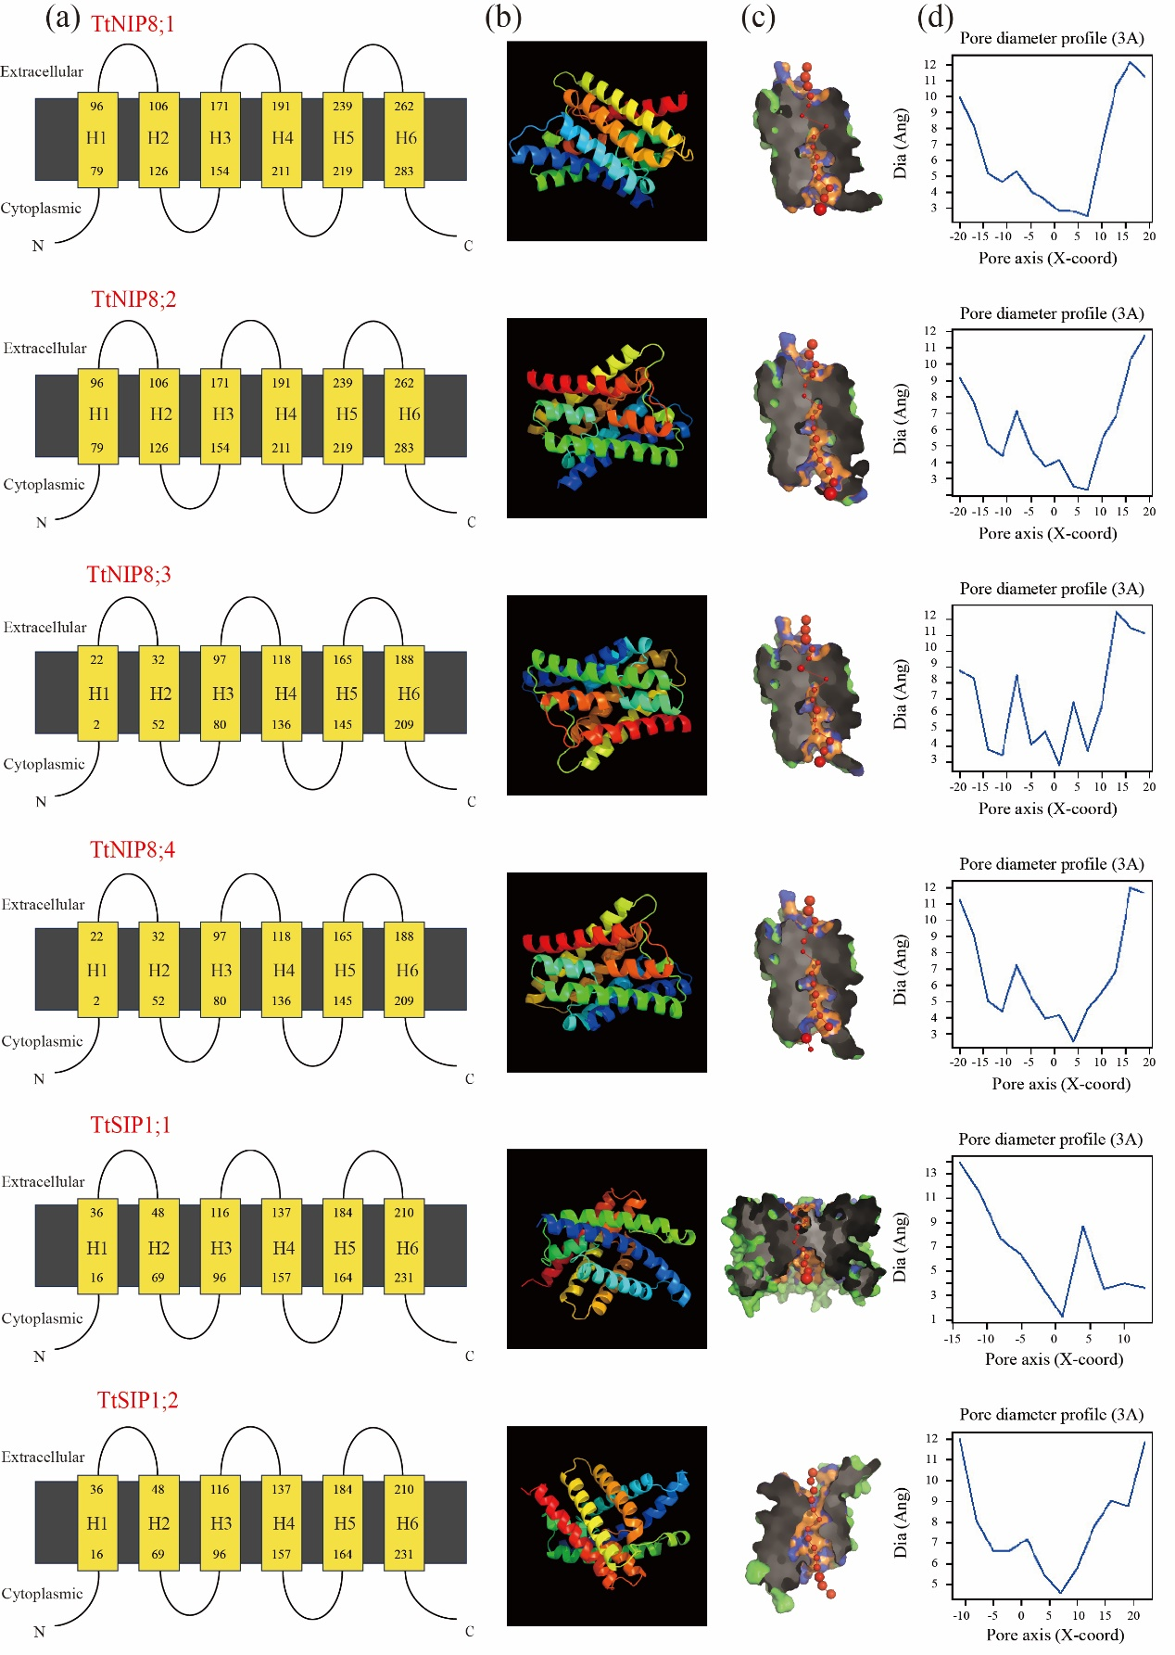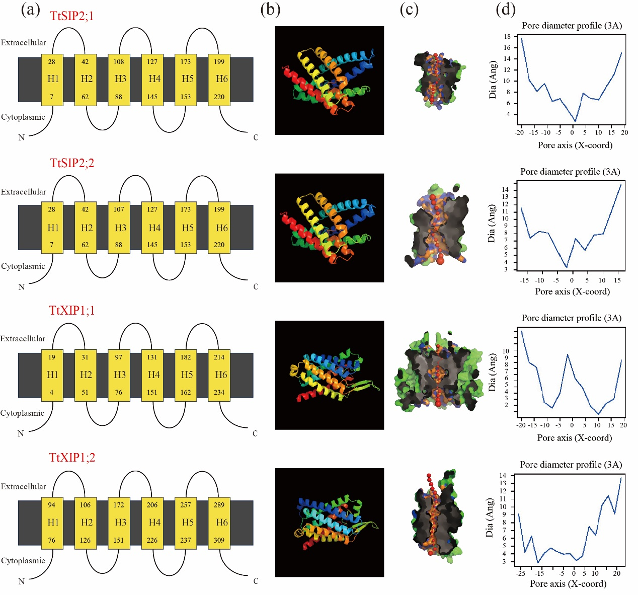
Fig. S1. The transmembrane region and 3D structure of TtAQPs predicted with Phyre2 server (https://www.sbg.bio.ic.ac.uk/phyre2/html/page.cgi?id=contact). Transmembrane topology (a) and 3D structure (b) of 58 TtAQPs were constructed using the Phyre2 and color-coded with a rainbow scheme (N- to C-terminus). Pore morphology (c) and dimensions (d) were analyzed using PoreWalker software, providing cross-sectional views and pore size measurements.

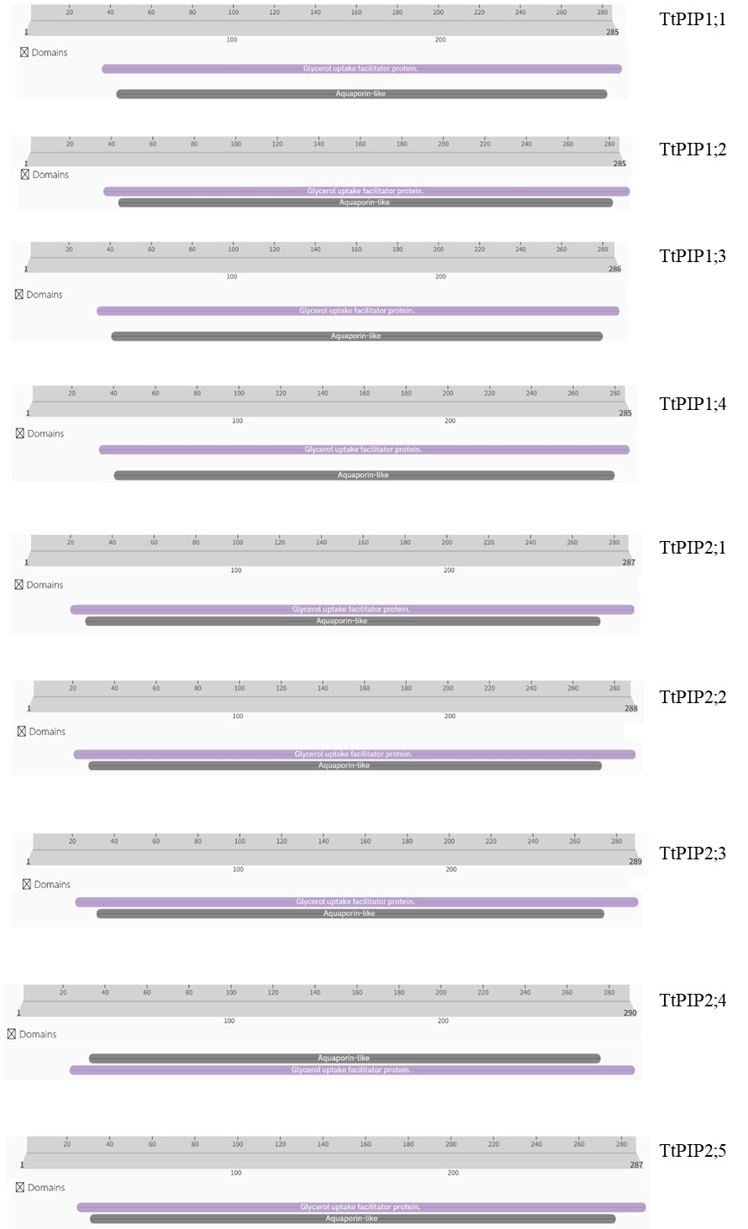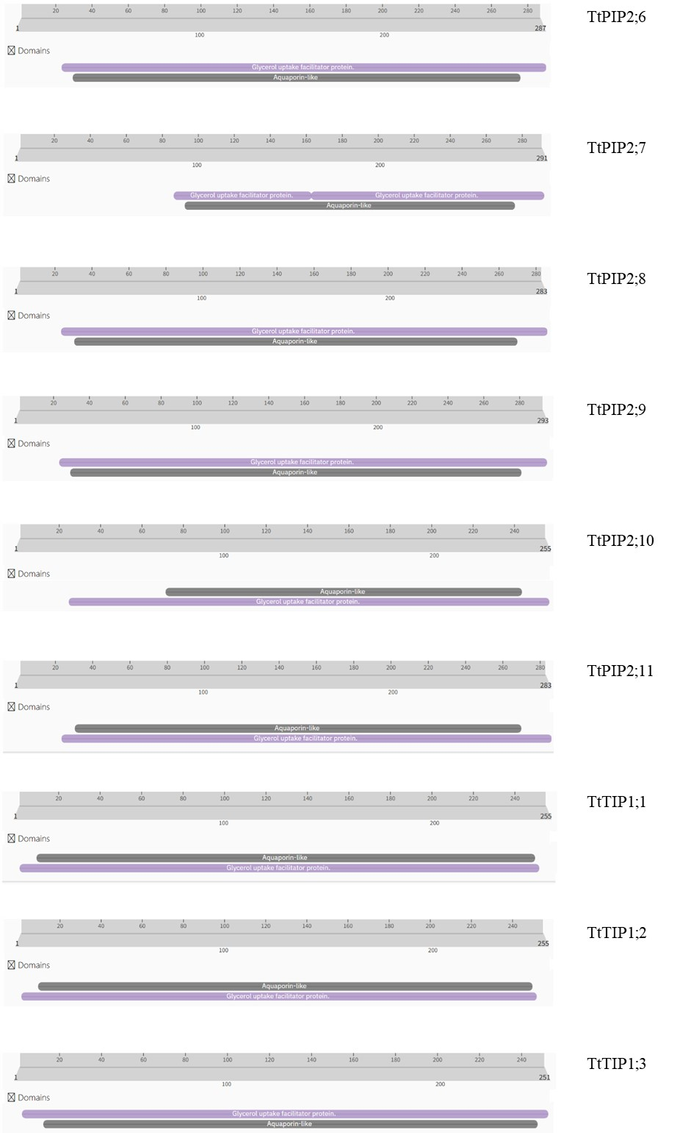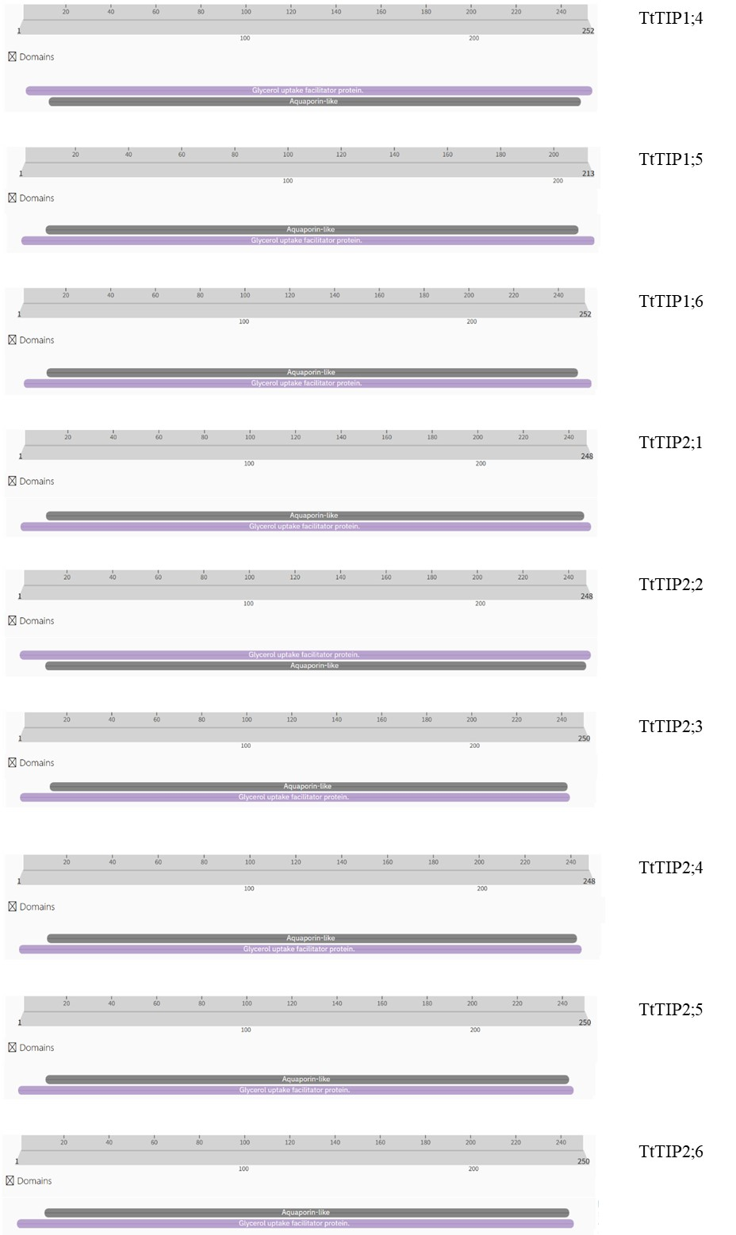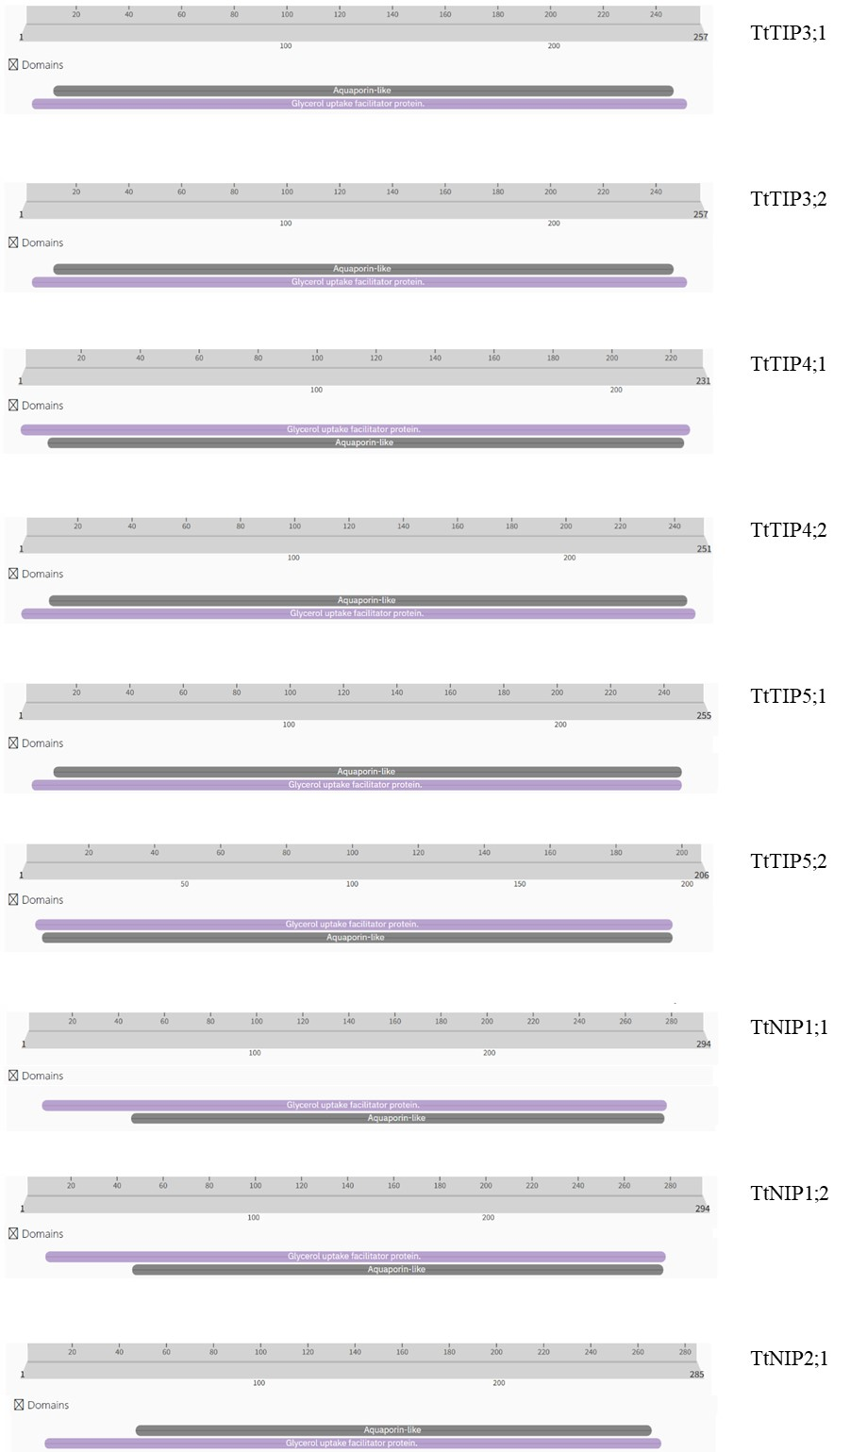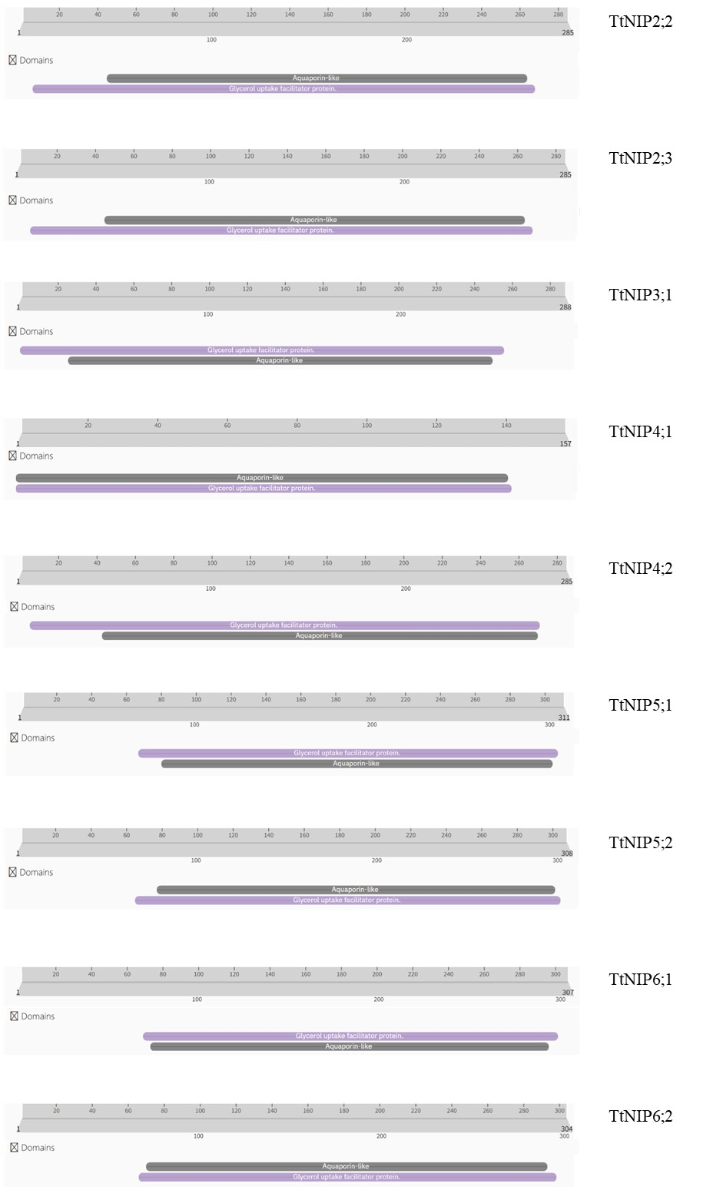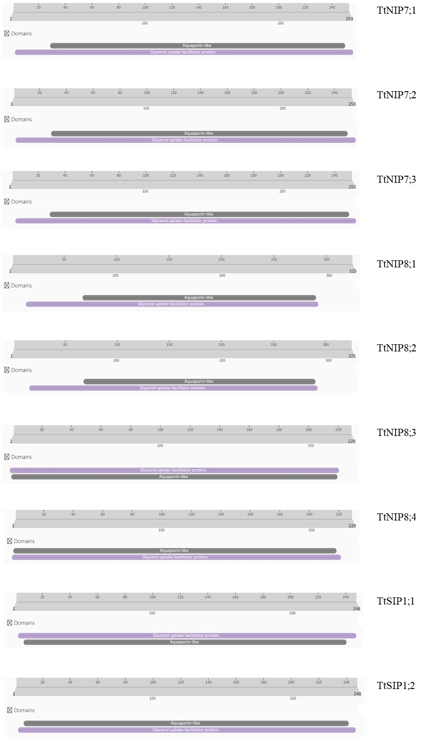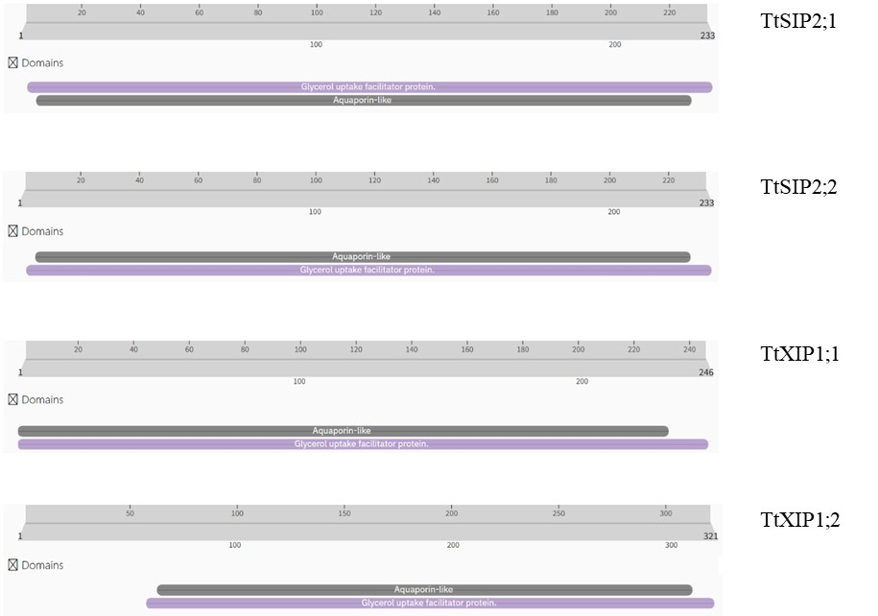
Fig. S2. The TtAQPs conserved domains predicted with InterProscan (https://www.ebi.ac.uk/interpro/search/sequence/). The predicted conserved domains of TtAQP family are presented here. All members have predicted domains including Aquaporin-like (grey) and Glycerol uptake facilitator protein (purple) within their amino acid sequences.

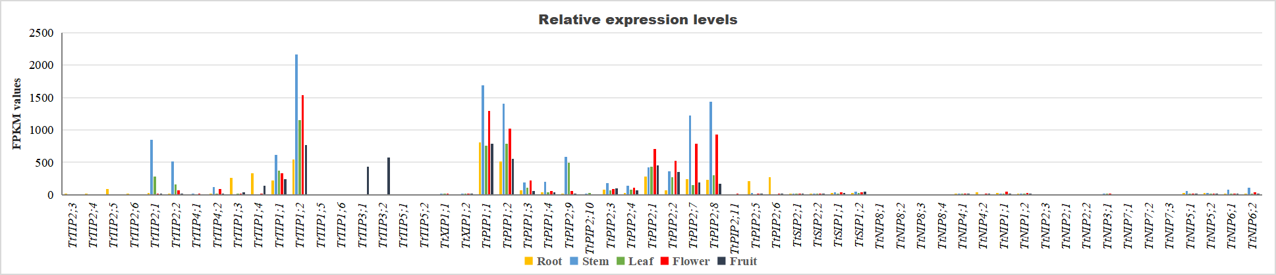
Fig. S3. The histogram showing the relative expression (FPKM values with RNA-seq) of 58 TtAQPs in the root, vine, leaf, flower bud, and young fruit of T. tetragonoides plants.

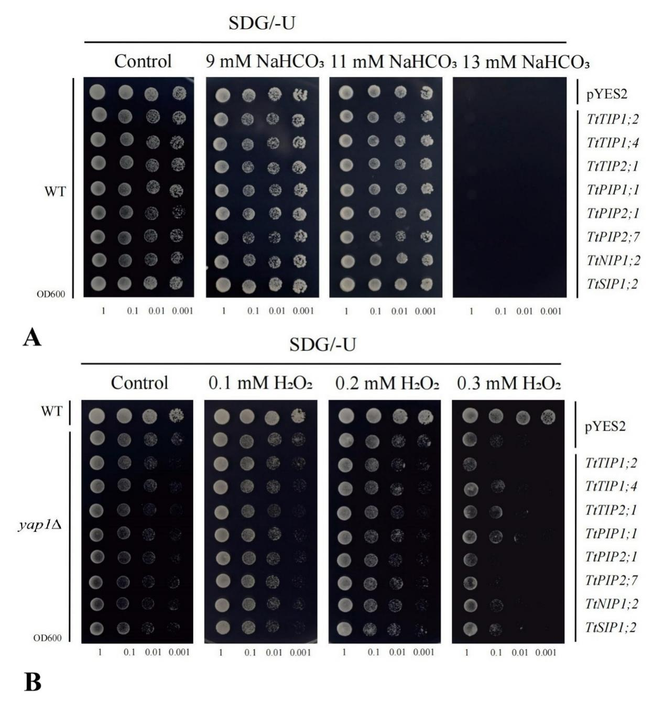
Fig. S4. 10 The tolerance confirmations of the eight TtAQPs’ heteroexpression in WT and H₂O₂-sensitive mutant strain (yap1Δ) yeast. (A) Alkaline stress (NaHCO₃, pH8.2) tolerance confirmations in WT; and (B) Oxidative stress (H₂O₂) tolerance confirmations in yap1Δ. WT was used as control.

Table S1. Primers and sequences lists used in this study.

Table S2. Duplication events for TtAQP genes.

Table S3. Ka Ks analysis of TtAQPs.

Table S4. The cis-acting elements (CEs) analysis of TtAQPs’ promoter sequences

Table S5. The FPKM values for all T. tetragonoides samples’ RNA-seq assays in this study.

