Fig. 1 Expression profiling of OsGLP genes in leaves under drought and salt stress. Relative expression (Fold Change) of OsGLPs (a) OsGLP3-6 (b) OsGLP3-7 (c) OsGLP4-1 (d) OsGLP8-4 (e) OsGLP8-7 (f) OsGLP8-10 (g) OsGLP8-11 (h) OsGLP8-12 in drought and salt stress treated leaves sample was determined relative to their expression in control leaves of KS282 and Super Basmati (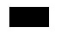Control, 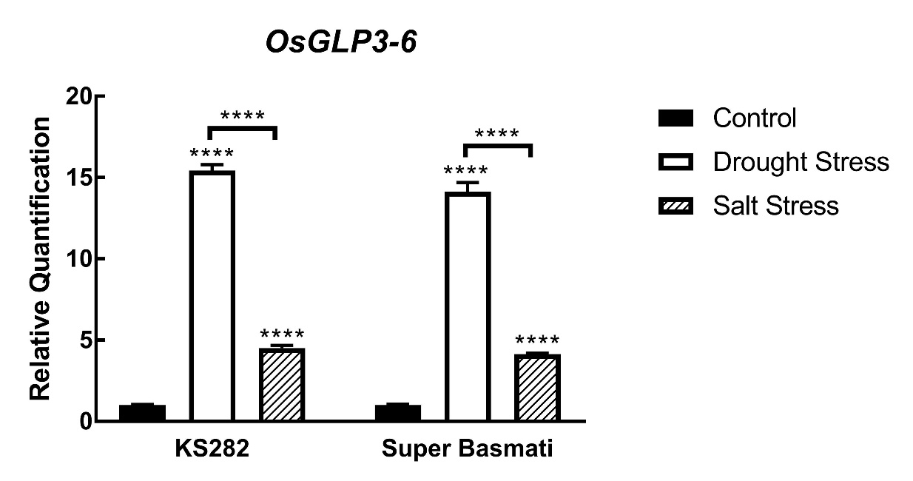Drought stress, Salt stress). Values indicate mean ± Standard Error Mean (SEM). Statistical analysis was performed with two-way ANOVA (* P<0.05, ** P<0.01, *** P<0.001, **** P<0.0001)

Fig. 2 (a) Venn diagram demonstrating the expression pattern of OsGLP genes regulated by drought and salt stress in leaves of KS282 and Super Basmati (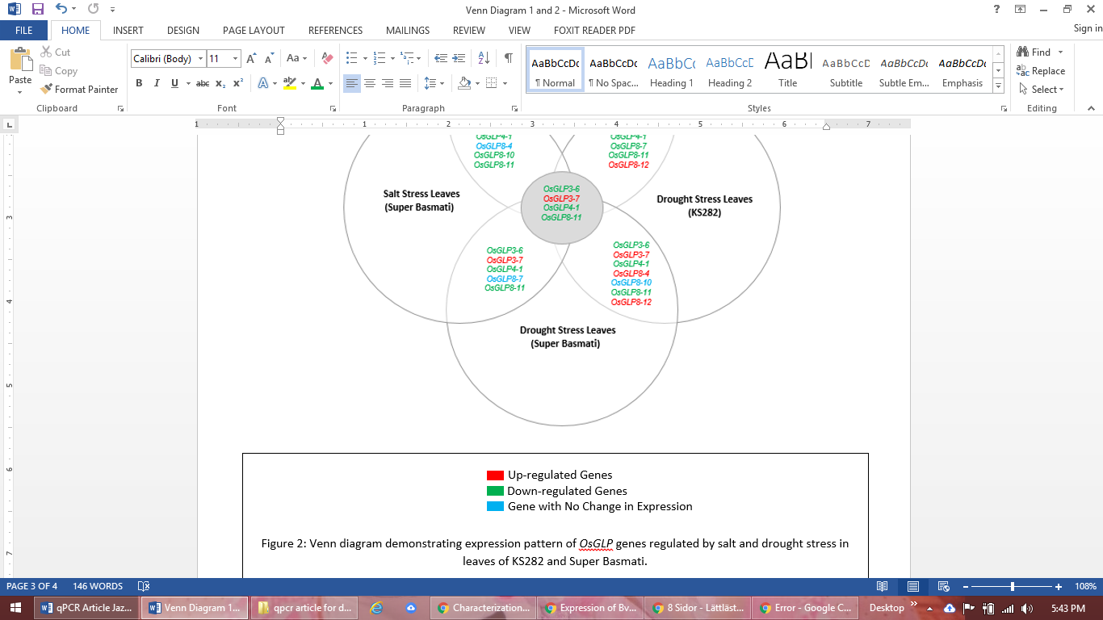Up-regulated, Down-regulated, No change in expression). Expression profiles of OsGLPs (in leaves) regulated commonly or specifically regarding particular stress type (drought and salt) and particular rice variety (KS282 and Super Basmati) (b) Salt stress induced comparative expression of OsGLP genes in leaves of KS282 and Super Basmati. Comparison of relative expression (Fold Change) of OsGLPs (OsGLP3-6, OsGLP3-7, OsGLP4-1, OsGLP8-4, OsGLP8-7, OsGLP8-10, OsGLP8-11, and OsGLP8-12) was performed between KS282 leaves and Super Basmati leaves under salt stress (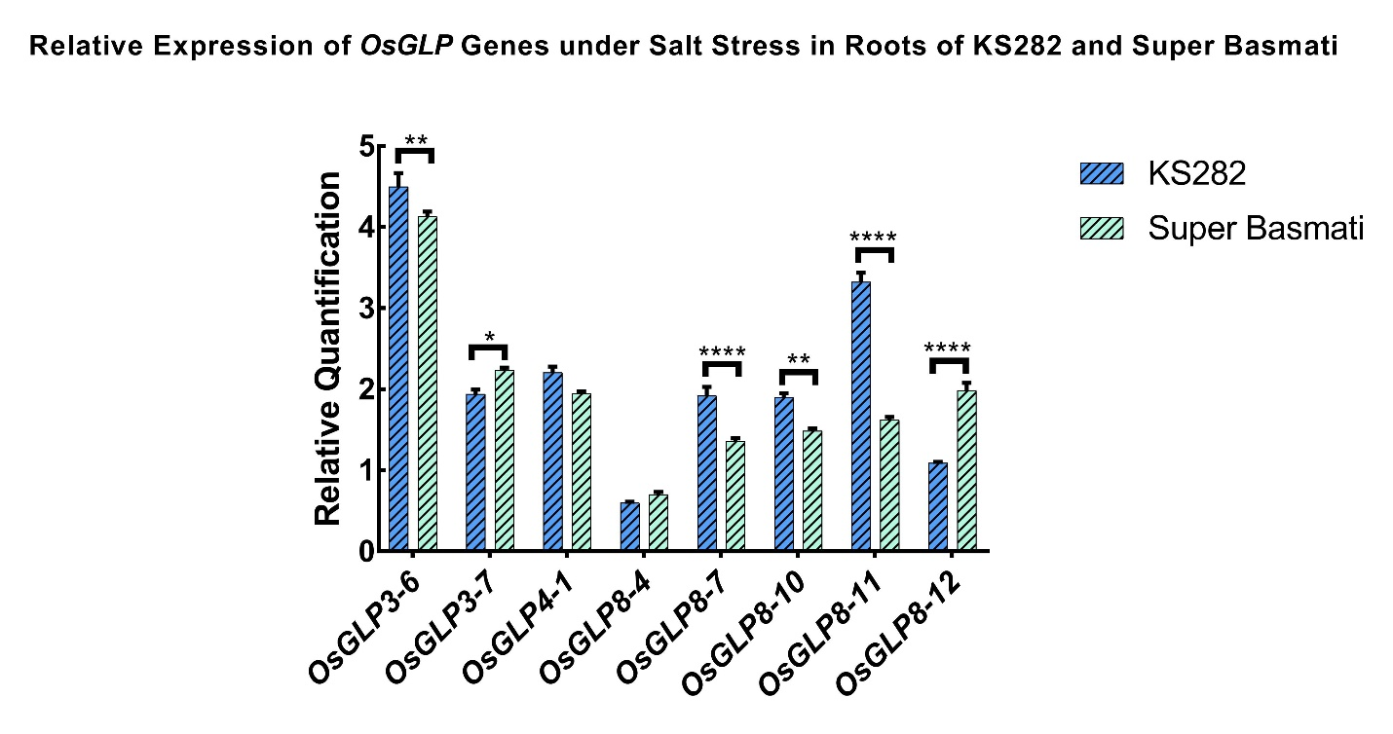KS282, 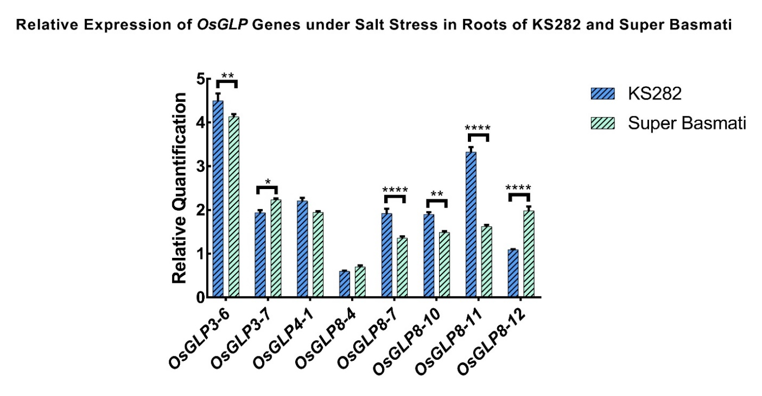Super Basmati). Values indicate mean ± Standard Error Mean (SEM). Statistical analysis was performed with two-way ANOVA (* P<0.05, ** P<0.01, *** P<0.001, **** P<0.0001) (c) Drought stress induced comparative expression of OsGLP genes in leaves of KS282 and Super Basmati. Comparison of Relative expression (Fold Change) of OsGLPs (OsGLP3-6, OsGLP3-7, OsGLP4-1, OsGLP8-4, OsGLP8-7, OsGLP8-10, OsGLP8-11, and OsGLP8-12) was performed between KS282 leaves and Super Basmati leaves under drought stress (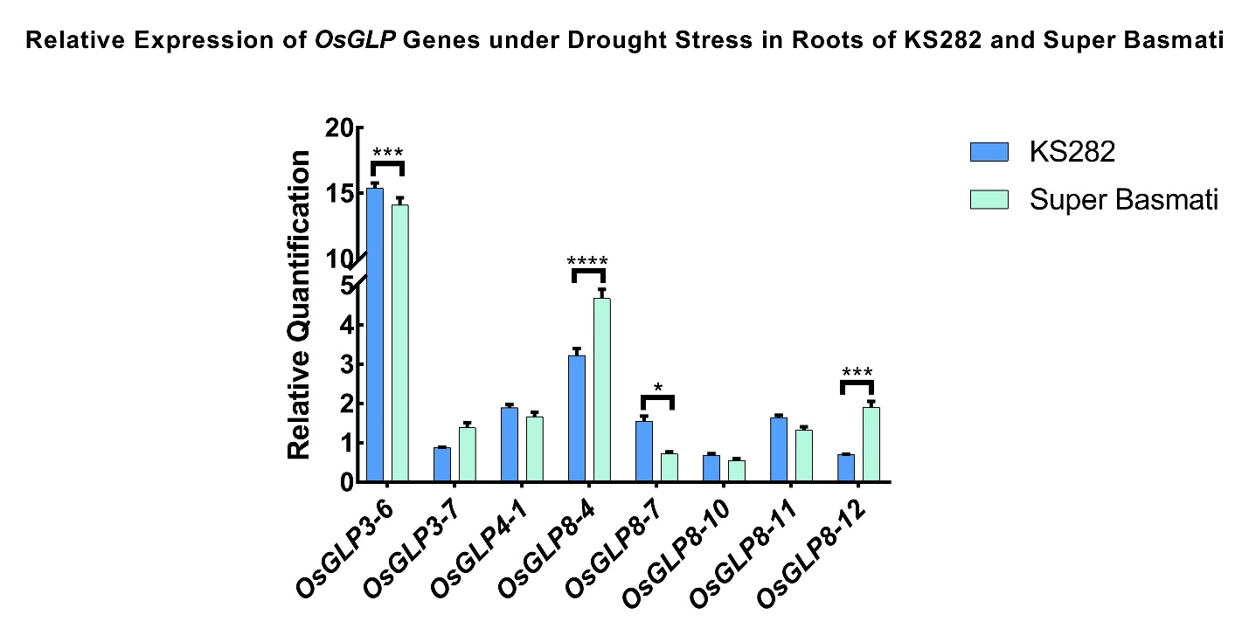KS282, Super Basmati). Values indicate mean ± Standard Error Mean (SEM). Statistical analysis was performed with two-way ANOVA (* P<0.05, ** P<0.01, *** P<0.001, **** P<0.0001)

Fig. 3 Expression profiling of OsGLP genes in roots under drought and salt stress. Relative expression (Fold Change) of OsGLPs (a) OsGLP3-6 (b) OsGLP3-7 (c) OsGLP4-1 (d) OsGLP8-4 (e) OsGLP8-7 (f) OsGLP8-10 (g) OsGLP8-11 (h) OsGLP8-12 in drought and salt stress treated roots samples was determined relative to their expression in control roots of KS282 and Super Basmati (Control, Drought stress, Salt stress). Values indicate mean ± Standard Error Mean (SEM). Statistical analysis was performed with two-way ANOVA (* P<0.05, ** P<0.01, *** P<0.001, **** P<0.0001)

Fig. 4 (a) Venn diagram demonstrating the expression pattern of OsGLP genes regulated by drought and salt stress in roots of KS282 and Super Basmati (Up-regulated, Down-regulated, No change in expression). Expression profiles of OsGLPs (in roots) regulated commonly regarding particular stress type (drought and salt) and particular rice variety (KS282 and Super Basmati) (b) Salt stress induced comparative expression of OsGLP genes in roots of KS282 and Super Basmati. Comparison of relative expression (Fold Change) of OsGLPs (OsGLP3-6, OsGLP3-7, OsGLP4-1, OsGLP8-4, OsGLP8-7, OsGLP8-10, OsGLP8-11, and OsGLP8-12) was performed between KS282 roots and Super Basmati roots under salt stress (KS282, Super Basmati). Values indicate mean ± Standard Error Mean (SEM). Statistical analysis was performed with two-way ANOVA (* P<0.05, ** P<0.01, *** P<0.001, **** P<0.0001) (c) Drought stress induced comparative expression of OsGLP genes in roots of KS282 and Super Basmati. Comparison of relative expression (Fold Change) of OsGLPs (OsGLP3-6, OsGLP3-7, OsGLP4-1, OsGLP8-4, OsGLP8-7, OsGLP8-10, OsGLP8-11, and OsGLP8-12) was performed between KS282 roots and Super Basmati roots under drought stress (KS282, Super Basmati). Values indicate mean ± Standard Error Mean (SEM). Statistical analysis was performed with two-way ANOVA (* P<0.05, ** P<0.01, *** P<0.001, **** P<0.0001)

Fig. 5 Heat map showing the tissue specific expression pattern of OsGLP genes under control and stress conditions. Heat map displays the expression level (2^{−ΔCT}) of OsGLPs (OsGLP3-6, OsGLP3-7, OsGLP4-1, OsGLP8-4, OsGLP8-7, OsGLP8-10, OsGLP8-11, and OsGLP8-12) in leaves and roots of KS282 and Super Basmati under control and stress (salt and drought) conditions relative to reference gene Actin. Each box exhibits the mean value for relative expression level from three independent experiments in duplicate. The color bar at the bottom of the heat map represents low to high expression from green to red color. CL, control leaves; CR, control roots; DL, drought leaves; DR, drought roots; SL, salt leaves; SR, salt roots

